

**Software Requirement Specification (SRS)**

**Document**

**School Bus Management System**

**Sprint-1**

Project Timeline: 07-12-2022 to 12-12-2022

**INDEX**

1. Introduction
   1. Purpose ---------------------------- 4
   2. Intended audience -----------------------------4
   3. Intended use ----------------------------4
   4. Scope -----------------------------4
2. Overall description -----------------------------5
   1. Assumptions and dependency -----------------------------5
3. System feature and requirements ----------------------------6
   1. Functionality ----------------------------6

3.1.1 Add Student ----------------------------6

3.1.2 Remove Student ---------------------------6

3.1.3 Update Student ---------------------------6

3.1.4 Add Bus Stop ---------------------------6

3.1.5 Display bus stop ---------------------------6

3.1.6 Remove from Bus -----------------------6

3.1.7 Menu ----------------------------6

3.1.8 Enter more than 5 ----------------------------6

3.1.9 Bus Amount

3.1.10 Exit -----------------------------6

3.1.11 Final Report -----------------------------6

3.2 System requirement -------------------------------7

3.2.1 Tools to be used -----------------------------7

3.3 System feature ----------------------------7

1. Data Flow Diagram
   1. DFD level 0 -------------------------------8
   2. Flow Chart --------------------------------9

* **Introduction:**

[1:31 AM] Samiksha Gulabrao Khode[CAPG-95]

•The School bus management system is a software which helps to manage the process of school bus transportation.

•The system consists of two main modules.

•Admin can add user or delete or modify student to the system.

•Maintains all data of users and bus route details.

* 1. **Purpos**e:

The purpose of this software or project is to show the requirements for School bus management system which creates direct contact between the Admin and Student menu. And it will provide an efficient and handy platform for the development of the proposed product or software. It applies proven methodologies and uses current software tools so that one can plan, control, and monitor student, processes, and other components.

* 1. **Intended Audience:**

This document is intended to be read by Admin and Student menu.

##### **Intended Use:**

* Admin Menu
* Student Menu

Since this is general-purpose Software hence anyone who is associated with development can use this software.

**1.4 Scope:**

This project aims to create the development to School bus management system. This system consists of an application that will serve as a platform for the development team and Admin to add/modify Features for a particular release.

This System provides a reliable platform for the developer team and Admin in an efficient manner.

It provides a platform for the interaction of the Development team and Student menu.

**Future Scope** –

It can be implemented into the next step that involves School bus management system. Another user like Admin and Student menu can also be integrated with the future proposed system. The admin can see interested /add/remove students. Student can also request/remove/check.

# **2. Overall Description: -**

The school bus management system is a software which helps to manage the process of school bus transportation.

It allows:

* It allows to orders the work for complex problem can add some of features like check interested students, add student to bus (if spaces are vacant), remove student from bus (if they leave the school or route), add bus stop (assigned to interested student) and print bus amount.
* The result and adjust the features according to the queued and capacity as well as Priority. They can request add to bus queue, remove from bus queue.

**Role:**

Add Student in the database(csv) taking Student Id, first name, last name, username, password, amount. These data are updates in csv file.

Remove Student from the database(csv) taking Student Id.

Add Bus Stop to the student while checking the status of available stop and add bus Stop.

Print bus Amount.

##### **2.1 Assumptions and Dependency:**

* The system should have any Distribution of Linux installed.
* The Proposed System is intended to work on Terminal GUI.
* The system should have either 8GB or more RAM.
* The service is used preferably on a desktop or laptop.

**3. System Features and Requirements:**

**3.1 Functionality:**

### Add Student: Add student in the database(csv) taking Student Id, firstName, lastName, username, password, amount. These data are updated in a csv file.

### Remove Student: Remove student from the database(csv) taking the unique Student Id.

### Update Students: The data of student csv got updated.

### Add busStop: Add busStop to the student while checking the status of available stop and add busStop.

### Display busStop: Show the available busStop and add busStop.

### Remove from bus: Taking student id and remove student from bus.

### Menu:show menu login page.

### Enter more than 5:It shows invalid operation

### Bus Amount: Print the bus amount.

### Exit:It's used to add custom menus to the standard menu bar.

### Final Report: At last, the final report will be given. The final report will include all the details of the student menu and the capacity of the bus.

**3.2 System Requirements**:

###### **3.2.1. Tools to used:**

* Valgrind
* Splint
* Make file
* C File Handling

#### **System Features:**

* Supportability:The system is easy to use.
* Design Constraints: The system is built using only C language.

* Usability:The School bus management system will cut down the gaps between the Admin and Student menu and will be more helpful by providing a platform for efficient interaction between both.

* Reliability & Availability**:** The system is available 24/7 that is whenever the user would like to use the system, they can use it up to its functionalities.

* Performance: The system will work on the user’s terminal**.** It is Terminal based Software.

# **4.Data Flow Diagram**:

## The DFD or Data Flow Diagram maps out the flow of information for the given software. The given DFD diagram depicted the flow of data and information of the proposed system.

##### **4.1 DFD Level 0** –

This is the DFD level 0 diagram of given software:

LEVEL 0 DFD

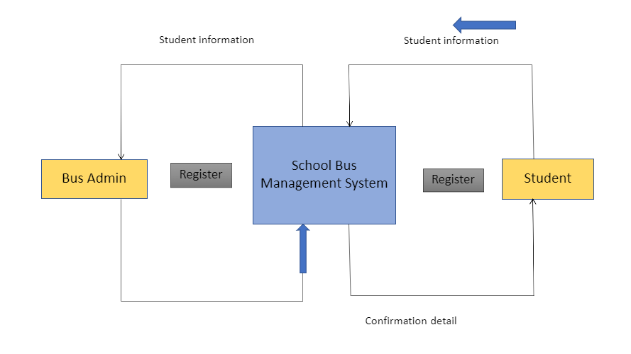

**4.1.2 Flow Chart Diagram**

