***SELF ASSESSMENT AND PERSONALIZED LEARNING PATH***

***Project website:*** ***http://lms.digi-safari.com/***

***Project Owner:*** *Digi Safari*

***Team Members:***

*A B M Kamrul Islam Riad*

*Hassan Alfeshkhi*

*Md Saiful Islam*

*Prathyusha Kommineni*

***Instructor:*** *Dr. Meng Han*

***Course:*** *IT 7993 Capstone Project*

***Submission Date:*** *November 29, 2020*

**Index**

1. **Title page** ­­­­­­­­­­­­­­­­……………………………………………………………………………………*1*
2. **Executive Summary** ……………………………………………………………………….*2*
3. **Project Presentation**

*3.1 Presentation link ………………………………………………………………*.2

1. **Introduction** ………………………………………………………………………………...*3*

*1.1* *Background …………………………………………………………………….,3*

1. **Analyses and Design** ………………………………………………………………………*3*
   1. *Blooms Taxonomy …………………………………………………………… .4*
   2. *Architecture …………………………………………………………………. ...4*
   3. *Milestones ……………………………………………………………………....5*
   4. *System Design and Testing ………………………………………………......6*
      1. *Start Spring Tool Suite ……………………………………….6*
      2. *Start Angular ………………………………………………….9*
2. **Implementation** ……………………………………………………………………………*12*

*6.1 Login Server …………………………………………………………………. 12*

*6.2 User Signup……………………………………………………………………14*

*6.3 Course Details………………………………………………………………...15*

*6.4 Take Quiz………………………………………………………………………16*

*6.5 Attempt Quiz Review………………………………………………………….18*

1. **Conclusion** …………………………………………………………………………………*19*
2. **Reference** ………………………………………………………………………………….*19*

**2. Executive Summary**

Digi-Safari (DS) provides software training and services to corporate clients looking to re-skill/ Up-skill existing/ new hires under the B2B (Business-Business) model. DS wants to extend the service for the B2C (Business-Consumer) segment, where individual learners can also directly register for self-paced training. To better assist learners in assessing their current skill level and pick the best-fit learning path, DS is planning to develop a Self-Assessment and Personalized Learning-path (SAPL) System. SAPL will provide an on-line self-assessment tool through a series of questions, which will auto-select the next question based on response from previous questions equivalent to the GRE type test. Based on the performance and candidate's career goal, SAPL will automatically come up with Personalized Learning-path. Candidates will then have the option of enrolling through Digi-Safari training programs.

**3. Project Presentation**

*3.1 Project Link:* <https://youtu.be/B4oeEeZ5s4Y>

**4. Introduction**

E-learning has proved the best means in the corporate sector, especially when training programs are conducted by MNCs for professional learners across the globe and employees are able to acquire important skills.

If a learner wants to learn a specific course and when he searches in Google, he finds tons of websites offering that course. But for example Mr. Mike already knows some basics of Java and not sure what is his skills level on those topics.

He must spend tons of hours in finding the right course with the personalized learning path. Unfortunately, the available Learning Management Systems offers the same course content for every learner.

We believe that every learner has either basic, intermediate, or expert skills on learning any technology. So, we need a system, which can evaluate the skills on a specific topic and prepare a customized learning path for the topics which he has basic / intermediate knowledge.

That is what our Self-Assessment and Personalized Learning Path system will do.

*4.1 Background*

SAPL is an intellectual way of learning technology. It is a full stack java web application which runs an assessment based on Bloom’s Taxonomy.

In SAPL, the learner will be asked a few questions like his expertise level on the course (complete beginner or know some stuff). If he selects a beginner, it will create the complete course topic as a learning path. If he selects, I know some stuff, it will further ask a few more questions to know what topics he already knows. Based on his input, it prepares a quiz with a set of questions to ask keeping Bloom’s Taxonomy in mind along with the timer.

Once the quiz is completed, it analyzes the results and categorizes the topics in which he is expert, intermediate and beginner. Based on that it prepares the customized learning path.

**5. Analysis and Design**

* 1. *Bloom’s Taxonomy*

It is a hierarchical ordering of cognitive skills that can help anybody to learn effectively. There are six levels in Bloom’s Taxonomy. Remember, Understand, Apply, Analyze, Evaluate and Create. With these six levels of learning, one can achieve efficiency.

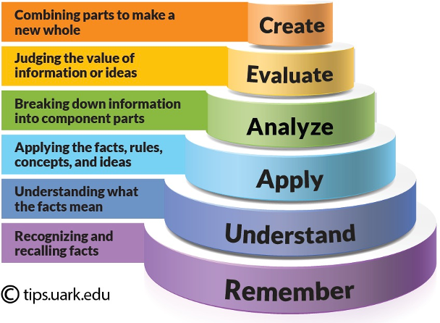

* 1. *Architecture*

SAPL (Self-Assessment and Personalized Learning Path) is a micro-services-based application. It is designed with the most widely used architectural patterns in terms of load balancing, scalability, and maintainability.

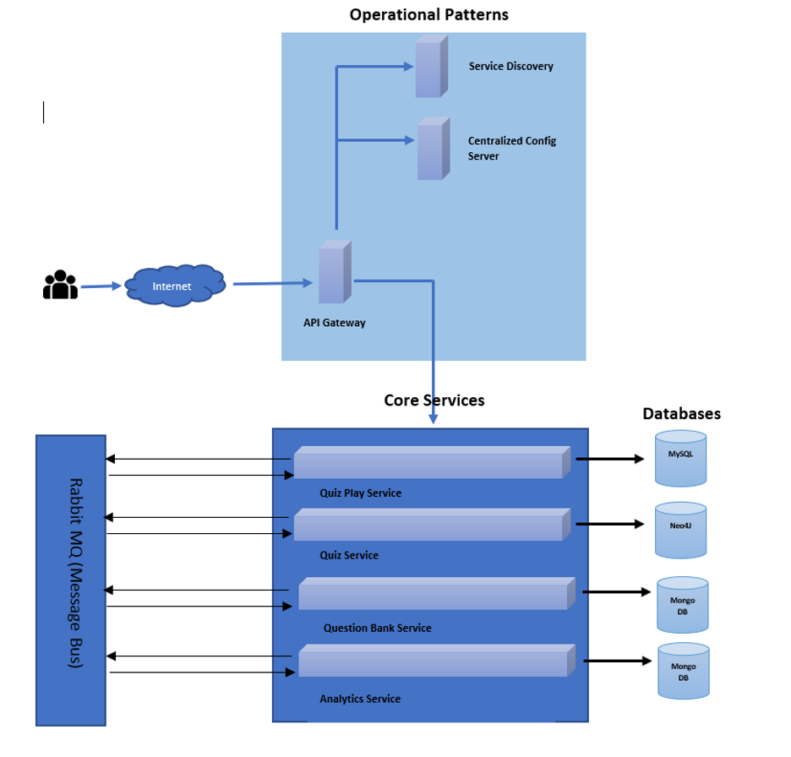

* 1. *Milestones*

The candidates must achieve the following milestones

* Designing the rich UI/UX front end application using Angular Framework
* Designing the back-end APIs (RESTful Webservices) using Spring & SpringBoot
* Implementing the microservice architecture using the spring cloud patterns
* Implementing the Continuous Integration and Continuous Deployment using Gitlab, Docker and Kubernetes(k8s)
* Deploying the application to AWS cloud.

*5.4 System Design and Testing*

The project testing plan start from Spring Boot Application and the code build up basis of Java, Maven and Spring Boot ( Controllers, Dependency and Database base Repository)

First we created the integrating part for user service that starts the end point response, the user login or sign up process. When it comes to testing the Spring Boot dependencies, we only need to add the spring-boot-starter-test dependency.

Secondly, the integration part with frontend that we use Angular for a single page application, that includes the user login, signup, course dashboard, course details, and quiz.

The steps to run the application:

* + 1. *Start Spring Tool Suite*

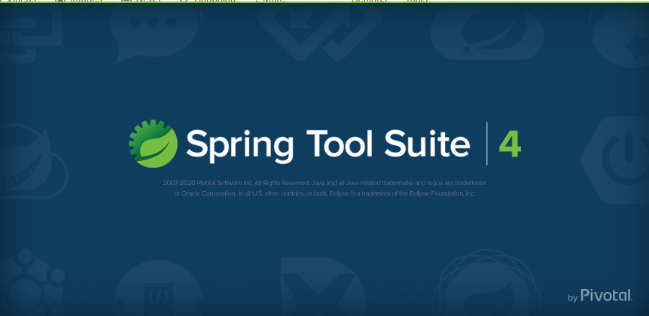

* **Select a directory as workspace and Lunch**

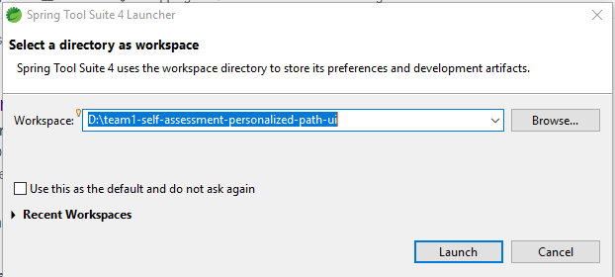

* **Import Maven project --File → import→ Maven → Existing Maven Projects → Next**

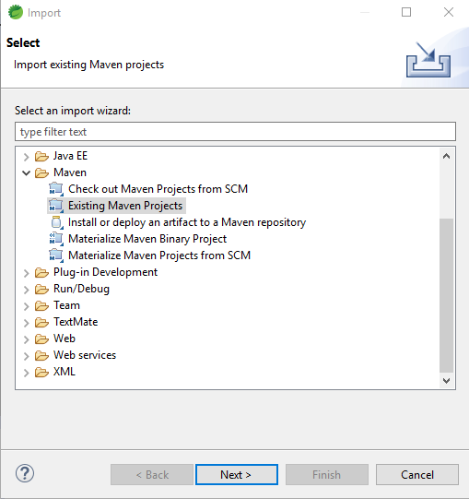

**Select → Root Directory → Finish**

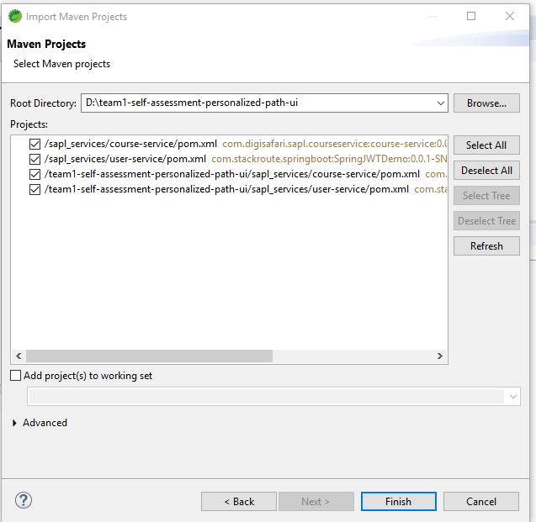

* So it will open many package we built up for your project but for serve start we need to run sapl-user-service

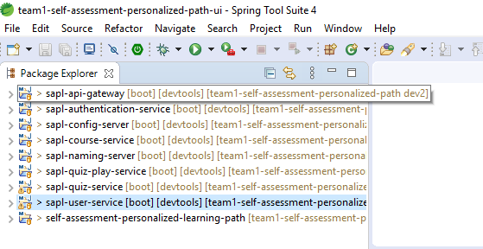

* Select → Right Click o sapl-user-service-package → Run As → Spring Boot App

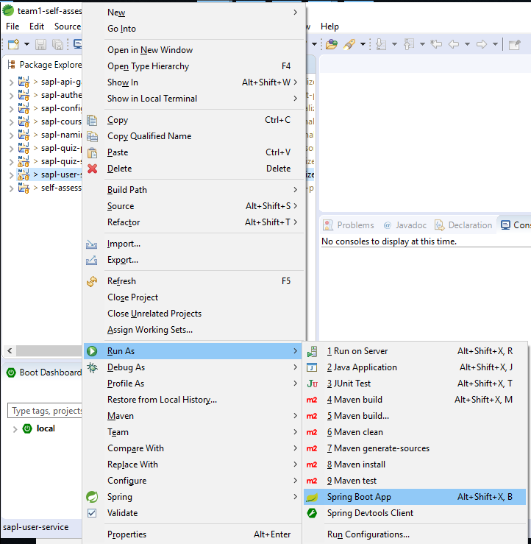

**→ The Spring Server is started as following: Tomcat started as localport: 8080**

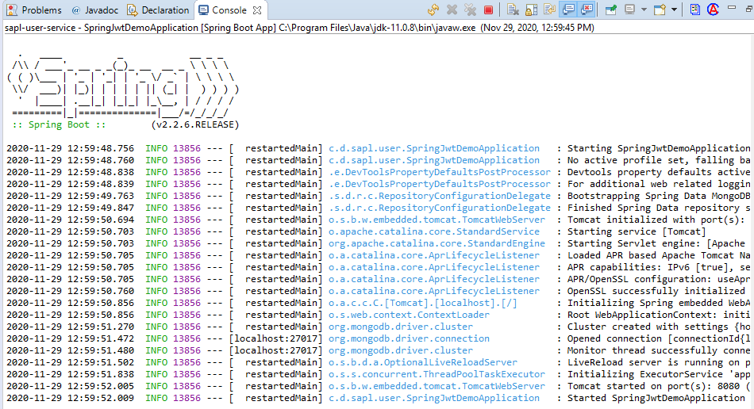

*5.4.2 Start Angular* **as FrontEnd interaction for the project**

* **Run Visual Code IDE steps: open the cmd prompt → access the Directory where the Angular project built up**

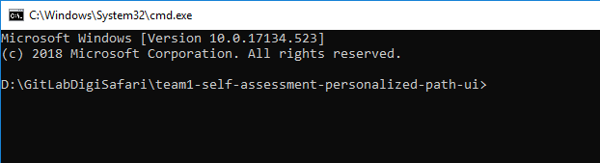

→ command c***ode .*** so the visual studio will start with your project directory

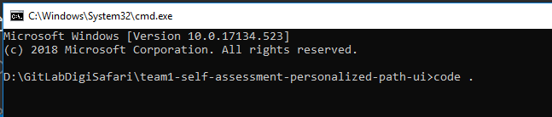

* The visual Code IDE is started with the Angular project created

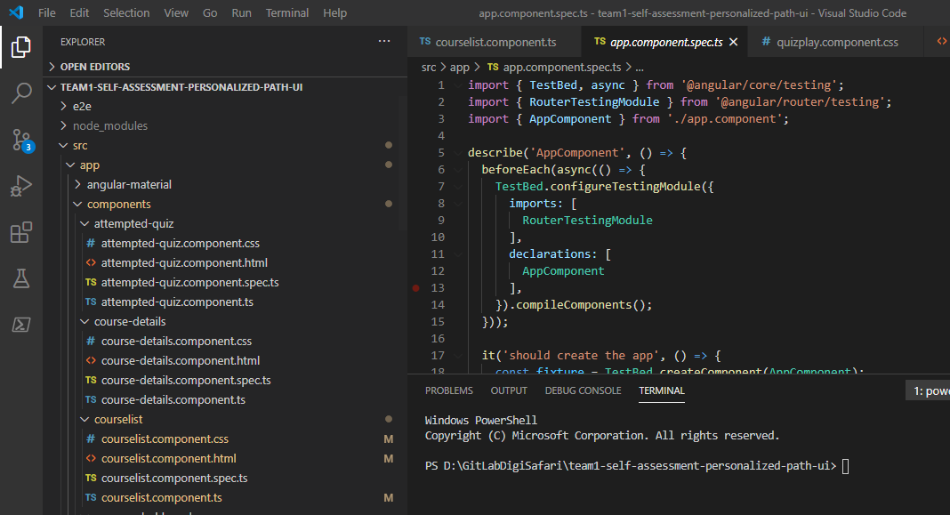

* In the Terminal Window run the code: **ng serve --open**

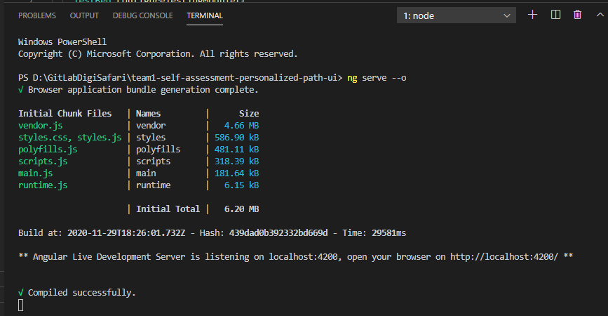

* **The local server page: *localhost:4200* is open where user can login and signup for course**

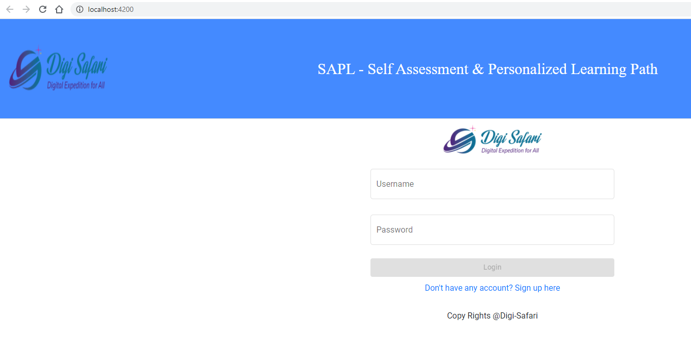

**→ So users can Sign in or Signup from the page.**

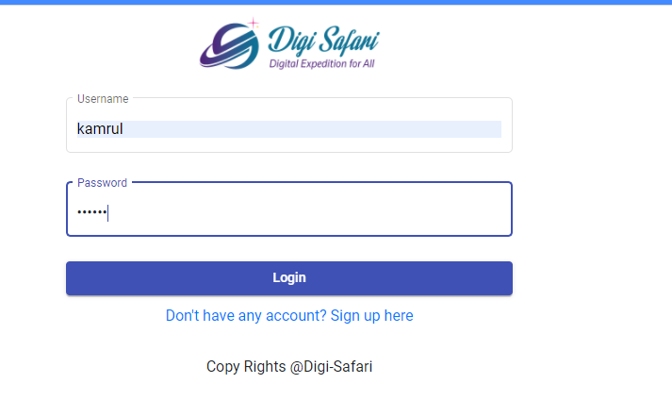

**→ When user login the page the backend server response:**

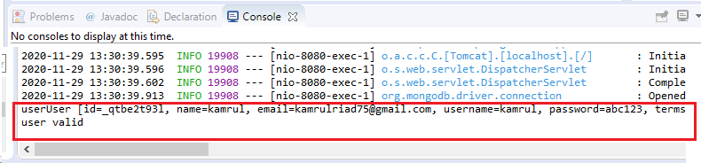

**→ The user can access the course dashboard**

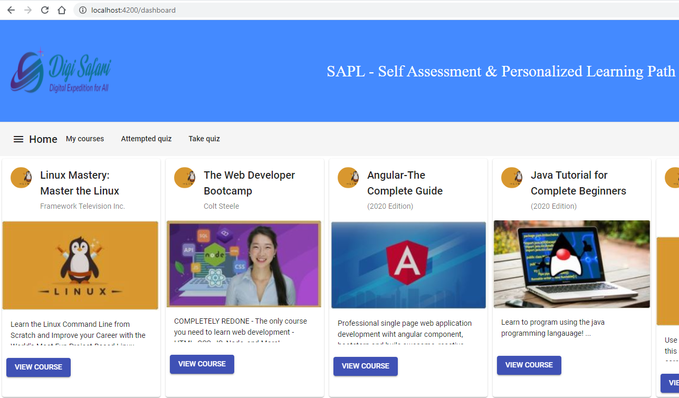

**6. Implementation**

*6.1 Login Server:*

The first time that a user seeks access to an application, the Login Server:

* Authenticates the user by means of user name and password
* Passes the client's identity to the various applications
* Marks the client being authenticated with an encrypted login cookie

In subsequent user logins, this login cookie provides the Login Server with the user's identity, and indicates that authentication has already been performed. If there is no login cookie, then the Login Server presents the user with a login challenge.To guard against sniffing, the Login Server can send the login cookie to the client browser over an encrypted SSL channel.The login cookie expires with the session, either at the end of a time interval specified by the administrator, or when the user exits the browser. It is never written to disk.

A partner application can expire its session through its own explicit logout.The Single Sign-On API enables:

* Applications to communicate with the Login Server and to accept a user's identity as validated by the Login Server
* Administrators to manage the application's association to the Login Server

Authenticating to the Login Server authenticate a user in this way:

* The Login Server checks for a login cookie. If one is present, the Login Server identifies the user from the encrypted information in the login cookie.
* If the login cookies is not present, the Login server prompts the user for the user’s credentials
* The user provides the username and password
* The Login server Authenticate the user by passing the provided name and password to the configured authentication local routing for external repository that establishes a login cookies on the server to facilitate the single sign or save for future authentication request
* 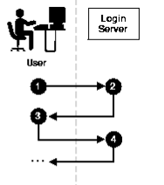
* The existing user can login the course and quiz service with invalid username and password

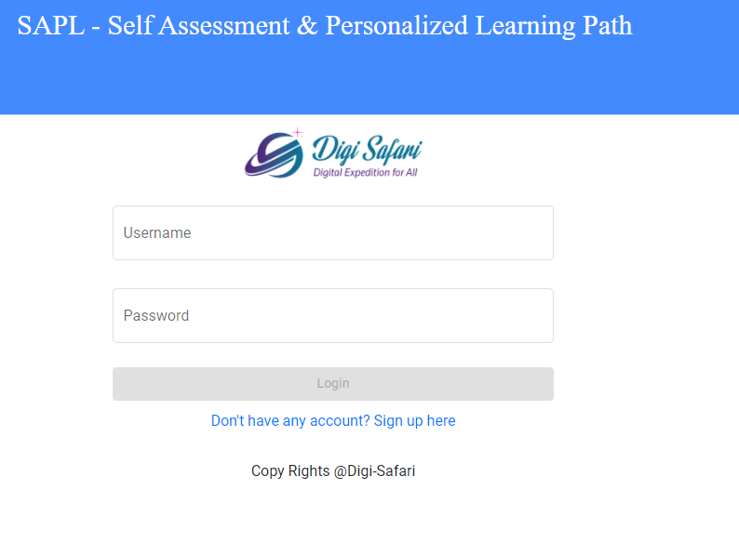

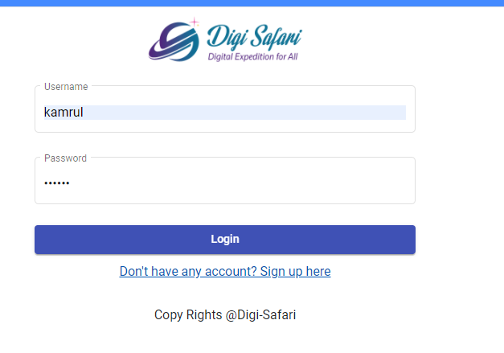

* 1. *User Signup:*

A single Sign on Authentication provides users with a seamless authentication experience when navigating through the application that is built. The implementation part of sign up creates the credential in the backend server so users can sign in any time regardless of domain that works in the authentication process. When user login for the first time the cookies get created on the central server as redirected to the app with a token without a login prompt which means you are logged in. The following figure the show the backend implementation process as user sign up authentication process

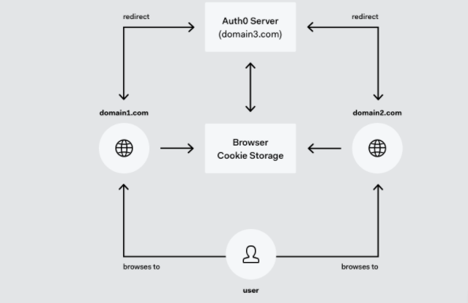

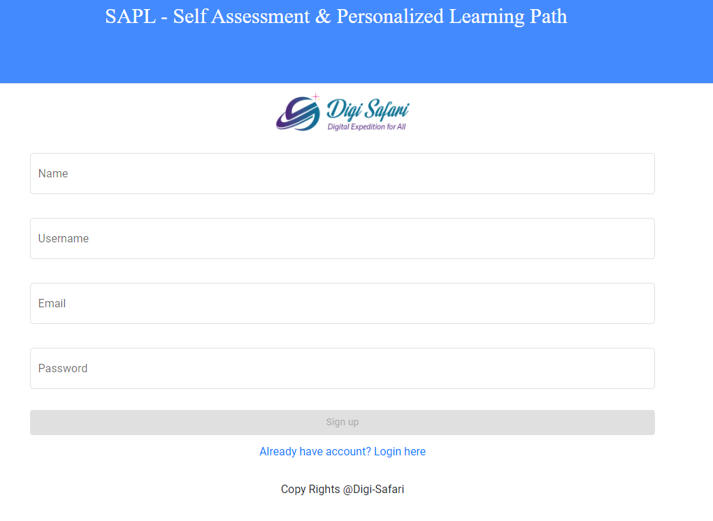

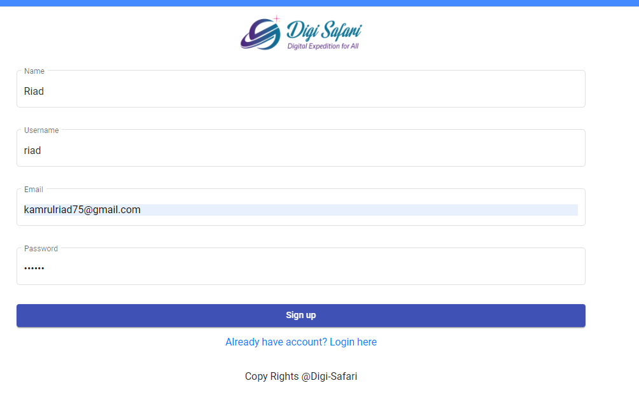

* 1. *Course Details*

Once user login is successful, the user course dashboard pops up so users can access the course details that are more suitable for a best learning path. So on this page users get the option to see the course details by clicking the view course button. Prior taking this cause, the user is asked to take quiz to assess the level of learning path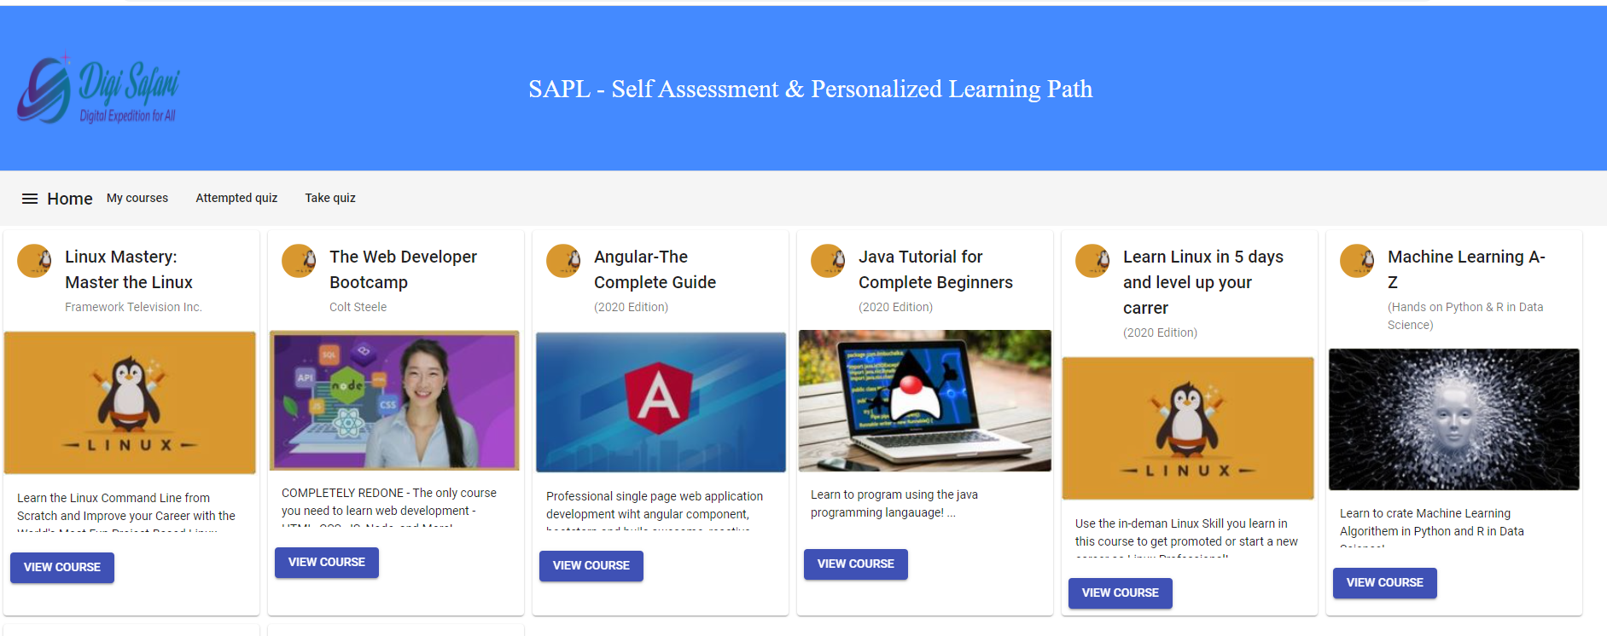

* 1. *Take Quiz*

After user login successfully , the user can take a quiz. When users access the Takequiz sites the cookies pop with asking the user experience of the technology. 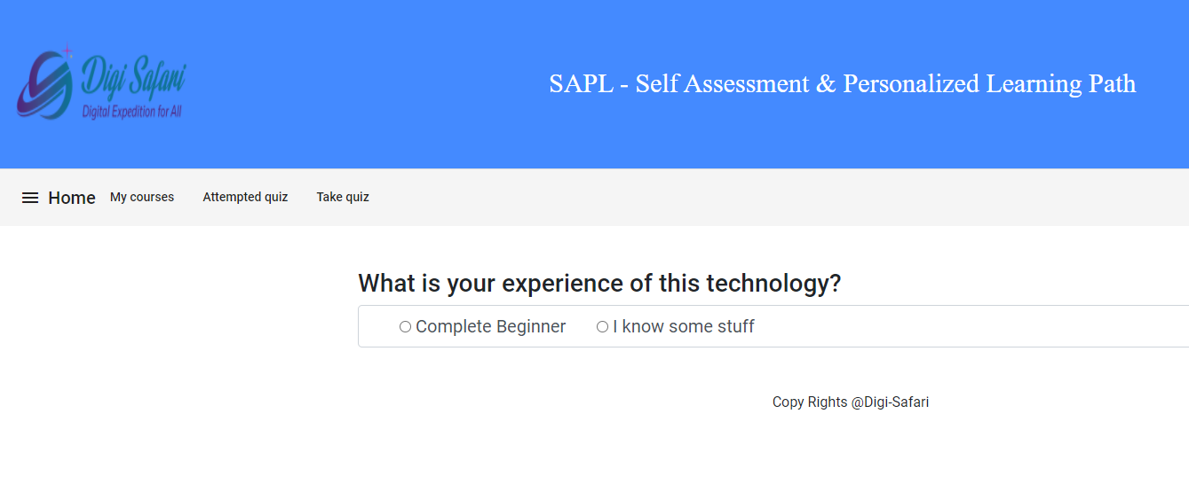

If user choose the complete Beginner option, the following pop up windows appear to evaluation the learning path

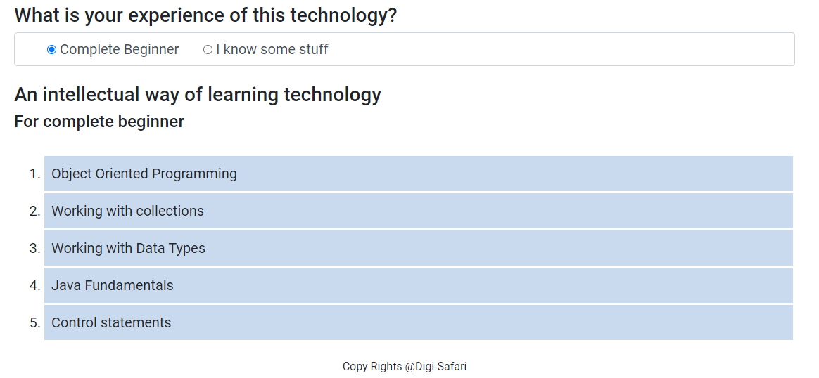

But if the user chooses some staff, the pop quiz topic screen appears so the user can choose the specific topic he/she wants to take the quiz. Once user select the topic then

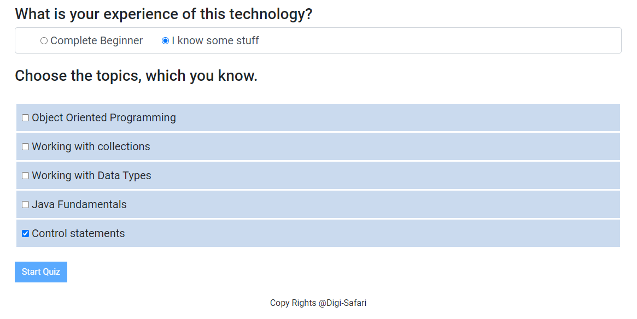

click start quiz button, the the quizzes screen appears with the following sample question so user can choose answer from the multiple options as following:

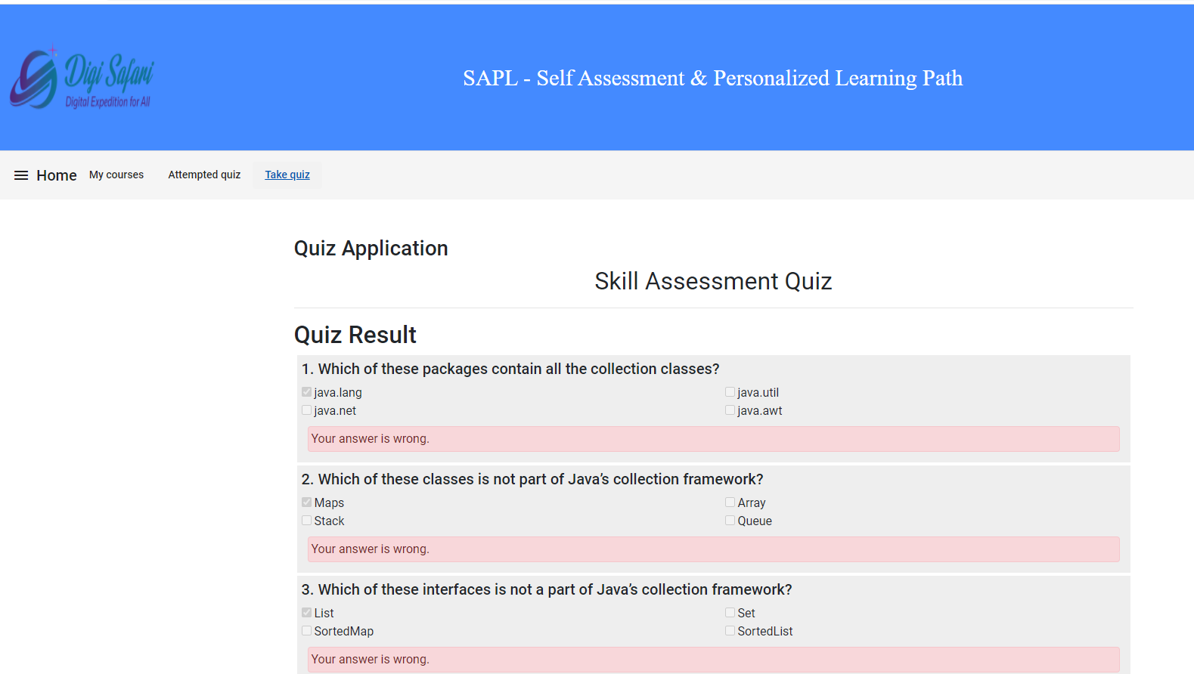

After submitting the quiz, the user level of learning path screen appears as following:

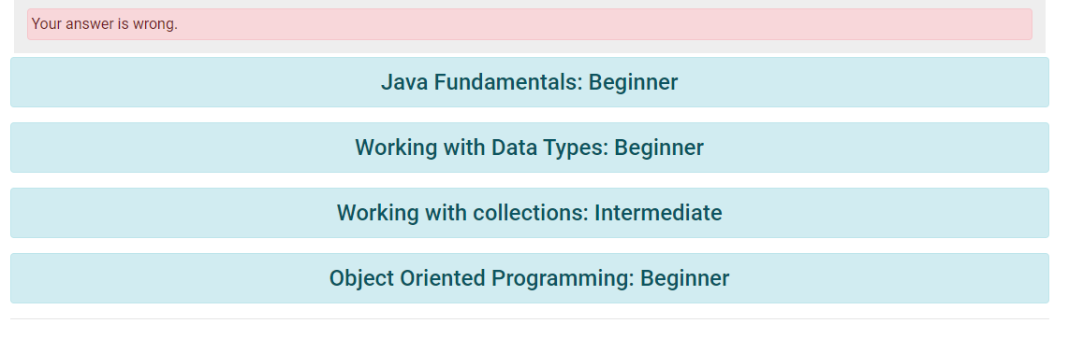

* 1. *Attempt quiz Review*

The attempt quiz is the part of the user previously attempting quiz in specific topic and courses. The process is generated as backend database for user action so user can recover or review his attempted quiz or activities that he/she took part in this self learning path

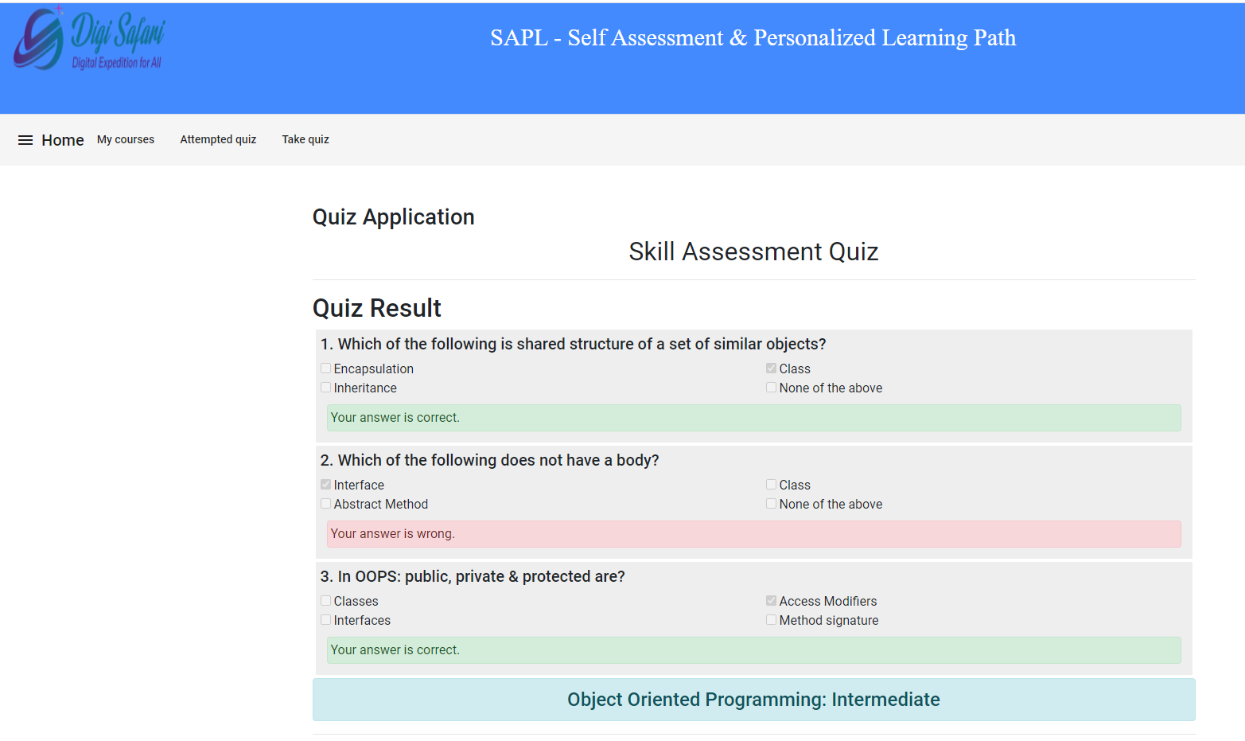

**The following are the outcome from the capstone project**

* Single page application development process
* Spring Security, Authentication & Authorization using JWT token
* Data management with Nosql databases, Spring Boot MongoDB
* Testing Restful Web Services, Gitlab CI pipelines for RESTful web service
* Implement HTTP API calls, GET, POST, PUT, DELETE, PATCH
* Create Form, Routing and Security
* Angular Forms with Driven Template, component interaction
* Refactoring and Deployment

**7. Conclusion**

In this capstone project, we team up a single page application and create the authentication server response as backend development. The capstone project we team together applied Three-tier architecture which covers the client-server software architecture in which we learned the user interface(presentation), functional process logic (business rules), computer data storage and data access. We learned how 3-tier architecture provides the benefits development and application layer by modularizing the user interface, business logic and data storage. We clearly understand the greater flexibility to development teams by allowing them to update the specific part of the application independently of the other parts. So this added flexibility can improve overall time-to-development and decrease the development cycle times by performing individual team tasks and team’s ability to replace or update code independent tiers without affecting the other part of the system.

**8. Reference**

1. <https://uxdesign.cc/design-sign-up-ba0e839e9efb>
2. <https://www.techopedia.com/definition/24649/three-tier-architecture>
3. <https://uxplanet.org/designing-ux-login-form-and-process-8b17167ed5b9>
4. <https://www.britannica.com/science/taxonomy>