**INFORMATION TECHNOLOGY**

# HERITAGE INSTITUTE OF TECHNOLOGY, KOLKATA

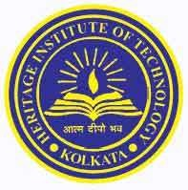

**BONAFIDE CERTIFICATE**

Certified that this project report **“ONLINE EXAMINATION SYSTEM”** is the bonafide work of **“KISLAY KANTI DHAR(COLLEGE ROLL 1754024,UNIVERSITY ROLL 12617002024)** who carried out the project work in the year 2019 for the partial fulfillment of the requirements of the Software Engineering Laboratory

DATE- 13/11/2019

------------------------------------------- -------------------------------------------

FACULTY SIGNATURE

HEAD OF DEPARTMENT