1. **Introduction**
   1. **Project Aims & Objectives**

The aim of this project is to create and deliver an online examination system in which admin can manage examinations ,student lists, see result. On the other hand a student can give exam and check his subject wise results.

* 1. **Background of Project**

Every year lots of student give exams in their universities which are semester exams, unit tests, internals etc. Managing all these exams written on paper can be tough and time consuming . Conducting online exams are easy for any universities with computer labs which are easily available now.Thus saving lots of papers and man-power

1. **System Analysis**
   1. **Software Requirement Specification**

**2.1.1 Functional Requirements**

A)Admin registration/login module:Various fields available on this screen will be: Login Name, Institute Name, Email Id, Password.

B)Exam details module:Exam Name, No. Of Questions, Time Limit, +ve, -ve Marks, Passing Marks. This must be monitored by the admin.

C)Student list screen:Student ID, Student Name.

D)Student Login module:Student ID, Student Name, Institute ID

E)Student Taking Exam:Display of Question with Options, Control Buttons To switch questions.

F)Result Displaying screen: No. of Correct Question, No. of Incorrect Questions**,** No. of Un-attempted Questions, Total Marks, Result (Pass/Fail).

**2.1.2 Non-Functional Requirements**

A)Security:Measurements can be expressed in a variety of ways to break into the the system and its data.Do not discuss solutions(ex:passwords) in a requirement document.

B)Availability:The System will be available only when the hosting server is online.

1. Performance:Requirements about the resources required,response time,transaction rates,throughput,benchmark specifications or anything else having to do with performance.

**2.1.3 Goal of implementation**

Goal of implementation of this project is to deliver an efficient application from which both faculty and student take profit

**2.2Software and Hardware specification**

**2.2.1hardware:**

Processor- intel i3 6006u @2.0 Ghz

Ram: 4 gb

Memory: 1 TB

**2.2.2software:**

Os 64 bit windows 10

Backend technologies:flask,python 3.7,flask-wtf forms

Front end technologies:HTML,bootstrap4,javascript,jijnja2 templates

1. **System Design**
   1. **Functional Oriented Design**

**DFD**

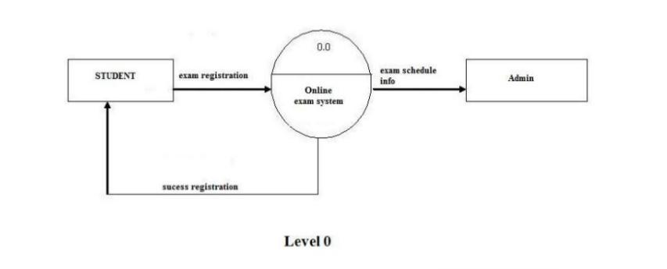

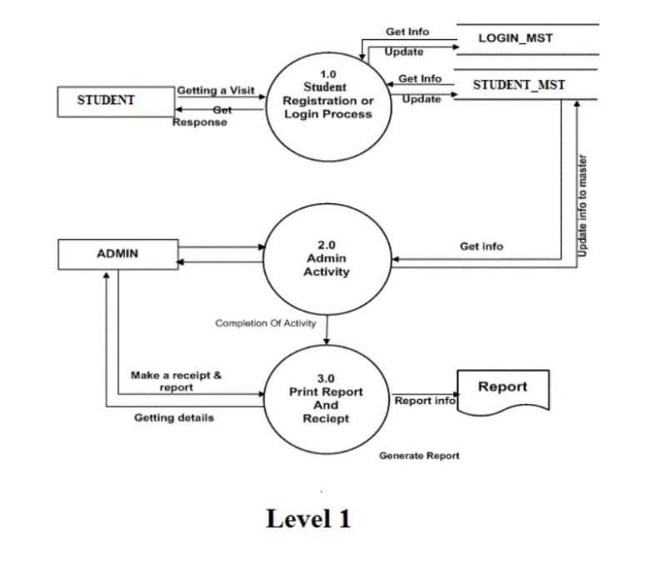

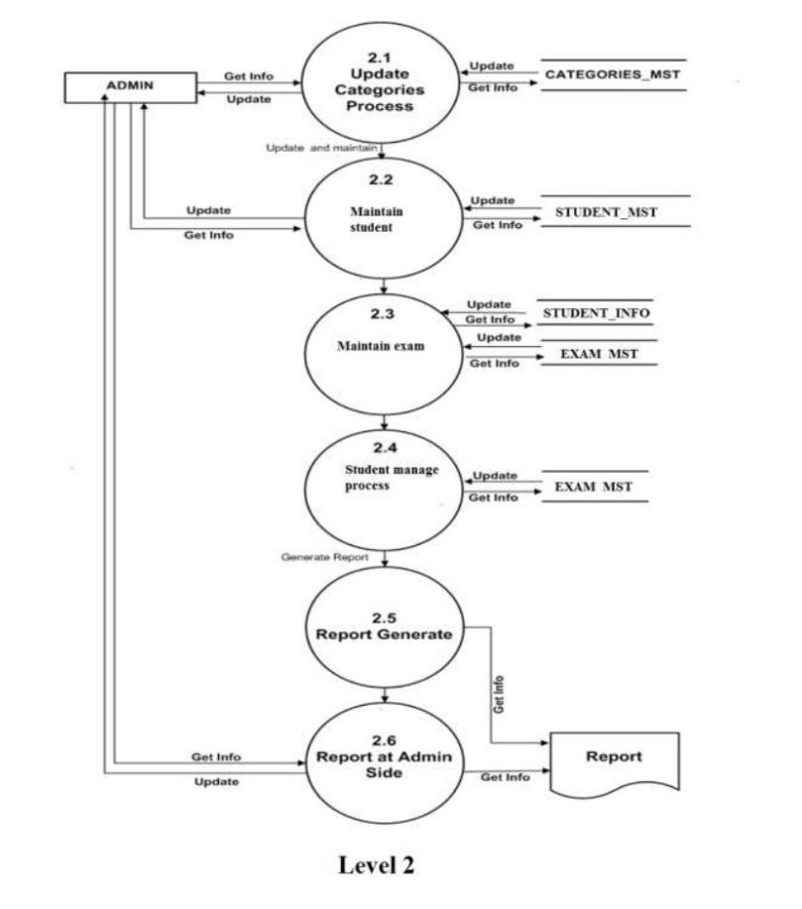

**3.2Object Oriented Design**

**ERD**

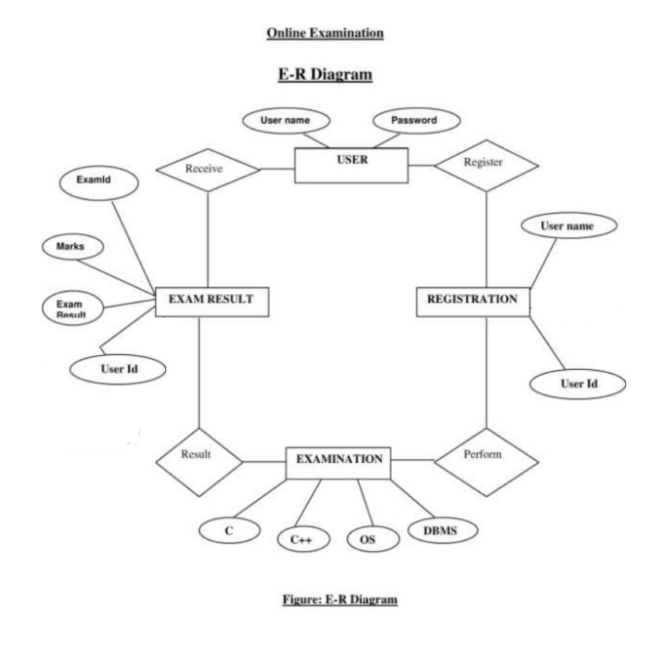

**Class diagram**

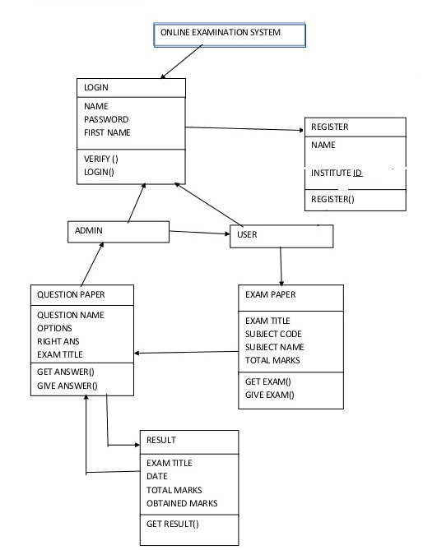

**Use Case Diagram**

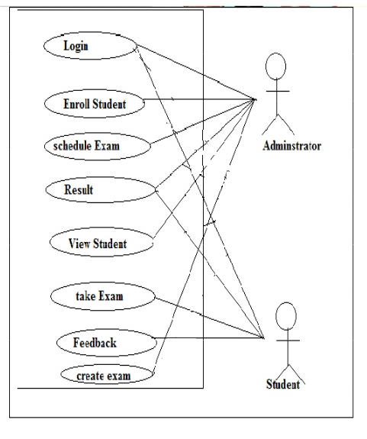

**Sequence diagram**

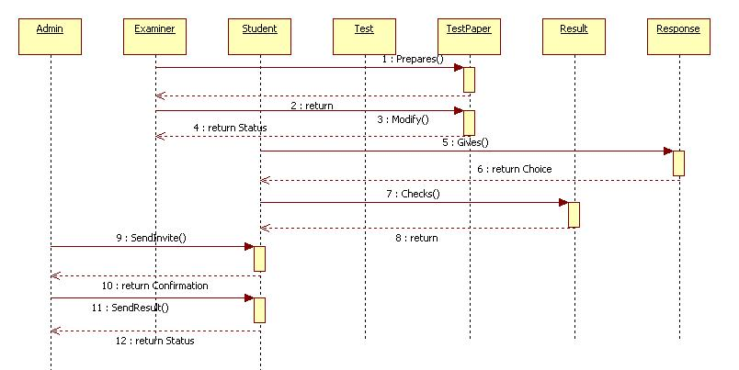

**Activity diagram**

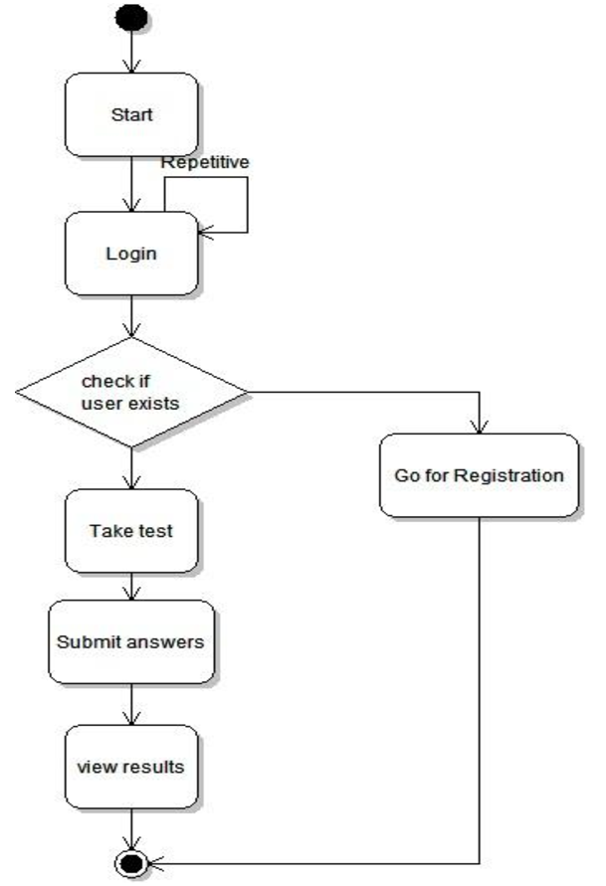

**Database Design**

Admin

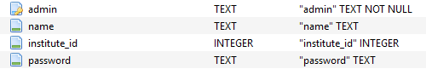

Institute



Paper

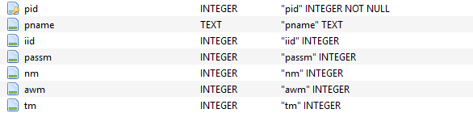

Questions

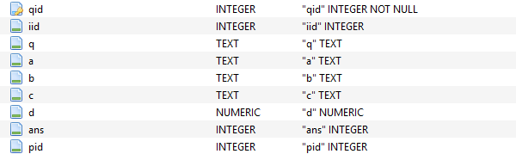

Result

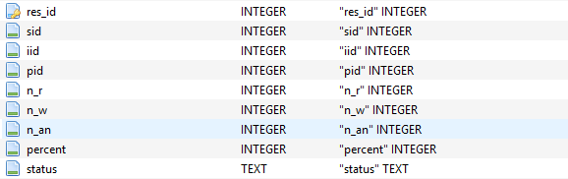

Student



1. **System Implementation and Coding**

**4.1Screenshot for pages**

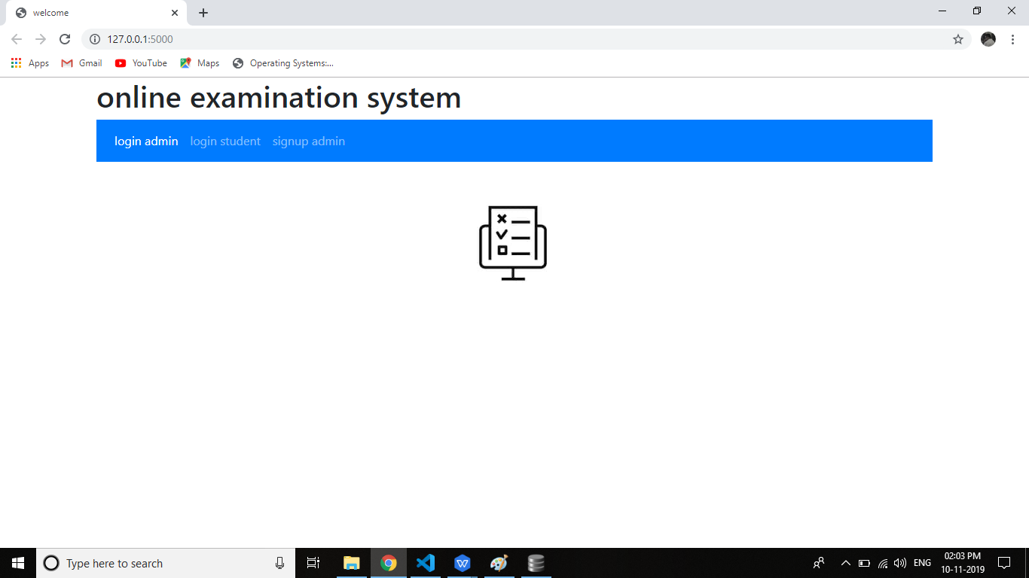

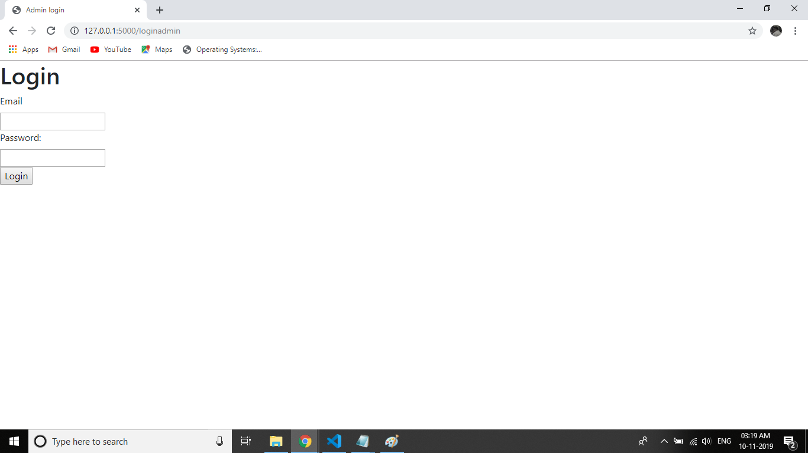

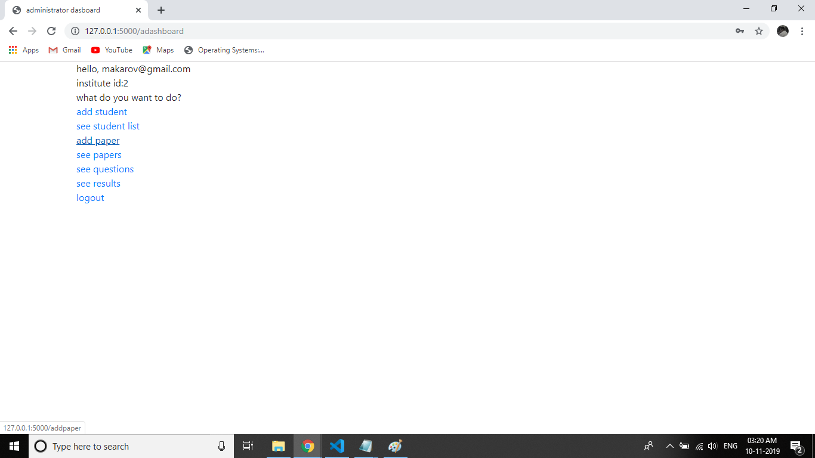

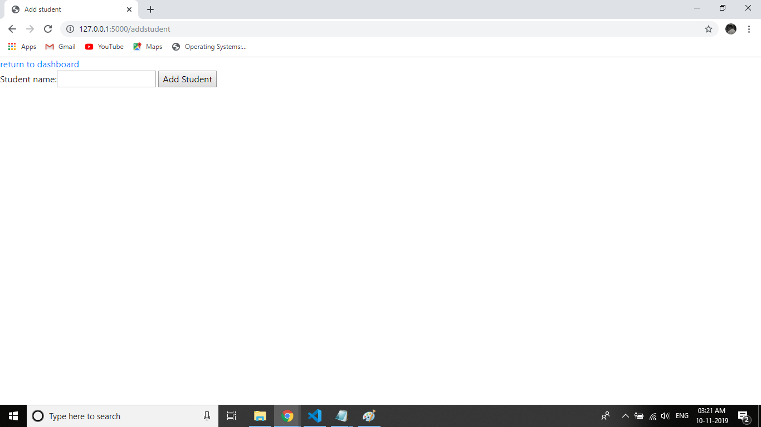

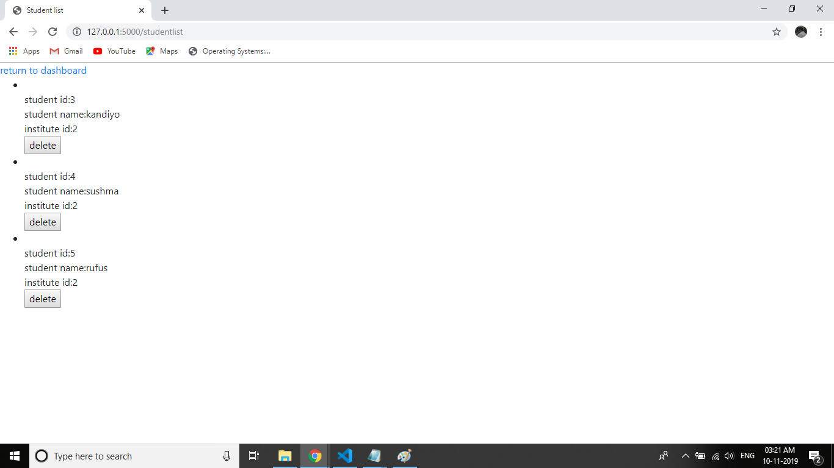

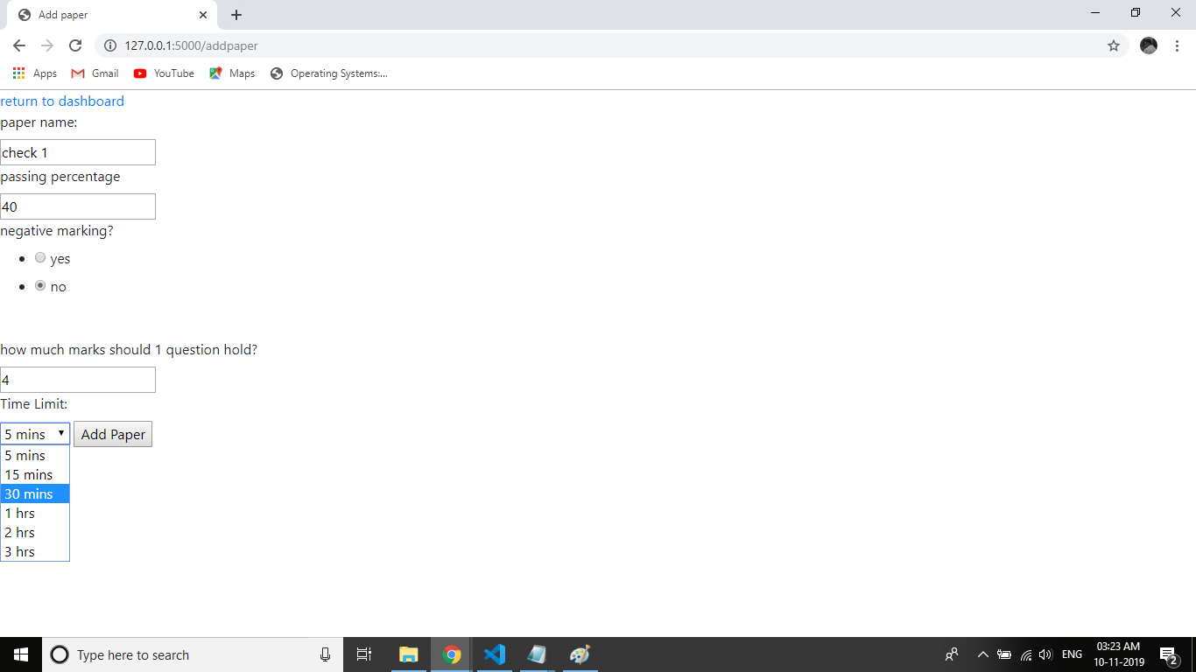

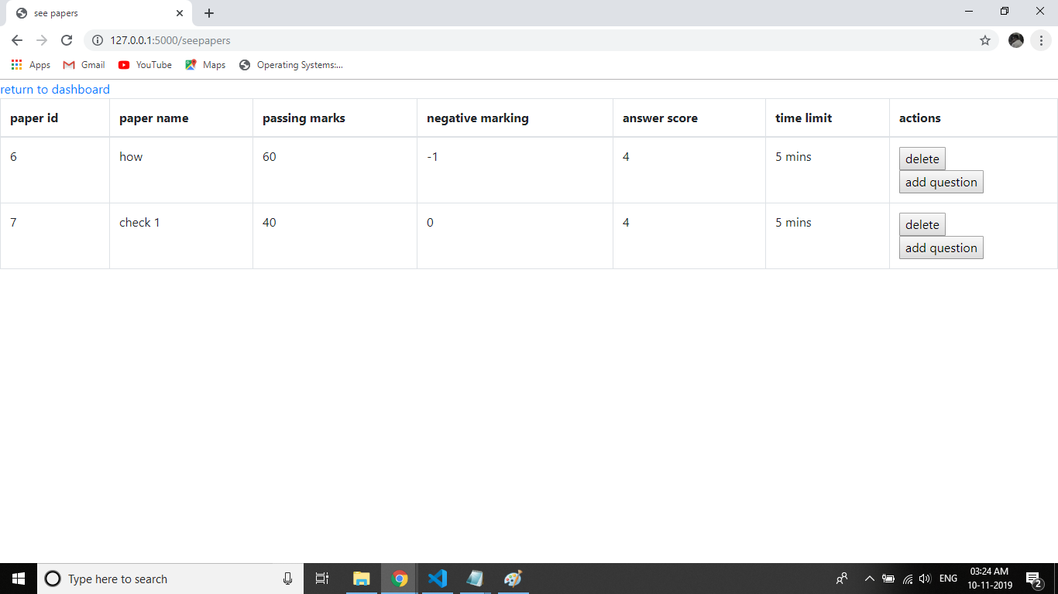

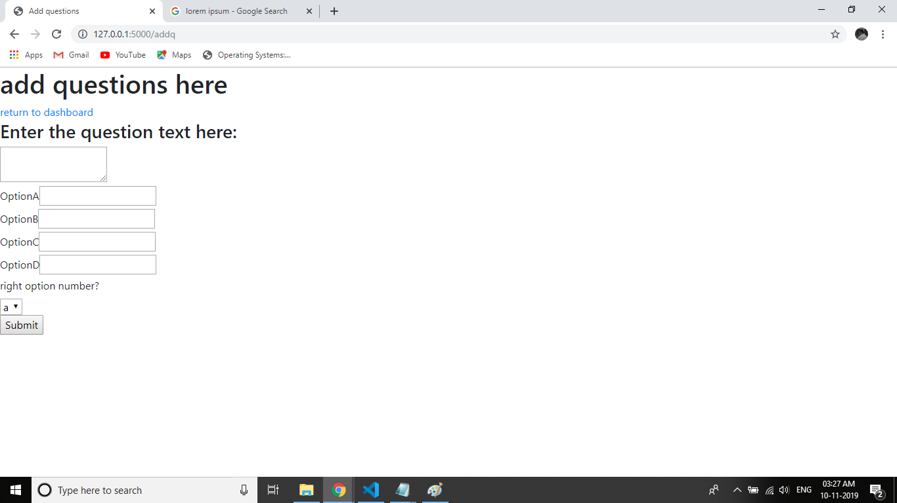

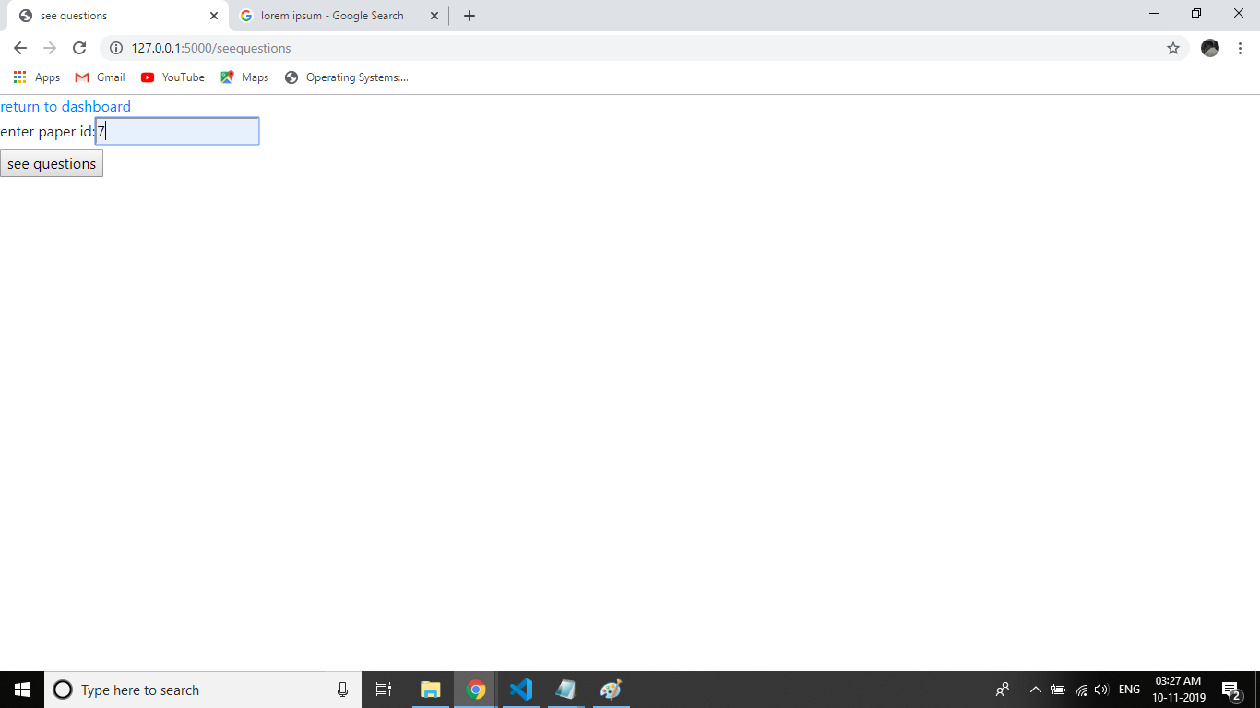

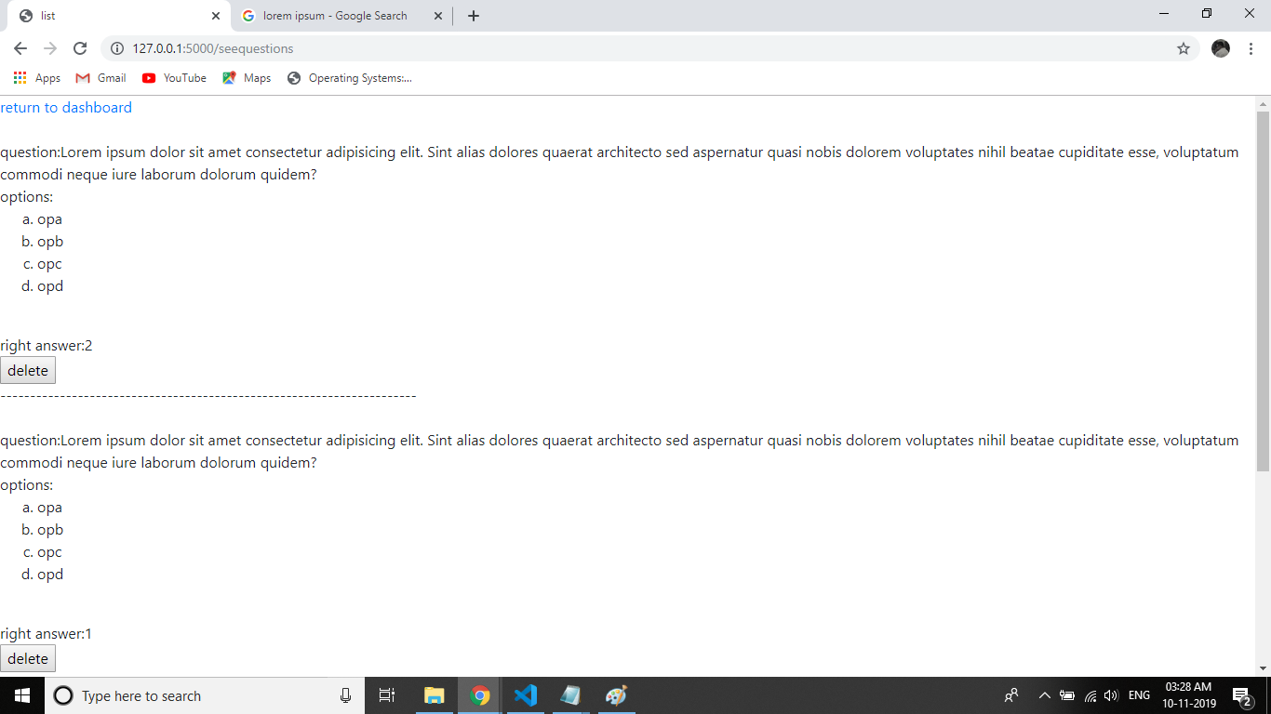

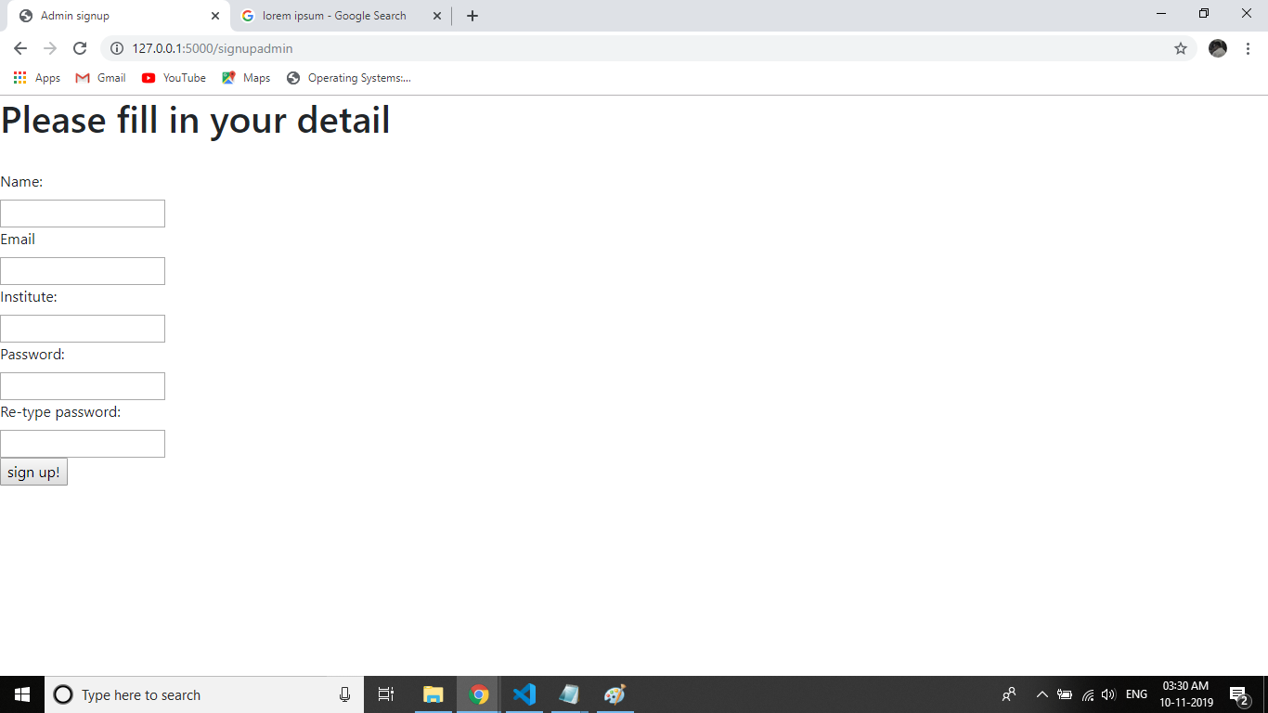

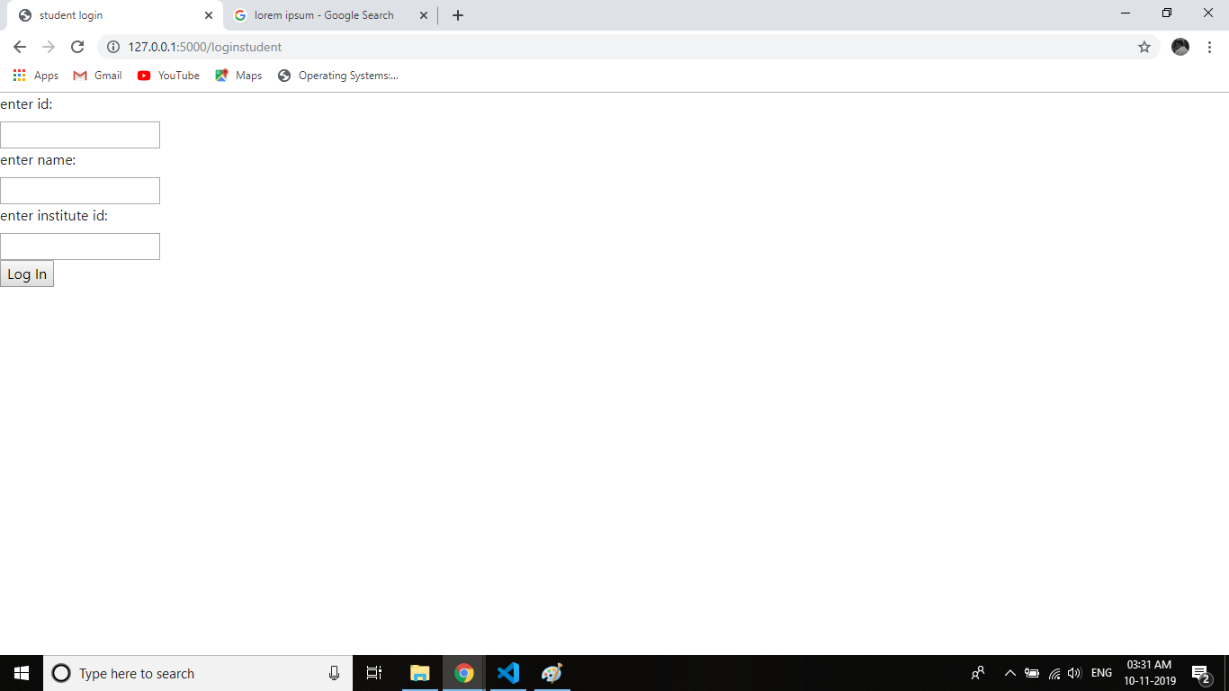

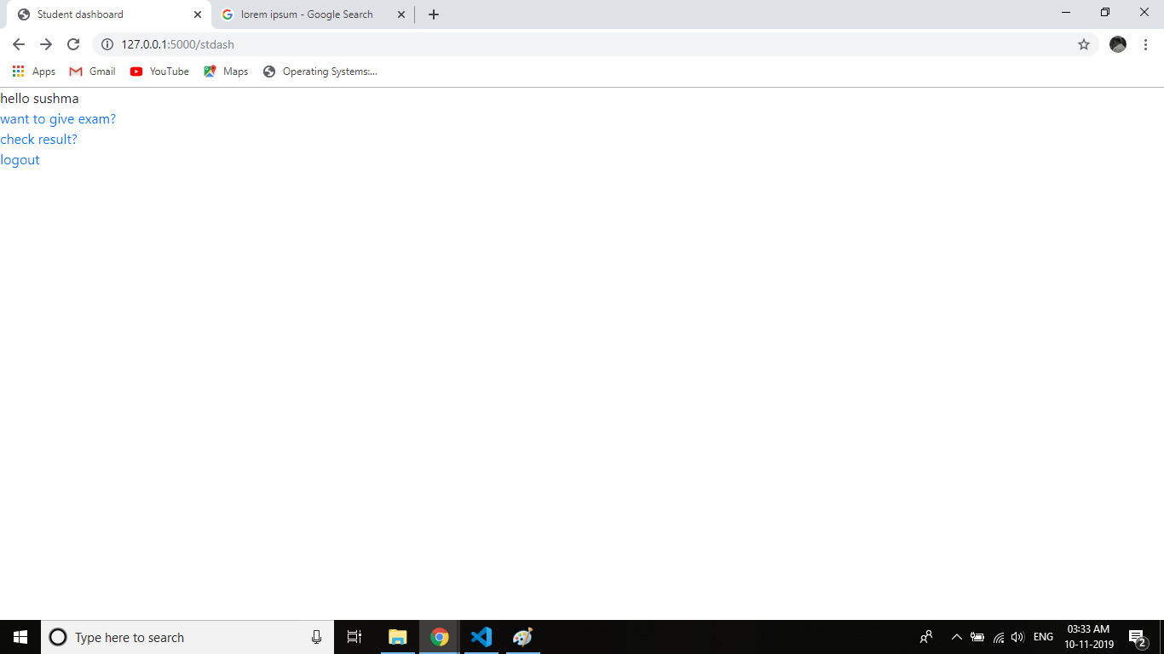

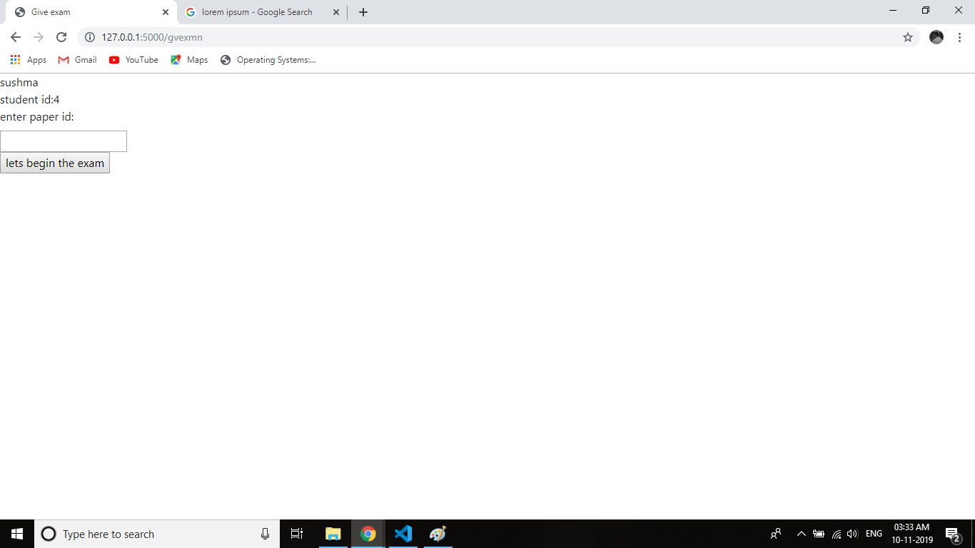

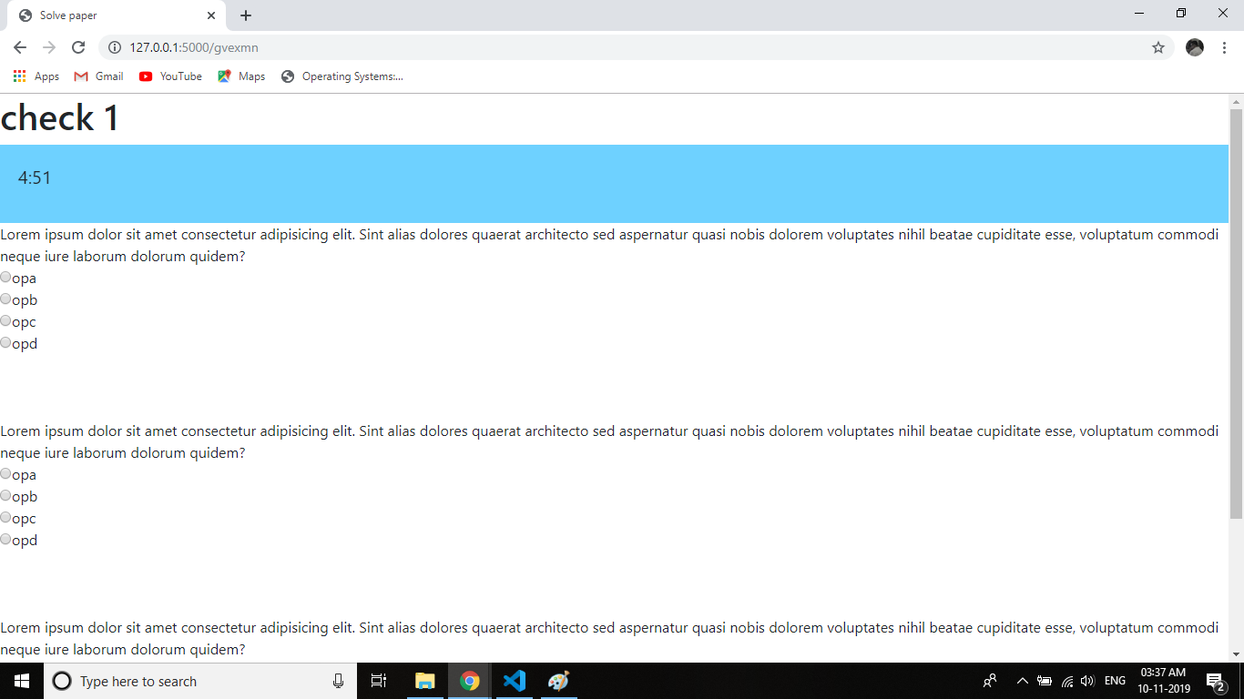

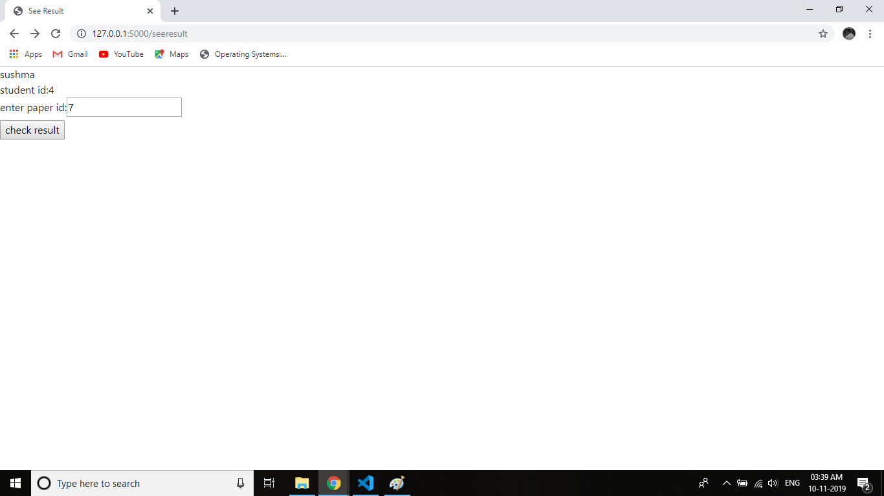

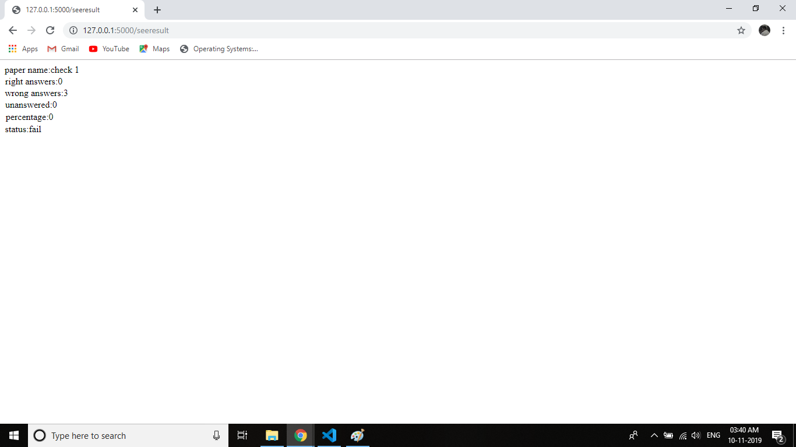

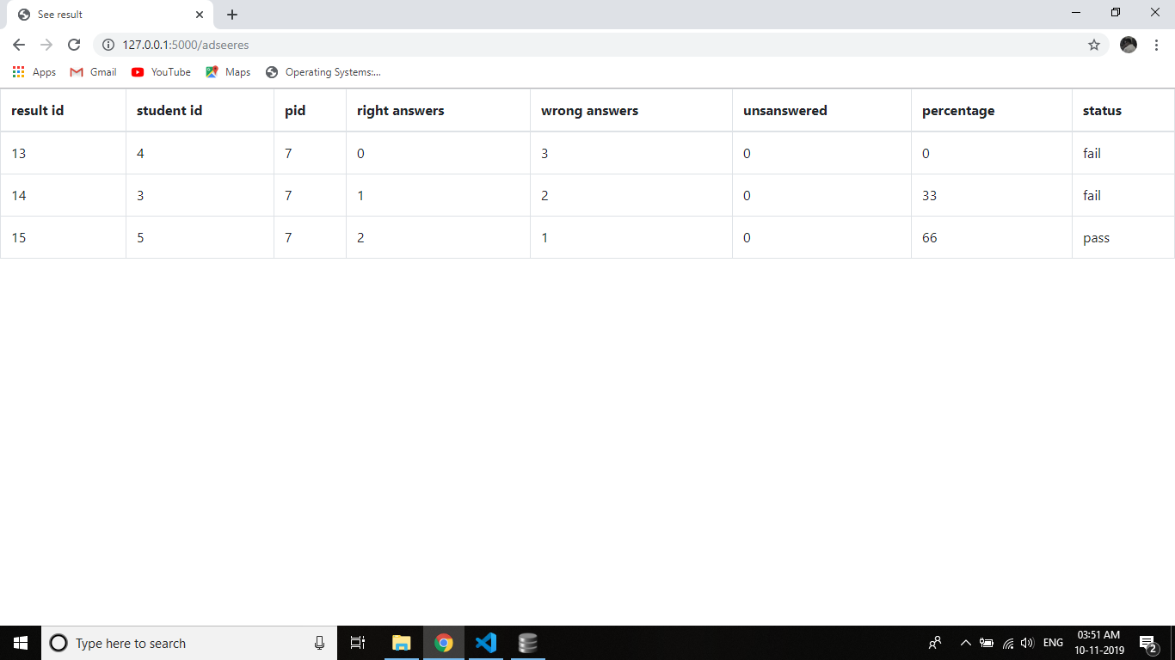

1. **System Testing**
   1. **White Box testing**

**White Box Testing** is defined as the **testing** of a software solution's internal structure, design, and coding. In this type of **testing**, the code is visible to the tester. It focuses primarily on verifying the flow of inputs and outputs through the application, improving design and usability, strengthening security.

* 1. **Black Box testing**

**BLACK BOX TESTING**, also known as Behavioral **Testing**, is a software **testing** method in which the internal structure/design/implementation of the item being tested is not known to the tester. These **tests** can be functional or non-functional, though usually functional.

**6. Future scope & Enhancement**

This project has lots of scope in quick exam conduction. And there are lots of ideas available to enhance the productivity of this project . One is applying the REST application technique where this system can interact with other systems to either get data or send data , thus making the job of admin much more less. Another can be a rating system or hint system. After the conduction of exam a discussion panel can also be provided.

**7.Conclusion**

This concludes that the project with mentioned required specifications is complete and it can perform

them accordingly. I tried my best to include all the necessary points that are required related to the given topic.I think the tests I did went smoothly and I had no problems.I do hope that my project will be interesting and maybe even knowledgeable.

**8.References**

* The applicable IEEE standards are published in ‘IEEE standards collection’ 2001 edition
* The standard python library -Doug Hellman
* Conda library-Anaconda.org
* Pydocs-python.org