STUDENT GUIDE
How to Use the Journal Research Desk
Search, explore and share ten years of true stories of hope and resilience
The top of the Journal Research Desk: its name, the number of posts, blogs and words, and the years covered.
Open it here: tinyurl.com/Journal-Research-Desk
Full address: https://kislingjeff-oss.github.io/JAKPublicBlogDatabase/desk/
Stories by Jeff Kisling · Guide updated October 2026

Welcome
The Journal Research Desk is a free website that lets you search every blog post Jeff Kisling has written, more than 3,200 of them, from 2015 to today. Each post is a short, true story. Many are about people working for peace, justice, the land and each other: Quakers, Indigenous communities, farmers, students and neighbors.
You can use the desk to research a school project, prepare a youth group discussion, find stories from a certain year, or just explore. Everything you find links straight to the original post, so you can read the whole story and share it.

What you need
- A web browser on a computer, tablet or phone. Nothing to install and no account to make.
- The address: tinyurl.com/Journal-Research-Desk.
- About ten minutes to try the examples in this guide.

What's inside this guide
Section | You will learn to
1. A quick tour | Find your way around the tabs at the top of the desk.
2. Search | Find posts by words, years, tags, blogs and age range.
3. Selected & Export | Turn your search into a reading list with working links.
4. Browse | Explore the eight blogs and the most-used tags.
5. Verified Facts | Check the history behind the stories.
6. Ten Years of Stories | Travel through time, month by month.
7. Age Ranges and About | Choose posts that fit your group, and learn how search works.
8. Tips for good research | Read carefully, check facts and give credit.

1. A quick tour
When you open the desk you land on the Search tab. Across the top is a row of tabs. Click a tab to switch to it. Each tab opens at the top of its page.
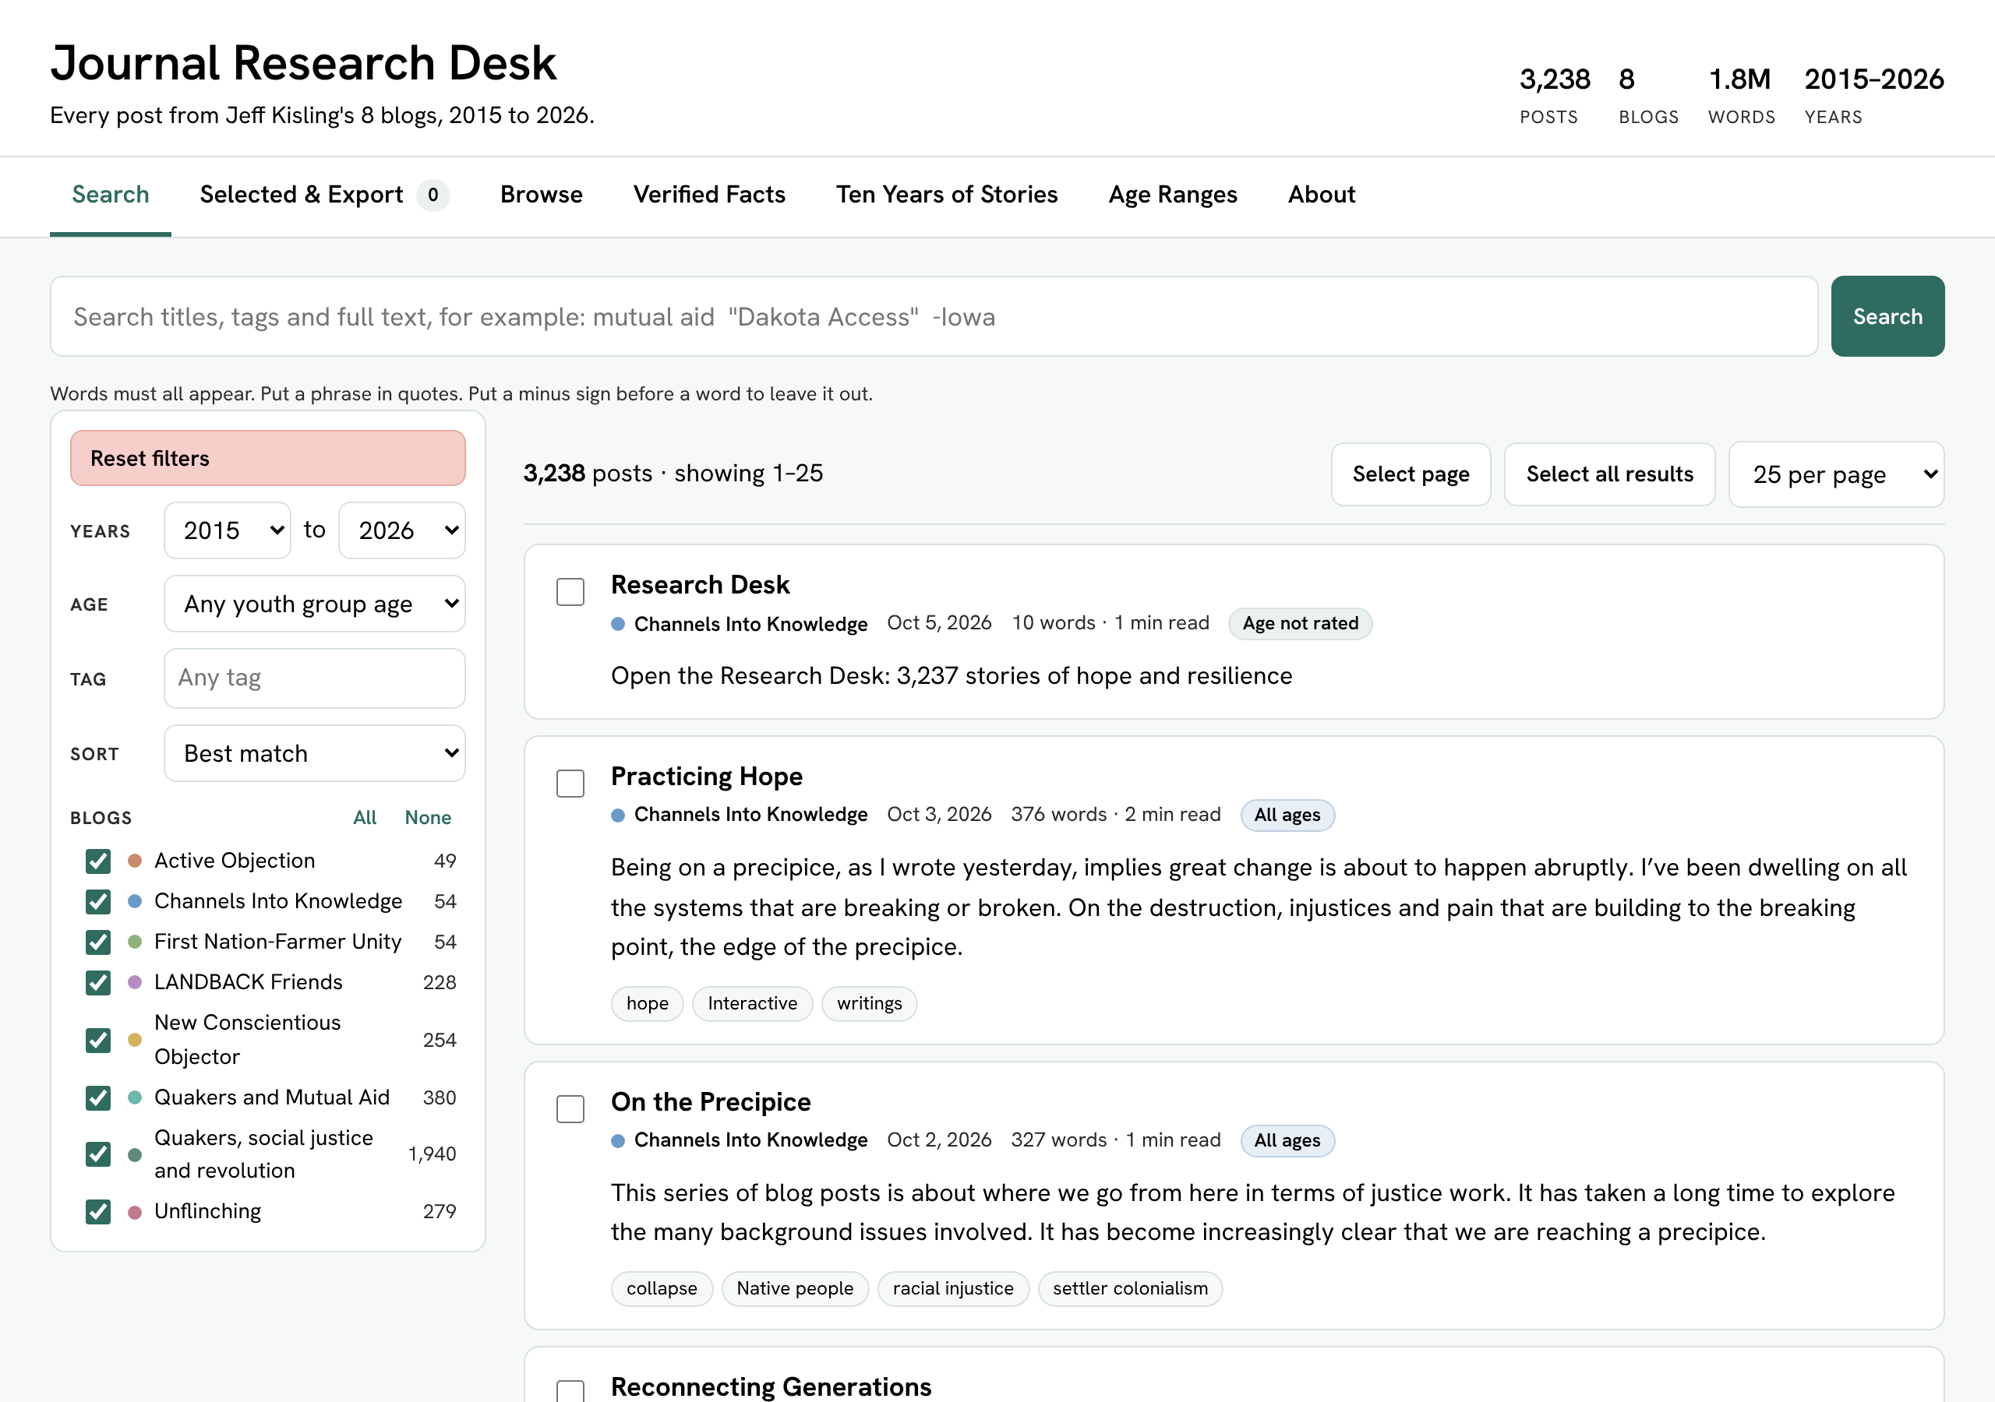
The desk as it first opens: the tabs, the search box, the filter panel on the left and the list of posts on the right.
Tab | What it's for
Search | Find posts. This is where most research starts.
Selected & Export | See the posts you've chosen and copy or download them as a list with links.
Browse | See all eight blogs and the most-used tags, then jump to them.
Verified Facts | Read 501 key historical facts from the posts, each checked against an outside source.
Ten Years of Stories | A timeline of every post, each paired with the closest verified event in history.
Age Ranges | How each post's suggested age range for youth groups is worked out.
About | The blogs in the library and how search works.
Tip: The numbers in the top right corner tell you the size of the library: how many posts, blogs and words, and which years it covers. They grow as new posts are added each day.

2. Search

The search box
Type one or more words in the search box and press Enter or click Search. A post matches when every word you typed appears somewhere in its title, tags, summary or full text.
The search box with a phrase in quotes and an extra word.
To do this | Type this | What happens
Find posts with all your words | mutual aid Iowa | Shows posts that mention mutual, aid and Iowa anywhere.
Find an exact phrase | "Dakota Access" | Words in quotes must appear together, in that order.
Leave something out | pipeline -Iowa | A minus sign removes posts that use that word.
Catch longer forms of a word | colon | Also finds colonial, colonialism and colonization.
Try it: Search for "Standing Rock" and see how many posts come up. Then add -Trump and watch the number change.

The filter panel
The panel on the left narrows your results. Use as many filters as you like; they all work together with your search words.
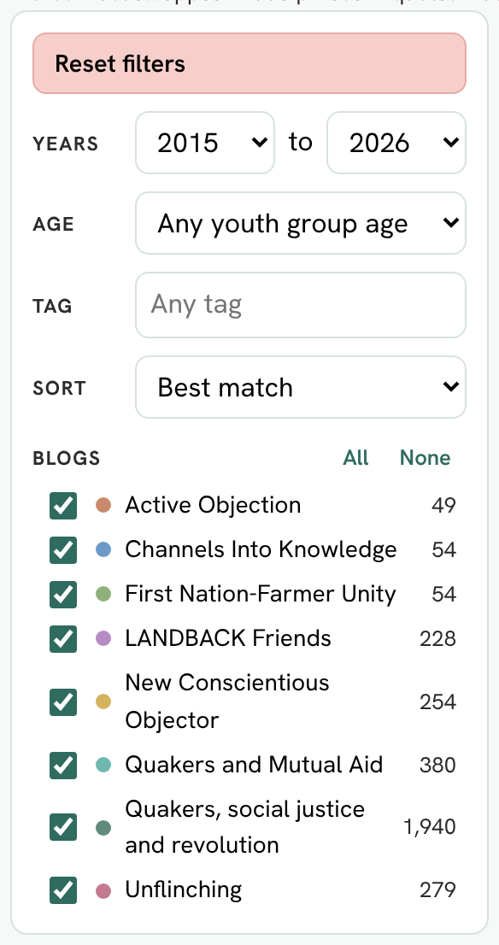
The filter panel: Reset filters, Years, Age, Tag, Sort and the list of blogs.
- Reset filters (pink button) puts every filter back to the start in one click.
- Years chooses a range, such as 2018 to 2020.
- Age shows only posts suited to the youngest person in your group. See the box below.
- Tag picks one topic label, such as "climate change" or "Quaker". Start typing and suggestions appear.
- Sort changes the order: Best match, Newest first, Oldest first, Title A to Z, or Longest first.
- Blogs lets you tick or untick each of the eight blogs. All and None switch them all at once. The number beside each blog is how many posts it has.
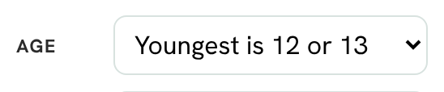
Choosing an age: here, posts suitable when the youngest person is 12 or 13.
For youth group leaders: Choose the age of the youngest person in your group. Posts that are suggested for older readers are hidden. Still read a post yourself before sharing it; the age ranges are guidance worked out by a computer.

Reading the results
Above the results, a bar tells you how many posts were found and which ones are showing. It also has buttons for selecting posts and choosing how many to show on each page.
The results bar: the count, Deselect page, Select all results and posts per page.
- Select page / Deselect page ticks or unticks every post on the page you're looking at.
- Select all results ticks every post your search found, on every page.
- Per page shows 10, 25, 50 or 100 posts at a time. Use the page numbers at the bottom to move through the rest.
Chips show which search and filters are on. Click the × on a chip to remove it.
Each result is a card. Here is what every part means:
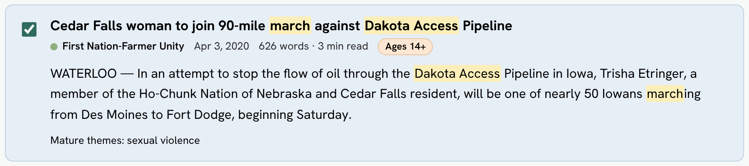
One result card, with the search words highlighted.
Part of the card | What it tells you
Tick box | Ticked posts go into your reading list on the Selected & Export tab.
Title | Click it to open the full post in a new tab.
Blog name and colored dot | Which of the eight blogs the post comes from.
Date, words, read time | When it was published, how long it is and about how many minutes it takes to read.
Age badge | The suggested youngest age for a youth group: All ages, Ages 12+, Ages 14+ or Ages 16+.
Summary | The opening lines of the post. Yellow highlights show where your search words appear.
Mature themes | Listed when a post deals with hard subjects, so leaders can prepare.
Tags | Topic labels. Click one to search that tag.

3. Selected & Export
Everything your search finds is selected for you automatically. The Selected & Export tab shows that list and turns it into something you can share: an email, a document, a spreadsheet or a web page, with a working link to every post. The number on the tab tells you how many posts are selected.
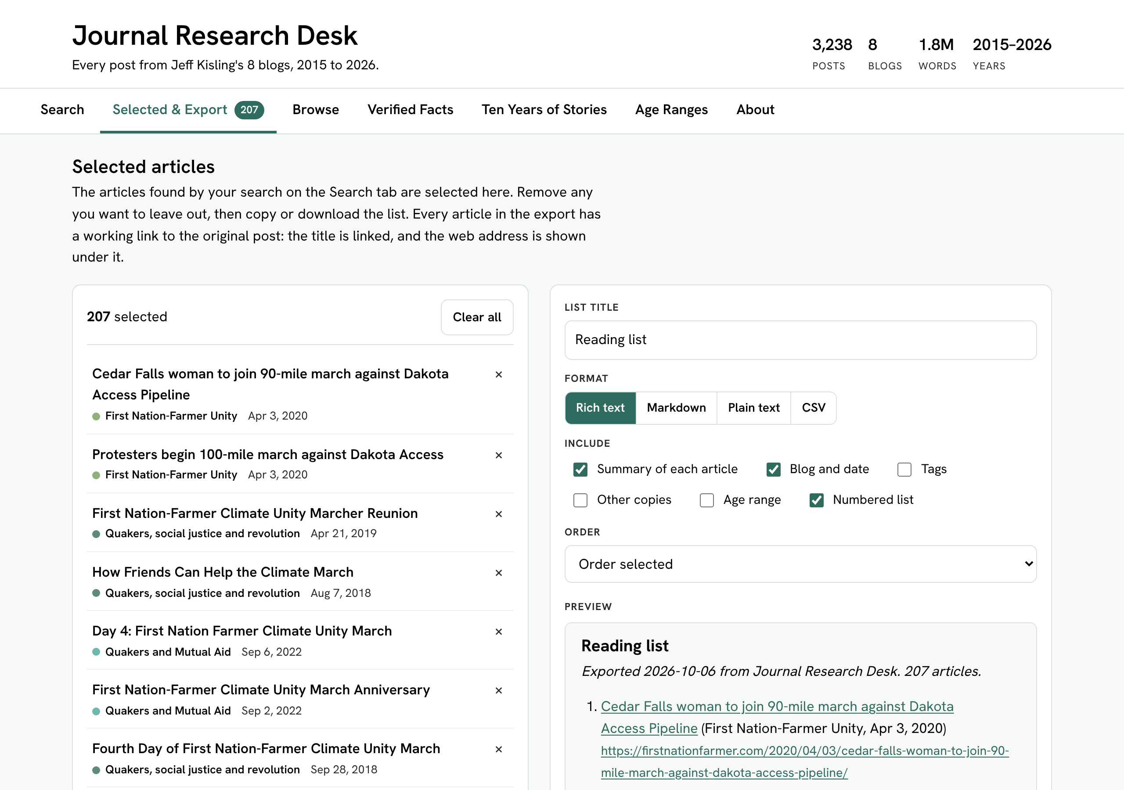
The Selected & Export tab: your selected posts on the left, export choices and a live preview on the right.

Make your list
- On the Search tab, search and filter until the results are the posts you want.
- Untick any results you want to leave out, or use Deselect page.
- Open Selected & Export. Click × beside a post to remove it, or Clear all to start over.
- Type a name for your list in List title, such as "Climate stories for Sunday".
- Choose a format and what to include, then click Copy or Download file.
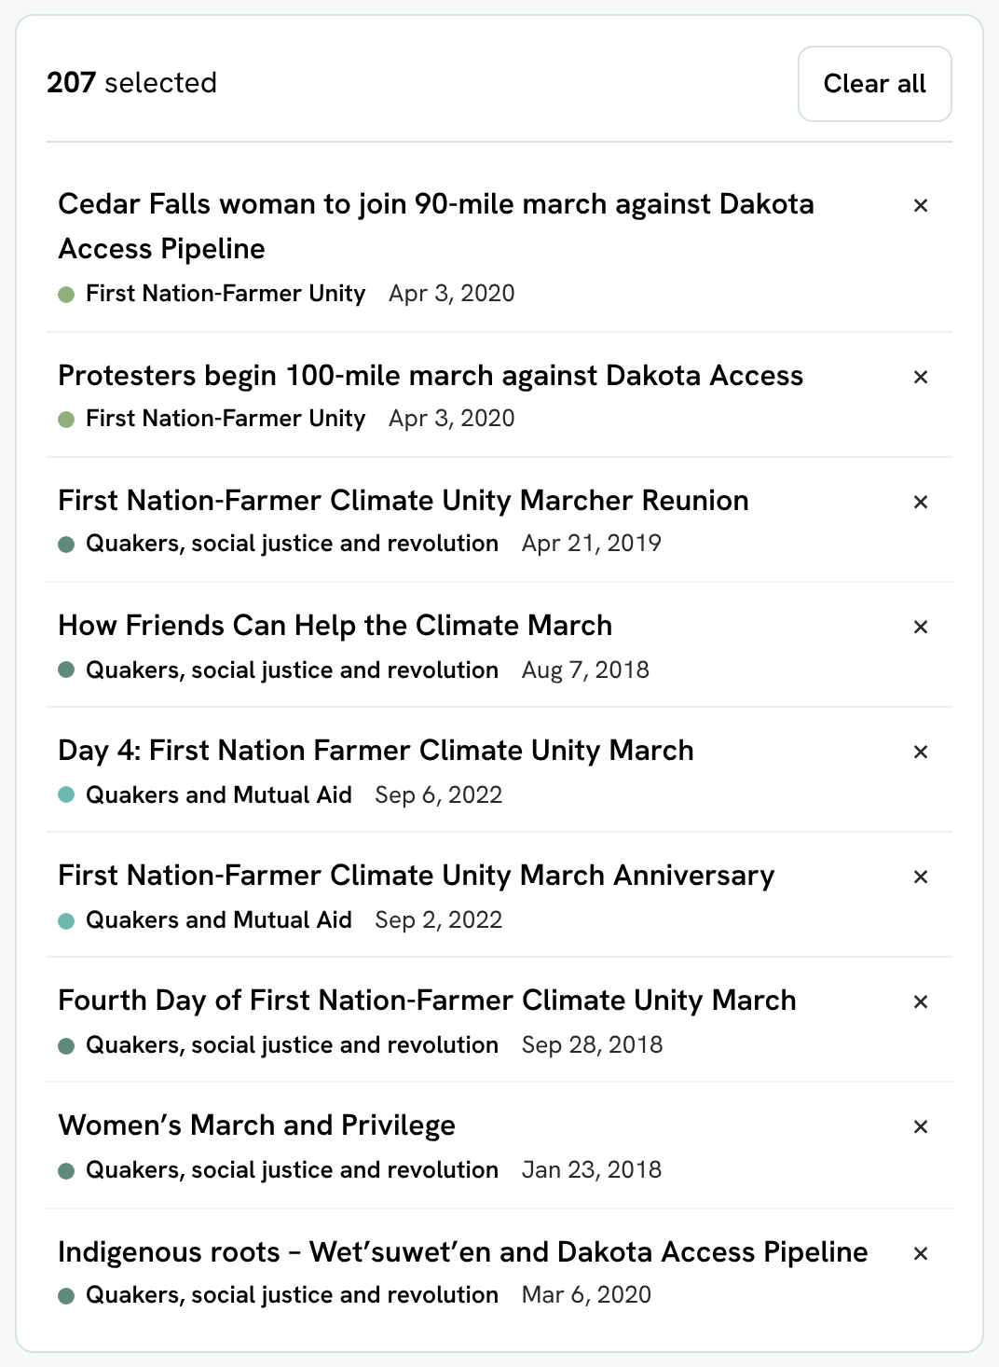
Export choices: list title, format, what to include and the order of the list.

Choose a format
Format | Best for | How the links work
Rich text | Email, Word, Google Docs | Titles are clickable, and the web address shows under each title.
Markdown | Notes apps and websites that use Markdown | Linked titles, plus the address on its own line.
Plain text | Text messages and simple notes | The web address is on its own line under each title.
CSV | Excel or Google Sheets | The Title column is a clickable link, and there is a URL column too.

Choose what to include
- Summary of each article: the opening lines of each post.
- Blog and date: where and when each post was published.
- Tags: the topic labels.
- Other copies: other places the same post was published.
- Age range: each post's suggested age and any mature themes.
- Numbered list: number the posts 1, 2, 3.
- Order: the order you selected them, newest first, oldest first, by blog, or title A to Z.
The preview shows exactly what you'll get. Every title in it is a working link.
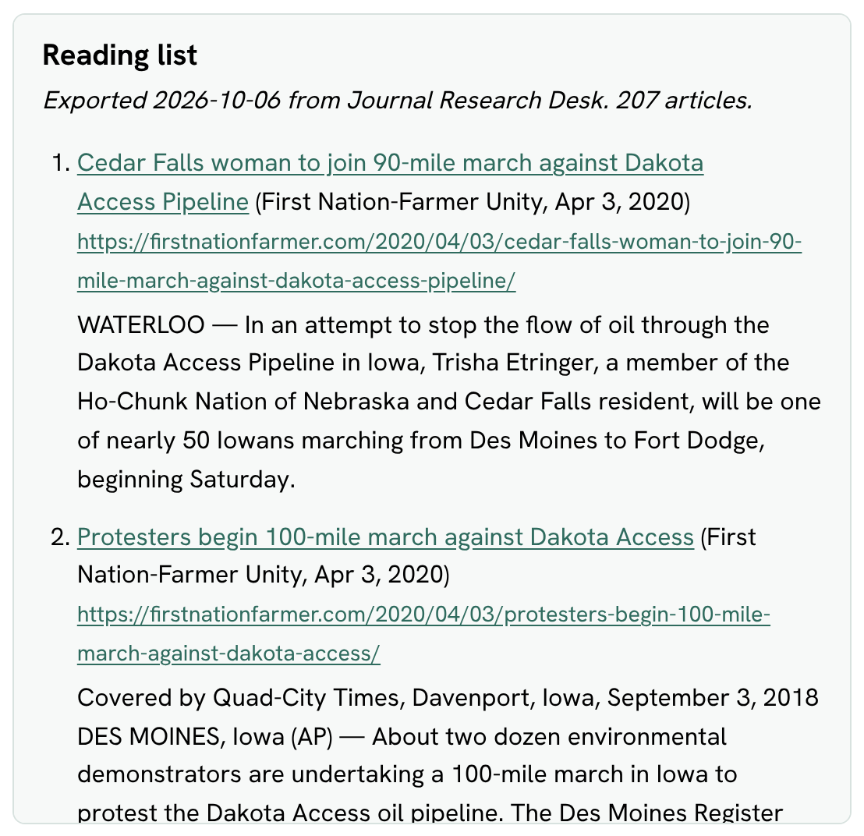
The live preview of a rich-text reading list.
Tip: Your selection is saved in your browser, so it's still there if you close the page and come back on the same device.

4. Browse
Not sure what to search for? The Browse tab shows the whole library at a glance.
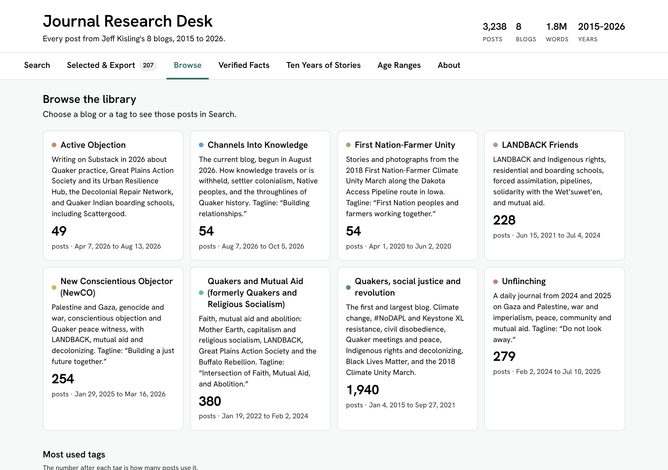
The Browse tab: one card for each of the eight blogs.
- Blog cards give a short description of each blog, how many posts it has and the dates it covers. Click a card to see all of that blog's posts on the Search tab, newest first.
- Most used tags lists the topic labels used most often. The number shows how many posts carry each tag. Click a tag to search it.
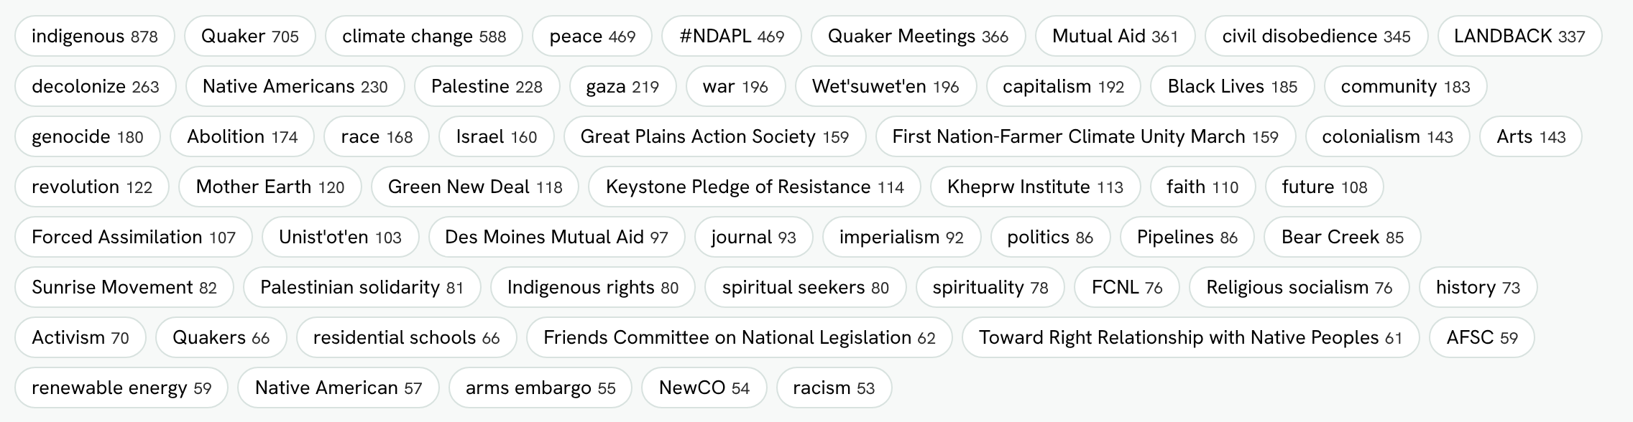
Most used tags. Click any tag to see its posts.

5. Verified Facts
Stories are stronger when the facts in them are right. The Verified Facts tab collects 501 key historical facts that the posts rely on, in 12 topics, from Quaker history and Indian boarding schools to climate change and Palestine. Each fact was checked against an outside source, such as a government archive, a court record, a news report or an encyclopedia.
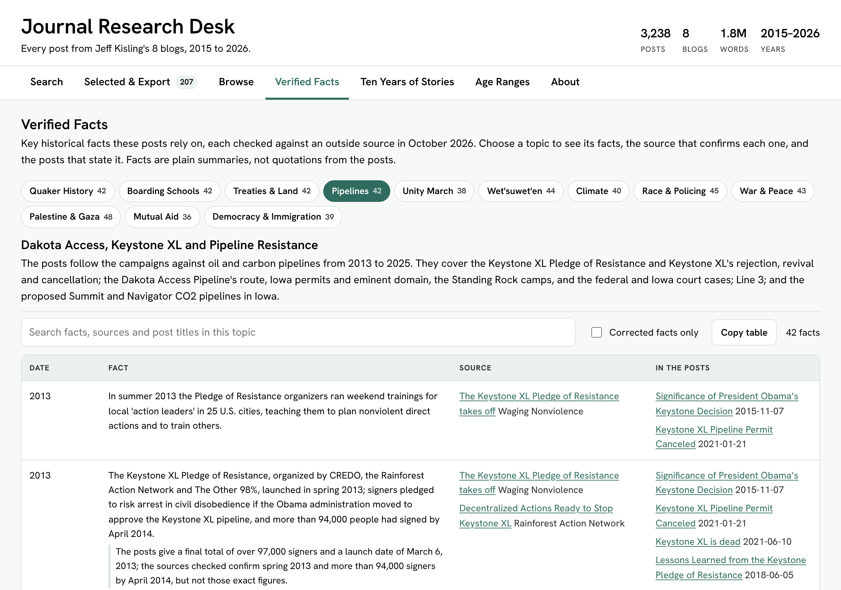
Verified Facts: topic buttons, the topic's introduction, and a table of facts.

How to use it
- Click a topic button. The number on each button is how many facts it has.
- Read the introduction to see what the topic covers.
- Scroll the table. The topic buttons, introduction and column names stay at the top while you scroll.
Column | What it shows
Date | When the event happened.
Fact | A plain summary of the fact, written for this collection, not a quotation from the posts.
Source | A link to the outside page that confirms the fact.
In the posts | Links to the posts that mention the fact, with their dates.
Search inside a topic, show only corrected facts, or copy the table.
- Search this topic filters the table and highlights your words.
- Corrected facts only shows facts where a post had a small detail wrong, such as a year. The table gives the right version and a note on what the post said.
- Copy table copies the table with working links, ready to paste into a document.
- Not yet verified, at the bottom of some topics, lists statements that could not be checked yet. They are not confirmed and not shown to be wrong.
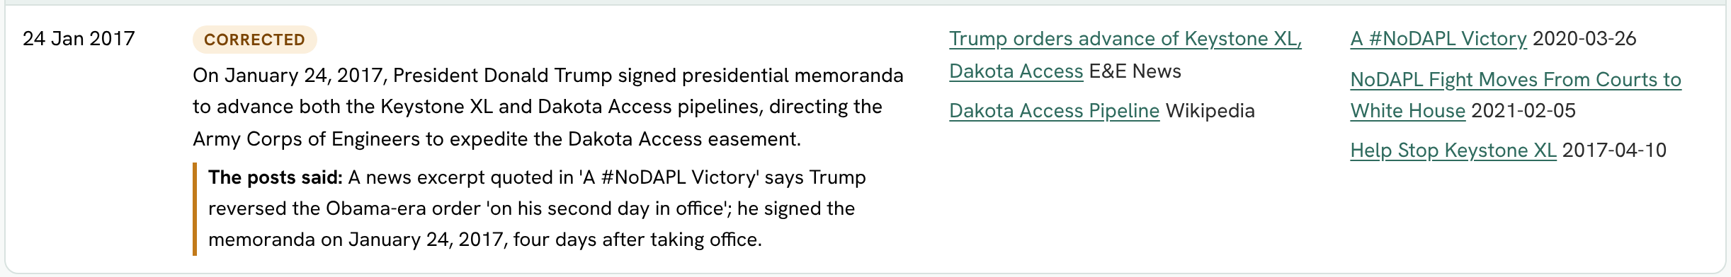
A corrected fact: the label, the right version, and what the post said.
Why this matters: Even careful writers make small mistakes. Checking a fact against a second source is what good historians and journalists do. This tab shows you how.

6. Ten Years of Stories
This tab is a timeline of every post. It shows what Jeff was writing about each month, and next to each story, the closest event in history from the Verified Facts collection. It's a great way to see how the stories connect to what was happening in the world.
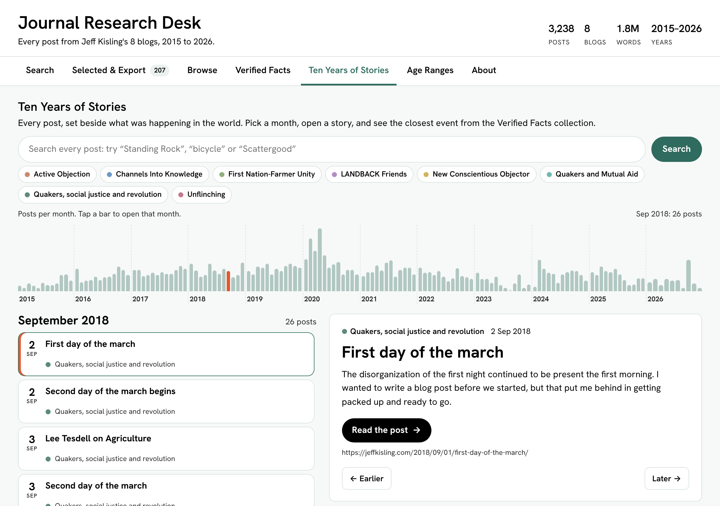
Ten Years of Stories: the monthly timeline, the posts for one month, and a story.

Move through time
Each bar is one month. Taller bars mean more posts that month. Hover over a bar to see the month and count, and click it to open that month.
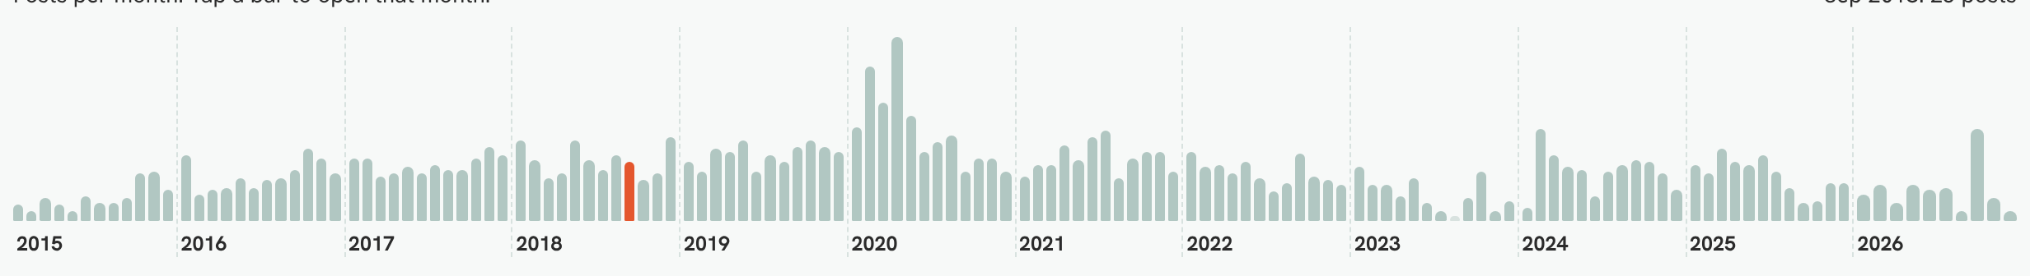
The timeline from 2015 to 2026. The highlighted bar is the month that's open.
- Blog buttons above the timeline turn each blog on or off.
- Search finds posts across all ten years. With the search box empty, the Search button opens a random story, which is a fun way to explore.
- Earlier and Later step to the previous or next post in time. The left and right arrow keys do the same.

Read a story
Click a post in the list to open its story card.
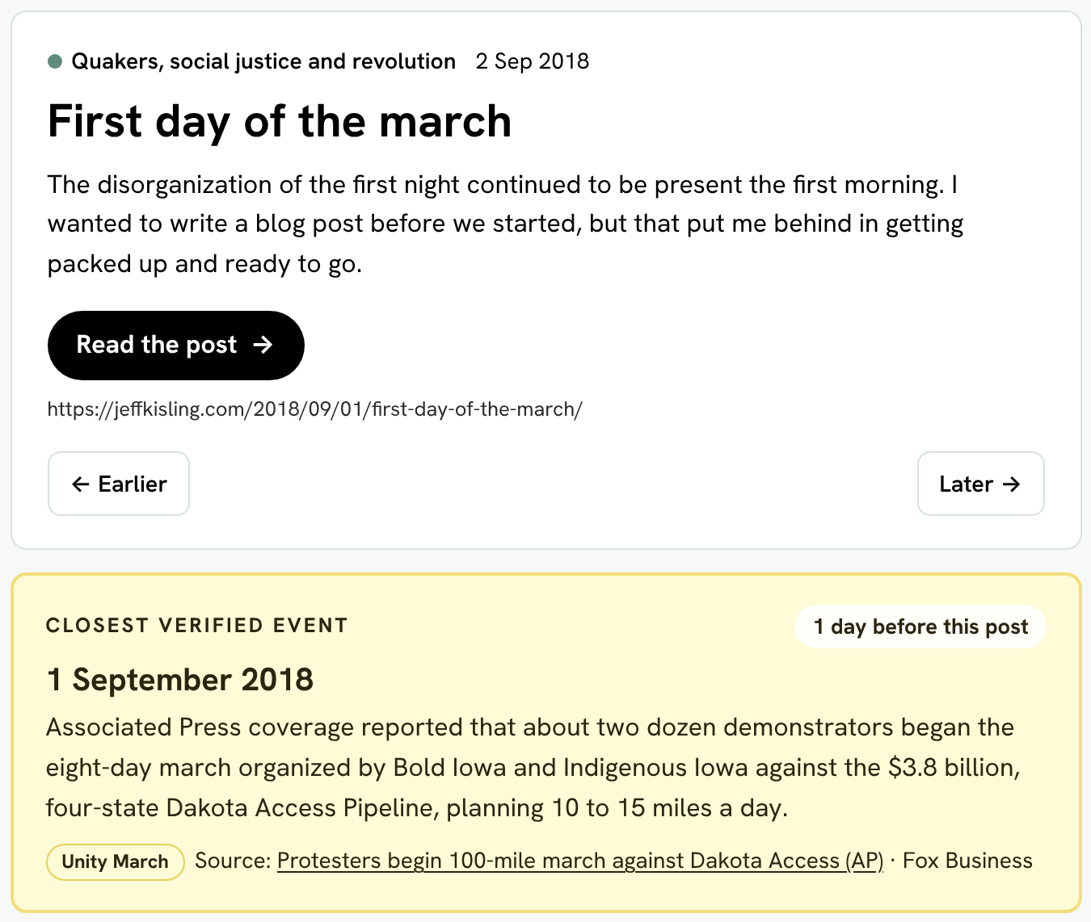
A story card: blog, date, title, summary, Read the post, and the closest verified event.
- Read the post opens the whole story in a new tab. The web address is shown underneath, so you can copy it.
- Closest verified event (the yellow card) shows the event from the Verified Facts collection with the date nearest to the post. The tag in the corner tells you how close, such as "1 day before this post". It also names the topic and links to the source.
- Verified facts this post states appears when the post itself is cited in the Verified Facts collection.
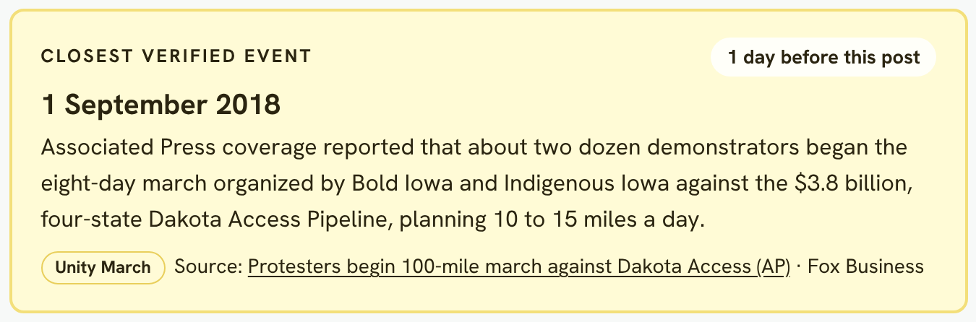
The closest verified event, with how many days apart it is and a link to its source.
Think about it: The closest event isn't always what the post is about, but often it is. Ask yourself: how does what was happening in the world help explain the story?

7. Age Ranges and About

Age Ranges
Every post has a suggested youngest age for reading and discussing it in a youth group with an adult leader. The Age Ranges tab explains how it's worked out and how many posts fall in each range.
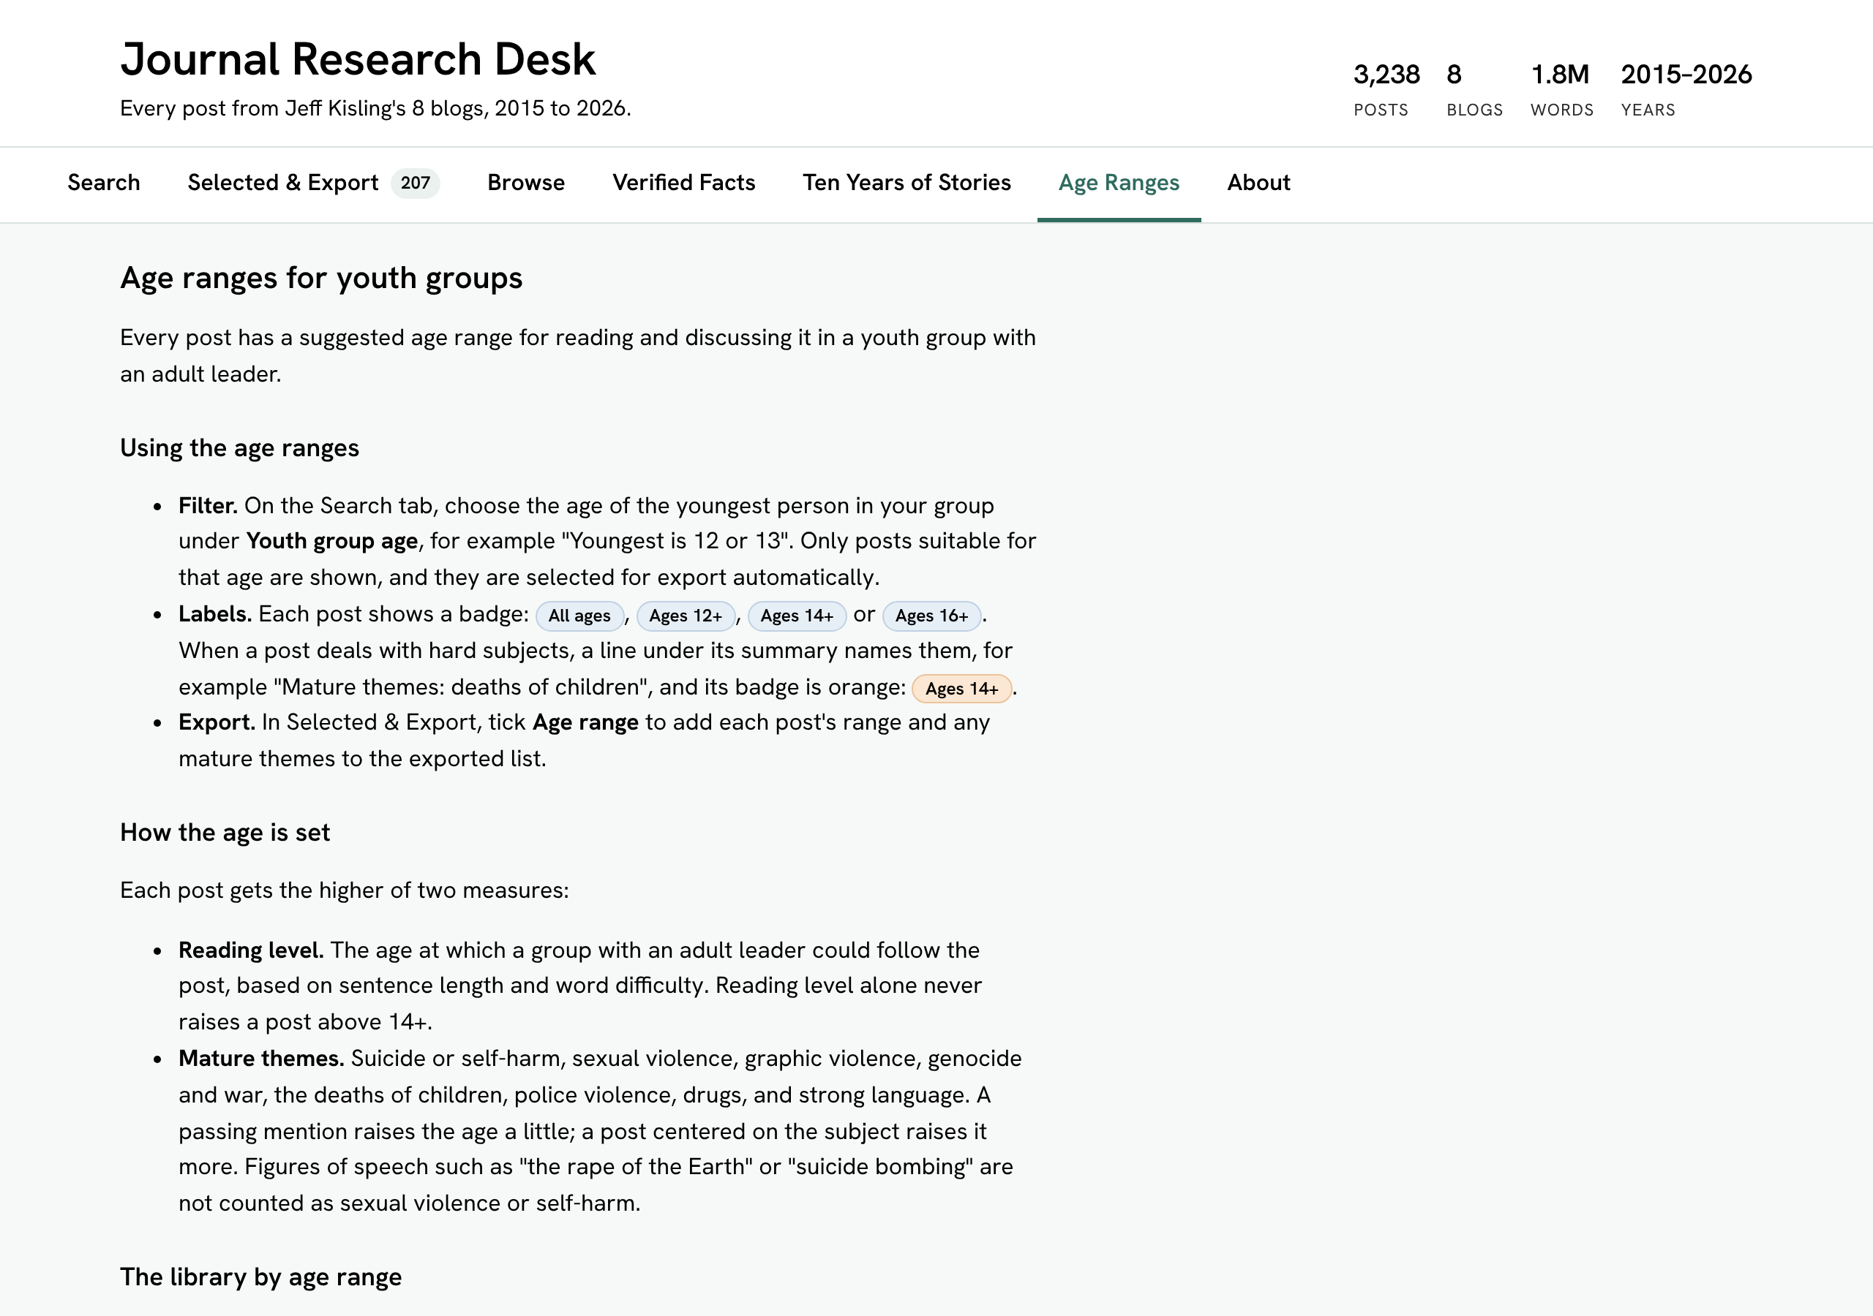
The Age Ranges tab.
- Reading level: longer sentences and harder words raise the age, up to 14+.
- Mature themes: hard subjects, such as war, violence or the deaths of children, raise the age more when they are the main subject of a post than when they are only mentioned.
- Not rated: posts that are mostly photos or video have too little text to rate.
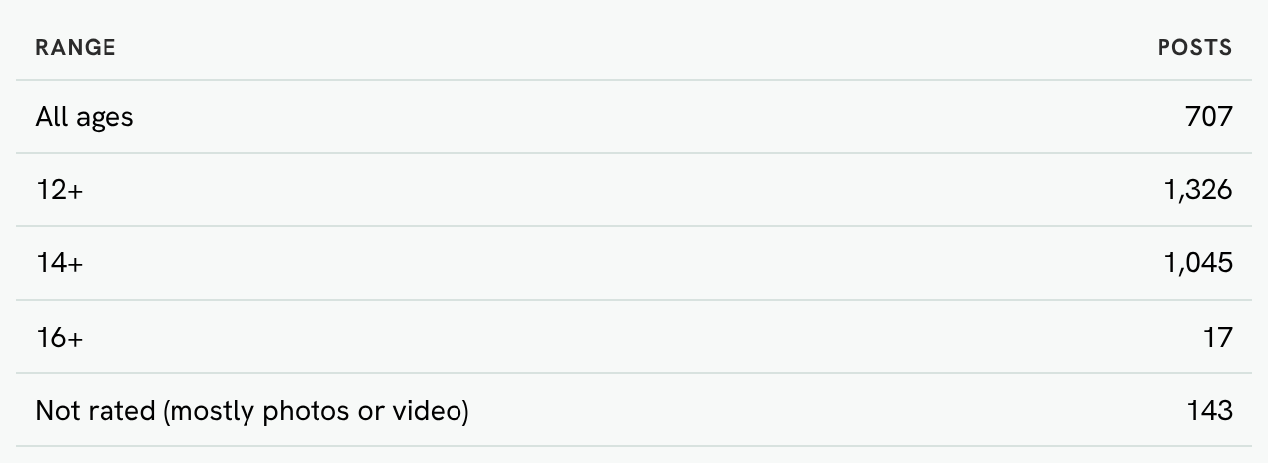
How many posts fall in each age range.
Remember: The age ranges are guidance from a computer, not an official rating. A trusted adult should read a post before sharing it with younger people.

About
The About tab lists the eight blogs with their dates and number of posts, and explains how search, age ranges and exporting work. Come here if you forget a search trick.
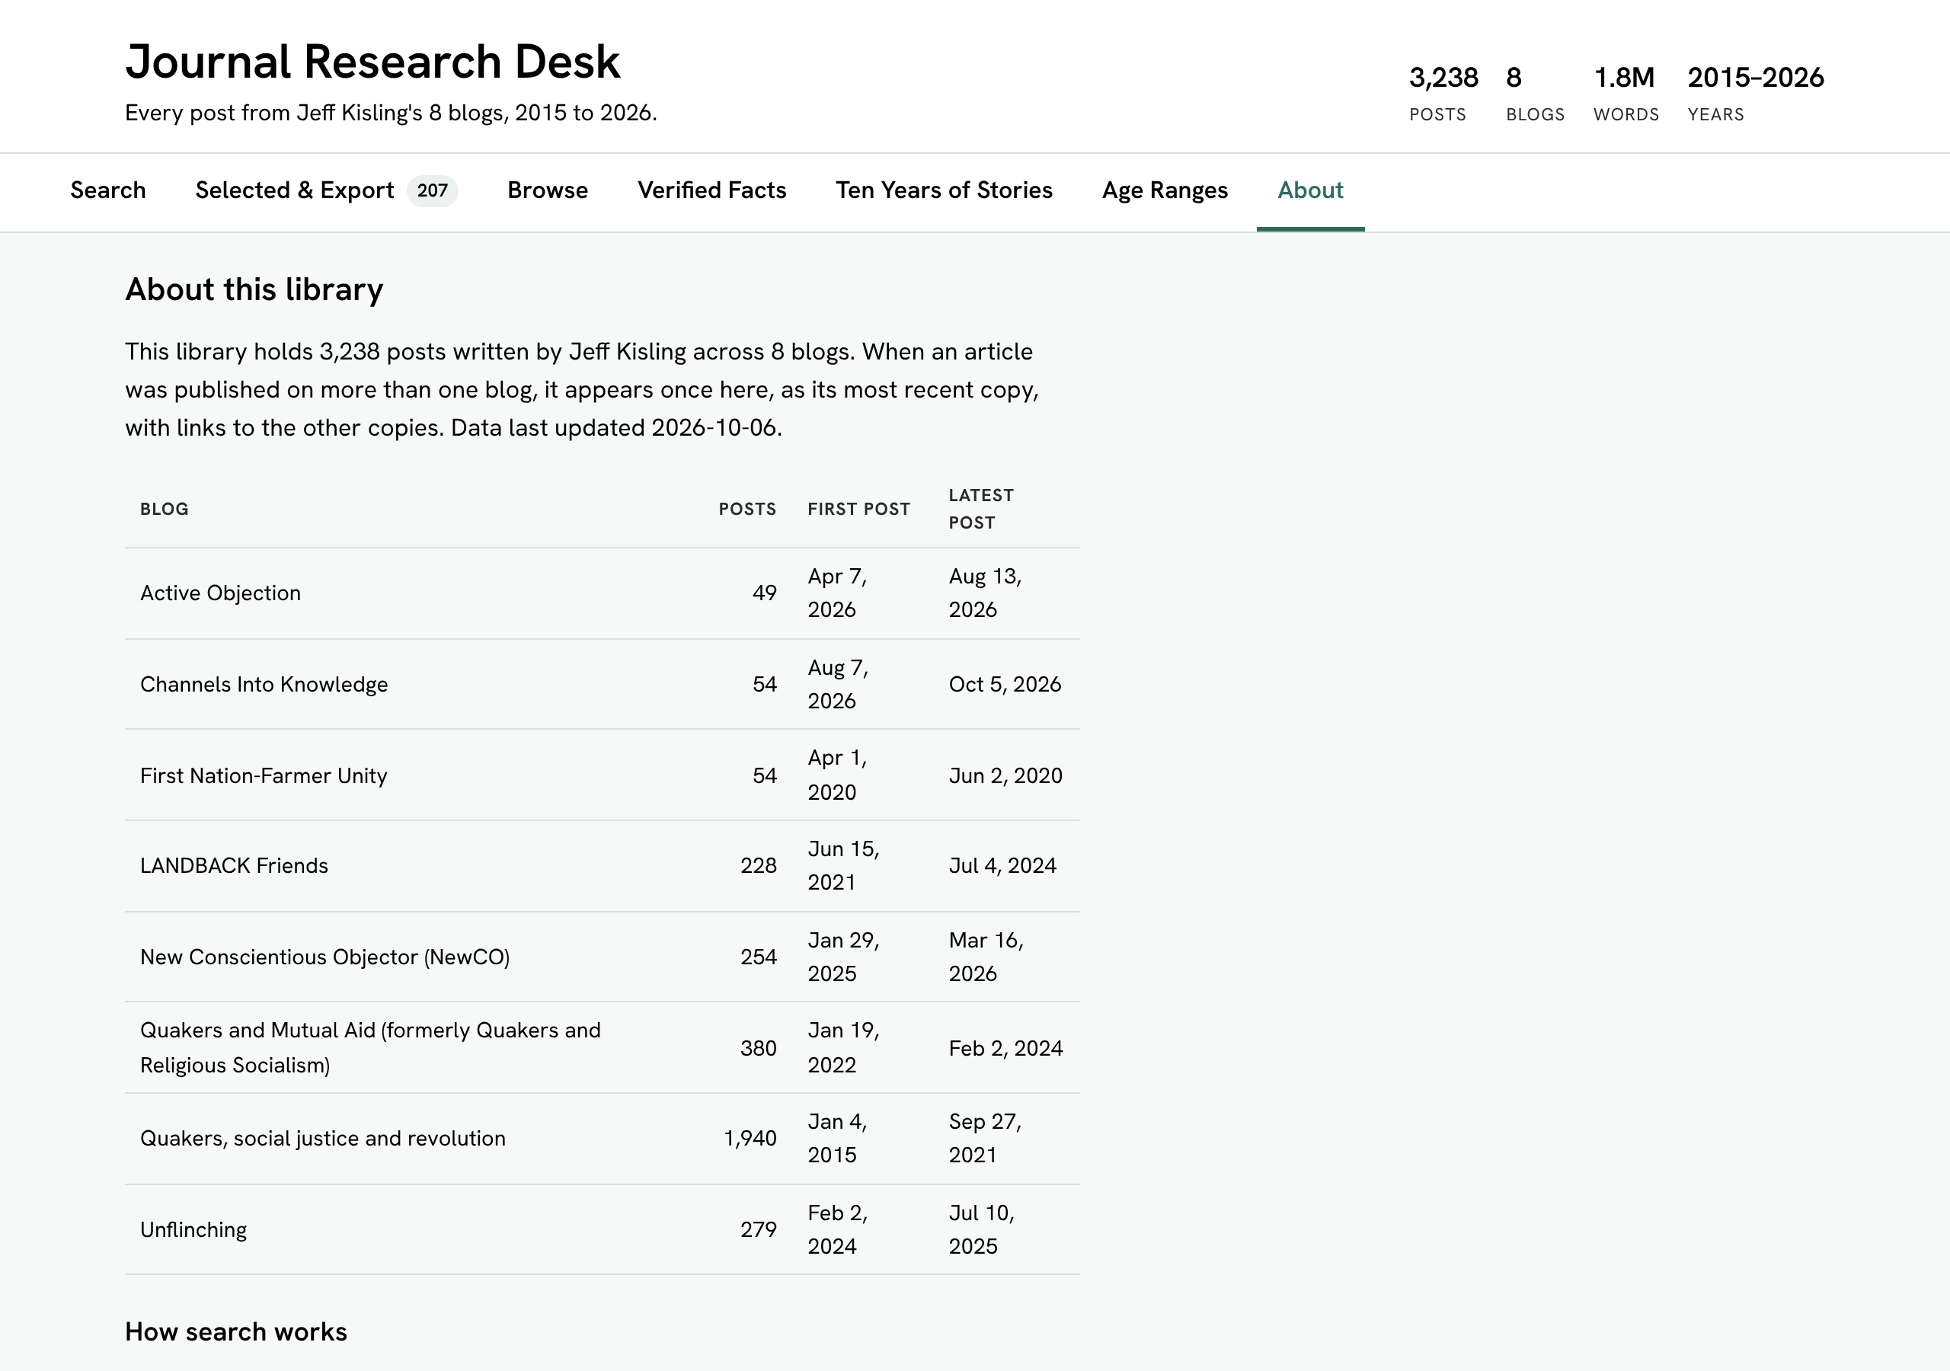
The About tab.

8. On your phone
The desk works on phones and tablets too. On a small screen the filter panel folds away; tap Filters to open it. Tables turn into easy-to-read cards.
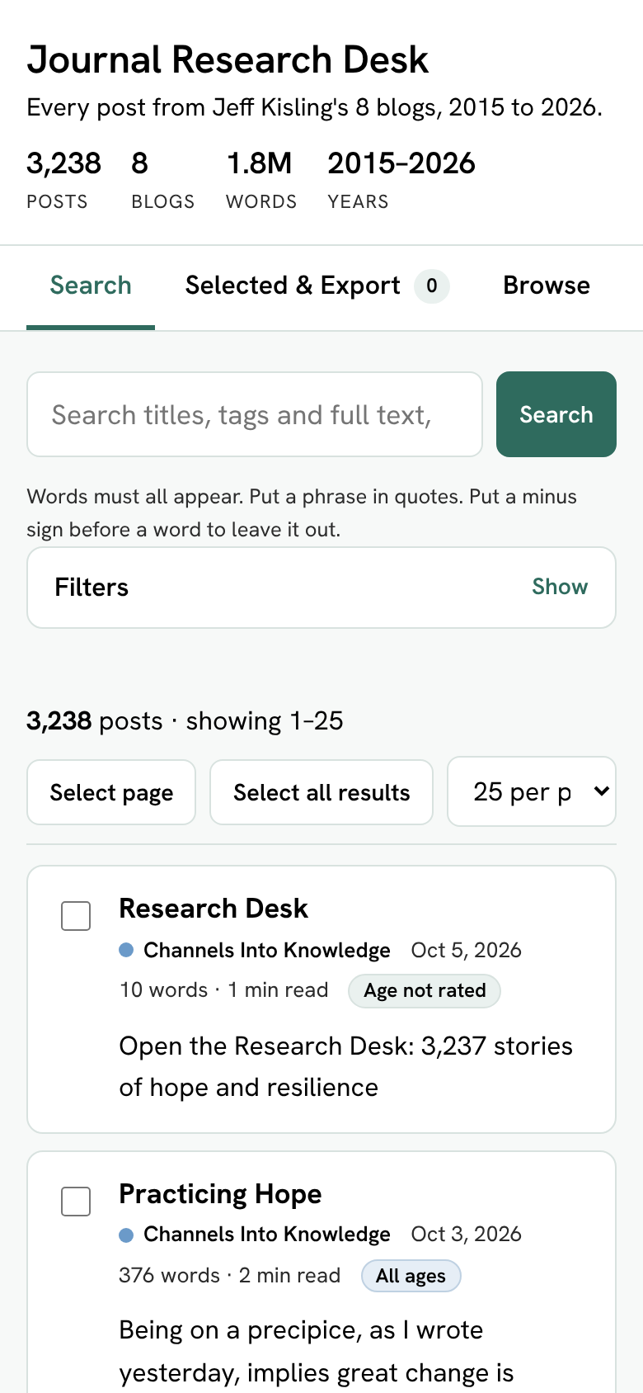
The Journal Research Desk on a phone.

9. Tips for good research
- Read the whole post. The summary is only the opening. Click the title and read the full story before you use it.
- Notice the date. Something written in 2016 may describe things differently from something written in 2026. The Ten Years of Stories tab shows what was happening at the time.
- Check the facts. Look for the fact on the Verified Facts tab, then open its source. If two sources disagree, say so.
- Keep your links. Export your reading list so you always have the link to each post.
- Give credit. When you quote or use a post, name the writer, the title, the blog, the date and the web address.
Example citation:
Kisling, Jeff. "First day of the march." Quakers, social justice and revolution, 2 September 2018, https://jeffkisling.com/2018/09/01/first-day-of-the-march/.

Quick reference
I want to… | Do this
Find posts about a topic | Search tab: type words, or pick a Tag.
Find an exact phrase | Put it in quotes: "water protectors".
See only one year | Set Years to the same year in both boxes.
Find posts for 12-year-olds | Set Age to "Youngest is 12 or 13".
Start over | Click Reset filters.
Make a reading list with links | Search, then Selected & Export, then Copy or Download file.
Put the list in a spreadsheet | Choose CSV and Download file, then open it in Excel or Google Sheets.
Check a historical fact | Verified Facts tab: pick a topic and open the Source link.
See what happened when a post was written | Ten Years of Stories tab: open the post and read the yellow card.
Discover something new | Ten Years of Stories tab: clear the search box and click Search.

Questions or ideas? The newest stories appear on Jeff's current blog, Channels Into Knowledge.

