SQL实战
Table student
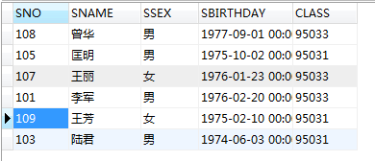
Table course
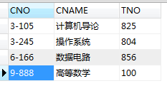
Table score
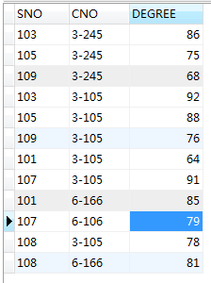
Table teacher
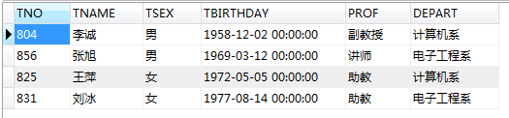

-- 1、查询Score表中的最高分的学生学号和课程号。
select
sno,
CNO
from SCORE
where DEGREE = (
select max(DEGREE)
from SCORE
);

-- 2、查询Score表中至少有5名学生选修的并以3开头的课程的平均分数。
SELECT AVG( DEGREE),CNO
FROM score
WHERE CNO LIKE '3%'
GROUP BY CNO
HAVING COUNT(*) >5;

-- 3、查询所有学生的Sname、Cname和Degree列。
SELECT
A.SNAME,
B.CNAME,
C.DEGREE
FROM STUDENT A
JOIN (COURSE B, SCORE C)
ON A.SNO = C.SNO AND B.CNO = C.CNO;

SELECT a.SNAME,b.CNAME,c.DEGREE FROM
student a LEFT JOIN course b LEFT JOIN score c
WHERE a.SNO=c.SNO AND b.CNO=c.CNO;

-- 4、查询“95033”班所选课程的平均分。
SELECT AVG( DEGREE)
FROM score
WHERE sno in（select sno from student WHERE class='95033'）

-- 5、查询选修“3-105”课程的成绩高于“109”号同学成绩的所有同学的记录。
select * FROM score
WHERE CNO="3-105" AND DEGREE > ALL
(SELECT DEGREE FROM score WHERE SNO='109')

-- 6、查询教师所有的单位即不重复的Depart列。
select distinct DEPART
from TEACHER;

-- 7、查询score中选学一门以上课程的同学中分数为非最高分成绩的记录
SELECT * FROM score
WHERE DEGREE < (
SELECT MAX(DEGREE) FROM score
)
GROUP BY SNO
HAVING COUNT(*) >1;

-- 8、查询和学号为108的同学同年出生的所有学生的Sno、Sname和Sbirthday列。
SELECT SNO,SNAME,SBIRTHDAY
FROM student
WHERE year(SBIRTHDAY)=(
SELECT year(SBIRTHDAY)
FROM student
WHERE SNO='108'
);

-- 9、查询“张旭“教师任课的学生成绩。
SELECT * FROM score
WHERE CNO=
(SELECT CNO FROM course,teacher
WHERE course.TNO=teacher.TNO AND teacher.TNAME='张旭'
);

-- 10、查询存在有85分以上成绩的课程Cno
SELECT CNO FROM score
GROUP BY CNO
HAVING MAX(DEGREE) >85;

-- 11、查询出“计算机系“教师所教课程的成绩表。
SELECT * FROM score
WHERE CNO IN(SELECT CNO FROM teacher,course
WHERE DEPART='计算机系' and course.TNO=teacher.TNO);
)

-- 12、查询所有教师和同学的name、sex和birthday.
select
TNAME name,
TSEX sex,
TBIRTHDAY birthday
from TEACHER
union
select
sname name,
SSEX sex,
SBIRTHDAY birthday
from STUDENT;

-- 13、查询所有“女”教师和“女”同学的name、sex和birthday.
select
TNAME name,
TSEX sex,
TBIRTHDAY birthday
from TEACHER
where TSEX = '女'
union
select
sname name,
SSEX sex,
SBIRTHDAY birthday
from STUDENT
where SSEX = '女';

-- 14、查询所有任课教师的Tname和Depart.
SELECT TNAME,Depart
FROM teacher a
WHERE EXISTS (
SELECT * FROM teacher,course b
WHERE a.TNO=b.TNO
)

-- 15、查询至少有2名男生的班号。
SELECT CLASS
FROM student
WHERE SSEX='男'
GROUP BY CLASS
HAVING COUNT(SSEX)>1;

-- 16、查询Student表中每个学生的姓名和年龄。
select
SNAME,
(year(now()) - year(SBIRTHDAY)) age
from STUDENT;

-- 17、查询Student表中最大和最小的Sbirthday日期值。
select MAX(SBIRTHDAY) FROM student
UNION
SELECT MIN(SBIRTHDAY) FROM student;

-- 18、以班号和年龄从大到小的顺序查询Student表中的全部记录。
SELECT *
FROM student
ORDER BY CLASS desc,year(NOW())-year(SBIRTHDAY) DESC;

-- 19、查询最高分同学的Sno、Cno和Degree列。
SELECT Sno,Cno,DEGREE
FROM score WHERE DEGREE=(SELECT MAX(DEGREE) FROM score);

-- 20、查询和“李军”同性别并同班的同学Sname.
SELECT Sname
FROM student
WHERE (SSEX,CLASS) =(SELECT SSEX,CLASS FROM student

WHERE SNAME='李军');

-- 21、查询所有选修“计算机导论”课程的“男”同学的成绩表
select * from score,student where score.sno=student.sno and SSEX='男'
and CNO=(SELECT CNO from course where CNAME='计算机导论');

-- 22、查询“计算机系”与“电子工程系“不同职称的教师的Tname和Prof
SELECT tname,PROF
FROM teacher
WHERE DEPART='计算机系' AND prof not in(
SELECT PROF
FROM teacher
WHERE DEPART='电子工程系'
)

-- 23、查询选修编号为“3-105“课程且成绩至少高于选修编号为“3-245”的同学的Cno、Sno和Degree,并按Degree从高到低次序排序。
SELECT Cno,SNO,DEGREE
FROM score
WHERE CNO='3-105' AND DEGREE >ANY (
SELECT DEGREE
FROM score
WHERE CNO='3-245'
)
ORDER BY DEGREE DESC;

-- 24、查询选修某课程的同学人数多于5人的教师姓名。
SELECT TNAME
FROM teacher
WHERE TNO=(
SELECT TNO
FROM course
WHERE CNO=(
SELECT CNO
FROM score
GROUP BY CNO
HAVING COUNT(SNO) >5)
)
)

-- 25、查询成绩比该课程平均成绩低的同学的成绩表(自关联)。
SELECT A.*
FROM SCORE A
WHERE DEGREE < (SELECT AVG(DEGREE)
FROM SCORE B
WHERE A.CNO = B.CNO);

