SMART ASSET MANAGEMENT SYSTEM
Final Project Documentation
Predictive Maintenance and Asset Lifecycle Management
Prepared for the Bachelor of Science in Informatics and Computer Science Project

Chapter 1: Introduction
The system provides a central register for organisational laptops, their assignments, maintenance records and lifecycle status. Its intelligent feature is predictive maintenance: it estimates the likelihood that an asset will require maintenance within 30 days.

Chapter 2: Requirements and Scope
Users register laptops, record specifications and lifecycle status, create maintenance records, view maintenance risk and assign laptops. Administrators use a needs-based recommendation workflow: department, organisational rank and primary work type determine the target specification, then available laptops are ranked. Lifecycle tracking records Available, Assigned, Maintenance, Retired and Disposed states.

Chapter 3: Design and Implementation
The solution uses PHP, MySQL, HTML and CSS. MySQL stores users, laptops, maintenance records, risk predictions and laptop history. The assignment page uses transparent suitability scoring based on processor tier, RAM, storage and department match; the administrator remains responsible for the final assignment. Logistic Regression remains the primary predictive-maintenance model, while Random Forest may be compared during evaluation.

Chapter 4: System Design Diagrams
The following diagrams document the implemented system and the needs-based assignment workflow.

Figure 4.1: Use-case diagram
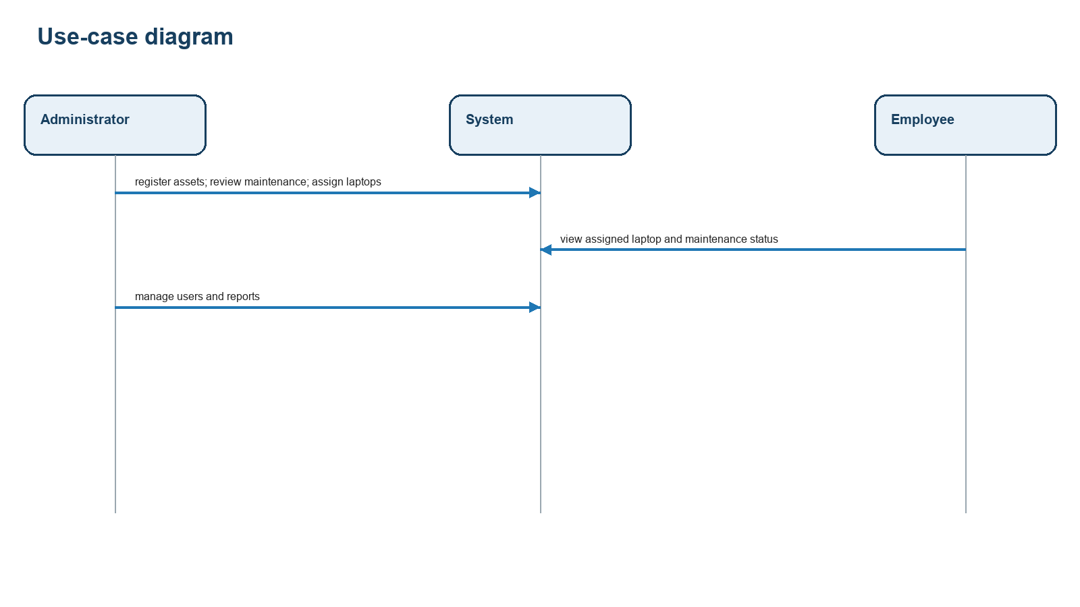
Figure 4.1: Use-case diagram

Figure 4.2: Entity-relationship diagram
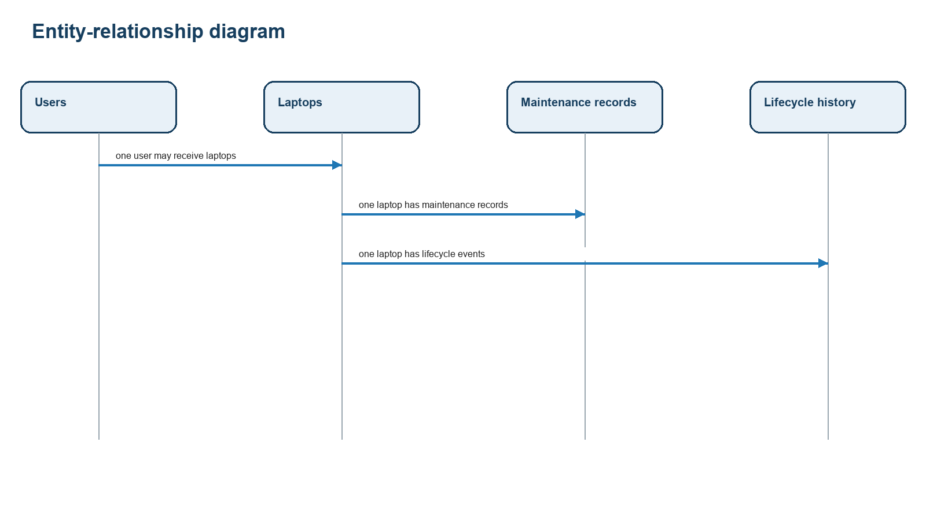
Figure 4.2: Entity-relationship diagram

Figure 4.3: Class diagram
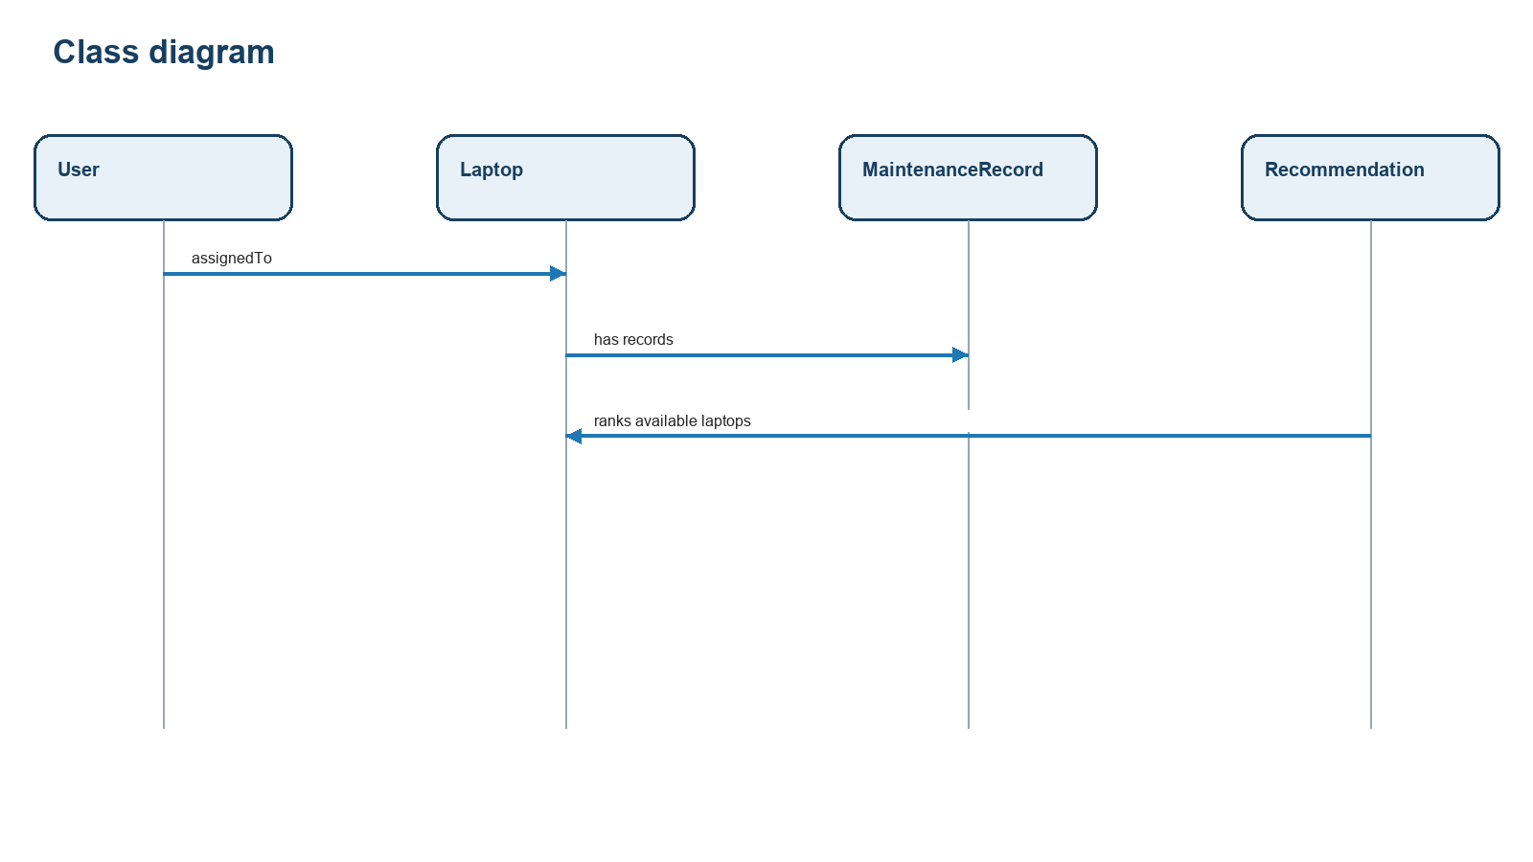
Figure 4.3: Class diagram

Figure 4.4: Activity diagram
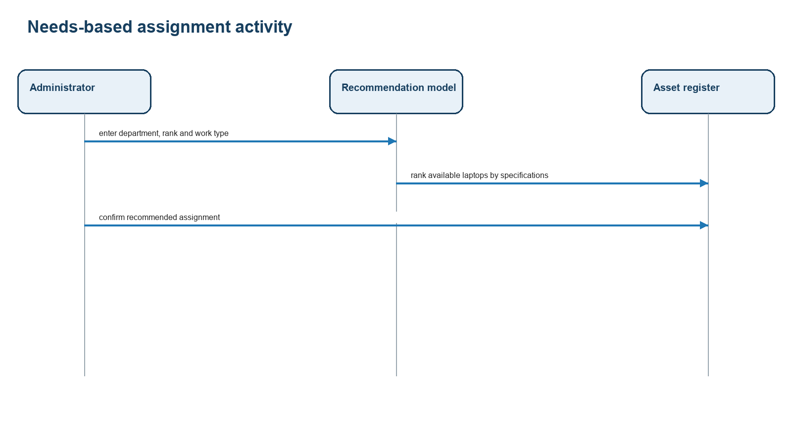
Figure 4.4: Activity diagram

Figure 4.5: Sequence diagram
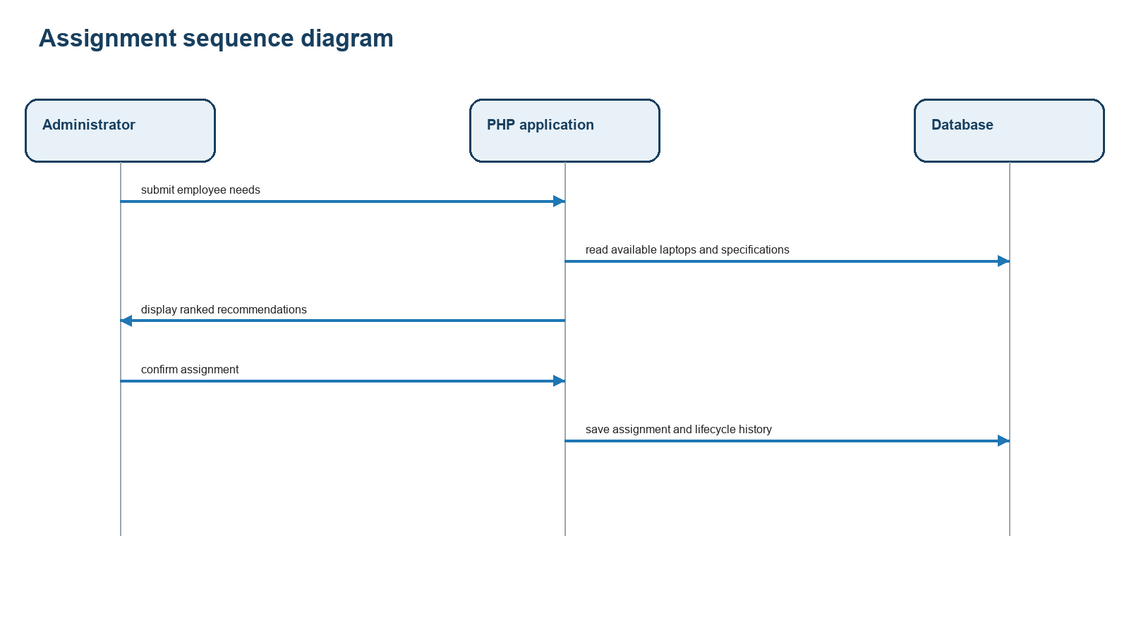
Figure 4.5: Sequence diagram

Figure 4.6: System architecture diagram
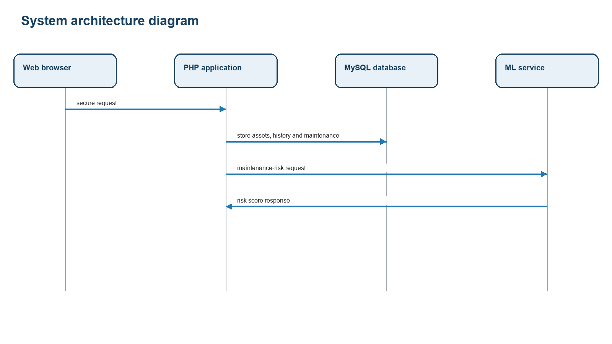
Figure 4.6: System architecture diagram

Chapter 5: Testing and Evaluation
Functional testing verifies login, asset registration, maintenance recording, lifecycle-status changes, recommendation ranking and assignment. Evaluation measures include task completion time, record completeness, maintenance-risk recall, precision, F1-score and PR-AUC against a baseline classifier. Assignment recommendations are reviewed for suitability against the defined minimum specification; administrators confirm every assignment.

Deployment Notes
Run database.sql for a new installation. Existing installations must run migrations/20260902_needs_based_assignment.sql before using the needs-based assignment page. The project should be deployed with database credentials kept outside source control.

