CHAPTER FOUR: SYSTEM ANALYSIS AND DESIGN

4.1 Introduction
This chapter translates the requirements of the Smart Asset Management System into an implementable design. The system is a web-based application for managing organisational ICT assets throughout their lifecycle. It supports secure user access, asset registration and allocation, maintenance monitoring, software-licence control, consent-based location check-ins, approved-area alerts, audit logging and management reporting. Predictive maintenance is implemented as decision support: recorded usage, condition and repair history are used to prioritise devices for review; the final maintenance decision remains with authorised ICT staff.

4.2 System Requirements
The requirements below are derived from the implemented PHP/MySQL application and define the services and quality attributes required for correct use in an organisational setting.

4.2.1 Functional Requirements
ID | Requirement
FR1 | The system shall authenticate users and provide role-based access for users, administrators and super administrators.
FR2 | The system shall allow authorised administrators to register, edit, search and view laptop asset records with unique asset tags and serial numbers.
FR3 | The system shall allow authorised administrators to assign an available asset to an active user, return it, change its lifecycle status and retain assignment history.
FR4 | The system shall record maintenance issues, repair status and usage observations, and present a low, medium or high maintenance-risk result.
FR5 | The system shall manage software inventory, licence capacity, active user assignments and licence revocation.
FR6 | The system shall enable an assigned user to submit a location check-in only after explicitly granting browser location permission and confirming consent.
FR7 | The system shall compare an authorised check-in against active approved areas, create an alert for an out-of-area check-in and optionally send an email alert.
FR8 | The system shall provide dashboards, filtered asset views and CSV, PDF or Excel reports for assets, maintenance and software licences.
FR9 | The system shall maintain audit records for sensitive administrative actions and location-related events.
FR10 | The system shall allow the super administrator to manage accounts and change non-super-administrator roles.

4.2.2 Non-functional Requirements
Category | Requirement
Security | Passwords shall be stored as secure hashes. State-changing requests shall be protected by CSRF validation, and database operations shall use prepared statements.
Privacy | Location is collected only through an explicit user check-in and browser permission. The system stores last-known authorised locations; it does not perform continuous device tracking.
Performance | Normal dashboard, search and record-update requests should complete within three seconds on the local organisational network under expected use.
Usability | The interface shall present clear menus, dashboard summaries, validation feedback and role-appropriate actions for administrators and employees.
Reliability | Asset, assignment, maintenance and licence transactions shall preserve referential integrity and retain history/audit records for accountability.
Maintainability | The application shall use modular PHP pages, a shared bootstrap layer, documented database schema/migrations and separated CSS/JavaScript assets.
Compatibility | The system shall run on a modern desktop browser with PHP, MySQL/MariaDB and Apache/XAMPP. Location check-in requires HTTPS in production.
Scalability | Database indexes on common asset, history, location, risk and licence-assignment queries shall support growth in organisational records.

4.3 System Analysis Diagrams

4.3.1 Use Case Diagram
The use case diagram identifies the main actors and the services available to them. Administrators operate the asset, maintenance, licensing, reporting and alert-management functions. Employees can view their allocation and initiate a consent-based check-in. Super administrators additionally control user roles.
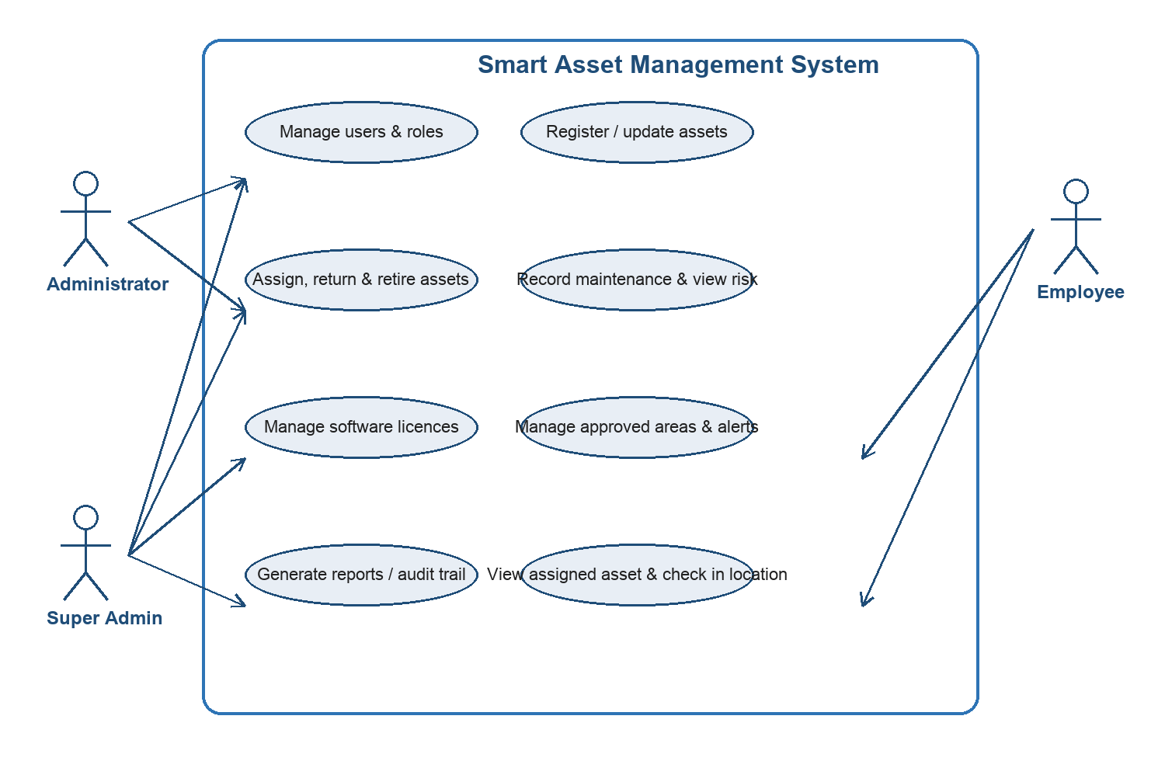

4.3.2 Sequence Diagram
This sequence models the consent-based location check-in workflow. Validation occurs before location storage: the API checks the session, CSRF token and that the asset belongs to the signed-in employee. Approved-area evaluation can then create an alert without turning the feature into background tracking.
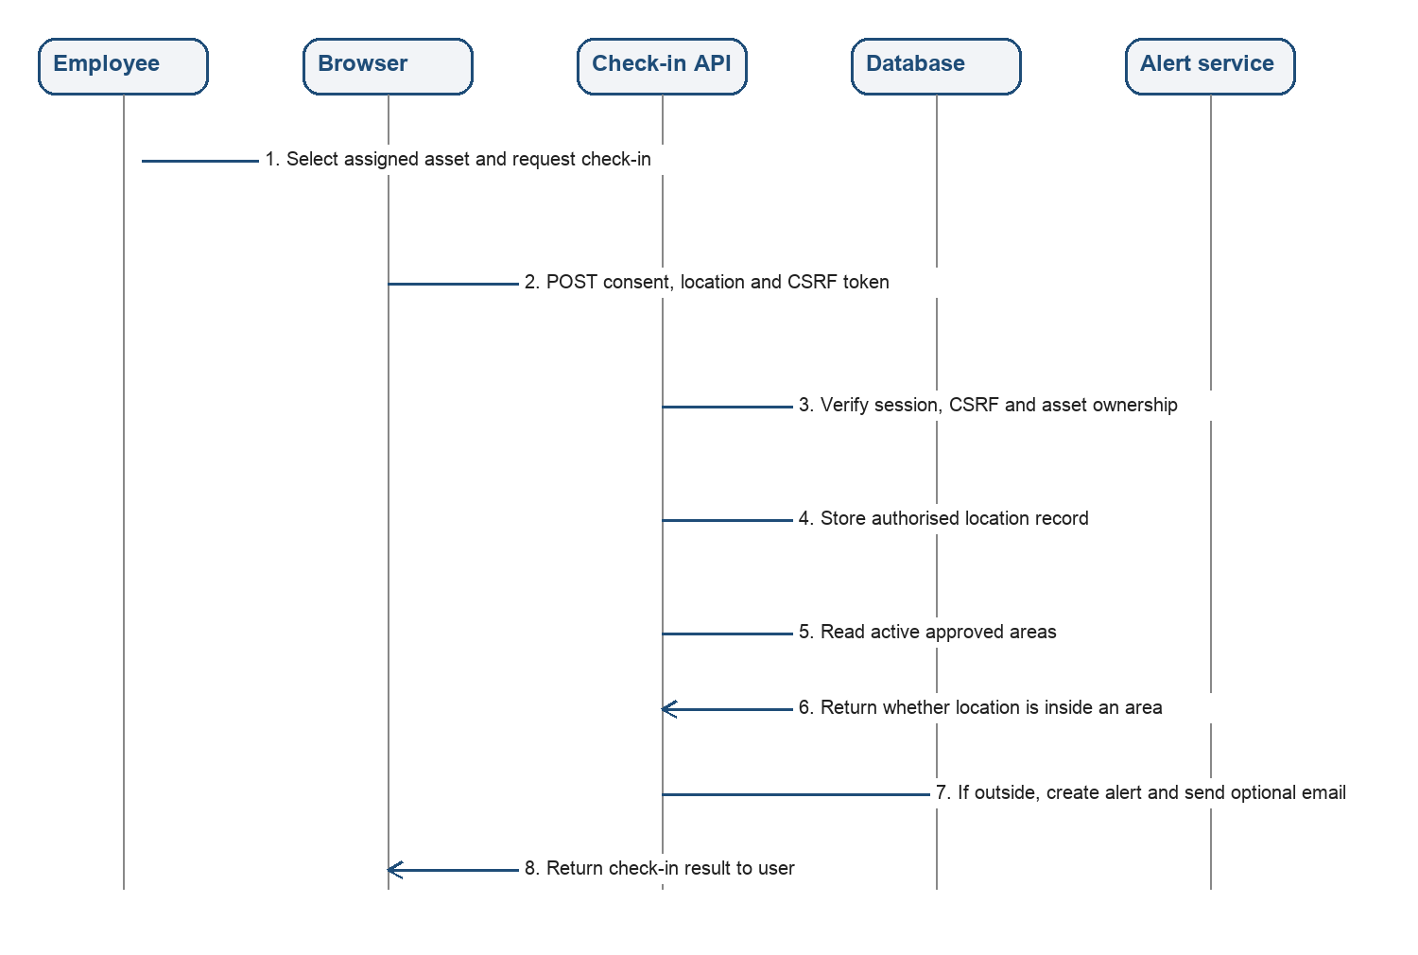

4.3.3 Entity Relationship Diagram
The ERD shows the principal persistent entities. Users are related to their assigned laptops, licence assignments, location check-ins and audit entries. Laptops are the central asset entity and are linked to maintenance, usage, risk, location, alert and history records.
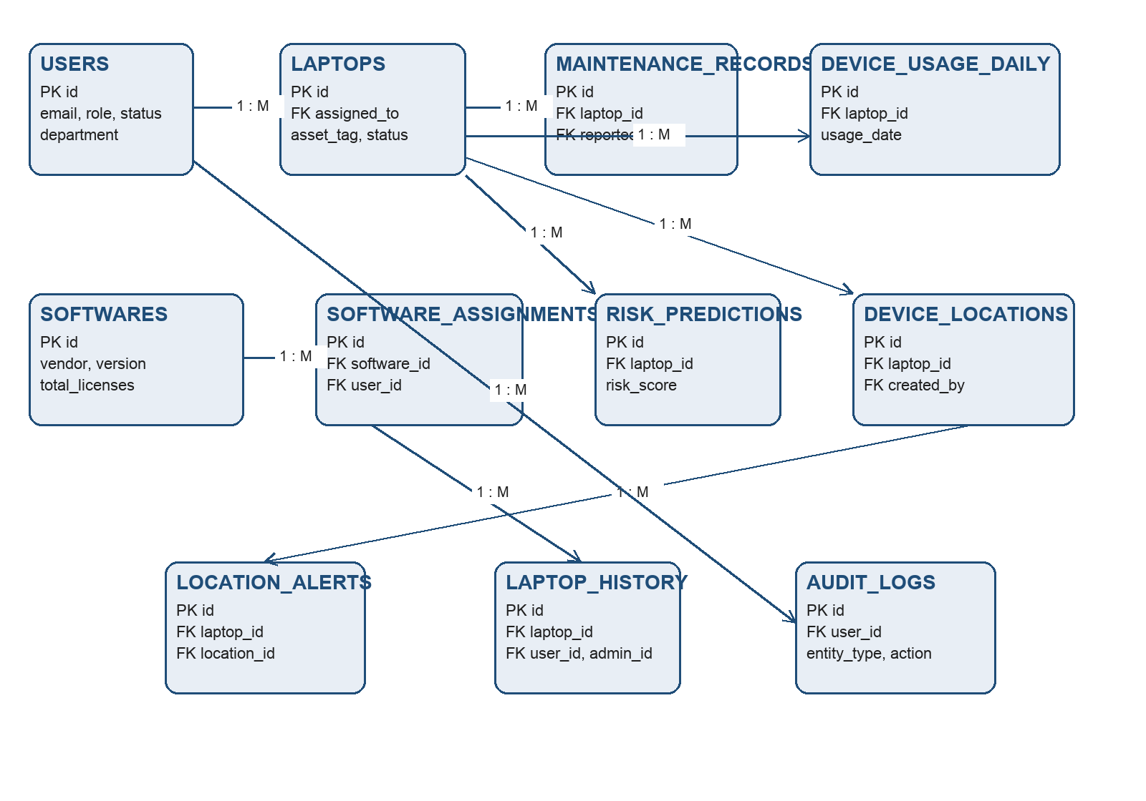

4.3.4 Class Diagram
The class diagram is a conceptual representation of the application domain. It emphasises the responsibilities represented in the database-backed PHP workflow: identity and authorisation, asset lifecycle operations, maintenance risk calculation, software allocation and authorised check-in handling.
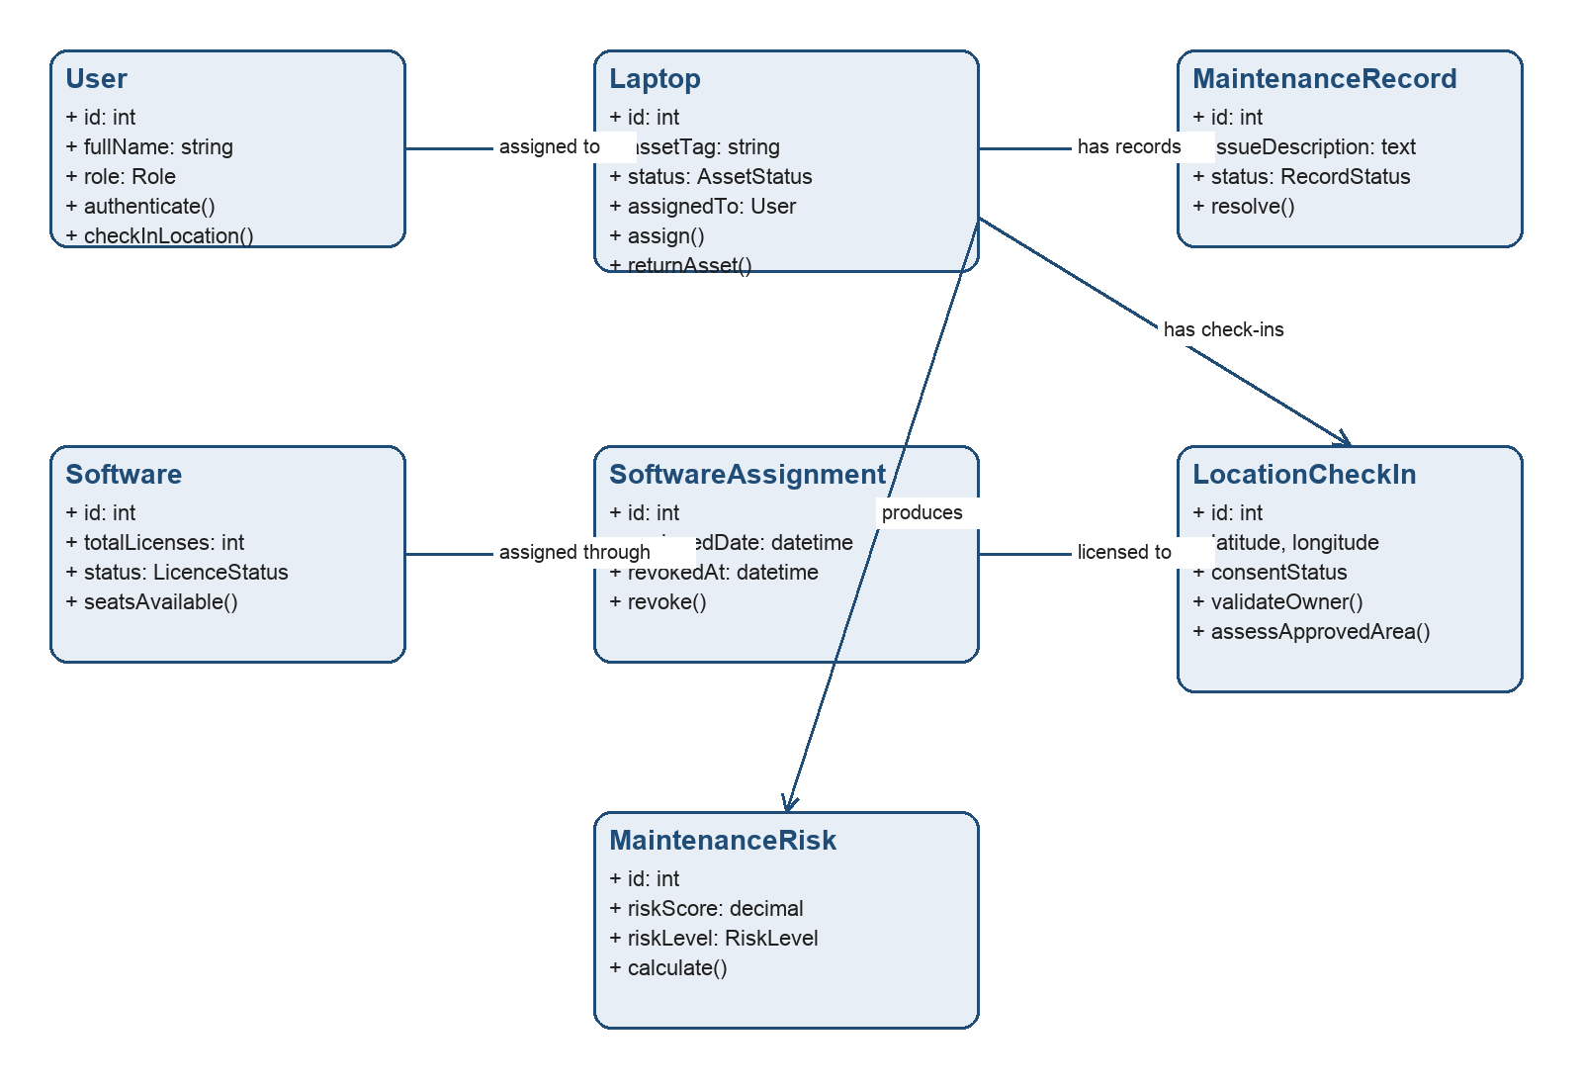

4.3.5 Activity Diagram
The activity diagram shows the maintenance-risk decision-support process. A high risk does not automatically retire or repair an asset; instead, it creates a maintenance record and prompts ICT review. The final result and administrative action remain auditable.
