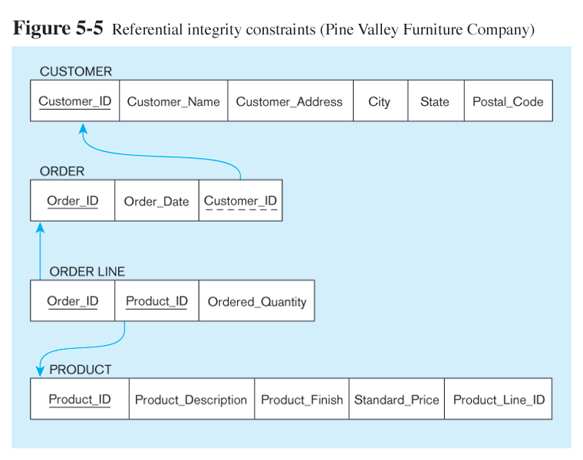

1. create the tables and constraints indicated in the above diagram?
2. insert sample indicated below:

Customer_T
=========
insert into CUSTOMER_T values (1, 'John Doe', '392 Sunset Blvd.', 'New York', 'NT','10059');

insert into CUSTOMER_T values (2, 'Mary Smith', '6900 Main St.', 'San Francisco', 'CA','94032');

insert into CUSTOMER_T values (3, 'Richard Newman', '2040 Riverside Rd.', 'San Diego', 'CA','92010');

insert into CUSTOMER_T values (4, 'Cathy Cook', '4010 Speedway', 'Tucson', 'AZ','85719');

ORDER_T
========
insert into ORDER_T (Order_ID, Order_date, Customer_ID) values(100, '01-OCT-04', 1);

insert into ORDER_T (Order_ID, Order_date, Customer_ID) values(101, '01-OCT-04', 2);

insert into ORDER_T (Order_ID, Order_date, Customer_ID) values(102, '02-OCT-04', 3);

insert into ORDER_T values(103, '03-OCT-04', 2);

insert into ORDER_T values(104, '10-OCT-04', 1);

insert into ORDER_T values(105, '10-OCT-04', 4);

insert into ORDER_T values(106, '10-OCT-04', 2);

insert into ORDER_T values(107, '10-OCT-04', 1);

PRODUCT_T
==========
insert into PRODUCT_T values (1000, 'Office Desk', 'Cherry', 95.0, 10);

insert into PRODUCT_T values (1001, 'Manager''s Desk', 'Red Oak', 199.0, 10);

insert into PRODUCT_T values (2000, 'Office Chair', 'Cherry', 75.0, 20);

insert into PRODUCT_T values (2001, 'Manager''s Desk', 'Natural Oak', 129.0, 20);

insert into PRODUCT_T values (3000, 'Book Shelf', 'Natural Ash', 35.0, 30);

insert into PRODUCT_T values (3001, 'Duplex Book Shelf', 'White Ash', 80.0, 30);

insert into PRODUCT_T values (4000, 'Table Lamp', 'Natural Ash', 15.0, 40);

insert into PRODUCT_T values (4001, 'Duplex Table Lamp', 'White Ash', 40.0, 40);

insert into PRODUCT_T values (9999, 'Keyboard', 'Plastic', 20.0, 50);

You should see an error message for the last insertion. Please try to figure out why,

ORDER_LINE_T
=============
insert into ORDER_LINE_T values (100, 4000, 1);

insert into ORDER_LINE_T values (101, 1000, 2);

insert into ORDER_LINE_T values (101, 2000, 2);

insert into ORDER_LINE_T values (102, 3000, 1);

insert into ORDER_LINE_T values (102, 2000, 1);

insert into ORDER_LINE_T values (103, 4001, 1);

insert into ORDER_LINE_T values (104, 2000, 1);

insert into ORDER_LINE_T values (105, 3001, 2);

insert into ORDER_LINE_T values (106, 3000, 1);

insert into ORDER_LINE_T values (106, 4000, 1);

insert into ORDER_LINE_T values (107, 4001, 1);

Queries to Perform

Query single table

1. Show product id and finish for all products

2. Show product id and finish for all products, sort by product_line_id by ascending order
3. Show product id and finish for all products, sort by product_line_id by descending order
4. Show each product_line_id and the total number of products for the product_line_id

5. Show product_id and description for all products whose names contain a string of "table"

6. Change a product_description from 'Duplex Table Lamp' to 'Arch Table Lamp'

7. Show dates and how many orders received in each individual day

