Today’s’ Lab tutorial
1. Start by creating an html document and everything below goes under body tag
Creating tables:
<table>
<tr>
<td> First Cell </td>
<td> Second Cell </td>
</tr>
<tr>
<td> Third Cell </td>
<td> Fourth Cell </td>
</tr>
</table>
Will give us:
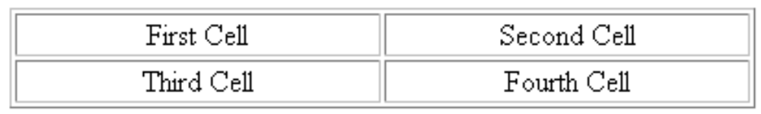

Colspan and rowspan attributes
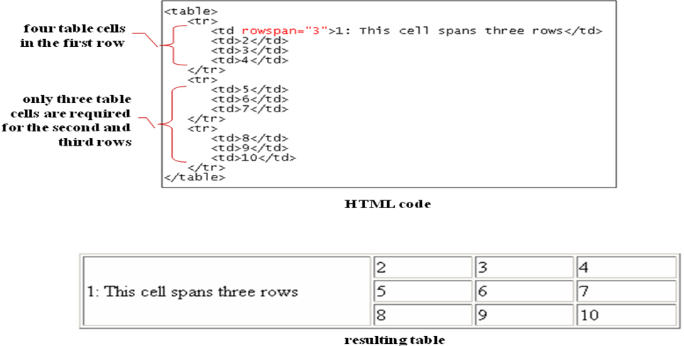
Try creating the following table

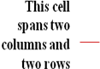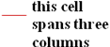

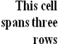

Hint: to put multiple attributes for example colspan and rowspan
<td rowspan=”2” colspan=”2”></td>
Notice after the first attribute there is a space then the second attribute is written.
Try also giving row a ground color using bgcolor attribute
<tr bgcolor=”green”><td></td></tr>
Also try using t e style attribute
<tr style=”background-color:green;”><td></td></tr>

