《C#中类的定义、对象的创建和使用》

**在实验课之前完成：**

1. 完成chap2中的Activity（P2.20），
2. 完成chap3中的两个Activity（P3.19和P3.28）。

内容：

Chap2程序：Display Colored Output

namespace addPrimaryColors

{

class colorChange

{

string c1, c2;

public void AcceptDetails()

{

Console.WriteLine("Instructions:");

Console.WriteLine("1. Please enter the two primary colors you want to add."+

"\n2. The list of primary colors includes:\n R:Red \n G:Green \n B:Blue");

Console.WriteLine("Please enter the first color:");

c1 = Console.ReadLine();

Console.WriteLine("Please enter the second color:");

c2 = Console.ReadLine();

}

public void AddColors()

{

if((c1=="R")&&(c2=="G")||(c1=="G")&&(c2=="R"))

{

Console.ForegroundColor = ConsoleColor.Yellow;

Console.WriteLine("Yellow");

}

else if ((c1 == "R") && (c2 == "B") || (c1 == "B") && (c2 == "R"))

{

Console.ForegroundColor = ConsoleColor.Magenta;

Console.WriteLine("Magenta");

}

else if ((c1 == "B") && (c2 == "G") || (c1 == "G") && (c2 == "B"))

{

Console.ForegroundColor = ConsoleColor.Cyan;//青色

Console.WriteLine("Cyan");

}

else

Console.WriteLine("Colors you entered are not the correct RGB color combination.");

}

static void Main(string[] args)

{

colorChange cC = new colorChange();

cC.AcceptDetails();

cC.AddColors();

}

}

}

实验结果：（按Ctrl+F5）

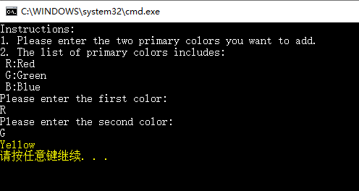

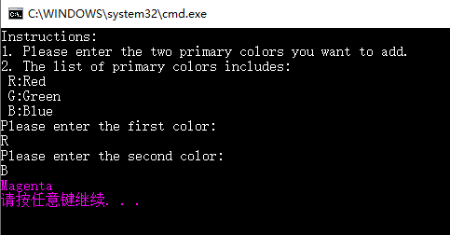

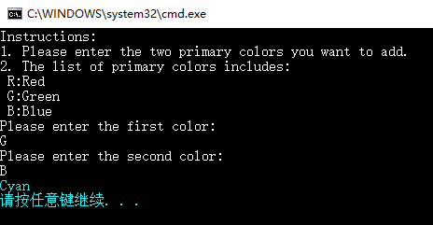

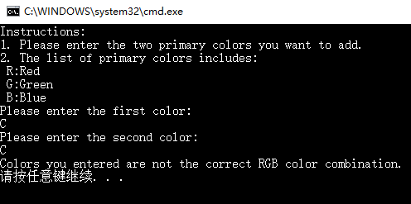

Chap3程序1：Swapping two Numbers by Using Methods with Parameters

class SwapNumber

{

void SwapNum(ref int a, ref int b)

{

int temp;

temp = a;

a = b;

b = temp;

}

static void Main(string[] args)

{

SwapNumber x = new SwapNumber();

int n1, n2;

Console.WriteLine("Enter the first number");

n1 = Convert.ToInt32(Console.ReadLine());

Console.WriteLine("Enter the second number");

n2 = Convert.ToInt32(Console.ReadLine());

Console.WriteLine("The value of first number is {0}", n1);

Console.WriteLine("The value of second number is {0}", n2);

x.SwapNum(ref n1, ref n2);

Console.WriteLine("Now the value of first number after swapping is {0}", n1);

Console.WriteLine("Now the value of second number after swapping is {0}", n2);

}

}

程序结果：

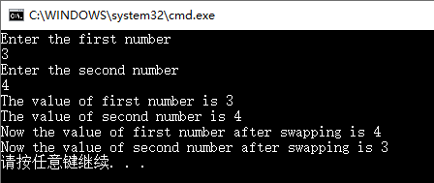

Chap3程序2：Counting the Numbers of Objects of a Class by Using Static Functions

class Program

{

static int Main(string[] args)

{

ObjectCount x1 = new ObjectCount();

ObjectCount x2 = new ObjectCount();

ObjectCount x3 = new ObjectCount();

Console.WriteLine("Number of objects created are {0}", x3.display());

Console.ReadLine();

return 0;

}

}

public class ObjectCount

{

public static int count;

public ObjectCount()

{

count++;

}

public int display()

{

return count;

}

}

程序结果：

