JavaFX UI Controls
Label | 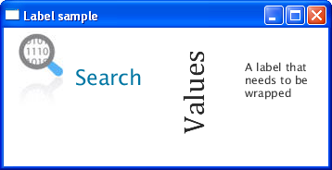 | https://docs.oracle.com/javafx/2/ui_controls/label.htm
Button | 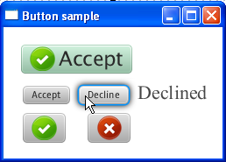 | https://docs.oracle.com/javafx/2/ui_controls/button.htm
Radio Button | 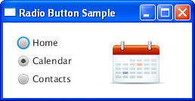 | https://docs.oracle.com/javafx/2/ui_controls/radio-button.htm
Toggle Button | 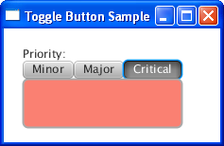 | https://docs.oracle.com/javafx/2/ui_controls/toggle-button.htm
Checkbox | 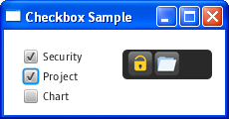 | https://docs.oracle.com/javafx/2/ui_controls/checkbox.htm
Choice Box | 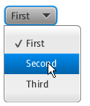 | https://docs.oracle.com/javafx/2/ui_controls/choice-box.htm
Text Field | 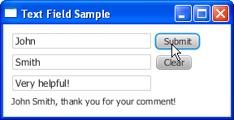 | https://docs.oracle.com/javafx/2/ui_controls/text-field.htm
Scroll Bar | 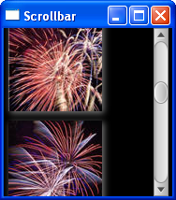 | https://docs.oracle.com/javafx/2/ui_controls/scrollbar.htm
Scroll Pane | 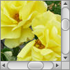 | https://docs.oracle.com/javafx/2/ui_controls/scrollpane.htm
List View | 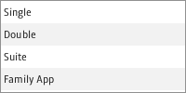 | https://docs.oracle.com/javafx/2/ui_controls/list-view.htm
Table View | 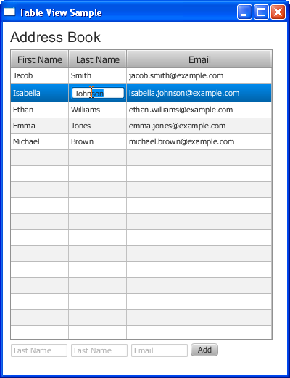 | https://docs.oracle.com/javafx/2/ui_controls/table-view.htm
Tree View | 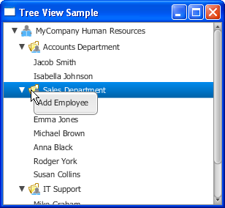 | https://docs.oracle.com/javafx/2/ui_controls/tree-view.htm
Combo Box | 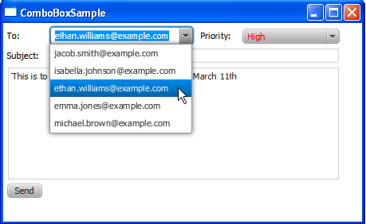 | https://docs.oracle.com/javafx/2/ui_controls/combo-box.htm
Separator | 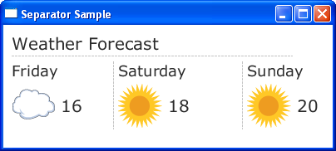 | https://docs.oracle.com/javafx/2/ui_controls/separator.htm
Slider | 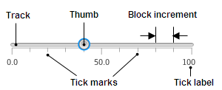 | https://docs.oracle.com/javafx/2/ui_controls/slider.htm
Progress Bar and Progress Indicator | 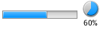 | https://docs.oracle.com/javafx/2/ui_controls/progress.htm
Hyperlink | 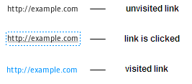 | https://docs.oracle.com/javafx/2/ui_controls/hyperlink.htm
HTML Editor | 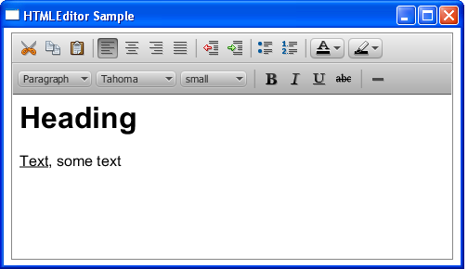 | https://docs.oracle.com/javafx/2/ui_controls/editor.htm
Tooltip | 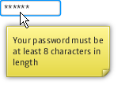 | https://docs.oracle.com/javafx/2/ui_controls/tooltip.htm
Titled Pane and Accordion | 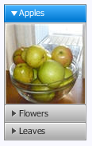 | https://docs.oracle.com/javafx/2/ui_controls/accordion-titledpane.htm
Menu | 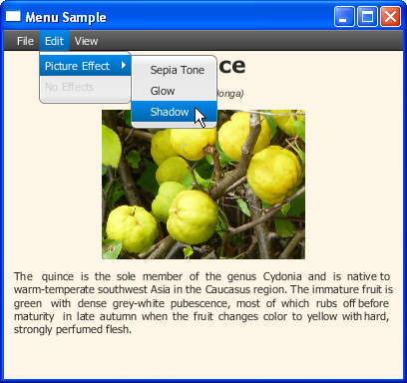 | https://docs.oracle.com/javafx/2/ui_controls/menu_controls.htm
Password Field |  | https://docs.oracle.com/javafx/2/ui_controls/password-field.htm
Color Picker | 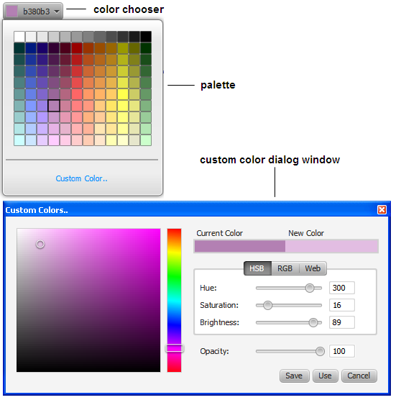 | https://docs.oracle.com/javafx/2/ui_controls/color-picker.htm
Pagination Control | 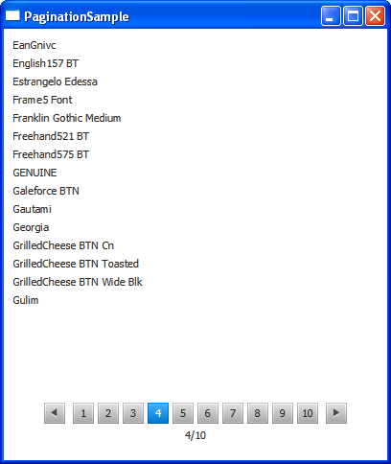 | https://docs.oracle.com/javafx/2/ui_controls/pagination.htm
File Chooser | 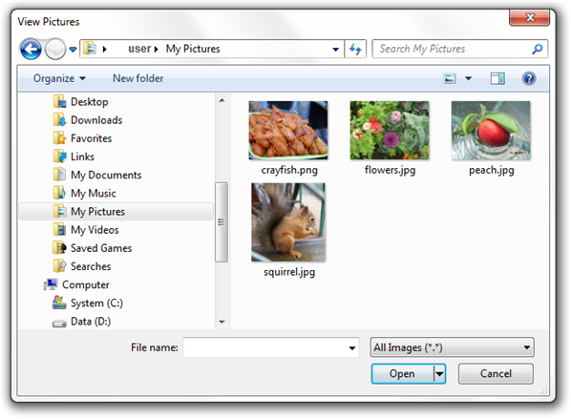 | https://docs.oracle.com/javafx/2/ui_controls/file-chooser.htm
Dialog

Charts
Group
Pie Chart | 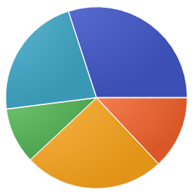 | https://docs.oracle.com/javase/8/javafx/user-interface-tutorial/pie-chart.htm
Line Chart | 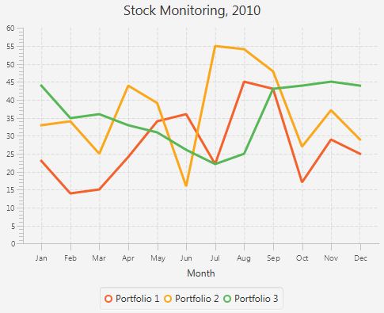 | https://docs.oracle.com/javase/8/javafx/user-interface-tutorial/line-chart.htm
Area Chart | 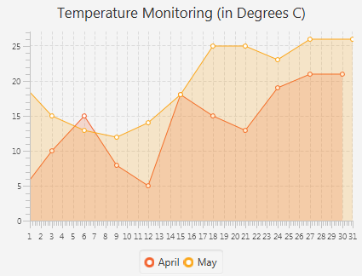 | https://docs.oracle.com/javase/8/javafx/user-interface-tutorial/area-chart.htm
Bubble Chart | 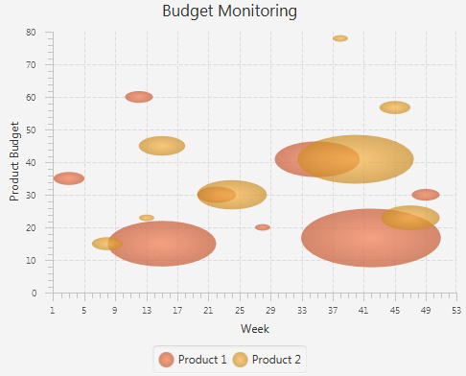 | https://docs.oracle.com/javase/8/javafx/user-interface-tutorial/bubble-chart.htm
Scatter Chart | 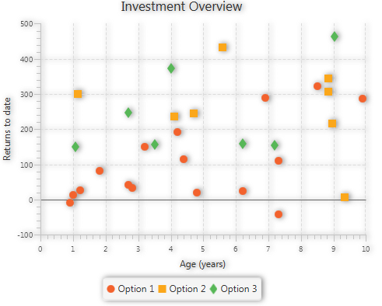 | https://docs.oracle.com/javase/8/javafx/user-interface-tutorial/scatter-chart.htm
Bar Chart | 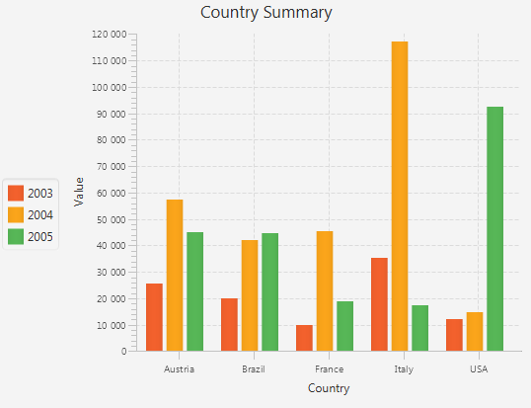 | https://docs.oracle.com/javase/8/javafx/user-interface-tutorial/bar-chart.htm

Layouts
BorderPane | 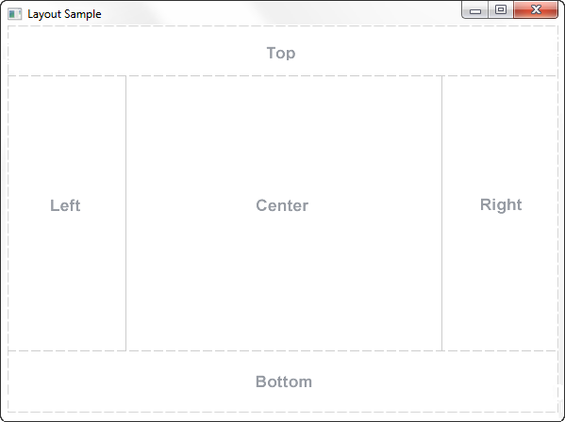 | https://docs.oracle.com/javase/8/javafx/layout-tutorial/builtin_layouts.htm
HBox | 
VBox | 
StackPane
GridPane | 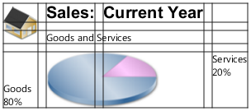
FlowPane | 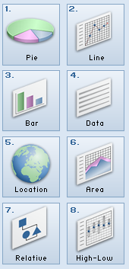
TilePane
AnchorPane

