Corrections to be effected on the app

1. This Registered LSR should be “LSR Request Form”

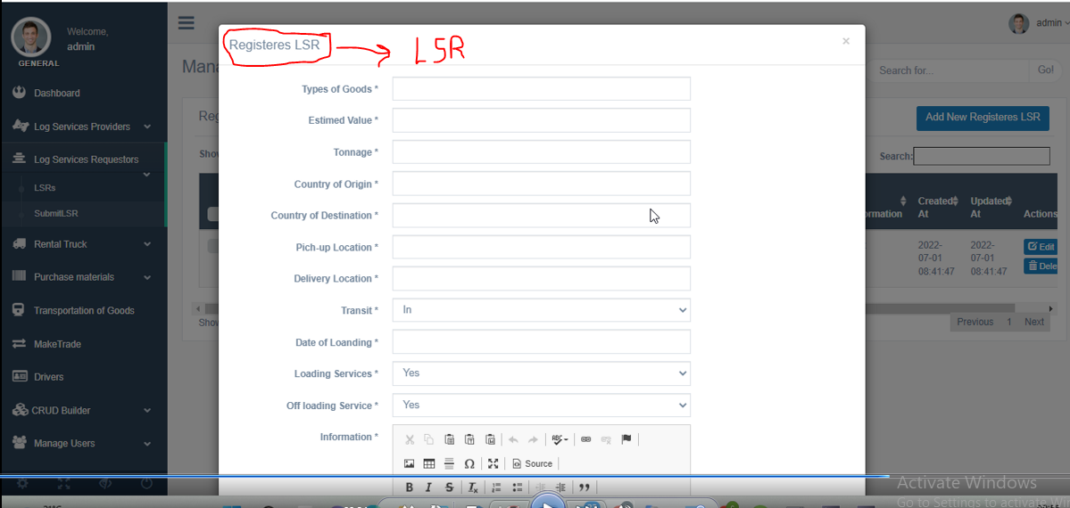

1. This Add New Registeres LSR should be “ Add New Request”

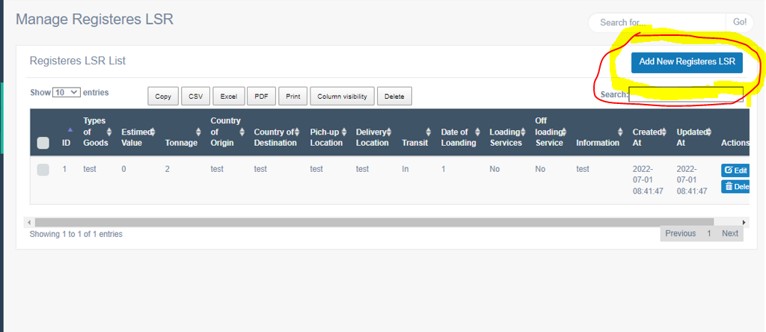

1. The sub-heading Lsps should be “LSP Details”. Also there is no need to include lsp to all the details.

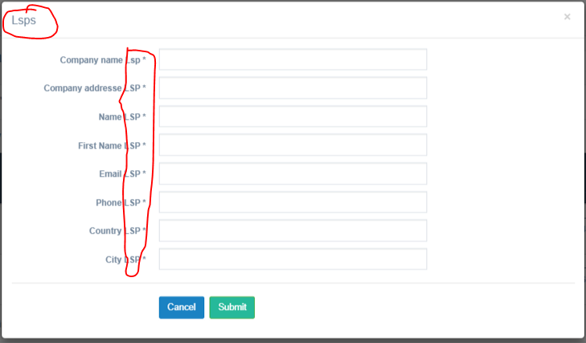

1. This next figure has the following corrections.

\*No 1=Manage Registered LSPs

\*No 2= Registered LSP list

\*no 3= Add New

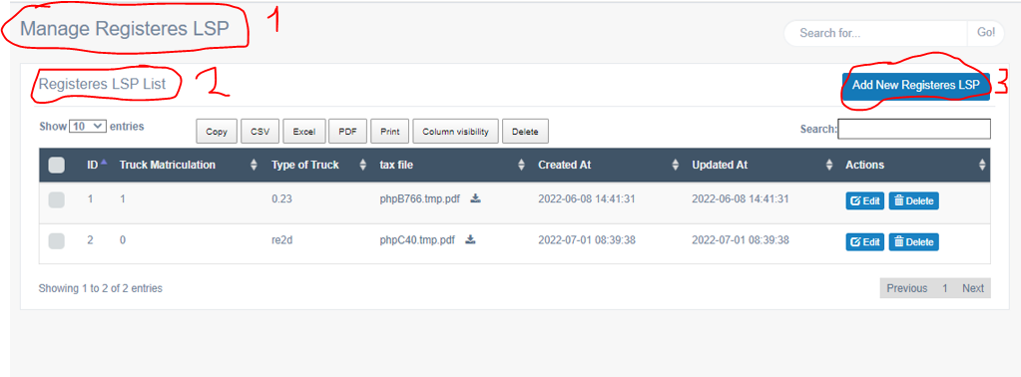

1. Please remove the Facebook icon

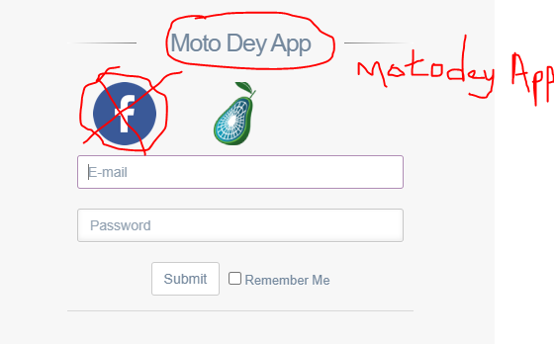

1. There we have the following corrections

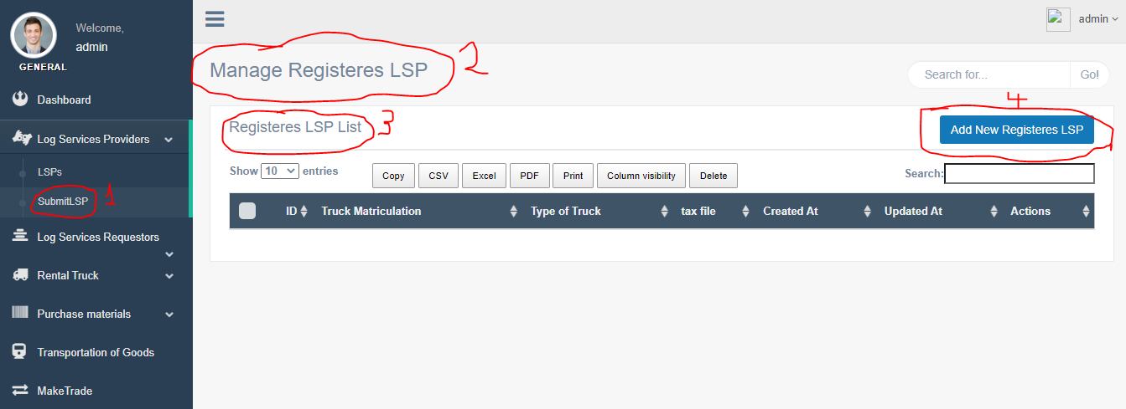

\*1. SubmitLSP should be “Trucks”

\*2. Manage Trucks

\*3. Registered Trucks

\*4. Add New Trucks

7. We need the follow adjustments below;

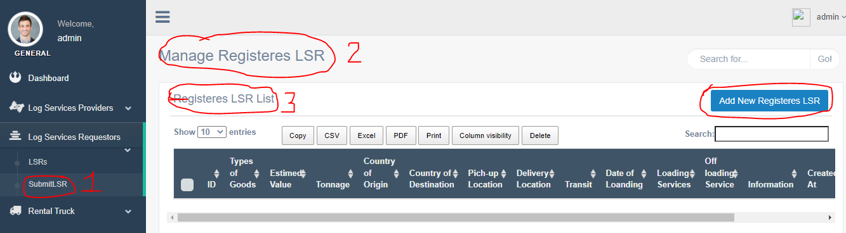

\*1. Cargo details

\*2. Manage LSR Request Form

\*3. Cargo information

\*4. Add new cargo

8. We will consider the following corrections here;

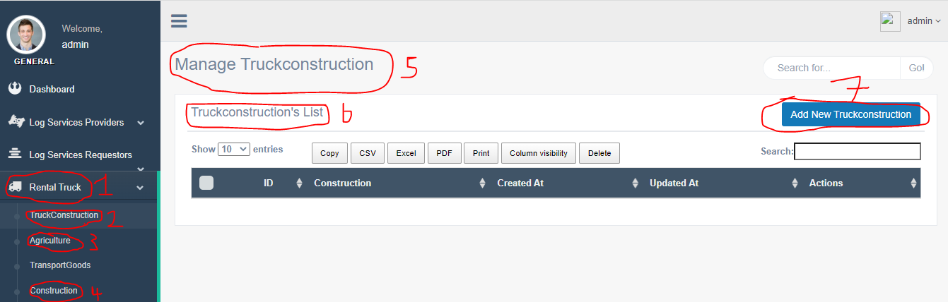

\*1. Truck Rentals/Materials

\*2. Heavy-duty trucks/Machines

\*3. Agricultural Equipment

\*4. Construction Materials

\*5. Manage Heavy-duty Trucks/Machines

\*6. Trucks List

\*7. Add New Trucks

9. We will need the change the following items;

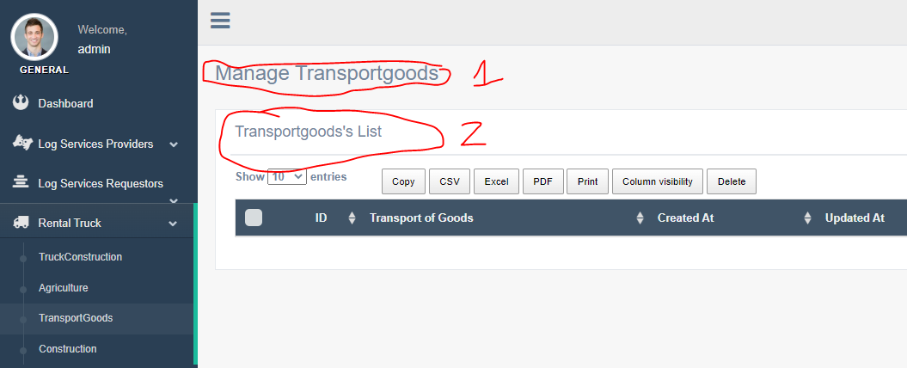

\*1. Manage transportation of goods

\*2. Cargo list

Note: something is wrong with Agriculture, Purchase materials and Make trade

10. Consider the following corrections

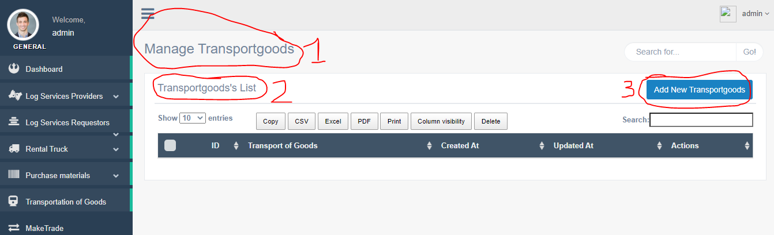

\*1. Manage Transportation of Goods

\*2. Manage Transport List

\*3. Add New Transaction

NB: These are the major corrections we have noticed. Still what about the tracking interface? Also this page was for the Motodey Admin. What about the pages for LSR and LSP?

Which payment methods will the application be using?