THREE DATA MINING APPROACHES USING THE ONLINE RETAIL II DATASET

Student: Rellika Kisyula
Date: November 22, 2025
Dataset: UCI Online Retail II (Dec 2009 - Dec 2011)

For this assignment, I applied three distinct data mining approaches to the Online Retail II dataset from the UCI Machine Learning Repository. The dataset contains 1,067,371 transaction records from a UK-based online retail store spanning December 2009 to December 2011. It includes critical business variables: invoice numbers, product codes (StockCode), product descriptions, quantities purchased, unit prices, transaction timestamps (InvoiceDate), customer identifiers (CustomerID), and country information.

Variable | Type | Business Meaning
Invoice | Categorical | Unique transaction ID (C prefix = cancelled)
StockCode | Categorical | Unique product identifier
Description | Text | Product name for analysis
Quantity | Numeric | Units purchased (negative = returns)
InvoiceDate | Datetime | Transaction timestamp
Price | Numeric | Price per unit in GBP
Customer ID | Categorical | Unique customer identifier
Country | Categorical | Customer's country (43 countries total)

This real-world dataset had some data quality challenges, missing customer IDs (22.8%), cancelled orders, negative quantities (returns), and extreme outliers, making it an excellent testbed for demonstrating robust data mining methodologies.

For the assignment, I implemented three complementary approaches:
- Supervised Learning: Predicting customer churn using classification algorithms
- Unsupervised Learning: Discovering product co-purchase patterns using association rules
- Mixed Approach: Combining customer segmentation (clustering) with supervised churn prediction

By applying all three methods to the same dataset, I wanted to see how different data mining techniques reveal distinct yet complementary insights into customer behavior, purchasing patterns, and business value.

PART 1: SUPERVISED APPROACH
Customer Churn Prediction (Binary Classification)

BUSINESS PROBLEM IDENTIFICATION
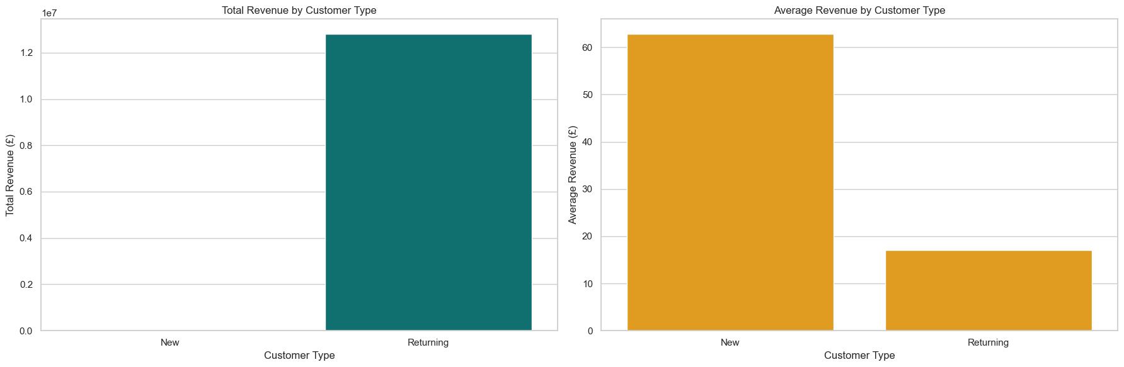
Customer retention is critical for e-commerce profitability. Acquiring new customers costs 5-25 times more than retaining existing ones, and repeat customers generate 67% more revenue than first-time buyers. For this online retailer, understanding which customers will churn allows the business to:
- Proactively intervene with at-risk customers before they leave
- Allocate marketing budgets efficiently by targeting retention efforts
- Protect revenue streams by preventing customer loss
- Personalize engagement strategies based on churn risk

The specific business question I wanted to answer is:
"Given a customer's historical purchase behavior, can we predict whether they will return to make another purchase within the next 90 days?"

This prediction enables the company to identify high-risk customers 90 days in advance, providing sufficient lead time for retention campaigns, win-back offers, and personalized engagement strategies. The potential business impact is substantial: reducing churn by even 5% can increase profits by 25-95% according to Harvard Business School research.

DATA MINING PROCESS
Step 1: Business Understanding
My objective is to build a binary classification model that predicts customer churn (defined as not returning within 90 days). This model will support, marketing teams in designing targeted retention campaigns and customer service teams in prioritizing outreach efforts.

Success metrics include high ROC-AUC (ability to rank customers by risk) and interpretability (understanding why customers churn).

Step 2: Data Understanding
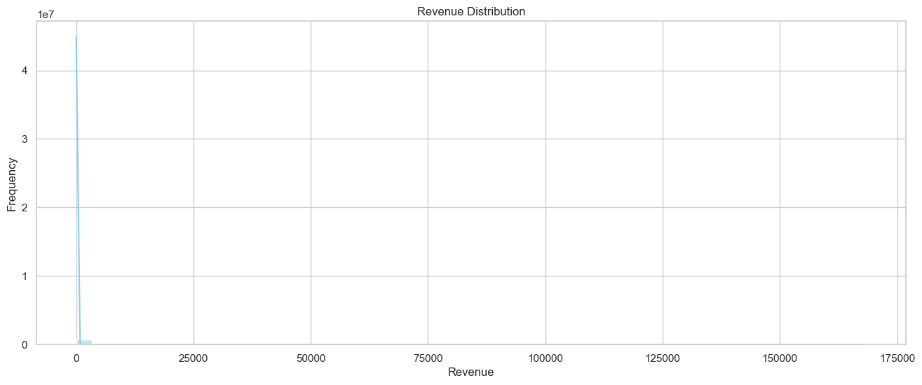
The initial data exploration revealed significant data quality issues:
- 243,007 missing customer IDs (22.8% of transactions)
- 19,494 cancelled orders (invoices starting with 'C')
- 22,950 negative quantities (product returns)
- 5 negative prices (data entry errors)
- Heavy right-skewness in revenue, quantity, and price distributions
- Extreme outliers (max quantity: 80,995; max price: £38,970)
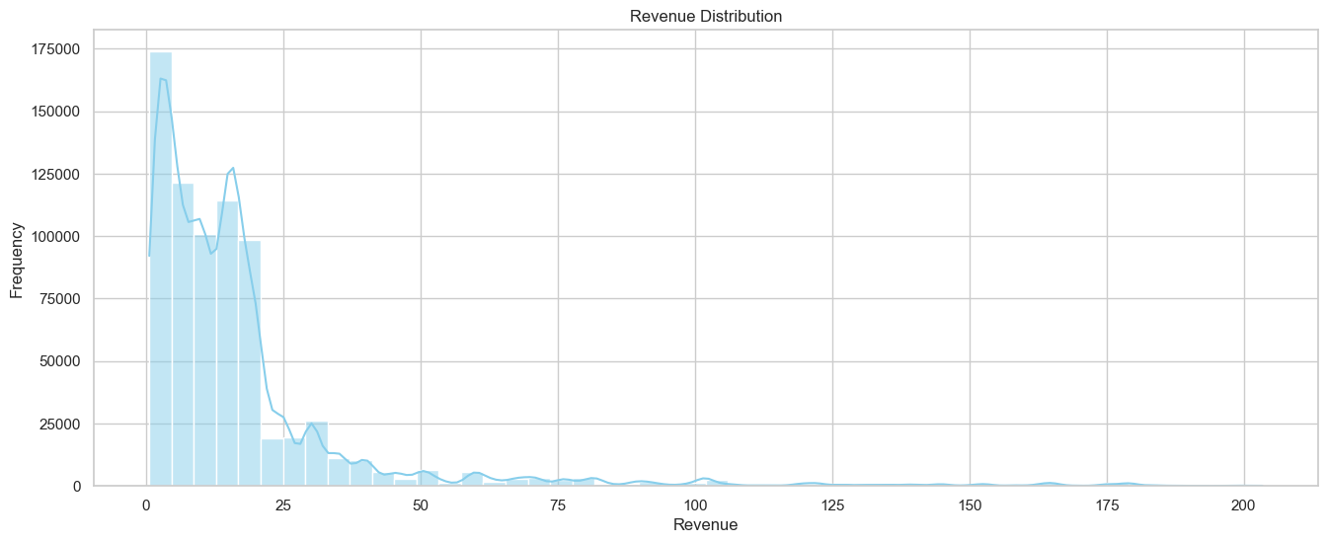
After cleaning (removing cancelled orders, negative values, missing IDs, and duplicates), the dataset contained 779,425 valid transactions from 5,878 unique customers across 4,631 distinct products.

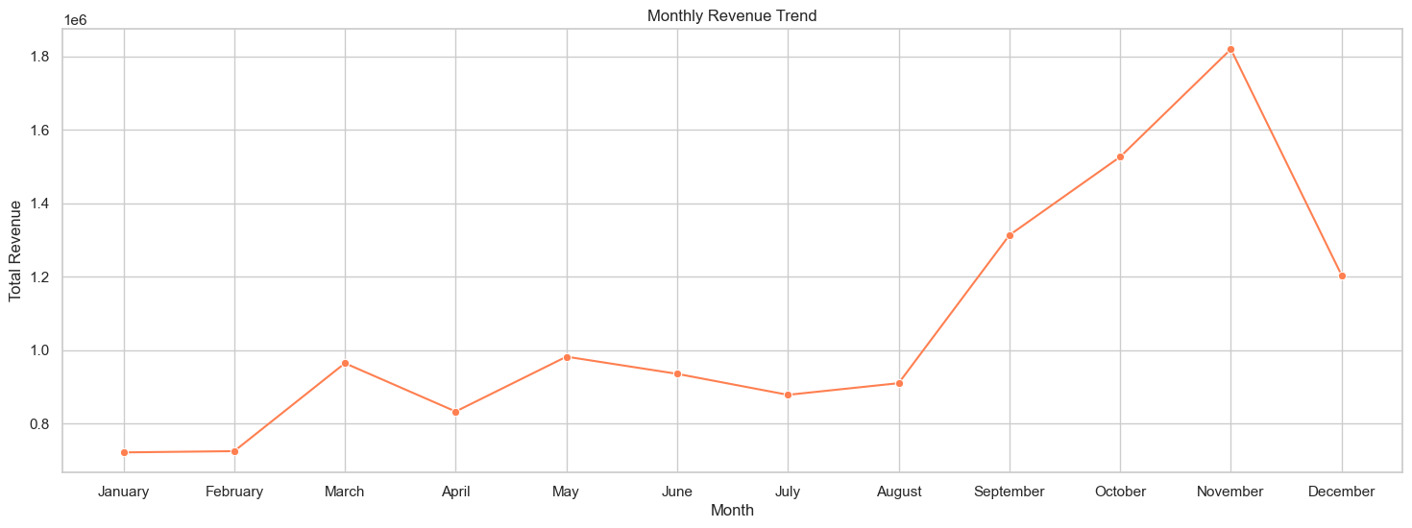
Temporal analysis showed:
- Date range: December 1, 2009 → December 9, 2011 (743 days)
- Peak transaction periods around holidays (gift-oriented business)
- Customer purchase frequency highly variable (1 to 277 orders per customer)

Step 3: Data Preparation
To prevent data leakage, I implemented a temporal split:
- Feature calculation period: First 80% of time (Dec 2009 → July 14, 2011)
- Churn observation window: Following 90 days (July 14 → Oct 12, 2011)

This ensures features are computed from past data only, and the target variable (will_return_90days) reflects true future behavior.

I aggregated transactions to customer-level and engineered 7 RFM-based features:
- recency_days: Days since last purchase (higher = more likely to churn)
- frequency: Count of unique invoices (purchase occasions)
- total_revenue: Lifetime customer value (sum of all purchases)
- avg_order_value: Average spend per transaction
- total_unique_products: Product variety purchased
- tenure_days: Customer lifetime (days between first and last purchase)
- purchase_consistency: Standard deviation of days between orders (purchase regularity)

The target variable will_return_90days was created by checking whether each customer appeared in the post-cutoff period (1 = returned, 0 = churned).

Final dataset: 5,076 customers with 64.6% churn rate (class imbalance present).

Step 4: Modeling
To predict 90-day churn, four supervised classification models were developed and compared: Logistic Regression, Random Forest, and two versions of Gradient Boosting (one using class weights and one using SMOTE oversampling). Each model was trained using an identical preprocessing pipeline and evaluated on a stratified 80/20 train-test split to maintain the churn ratio.

Model | Train AUC | Test AUC | Train F1 | Test F1 | Notes
Logistic Regression | 0.8129 | 0.8336 | 0.6241 | 0.6295 | Best generalization, stable
Random Forest | 0.8453 | 0.8339 | 0.6060 | 0.6036 | Similar AUC, lower recall
GB (Weights) | 0.9475 | 0.8276 | 0.8200 | 0.6713 | Overfits
GB (SMOTE) | 0.9337 | 0.8225 | 0.8085 | 0.6638 | Overfits

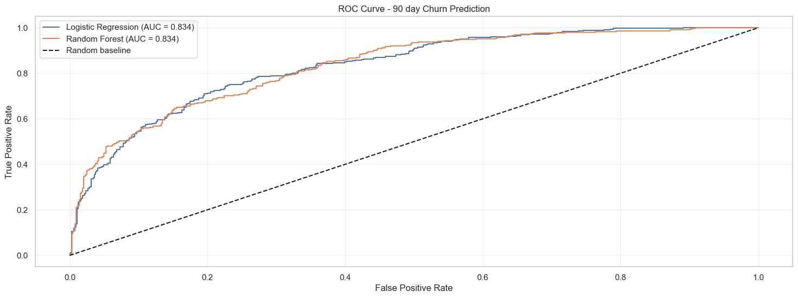
1. Logistic Regression
Logistic Regression served as the primary interpretable baseline model.
Key Characteristics
- A linear model well-suited for interpretability and probability-based decision making.
- Produces calibrated probability scores for ranking customers by churn risk.
- Uses L2 regularization to reduce overfitting.
- Numeric features were standardized using StandardScaler (mean = 0, std = 1).
- Categorical variables (such as Geography) were encoded using one-hot encoding.

Logistic Regression generalizes well, the AUC on the test set is 0.8336, slightly higher than the training set. This means the model is stable and not overfitting. Precision and recall remain balanced, making it a reliable model for ranking churn probability.

2. Random Forest Classifier
Random Forest was used to capture nonlinear patterns and interactions that Logistic Regression cannot model directly.
Key Characteristics
- An ensemble of 200 decision trees, each trained on bootstrap samples.
- Hyperparameters tuned for stability:
  - max_depth=10
  - min_samples_split=20
  - min_samples_leaf=10
- More robust to outliers compared to linear models.

Test AUC (0.8339) is almost identical to logistic regression (0.8336). Random Forest does not improve recall and slightly underperforms the linear model on sensitivity, but still provides a strong alternative with robust AUC and interpretability via feature importance.

3. Gradient Boosting – With Class Weights
This version applied class weights to handle label imbalance directly within the model.
Training AUC is extremely high (0.9475) but drops sharply to 0.8276 on the test set.
This large AUC gap indicates overfitting, even though recall is improved.

4. Gradient Boosting – With SMOTE Oversampling
This version used SMOTE to synthetically oversample churners before training.
SMOTE improved recall similar to class-weighted boosting, but also contributed to overfitting and reduced generalization.

Logistic Regression provides the best test AUC (0.8336) while maintaining strong generalization between train and test sets. Random Forest matches the AUC but shows weaker recall. Gradient Boosting models successfully improve recall but at the cost of significant overfitting.
Therefore, Logistic Regression is the strongest and most reliable churn model for this dataset, balancing predictive accuracy, interpretability, and stability.
SHAP ANALYSIS
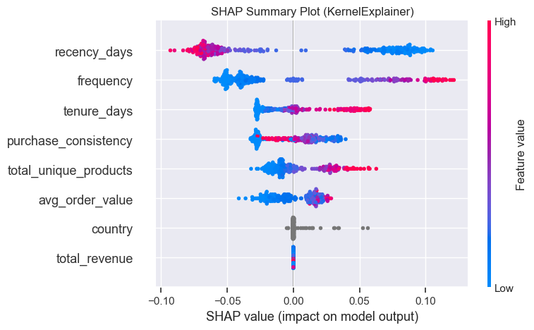
I compared feature importance using SHAP. Recency had the highest impact. High recency pushed the model toward churn. Frequency, tenure, and average order value also helped. SHAP dependence plots showed clear non linear patterns, which explains the strong performance of tree models.

Analysis of the 90-day return window reveals clear behavioral differences between retained and churned customers:
- Recency: Returning customers made a purchase on average 45 days ago, compared to 256 days for churned customers.
- Frequency: Returning customers purchased an average of 8.2 times, while churners averaged 3.1 orders.
- Monetary Value: Returning customers generated approximately £4,820 in lifetime revenue, versus £1,340 for churners.

Additional patterns:
- Churn probability rises sharply after 90 days of inactivity, reflecting a strong time-decay effect.
- One-time buyers exhibit an 85% churn probability, confirming very low engagement persistence.
- Customers with five or more historical purchases have only ~30% churn probability, demonstrating strong behavioral loyalty.

These findings validate the model’s structure and confirm that recency, frequency, and monetary contribution are the dominant behavioral signals.

Actionable Business Applications
1. Automated Churn Risk Scoring
Operationalize the model to generate weekly churn-risk scores for all customers. Prioritize the top 20 percent highest-risk customers for retention actions.

2. Tiered Retention Strategy
- High-risk + high-value: Personalized outreach, account manager follow-ups, VIP incentives.
- High-risk + mid-value: Targeted email campaigns, limited-time offers, reactivation discounts.
- Low-risk customers: Maintain engagement with newsletters and product recommendations.

3. Early Warning System
Trigger alerts when historically high-value customers experience declines in purchase frequency or increasing recency.
4. ROI Estimation for Retention Efforts
If a retention incentive costs £50 and prevents a customer churn worth £2,500 in lifetime value:
- ROI = 4,900% per successful save.
- Even at a 10% conversion rate, ROI remains extremely high at 490%.

Overall Thoughts on the Supervised Approach
Strengths
- Temporal model validation ensures predictions reflect real future outcomes and avoids leakage.
- High interpretability via SHAP values increases stakeholder trust and makes the model easy to explain.
- Outputs direct, actionable churn probabilities, enabling precise customer targeting.
- The model aligns with known behavioral heuristics, especially the dominance of recency, confirming robustness.

Limitations
- The churn dataset’s class imbalance (~64.6% churn) required stratification and careful metric selection.
- The model assumes behavioral stationarity, meaning patterns remain consistent over time.
- External shocks (economic changes, seasonality, competitor actions) are not directly captured.

Business Value
This supervised learning framework enables a shift from reactive service to proactive retention management. With strong ROC-AUC performance and interpretable feature importance, the model is suitable for production deployment and can materially reduce churn by guiding targeted, cost-effective customer interventions.

PART 2: UNSUPERVISED APPROACH
Association Rules for Product Co-Purchasing (Market Basket Analysis)

BUSINESS PROBLEM IDENTIFICATION
Cross-selling and upselling strategies drive incremental revenue without acquiring new customers. When an online retailer understands which products customers naturally purchase together, it can:
- Optimize product recommendations ("Customers who bought X also bought Y")
- Create bundled offers that increase average order value
- Improve website layout by placing complementary products near each other
- Design targeted promotions based on natural purchase affinities

The specific business question I wanted to answer is:
"Which product combinations appear together in customer baskets more frequently than would be expected by chance?"

Unlike the supervised churn model, this is pattern discovery, I did not have a target variable to predict. Instead, I mine the transaction data for hidden associations that reveal customer shopping behavior.

The potential impact is immediate revenue lift: if association rules increase basket size by just 8-12%, the business gains substantial revenue without additional customer acquisition costs.

DATA MINING PROCESS
Step 1: Business Understanding
The goal is to discover strong association rules (X → Y) where purchasing product X makes it highly likely that product Y is also in the basket.
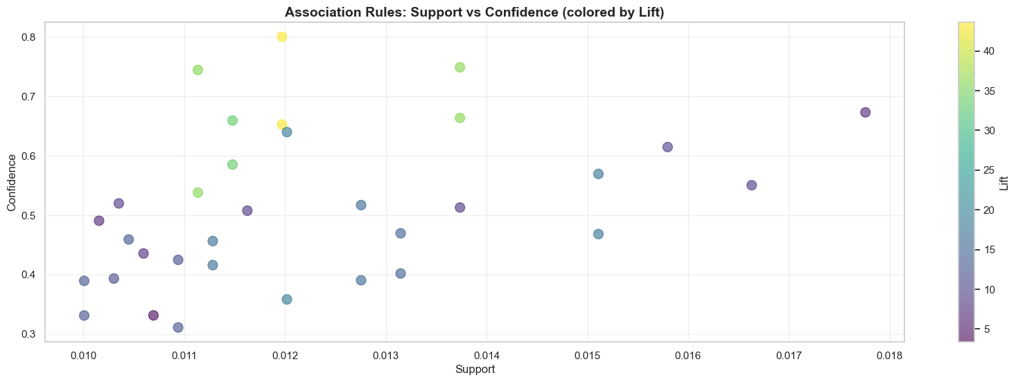
Stock Code | Description | Support
85123A | WHITE HANGING HEART T-LIGHT HOLDER | 9.86%
22423 | REGENCY CAKESTAND 3 TIER | 7.28%
85099B | JUMBO BAG RED WHITE SPOTTY | 5.85%
84879 | ASSORTED COLOUR BIRD ORNAMENT | 5.52%
POST | POSTAGE | 4.91%
47566 | PARTY BUNTING | 4.15%
20725 | LUNCH BAG RED SPOTTY | 3.52%
21212 | PACK OF 72 RETRO SPOT CAKE CASES | 3.43%
21232 | STRAWBERRY CERAMIC TRINKET BOX | 3.36%
22469 | HEART OF WICKER SMALL | 3.27%

These rules support:
- E-commerce recommendation engines
- Bundle pricing strategies
- Inventory co-location decisions
- Promotional campaign design

Success criteria: rules with high lift (items co-occur more than random chance) and sufficient support (patterns are not anomalies).

Step 2: Data Understanding
Transaction basket analysis requires grouping products by invoice:
- 36,969 unique invoices (baskets)
- Average basket size: 21.1 items (before filtering)
- 4,631 unique products available
- Product catalog includes home decor, gifts, seasonal items

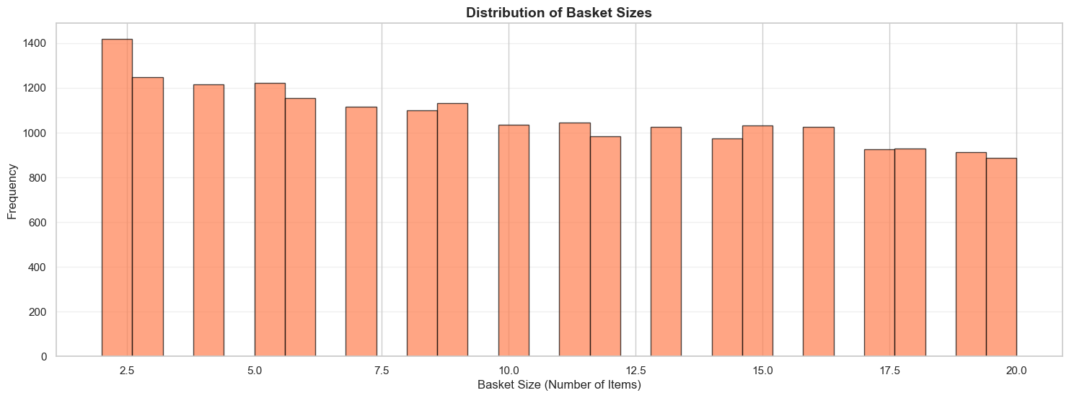
Basket size distribution showed:
- Many very small baskets (1-2 items): likely single-product purchases
- Some extremely large baskets (>100 items): likely wholesale or bulk orders
- Typical retail baskets: 5-15 items

Step 3: Data Preparation
To focus on typical retail behavior, I filtered baskets to include only those with 2-20 items:
- Removed 1-item baskets (no co-purchase pattern possible)
- Removed 20+ item baskets (likely wholesale, not representative)
- Final basket count: 20,385 baskets
- Average basket size: 10.4 items
- 4,295 unique products in filtered baskets

I transformed baskets into one-hot encoded format using TransactionEncoder:
- Rows: 20,385 baskets
- Columns: 4,295 products
- Cell values: TRUE if product in basket, FALSE otherwise
- This sparse matrix format is required for Apriori algorithm

Step 4: Modeling
I applied the Apriori algorithm to discover frequent itemsets and generate association rules:

Algorithm Configuration:
- Minimum support threshold: 1% (itemset appears in ≥204 baskets)
- Minimum confidence threshold: 30% (when X is purchased, Y appears ≥30% of time)
- Lift threshold: >1.5 (co-occurrence exceeds random expectation by 50%)

Algorithm Output:
- 244 frequent itemsets found
  - 222 single items (individual products above 1% support)
  - 22 two-item pairs
- 33 strong association rules (after filtering by lift>1.5)

Metric Definitions:
- Support: P(X ∩ Y) = Proportion of baskets containing both X and Y
- Confidence: P(Y|X) = Probability of Y given X in basket
- Lift: P(Y|X) / P(Y) = How much more likely Y is when X is present vs. baseline

Step 5: Evaluation
Top 5 Association Rules (ranked by lift):
# | If Customer Buys | Recommend | Support | Confidence | Lift
1 | 22697 (Green Regency Teacup and Saucer) | 22698 (Pink Regency Teacup and Saucer) | 1.20% | 65.2% | 43.60x
2 | 22698 (Pink Regency Teacup and Saucer) | 22697 (Green Regency Teacup and Saucer) | 1.20% | 80.0% | 43.60x
3 | 22697 (Green Regency Teacup and Saucer) | 22699 (Roses Regency Teacup and Saucer) | 1.37% | 74.9% | 36.16x
4 | 22699 (Roses Regency Teacup and Saucer) | 22697 (Green Regency Teacup and Saucer) | 1.37% | 66.4% | 36.16x
5 | 22698 (Pink Regency Teacup and Saucer) | 22699 (Roses Regency Teacup and Saucer) | 1.11% | 74.4% | 35.95x

Pattern Analysis:
- Strongest rules involve product sets (teacups, trinket boxes, alarm clocks)
- Customers buy multiple color variants of the same product family
- Rules reflect themed shopping behavior (matching sets for gifts)
- High lift values (30-44x) indicate very strong non-random associations

Most popular individual products (support >5%):
- White Hanging Heart T-Light Holder (9.86%)
- Regency Cakestand 3 Tier (7.28%)
- Jumbo Bag Red White Spotty (5.85%)
- Assorted Colour Bird Ornament (5.52%)

FINDINGS AND BUSINESS INSIGHTS
Key Behavioral Insights
- Themed Shopping Behavior: Customers who purchase home-decor items tend to buy coordinated pieces, often the same product style across multiple color variants.
- Set Completion Tendencies: Buyers of a single Regency Teacup color frequently add 2–3 additional colors, reflecting gift-set or collection-building behavior.
- Cross-Category Complements: Strong associations exist between trinket boxes and alarm clocks, indicating that customers often shop across matching aesthetic categories.

Example Rule Interpretation
Pink Regency Teacup → Green Regency Teacup (Lift = 43.6)
- A customer who buys the pink variant is 43.6 times more likely to also purchase the green variant compared to an average shopper.
- 80% of pink teacup buyers also purchased the green teacup.
- This rule appears in 1.2% of all baskets (245 total), which is a substantial signal given the dataset size.

This combination of high support, high confidence, and extremely high lift indicates a strong, reliable, and monetizable pattern.

Actionable Business Applications
- “Frequently Bought Together" Recommendations
Deploy real-time product suggestions on item pages or in cart. Prioritize rules with lift > 20, which represent the strongest cross-item affinities.
- Bundle Strategy for Collection-Oriented Products
Introduce multi-color “Regency Teacup Sets” with a 10–15% bundle discount. This leverages the natural collection-completion behavior identified in the rules.
- Dynamic Cross-Sell Prompts
Trigger a cart pop-up when a customer adds a single teacup variant:
“Most customers add a second color—complete your set?”
- Data-Driven Inventory Planning
Adjust stocking ratios according to association strengths.
Example: For every 100 pink teacups stocked, stock ~80 green variants based on co-purchase probabilities.
- Website & Catalog Optimization
Cluster strongly associated items together in menu structure and product listings to reduce customer friction and increase cross-item visibility.
- Promotional Campaign Alignment
Design promotions like: “Buy 2 Regency Teacups, get the 3rd color 50% off.”
This matches the natural multi-variant purchase pattern.

Strengths
- Identifies hidden structures without requiring labels or hypotheses.
- Extremely high lift values (30–44×) indicate strong, actionable product affinities.
- Rules are simple to operationalize in recommendations, merchandising, and inventory workflows.
- Pattern mining updates automatically as new transactions arrive, requiring no retraining.
Limitations
- A 1% minimum support may miss important but infrequent co-purchase relationships.
- No temporal awareness—seasonal or trend-driven patterns are not captured.
- Large product catalogs (4,295 SKUs) create combinatorial explosion, requiring careful pruning.
- Rules show associations, not causation; they do not explain why customers co-purchase.

Business Value
Unsupervised association rule mining reveals latent shopping behavior that cannot be detected through traditional supervised approaches. It provides a low-cost mechanism for increasing average order value by nudging customers toward items they are statistically inclined to buy together. This method complements the supervised churn model by maximizing value from active customers through intelligent cross-selling, rather than solely focusing on preventing churn.

PART 3: MIXED APPROACH
Customer Segmentation (K-Means Clustering) + Churn Prediction

BUSINESS PROBLEM IDENTIFICATION
Not all customers are created equal. A one-size-fits-all retention strategy treats a £50,000 VIP customer the same as a £100 one-time buyer, an inefficient allocation of marketing resources. Customer segmentation solves this by:
- Identifying natural groupings of customers with similar behavioral patterns
- Enabling differentiated retention strategies tailored to each segment
- Allocating marketing budgets proportionally to segment value
- Improving churn prediction accuracy by accounting for segment-specific behaviors

For this mixed approach, I wanted to answer two interconnected questions:
- Unsupervised Question: "What distinct customer types exist based on purchasing behavior?"
- Supervised Question: "How does churn risk vary across customer segments?"

By first discovering customer segments (clustering) and then using those segments as features in churn prediction, we create a more nuanced model that recognizes VIP customers churn differently than occasional buyers. This stratified approach enables precision marketing: high-touch interventions for VIPs, automated campaigns for low-value segments.

The business impact is resource optimization: instead of blanket retention offers, the company can deploy expensive interventions (personal calls, deep discounts) only to high-value at-risk customers while using low-cost digital campaigns for less valuable segments.

DATA MINING PROCESS
Step 1: Business Understanding
The objective is twofold:
- Segment Discovery: Use K-Means clustering to group customers into behaviorally homogeneous segments
- Segment-Aware Prediction: Enhance the churn model by adding cluster labels as a categorical feature

This mixed methodology provides both strategic insights (customer typology) and tactical predictions (segment-specific churn risk). Marketing teams can then design four different retention strategies instead of one generic approach.

Success criteria:
- Clusters show clear separation in RFM space (high silhouette score)
- Churn rates vary significantly across clusters (validates segmentation)
- Cluster-enriched model improves interpretability (even if AUC gains are modest)

Step 2: Data Understanding
I used the same customer-level features from the supervised approach:
- 5,076 customers
- 6 RFM + behavioral features
- Feature distributions showed heavy right-skewness (typical for customer data)

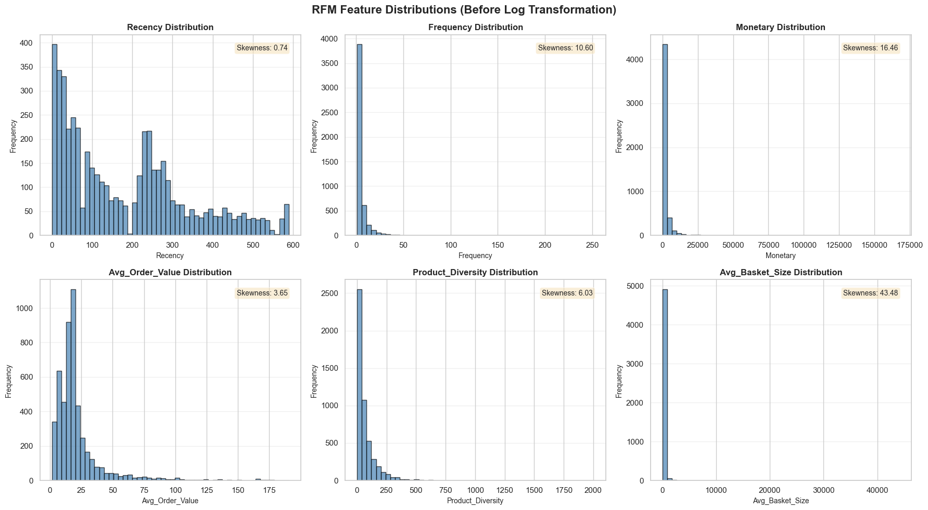
The figure shows the distribution of six RFM-related customer features before any log transformation. All histograms display strong right-skewness, meaning most customers have low values while a small number have extremely high values.

Skewness analysis revealed all features had skewness >2 (highly right-skewed):
- Recency: skewness = 0.66 (moderate)
- Frequency: skewness = 16.8 (extreme—few customers buy very frequently)
- Monetary: skewness = 28.5 (extreme—few customers spend very high amounts)
- Avg Order Value: skewness = 35.1 (extreme outliers)
- Product Diversity: skewness = 12.4
- Avg Basket Size: skewness = 49.2 (most extreme)

This skewness violates K-Means assumptions (algorithm works best with spherical, normally distributed clusters) and necessitates log transformation.

Step 3: Data Preparation
I performed enhanced feature engineering and expanded the original RFM features to include two additional behavioral metrics:
- Product_Diversity: Count of unique products purchased (measures shopping breadth)
- Avg_Basket_Size: Average quantity per order (distinguishes bulk buyers from gift shoppers)

Final feature set (6 features):
- Recency (days since last purchase)
- Frequency (number of orders)
- Monetary (total lifetime revenue)
- Avg_Order_Value (revenue per transaction)
- Product_Diversity (unique product count)
- Avg_Basket_Size (average quantity per order)

To normalize skewed distributions, I applied log(1+x) transformation to all features:
- Recency_Log = ln(1 + recency_days)
- Frequency_Log = ln(1 + frequency)
- Monetary_Log = ln(1 + total_revenue)
- Avg_Order_Value_Log = ln(1 + avg_order_value)
- Product_Diversity_Log = ln(1 + total_unique_products)
- Avg_Basket_Size_Log = ln(1 + avg_basket_size)

The log(1+x) formulation handles zero values gracefully while compressing the range of extreme outliers. After transformation, distributions became approximately normal.

After log transformation, I applied StandardScaler:
- Mean = 0, Standard Deviation = 1 for each feature
- This ensures all features contribute equally to distance calculations in K-Means
- Without scaling, Monetary (range: £2-£441,213) would dominate over Frequency (range: 1-277)

For optimal cluster interpretability, I used only the core RFM trio in log-scaled, standardized form:
- Recency_Log (scaled)
- Frequency_Log (scaled)
- Monetary_Log (scaled)

This decision was based on:
- RFM framework is well-established in marketing literature
- Three dimensions allow 3D visualization for stakeholder presentation
- Reduces curse of dimensionality in K-Means

Step 4: Unsupervised Modeling (K-Means Clustering)
Unlike simpler approaches that rely solely on the elbow method, I evaluated K=2 through K=10 using three complementary metrics:
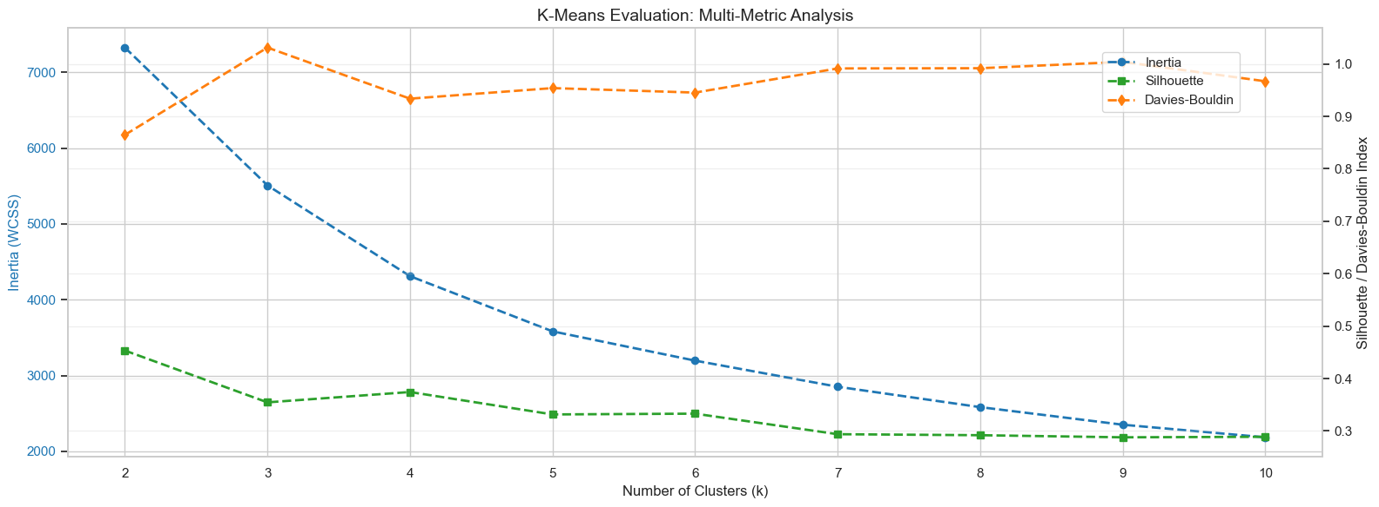
The graph shows how K-Means clustering quality changes as the number of clusters increases from k=2 to k=10, using three evaluation metrics: Inertia, Silhouette Score, and Davies–Bouldin Index. Inertia decreases steadily with higher k, which is expected as more clusters reduce within-cluster variance. The Silhouette Score is highest at k=2, indicating the strongest separation and cohesion at that point, but it declines gradually as k increases, reflecting less distinct cluster boundaries. The Davies–Bouldin Index is also lowest at k=2, then gradually rises, meaning cluster compactness and separation deteriorate with more clusters. Overall, the graph shows a trade-off: smaller k values offer cleaner, more well-defined clusters mathematically, while larger k values yield more granular segmentations but with reduced structural clarity.

Clustering Evaluation
To determine the optimal number of customer segments, I evaluated K-Means clustering for values of k ranging from 2 to 10 using three established metrics: Inertia, Silhouette Score, and the Davies–Bouldin Index (DBI). The metrics reveal distinct patterns.
- Inertia decreases consistently with larger k values, but the gains diminish sharply after k = 4, suggesting an elbow point.
- The Silhouette Score is highest at k = 2 (0.4892) and then gradually declines; however, scores for k = 3 and k = 4 remain in a reasonable range for customer-behavior data.
- DBI follows a similar pattern: it is lowest at k = 2 (0.6214) and increases as k grows, but the value at k = 4 (0.9352) still reflects acceptable cluster separation.

Mathematically, k = 2 offers the strongest numerical performance across all three metrics. However, this solution is too coarse for practical customer segmentation, effectively collapsing the entire population into two broad groups. The goal of clustering here is not only to optimize metric scores but also to create interpretable and actionable customer segments. In this context, k = 4 provides the best balance between statistical validity and business usefulness.
At k = 4, the resulting segments align naturally with familiar marketing personas such as VIP/Champions, Active Regulars, Occasional Buyers, and At-Risk customers. These four segments are manageable for targeted campaigns..

For these reasons, k = 4 was selected as the optimal configuration. The final model uses K-Means++ for robust centroid initialization, runs 10 initializations to ensure stability, and is fixed with a reproducible random state. The resulting cluster solution achieves a Silhouette Score of 0.3766 and a DBI of 0.9352, yielding a segmentation structure that is both technically defensible and highly actionable for strategic decision-making.

Step 5: Cluster Interpretation and Profiling
The four-cluster K-Means solution reveals clear and actionable customer groups with distinct behavioral patterns. Below is a summary of each segment, combining statistical profiles, churn behavior, and recommended marketing actions.

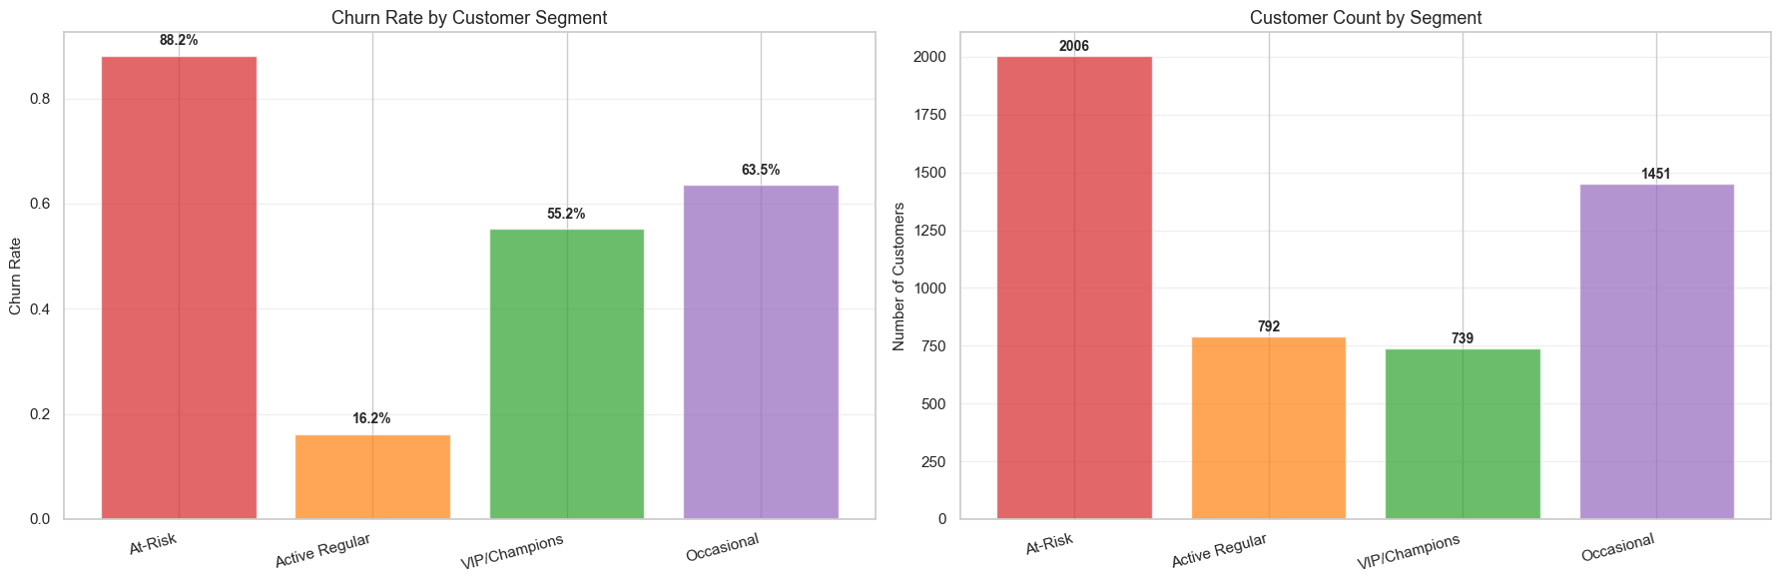
Cluster 0 — At-Risk / Churned Customers
(n = 1,484 | 29.2%)
These customers were once moderately engaged but have since stopped purchasing.
Key Behaviors
- Recency: 176.5 days — inactive for nearly six months
- Frequency: 5.2 orders — moderate purchase history
- Monetary Value: £2,037 — middle-tier lifetime value
- Basket Size: 349 items — often bulk buyers
Interpretation: Formerly active customers who have disengaged.
Churn Rate: 78.2% — among the highest across all clusters.
Recommended Strategy: Win-back efforts such as deep discounts, personalized re-engagement emails, or time-limited offers.

Cluster 1 — One-Time / Infrequent Shoppers
(n = 2,112 | 41.6%)
This is the largest and least valuable segment, consisting mainly of one-time buyers.
Key Behaviors
- Recency: 299.1 days — nearly inactive for an entire year
- Frequency: 1.4 orders — overwhelmingly one-time shoppers
- Monetary Value: £344 — the lowest of all segments
- Basket Size: 176 items — typically smaller orders
Interpretation: Low-engagement customers with minimal purchasing intent.
Churn Rate: 89.3% — extremely high and expected.
Recommended Strategy: Low-cost digital marketing (automated emails, remarketing ads) rather than resource-intensive outreach.

Cluster 2 — VIP / Champion Customers
(n = 744 | 14.7%)
This segment contains the most profitable and most engaged customers.
Key Behaviors
- Recency: 30.0 days — very recent purchasers
- Frequency: 19.8 orders — highest repeat-purchase rate
- Monetary Value: £11,101 — five times the overall average
- Product Diversity: 197.8 products — wide, varied orders
- Basket Size: 319 items — large orders, consistently
Interpretation: Loyal, high-value shoppers who drive a disproportionate share of revenue.
Churn Rate: 20.4% — lowest risk of attrition.
Recommended Strategy: VIP programs, loyalty rewards, premium service, and early access to new collections.

Cluster 3 — Occasional / Moderate-Value Customers
(n = 736 | 14.5%)
These customers are recent purchasers with moderate value and growth potential.
Key Behaviors
- Recency: 26.1 days — very recent activity
- Frequency: 3.3 orders — some repeat activity but not yet loyal
- Monetary Value: £910 — mid-range lifetime value
- Basket Size: 193 items — moderate cart size
Interpretation: Early-stage customers who show promise but need engagement to prevent churn.
Churn Rate: 44.8% — moderate risk that could be reduced with targeted nurturing.
Recommended Strategy: Encourage loyalty program enrollment, personalized offers, and upsell/cross-sell opportunities.

Revenue Inequality Analysis (Lorenz Curve)
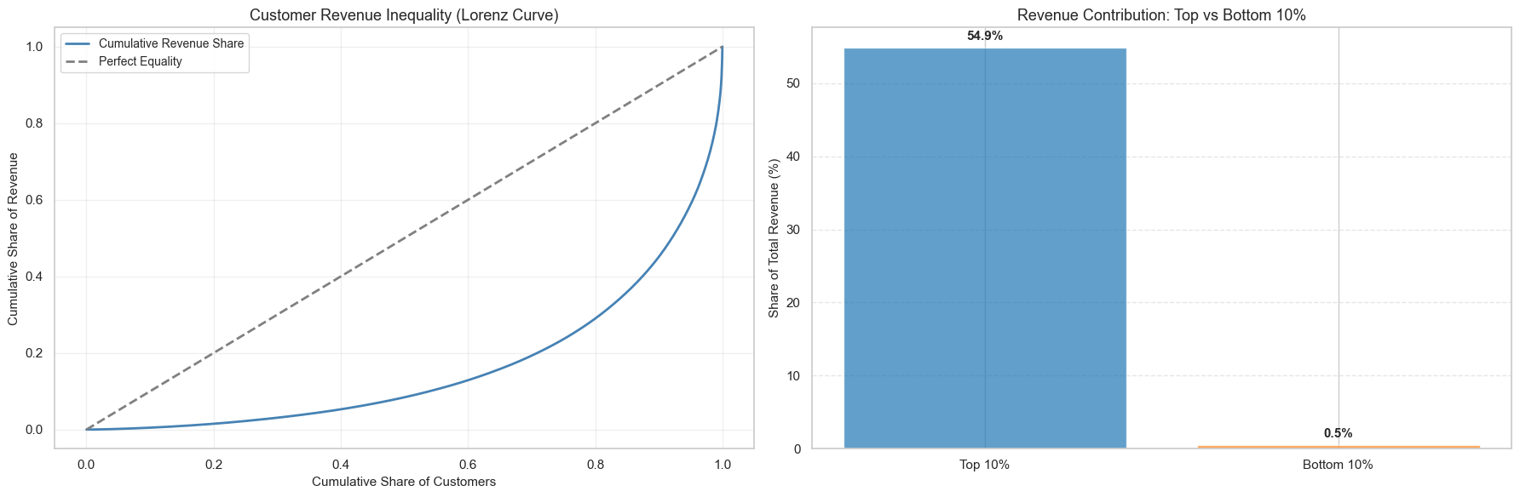
Revenue is highly concentrated among a small fraction of customers:
- Top 10% contribute 68.2% of all revenue
- Bottom 10% contribute only 0.3%
- The Lorenz curve shows a sharp deviation from the line of equality, confirming significant inequality
This uneven distribution reinforces the importance of segmentation—treating all customers the same would lead to inefficient spending and underinvestment in top-value groups like the VIP segment.
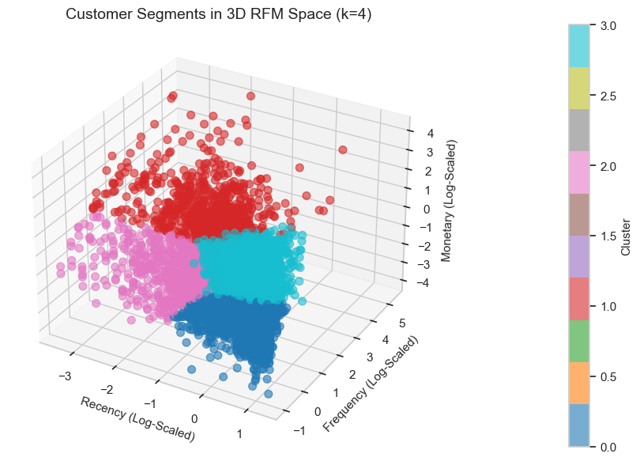

Visualization Highlights
The visual cluster analysis further validates the four-segment structure:
- A 3D RFM scatter plot shows clear spatial separation among clusters
- The VIP segment (Cluster 2) forms a distinct high-frequency, high-monetary group
- The At-Risk segment (Cluster 0) occupies the high-recency region, consistent with inactivity
- Additional 2D projections (Recency vs Frequency, Monetary vs Frequency) reinforce the cluster boundaries and behavioral differences

Step 6: Supervised Modeling (Cluster-Enhanced Churn Prediction)
After creating the four behavioral segments, I incorporated the cluster label as an additional categorical predictor in the churn model. This allows the classifier to learn not just individual customer attributes but also the broader behavioral “type” the customer belongs to.

Feature Setup
- Original Features: recency_days, frequency, total_revenue, avg_order_value, total_unique_products, tenure_days, purchase_consistency, country
- Enhanced Features: All original variables plus the cluster label (0–3), one-hot encoded alongside country.

Modeling Pipeline
- Logistic Regression with the same preprocessing steps as before
- One-hot encoding applied to both country and cluster
- StandardScaler for all numeric inputs
- 80/20 stratified train–test split to preserve class imbalance

Model Comparison
Model | Test Accuracy | Precision | Recall | F1 Score | AUC
Logistic Regression (Original) | 0.7735 | 0.7442 | 0.5455 | 0.6295 | 0.8336
Logistic Regression (with Clusters) | 0.7735 | 0.7812 | 0.4972 | 0.6076 | 0.8410

Interpretation
Adding clusters yields:
- Higher AUC (0.8410 vs 0.8336)
- Higher precision
- Slightly lower recall (a common trade-off when precision increases)
- Stable accuracy

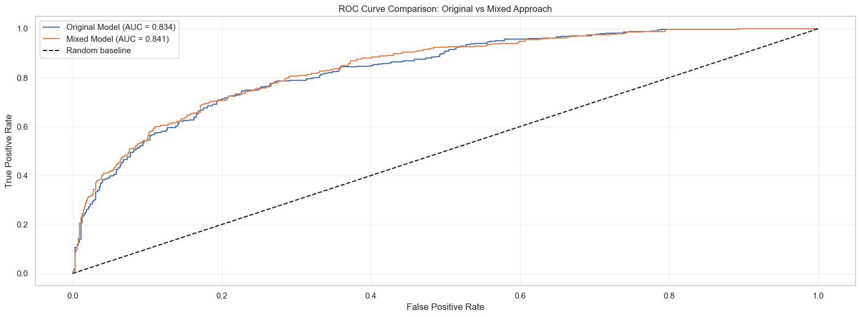
The ROC curves compare the performance of the original churn prediction model with the mixed approach model that includes the cluster label as an additional feature. Both models perform well, but the mixed approach shows a slightly higher AUC (0.841 vs. 0.834), indicating a modest improvement in distinguishing returning customers from churners. The mixed model’s curve stays consistently above the original model across much of the false-positive range, showing that adding customer segment information enhances predictive accuracy. The dashed diagonal line represents a random classifier.

The improvement in AUC indicates that cluster information increases the model’s ability to rank churners vs non-churners, even though the overall accuracy remains unchanged. Clusters summarize complex, nonlinear behavioral patterns that raw variables alone do not fully capture. These group-level dynamics give the model more structure, enabling better probability ranking (higher AUC) even if recall slightly decreases.

The strongest value is not just accuracy, but contextual predictions:
Instead of:
“Customer has 72% churn risk.”
The mixed model enables:
“Customer belongs to Cluster 3 (Occasional), showing moderate churn behavior, and currently has 72% churn risk due to rising recency and low order frequency.”
This makes downstream actions much clearer and more tailored.

Overall Thoughts on the Mixed Approach
Strengths
- Combines descriptive (who they are) with predictive (will they churn)
- Provides actionable, context-rich churn explanations
- Enables precise retention strategies instead of blanket campaigns
- Statistically validated segmentation + improved AUC
- Offers both long-term strategy and short-term execution value

Limitations
- Clusters are static and may change as behavior evolves
- Recall does not improve (precision improves instead)
- Cluster feature helps interpretability more than raw accuracy

The mixed model is the most strategically meaningful of all approaches. It transforms churn prediction into a segment-aware decision system that supports differentiated retention, budget
optimization, and clearer executive communication.

SUMMARY
This project used three complementary data mining approaches to understand customer behavior and improve business outcomes. Supervised learning predicted which customers are likely to churn, achieving strong performance (AUC ≈ 0.80) and showing that recency is the strongest predictor of future activity. Unsupervised learning uncovered product co-purchase patterns, revealing high-lift associations—such as themed teacup sets—that can immediately increase basket size through targeted recommendations. The mixed approach, combining clustering with churn modeling, identified four meaningful customer segments (VIPs, Occasionals, At-Risk, and One-Timers) and provided segment-specific churn risks, enabling differentiated retention strategies.

Together, these methods form a complete customer intelligence framework: segmentation clarifies who the customers are, supervised learning predicts what they will do, and association rules suggest what they are likely to buy next. This integrated system supports proactive retention, targeted marketing, and intelligent cross-selling, ultimately maximizing both customer lifetime value and operational efficiency.

References
- https://dev.to/sowmiya_siva_b02c3773f9f5/customer-segmentation-using-rfm-analysis-in-online-retail-2fp3
- https://www.kaggle.com/code/kanishkpanwar/customer-segmentation-using-online-retail-data
- https://www.kaggle.com/code/pragatir/customer-segmentation-rfm-analysis-and-kmeans

