1. End-to-End Pipeline Overview
Business Objective
The Call Quality Automation application automates the manual evaluation of customer-service calls performed by the Call Quality team.
The Call Quality team uploads call recordings through the application. A scheduled pipeline automatically processes the calls uploaded during the day and generates:
- Call transcription
- English translation
- Speaker identification
- Agent evaluation across 21 quality parameters
- Call summary
- Product feature identification
- Problem category identification
The complete processing pipeline executes sequentially, where the output of each stage becomes the input for the next stage.

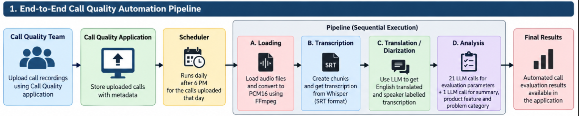

2. End-to-End Flow
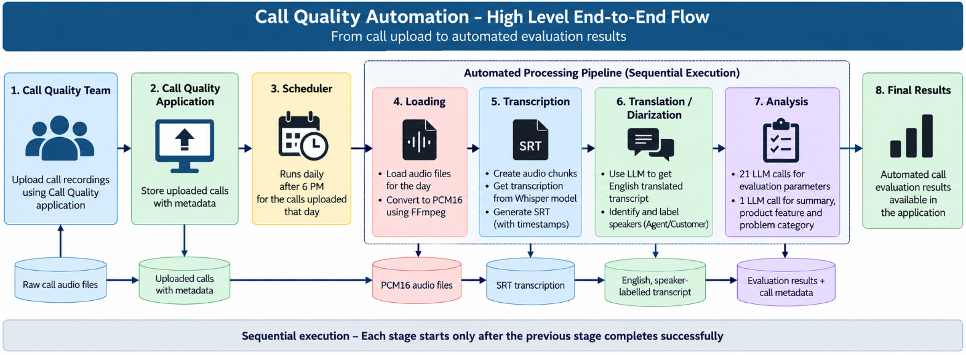

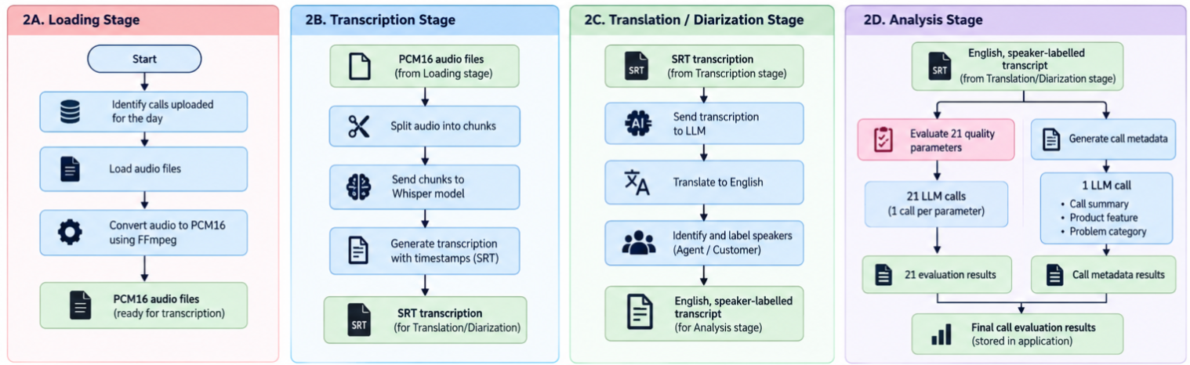

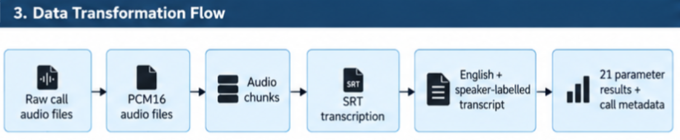s

