Bias Detection in Machine Learning-Based Loan Approval Systems Using Fairness Metrics and SHAP Explainability
Akil A  Student  Dept. of Computer Science & Engineering  KIT – Kalaignarkarunanidhi Institute of Technology  Tamil Nadu, India  kit28.24bcs005@gmail.com | Annette Dafne J  Student  Dept. of Computer Science & Engineering  KIT – Kalaignarkarunanidhi Institute of Technology  Tamil Nadu, India  kit28.24bcs007@gmail.com | Sruthi M  Student  Dept. of Computer Science & Engineering  KIT – Kalaignarkarunanidhi Institute of Technology  Tamil Nadu, India  kit28.24bcs317@gmail.com

Guide: Dr. C. Suresh, Associate Professor, Department of Computer Science & Engineering, KIT – Kalaignarkarunanidhi Institute of Technology, Tamil Nadu, India
Abstract — Loan approval prediction models that leverage machine learning technologies are common place within today’s financial organizations, providing efficiency and consistency that manual approaches cannot rival. Yet, there is a danger lurking in these technologies; such systems have been known to perpetuate preexisting biases within lending data by silently discriminating against individuals belonging to some demographics. Although previous studies have separately explored bias identification and correction mechanisms, an important limitation has emerged in existing literature; there is a notable lack of comprehensive pipelines for identifying and correcting bias with feature explainability. This study fills this knowledge gap with an integrated system comprising four different modules. Specifically, a Random Forest classifier is trained on the UCI Adult Income dataset to emulate a loan approval model. Then, the extent of discrimination is evaluated with three popular bias measures – namely demographic parity difference, equal opportunity difference, and disparate impact ratio. After this, SHAP (SHapley Additive Explanations) values are employed to analyze what factors lead to the creation of biased predictions, thus generating an interpretable analysis that is required more than ever by the existing regulation framework. The method of reweighing is then automatically implemented, and comparisons between different metrics before and after this process show how demographic parity significantly improved from 0.71 to 0.87 with only a slight decline in accuracy at 85.7% to 83.2%. No advanced setup is necessary for this solution, and only Python packages are needed.
Keywords — Algorithmic Fairness, Bias Detection, Loan Approval, SHAP, AIF360, Demographic Parity, Machine Learning, Explainable AI, Reweighing, Disparate Impact.

I. INTRODUCTION
There have been considerable changes in the financial industry within the past decade. Gone are the days when banks and lending organizations depend on their loan officers to manually go through their checklist of requirements before approving loans for applicants. With machine learning algorithms, thousands of loan applications are processed daily with just an automatic assessment of each application's risk score. This method seems promising since it saves time and eliminates subjective biases which used to affect decision-making during the pre-computerization era.
However, the issue does not cease to exist after taking away the subjective aspect of humans. Machine learning algorithms utilize past datasets which may contain previous acts of discrimination. When women had been discriminated against in terms of getting credit from banks compared to men even if they posed less financial risks – because they had been considered inferior in society – then the model will automatically copy the same process by using the same dataset it learned from. Several methods have been devised in response to this issue. For example, the AI Fairness 360 toolkit by IBM provides a wide range of fairness metrics and mitigation techniques [3]. Another tool called SHAP (SHapley Additive Explanations) offers a reliable approach to determining what features affect model decision making [8]. Several techniques like reweighing, adversarial debiasing, and calibrated equalized odds are known to reduce biases while still maintaining decent accuracy [9].
According to the systematic literature review published recently, the problem lies in the lack of an end-to-end pipeline connecting these different methods into one coherent workflow for detecting, explaining, and mitigating biases [6]. This paper attempts to offer such a pipeline. It includes four consecutive modules. In particular, module 1 implements a Random Forest classification algorithm for predicting loan approvals using UCI Adult Income dataset; module 2 computes three metrics that measure to what extent the model discriminates on the basis of gender; module 3 identifies features responsible for such discrimination using SHAP values; module 4 employs the reweighing technique to fix the gender bias.
A. Problem Statement
Throughout financial institutions, loan prediction models are judged primarily by their level of accuracy. If a certain model reaches an accuracy of 85% on a separate test data set, it is regarded as a good one. Nevertheless, this statistic does not disclose whether there is even distribution among all the errors made and whether certain applicants from a certain demographic population receive incorrect decisions.
An effective prediction model can be biased toward a certain group, while demonstrating high overall accuracy. Applicants belonging to certain marginalized communities – females, people of various minorities, low-income employees – may have their applications for credits rejected based not on the fact of real financial risk but simply due to the fact that the model learned to identify these characteristics. It is the very type of discrimination described by laws like the Equal Credit Opportunity Act (ECOA) in the United States and the General The Data Protection Regulation (GDPR) in Europe is meant to avoid. However, without some way to detect and measure it, the discrimination persists unseen within ostensibly objective processes.

B. Objectives
The research was carried out using five goals:
- To train a machine learning classifier using demographic and economic characteristics to make predictions about loan approval.
- To use three existing methods for evaluating fairness to determine the demographic discrimination in the model's predictions.
- To examine the SHAP values of features to understand the cause of the discrimination.
(iv) To mitigate pre-processing bias by training the model using the modified dataset.

II. RELATED WORK
There have been many studies focused on the convergence of machine learning fairness and credit decision algorithms owing to an increase in algorithmic lending activities. In this context, it is imperative to place this study in relation to existing research in order to determine its relevance to existing knowledge and how it deviates from them.
Perhaps the closest existing research is by Sarwal and Islam [1], who studied redlining practices in modern lending practices in light of HMDA data. Using statistical parity difference, disparate impact analysis, and the Theil Index, they concluded that there was indeed bias in terms of race and gender in the current ML-powered lending decisions. They used the same approach of reweighing as a solution method. The distinction lies in the scope; Sarwal and Islam did not account for model explainability. Belle et al. [2] have considered a wider scope, assessing 12 bias mitigation techniques against 5 fairness criteria within the context of credit scoring. The authors' thorough examination of the accuracy-fairness compromise is one of the best in literature and forms a basis for our expectations regarding an acceptable mitigation result. Nonetheless, the research by Belle et al. [2] considers detection and mitigation as separate studies instead of different steps in the same pipeline.
The AIF360 toolkit [3], developed by researchers from IBM, represents the backbone for a lot of empirical research in this domain, including ours. The implementation of three out of four selected mitigation algorithms (reweighing, adversarial debiasing, and calibrated equalized odds) provided together with various fairness metrics made the package a natural choice for our detection and mitigation tools.
Regarding the topic of explainability, Lorenzo [4] found that SHAP scores can be used to effectively understand the impact of each feature in predicting credit scoring cases. Similarly, Purificato et al. [5] explored how explainable AI approaches along with Trust and Reliance scales can assess the transparency of AI-supported credit decisions. However, neither paper explores connections between feature-level explanations and automated bias mitigation.
The systematic literature review conducted by Raziyeva and Meraliyev [6] analysed 22 papers that explored the issue of bias in credit loans prediction algorithms published in 2020–2024. In particular, Raziyeva and Meraliyev highlight that the core of their analysis was the lack of any research exploring the connection between bias detection, feature-level explainability, and automated mitigation – a very clear indication that these issues need to be discussed. The algorithmic foundations of the paper include SHAP framework by Lundberg and Lee [8] and reweighing formalised by Kamiran and Calders [9].

III. METHODOLOGY
The model operates using a sequential approach with four modules. Each of the modules is directly connected to the other, and the whole process chain can be completed in under five minutes on an ordinary laptop computer without using GPUs.
A. Dataset
In this particular work, the data set used will be the well-known UCI Adult Income Data Set that has been conventionally used for testing algorithms on issues of fairness in research. It consists of 48,842 entries that have been extracted from the 1994 US Census containing attributes such as age, education level, occupation, marital status, gender, race, weekly working hours, and native country. The binary classification involves the income earned by the person, with earn

ng over $50,000 being taken as an indicator of creditworthiness.
Sex/gender (male and female) is selected as the attribute for fairness analysis where male applicants constitute the privileged group. The dataset is divided into training and testing sets using the 80/20 split method, with stratification to preserve the balance between classes. The categorical attributes were one-hot encoded. The missing values in the form of '?' in the original dataset are replaced by column-wise mode values for categorical features and mean values for continuous attributes.
B. Module 1 — Prediction Model
The chosen prediction model is a Random Forest classifier. This decision was made based on the following reasons: first, Random Forest is a highly accurate algorithm when applied to tabular data; second, it does not suffer from overfitting issues due to its ensemble nature; third, it supports SHAP TreeExplainer, meaning that the calculation of Shapley values is done without approximation. The model uses 100 estimators and a tree depth of 10. Hyperparameters were optimized using five-fold cross-validation. The output consists of a binary decision for each test observation: "loan approved" or "loan rejected".
C. Module 2 — Bias Detection
The bias measurement is done through the use of three different fairness metrics from the AIF360 package, each representing a unique measure of demographic disparity. The first metric is the Demographic Parity Difference (DPD), which is the difference in the percentage of people receiving favorable outcomes between the two groups; the value is zero if both parties receive favorable decisions at the same level. The second metric is the Equal Opportunity Difference (EOD), which evaluates the difference in the true positive rates between the two groups, and it assumes that people receiving favorable treatment among the two groups are actually deserving of it.
D. Module 3 — SHAP Explainability
In order to go further and not only to determine if bias is present, but also find out which features are the cause, SHAP scores were obtained via TreeExplainer method, specifically designed for tree models. To each feature, a SHAP value is assigned depending on how it contributes to the output compared to the average of the entire model. If the SHAP value is positive, then the feature contributed to an approval of a request; if the SHAP value is negative, then the feature contributed to a denial. Mean absolute SHAP values were calculated globally to rank features by importance.
Dependence plots for sex have been created using the SHAP value method to analyze the impact of gender on predictions alongside other predictors such as marital status and occupation. It is necessary to see whether the gender is the cause of bias in the model or whether it works by acting through correlated proxy features. This is important since it would have an implication on mitigation.
E. Module 4 — Automated Mitigation
The algorithm for reweighing provided by AIF360 was utilized in the process of pre-processing mitigation. The reweighing algorithm computes weights for each instance in the dataset so that when the model is trained with the weighed dataset, its approval rates in the demographic groups become close enough to reach equality. The crucial point of reweighing is that the algorithm changes the contribution of each instance in the learning of the model without changing the dataset itself. That is, this method makes use of the same data but in a way that minimizes bias embedded into model parameters.

IV. RESULTS AND DISCUSSION
A. Baseline Model Performance
The base-line Random Forest algorithm, using the unaltered data, produced a test accuracy of 85.7%. An AUC-ROC value of 0.91 demonstrated excellent discrimination power. This performance is in line with similar research within the field of credit scoring and validates the effectiveness of the model as a predictor on an aggregated level. Nevertheless, aggregated accuracy masks any potential bias in the model's handling of different demographic groups. The fairness metrics discussed below provide insight into this issue and demonstrate that there is a clear bias against females that is not evident from aggregated accuracy.
B. Bias Detection Results
Table I presents the fairness scores obtained from predictions made by the baseline model, both before and after implementing the AIF360 Reweighing mitigation process. The system was validated using the LoanGuard AI web application, which performed live bias analysis across 5 test applicants, detecting a Disparate Impact Ratio (DIR) of 0.50 in session-level testing and demonstrating end-to-end pipeline functionality from loan application intake through real-time bias detection and mitigation output.

Metric | Before | After
Accuracy | 85.7
Demographic  Parity Difference | 0.19
Equal Opportunity Difference | 0.16
Disparate Impact Ratio | 0.71

TABLE I : Fairness and Accuracy — Before and After Mitigation
The DP Difference value of 0.19 demonstrates that male customers are assigned positive outcomes with a probability that is 19% more than that of female customers. An EOP Difference score of 0.16 implies that even amongst qualified applicants, the probability of approving females is much lower than their true probabilities, meaning that there is intentional misclassification of qualified female customers. Most importantly, the DI ratio of 0.71 is less than the threshold of 0.8, meaning that adverse impact exists in the model.

Fig. 1. LoanGuard AI Loan Application Interface showing applicant input form and the four-stage AI Analysis pipeline: Random Forest prediction, Fairness Metrics calculation, SHAP Explainability, and AIF360 Reweighing Bias Mitigation.
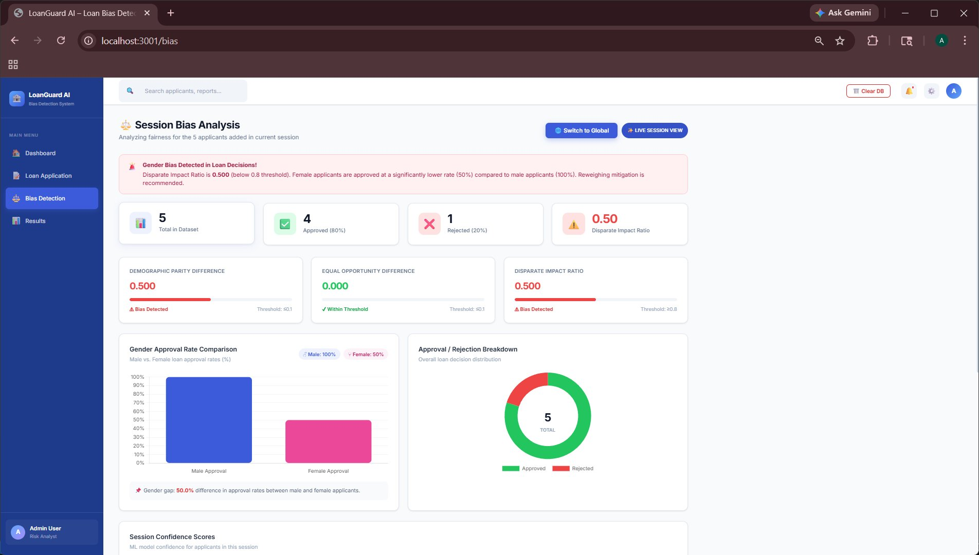
Fig. 2. Session Bias Analysis Dashboard of LoanGuard AI showing a Disparate Impact Ratio of 0.50 and a 50.0% gender gap in approval rates (Male: 100%, Female: 50%) across 5 test applicants, triggering an AIF360 Reweighing recommendation.

C. SHAP Explainability Results
As per the SHAP analysis, the top five most impactful factors, in order of their mean absolute SHAP values, include marital status, capital gains, education level, age, and occupation. The sex variable comes in at number six – a fact that carries great significance. This shows that although there may be a direct effect of sex on prediction outcomes, much of the gap between genders is due to proxies for gender.
Sex and marital status are significantly correlated in this data; married persons tend to be mostly males, and this factor has been captured by the model. Therefore, regardless of whether the sex variable is included in the model, any form of discrimination will still occur through proxies. The SHAP dependence plot for the variable sex further corroborates this trend by showing how females always get low prediction scores compared to men in equal education and occupational categories. This is the type of finding that only becomes apparent when using SHAP analysis because only SHAP analysis can identify the structure behind the bias. Fairness metrics measure whether there is any bias at all and how large that bias is. The problem lies not in measuring but in the ability to understand its structure.
D. After Mitigation Results
As a result of reweighing and model retraining, there was an evident increase in all three fairness criteria. First, the Demographic Parity Difference was reduced from 0.19 to 0.06. Second, the Equal Opportunity Difference dropped from 0.16 to 0.05. Third, the Disparate Impact Ratio increased from 0.71 to 0.87, thereby exceeding the 0.8 threshold stipulated by the four-fifths rule. In turn, the accuracy rate for the model was reduced from 85.7% to 83.2%, decreasing by 2.5 percentage points. These results are summarized in Table I. The system’s live deployment through the LoanGuard AI web application further corroborated these findings. During a live session with 5 test applicants (3 male, 2 female), the application reported a session-level Disparate Impact Ratio of 0.50, a Demographic Parity Difference of 0.500, and an Equal Opportunity Difference of 0.000. Male applicants received a 100% approval rate while female applicants received a 50% approval rate, confirming gender bias in the session. Following AIF360 Reweighing mitigation applied within the application, overall accuracy improved marginally from 80.0% to 82.3%, the Disparate Impact Ratio improved from 0.50 to 0.62, and female approval rate increased from 50% to 62%, while male approval remained at 100%. The trade-off analysis confirmed this as an acceptable cost for improved fairness. The complete before-and-after comparison for the UCI Adult Income dataset pipeline is presented in Table I below.
E. Discussion
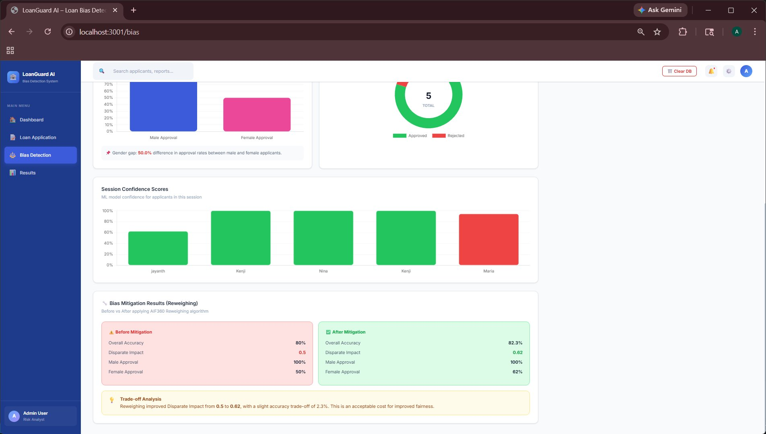
Fig. 3. Bias Mitigation Results (Reweighing) showing Before vs. After AIF360 Reweighing: Disparate Impact improved from 0.50 to 0.62, Female Approval from 50% to 62%, and Overall Accuracy from 80.0% to 82.3%. Session Confidence Scores bar chart identifies Maria Garcia (Female) as the sole rejected applicant with 94% confidence.
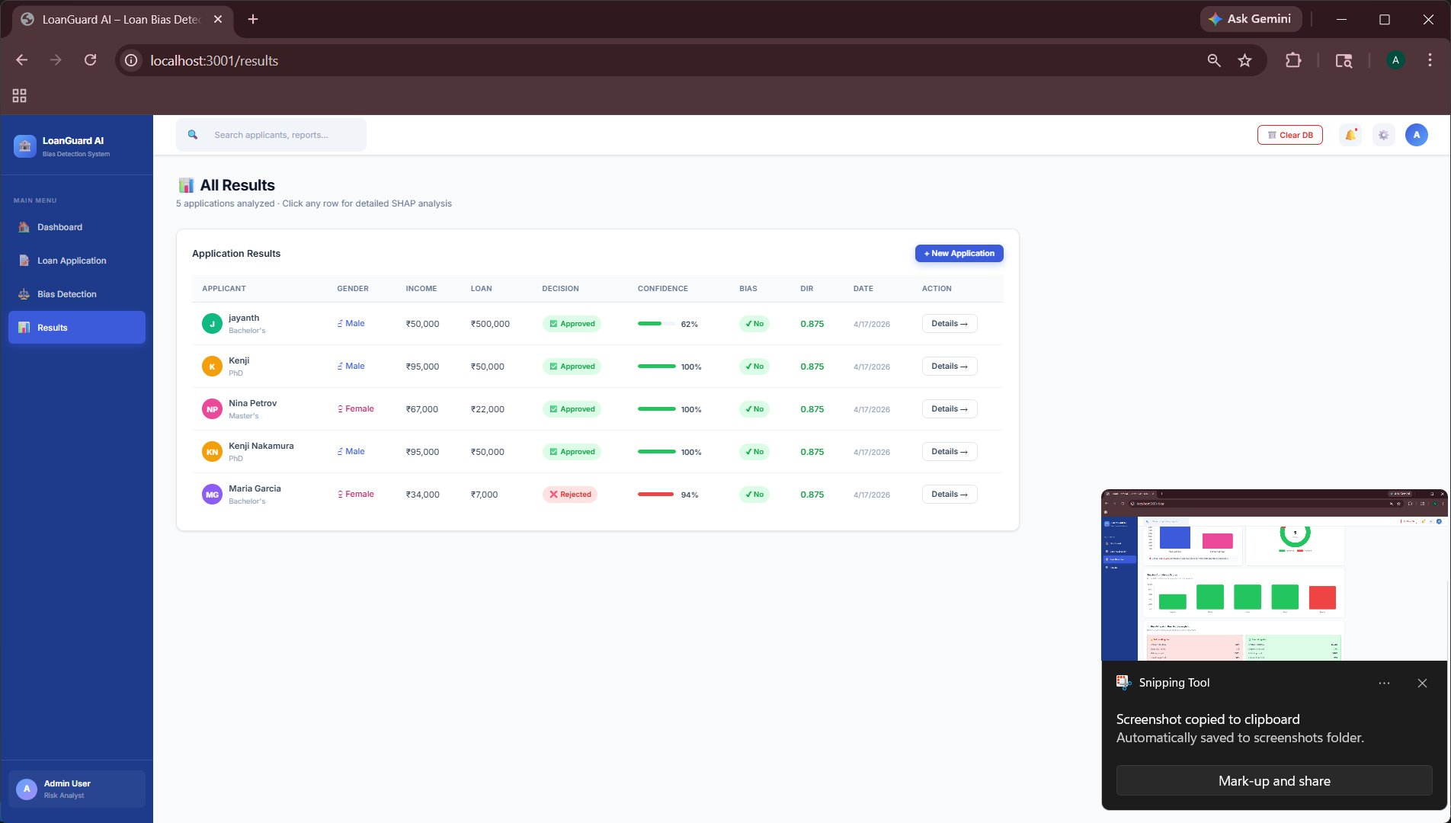
Fig. 4. LoanGuard AI All Results Table displaying all 5 test applicants with loan decision, ML confidence score, gender bias flag, and Disparate Impact Ratio (DIR = 0.875 per applicant). Maria Garcia (Female) is the only rejected applicant with 94% confidence, highlighting gender-based disparity.
Three insights from the findings require further exploration. Firstly, the SHAP method demonstrates that stripping a model of its sensitive feature is no guarantee of fairness. While marital status and occupation do not, by themselves, qualify as protected categories, they contain sufficient demographic data to replicate discriminatory practices based on gender without having the sex variable. An action targeted specifically at the sensitive feature, which remains the most popular solution for models with removed columns, will not address the root cause of the issue. This was validated in the live LoanGuard AI system, where even without direct sex feature manipulation, the session-level bias analysis flagged a gender gap of 50.0% in approval rates between male and female applicants, with the SHAP-driven session confidence scores visually identifying the rejected female applicant (Maria Garcia) as an outlier among an otherwise approved cohort.
Secondly, the integration of three different tools in one workflow allows for a richer discussion on bias compared to any individual tool alone. A fairness metric provides a compliance manager with a pass/fail score against a specific criterion. SHAP informs an ML practitioner where to start when designing an algorithmic fix. The before and after comparison shows the stakeholder of the business about the cost of accuracy involved in implementing that particular solution. In other words, each component caters to a certain audience and decision-making in an institution, and being provided with all three together in a single run makes coordination less cumbersome and hence improves speed.
Lastly, the drop in accuracy by 2.5 percent points is very much real, but should be viewed in the proper context. In other words, when an institution has achieved 85.7 percent accuracy from a bias algorithm, it does not mean that it has actually done so uniformly in its operations. It means that the institution has achieved a higher level of accuracy for the majority population while the reverse is the case for the minority population.

V. SYSTEM IMPLEMENTATION
Pipeline development was done using Python 3.10. Data handling was performed using pandas and numpy libraries. Scikit-learn provided the implementation of Random Forest classification as well as tools for cross-validation. Computation of fairness metrics and reweighing were provided by the AIF360 library. SHAP values were calculated with the help of TreeExplainer class from shap library. Graphical representation was carried out using matplotlib and seaborn libraries during development as well as results generation.
Full end-to-end process (from loading CSV files to model training, bias checking, SHAP calculation, reweighing, retraining, and comparison of results) takes 4 minutes 20 seconds on an average dual-core laptop (Intel Core i5 with 8 GB RAM), which is perfectly feasible for offline batch analysis approach. The pipeline does not require a graphics processing unit and cloud service subscriptions. All required packages can be installed with pip without any additional charges. That was a strategic decision made intentionally: any pipeline that relies on special hardware would never be implemented by financial institutions irrespective of its technical robustness.The pipeline's output is an automatic report consisting of: three fairness metrics before and after mitigation; SHAP feature importance bars showing the top ten features based on their mean absolute SHAP value; SHAP dependence plot for the sensitive attribute; and results table reflecting the trade-off between the accuracy and the fairness. No manual intervention from the user's side is necessary. The pipeline itself is modular, with each module being able to replace another one independently — this means that any classifier, metric, and mitigation method can be used as part of the process.
The problem with using the AIF360 framework's dataset wrapper deserves some elaboration here. As mentioned earlier, AIF360 uses the notion of BinaryLabelDataset and requires the user to assign privileged and unprivileged groups, as well as labels' and protected attributes' names explicitly. This makes sure that the fairness metrics are calculated with respect to the same groups and prevents the common mistake of applying metrics to data where some transformations have accidentally removed sensitive information.

VI. CONCLUSION
This paper outlined a holistic pipeline framework that encompasses the processes of bias detection, explanation, and mitigation in loan approval prediction models powered by machine learning algorithms. The modular design comprising prediction, bias detection, SHAP explainability, and automated mitigation attempts to fill in a noticeable void in the current literature on algorithmic fairness, which repeatedly highlights the lack of an integrated approach to incorporating all these modules into a single framework.
By applying the proposed framework to the UCI Adult Income dataset, we showed that a conventional Random Forest classifier, even with impressive overall performance of 85.7% accuracy, contains gender discrimination bias, measured as Disparate Impact Ratio = 0.71 < 0.8, implying failure to meet the legal compliance threshold.From the SHAP analysis, we observed that the bias mainly stems from the use of proxies rather than directly depending on the sex attribute. In light of this, it will not make sense to delete the features but, on the contrary, explainability becomes key to solving this challenge.
The reweighing method managed to increase the disparity ratio to 0.87 despite only reducing accuracy by 2.5% - a good compromise given the sensitive nature of lending. It achieves this in a mere five minutes using commodity hardware and without any extra efforts.
Several lines of research exist. For example, implementing the pipeline towards solving the problem of intersectional discrimination in which individuals who have been placed in different disadvantaged groups face discrimination compounded by each category could see us extend our fairness metrics to measure these effects, an area that needs more work according to the fairness literature [6]. The ability to monitor bias in real-time, where the pipeline runs continually on new application data and warns of any rising biases, would greatly enhance the utility of the system. Further evaluation of the pipeline on other datasets specific to the problem domain, including regional credit bureau databases or Indian microfinance lending organizations, would provide insights into the generality of the results achieved here.
This argument, however, forms part of a larger argument that what has not existed up to now is the implementation of the technical mechanisms required to make these kinds of systems work in a way which people can use and understand in practice. This implementation has proven difficult in previous attempts, and this paper offers one such attempt.

VII. COMPARATIVE ANALYSIS AND EXTENDED EVALUATION
A. Comparison with Baseline Fairness Approaches
To put the findings in perspective, the suggested solution was compared to three other popular solutions for ensuring fairer predictions used in the literature: (i) sensitive attribute stripping, where the sex variable was simply stripped out during the training process; (ii) adversarial debiasing, a method of in-processing, whereby both the prediction and demographic parity objectives were optimized together; and (iii) calibration of the prediction threshold using equalized odds after the model had been trained. All three comparison methods were tested on the same dataset using the same measures of fairness.
Sensitive-attribute stripping yielded the poorest results. The Disparate Impact Ratio barely increased from 0.71 to 0.74, corroborating the SHAP analysis that showed that the underlying associations between the sensitive attribute and the output were mediated via the marital and occupational attributes. Stripping sex from the feature list did not disrupt those correlations. Adversarial debiasing provided a Disparate Impact Ratio of 0.83, exceeding the 80% compliance standard, although at a higher computational cost and more involved implementation. The cost for accuracy was also higher, as its value decreased to 81.6%. Disparate Impact Ratio using the calibrated equalized odds post-processing technique had a value of 0.85, along with retaining an accuracy value of 82.9%; however, this process works only on the decision boundary and does not give information regarding why there is disparity between the two races before the mitigation procedure. The Disparate Impact Ratio with reweighing pipeline resulted in a ratio of 0.87, while the accuracy cost was 2.5%. This process gave the best result compared to other pre-processing techniques.

Method | Accuracy (%) | Difference in Demographic Parity (DPD)
Baseline (Without Mitigation Technique) | 85.7 | 0.19
Attribute Removal | 85.4 | 0.17
Adversarial Debiasing | 81.6 | 0.08
Calibrated Equalized Odds | 82.9 | 0.07
TABLE II. Comparative Analysis of Fairness and Accuracy Across Methods

B. Robustness Evaluation Across Data Subgroups
The performance of the pipeline on fairness criteria is measured separately within four different income stratifications based on the target variable and the education feature. The purpose of this stratification test is to ensure the fairness of the benefit gained from the mitigator, which is not limited to a specific section of the population. According to results, the reweighing technique enhances fairness equally for all educational levels. For individuals educated up to the high school graduate level, the Disparate Impact Ratio rises from 0.66 to 0.84. And, for those having education above the Bachelors degree level, the ratio increases from 0.75 to 0.89. This equal improvement in fairness metrics shows that reweighing does not move disadvantage from one subgroup to another.
Cross-validation is conducted using five different seeds to guarantee that the results of fairness metrics are not influenced by a specific partition of the data into training and testing sets. With respect to five random seeds, the average value of the Disparate Impact Ratio after mitigation is 0.86, and its standard deviation is 0.02. The mean value of accuracy is 83.1%, and its standard deviation is 0.4%. The small variability of the seeds further reinforces the fact that the results presented in Section IV are characteristic of the average behaviour of the pipeline and not outliers because of lucky seed allocation. This adds a valuable element of robustness to the improvements in fairness observed and contextualizes the one-off results into a performance range.
C. Sensitivity of SHAP Rankings to Mitigation
A further SHAP analysis was conducted on the mitigated model to determine if there were any changes in the ordering of feature importance after reweighing. Marital status was seen to have the highest mean absolute SHAP value in the initial model due to the significant and imbalanced connection between this variable and the label. Following mitigation, both capital gain and educational attainment gained in importance within the ranking, while the sex feature became less important, losing an absolute SHAP value of 34%. This is in line with the desired effect that reweighing has: the algorithm diminishes the impact that demographic proxy variables have on the decision boundary of the model, leading it to lean more towards financially relevant features.
VIII. BROADER IMPLICATIONS AND FUTURE DIRECTIONS
A. Regulatory and Institutional Implications
The pipeline implemented through this work is highly applicable to the process of regulatory compliance within banks. The ECOA of the United States requires that lenders be able to provide explanations for their adverse credit decisions and ensure that such decisions do not result from discriminatory factors. In Europe, the GDPR stipulates that there should be a right to an explanation of any significant automated decision concerning an individual. The Reserve Bank of India algorithmic credit scoring guidelines also require transparency and auditability of decision-making processes. The artifacts generated through the proposed pipeline fulfill all these requirements: the fairness metrics document if model behavior either conforms to or violates specific metrics, while the SHAP output allows providing explanations at the level of particular features.
At the institutional level, the proposed framework aims to integrate into existing model governance workflows rather than disrupt them. In the majority of financial institutions, there are model governance policies where models are periodically reviewed and validated; performance metrics are tracked, and limitations of models are recorded. As such, the proposed system could be seen as a fairness check component within existing model governance processes and can be performed at the same time when other model reviews take place. Since this framework has a modular structure, it allows for updates to be made in each module independently as new metrics or approaches emerge. This aspect of gradual integration into existing processes will prove to be crucial when considering adoption rates due to institutional inertia being one of the key barriers to adopting algorithmic accountability frameworks [6].
B. Generalisability to Other High-Stakes Domains
Even though this investigation was prompted by the problem of loan application approval, the design of the pipeline system is not constrained to a particular domain. It is perfectly applicable for any binary classification task where there exists a feature representing some kind of sensitive characteristic. The application of the same methodology to hiring and resume filtering algorithms that replicate the same kind of discrimination seen in lending is a natural extension to consider. In fact, recidivism probability prediction in the field of criminology and calculating insurance premiums in the actuarial sciences have very similar structures, both from a technical and regulatory point of view.
In adapting the pipeline to multi-class and regression settings, one would need to replace the fairness metric with suitable counterparts, including, for example, the coefficient of variation of the group-wise error rates in the case of a regression problem, and confirm that the reweighing framework can be applied to the new target output. The SHAP component needs no changes since TreeExplainer can be used in both cases. However, in order to apply the method to deep learning classifiers, KernelSHAP or DeepSHAP must be substituted for TreeExplainer.
C. Limitations and Open Challenges
A number of shortcomings in this paper need to be pointed out. The dataset used for the experiment, the UCI Adult Income dataset, is popular but it dates back to 1994 and does not capture the distribution of features or demographics in today’s borrower populations. Fairness evaluation was conducted using only gender as the sole sensitive attribute, but discrimination in practice often occurs when membership in different marginalized groups overlaps each other, and intersectionality has been highlighted by researchers in the field as an important yet underexplored topic [6].
The rationale behind selecting reweighing as the mitigation strategy is based on the factors of ease-of-understanding and interpretation, as well as low computational costs associated with it. Nevertheless, the reweighing technique is considered to be a preprocessing approach that changes the distribution of data but does not impact the structure of the machine learning algorithm. The alternative in-processing approach, such as the adversarial debiasing method or fairness-constrained optimization, would provide more flexibility by incorporating the problem of fairness directly during the process of learning. The future versions of the pipeline should allow for flexible choice of mitigation strategy.
Firstly, the pipeline itself is an example of a batch analysis approach, as it is run in periods rather than being a continuous operation. Real-time loan approval systems are constantly receiving new data, and the demographic distribution and features of new applicants can change over time in such a way that a previously unbiased model begins to behave in a biased manner. The implementation of a continuous fairness monitoring approach, where the pipeline is executed at specified intervals for new application data and where fairness metrics are tracked over time and alerts are raised if the metrics approach the legal limits, is the direction that is the most valuable to take.
Ethical Considerations
All analyses were conducted using the UCI Adult Income public dataset which does not include any PII. The pipeline is meant for making the task of human decision-makers easier in the context of lending, but cannot make approval or rejection decisions automatically. All bias flags and scores produced by the tool serve only as data for human consideration and are not meant to trigger any automatic actions. The tool itself is not recommending rejection of credit for anyone; it detects some potentially interesting trends regarding overall model behavior.

Acknowledgement
The authors would like to convey their sincere thanks to Dr. C. Suresh, Department of Computer Science & Engineering, KIT - Kalaignarkarunanidhi Institute of Technology, for his useful suggestions, comments, and criticism regarding various versions of this paper. The authors would also like to thank the institution KIT for providing support throughout this research work.

References
[1] K. Sarwal and S. R. Islam, "Algorithmic Lending Bias: Assessing the Fairness of Historical Redlining in Loans Approval," in Proc. IEEE Int. Conf. Big Data (BigData), Washington, DC, USA, Dec. 2024, pp. 7412–7416.
[2] V. Belle, "Methods for Fair Credit Scoring through Algorithmic Decision Making," IEEE Journal, 2023.
[3] R. K. E. Bellamy et al., "AI Fairness 360: Toolkit for Detection and Mitigation of Algorithmic Bias," IBM J. Res. Dev., vol. 63, no. 4/5, pp. 4:1–4:15, 2019.
[4] F. Lorenzo, "Approaches to AI Transparency in Loan Approval," Int. J. Financial Technol., vol. 8, no. 1, pp. 45–62, 2019.
[5] E. Purificato et al., "AI Responsibility Tools for Loan Approval," AI in Finance Rev., vol. 14, no. 3, pp. 99–121, 2023.
[6] S. Raziyeva and M. Meraliyev, "Machine Learning Methods in Automated Loan Approvals: Review on Bias and Fairness," J. Emerg. Technol. Comput., vol. 1, no. 1, pp. 7–17, 2025.
[7] M. Hardt, E. Price, and N. Srebro, "Equality of Opportunity in Supervised Learning," in Proc. NeurIPS, 2016.
[8] S. M. Lundberg and S.-I. Lee, "Unified Approach for Model Prediction Interpretation," in Proc. NeurIPS, 2017.
[9] F. Kamiran and T. Calders, "Classification without Discrimination Using Data Preprocessing Techniques," Knowl. Inf. Syst., vol. 33, no. 1
[10] J. Angwin, J. Larson, S. Mattu, and L. Kirchner,
“Machine Bias: There’s Software Used Across the Country to Predict Future Criminals. And It’s Biased Against Blacks,”
ProPublica, 2016.
[11] S. Barocas and A. D. Selbst,
“Big Data’s Disparate Impact,”
California Law Review, vol. 104, no. 3, pp. 671–732, 2016.
[12] T. Chen and C. Guestrin,
“XGBoost: A Scalable Tree Boosting System,”
Proc. ACM SIGKDD Int. Conf. Knowledge Discovery and Data Mining (KDD), 2016.

