Tutorial 2:

* Run zookeeper  
  .\bin\windows\zookeeper-server-start.bat .\config\zookeeper.properties

* Run kafka server:

.\bin\windows\kafka-server-start.bat .\config\server.properties

* Create topic:

kafka-topics.bat --create --bootstrap-server localhost:9092 --topic test

* Create producer:

kafka-console-producer.bat --broker-list localhost:9092 --topic test

* Create consumer to read from test of producer

kafka-console-consumer.bat --topic test --bootstrap-server localhost:9092 -from-beginning

* Result:

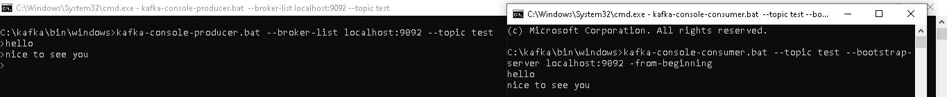

Tutorial 6:

* Step1: Start Kafka cluster using Terminal

.\bin\windows\kafka-server-start.bat .\config\server.properties

* A screen shot of a computer

  Description automatically generated
* Step 2: Run KafkaProducer in Jupyter Notebook

* Open another Jupyter Notebook



* Create dataframe from Kafka data

If facing this issue



downgrade the version of pandas to pip install pandas==1.5.3

Creating a Kafka Source for Streaming Queries

Phần 2 của ví dụ 6 chưa được

Tutorial 8

https://towardsdatascience.com/make-a-mock-real-time-stream-of-data-with-python-and-kafka-7e5e23123582

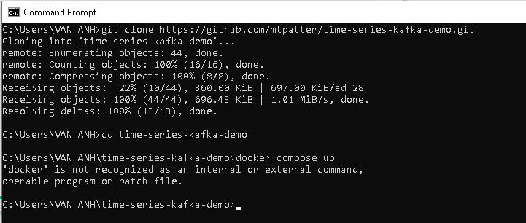

Cài docker

Cai ubuntu

Bimat182

Cai xong docker

Dùng machine learning, deep learning để xử lý dl lớn

Xử lý streaming

Giống Vd15

Có tập dl file csv

Stream dữ liệu lên kafka server

Lấy dl từ kafka sever về -> cho vào data frame streaming trong spark-> mô hình machine learning để xl dl -> hiển thị kq real time -> hiển thị kq lên web app (Nodejs,…) thay vì terminal