

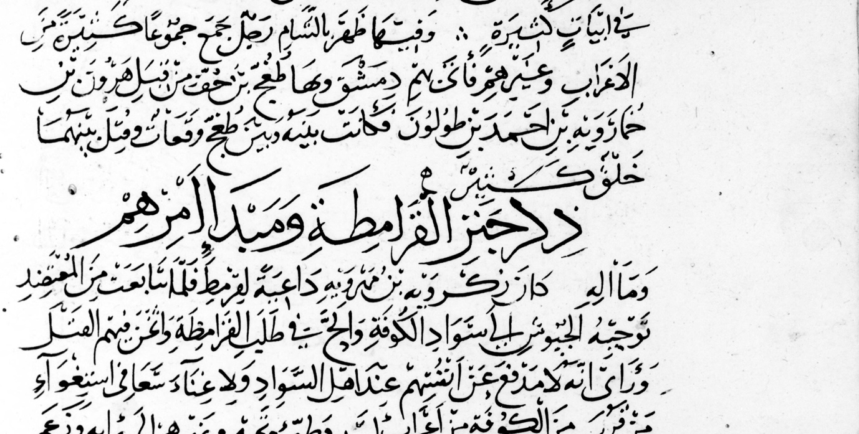
The Centre for Digital Humanities (CDH) at the Aga Khan University’s Institute for the Study of Muslim Civilisations (AKU-ISMC) will organise a research workshop on Miskawayh (d. 1030) at the Aga Khan Centre, London, on Saturday, 10 October 2026.

Miskawayh made wide-ranging contributions to the intellectual life of his time. Although his work has been the subject of numerous studies, these have largely focused on a single dimension of his scholarship—typically treating him either as a philosopher or as a historian—while overlooking the breadth of his other intellectual interests.
This workshop aims to bring together these diverse strands of his thought for collective discussion and the development of possible publications. Proposed themes may include, but are not limited to, the following (additional suggestions are warmly welcome):
- The writer as actor, to investigate his administrative career as a Buyid chancery official and the values it taught him.
- Miskawayh and Abu Hayyan al-Tawhidi: the philosophical sparring.
- The Tajarib and the Akhlaq what is the connection between these two works.
- The sources and composition of the Tajarib.
- The Tajarib as the earliest major witness to Tabari’s Ta’rikh.
- Miskawayh and Ibn al-Athir: comparing how these two great scholars used Tabari’s Ta’rikh.

Please, submit your paper proposal by clicking here.

