The Aga Khan University’s Institute for the Study of Muslim Civilisations (AKU-ISMC), in collaboration with Queen Mary University of London, hosted a two-day workshop titled “Arabic Pasts: Histories and Historiography and Digital Method Workshop” on 9–10 October 2025.
Across seven dynamic panels, 23 scholars from around the world presented their research, sharing fresh perspectives on Arabic historiography.
Arabic Pasts is an annual, informal, and exploratory workshop that provides a space to engage with new methodologies, case studies, and research directions in the study of history writing in Arabic—from the seventh century to the present, and across the Middle East, North Africa, and beyond.
We are grateful to all participants for their contributions and intellectual energy. We look forward to welcoming you again in October 2026!
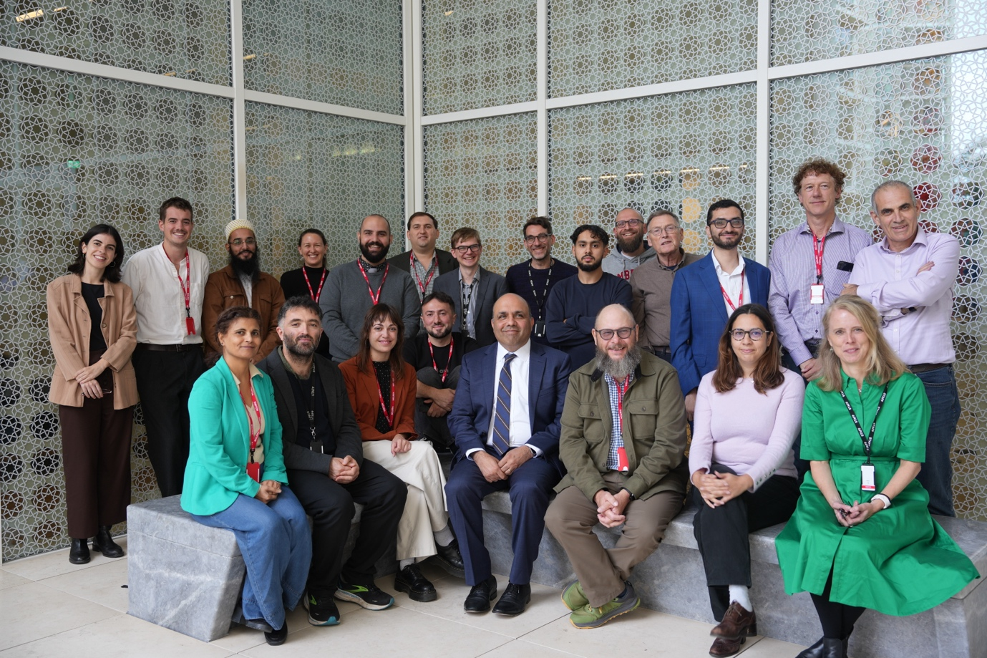
A group photograph with presenters and the organisers.

