This is a document to test the blog upload process. BOLD UNDERLINED ITALS

Big heading
Text under the big heading
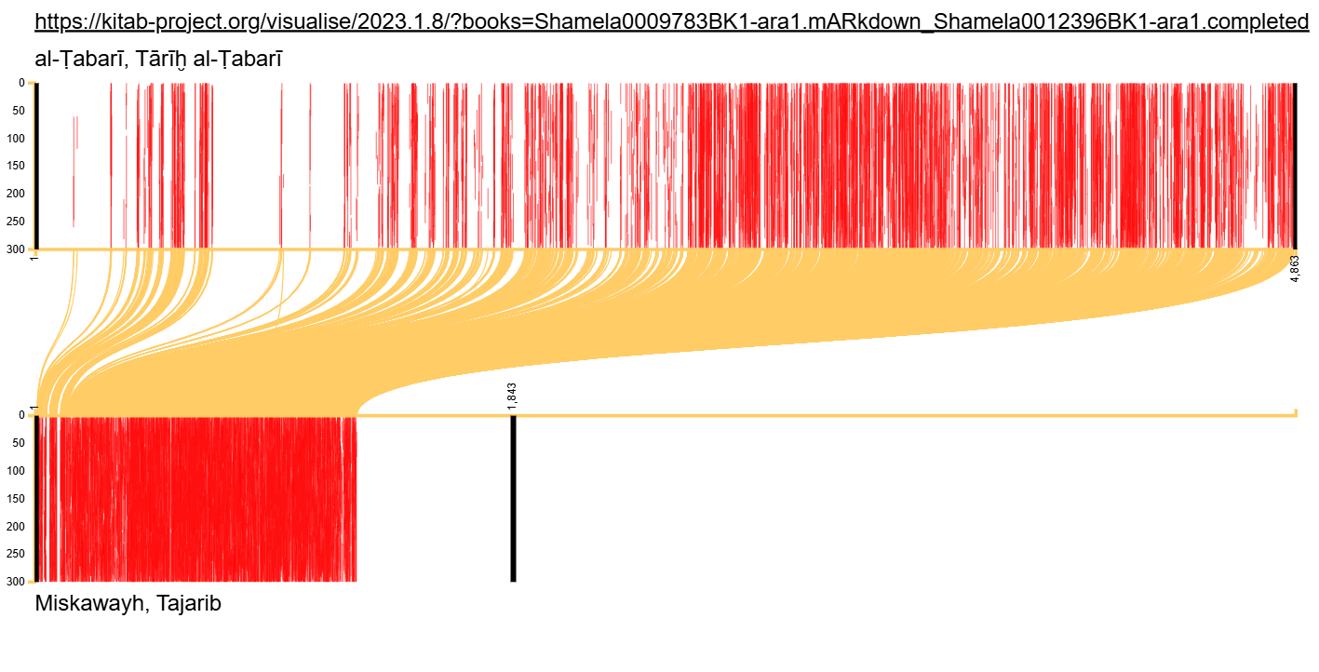
Image is above this

Smaller header
Text with a footnote.
الكتابة العربية وهي ممكن سبب للمشاكل

A footnote for that text

