In manuscripts dedicated to dreams and divination, one occasionally finds a short narrative involving Muḥammad Khawārazmshāh. It claims that he summoned specialists in dream interpretation and demanded from them to write a minimal ‘work’ on the subject that would fit on a single page and that he would be able to carry around with him at all times.

According to the narrative, the specialists tasked with creating the mini-work solved the problem by producing what is referred to as a *muqaddima* which was organised alphabetically with each letter pointing to some specific interpretation such as ‘fame’, ‘victory’, ‘happiness’, and so forth. The idea was that, whenever someone had dreamt something, they had to take the first letter of the object they had seen in their dreams and then navigate to the relevant letter in the mini-work. For example, if they had dreamt that they were riding a***f****aras* ‘horse’, they would have to navigate to the letter ***fāʾ*** where they would then learn what the dream meant (which pushes to an almost comical extreme the idea of other alphabetically ordered dream books).

I have come across two manuscripts which contain said narrative, one held by the Staatsbibliothek zu Berlin and the other by Princeton University Library. When put next to each other, these two witnesses are interesting for two reasons. On the one hand, they are illustrative with regard to the extent to which terms for ‘writing’ sometimes *were* used interchangeably (see the shift between *ṣannafa, allafa* and *waḍaʿa* highlighted in red below). On the other hand, they are a good example of a transformation which is of interest in the context of text reuse and its detection: Linear succession of content is transformed into a table and made more navigable, or tabular content is brought into linear succession, some reshuffling and changes included.

Such formal transformations are a reminder that texts can be reused in strikingly different ways which may include layout changes that, not least, represent an interesting challenge for automated text reuse detection.

SBB, Wetzstein II 1577, 229v:

نقل عن محمد خوارزم شاه أنه جمع من كان تحت

قبضته من أهل مملكته من العلماء بتعبير الرؤيا وأمرهم

أن يصنفوا مختصرا في تعبير الرؤيا في غاية الاختصار بحيث يكون

ورقة واحدة لا بفارقه سفرا ولا حضرا فاجتمعوا كلهم وصنفوا هذه

المقدمة التي لا يوجد مثلها وهي على حروف المعجم فإذا رأى النائم مناما يأخذ

أول حرف رؤياه مثاله رأى كأنه راكب فرسا يأخذ حرف الفاء وهذا **الألف** تدل

على قضاء الحاجة **الباء** تدل على رفعة وجاه والله أعلم **التاء** تدل على النصر

والتأييد و**الثاء** تدل على قضاء الحاجة والله أعلم **الجيم** تدل على تعب

من جهة ملك **الحاء**تدل على الرياسة والجاه [...]

:Princeton, Garrett no. 550Hq, 42v

القول على تعبير الرؤيا المصحح وما دل عليه ذلك نقل عن الثقات الأخيار أن الملك محمد بن خوارزم

شاه جمع من كان تحت يده من العلماء بتعبير الرؤيا وأن يضعوا له مختصرا في تعبير الرؤيا إلى غاية الاختصار

حيث يكون في ورقة واحدة لا تفارقه في حضره ولا في سفره فأجمعوا كلهم وألفوا هذه المقدمة التي لم يسمع بمثلها

وهي على حروف المعجم حتى إذا رأى النائم في منامه فيأخذ أول حرف من الذي رأى مثاله إن يرى النائم كأنه في ماء

فيأخذ حرف الميم أو يرى كأنه راكب فرس فيأخذ حرف الفاء وبالله التوفيق

أ يدل قضا الحاجة

ب تدل على رفعة جاهه

[...]

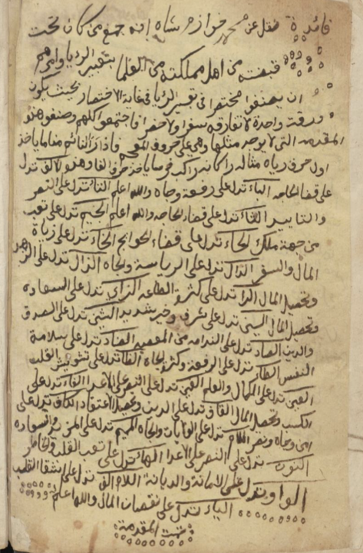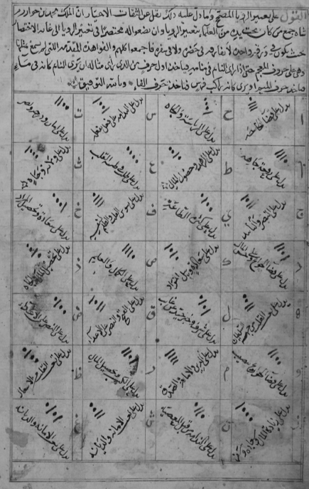

SBB, Wetzstein II 1577, 229v Princeton, Garrett no. 550Hq, 42v