vLLM Inference Benchmark Report
H200 GPU · vLLM 0.28.0 · Qwen/Qwen3.8-27B · 2026-09-04

1. Overview
This report summarizes inference benchmarks run against a self-hosted vLLM server on a single NVIDIA H200 GPU (143,771 MiB / ~140 GiB VRAM). The server ran vLLM 0.28.0, serving Qwen/Qwen3.8-27B — a Qwen3.5-architecture hybrid Mamba/attention multimodal reasoning model (~27B parameters, bf16) — through an OpenAI-compatible API. Two test dimensions were measured: single-request (sequential) generation across 10 open-ended system design prompts, and aggregate throughput under increasing concurrent load (1 to 96 simultaneous requests).

2. First-time provisioning timeline
Before any benchmark could run, the server had to be provisioned from a bare Ubuntu 24.04 box to a live vLLM endpoint. This section summarizes that one-time setup, from initial SSH access through system dependencies, the vLLM install, the model download, and GPU load, to the first successful inference response.
Step | Duration
System package install (python3-venv, pip, git, curl) | ~1 min
pip install vllm (torch + CUDA deps + vLLM wheel) | ~6 min
Model download (18 shards, ~54 GB from Hugging Face) | ~6 min
Model load onto GPU + multimodal warmup + CUDA graph capture | ~1 min
Total: bare box → live, serving endpoint | ~15 min

The two dominant costs — installing vLLM and downloading the model — are both one-time or cacheable on a given host. Swapping to a different model on the same box skips the pip install entirely, and only the model download time would repeat, scaling with that model's size rather than the ~54 GB used here.

3. Sequential (single-request) benchmark
10 system design prompts were sent one at a time with max_tokens=12,000. Throughput per request was remarkably constant across every prompt regardless of topic or output length.
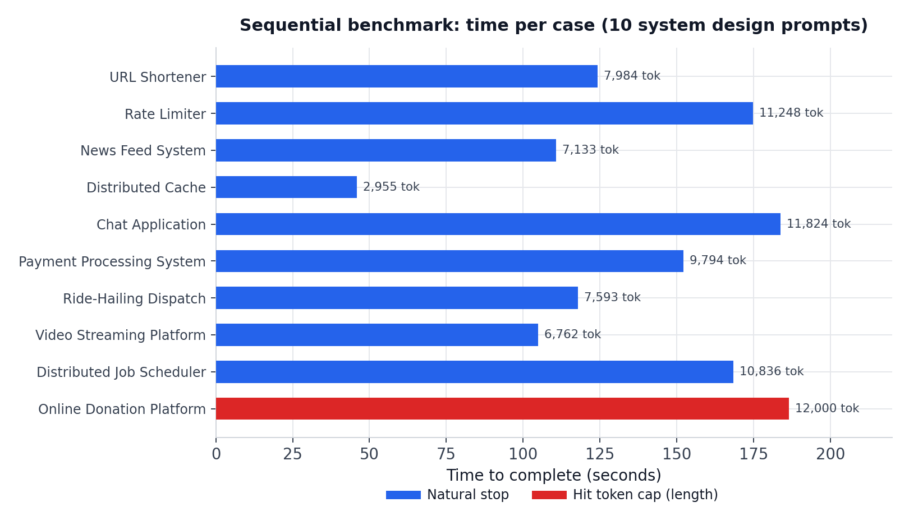
Metric | Value
Cases run | 10
Reached natural stop | 9 / 10
Hit token cap (length) | 1 / 10
Total wall time | 1369.6 s (22.8 min)
Total completion tokens | 88,129
Avg tokens per case | 8,813
Avg throughput per request | 64.4 tok/s
Time per case (min / avg / max) | 45.8s / 136.9s / 186.6s
VRAM used (constant) | 128.9 GiB

Per-case detail
# | Case | Time (s) | Tokens | Tok/s | Finish
1 | URL Shortener | 124.2 | 7,984 | 64.3 | stop
2 | Rate Limiter | 174.8 | 11,248 | 64.3 | stop
3 | News Feed System | 110.7 | 7,133 | 64.5 | stop
4 | Distributed Cache | 45.8 | 2,955 | 64.5 | stop
5 | Chat Application | 183.8 | 11,824 | 64.3 | stop
6 | Payment Processing System | 152.2 | 9,794 | 64.4 | stop
7 | Ride-Hailing Dispatch | 117.9 | 7,593 | 64.4 | stop
8 | Video Streaming Platform | 104.9 | 6,762 | 64.5 | stop
9 | Distributed Job Scheduler | 168.4 | 10,836 | 64.4 | stop
10 | Online Donation Platform | 186.6 | 12,000 | 64.3 | length

4. Concurrency benchmark
To test vLLM's continuous batching, requests were fired simultaneously at increasing concurrency levels (1, 2, 4, 8, 16, 32, 64, 96), each request capped at max_tokens=1,500. GPU state was sampled once per second via nvidia-smi throughout each batch. All 232 requests across every level succeeded with zero failures or timeouts.
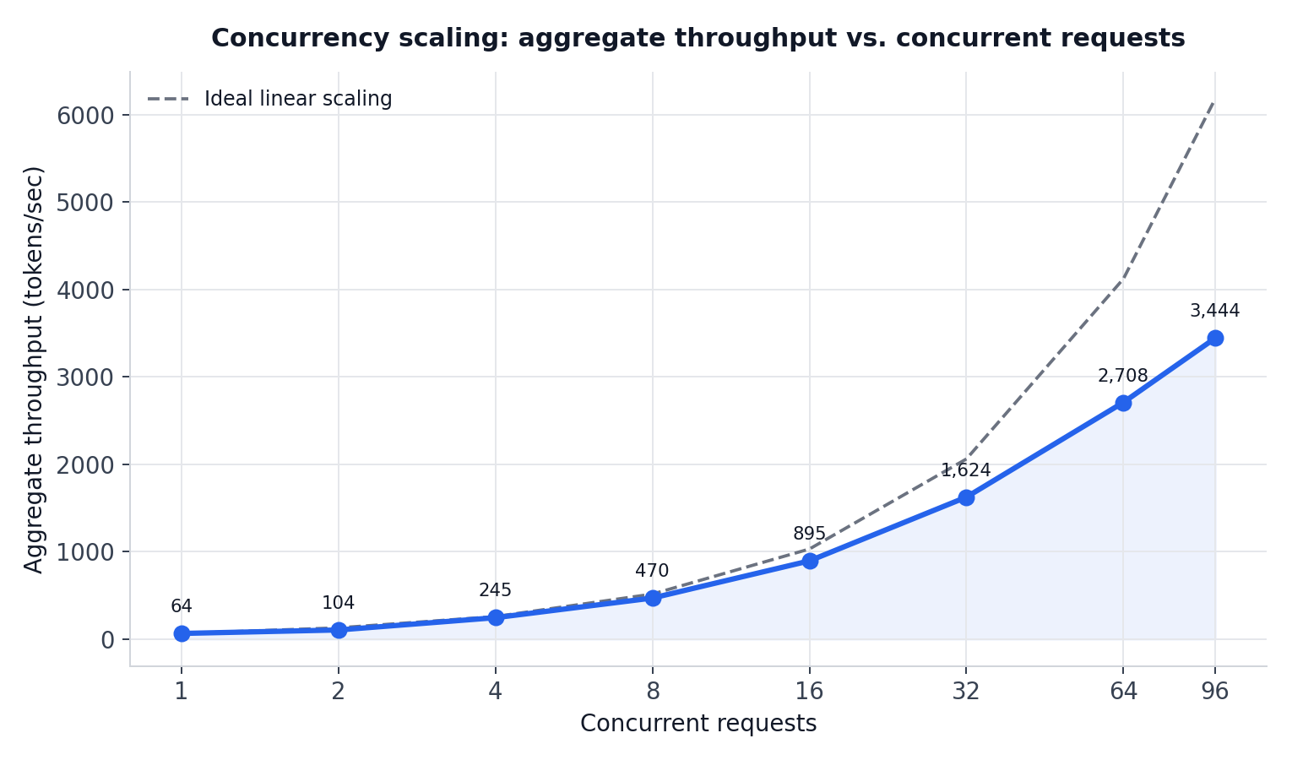
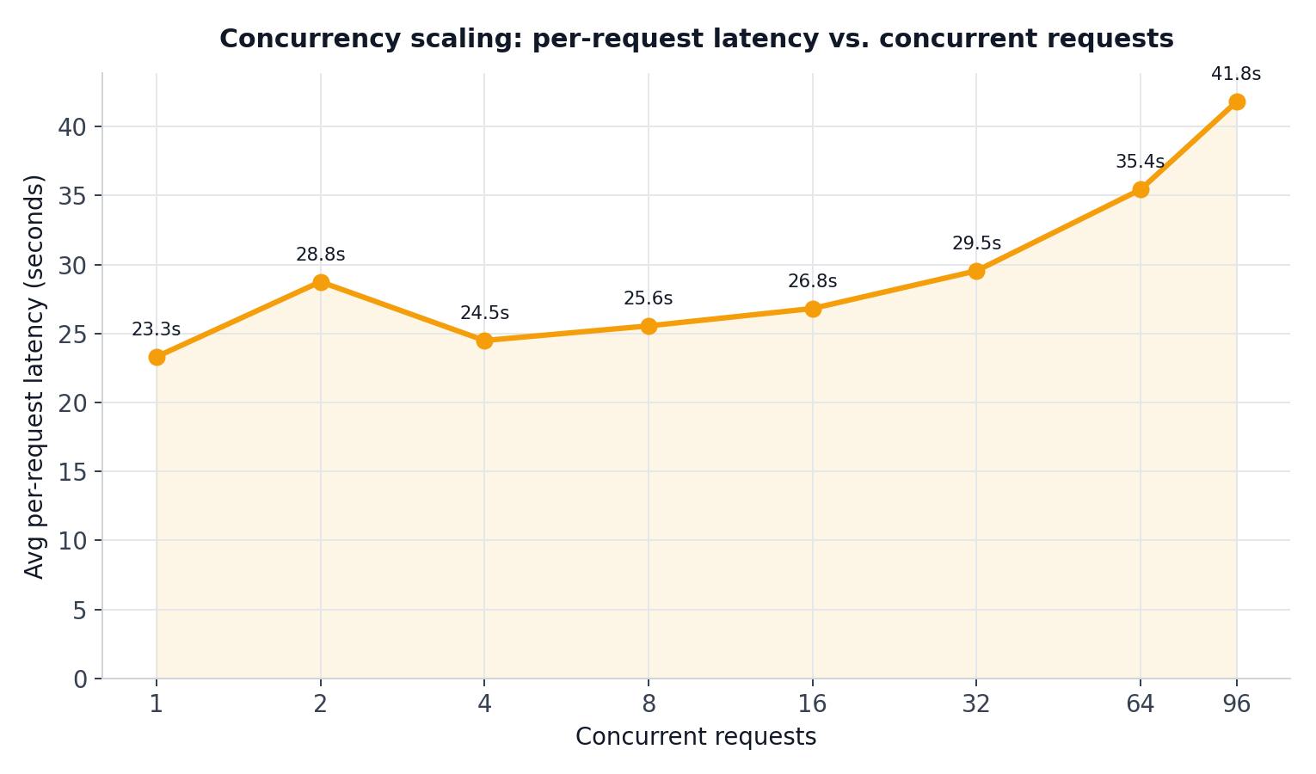

Key finding: going from 1 to 96 concurrent requests produced a 53.5x increase in aggregate throughput (64.4 → 3443.6 tok/s), while average per-request latency rose only 1.8x (23.3s → 41.8s). Scaling is close to linear through 16 concurrent requests, then becomes noticeably sub-linear from 32 onward (the measured curve falls increasingly below the ideal-linear reference line in the chart above) — throughput is still climbing at 96 with no hard plateau or failure observed, but each additional concurrent request is yielding diminishing throughput gains beyond 16.

Concurrency | Batch time (s) | Aggregate tok/s | Avg latency (s) | GPU util (avg) | VRAM peak (GiB)
1 | 23.3 | 64.4 | 23.3 | 95% | 128.9
2 | 28.8 | 104.3 | 28.8 | 81% | 128.9
4 | 24.5 | 244.9 | 24.5 | 100% | 128.9
8 | 25.6 | 469.5 | 25.6 | 97% | 128.9
16 | 26.8 | 894.8 | 26.8 | 100% | 128.9
32 | 29.6 | 1,624.3 | 29.5 | 96% | 128.9
64 | 35.5 | 2,708.1 | 35.4 | 97% | 128.9
96 | 41.8 | 3,443.6 | 41.8 | 97% | 128.9

5. GPU and VRAM behavior
VRAM usage was essentially flat across every test — from a single request up through 96 concurrent requests — because vLLM pre-allocates its KV cache block pool once at server startup rather than growing memory per request. GPU compute utilization was already pinned at 95-100% even at concurrency=1, showing the model is compute-bound at the token level; continuous batching lets vLLM interleave many requests' decode steps into that same saturated compute budget instead of processing them one at a time.
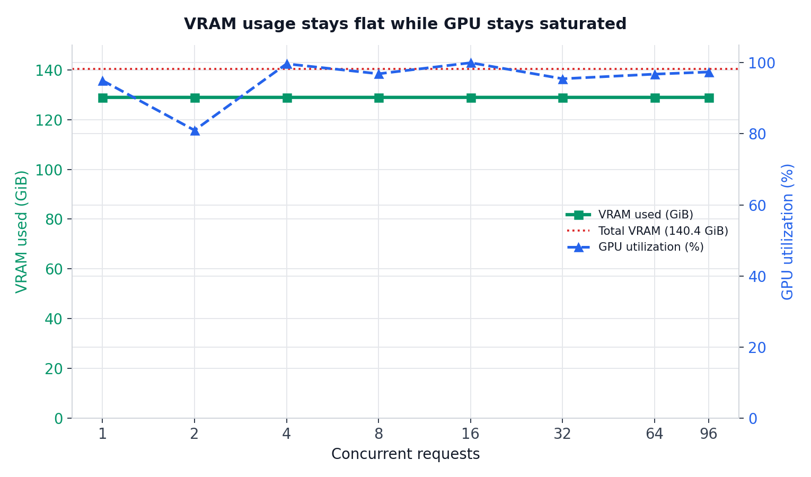
Idle/loaded VRAM footprint (model weights + pre-allocated KV cache pool): 128.9 GiB out of 140.4 GiB total — leaving ~11.5 GiB of headroom that remained unused even at 96 concurrent requests in this test.

6. Conclusions and recommendations
- This deployment is significantly under-utilized for single-user/interactive use — a lone requester sees the same ~64 tok/s whether alone or one of 96 simultaneous requesters.
- Throughput scaling is close to linear up to 16 concurrent requests, then becomes increasingly sub-linear from 32 onward, though it was still climbing at 96 with no failures or latency cliff; the true ceiling for this model + GPU combination would require pushing further (128, 192, 256+) to locate.
- VRAM headroom (~11.7 GiB observed unused), not raw request count, is the more likely eventual limiting factor — KV cache size grows with both concurrency and sequence length, so workloads with long contexts (as seen in the sequential test, up to 12,000 tokens) run concurrently will consume that headroom faster than the short 1,500-token-capped concurrency test did.
- For production capacity planning: size expected concurrent long-context sessions against the available VRAM headroom, not just peak request count.
- This single H200 instance can likely absorb substantially more concurrent load than initial assumptions would suggest, for workloads similar in shape to these system-design prompts.

Raw data: benchmark_results_full_stop.json, benchmark_concurrency_results.json, benchmark_concurrency_results_high.json. Scripts: benchmark_vllm.py, benchmark_vllm_concurrency.py.

