Integer Programming and Network Models

Submission instructions
Solve all problems below using CVXPY and submit one Jupyter notebook (.ipynb). Organize the notebook into sections labeled with the example numbers.
For each problem, include: (1) a Markdown cell defining the decision variables, objective, constraints, and variable domains; (2) executable CVXPY code; and (3) the solver status, optimal decisions, objective value with units, and a brief interpretation. Check that the reported solution satisfies the constraints.

Example 7-1
Hankook Supermarket has secured KRW 15.5 billion to expand by opening stores and storage facilities. Each new store costs KRW 1 billion and earns KRW 30 million per month. Each storage facility costs KRW 3 billion and earns KRW 72 million per month. Management plans to open at least one storage facility and no more than five stores.
Formulate and solve an integer programming model in CVXPY. Report the optimal numbers of stores and storage facilities and the maximum monthly profit.

Example 7-2
H Group is considering three projects over the next three years. The table gives each project’s annual funding needs and present value of profit.
Table. Investment plan (KRW 100 million)
Project | Profit PV | Year 1 | Year 2 | Year 3
Factory expansion | 450 | 100 | 100 | 100
New warehouse | 200 | 150 | 50 | 50
Advanced machinery | 350 | 50 | 200 | 100
Available funds | — | 250 | 400 | 200
Each project is either selected in full or not selected. Formulate and solve a binary integer programming model in CVXPY. Report the selected projects, the maximum present value of profit, and the funds used in each year.

Example 7-3
K Manufacturing must produce 20,000 units using three machines. Each machine incurs a fixed cost when activated. The table lists each machine’s fixed cost, variable cost, and production capacity.
Machine | Fixed cost  (KRW 10,000) | Variable cost  (KRW 10,000/unit) | Capacity  (units)
1 | 300 | 2 | 8,000
2 | 100 | 10 | 13,000
3 | 200 | 5 | 14,000
Formulate and solve an integer programming model in CVXPY. Produce exactly 20,000 units. Report which machines are activated, each machine’s production quantity, and the minimum total cost.

Example 6-2
A commuter travels from home (S) to work (T). The number on each directed arc is the travel time in minutes. Possible routes include S → 1 → 4 → T and S → 3 → 5 → T.
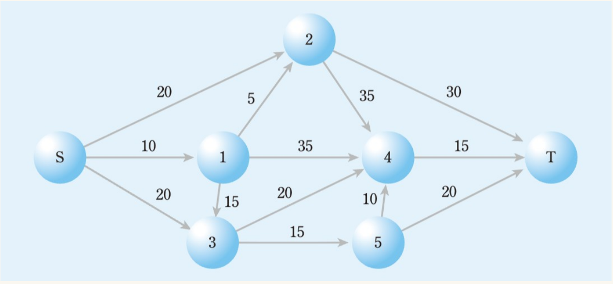
Formulate and solve an integer programming model in CVXPY to find the shortest route. Report the selected arcs, the route from S to T, and the minimum travel time.

Example 6-3
A dam (H) supplies water to cities 1–5 through a pipeline network. An earthquake has destroyed the water-storage facility in city 5. Determine the maximum amount of water that can be sent from the dam to city 5.
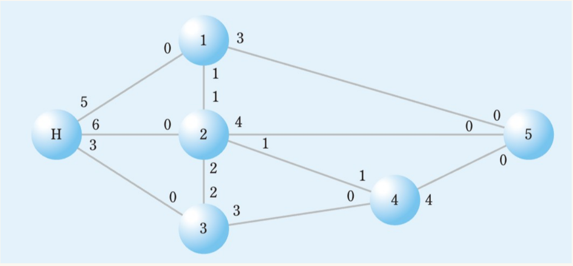
The numbers indicate directional capacities per unit of time; a capacity of 0 means that flow is not allowed in that direction. Formulate and solve a maximum-flow model in CVXPY. Report the maximum flow to city 5 and the flow on each allowed arc.

Example 6-4 Transportation
Samsung Cider operates plants in Masan, Daejeon, and Gunsan and warehouses in Busan, Daegu, Gwangju, and Seoul. Find the shipping plan that meets demand at minimum transportation cost.
Plant | Busan | Daegu | Gwangju | Seoul | Supply
Masan | 8 | 9 | 11 | 16 | 50
Daejeon | 12 | 7 | 5 | 8 | 80
Gunsan | 14 | 10 | 6 | 7 | 120
Demand | 90 | 70 | 40 | 50 | 250
Unit shipping costs are in KRW millions. Supply and demand are in units.
Formulate and solve a linear programming model in CVXPY. The quantity delivered to each destination must exactly equal its demand. Report the optimal shipping quantities in a table and the minimum transportation cost. Check the supply and demand constraints.

Example 6-5 Transshipment
R Electronics ships from plants in Denver and Atlanta through hubs in Kansas City and Louisville to four destinations. Find the least-cost shipping plan. All shipments pass through a hub.

Plant to hub shipping costs (unit: $ per unit) and Supply constraints (unit: unit)
Plant | Kansas City | Louisville | Supply
Denver | 200 | 300 | 6,000
Atlanta | 300 | 100 | 4,000

Hub to destination shipping costs (unit: $ per unit) and demand constraints (unit: unit)
Hub | Detroit | Miami | Dallas | New Orleans
Kansas City | 200 | 600 | 300 | 600
Louisville | 400 | 400 | 600 | 500
Demand | 2,000 | 1,500 | 3,500 | 3,000
Supply and demand are in units. Formulate and solve a linear programming model in CVXPY, including plant supply, hub flow-balance, and destination demand constraints. The quantity delivered to each destination must exactly equal its demand. Report both shipping tables and the minimum total cost.

Example 6-6
Sewon Industry must assign three jobs to three machines. Each job must be processed entirely on one machine, and each machine receives exactly one job. Determine the assignment that minimizes total processing cost.
Job | Machine 1 | Machine 2 | Machine 3
Job 1 | 27 | 31 | 60
Job 2 | 49 | 38 | 37
Job 3 | 34 | 27 | 35
Processing costs are in units of KRW 10,000.
Formulate and solve a binary integer programming model in CVXPY, including one-machine-per-job and one-job-per-machine constraints. Report the optimal job-to-machine assignments and the minimum total processing cost.

