- A sports equipment company manufactures standard baseball gloves and catcher's mitts. Production involves sewing, finishing, and packaging/shipping processes. The production capacity available to the company next month is 900 hours for sewing, 300 hours for finishing, and 100 hours for packaging/shipping. The production time required for each process per unit and the profit per unit are shown in the table below.

Process  Product | Sewing  (hour) | Finishing  (hour) | Packaging/shipping  (hour) | Profit  (KRW per unit)
Standard baseball glove | 1 | 1/2 | 1/8 | 25,000
Catcher's mitt | 3/2 | 1/3 | 1/4 | 40,000
(1-1) Develop a linear optimization model that maximizes the total profit.
Solution to (1-1)
Decision variables: X₁ = number of standard baseball gloves produced next month, X₂ = number of catcher’s mitts produced next month.
Maximize Z = 25,000X₁ + 40,000X₂ (total profit, KRW)
subject to
X₁ + (3/2)X₂ ≤ 900 (sewing, hours)
(1/2)X₁ + (1/3)X₂ ≤ 300 (finishing, hours)
(1/8)X₁ + (1/4)X₂ ≤ 100 (packaging/shipping, hours)
X₁, X₂ ≥ 0.
(1-2) Find the optimal solution using a graph.
Solution to (1-2)
Draw each constraint as a straight line. The intercepts can be read off directly:
sewing X₁ + (3/2)X₂ = 900 (900, 0) and (0, 600)
finishing (1/2)X₁ + (1/3)X₂ = 300 (600, 0) and (0, 900)
packaging/shipping (1/8)X₁ + (1/4)X₂ = 100 (800, 0) and (0, 400)
The finishing and packaging/shipping lines cross where (1/2)X₁ + (1/3)X₂ = 300 and (1/8)X₁ + (1/4)X₂ = 100. Multiplying the second equation by 8 gives X₁ + 2X₂ = 800, so X₁ = 800 − 2X₂. Substituting into the first: (1/2)(800 − 2X₂) + (1/3)X₂ = 300, that is 400 − (2/3)X₂ = 300, so X₂ = 150 and X₁ = 500.
Shading the side of each line that satisfies its inequality and keeping X₁ ≥ 0 and X₂ ≥ 0 leaves the quadrilateral with corner points (0, 0), (600, 0), (500, 150) and (0, 400). Note that the sewing line lies entirely outside this region: every point that satisfies the packaging/shipping constraint automatically satisfies the sewing constraint, so sewing can never be binding.
The optimum of a linear program is always at a corner point, so evaluate Z = 25,000X₁ + 40,000X₂ at each corner:
(0, 0) Z = 0
(600, 0) Z = 15,000,000
(500, 150) Z = 18,500,000 ← optimal
(0, 400) Z = 16,000,000
Equivalently, slide the iso-profit line 25,000X₁ + 40,000X₂ = Z outward, parallel to itself. Its slope is −25,000/40,000 = −0.625, which lies between the slope of the packaging/shipping line (−0.5) and the slope of the finishing line (−1.5), so the line last touches the feasible region at the corner where those two constraints meet.
Optimal solution: X₁ = 500 standard baseball gloves and X₂ = 150 catcher’s mitts, with maximum profit Z = 18,500,000 KRW.
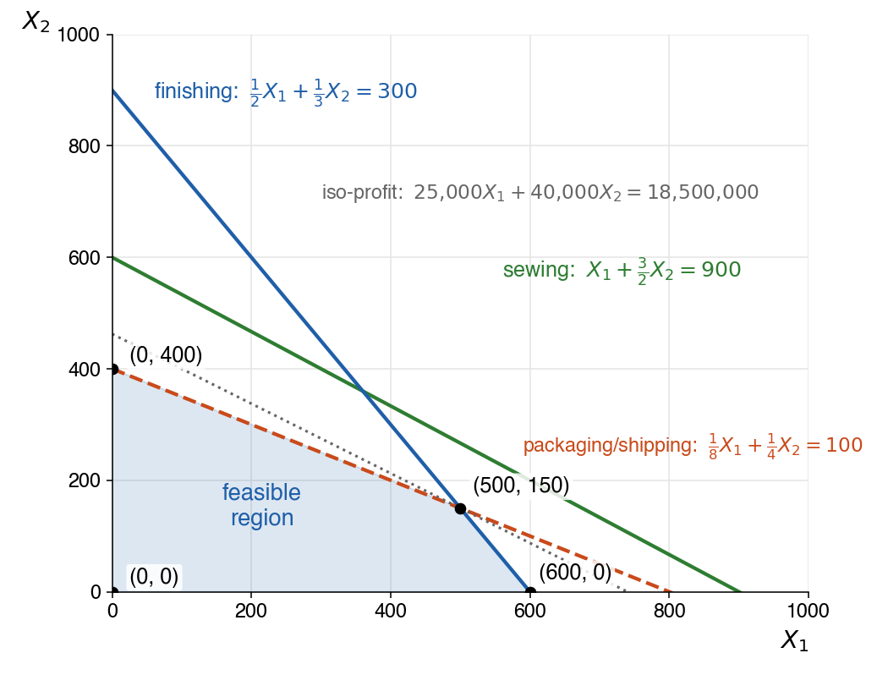
Figure 1-2. The three constraints, the shaded feasible region, and the iso-profit line through the optimal corner (500, 150).
(1-3) Calculate the slack variables and discuss the managerial implications.
Solution to (1-3)
A slack variable measures how much of a resource is left unused. Adding one to each constraint turns the inequalities into equations:
sewing X₁ + (3/2)X₂ + S₁ = 900, S₁ ≥ 0
finishing (1/2)X₁ + (1/3)X₂ + S₂ = 300, S₂ ≥ 0
packaging/shipping (1/8)X₁ + (1/4)X₂ + S₃ = 100, S₃ ≥ 0
At the optimal solution X₁ = 500 and X₂ = 150:
S₁ = 900 − (500 + 225) = 175 hours
S₂ = 300 − (250 + 50) = 0 hours
S₃ = 100 − (62.5 + 37.5) = 0 hours
Managerial implications:
Finishing and packaging/shipping are binding (S₂ = S₃ = 0). Both departments are fully utilized and are the bottlenecks of the plant. The only way to increase profit is to add capacity in these two departments, for example through overtime or additional equipment. Adding capacity anywhere else leaves profit unchanged.
Sewing is non-binding (S₁ = 175). Of the 900 sewing hours available, 175 hours (about 19%) will be idle. Buying more sewing capacity would be a waste of money. Instead, management could reassign up to 175 hours of sewing labor to the finishing or packaging/shipping departments, reduce sewing staffing or shifts, or use the idle time for other work, without affecting the optimal production plan. In fact the sewing constraint is redundant here: because packaging/shipping forces X₁ + 2X₂ ≤ 800, every feasible plan uses at most 800 sewing hours.
- An investment firm is investing 10 billion KRW across two stocks: Petroleum Corporation and Steel Corporation. Based on data analysis for each company's stock, they have created the following table.
Stock | Price per share (KRW/share) | Expected Annual Return per share (KRW/share) | Risk index per share (per share)
Petroleum Corporation | 25,000 | 6,000 | 0.5
Steel Corporation | 50,000 | 10,000 | 0.25

The risk index per share indicates the risk level of each stock. Petroleum Corporation appears to have a higher risk level than Steel Corporation. The firm invests subject to the constraints that the portfolio’s total risk index does not exceed 80,000 and that its investment in Petroleum Corporation does not exceed 100,000 shares.
(2-1) Develop a linear optimization model that maximizes the total annual return.
Solution to (2-1)
Decision variables: X₁ = number of shares of Petroleum Corporation purchased, X₂ = number of shares of Steel Corporation purchased.
Maximize Z = 6,000X₁ + 10,000X₂ (total annual return,KRW)
subject to
25,000X₁ + 50,000X₂ ≤ 10,000,000,000 (budget, KRW)
0.5X₁ + 0.25X₂ ≤ 80,000 (total risk index)
X₁ ≤ 100,000 (Petroleum Corporation cap, shares)
X₁, X₂ ≥ 0.
For graphing it is convenient to simplify the first two constraints. Dividing the budget constraint by 25,000 gives X₁ + 2X₂ ≤ 400,000, and multiplying the risk constraint by 4 gives 2X₁ + X₂ ≤ 320,000.
(2-2) Find the optimal solution using a graph.
Solution to (2-2)
Draw each constraint as a straight line. The intercepts can be read off directly:
budget X₁ + 2X₂ = 400,000 (400,000, 0) and (0, 200,000)
risk 2X₁ + X₂ = 320,000 (160,000, 0) and (0, 320,000)
cap X₁ = 100,000 a vertical line
The budget and risk lines cross where X₁ + 2X₂ = 400,000 and 2X₁ + X₂ = 320,000. From the first, X₁ = 400,000 − 2X₂. Substituting into the second: 800,000 − 4X₂ + X₂ = 320,000, so X₂ = 160,000 and X₁ = 80,000.
The risk line and the cap cross at X₁ = 100,000, X₂ = 320,000 − 200,000 = 120,000. This point satisfies the budget constraint (100,000 + 240,000 = 340,000 ≤ 400,000), so it is a corner of the feasible region. The budget line and the cap cross at (100,000, 150,000), but that point violates the risk constraint (200,000 + 150,000 = 350,000 > 320,000), so it is not feasible.
The feasible region is the pentagon with corner points (0, 0), (100,000, 0), (100,000, 120,000), (80,000, 160,000) and (0, 200,000). Evaluate Z = 6,000X₁ + 10,000X₂ at each corner:
(0, 0) Z = 0
(100,000, 0) Z = 600,000,000
(100,000, 120,000) Z = 1,800,000,000
(80,000, 160,000) Z = 2,080,000,000 ← optimal
(0, 200,000) Z = 2,000,000,000
Equivalently, the iso-return line 6,000X₁ + 10,000X₂ = Z has slope −0.6, which lies between the slope of the budget line (−0.5) and the slope of the risk line (−2). Sliding it outward, it last touches the feasible region at the corner where the budget and risk constraints meet.
Optimal solution: buy X₁ = 80,000 shares of Petroleum Corporation (2,000,000,000 KRW) and X₂ = 160,000 shares of Steel Corporation (8,000,000,000 KRW). The maximum total annual return is Z = 2,080,000,000 KRW, or 20.8% of the 10 billion KRW invested.
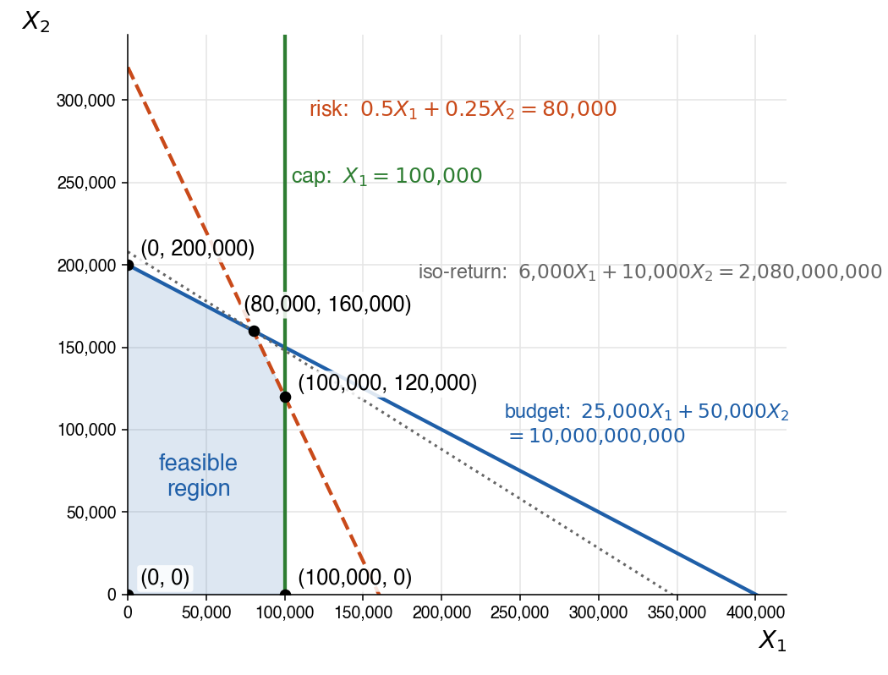
Figure 2-2. The three constraints, the shaded feasible region, and the iso-return line through the optimal corner (80,000, 160,000).
(2-3) Calculate the slack variables and discuss the managerial implications.
Solution to (2-3)
Adding a slack variable to each constraint:
budget 25,000X₁ + 50,000X₂ + S₁ = 10,000,000,000, S₁ ≥ 0
risk 0.5X₁ + 0.25X₂ + S₂ = 80,000, S₂ ≥ 0
cap X₁ + S₃ = 100,000, S₃ ≥ 0
At the optimal solution X₁ = 80,000 and X₂ = 160,000:
S₁ = 10,000,000,000 − (2,000,000,000 + 8,000,000,000) = 0 KRW
S₂ = 80,000 − (40,000 + 40,000) = 0
S₃ = 100,000 − 80,000 = 20,000 shares
Managerial implications:
The budget constraint is binding (S₁ = 0). The entire 10 billion KRW is invested; no cash is left idle.
The risk constraint is binding (S₂ = 0). The portfolio sits exactly at the firm’s risk tolerance, so risk tolerance, not money, is what limits the return. Petroleum Corporation earns more per KRW invested (6,000/25,000 = 24%) than Steel Corporation (10,000/50,000 = 20%), but it also carries twice the risk per share. If the firm were willing to accept a higher total risk index, it would shift funds from Steel to Petroleum and earn a higher return. Conversely, tightening the risk limit would reduce the return.
The cap on Petroleum Corporation is non-binding (S₃ = 20,000). The firm buys only 80,000 of the 100,000 shares it is allowed to hold, so this restriction plays no role in the decision; the risk limit already keeps the Petroleum holding below the cap. Raising the cap would not change the optimal portfolio, and it could be lowered to 80,000 shares with no loss of return.

