- Consider the following production planning problem.
Maximize Z=7X₁+5X₂ (Profit, Unit: 10,000 KRW)
subject to
2X₁ + 5X₂ ≤ 600 (Labor, Unit: Hour)
4X₁ + 2X₂ ≤400 (Facility, Unit: Hour)
X₁, X₂ ≥ 0.

(X₁: The production quantity of Product 1, X₂: The production quantity of Product 2)

Solution to (1-1) Graph the constraints and shade the feasible region.

Draw each constraint as a straight line and shade the side that satisfies it. The intercepts can be read off directly:

labor 2X₁ + 5X₂ ≤ 600 intercepts (300, 0) and (0, 120)
facility 4X₁ + 2X₂ ≤ 400 intercepts (100, 0) and (0, 200)

The two lines cross where 2X₁ + 5X₂ = 600 and 4X₁ + 2X₂ = 400. Solving the pair gives X₁ = 50 and X₂ = 100.

Shading the side of each line that satisfies its inequality and keeping only X₁ ≥ 0 and X₂ ≥ 0 leaves the quadrilateral with corner points (0, 0), (100, 0), (50, 100) and (0, 120).
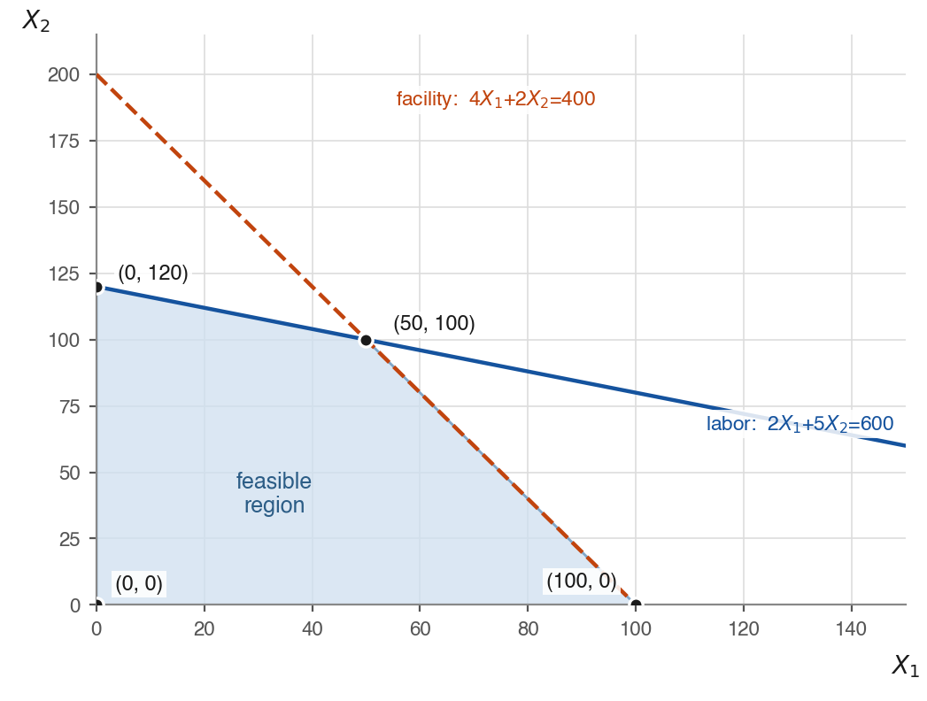
Figure 1-1. The two constraints and the shaded feasible region.
Solution to (1-2) A = (50, 50) is a feasible solution that is not optimal. Explain, using the iso-profit line, how to find a feasible solution that is more profitable than A.

A = (50, 50) is feasible, since labor 2(50) + 5(50) = 350 ≤ 600 and facility 4(50) + 2(50) = 300 ≤ 400. Its profit is Z = 7(50) + 5(50) = 600.

Draw the iso-profit line 7X₁ + 5X₂ = 600 through A. Every point on that line earns exactly 600, and every point on the far side of it (away from the origin) earns more. So move the line outward, parallel to itself, and take any feasible point it reaches.

Example: B = (60, 60) is feasible (labor 420 ≤ 600, facility 360 ≤ 400) and gives Z = 7(60) + 5(60) = 720 > 600, so B is more profitable than A.

Continuing to push the line outward until it last touches the feasible region locates the optimum, which is what (1-3) asks for.
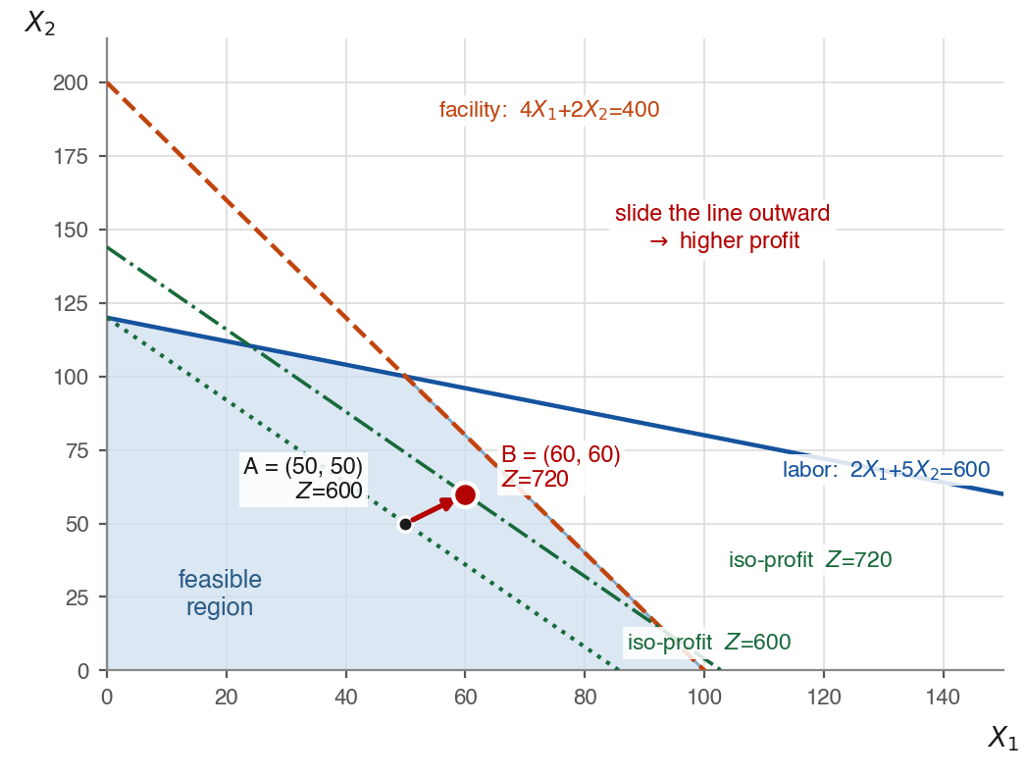
Figure 1-2. Sliding the iso-profit line outward from A to a better point B.

Solution to (1-3) Find the optimal solution of this problem.
The optimum of a linear program is always at a corner point, so evaluate Z = 7X₁ + 5X₂ at each of the four corners found in (1-1):

(0, 0) Z = 0
(100, 0) Z = 700
(50, 100) Z = 850 ← optimal
(0, 120) Z = 600

Optimal solution: X₁ = 50 units of Product 1 and X₂ = 100 units of Product 2, with maximum profit Z = 850, that is 8,500,000 won.
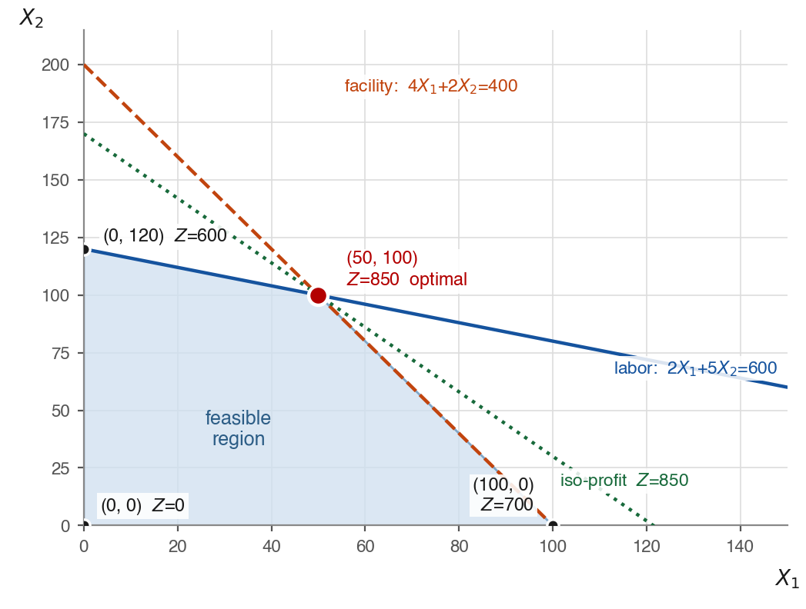
Figure 1-3. The iso-profit line last touches the region at the optimal corner.

Solution to (1-4) Introduce a slack variable for each constraint and calculate their values at the optimal solution found in (1-3).
A slack variable measures how much of a resource is left unused. Adding one to each constraint turns the inequalities into equations:

labor 2X₁ + 5X₂ + S₁ = 600, S₁ ≥ 0
facility 4X₁ + 2X₂ + S₂ = 400, S₂ ≥ 0

so that S₁ = 600 − (2X₁ + 5X₂) and S₂ = 400 − (4X₁ + 2X₂).

At the optimal solution X₁ = 50 and X₂ = 100:

S₁ = 600 − (2(50) + 5(100)) = 600 − 600 = 0
S₂ = 400 − (4(50) + 2(100)) = 400 − 400 = 0

Both slack variables are zero, so no labor hours and no facility hours are left over.

For comparison, the slacks at the other corner points are (0, 0): S₁ = 600, S₂ = 400; (100, 0): S₁ = 400, S₂ = 0; (0, 120): S₁ = 0, S₂ = 160. A slack is zero exactly when the corner lies on that constraint line.

Solution to (1-5) At the optimal solution, classify each constraint as binding or non-binding, and explain its managerial implication.

A constraint is binding at a point when it holds with equality there, that is when its slack variable is zero; it is non-binding when slack remains. At the optimal solution X₁ = 50, X₂ = 100:

labor 2(50) + 5(100) = 600 = 600 S₁ = 0 binding
facility 4(50) + 2(100) = 400 = 400 S₂ = 0 binding

Managerial implication. Both resources are bottlenecks. All 600 labor hours and all 400 facility hours are consumed at the optimum and nothing is idle, which is precisely why the optimal plan sits where the two constraint lines cross. Because both constraints bind, both limit profit, and the firm can raise Z only by adding capacity — overtime or an extra shift for labor, additional machine time for the facility. Each extra hour therefore has a positive value at the margin, so it is worth paying for extra capacity up to that value. There is no idle capacity anywhere to cut or redeploy.

- Solve each of the following linear optimization models graphically. For each model, find the optimal solution, calculate the slack variables, identify the binding and non-binding constraints, and explain their managerial implications.

Solution to (2-1)
Maximize X₁ + X₂
subject to
2X₁ + X₂ ≤ 10
X₁ + 3X₂ ≤ 15
X₁ ≥ 0, X₂ ≥ 0

Plot the two constraint lines: 2X₁ + X₂ = 10 passes through (5, 0) and (0, 10), and X₁ + 3X₂ = 15 passes through (15, 0) and (0, 5). They cross where X₁ = 3 and X₂ = 4.

The feasible region is the quadrilateral (0, 0), (5, 0), (3, 4), (0, 5). Evaluate Z = X₁ + X₂ at each corner:

(0, 0) Z = 0
(5, 0) Z = 5
(3, 4) Z = 7 ← optimal
(0, 5) Z = 5

Optimal solution: X₁ = 3, X₂ = 4, with maximum Z = 7.

Slack variables. Writing 2X₁ + X₂ + S₁ = 10 and X₁ + 3X₂ + S₂ = 15 gives S₁ = 10 − (2X₁ + X₂) and S₂ = 15 − (X₁ + 3X₂). At the optimum:

S₁ = 10 − (2(3) + 4) = 0 binding
S₂ = 15 − (3 + 3(4)) = 0 binding

Managerial implication. Both slacks are zero, so both resources are bottlenecks and are used up completely. Neither leaves idle capacity, and the optimum is the point where the two constraint lines cross. Profit can be increased only by acquiring more of one of the two resources, and each is worth paying for at the margin.
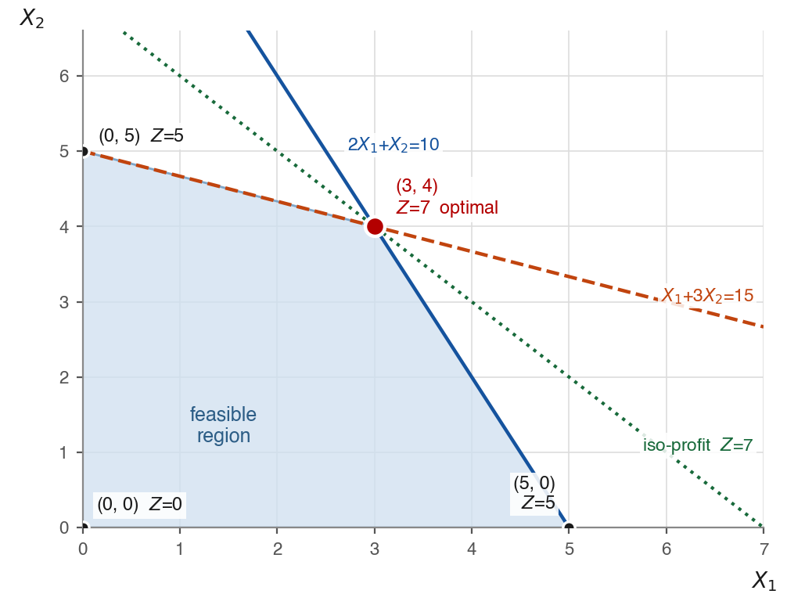
Figure 2-1. Feasible region, corner points and the optimal solution.

Solution to (2-2)
Maximize X₁ + 4X₂
subject to
X₁ + 2X₂ ≤ 8
3X₁ + 2X₂ ≤ 12
X₁ ≥ 0, X₂ ≥ 0

Plot the two constraint lines: X₁ + 2X₂ = 8 passes through (8, 0) and (0, 4), and 3X₁ + 2X₂ = 12 passes through (4, 0) and (0, 6). They cross where X₁ = 2 and X₂ = 3.

The feasible region is the quadrilateral (0, 0), (4, 0), (2, 3), (0, 4). Evaluate Z = X₁ + 4X₂ at each corner:

(0, 0) Z = 0
(4, 0) Z = 4
(2, 3) Z = 14
(0, 4) Z = 16 ← optimal

Optimal solution: X₁ = 0, X₂ = 4, with maximum Z = 16.

Slack variables. Writing X₁ + 2X₂ + S₁ = 8 and 3X₁ + 2X₂ + S₂ = 12 gives S₁ = 8 − (X₁ + 2X₂) and S₂ = 12 − (3X₁ + 2X₂). At the optimum:

first constraint X₁ + 2X₂ = 8 = 8 S₁ = 0 binding
second constraint 3X₁ + 2X₂ = 8 < 12 S₂ = 4 non-binding

Managerial implication. The first resource is the bottleneck: it is fully consumed and is the only thing limiting profit, so extra units of it would raise Z and are worth paying for. The second resource is not a bottleneck — 4 of its units sit idle at the optimum — so buying more of it would add cost without adding any profit, because its value at the margin is zero. The sensible actions for that idle capacity are to redeploy it to another product or process, rent or sell it, or scale it down to save its cost. A constraint with positive slack everywhere in the feasible region never restricts anything at all and can be dropped from the model as redundant.

Note also that X₁ = 0 at the optimum: with these objective coefficients Product 1 is not worth producing, and the whole of the binding resource is devoted to Product 2.
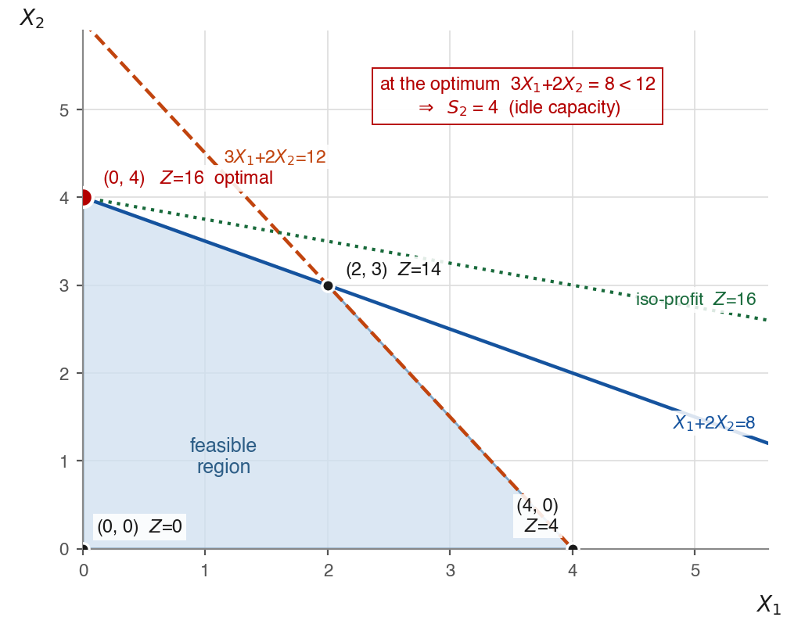
Figure 2-2. The optimum lies at (0, 4), where the second constraint still has slack.

