Bachelor of Software Engineering

Investigative Studio II

CS301.2 Interactive Design Document

Nakita Henry (270210724)
Jack Crichton (270399561)

Date of submission
19/04/2026

ABSTRACT
Running and managing a small business in New Zealand can become a logistical headache for many owners who can commonly find themselves with multiple open tabs. Payroll in one, rostering in the next, compliance checking in the one after that, with the “bonus” of figuring out the business analytics forecasting through confusing spreadsheets and unreadable data. Vizura is designed to fix that. Made for the NZ small business market, Vizura is a proposed cloud-based platform that collates analytics and forecasting, rostering, payroll, and employee management into a consolidated system.
The platform is built around four modules that share a common underlying data set. What this means is that when rostering and payroll can transfer data automatically, admins don’t need to manually enter the hours that have been worked, reducing time and labour costs. It also means that when analytics gain information from historical data, the forecasts can genuinely reflect real sales rather than same-day sales from the year/month prior.
The analytics module uses ensemble Machine Learning (ML) that provides 30-day revenue forecasts, anomaly flagging, and trend visualisations. Within this module will reside a Natural Language (NL) query interface that will allow a user to type a plain English question like “what was my highest grossing month this year?” and receive a plain English answer. This is so the analytics can be understood by all types of users. The rostering module provides drag-and-drop scheduling for admins for ease, shift swapping workflows, and employee availability management to streamline the rostering process. The payroll module provides all calculations, focusing on the Holidays Act 2003 and Employment Relations Act 2000. Lastly, the employee management module will maintain staff records, contracts, pay rates, and swap/leave requests in one organised location.
Vizura is comprised of React.js for the frontend, Node.js for the backend, Python for the NL and payroll calculator, PostgreSQL for the database, and Amazon Web Services (AWS) for cloud hosting and storage. This document will cover the full design process of Vizura, including usability testing, system architecture, an SRS document, and a breakdown of the 12-week project timeline for the Minimum Viable Product.
Keywords: small business management, cloud-based platform, business consolidation, payroll automation, employee rostering, workforce management, machine learning forecasting, natural language processing, revenue prediction, New Zealand compliance.
TABLE OF CONTENTS
ABSTRACT 1
INTRODUCTION 3
OVERVIEW 3
INNOVATIVE FEATURES 4
LOW FIDELITY WIREFRAMES 5
Nakita’s wireframes: Developed using Balsamiq 5
HIGH FIDELITY MOCKUPS 5
PROJECT VIZURA – SUMMARY 6
TARGET USERS 7
Overview 8
Frontend 8
Backend 8
Security Architecture 9
Testing 9
PROJECT TIMELINE 9
Key Development Stages 9
Stage 2 – MVP Completion 10
Stage 3 – Module Expansion 10
Stage 4 – Vizura Functionality Checkpoint 10
Work Breakdown 10
CITATIONS 11
APPENDIX A: LOW FIDELITY WIREFRAMES – NAKITA 12
APPENDIX B: LOW FIDELITY USABILITY TESTING – KITA 14
APPENDIX C: LOW FIDELITY WIREFRAMES – JACK 19
APPENDIX D: LOW FIDELITY USABILITY TESTING – JACK 23

In today's business world, there is a constant and ever-growing increase in data and operational burden for small business owners. Between managing staff, maintaining compliance, and analysing sales data, it's no wonder that some may fall short without the use of extensive resources.
Most small businesses in New Zealand (NZ) currently tackle these expectations by using multiple systems at once. It's not uncommon to find owners using Deputy (Deputy, n.d.) for rostering, PayHero (PayHero, n.d.) for payroll, and Xero (Xero, n.d.) for accounting and although these are all great systems, having three separate subscriptions increases the operational load by requiring training for each and manual data transfer between them. Vulnerable to human error and time-consuming, this approach could be better optimised through system consolidation. Vizura tackles this fragmented approach by integrating analytics and forecasting, rostering, payroll, and employee management into a single platform.
The development team for Vizura, Kija, identified this market gap through the combination of personal retail and hospitality experience in NZ, as well as supported research (Henry & Crichton, 2026) which confirmed that Machine Learning (ML), Artificial Intelligence (AI)-driven scheduling, and Natural Language (NL) processing greatly reduced labour in small businesses. The overall purpose of Vizura is to address each requirement and consolidate them into a single platform that is affordable, practical, and user-friendly.

OVERVIEW
The goal of Vizura is to design, develop, and deliver a working proof-of-concept, Minimum Viable Product (MVP). To develop this MVP will be to demonstrate that Vizura is more than a concept and capable of functioning as a practical and useful platform. With the MVP completion, Kija aims to achieve the following.
- To achieve the consolidation of analytics and forecasting, rostering, payroll, and employee management into a single platform that maintains a shared data layer so users can focus on one platform and reduce resources that could be spent elsewhere.
- To automate payroll calculations in compliance with the Holidays Act 2003 (HDA2003) and the Employment Relations Act 2000 (ERA2000), which will reduce users' manual workload and decrease the risk of human error in the event of needing to manually transfer data.
- To maintain a 30-day sales forecast ensemble ML engine that will provide users with data-driven revenue predictions rather than rough estimates (Henry & Crichton, 2026).
- To develop an NL query interface that will be accessible through the analytics module, so that users can still gain insights from their own business data through trend visualisations and plain English responses.
- To build an interface that is accessible and easy to navigate.
- The functional MVP will be completed within the allotted 12-week timeframe.
- Any future development will focus on refinement and feature expansion based on user feedback and suggestions.
- Vizura will have two user types to begin with, admins and employees, that will be set and validated via login credentials. Admins will have full access across all the modules, and employees will have access to a personal dashboard, which will provide relevant information, such as upcoming shifts, leave/swap requests, pay slips, pay rate, leave balances, and their individual contracts.
As Kija achieves these expectations, the resulting product will be a platform built for small NZ business owners and their employees, with an initial focus on retail and hospitality. Combining payroll, shift-based rostering, real-time sales data, and revenue forecasting will see these industries benefit the most from Vizura in its beginning stages.

INNOVATIVE FEATURES
Firstly, Vizura’s core innovation is consolidation, integrating four critical business functions into a single platform with a shared data layer. This will allow for information to flow between the modules without manual input, reducing time and thus freeing up resources.
The proposed features are built from a market gap showing a lack of consolidation platforms at an affordable price in NZ.
The NL query interface allows business owners to ask plain English questions about their data and receive clear responses without the need for prior technical experience. This step should remove a realistic barrier that has frustrated all those who aren't the best with data
The ML forecasting engine will combine multiple algorithms to produce 30-day revenue predictions that can be visualised. This will provide users with reliable data as a basis for decisions around stock, cash flow, and shift times/sizes.
Finally, the built-in compliance with the Holidays Act 2003 and Employment Relations Act 2000 means that each pay calculation, leave entitlement, and public holiday will be handled accurately. This is a foundational aspect of the payroll module and seems to be uncommon amongst other affordable platforms in the NZ market.

LOW FIDELITY WIREFRAMES
To gain the best understanding of user preference, both team members created individual designs for this stage and conducted usability testing on each with 10 participants. The test results provide Kija with a better understanding of key placement, spacing, and overall layout. This information is used to develop the next stage of high-fidelity mock-ups.

Nakita’s wireframes: Developed using Balsamiq
For my wireframes, I developed two frames per page to ensure sufficient A/B testing could be completed. Following the development of all, I conducted an A/B test with 10 research participants, with the option to provide feedback or suggestions. The full wireframes and survey results/responses can be found in Appendix B.
The survey results found that across all pages, the common theme of centralised information and positioning was favoured (See Appendix B, Table B1). This shows that there is a consistent and very strong preference for version A across approx. 80% of all pages (8/10 questions returned a majority preference for A). In particular, the register/login page, the participants preferred version A, citing that they liked the centralised layout, consistent sizing, and clean space between the elements (see Appendix Figures B3 and B2). The landing page and employee profile page were the only two that the participants preferred version B (see Appendix B, Figures B1 and B9). On the landing page, participants thought that the centred navigation bar in version B was cleaner, as well as better spacing and layout in the employee profile page.
Overall, the feedback cited symmetry and decluttering as the main user preferences. This feedback is both valuable and insightful and will be carried over into the next stage of High Fidelity mock-ups.

HIGH FIDELITY MOCKUPS
The high-fidelity (hi-fi) mock-ups were designed using Figma, supported by the results of the low-fidelity (lo-fi) user testing. Due to time and resources, the entirety of the hi-fi was not completed within this phase of the project, however any remaining mock-ups or user testing will be completed before the beginning of the MVP development.
For the current set, we have set a colour theme (light/dark), as well as some components have been completed, which will provide a clear understanding with the stylistic direction Vizura is taking.

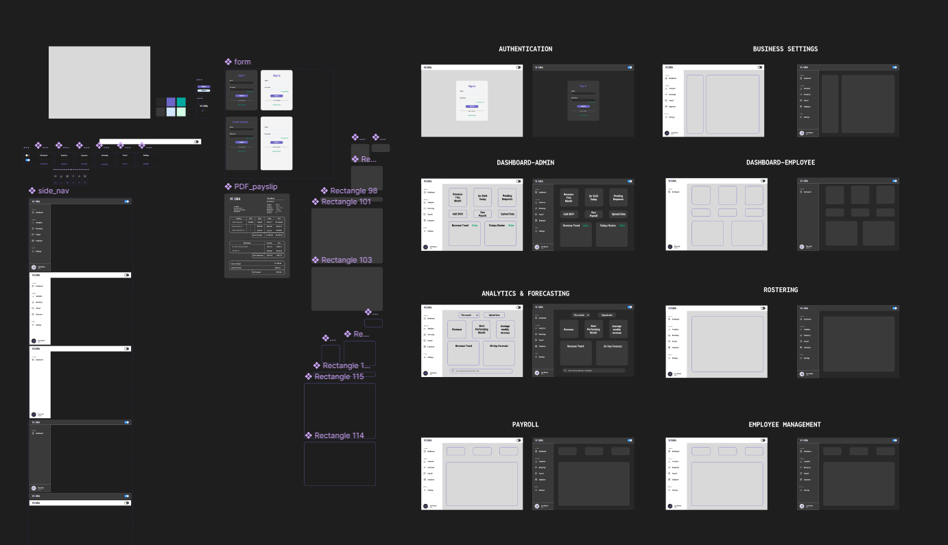
PROJECT VIZURA – SUMMARY
Figure 1: High Fidelity Mock-ups – In Progress

Vizura is the brainchild of Team KiJa, two former employees of the retail and hospitality sectors. The combining of commonly used payroll, rostering, analytical systems and management applications, fleshed out by a clean, useable application, and an AI Natural Language prompt system. Majority of the employees of SMEs within these sectors, including middle and upper-management, Human Resources and training staff alike. SMEs spend time, resources and ultimately haemorrhage profit margin. Time spent teaching users to learn multiple applications, error handling and misuse could be costly.
Vizura has been designed to remedy this problem, becoming the ultimate hub for SME systems and information, which is collated, organised and executed, in an all-in-one location, designed for all user types, restricted/predesignated by authority level. The goal is to make user friendly dashboard, with four main facets of industry systems: Analytics & Forecasting, Rostering, Payroll, and Employee Management. On the dashboard you will be able to access the NLQ AI system.
The user will enter a prompt relative to their work, in example; a leave or sales related question/query. The system will interpret the requirements of the prompt, access the available data, taking privilege into account, as to not disclose any classified information. The NLQ will then either answer your question via a text result, offer the user some information followed by a navigation option to the location of the user's prompt needs, or generate/locate a subsequent payslip PDF or other data file, once again taking privilege into account.
In having all four facets of the industry systems interconnected, there is less time delay for relay of information, less margin for error, less training required for application users, and four times less application subscription and system repair costs.

TARGET USERS
The basis of this application is to be self-functional, allowing for external support requests from team KiJa is bugs are encountered.
The primary user will be the Employer/Admin role. As they will be at the top of the privilege/role for the system, they will responsible for setting up the business functionality within Vizura. This means;
- Adding roles (HR, Sales, Merchandising, Manager etc.)
- Adding business type
- Adding business details, information, data
- Adding staff/new users
- Adjusting user privilege
- Rostering
- Payroll Details and more

The secondary user will be the Employee. This user will use the system, once the employer has created the business account, they will have access to;
- Viewing roster & making swap or leave requests
- View analytics and sales projections available
- View and download payslips and available leave

Overview
Vizura will run an up-to-date tech stack, built with modern, industry-standard systems. By design, the MVP will be well structured and consist of functional and non-functional requirements, divided into two stages.
Prioritising the payroll and compliance systems initially, means working through the application baseline functional requirements, ensuring they are well protected and in harmony with one another, checking regularly for bugs and vulnerabilities with consistent user and security testing moving into the development phase.

Frontend
- React.js for adaptive, smooth, UI development, especially once we move towards creating a mobile version
- Recharts for interface systems, such as rosters and charts
- Tailwind CSS library presets for clean, consistent UI design
- Axios for API communication

Backend
- Python
- Pandas & NumPy for data processing
- Prophet for time-series forecasting
- Scikit-learn for anomaly detection
- SpaCy for natural language query processing
- Node.js
- Express framework
- Database
- PostgreSQL – for data sequencing and relation
- Amazon AWS for full application database
- EC2 (Elastic Compute Cloud) for adjustable database sizing structure
- RDS (Relational Database Service) automating backups, recovery, managing PostgreSQL
- S3 (Simple Storage Service) for secure storage of files, payslips, etc

Security Architecture
  - Access Control: Roles (Employer, Management, Employee Etc)
  - MFA (Multi-Factor Authentication)
  - Digital Signatures
  - Message Authentication
  - Database Encryption
  - Endpoint detection and response
  - Firewalls
  - Vulnerability testing

Testing
- SCA (Software Composition Analysis)
- SAST (Static Application Security Testing)
- DAST (Dynamic Application Security Testing)
- IAST (Interactive Application Security Testing)
- AI Integration

PROJECT TIMELINE

Key Development Stages
After submitting our IDD by April 19th, team KiJa will be starting on Stage 1.
Stage 1 – Vizura Baseline Framework
The initial iteration will focus on the application structure, building the code foundation, connections, database, security, and a basic frontend, primarily on the UI, rather than specific design/aesthetic details. At this stage we will be building the login and registration systems, dashboard, database, and payroll module.
Stage 1 Estimated timeframe: April 20th - May 24th (5 weeks)

Stage 2 – MVP Completion
Completion of all functional requirements necessary for Vizura. Backend/API integration, appropriate installation of security measures, and testing. Completed payroll module, working login system, and dashboard. Frontend will have additional updates
Stage 2 Projected Timeframe: May 25th - June 28th (5 weeks)

Stage 3 – Module Expansion
Building of the next modules, following order; Rostering, Analysis, Management
Integration and building of AI chatbot.
Testing results drive updates and bug fixes, improving the existing system during expansion. Incorporation of non-functional requirements by order of priority.
Stage 3 Projected Timeframe: 8 weeks (1st half of 2nd semester)

Stage 4 – Vizura Functionality Checkpoint
Completion of first total iteration of Vizura as the system was designed. UI and UX work smoothly. All four modules work as intended. Systems and data are secure. Now looking towards real-world testing/application and future development additions to the Vizura system.
Stage 4 Projected Timeframe: 8 weeks (2nd half of 2nd semester)

Work Breakdown
As a full stack development team of two, team KiJa will ultimately be dividing ALL development, in an effort to; learn all aspects of Vizura’s system functionality, and to evenly divide the workload. Having said that, tasks will be allocated to each member to lead, and the other will assist, oversee and investigate the others' work, so we can remain fully informed on all aspects of Vizura code. We’re using Jira to visualise and monitor our workflow, allowing for backlog, subtask information, and precise work breakdown.

CITATIONS

Deputy. (n.d.). Deputy – Staff scheduling, time and attendance software. https://www.deputy.com/nz/
Employment Relations Act 2000, No 24. (N.Z.).
Henry, N., & Crichton, J. (2026). [Proposal and Presentation Pitch]. [Yoobee College].
Holidays Act 2003, No 129. (N.Z.).
PayHero. (n.d.). PayHero – NZ payroll software. https://www.payhero.co.nz/
Xero. (n.d.). Xero accounting software. https://www.xero.com/nz/

APPENDIX A: LOW FIDELITY WIREFRAMES – NAKITA
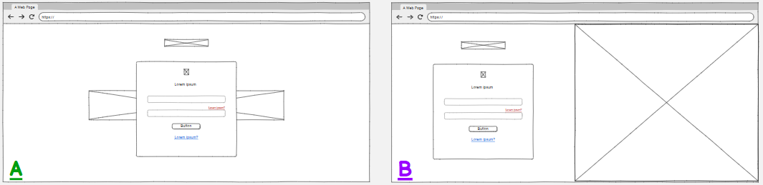
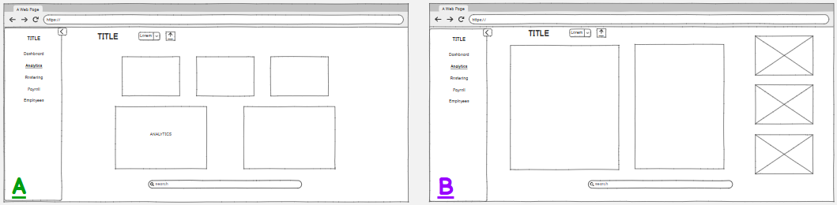
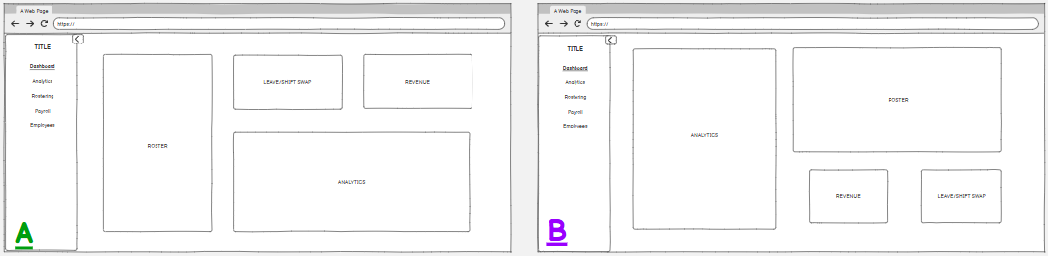
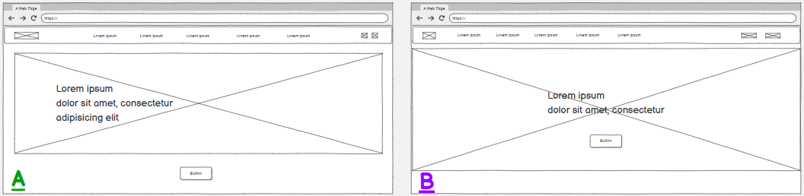
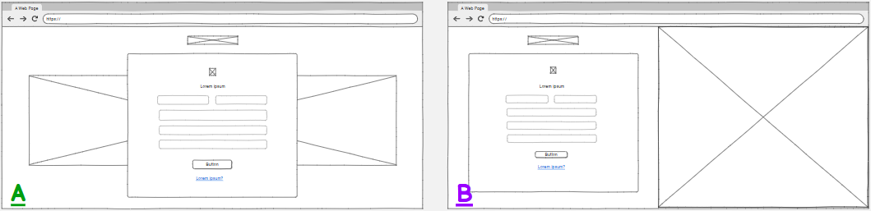
This appendix presents the first iteration of low-fidelity wireframes, with two style options for each screen for users to choose from.
Figure A5: Analytics Page (Style A and B)
Figure A4: Admin Dashboard (Style A and B)
Figure A3: Landing Page (Style A and B)
Figure A2: Sign Up Form (Style A and B)
Figure A1: Sign In Form (Style A and B)

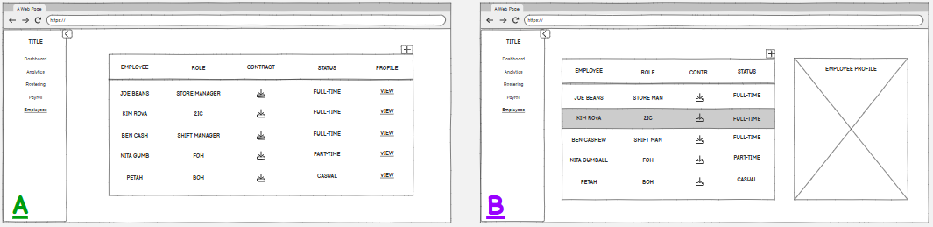
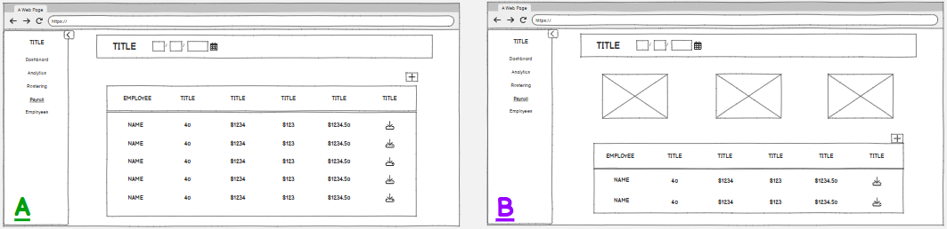
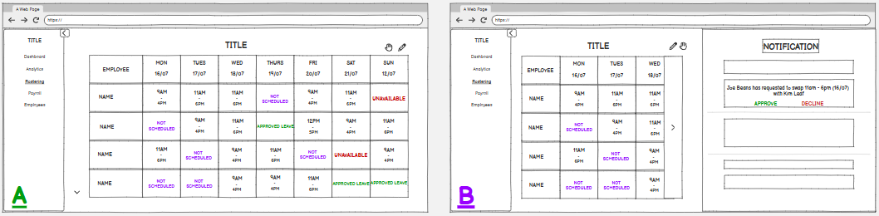
Figure A6: Rostering Page (Style A and B)
Figure A8: Employee Management Page (Style A and B)
Figure A7: Payroll Page (Style A and B)

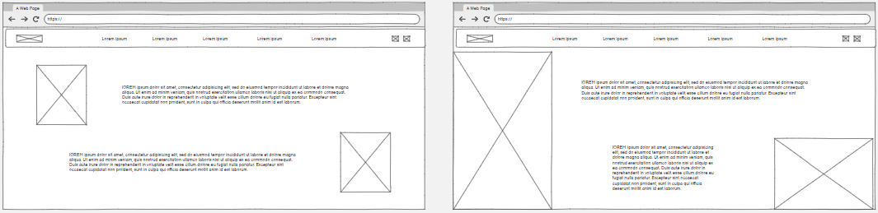
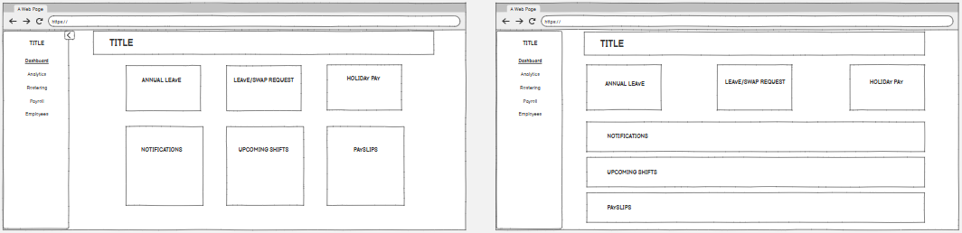
Figure A10: About Us Page (Style A and B)
Figure A9: Employee Dashboard (Style A and B)

APPENDIX B: LOW FIDELITY USABILITY TESTING – KITA
This appendix presents the usability testing from the first iteration of low-fidelity wireframes, inclusive of selection data and participant observations.
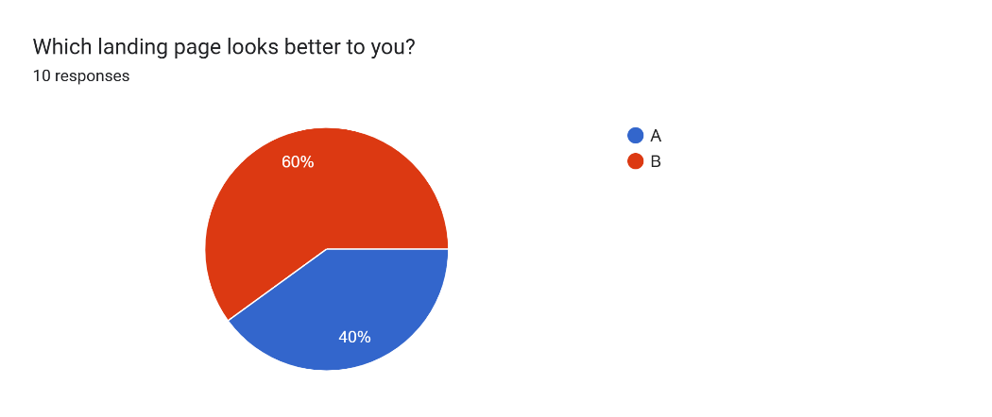

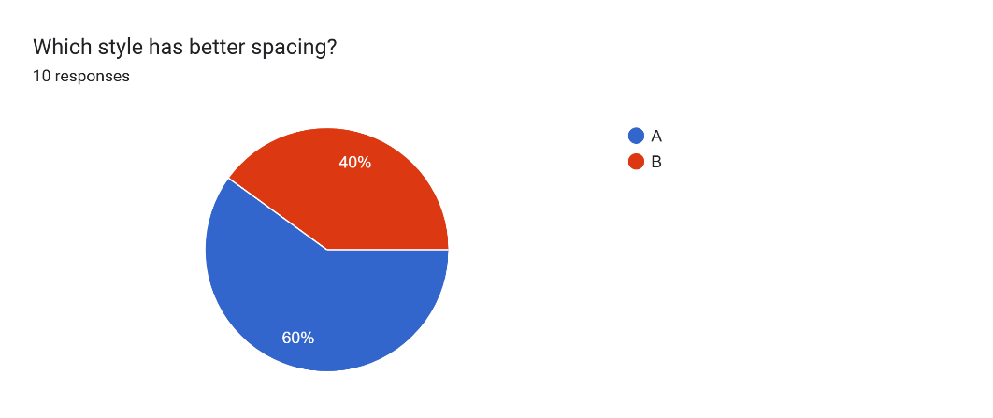
Figure B1: Landing Page Preference – Style A vs Style B

Figure B2: Sign In Form Spacing – Style A vs Style B

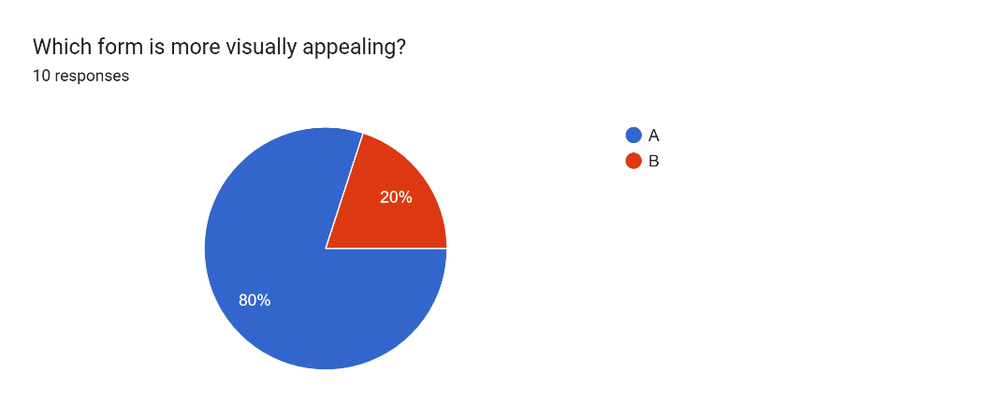

Figure B3: Sign Up Form Preference – Style A vs Style B

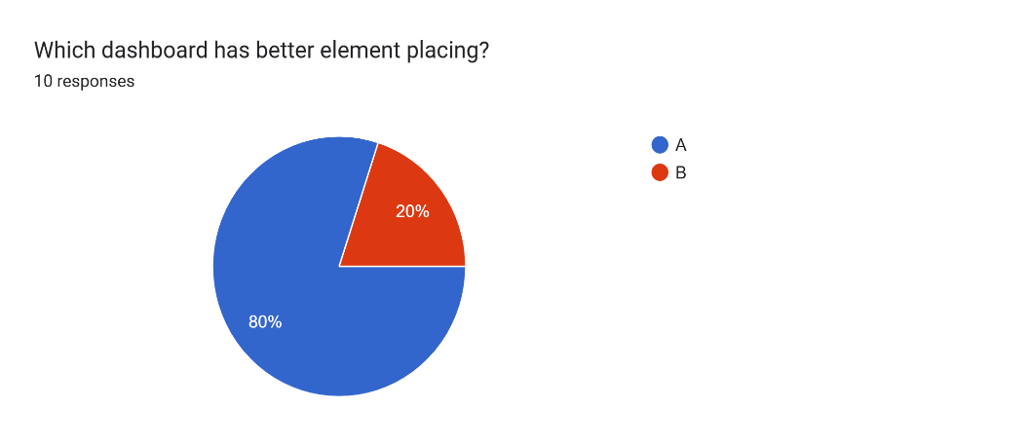
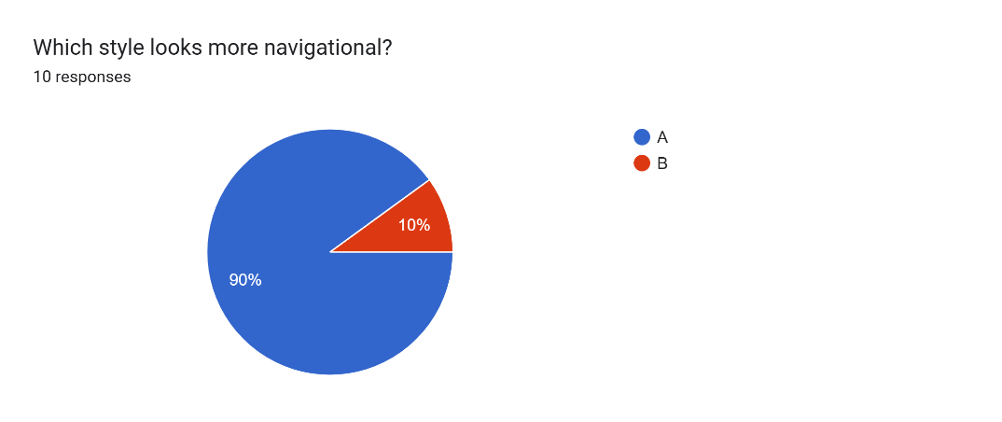
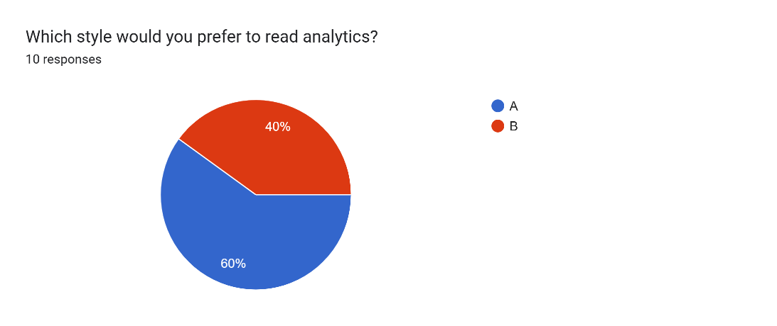
Figure B6: Rostering Form Navigation – Style A vs Style B
Figure B5: Analytics Style Preference – Style A vs Style B
Figure B4: Dashboard Element Preference – Style A vs Style B
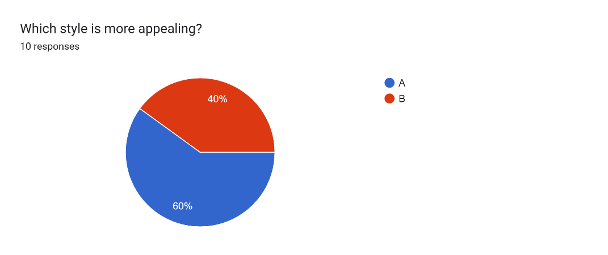
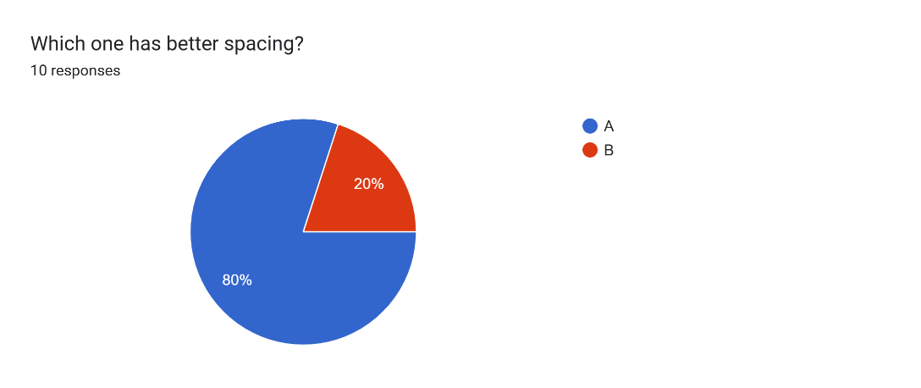
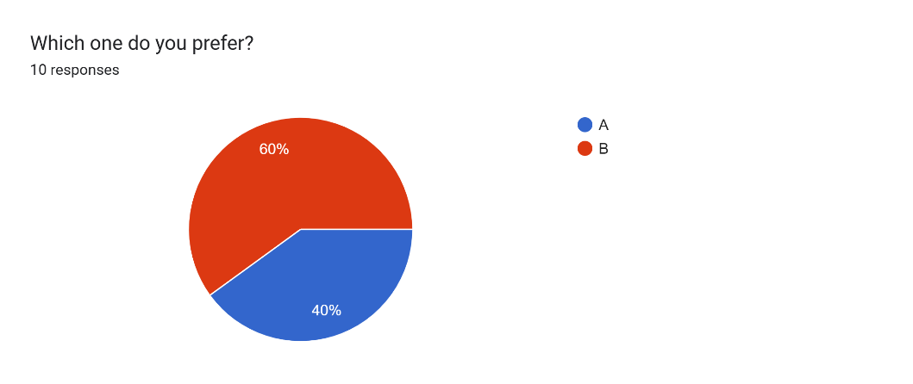
Figure B8: Employee Page Preference – Style A vs Style B
Figure B7: Payroll Page Spacing – Style A vs Style B
Figure B9: Employee Dashboard preference – Style A vs Style B
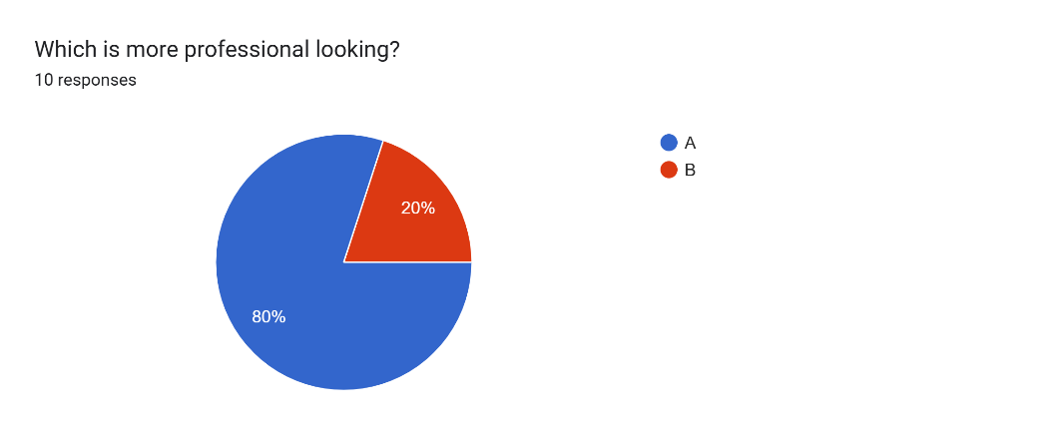

Figure B10: About Us Page Preference – Style A vs Style B

Question | Comments
Q1 | - “Maybe the image could be a little less in length and the button could be like it is in A”  - “A feels weirdly off center but hard to tell without the image context in a lo-fi”  - “a ;looks like its slightly bigger font”  - “Title looks more tidier in the centre”  - “A, but would look better with the wording in the centre”  - “Having things centered on a landing page feels nicer imo. I do like the button placement of A though, however button placement of B also works”  - “The navigation bar looks way nicer to me”
Q2 | - “Nice layout  - “Keeping thing centered is generally preferred”  - “I prefer the centralised layout for the login icon”  - “I like A, but B is nice with the big image placement”  - “Asymmetry scratches my brain nicely”
Q3 | - “I like this one too”  - “Same as prior”  - “Centralised layout looks nicer on the signup”  - “B because it would flow nicely with the sign up form”  - “Same reason as the previous one. Asymmetry tickles my brain nicely”
Q4 | - “I think a more symmetrical design would look better overall”  - “Sizing is more consistent in A”  - “everything lines up nicely”  - “I feel like the layout on this one is more nicer”  - “Better layout”  - “A lot more space for the roster”
Table B1: Participant comments on A/B testing – grouped by question

Q5 | - “B feels cleaner with spacing and sizing, though i do think the search is oddly placed maybe to the left between the boxes?”  - “seems more professional”  - “The two big boxes can display more”  - “I like this setup, but the bar should be above”  - “just feels nicer”  - “I feel its more organised in A”
Q6 | - “a is cleaner B feels a little intrusive”  - “if the notification tab could be closed or minimised”  - “Having a bigger view of the schedule is more handier”  - “A, but with B as a click option”  - “Maybe when something is clicked it brings up B as an overlay?”  - “I like to have the full page”
Q7 | - “A feels less disjointed”  - “more space to include necessary info like hours worked tax kiwi saver and other stuff people want to see”  - “Having a bigger box with more lists is a better look for the payroll”  - “All the info is right there in A, easy to see and access”  - “Unsure what's actually needed on a payroll page but this seems cleaner cause you can see more”
Q8 | - Less clutter and more table space  - able to highlight staff members making it easy to navigate each row  - Employee screen A looks more useful  - A with B as a click option for clarity  - same as previous
Q9 | - B sizing and spacing's more consistent  - The layout is more optimised on screen B  - I like A although it is hard to imagine without styling
Q10 | - Professional layout  - looks professional  - having a bigger image on the left means an image can be more visible  - A is a common layout that doesn't fail

APPENDIX C: LOW FIDELITY WIREFRAMES – JACK
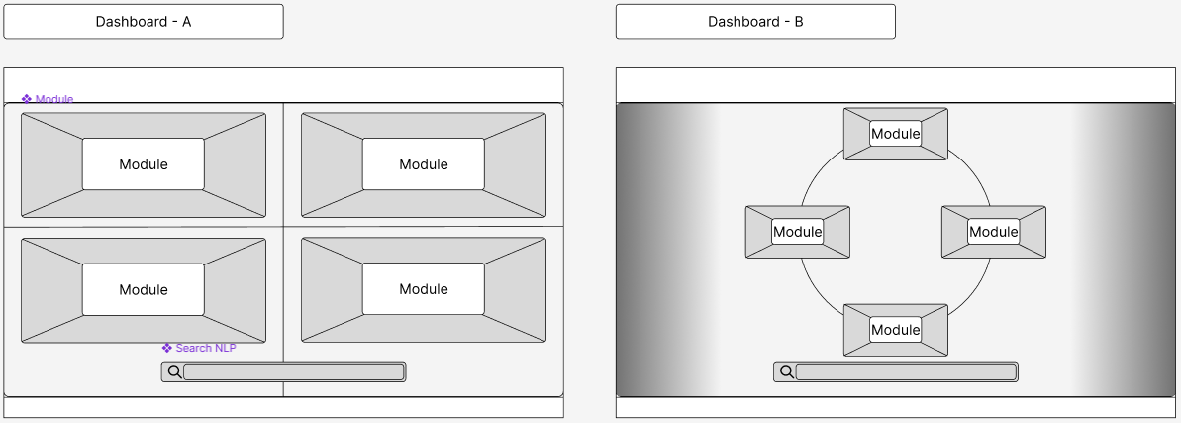
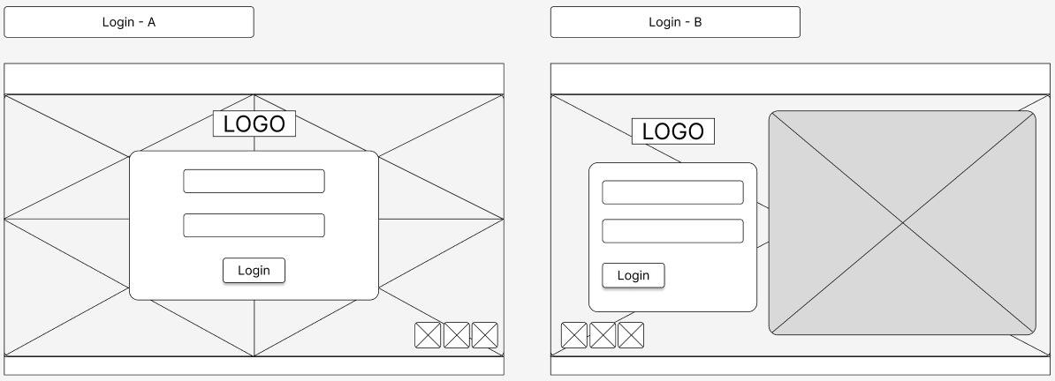
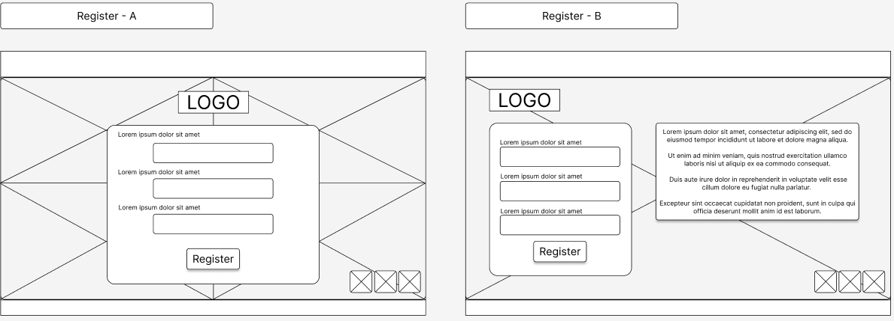
Figure C3: Dashboard Page Variations A and B
Figure C1: Login Page Variations A and B
Figure C2: Register Page Variations A and B
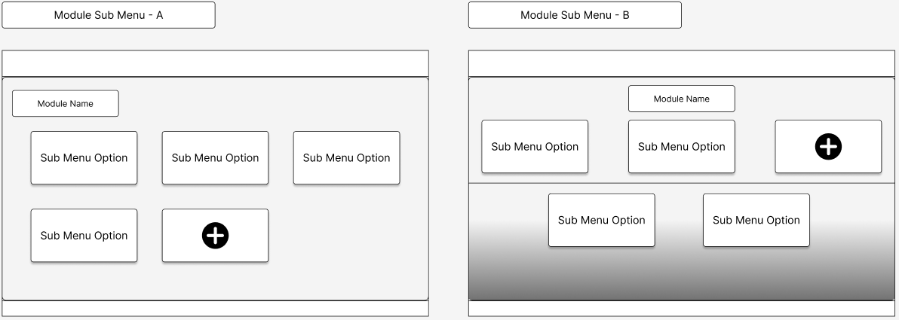
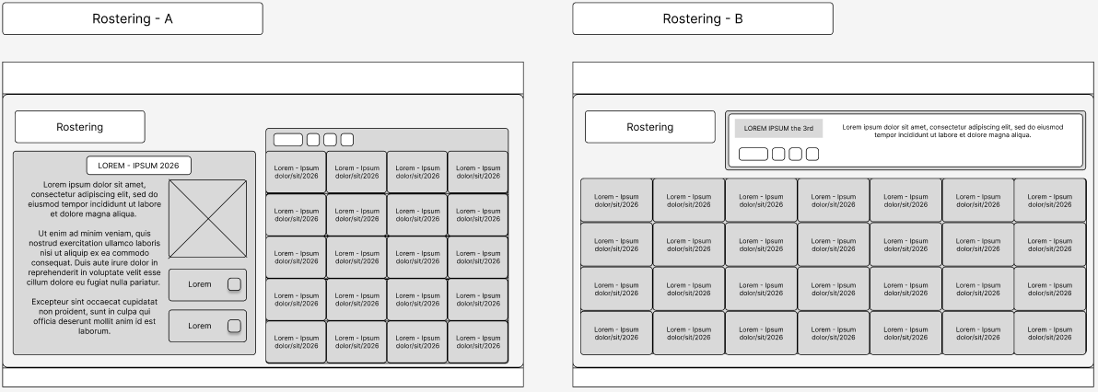
Figure C5: Rostering Page Variations A and B
Figure C6: Analytics Page Variations A and B
Figure C4: Module Sub Menu Page Variations A and B
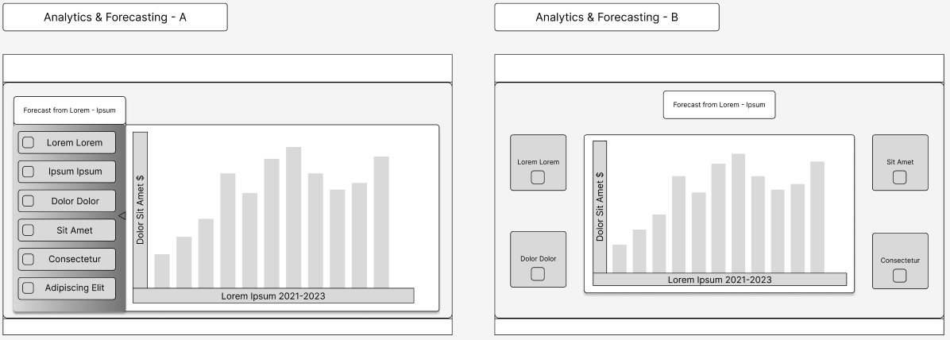

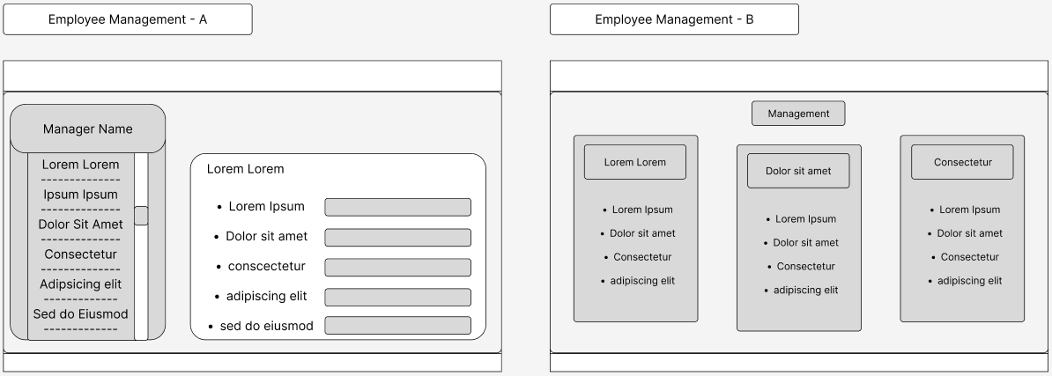
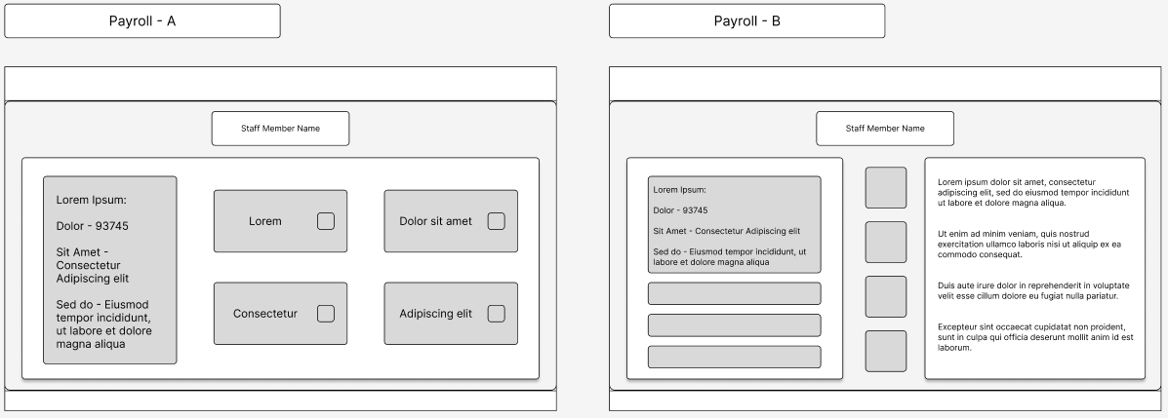
Figure C8: Employee Management Page Variations A and B
Figure C7: Payroll Page Variations A and B
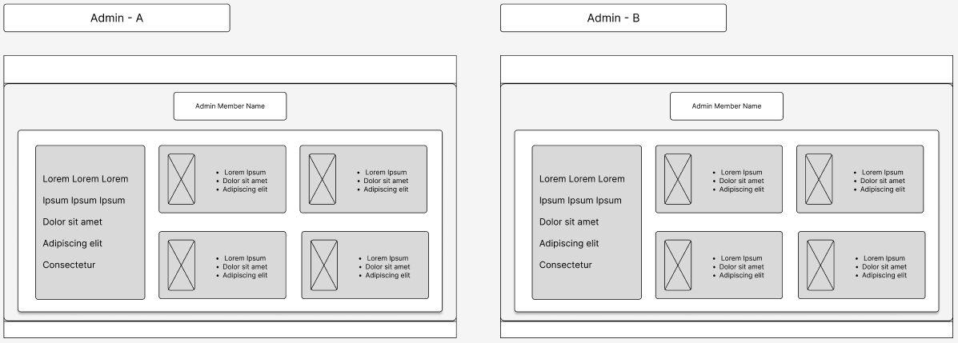
Figure C9: Admin Page Variations A and B

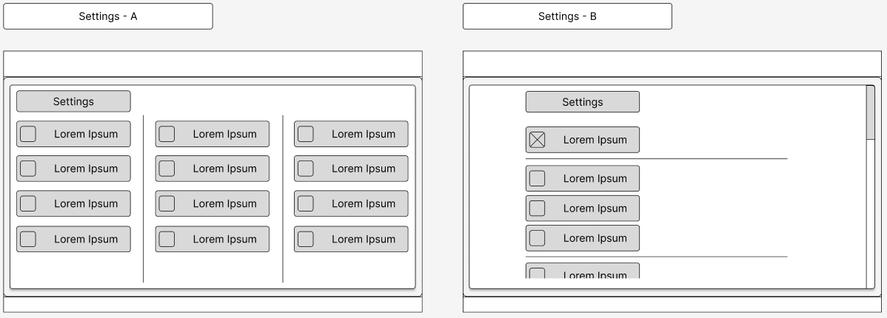
Figure C10: Settings Page Variations A and B

APPENDIX D: LOW FIDELITY USABILITY TESTING – JACK
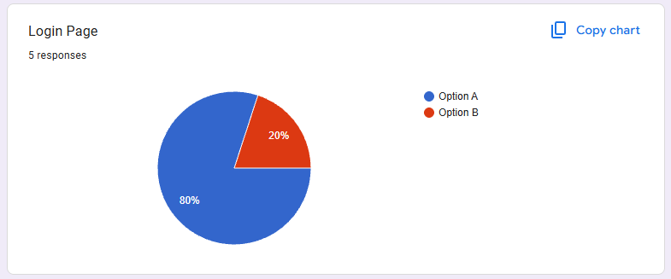
Figure D2: Login Page Preference – Style A vs Style B
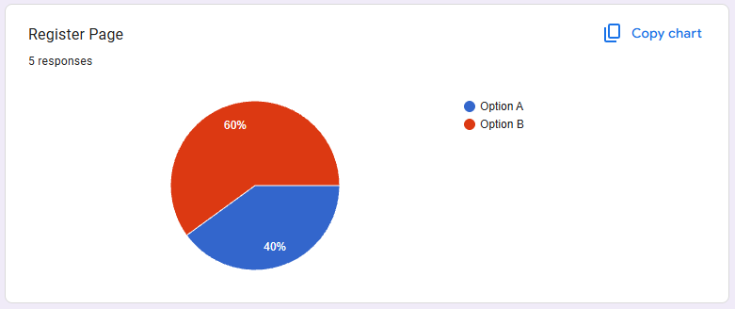
Figure D2: Register Page Preference – Style A vs Style B
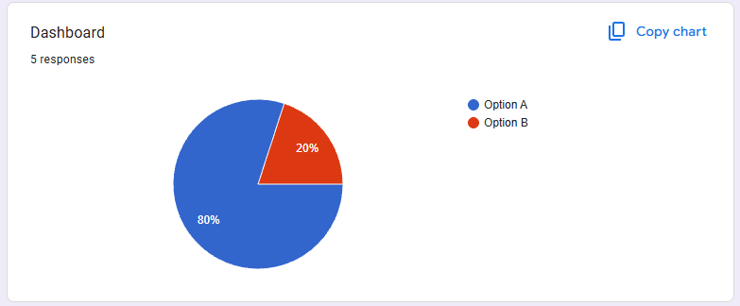
Figure D3: Dashboard Page Preference – Style A vs Style B
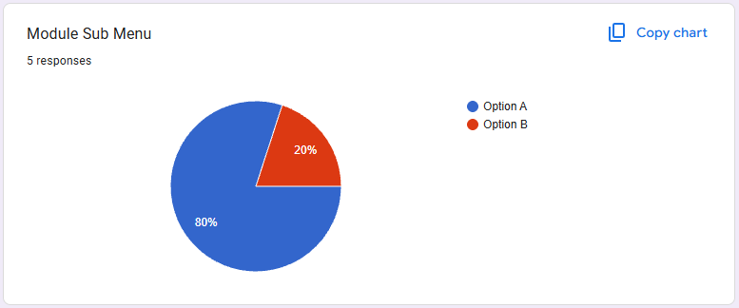
Figure D4: Module Sub Menu Preference – Style A vs Style B
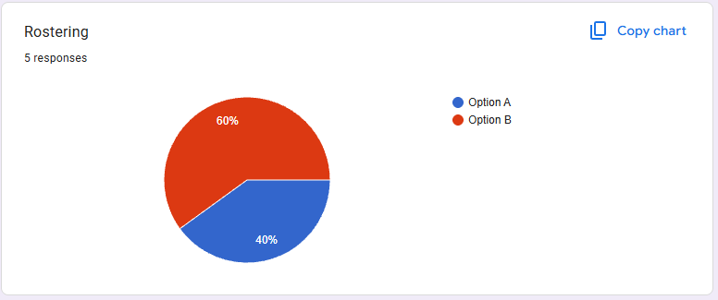
Figure D5: Rostering Page Preference – Style A vs Style B
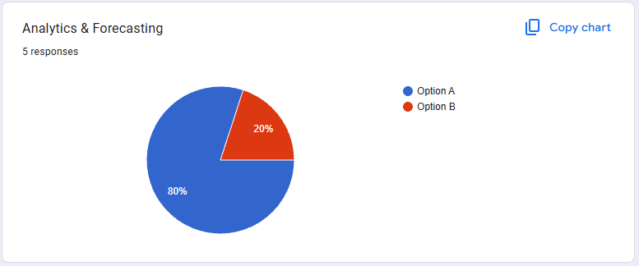
Figure D6: Analytics and Forecasting Page Preference – Style A vs Style B

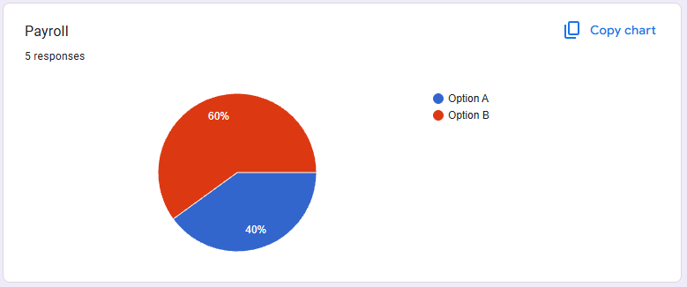
Figure D7: Payroll Page Preference – Style A vs Style B
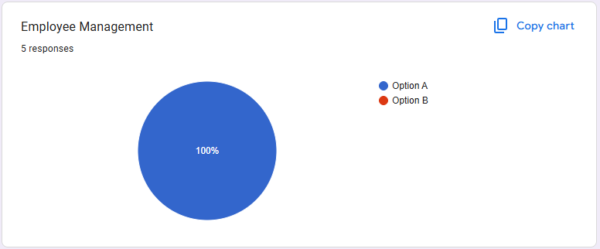
Figure D8: Employee Management Page Preference – Style A vs Style B
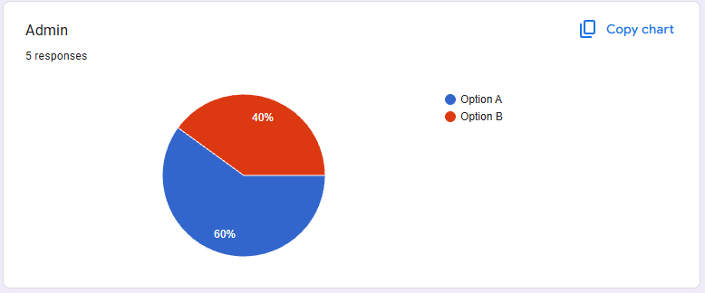
Figure D9: Admin Page Preference – Style A vs Style B

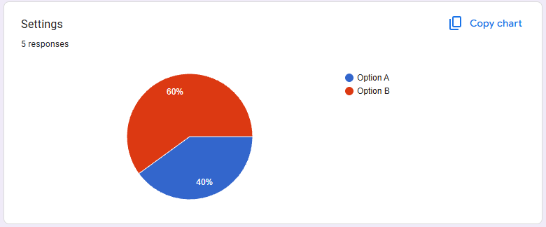
Figure D10: Settings Page Preference – Style A vs Style B

QUESTION # | FEEDBACK
Q1 | - I like the asymmetry  - More obvious log in
Q2 | - Again, the asymmetry
Q3 | - Unsure what's going on with B  - Clean simple to use
Q4 | - Cleaner. Unsure why you're creating new sub menu options at the end of the top row on B. Should either be at the start (top left) or end
Q5 | - Being able to see things seems better  - More slots available
Q6 | - feels nicer
Q7 | - nicer formatting
Q8 | - There's a scroll bar with all people there. With B it seems like you'd have to click an arrow until you get to the right person? Visually nice though, just not practical IMO
Q9 | - They're the exact same lmao
Q10 | - Just a gut feeling. I like the list instead of having everything there at the same time. Overstimulating
Table D1: Participants' comments on questions

