Bachelor of Software Engineering

Investigative Studio II

CS301.1 Proposal and pitch Presentation

Nakita Henry (270210724)
Jack Crichton (270399561)

Date of submission
20/03/2026

ABSTRACT
Small businesses in New Zealand commonly deal with significant operational issues in managing their workforce, ensuring correct payroll compliance, and making well-informed business decisions. Currently, many small business owners rely on a fragmented combination of spreadsheets, individual payroll tools, and analytics platforms, which can be a costly and error-prone approach that consumes valuable time and resources. Vizura is a proposed cloud-based, AI-powered business operations platform that is created to overcome these challenges through consolidation and providing a single, accessible solution for all user types.
Our platform will offer four integrated modules that detect sales trends, identify anomalies, and generate forecasts, alongside a natural language query interface that allows non-technical users to analyse their business data in a conversational manner. The rostering module will provide drag-and-drop shift scheduling, employee availability management, and a shift-swapping system, enabling managers to build and publish rosters efficiently. The payroll module will automate calculations in full compliance with the NZ Holidays Act (2003), and the Employment Relations Act (2000). This will cover holiday pay, annual leave entitlements, overtime, and public holiday rules, with automatically generated pay slips. Lastly, the employee management module will centralise staff profiles, contract types, pay rates, and leave requests.
Vizura will be developed using a modern technology stack including React.js for the frontend, Node.js for the backend API, Python for the AI/Payroll Calculator, PostgreSQL for data management, and Amazon Web Services for cloud hosting and storage. The platform will target New Zealand small businesses, marketing itself as an affordable, intelligent, and compliant all-in-one operations platform. The objective of this project is to deliver a functional minimum viable product that demonstrates the core capabilities of all four modules as a proof of concept, with future iterations planned for 302.

Keywords: Small business operations, Workforce management, Payroll compliance, Machine learning forecasting, Natural language processing, Business analytics, NZ employment law

TABLE OF CONTENTS

ABSTRACT ii
TABLE OF CONTENTS iii
INTRODUCTION 1
LITERATURE REVIEW 1
ML for Business Analytics and Forecasting 2
AI-Driven Workforce Scheduling and Management 2
Natural Language Processing for Business Intelligence 3
Landscape of AI integration within SMEs 4
RESEARCH QUESTION(S) 5
PROPOSED RESEARCH METHODOLGY 6
Product rationale 6
Proposed Product Features 7
Technology Stack 8
Explanation of the innovative and creative aspects of the product 8
Potential impact and applications of the product. 9
DEVELOPMENT STRATEGY 10
Planning 10
System Design 10
Implementation 11
Testing 11
Deployment and Iteration 12
TEAM COLLABORATION 12
CITATIONS 14
APPENDIX 16

In deciding a capstone project topic, the team at KiJa looked inwards. Searching within New Zealand industry for a possible lacuna in current SME (small-medium enterprise) systems, our focus primarily turned towards the hospitality and retail industries. Our team at KiJa, have ample professional work experience in the retail and hospitality industries respectively. Examining the online and physical workspaces, we determined a common, industry-wide problem; SME internal systems are fragmented by functionality, delaying workflow, income, and limiting accessible information/ services to employers/employees/stakeholders/admin alike.
Vizura will take said information, interpret and collate, while storing that information safely. Vizura will adapt to specific business models, and using an AI NLP agent, the team will be able to request the necessary information, services, or systems to allow for a singular, centralized system hub, for business requirements. Our MVP will provide good insight into the final product, a functioning system, able to receive information, store safely, categorize and organize by confidentiality levels/admin levels. The second stage will include design upgrades, further/secondary functionality, and potentially other changes subject to testing results/feedback.

LITERATURE REVIEW
Running a small business has never been straightforward, but the operating demands placed on owners today are greater than ever. Between managing staff, keeping compliance, and making sense of sales data, many owners find themselves operating multiple tools while still struggling to get a clear picture of how their business is actually performing. This review looks at three areas of technology: Machine Learning (ML) for business analytics and forecasting, Artificial Intelligence (AI) driven workforce scheduling and management, and Natural Language (NL) processing for conversational data querying.
It draws on six peer-reviewed and conference publications from 2023 to 2025, chosen for their relevance to small and medium business operations and the practical application of AI in that context. The aim is to understand what the research says works, where the gaps sit, and what that means for a platform like Vizura.

ML for Business Analytics and Forecasting
Traditional statistical forecasting has served businesses for decades, but machine learning has changed what's possible, and the research makes a strong case for the shift. A 2023 study by Rana and Machale tested ensemble ML approaches for sales forecasting, comparing XGBoost, LightGBM, and CatBoost across a structured retail dataset. Rather than picking the best single algorithm, they looked at what happened when all three were stacked together. The combined model achieved an R² value of 0.9990, getting the prediction right 99.9% of the time, and outperformed every individual approach on the margin of error too.
For Vizura, this directly supports the decision to build the 30-day forecasting module on an ensemble of algorithms rather than a single one. The evidence is clear: the unified approach is more reliable.
Sun (2022) offers another layer to this. A comparative study across retail sales data from over 1,000 physical stores found that LSTM performed best as a standalone model, largely because its built-in memory makes it well-suited to longer-term patterns including seasonal shifts or gradual changes in customer behaviour. When combined with XGBoost and LightGBM through model fusion, though, the results improved again, producing more accurate and more consistent predictions among different conditions. Across both studies, the same pattern holds: these algorithms cover each other's blind spots in ways no single model can.
One gap worth noting is that both studies used large, well-structured retail datasets. Small businesses typically don't have that. Their data tends to be patchy, inconsistent, and often doesn't stretch back far enough to establish reliable trends. Neither study covers that reality, so detailed calibration and ongoing testing will be required to make this work for Vizura's actual users.

AI-Driven Workforce Scheduling and Management
Workforce scheduling is one of those problems that sounds straightforward until you're actually doing it. Research increasingly points to AI as the most practical way to handle it well. A 2024 study by Murugesan et al. looked at AI's role in workforce management across a range of industry settings, finding that AI-driven approaches predict labour requirements, resource allocation, and scheduling demands far more accurately than traditional methods, where HR teams are essentially making educated guesses based on past experience. For small NZ businesses where the person doing the roster is often the same person handling everything else, that kind of automation is genuinely useful. The study also found AI expanding beyond scheduling into payroll processing and productivity, which sits closely with what Vizura is trying to do.
Ekuma (2024) takes a more extensive view, looking at how AI and automation have changed HR development practices across learning, talent management, and workforce planning. The finding is positive overall, but comes with a clear caution that these tools need to be adopted thoughtfully, with real attention paid to ethical, practical, and cultural matters. For Vizura, that means transparency can't be an afterthought. Employees need to be able to see and understand how their pay and schedules are being calculated. One consistent gap across the scheduling literature is that almost all of it focuses on large enterprise rollouts. Research on lightweight, affordable tools built for businesses with fewer than 20 staff is scarce, and that's exactly who Vizura is built for.

Natural Language Processing for Business Intelligence
Of all the features Vizura is being built around, the natural language query interface is arguably the most forward-looking, and the research in this space is moving quickly. Gawande et al. (2025) proposed a multimodal AI-powered chatbot that lets users query databases using plain English and voice input, rather than having to write SQL themselves. The system used a fine-tuned T5 transformer model to convert natural language into executable queries, and a user study with 20 participants returned strong usability and satisfaction scores. It's a meaningful proof of concept that transformer-based approaches can work in real user-facing applications, not just in research settings.
Eslami et al. (2024) looked at the wider text-to-SQL landscape, tracing how these systems have evolved from early rule-based approaches through to modern large language models. SQL is used widely by developers, but for non-technical users, it is still a real barrier. As more organisations rely on relational databases to manage growing volumes of data, tools that remove that barrier are becoming increasingly relevant. The study also flags that handling complicated, multi-condition queries accurately is still an unsolved problem, which is a useful reality check on scoping Vizura's MVP. Starting with a defined set of common query types is both a sensible technical decision and the one the research supports.
Across all three areas, the research points in the same direction. The technology works, but almost all of the implementations have been built for large organisations with large budgets. Accessible, integrated tools designed specifically for small businesses are largely absent from the literature.
Rana and Machale (2023) and Sun (2022) build a strong case for ensemble machine learning as the foundation of Vizura's forecasting module, while noting that performance on the small, patchy datasets most small businesses actually have still needs to be validated. Murugesan et al. (2024) and Ekuma (2024) confirm that AI-driven scheduling and payroll automation deliver real efficiency gains, but are clear that clarity and ethical design need to be baked in from the beginning. Gawande et al. (2025) and Eslami et al. (2024) show that NLP-powered querying is both technically achievable and appreciated by non-technical users, with query complexity being the main challenge to manage carefully in scope.
The thread running through all of it is the same gap. Nobody has built a unified, multi-functional platform designed specifically for the small business setting. That's the space Vizura is moving into, and research that follows this project's development could contribute something genuinely new to a pretty underserved area.

Landscape of AI integration within SMEs
Harnessing the landscape of technology, from the perspective of an SME can be both daunting and risky. Choosing the correct systems can make or break the success of the business, on the grounds that including new systems, especially those relying on AI systems or AI integration, comes with its own host of challenges, setbacks and risks. Making the decision to integrate AI into existing systems and business models requires resources, training, and understanding the requirements of the business, from an informational and logical perspective. Four articles have been cited, reviewed, and synthesized to help better understand what it looks like for an SME to integrate some form of AI system into their business model.
“Despite the vast potential of AI, its integration within small and medium-sized enterprises (SMEs) faces considerable hurdles, notably the challenges of change management. Overcoming these challenges and fostering AI adoption is imperative for SMEs to thrive” (Schwaeke et al., 2025). Usually incorporation/integration of AI involves some form of system automation, contextually structured per business model, and can involve some serious changes to an actively operating system. “This research suggests a fresh method for bettering private companies by combining large-scale data analysis with artificial intelligence and enhanced safety measures” (Mantri & Mishra, 2023). The issue lies more in the inaction to make said changes, leaving you behind in an extremely competitive market. “Failure to embrace AI could have dire consequences for SMEs, including lost competitiveness and market share, diminished economic influence, and reduced employment opportunities” (Schwaeke et al., 2025).
From the perspective of functionality within SMEs, the landscape of AI technology has also shifted in the last decade. “Research on algorithmic management has evolved from examining basic automation tools to investigating sophisticated AI agents that exercise autonomous control over information processing and organizational decision-making, fundamentally reshaping work arrangements and power dynamics” (Wang et al., 2026). Integrating these technologies is more of a “when” than “if” in this climate. Finding the most appropriate means to integrate successfully, ethically, and safely is the primary goal. “Adopting these technologies has great long-term consequences for sustainability, competitiveness, and continued innovation, thus small enterprises should definitely consider it” (Faruque et al., 2024).

RESEARCH QUESTION(S)
To what extent can a unified cloud-based platform reduce administrative overhead for small NZ businesses managing payroll compliance and workforce scheduling?
How can NLP-driven query interfaces lower the technical barrier for non-expert users interacting with business data analytics tools?

PROPOSED RESEARCH METHODOLGY

Product rationale
The product rationale for Vizura emerges directly from what the research identified as missing, and from what anyone running a small business in New Zealand can see pretty clearly when they look at the tools currently available to them.
Right now, the most common approach is to stitch together several separate products. Deputy handles rostering, PayHero manages payroll, Xero takes care of the accounting. Each one does its job reasonably well in isolation, but using all three means paying three subscriptions, learning three systems, and manually moving data between them whenever something changes. That's not just inconvenient, but it creates real risk, particularly around compliance, and it eats up time that small business owners simply don't have to spare.
What the literature makes clear is that ML-based forecasting, AI-driven scheduling, and NL data querying all deliver genuine value. The problem is that every meaningful implementation has been built for large organisations with the budgets and technical teams to support them. An affordable, properly integrated version built for small businesses doesn't really exist yet.
Vizura is built on the premise that it should. The goal is to bring these capabilities together in a single platform that doesn't require a technical background to use, designed around the way small business owners actually work rather than the way enterprise software assumes they do.
There's one more piece that sets Vizura apart from the tools already on the market. NZ employment law is specific and getting it wrong is costly. The Holidays Act 2003 and the Employment Relations Act 2000 set out clear obligations around pay, leave, and working conditions, and existing affordable tools handle those requirements inconsistently at best. Vizura is built with full compliance to both pieces of legislation from the ground up, not as an add-on.

Proposed Product Features
Vizura is organised into four integrated modules, each built to handle a particular operational need while sharing a common data layer underneath. That shared foundation is what allows intelligence to move across the platform rather than each feature operating in isolation.
The analytics and forecasting module lets business owners upload sales data via CSV or Excel, or enter figures manually, and immediately see AI-generated trend visualisations, anomaly alerts, and 30-day revenue forecasts. An ensemble ML model combining XGBoost and Prophet works from the business's own historical data to generate forecasts with confidence intervals. A natural language query interface, built on a fine-tuned transformer model, lets users ask plain English questions like "what was my best performing month this year?" and get instant visual answers without having to understand a line of code.
The employee rostering module gives managers a drag-and-drop weekly roster builder where shifts are assigned visually, with real-time conflict recognition based on each employee's submitted availability. Employees can request shift swaps through the platform, and those requests are routed to the manager for approval before anything is confirmed. Completed rosters can be saved as reusable templates, which cuts down the time spent rebuilding the same schedule week after week.
The payroll and leave management module automates pay calculations in full accordance with NZ employment law. Holiday pay is calculated at 8% of gross earnings per pay period, four weeks of annual leave is tracked and updated with each pay run, overtime is applied at the correct rate depending on the circumstances, and NZ public holidays are automatically detected with the right pay rules applied. PDF payslips are generated for each employee each pay period and made available for both the manager and the employee to download.
The employee management module brings all staff records into one place, covering contract type, pay rate, start date, and role. A leave request and approval workflow is built in, and an onboarding checklist walks managers through setting up each new employee's entitlements. Every employee also gets their own personal dashboard showing upcoming shifts, leave balances, and recent payslips.

Technology Stack
Vizura is built on a modern, industry-standard tech stack chosen to harmonize development efficiency, scalability, and commercial credibility.
The frontend is built in React.js, which provides a component-based architecture well suited to the platform's more complex interface elements like the drag-and-drop roster builder and interactive analytics dashboard. Supporting libraries include react-beautiful-dnd for drag-and-drop capability, Recharts for data visualisation, Tailwind CSS for consistent and efficient UI development, and Axios for API communication.
The backend runs on Node.js with the Express framework, providing a lightweight RESTful API layer that handles user authentication via JSON Web Tokens and bcrypt, manages data routing between modules, and coordinates communication with the Python AI microservice. Python handles all AI and payroll calculation logic, exposed as a separate microservice via FastAPI. The Python layer uses Pandas and NumPy for data processing, scikit-learn for anomaly detection, Prophet for time-series forecasting, and spaCy for natural language query processing. Keeping the AI engine as its own microservice means CPU-intensive operations don't slow down the rest of the application for the user.
PostgreSQL serves as the primary relational database, chosen for how well it handles the interconnected data structures that run through Vizura, covering the relationships between employees, shifts, pay runs, and analytics datasets. The full application is deployed on Amazon Web Services, using EC2 for application hosting, RDS for managed PostgreSQL, and S3 for secure storage of uploaded files and generated payslip PDFs.

Explanation of the innovative and creative aspects of the product
Vizura's central innovation isn't any single feature in isolation. It's the fact that everything lives in one place. Most small businesses today are already using some combination of tools to handle their operations, but those tools weren't built to talk to each other. The result is a patchwork of subscriptions, manual data transfers, and workarounds that eat up time without actually solving the underlying problem. Vizura brings forecasting, scheduling, payroll, and employee management into a single platform with a shared data layer, so information moves automatically between functions rather than being re-entered by hand.
What makes this genuinely different from the tools already on the market is the combination of intelligence and compliance in an affordable package. ML-driven forecasting and natural language querying exist in enterprise software, but not in tools priced and designed for a business with ten employees. Full, accurate compliance with the Holidays Act 2003 and the Employment Relations Act 2000 is technically required of every NZ employer, but handled poorly by most affordable platforms. Vizura addresses both of those gaps at once, which no current tool in this price range does.

Potential impact and applications of the product.
For small business owners, the most immediate impact is time. The hours spent each week building rosters, running payroll manually, chasing compliance, and trying to make sense of sales figures add up quickly, and for most small operators, those are hours taken away from actually running the business. Vizura is designed to give that time back.
Outside individual businesses, the platform has broader value across the NZ small business sector, which makes up the overwhelming majority of employers in the country. Better forecasting means more confident decisions around hiring and stock. Accurate, automated payroll means fewer compliance errors and less exposure to costly disputes. Accessible data querying means owners who have never written a line of code can still get real answers from their own business data.
As the platform matures, the shared data layer opens up further applications, including cross-module insights like flagging when a forecasted revenue dip may prompt a reduction in scheduled hours, or when leave balances are approaching thresholds that affect payroll. The foundation is built for that kind of intelligence, and it's where Vizura's long-term value lies.

DEVELOPMENT STRATEGY
The research underpinning Vizura doesn't just justify the product, it actively shapes how it gets built. Each finding from the literature review has a direct implication for what gets prioritised, what gets scoped carefully, and what needs to be tested before it can be trusted. The development process follows the Software Development Life Cycle (SDLC), moving through six stages: planning, system design, implementation, testing, deployment, and iteration (The complete guide to SDLC, 2023).

Planning
The planning phase is grounded in the gaps the literature identified. The research is consistent in showing that ML-based forecasting, AI-driven scheduling, and natural language querying all perform well at enterprise scale, but haven't been meaningfully translated into tools built for small businesses. That framing defines the scope of the MVP. Rather than trying to replicate enterprise software, the goal is to build the simplest version of Vizura that sincerely solves the core problems, with compliance, integration, and usability as mandatory foundations from day one.
User requirements are drawn from both the research and direct observation of how small NZ businesses currently operate. The recurring pain points, multiple subscriptions, manual data transfers, compliance uncertainty, and limited visibility into business performance, form the functional backbone of what the platform needs to deliver.

System Design
The architecture decisions made during the design phase reflect specific research findings. Eslami et al. (2024) identified query complexity as the principal challenge in natural language to SQL systems, which directly informed the decision to scope the NL query interface to a defined set of common query types in the initial build rather than attempting open-ended querying from the start. Rana and Machale (2023) and Sun (2022) together support the ensemble ML approach in the forecasting module, combining XGBoost, Prophet, and supporting models rather than committing to a single algorithm.
The decision to separate the AI engine as a standalone Python microservice is both a technical best practice and a practical response to the computational demands that ML forecasting and NLP processing place on a system. Keeping those operations isolated ensures they don't affect the responsiveness of the rest of the application.

Implementation
Development uses an iterative, feature-by-feature approach rather than attempting to build everything in parallel. The payroll and compliance engine is prioritised first, given that errors in this area carry the most immediate risk for users. Getting the Holidays Act and Employment Relations Act calculations right, and verifiable, is the foundation everything else sits on.
The rostering module follows, as it feeds directly into payroll and represents one of the most time-consuming manual tasks for small business owners. The analytics and forecasting module comes next, with the natural language query interface developed in parallel as a layer on top of the existing data infrastructure. Each module is built to connect to the shared data layer from the outset, so integration isn't something that needs to be retrofitted later.

Testing
Testing is structured around the two biggest risks the research detects. The first is model effectiveness on small, inconsistent datasets. Both Rana and Machale (2023) and Sun (2022) conducted their studies on large, well-structured retail datasets, which is not the reality for most of Vizura's target users. The forecasting module will be tested against deliberately imperfect data, including short histories, gaps, and irregular patterns, to validate that predictions stay useful rather than misleading under practical conditions.
The second risk is usability. Gawande et al. (2025) demonstrated strong satisfaction scores for NLP-driven interfaces among non-technical users, but that result came from a controlled user study. Real small business owners will interact with the platform differently, and usability testing with actual target users is built into the testing phase to catch friction points that controlled studies tend to miss.
Compliance accuracy is tested against NZ-specific scenarios including variable hours, public holiday calculations, and leave accrual edge cases, with each calculation verified against the relevant legislation before the payroll module is considered complete.

Deployment and Iteration
The proof of concept is deployed as a functional, hosted application on AWS, available to a small group of test users from the target market. Feedback from that group feeds directly into the next iteration, with priority given to issues that affect core functionality or compliance. The goal at this stage isn't a polished product, it's a working demonstration that the integrated approach is viable and that the core features deliver genuine value to the people they're built for.
The literature makes clear that the gap Vizura is entering is real. The development strategy is built to close that gap carefully, with the research informing not just what gets built, but how confidently each piece can be trusted once it is.

TEAM COLLABORATION
The Team at KiJa consists of two members. Kita Henry and Jack Crichton. Both are Software Engineering students in their third year at Yoobee Colleges. This Capstone project will be the first foray into the software industry for KiJa. KiJa will also be incorporating tutors of their designated electives into the project. Arthur, Fozia, and our primary tutor, Geethu will work as overseers and scrum masters, to assist the direction, scope and success of Project Vizura. Kita and Jack will split all work. Both working together as full-stack developers, to ensure both members not only understand, but are actively aware of all portions of the program, front to back.
KiJa intend to use organisation and management tools; Jira (see Figure 1), Confluence (see Figure 2), GitHub and other shared software to ensure both members can work together on all aspects of the project. Into the midst of the coding, KiJa will be doing daily sprints, and weekly scrums, to ensure all work backlog is caught early, addressed and then sorted before moving forward with the project. The project will involve some learning, as neither member took the Cloud Software elective for Year Two. KiJa intends to meet with Arthur (Cloud Tutor) weekly to discuss our learning of cloud/cloud storage for said week.
The two members at KiJa will distribute the work evenly, and if one member struggles to finish, fix or troubleshoot work allocated in the timeframe posted on Jira, that work will be added to the backlog, to be reviewed by both members together, to complete backlog archive before moving forward. Following the SDLC (Software Development Life Cycle) the team will take the tasks in stages, ensuring all requirements have been met up to that stage.

CITATIONS
Ekuma, K. (2024). Artificial intelligence and automation in human resource development: A systematic review. Advances in Developing Human Resources, 26(1). https://doi.org/10.1177/15344843231224009
Eslami, S., Golshan, B., & Hristidis, V. (2024). From natural language to SQL: Review of LLM-based text-to-SQL systems. arXiv. https://arxiv.org/abs/2410.01066
Faruque, M. O., Chowdhury, S. N., Rabbani, M. G., & Khan, N. A. (2024). Technology adoption and digital transformation in small businesses: Trends, challenges, and opportunities. International Journal for Multidisciplinary Research, 6(5). https://doi.org/10.36948/ijfmr.2024.v06i05.29207
Gawande, A., Bhusari, P., Ingole, P., & Wakekar, R. (2025). Bridging natural language and databases: Intelligent conversational system for automated SQL query generation using natural language processing. International Journal on Advanced Computer Engineering and Communication Technology, 14(3s), 86–93. https://journals.mriindia.com/index.php/ijacect/article/view/1602
Mantri, A., & Mishra, R. (2023). Empowering small businesses with the force of big data analytics and AI: A technological integration for enhanced business management. The Journal of High Technology Management Research, 34(2), Article 100476. https://doi.org/10.1016/j.hitech.2023.100476
Murugesan, U., Subramanian, P., Srivastava, S., & Dwivedi, A. (2024). Workforce management in the era of generative AI. Electronic and Electrical Engineering Letters. https://www.eelet.org.uk/index.php/journal/article/download/2359/2116/2607
Rana, R., & Machale, T. (2023). Ensemble machine learning models to forecast sales. EAI Endorsed Transactions on Internet of Things, 10. https://doi.org/10.4108/eetiot.6453
Schwaeke, J., Peters, A., Kanbach, D. K., Kraus, S., & Jones, P. (2025). The new normal: The status quo of AI adoption in SMEs. Journal of Small Business Management, 63(3), 1297–1331. https://doi.org/10.1080/00472778.2024.2379999
Sun, Y. (2022). Sales prediction based on machine learning approach. In Proceedings of the 2022 International Conference on Computers, Information Processing and Advanced Education. Atlantis Press. https://www.atlantis-press.com/article/126001716.pdf
Wang, S., & Zhang, H. (2026). Industrial information integration through autonomous AI agents: Paradoxical effects on transparency, dehumanization, and responsible retail operations. Journal of Industrial Information Integration, 51, 101089. https://doi.org/10.1016/j.jii.2026.101089
The complete guide to SDLC. (2023). Atlassian. https://www.atlassian.com/en/agile/software-development/sdlc

APPENDIX
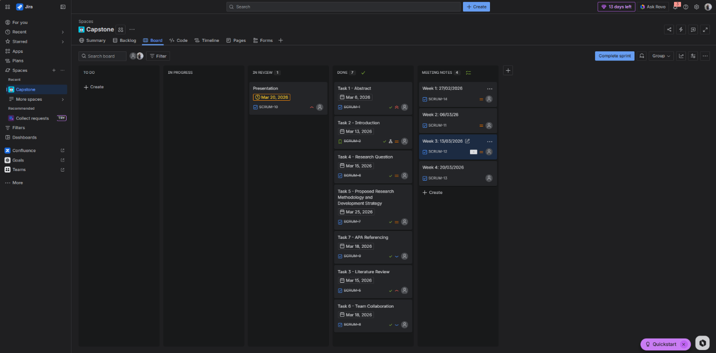
Figure 1: Jira board for project management.
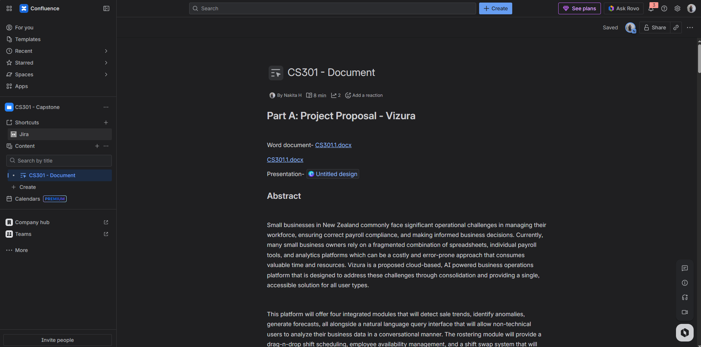
Figure 2: Confluence board for team collaboration.

