**Research Proposal**

**Web Application for an Online Cosmetic Store**

**Why This Topic Was Chosen (Project Relevance):**

The cosmetics market is one of the fastest-growing industries in Kazakhstan. More and more people prefer to order beauty products online due to the convenience, accessibility to a wide range of products, and time savings. This topic was chosen to create a modern, user-friendly, and competitive web application that meets user needs by providing enhanced functionality and an attractive interface.

**Analysis of Competitors**

* Only.kz:

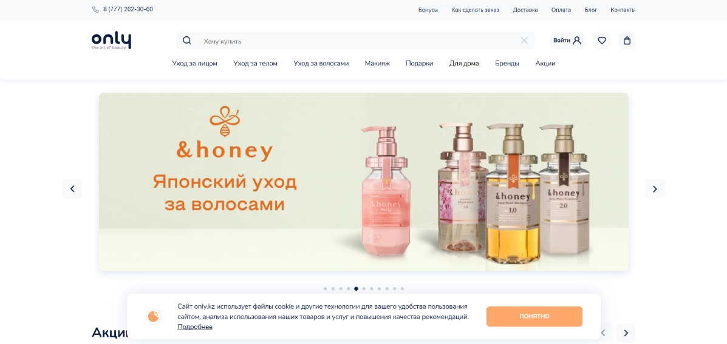

Figure 1. Only.kz's main page

* + Advantages: Minimalist design, affordable prices, and fast website performance.
  + Disadvantages: Narrow product range and absence of a review system.

Figure 2. Only.kz's pricing

* Makeup.kz:

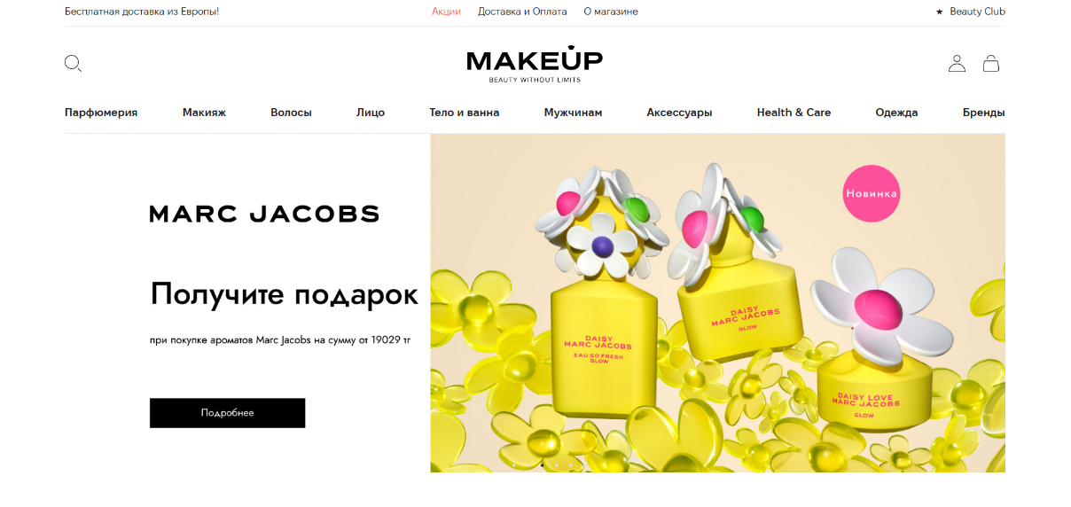

Figure 3.Makeup.kz's main page

* Advantages: Wide product range, frequent promotions, and fast delivery.
* Disadvantages: Limited filtering options and lack of personalized recommendations.

Figure 4.Makeup.kz's pricing

**How Application Will Compete:**

* More advanced filtering options (by skin type, brand, price, etc.).
* Loyalty system for returning customers.
* Attractive and intuitive design.
* Built-in reviews and product ratings from users.

**Target Audience**

* Age: 18–35 years old.
* Gender: Women and men.
* Needs: Easy search for beauty products, access to other users' reviews, affordable prices, and a loyalty program.

**Project Features**

* Product Filters: Users can search products by categories, brands, prices, skin types, and other parameters.
* Recommendations: Display of popular products and new arrivals.
* Reviews and Ratings: Customers can leave feedback and rate products.
* Loyalty System: Users earn bonus points for purchases, which can be redeemed for discounts.
* Responsive Interface: Seamless experience across all devices, including smartphones and tablets.

**Work Plan**

| **Task** | **Week 7** | **Week 8** | **Week 9** | **Week 10** |
| --- | --- | --- | --- | --- |
| **Research & Proposal** | **✔** |  |  |  |
| **Create ERD** |  | **✔** |  |  |
| **Develop UI/UX** |  | **✔** |  |  |
| **Implement Core Features** |  |  | **✔** |  |
| **Testing & Bug Fixing** |  |  |  | **✔** |

**Architectural Definition**

The architectural definition of the cosmetic store web marketplace using Go focuses on the components and design decisions that will enable the platform to be efficient, scalable, and secure. Below is the breakdown of the key architectural components when utilizing Go for the backend development.

* **Frontend (User Interface):** The frontend will handle user interactions and display cosmetic products. This will be built using HTML, CSS, JavaScript, and frontend frameworks like React or Vue.js to ensure a responsive and dynamic UI.
* **Backend (Go):** The backend will be responsible for processing business logic, interacting with the database, and handling API requests. Go (Golang) will be used as the server-side language because of its high performance, concurrency support, and ease of scaling.
* **Database**: The database will store key data such as user profiles, products, orders, and payments. A relational database like MySQL or PostgreSQL will be used to ensure structured storage and easy querying of data.
* **Authentication & Authorization:** User authentication and authorization will be implemented using JWT (JSON Web Tokens) or OAuth for secure user sessions, account management, and data access control.
* **Payment Integration**: Integration with third-party payment gateways (e.g., Stripe or PayPal) will be done to securely process payments.
* **Hosting & Deployment:** The platform will be hosted on a cloud platform like AWS, DigitalOcean, or Heroku for scalability and reliability.

**References**

* <https://makeup.kz/>
* <https://only.kz/>
* https://d8kxfugt0wi.app.projectmanager.com/share/1RF15FLF