User Manual for LED Badge

I. What is LED badge?
1、Open the Inner box, make sure the following items inside:
Item | Quantity
LED Badge | 1pc
USB Charger | 1pc
USB Cable | 1pc
CD | 1pc
User Manual | 1pc

Software install
Step1：Open the CD，see the following message：

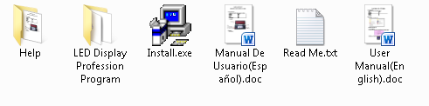

Please check “Read Me.txt”, then

- Run the "Install.exe"
- If you want to input Spanish characters, Please click
"2. Professional Program”
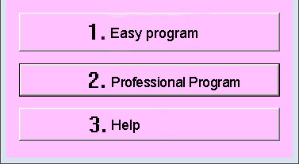
After finished, you will see the shortcut on the desktop.
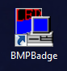

I How to use “Professional Program”?

Any languages can be input to LED badge by this program.
1
2
3
4
5
14
6
7
8
9
10
11
12
13
15
16
17

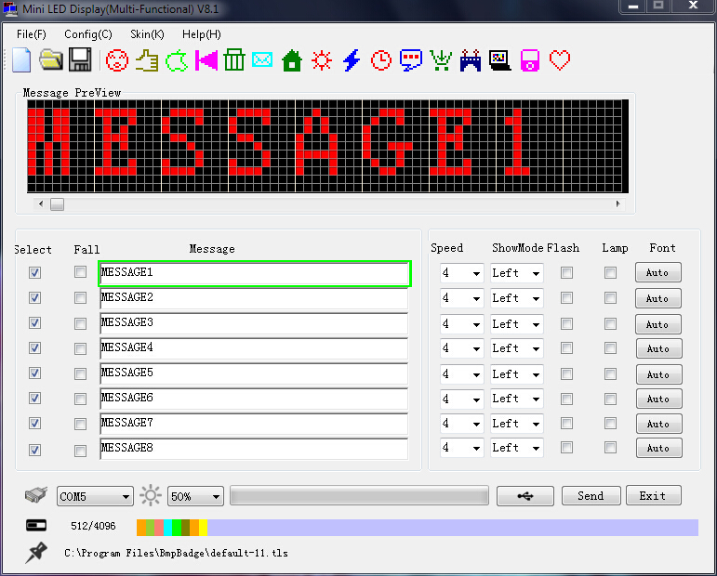

Function:
- File：Can New, Open, Save, Save As and Exit.
- Config: You can see “Option” and “Language”
Option: Select 11 pixels, 12 pixels or 16 pixels according to your Led badge
Language: select the language you want, Simple Chinese, Traditional Chinese, Japanese, Korean, English and Spanish are available。
- Skin: Choosing the skin of interface.
- Help: If you need to know how to use the Led badge, please click here
- Available icons: Click which coin you want to display on the Led badge
- Select：Selecting which message you want to display on the Led Badge, total 8
messages
- Fall: Characters can vertical 90 degree
- Message: Input the content you want to display on the Led badge
- Speed: 8 speeds available, 1 is the slowest, 8 is the fastest
- Show mode: Left, Right, Up, Down, Freeze, Animation, Piling, Split, Laser, Rotate
- Flash: If select the blank , the message will be flash on the Led badge
- Lamp: If select the blank, a border will show around the message.
- Font: “Auto” means show the default font, If you want to choose the font type and font size by manual, please click “Auto”, you will see the following picture
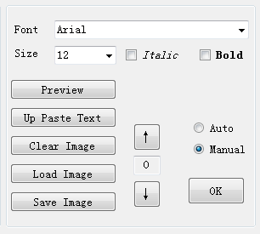
Please follow the “Manual mode Guide” below.

- Preview window: Set the preview width in “Option”
- Com: After you connect the Led badge to the PC, the Com port will come out automatically
- Brightness: 25%、50%、75%、100%；
- Send: When you finish your editing, you can send the message to your Led badge.

Manual Mode Guide：
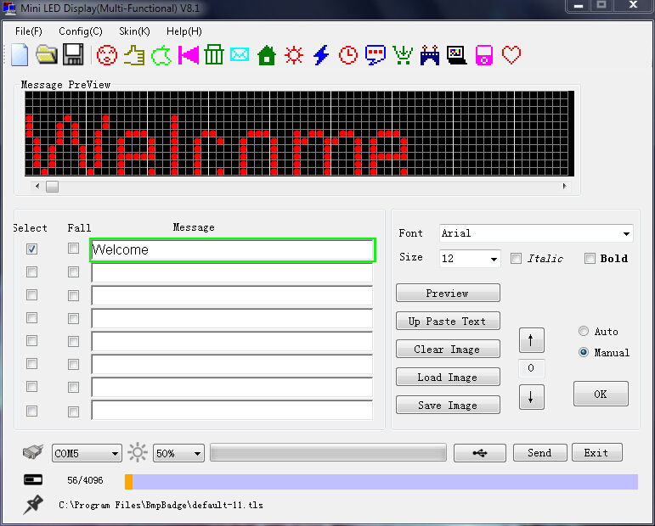

- You can set Font type, size, Italic and Bold, Also can load image
- In Message Preview, you can draw any image that you want to display (press the right button of mouse to cancel the dots one by one), click “Up Paste Text” to clear the whole image you drew.
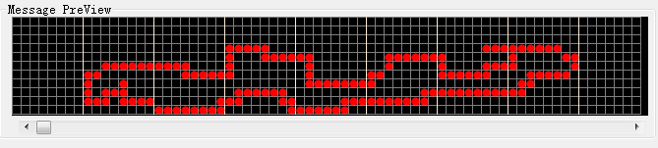
- If you want to back Auto mode, please click “Auto”, then press “OK”

How to charge?
When the LED card battery is about to run out, the brightness will be decreased, so it is necessary to charge the battery The correct charging method :
Use the charger (recommended)
Turn on the LED badge (Attention), plug in the USB line, connect to the charger to start charging. At this time, the charging icon will appear on the LED badge, and the charger indicator is red. When the indicator light is changed completely green, please don't remove the charger until the charging icon is full and static.
USB charging (not recommended)
Turn on the LED badge (Attention), connect the Led badge to PC via the USB cord, Then charging icon appears on the badge, when this icon is full and static, please remove the Led badge from the PC.
Charging Icon
