**INSPECT (v5.0) Data Flagging Tool Help**

1. **Introduction**

INSPECT is an online tool that allows visual inspections of data series provided by TERENO sensor observation services. INSPECT is developed based on the 52°North Sensor Web Client v3.11. The online tool can be used to query and visualize time series; however, only authorized users are allowed to perform data flagging. The flagging tool is available at: <http://icg4aida.icg.kfa-juelich.de/agrosphaere/technik>

1. **Overview**

This is the default view when the users access the flagging tool via the AIDA portal. The main page is divided into three sections: *Header*, *Legend* and *Diagram*.

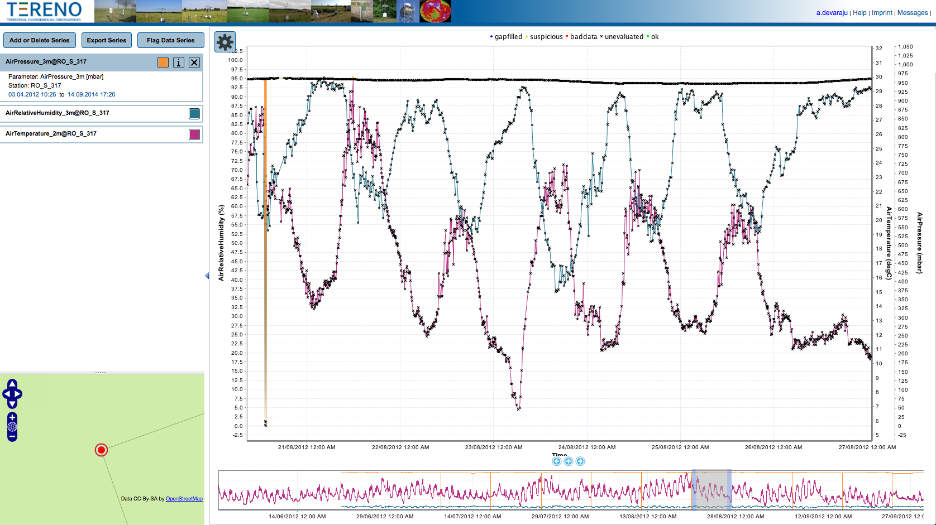

**Main Diagram**

**Header**

**Legend**

**Overview Diagram**

**Overview Map**

**Legend Entries**

**Date & Axis Changer**

**Diagram**

Figure 1. Main view of INSPECT.

1. **Header**

The following are short descriptions of the links on the header.

|  |  |
| --- | --- |
| Link | Descriptions |
| {a.devaraju} | The username of the logged in user. This is detected automatically when you log in via AIDA. |
| Help | Help manual |
| Imprint | Statements covering the scope of rights and basic issues that arise out of the operation of the tool. |
| Messages | This link displays the message/error console. |

1. **Main and Overview Diagrams**

The selected time series are displayed as main and overview diagrams. The left and right arrows below the main diagram can be used to navigate the time axis of the main diagram. The time period of the main diagram can also be adjusted by (a) moving and adjusting the grey box on the overview diagram, or (b) selecting specific start and end dates via the *Date & Axis Changer*. The *Date & Axis Changer* can also be used to change the time interval (e.g., hours, days, weeks) of the overview diagram, and the range of y-axes. The following options are available to change the range of a y-axis:

* Auto: The axis range is automatically adjusted to fit the data
* AutoIncludeZero: If the range is automatically calculated, the axis is forced to include zero.
* Custom: The range of an axis is set by the user.

**Left and right arrows**

**Date & Axis Changer**

**Grey box**

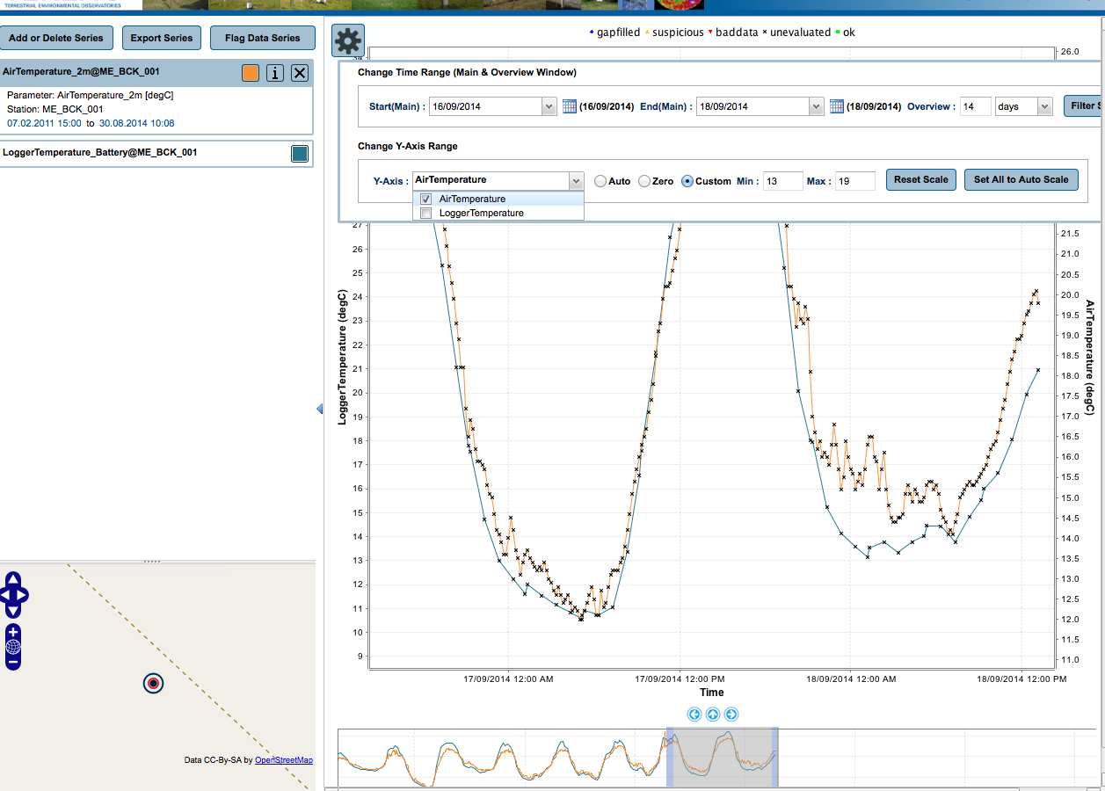

Figure 2. Main and overview time series diagrams.

Hovering mouse over data points will display tooltips containing date, value, processing level and flag information. The data levels (e.g., Level 1, Level 2a, Level 2b, Level 2c) represents a summary of processing and assessment applied to the data. Flags are quality descriptors (e.g., ok, baddata, suspicious, etc.).

1. **Legend**

The legend is divided in a button area, underneath legend entries and an overview map. The overview map indicates the location of the station that produced the selected time series.

|  |  |
| --- | --- |
| Buttons | Descriptions |
| Add or Delete Series | This menu has five sub-menus: (a) add a time series to the diagram view, (b) delete all time series at once, and (c) restore default time series colors, (d) save current time series view, (e) open saved time series view (history). |
| Export Series | Produce the current view of time series as PDF file |
| Flag Data Series | Flag the data series and change the symbols of the data flags. |

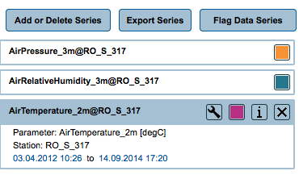

Figure 3. Legend entries.

The tool will display the first 12 series based on default color scheme as below. The default colors can be overridden by assigning a new color with the time series legend box (see the color box on the legend entry). You can reset the series to default colors by selecting the following options: *Add or Delete Series > Reset Series Colors*

1. #f79133 orange
2. #26778e turquoise
3. #b83084 lila
4. #3E6CF0 blue
5. #006300 dark green
6. #800000 maroon
7. #636363 grey
8. #99CC00 green
9. #FF00FF pink
10. #FFCC00 yellow
11. #000080 dark blue
12. #6F4210 brown

A legend entry header (Figure 3) consists of label (e.g., *AirTemperature_2m@RO_S_317*) and 4 buttons  as below:

* This tool button is only visible when the maintenance information of a given time series is available for the specified period.
* The color button is used to change the diagram style (e.g., line color, width, type) of the time series
* The info button displays the metadata of a sensor
* The remove button deletes the time series from the diagram view

Under the header are some additional information about time series and the possibility to jump to the *first* and *last* value of the time series.

* 1. **Add Series**

The time series can be added or modified with three options: *Map Search*, *Theme Search* and *Saved Search Templates*.

With the map-based search (Figure 4), first, it is necessary to select an observation service and then an observed property. The sensors locations are filtered on the map accordingly. After selecting a sensor location on the map, a mini-window with sensor metadata will be displayed. Then, the user can submit the request for adding the time series.

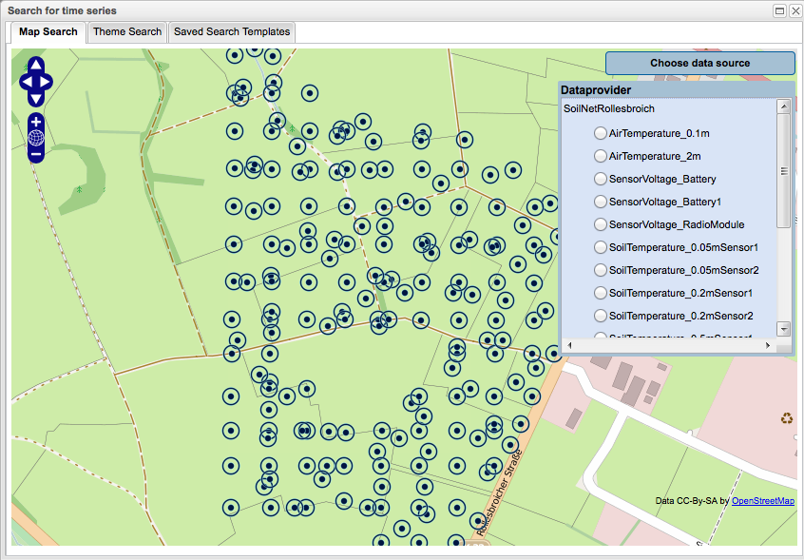

Figure 4. Add time series (map-based search)

The theme-based search (Figure 5), allow user to add one or more time series. First, select the service, followed by an offering and a station and then it’s related observed properties. You may enable the time range option to add series on a specific time period. There are four buttons available on this window:

* **Add to Existing Series**: This will add the newly selected time series into existing time series.
* **Clear and Add New Series**: This will clear existing time series and then add the new time series.
* **Clear Form**: Reset all values.
* **Save Current Search**: This will save the search information (e.g., service, offering, station, property). The information is stored locally within the user’s browser with no expiration date. The data will not be deleted when the browser is closed, and will be available the next day, week, or year.

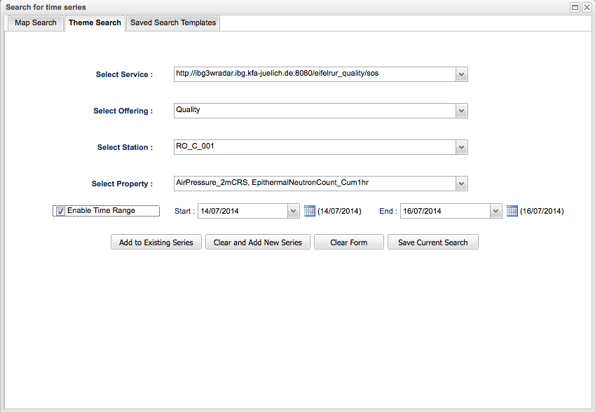

Figure 5. Add time series (theme-based search)

With the search templates (Figure 6), you can add time series based on previous search information. Click *Modify Station*, to change the station that has the same set of observed properties.

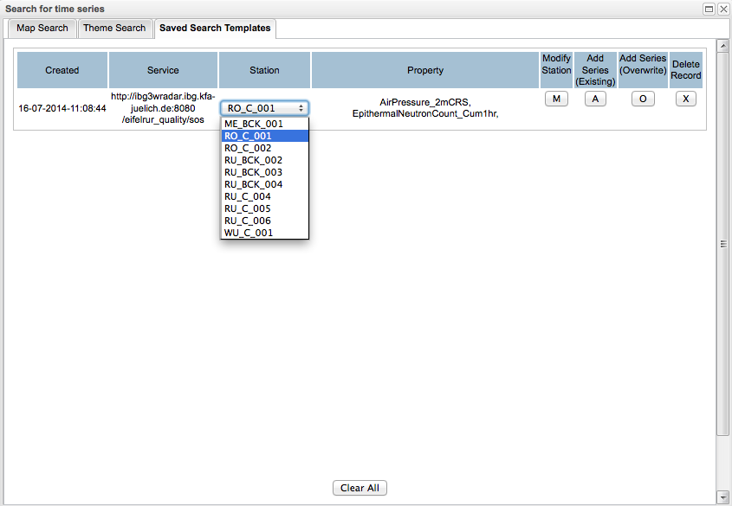

Figure 6. Saved Search Template

* 1. **Flag Data Series**

Data series can be flagged with the following options:

* **Multi-Point Flagging**: Select one or more data points of a selected time series (on the *Legend Entries*) and then add/overwrite the flags (Figure 7).
* **Range Flagging**: Specify the start and the end of one or more time series, and then add/overwrite the flags (Figure 8).
* **View-based Flagging**: With the view-based flagging option (Figure 9), users can either flag data points of one or more time series as displayed on the main diagram or assign a custom rule with a particular observed property (e.g., AirTemperature < 20). The latter is only possible with the online-mode of flagging.

The *Approve Data Series* button on the range-based and view-based windows enable the users to release the data series (either in offline/online mode) without modifying the flags information. Note that this option only updates the data level of non-unevaluated data.

If you click *Add Flag*, only data points with *unevaluated* flags will be updated. If you click *Overwrite Flag*, this will replace existing flags with the newly selected flags.

Note: You are not allowed to flag Level 1 data. Users can view all time series from a selected service, but can only flag time series from the stations they are responsible for. An error message will be displayed if you try to flag non-permitted time series. This validation is included in all three types of data flagging (multi-point, range and view).

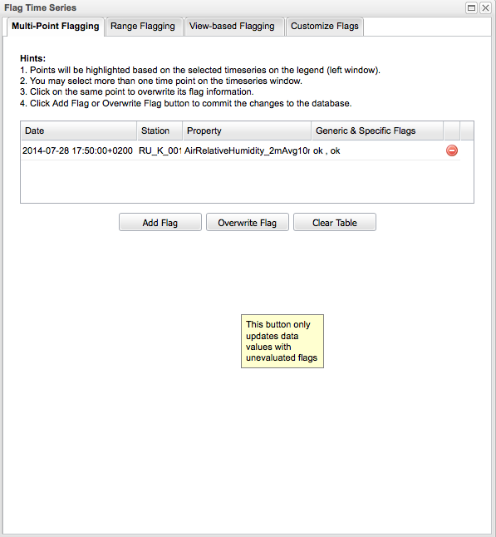

Figure 7. Multi-point flagging.

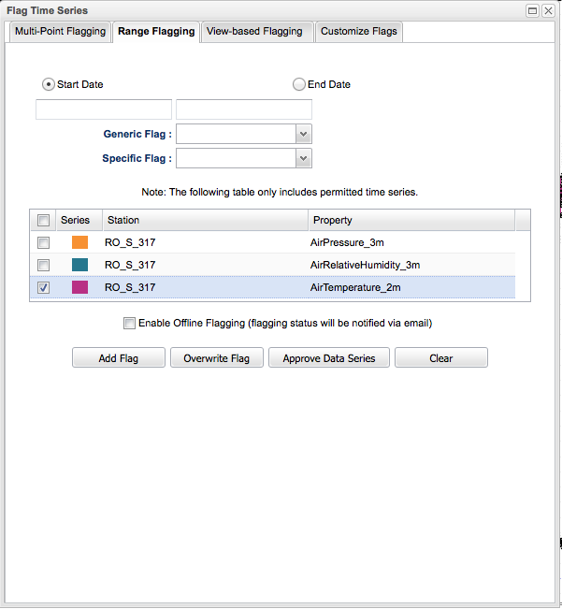

Figure 8. Range-based flagging.

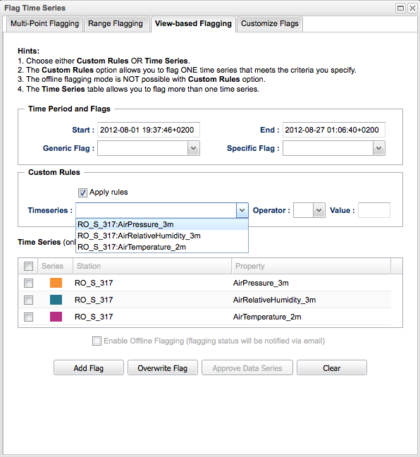

Figure 9. View-based flagging.

The data flags are distinguished based on colors and shapes. Select *Customize Flags* to change the default shapes of flags.

