Final Results Submission
P09: Visual Similarity Search using Self-Supervised Embeddings (Oxford-IIIT Pet)
Stage 5, final results. Owner: Aslan Iakupov. Submission: 3 November 2026. Experiments: 31 October 2026.

1. Summary
We compare four frozen pretrained image encoders for breed-based visual retrieval on Oxford-IIIT Pet. All models use a fixed gallery of 1,840 images, 1,840 validation queries and 3,669 official test queries. The Stage 5 experiment executes the complete evaluation again and preserves per-query rankings for failure analysis. DINOv2 B/14 achieves the highest reproduced test Precision@5 at 90.64%. This report presents full quality metrics, repeated runtime measurements, the comparison with Stage 3, and three observed zero-hit retrieval failures.

2. Experimental setup
The research question is whether DINO and DINOv2 embeddings provide better retrieval quality than supervised DeiT embeddings, and what runtime cost accompanies the quality difference. The experiment evaluates pretrained representations without training or fine-tuning. Breed agreement defines relevance; it is a measurable proxy for visual similarity rather than a complete description of perceptual similarity.
Encoder | Pretraining family | Feature dimension
DINO S/16 | Self supervised DINO | 384
DeiT S/16 | Supervised ImageNet 1k | 384
DINOv2 B/14 | Self supervised DINOv2 | 768
DeiT B/16 | Supervised ImageNet 1k | 768
- Dataset split: The official trainval partition is split 50/50 with breed stratification and seed 42. The committed manifest is reused unchanged. Gallery, validation and test image IDs are mutually disjoint. Every breed has 46 to 50 gallery images. The complete 7,349-image dataset is checked against the manifest before inference.
- Preprocessing: All inputs are converted to RGB, resized to a 256-pixel shorter side using bicubic interpolation, center-cropped to 224 by 224 pixels and normalized with ImageNet statistics. Frozen encoders return CLS features, which are L2-normalized in FP32. Exact cosine similarity ranks the gallery. Labels enter metric computation only.

3. Final evaluation metrics
For a query q, let cK(q) be the number of same-breed images in the first K neighbors and G(q) the number of same-breed gallery images. P@K = cK(q)/K, R@K = cK(q)/G(q), and Hit@5 is one if c5(q) is positive and zero otherwise. Every reported score is the mean over all queries in that split, not over the latency sample. Tables use percentages.
Table 1 Stage 5 test quality on 3669 queries
Model | P@5 | P@10 | R@5 | R@10 | Hit@5
DINO S/16 | 84.16 | 81.56 | 8.47 | 16.41 | 97.47
DeiT S/16 | 86.65 | 85.27 | 8.72 | 17.16 | 96.92
DINOv2 B/14 | 90.64 | 88.81 | 9.12 | 17.87 | 98.20
DeiT B/16 | 87.52 | 86.04 | 8.80 | 17.31 | 96.78
Table 2 Stage 5 validation quality on 1840 queries
Model | P@5 | P@10 | R@5 | R@10 | Hit@5
DINO S/16 | 86.09 | 82.78 | 8.66 | 16.65 | 98.26
DeiT S/16 | 88.83 | 86.92 | 8.93 | 17.49 | 98.59
DINOv2 B/14 | 91.12 | 88.84 | 9.16 | 17.87 | 98.48
DeiT B/16 | 89.39 | 87.67 | 8.99 | 17.64 | 98.75
Table 3 Stage 3 recorded test quality on the identical manifest
Model | P@5 | P@10 | R@5 | R@10 | Hit@5
DINO S/16 | 84.16 | 81.56 | 8.47 | 16.41 | 97.47
DeiT S/16 | 86.65 | 85.27 | 8.72 | 17.16 | 96.92
DINOv2 B/14 | 90.64 | 88.81 | 9.12 | 17.87 | 98.20
DeiT B/16 | 87.52 | 86.04 | 8.80 | 17.31 | 96.78
The maximum absolute Stage 5 versus Stage 3 difference across all 40 quality values is 0.000000 percentage points. New quality values are recomputed independently from every saved top-10 ranking and the committed gallery labels. Historical aggregate values are cross-checked against JSON, CSV and the recorded download verification file; their original rankings are not available in the supplied archives.
Recall is numerically lower than precision because only 5 or 10 of the 46 to 50 relevant gallery images can be returned. Hit@5 measures the presence of at least one relevant neighbor and does not imply that all five results are correct. Individual failure counts and illustrated zero-hit queries are examined below.

4. Runtime measurements
Training time is not applicable: all four encoders use frozen pretrained weights, with no training or fine-tuning. We measure inference, gallery construction, image decoding and preprocessing, and exact nearest-neighbor search.
Historical Stage 3 measurements use Tesla T4 on Linux, PyTorch 2.11.0+cu130, CUDA 13.0, FP32, gallery batch size 64 and two workers. Stage 5 uses the local GTX 1060 3GB on Windows with PyTorch 2.5.1+cu118, CUDA 11.8, FP32, gallery batch size 8 and two workers. The lower batch size accommodates local device memory. Single-query latency uses batch size one. DINOv2 runs without optional xFormers acceleration. Cross-hardware timing differences do not measure a change in model quality.
Each timing experiment uses three fresh gallery builds and the same 200 test query IDs sampled with seed 42. Model order rotates between repeats. The tables report the median of three repeat-level medians, followed by the minimum and maximum in brackets. Gallery values summarize three complete rebuild times. These ranges describe repeat variability, not statistical confidence intervals.
Table 4 Historical Tesla T4 runtime median and range across three repeats
Model | Gallery s | Embedding ms | Search ms | Preprocess ms
DINO S/16 | 13.207  [13.173, 13.238] | 6.100  [6.059, 6.222] | 0.226  [0.224, 0.227] | 5.864  [5.839, 5.869]
DeiT S/16 | 13.192  [12.915, 13.269] | 5.082  [5.011, 5.092] | 0.225  [0.224, 0.225] | 5.837  [5.752, 5.855]
DINOv2 B/14 | 30.597  [30.461, 30.681] | 18.859  [18.786, 19.102] | 0.264  [0.252, 0.264] | 5.891  [5.804, 5.962]
DeiT B/16 | 22.807  [22.444, 22.833] | 12.544  [12.368, 12.763] | 0.254  [0.252, 0.261] | 5.872  [5.864, 5.959]
Table 5 Newly measured GTX 1060 runtime median and range across three repeats
Model | Gallery s | Embedding ms | Search ms | Preprocess ms
DINO S/16 | 35.157  [34.645, 35.372] | 11.589  [11.289, 11.645] | 0.373  [0.350, 0.375] | 5.608  [5.471, 5.653]
DeiT S/16 | 33.869  [32.741, 34.130] | 9.586  [9.401, 9.728] | 0.372  [0.362, 0.386] | 5.577  [5.550, 5.650]
DINOv2 B/14 | 77.617  [77.395, 79.014] | 37.399  [37.358, 37.484] | 0.423  [0.392, 0.572] | 5.577  [5.568, 5.682]
DeiT B/16 | 66.314  [65.165, 67.740] | 28.815  [28.710, 29.420] | 0.526  [0.378, 0.564] | 5.579  [5.490, 5.643]
Gallery timing includes image loading, deterministic transforms, forward passes, L2 normalization and transfer to host arrays after file-cache warm-up. Saving arrays is excluded. Per-query preprocessing includes decoding and transforms. Embedding includes the host-to-device copy, inference and normalization. Search includes exact cosine top-5 and return of result indices to the host. CUDA synchronization and warm-up precede measured GPU work.
The gallery timer also includes creation of DataLoader worker processes. Windows uses process spawning, whereas the historical environment is Linux. Consequently, a gallery-build difference between these environments includes operating-system and worker-startup costs as well as GPU inference and batch-size effects.

5. Comparison and observations
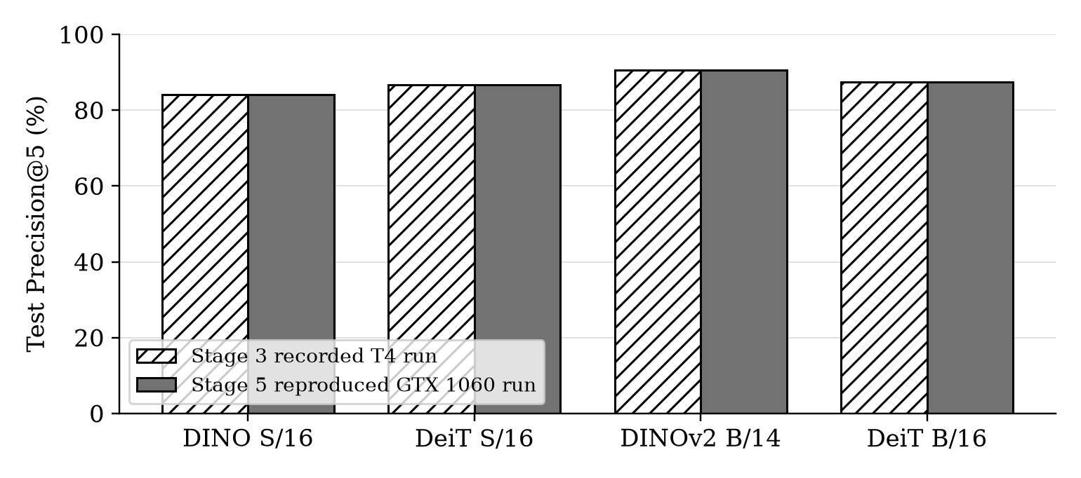
Figure 1 Test Precision at 5 in the recorded Stage 3 and reproduced Stage 5 evaluations
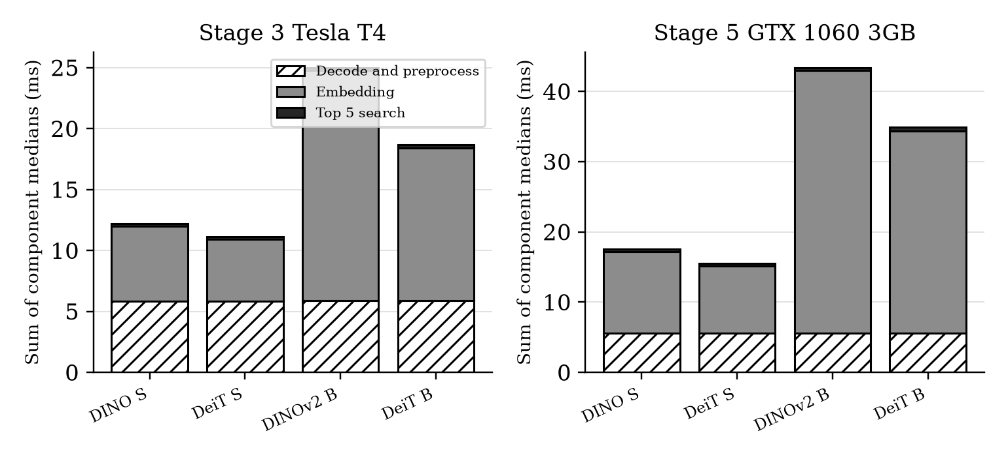
Figure 2 Component medians on two devices with separate vertical scales
- Retrieval quality: DINOv2 B/14 gives the highest test P@5, 90.64%, exceeding supervised DeiT-B by 3.12 percentage points.
- Inference cost: supervised DeiT-S has the lowest median embedding time in both environments: 5.082 ms on Tesla T4 and 9.586 ms on GTX 1060. DINOv2 takes 18.859 ms and 37.399 ms, respectively.
- Interpretation: the older DINO small model does not outperform supervised DeiT-S on test precision. Architecture size, patch size, pretraining data and implementations differ, so the comparison does not isolate supervision as the cause.

6. Failure analysis
6.1 Representative failure example 1
Model: DINO S/16. Test query: Abyssinian_21. Ground-truth breed: Abyssinian. All five returned breeds differ from the query breed, so P@5 = 0, R@5 = 0 and Hit@5 = 0 for this query.
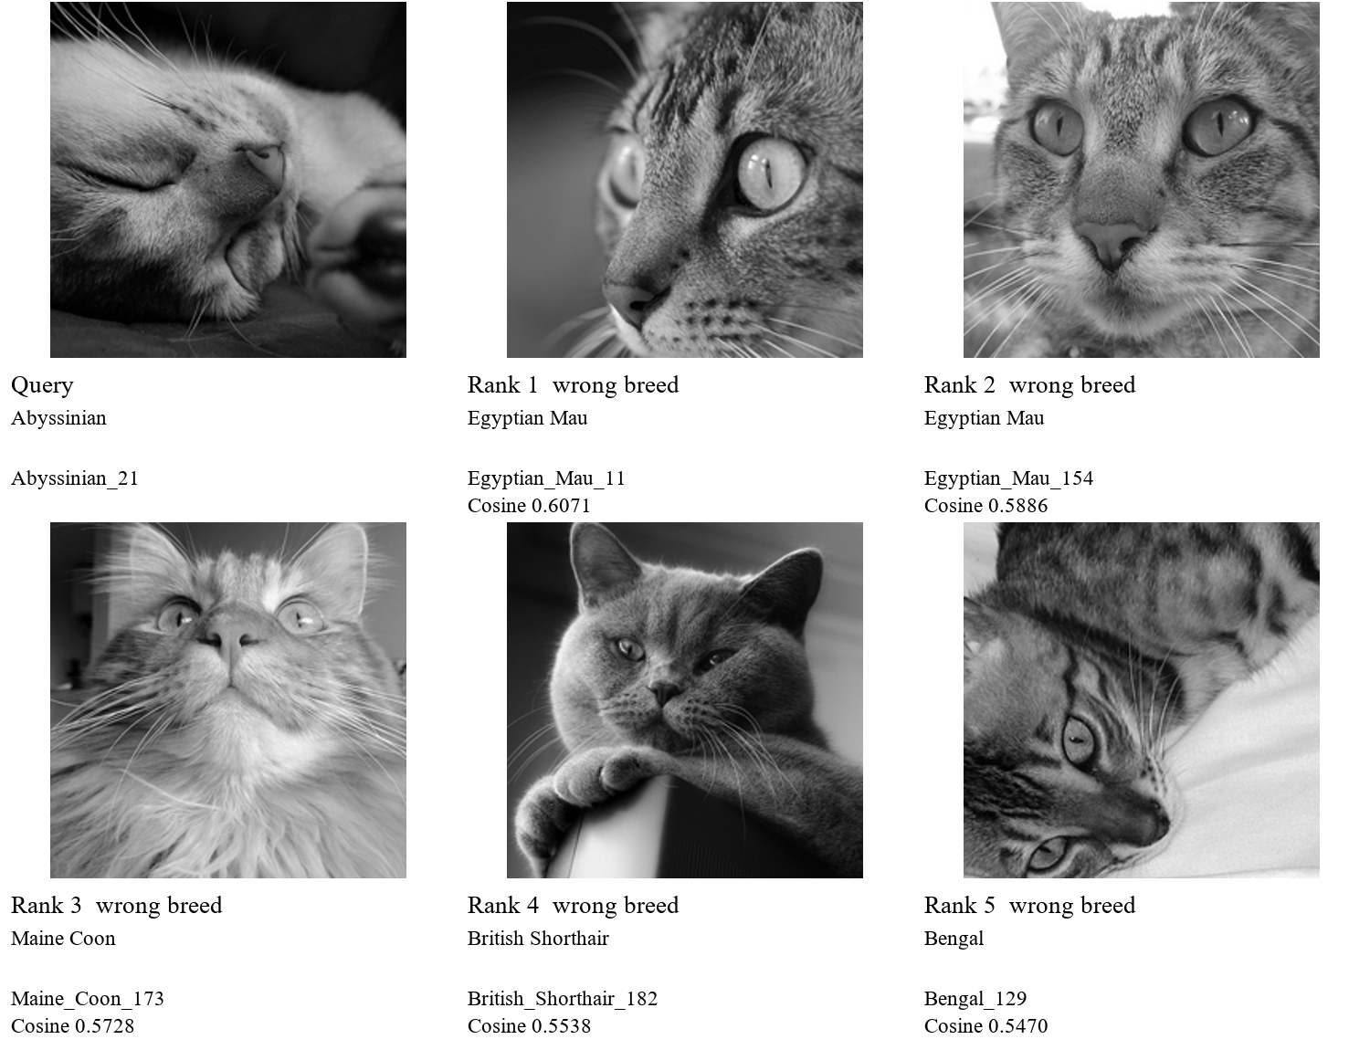
Figure 3 Actual query and five highest ranked neighbors shown with the encoder center crop
Observed pattern: the query is a sleeping cat photographed closely from the side. Its closed eyes, cheek and muzzle dominate the encoder crop, with little of the upright head outline or body visible. DINO returns two Egyptian Mau images, a Maine Coon, a British Shorthair and a Bengal. Several neighbors also emphasize a cat face rather than a full-body breed profile.
A plausible explanation is reduced access to breed-specific shape cues under this pose and partial view, allowing broad feline facial appearance to dominate the embedding. This is a model-specific difficulty: DINOv2 retrieves five same-breed neighbors for the same query, whereas DINO and DeiT-B retrieve none. The contrast supports using the example to examine representation robustness; it does not prove which feature caused DINO's ranking.
These are observed retrieval outputs. The visual explanation is a hypothesis, not a causal attribution established by an intervention or attention analysis. The report shows the 224-pixel encoder crops in grayscale, enlarged for readability; the supporting package retains color contact sheets of the full photographs.
6.2 Representative failure example 2
Model: DINOv2 B/14. Test query: Siamese_228. Ground-truth breed: Siamese. All five returned breeds differ from the query breed, so P@5 = 0, R@5 = 0 and Hit@5 = 0 for this query.
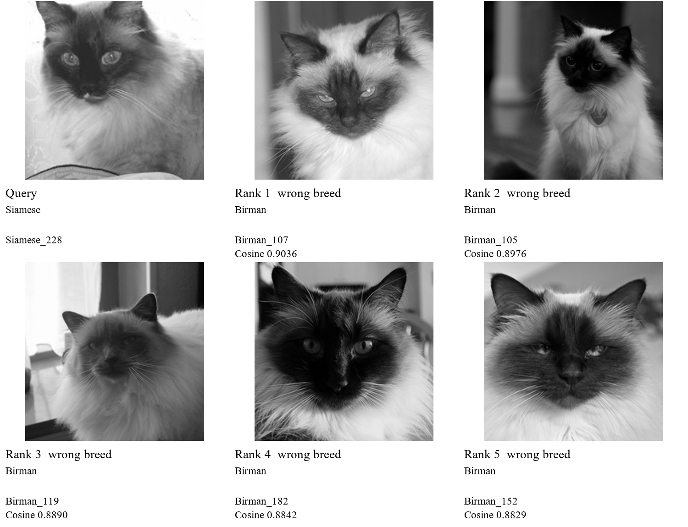
Figure 4 Actual query and five highest ranked neighbors shown with the encoder center crop
Observed pattern: the Siamese-labeled query has a dark face and ears, light surrounding fur and blue eyes. All five DINOv2 neighbors are labeled Birman and show a closely related color-point face pattern. Their cosine similarities are high, including approximately 0.904 for rank one, despite zero breed agreement. All four evaluated encoders have P@5 = 0 for this query.
This case illustrates a fine-grained breed boundary where perceptual resemblance and the label-based relevance rule disagree. Similar face markings and fur appearance plausibly make the Birman images strong visual neighbors. Cosine similarity is not a calibrated probability of a correct breed match. The image and inherited annotation would need an independent review before making any claim of a labeling error; the experiment itself establishes only the observed cross-breed retrieval.
These are observed retrieval outputs. The visual explanation is a hypothesis, not a causal attribution established by an intervention or attention analysis. The report shows the 224-pixel encoder crops in grayscale, enlarged for readability; the supporting package retains color contact sheets of the full photographs.
6.3 Representative failure example 3
Model: DeiT B/16. Test query: leonberger_73. Ground-truth breed: Leonberger. All five returned breeds differ from the query breed, so P@5 = 0, R@5 = 0 and Hit@5 = 0 for this query.
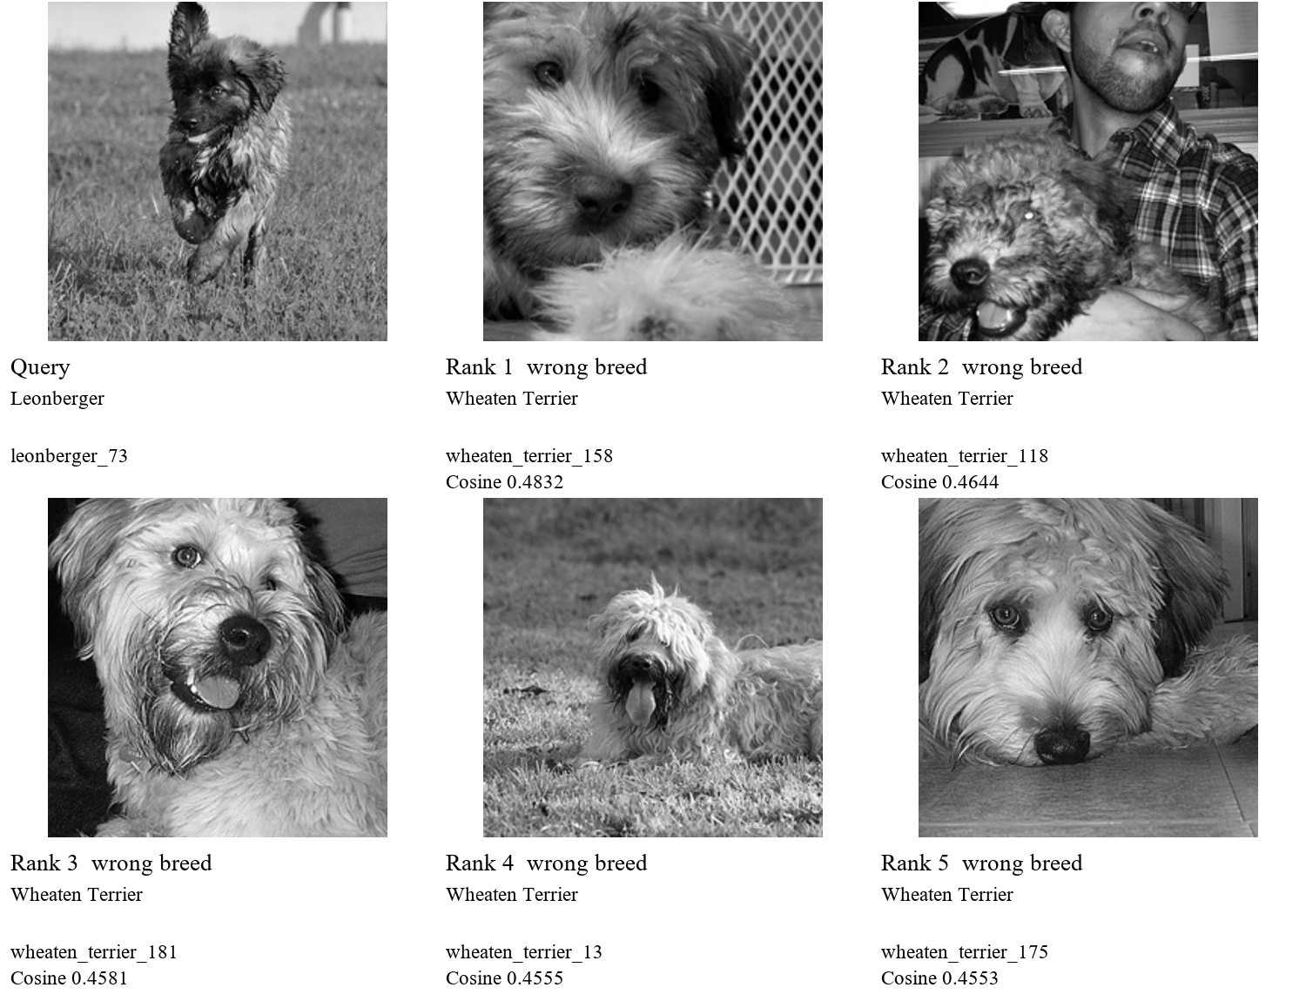
Figure 5 Actual query and five highest ranked neighbors shown with the encoder center crop
Observed pattern: a Leonberger-labeled dog is running through grass, with a shaggy coat, a dark muzzle and a less conventional pose than a standing breed portrait. DeiT-B returns five Wheaten Terrier images. Several returned dogs share shaggy facial hair, while most backgrounds differ from the query. This does not support a simple claim that matching grass backgrounds alone explain the failure.
A plausible confusion is that shared coat texture and face appearance outweigh breed-specific proportions in this representation. The photograph provides no calibrated body-size cue, and the running pose changes the visible silhouette. On this exact query, DeiT-S and DINOv2 each retrieve five correct-breed neighbors and DINO retrieves four. The larger supervised model therefore has a specific failure that is not shared by all encoders; a better average score does not guarantee better retrieval for every query.
These are observed retrieval outputs. The visual explanation is a hypothesis, not a causal attribution established by an intervention or attention analysis. The report shows the 224-pixel encoder crops in grayscale, enlarged for readability; the supporting package retains color contact sheets of the full photographs.

7. Failure statistics and verification
Table 6 Stage 5 zero hit query counts and wrong breed slots in the first five results
Model | Validation zero hit queries | Test zero hit queries | Wrong test slots out of 18345
DINO S/16 | 32 | 93 | 2906
DeiT S/16 | 26 | 113 | 2449
DINOv2 B/14 | 28 | 66 | 1718
DeiT B/16 | 23 | 118 | 2290
Table 7 Precision at 5 for the three illustrated queries across all reproduced models
Test query | DINO S/16 | DeiT S/16 | DINOv2 B/14 | DeiT B/16
Abyssinian_21 | 0% | 20% | 100% | 0%
Siamese_228 | 0% | 0% | 0% | 0%
leonberger_73 | 80% | 100% | 100% | 0%
The three illustrated failures are selected retrospectively from zero-hit test queries for diagnosis. They are not a random sample and cannot establish the prevalence of a visual error category. No parameter, model setting or threshold is changed after inspecting them. Breed labels can penalize visually similar animals from different breeds, while background, pose, occlusion and center cropping may also influence neighbors.
Checks performed
The manifest SHA-256 and all image IDs, breed labels and official query partitions are checked. All downloaded JPEGs decode successfully. Dataset files are obtained from the pinned timm mirror because the Oxford host did not respond during this run; Parquet SHA-256 values match the mirror metadata and JPEG byte streams are extracted without re-encoding. All new ranking files are checked for complete query coverage, gallery membership, unique neighbors and descending finite scores. Every new quality metric is recomputed from those rankings. All timing summaries are independently reconstructed from twelve fresh timing records.
All 15 project unit tests pass locally. All twelve gallery, validation and test embedding arrays have the expected image order, labels and feature dimensions, finite values and unit norms. Model inference uses pretrained weights in evaluation mode. The saved environment, downloaded-weight hashes, input image hashes, run logs and source inventory identify the executed configuration. The support package includes a portable reproduction guide and source code, rather than machine-specific virtual environments or downloaded model weights.
Limits of the comparison
The gallery contains only 1,840 images; search scalability to large collections is not tested. Image IDs are disjoint across partitions, but no perceptual near-duplicate audit is performed. Quality uncertainty is not estimated with confidence intervals and no significance claim is made. The test split was already evaluated in earlier stages, so this is a fixed-protocol reproduction rather than an untouched holdout study. The Windows GPU also drives the desktop, which can introduce timing noise. We report each hardware environment separately. This checkpoint does not validate the Stage 6 interactive demo; demo/app.py remains a placeholder in the supplied source.

8. Conclusions
DINOv2 B/14 achieves the highest reproduced test Precision@5 and exceeds DeiT B/16 by 3.12 percentage points under the agreed retrieval protocol. The result supports DINOv2 as the accuracy-oriented default. A smaller supervised encoder remains useful when inference latency or resource use is more important. These outcomes apply to this fixed gallery, relevance rule and preprocessing pipeline.
Stage 5 contributes a complete local reproduction, final metric and runtime tables, comparison figures and three actual failed searches with rank-level evidence. The historical Tesla T4 results remain a separate reference. New artifacts preserve the query identities and neighbors required for reviewing failures and recomputing quality without running the encoders again.
Evidence and reproducibility
Team project plan, docs/project_plan.tex in the supplied Stage 3 source archive. Stage 5 owner Aslan, deadline 3 November; Stage 6 owner Danil, deadline 10 November.
Karim Khabibrakhmanov. Stage 3 visual retrieval model comparison. Recorded execution 14 October 2026. Historical metrics and timing records: results/stage3/quality and results/stage3/timing_repeats.
Aslan Iakupov. Stage 4 Project Progress Check. 27 October 2026. The Stage 5 work addresses its remaining metric checks, timing variability, comparison figures and retrieval failure analysis.
Stage 5 local execution evidence: quality JSON, artifacts/runs top-10 arrays, timing_repeats JSON, environment.txt, tests.log, dataset_verification.json and image_hashes.csv in the accompanying evidence archive.
Dataset mirror: https://huggingface.co/datasets/timm/oxford-iiit-pet at revision 089695c834a7deb60505b7cc506672db1c31a6aa. Project repository: https://github.com/kite121/Visual_retrieval_system.
Official PyTorch previous-version installation instructions: https://pytorch.org/get-started/previous-versions/. The local run uses torch 2.5.1 and torchvision 0.20.1 with CUDA 11.8.
Split manifest SHA-256
82f40e25888189aba46d1c1ff2c74894284c1ff7fa50362026c8abbea0ec9f80

Appendix A Historical runtime measurements
Mean and p95 component latency from each quality run and all timing repeats are retained in the supporting CSV files and the timing appendix. End-to-end request latency is not directly measured. Sums of component medians are only descriptive approximations; neither medians nor p95 values can be added to obtain an end-to-end distribution.
Each component cell gives median / mean / p95 in milliseconds over 200 individual test requests. Q denotes the complete quality run; R1 to R3 denote fresh timing repeats. Gallery is one complete build time in seconds. These values are kept separate from the median across repeat medians in the main tables. The p95 is the empirical 95th percentile, not a confidence interval.
Table 8 All Stage 3 quality and repeated timing records
Model | Run | Gallery s | Embedding ms  median/mean/p95 | Search ms  median/mean/p95 | Preprocess ms  median/mean/p95
DINO S/16 | Q | 13.899 | 6.371/6.551/7.044 | 0.227/0.233/0.281 | 5.841/5.797/7.462
DINO S/16 | R1 | 13.238 | 6.059/6.555/9.973 | 0.227/0.239/0.325 | 5.839/6.103/9.688
DINO S/16 | R2 | 13.173 | 6.222/6.415/7.421 | 0.226/0.235/0.294 | 5.864/5.940/7.990
DINO S/16 | R3 | 13.207 | 6.100/6.414/8.734 | 0.224/0.234/0.309 | 5.869/5.894/8.270
DeiT S/16 | Q | 13.121 | 5.033/5.244/6.831 | 0.218/0.226/0.275 | 5.706/5.750/7.409
DeiT S/16 | R1 | 12.915 | 5.011/5.216/6.119 | 0.225/0.232/0.288 | 5.855/5.837/7.577
DeiT S/16 | R2 | 13.192 | 5.092/5.289/6.336 | 0.225/0.232/0.301 | 5.752/5.779/7.422
DeiT S/16 | R3 | 13.269 | 5.082/5.255/6.168 | 0.224/0.232/0.280 | 5.837/5.880/7.808
DINOv2 B/14 | Q | 29.458 | 19.078/19.044/21.105 | 0.263/0.288/0.384 | 5.859/6.165/9.155
DINOv2 B/14 | R1 | 30.597 | 18.786/18.879/20.960 | 0.264/0.280/0.375 | 5.891/6.122/9.141
DINOv2 B/14 | R2 | 30.461 | 19.102/19.047/21.087 | 0.264/0.278/0.380 | 5.962/6.047/8.865
DINOv2 B/14 | R3 | 30.681 | 18.859/19.077/21.187 | 0.252/0.265/0.357 | 5.804/5.923/9.317
DeiT B/16 | Q | 23.347 | 12.633/12.413/13.393 | 0.254/0.263/0.339 | 5.769/5.808/7.736
DeiT B/16 | R1 | 22.444 | 12.763/12.450/13.513 | 0.261/0.273/0.349 | 5.959/6.105/9.549
DeiT B/16 | R2 | 22.807 | 12.544/12.395/13.419 | 0.254/0.263/0.333 | 5.872/5.997/8.358
DeiT B/16 | R3 | 22.833 | 12.368/12.256/13.462 | 0.252/0.265/0.357 | 5.864/5.929/7.753
Table 9 Stage 2 runtime records from 12 October 2026 with the same component format
Model | Run | Gallery s | Embedding ms | Search ms | Preprocess ms
DINO S/16 | Q | 17.630 | 7.651/8.658/12.088 | 0.346/0.385/0.535 | 7.706/8.472/12.923
DeiT S/16 | Q | 17.129 | 8.527/9.146/11.948 | 0.450/0.475/0.581 | 11.194/11.020/13.567
The historical Stage 2 JSON stores sample size 200 but not query IDs. Identity of timing IDs is verified across Stage 3 and Stage 5; it cannot be independently verified for Stage 2 from its aggregate files. Earlier and later measurements are not pooled.

Appendix B Reproduced runtime measurements
Each component cell gives median / mean / p95 in milliseconds over 200 individual test requests. Q denotes the complete quality run; R1 to R3 denote fresh timing repeats. Gallery is one complete build time in seconds. These values are kept separate from the median across repeat medians in the main tables. The p95 is the empirical 95th percentile, not a confidence interval.
Table 10 All Stage 5 quality and repeated timing records
Model | Run | Gallery s | Embedding ms  median/mean/p95 | Search ms  median/mean/p95 | Preprocess ms  median/mean/p95
DINO S/16 | Q | 36.730 | 11.484/11.750/13.382 | 0.369/0.381/0.456 | 5.581/5.553/6.769
DINO S/16 | R1 | 34.645 | 11.589/11.743/13.115 | 0.375/0.379/0.429 | 5.653/5.629/6.841
DINO S/16 | R2 | 35.372 | 11.289/11.420/12.175 | 0.350/0.358/0.403 | 5.471/5.375/6.489
DINO S/16 | R3 | 35.157 | 11.645/12.087/14.126 | 0.373/0.395/0.484 | 5.608/5.503/6.812
DeiT S/16 | Q | 35.377 | 10.074/10.525/14.022 | 0.397/0.424/0.604 | 5.825/5.791/7.094
DeiT S/16 | R1 | 34.130 | 9.728/10.026/11.482 | 0.386/0.394/0.454 | 5.650/5.583/6.874
DeiT S/16 | R2 | 32.741 | 9.401/10.109/12.734 | 0.362/0.387/0.498 | 5.577/5.602/7.477
DeiT S/16 | R3 | 33.869 | 9.586/9.823/11.264 | 0.372/0.383/0.443 | 5.550/5.506/6.774
DINOv2 B/14 | Q | 81.764 | 37.499/37.507/37.681 | 0.564/0.557/0.664 | 5.815/5.767/7.111
DINOv2 B/14 | R1 | 79.014 | 37.484/37.498/37.690 | 0.572/0.576/0.648 | 5.682/5.631/7.033
DINOv2 B/14 | R2 | 77.617 | 37.358/37.376/37.571 | 0.423/0.457/0.623 | 5.577/5.568/6.837
DINOv2 B/14 | R3 | 77.395 | 37.399/37.399/37.572 | 0.392/0.431/0.602 | 5.568/5.503/6.741
DeiT B/16 | Q | 64.626 | 28.791/28.803/29.032 | 0.412/0.460/0.619 | 5.616/5.579/6.708
DeiT B/16 | R1 | 65.165 | 28.815/28.835/29.035 | 0.564/0.543/0.624 | 5.643/5.553/6.686
DeiT B/16 | R2 | 67.740 | 28.710/28.712/28.847 | 0.378/0.402/0.546 | 5.490/5.422/6.618
DeiT B/16 | R3 | 66.314 | 29.420/29.486/30.082 | 0.526/0.515/0.629 | 5.579/5.498/6.725
Table 11 Recorded Stage 3 validation quality percentages for all 1840 queries
Model | P@5 | P@10 | R@5 | R@10 | Hit@5
DINO S/16 | 86.09 | 82.78 | 8.66 | 16.65 | 98.26
DeiT S/16 | 88.83 | 86.92 | 8.93 | 17.49 | 98.59
DINOv2 B/14 | 91.12 | 88.84 | 9.16 | 17.87 | 98.48
DeiT B/16 | 89.39 | 87.67 | 8.99 | 17.64 | 98.75
Stage 2 quality values equal the corresponding two small-model rows in the recorded Stage 3 validation and test tables. Supporting CSV and JSON files retain full numeric precision; report tables are rounded for readability. Every available runtime component summary is preserved above and in timing_distributions_all.csv.

