

Prompt

Software Engineering Large Practical
Documentation

Table of Contents

1. Installation

2. Prompt Application running in the AVD

2.1 Browsing and Searching for Courses

2.2 Building your Personal Timetable

2.3 Saving and Loading your Timetable

3. Additional Features

3.1 Location Finder

3.2 Offline Compatibility Mode

3.3 Design Features

4. Android Lint

1. Installation

This project depends on a support library (ActionBarSherlock) for some of its features to function correctly, this support library, which I have added to my submission folder, need to my imported and added to the SELP project in Eclipse. The following is a guide on how to install this library successfully and how to get the project to compile and run on the AVD.

- Inside my submission folder 'SELP_Submit', there will be 2 folders, 'SELP' and 'actionbarsherlock' as well as this document, 'doc'. My project is contained inside the SELP folder. This should be imported into eclipse as one would usually go ahead. File → Import → Android → Existing Android Code Into Workspace → SELP.

- As the project is loaded into Eclipse, errors will appear as shown in Figure 1, this is because of the missing support library I used:

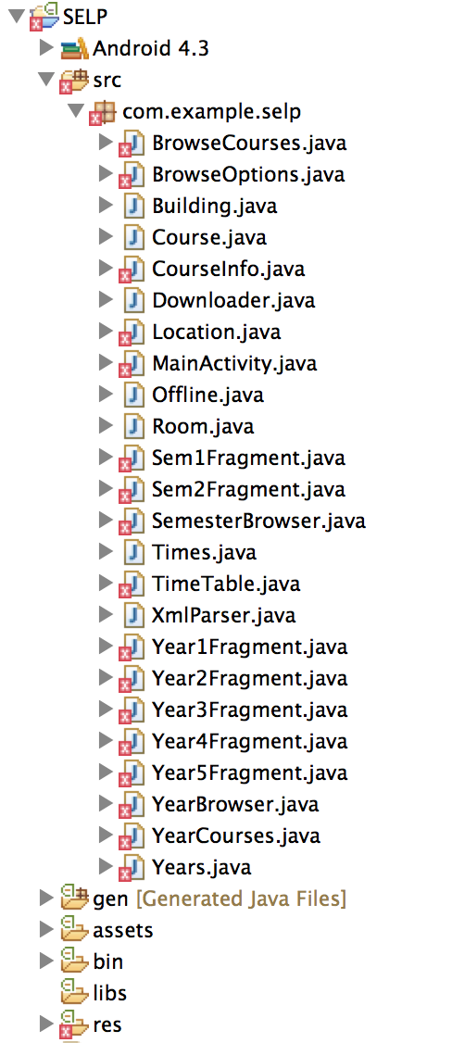

Figure 1: Initial errors shown in Eclipse on import of SELP project.

3. The next step is to install the support library, 'actionbarsherlock', found in SELP_Submit. In Eclipse go to:

File → Import → Existing Android Code Into Workspace → actionbarsherlock → Open

4. To add the library to the SELP project, right click on the SELP project in Eclipse:

Properties → Android → Add → actionbarsherlock → Apply → OK
After doing this step, you should see the green tick as shown in Figure 2.

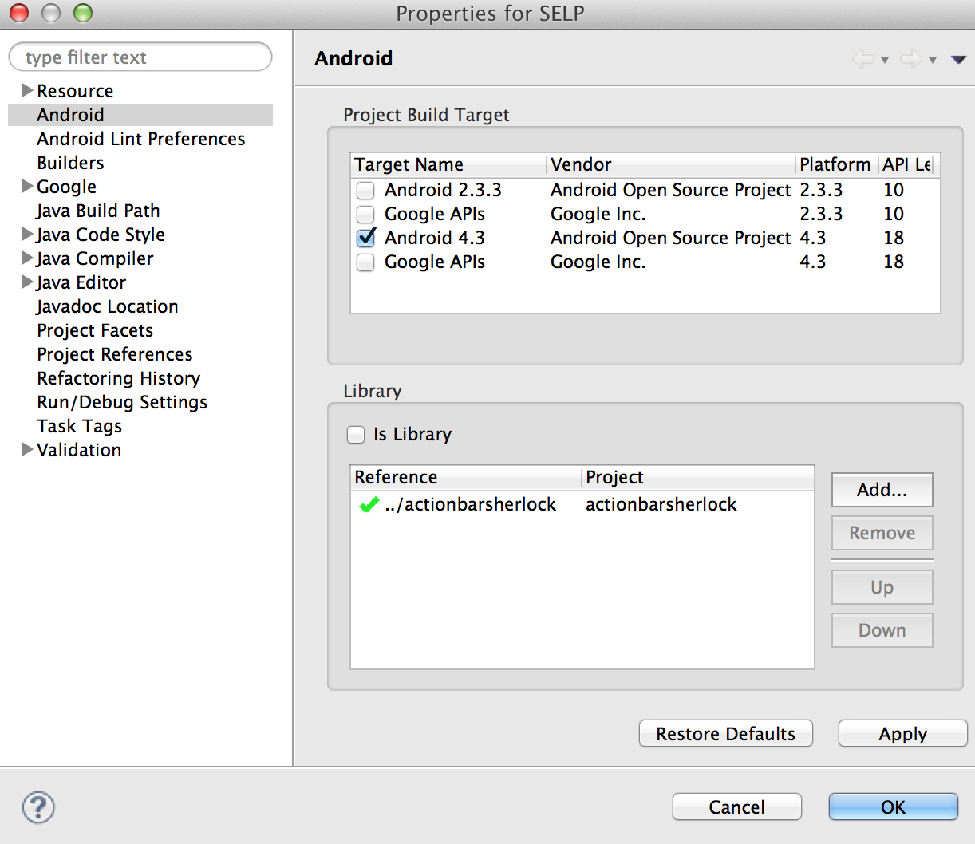

Figure 2: Dialog after clicking adding actionbarsherlock.

This after clicking OK on this dialog box, actionbarsherlock should be added successfully to the project SELP and you can go ahead and run the project on the selected AVD.

2. Prompt Application running in the AVD.

This section will include screenshots from the AVD showing that my app is running the way it should and meets the design requirements stated for this coursework. Subsections will explain how to go about to use the app to do specific tasks and what each activity allows the user to do.
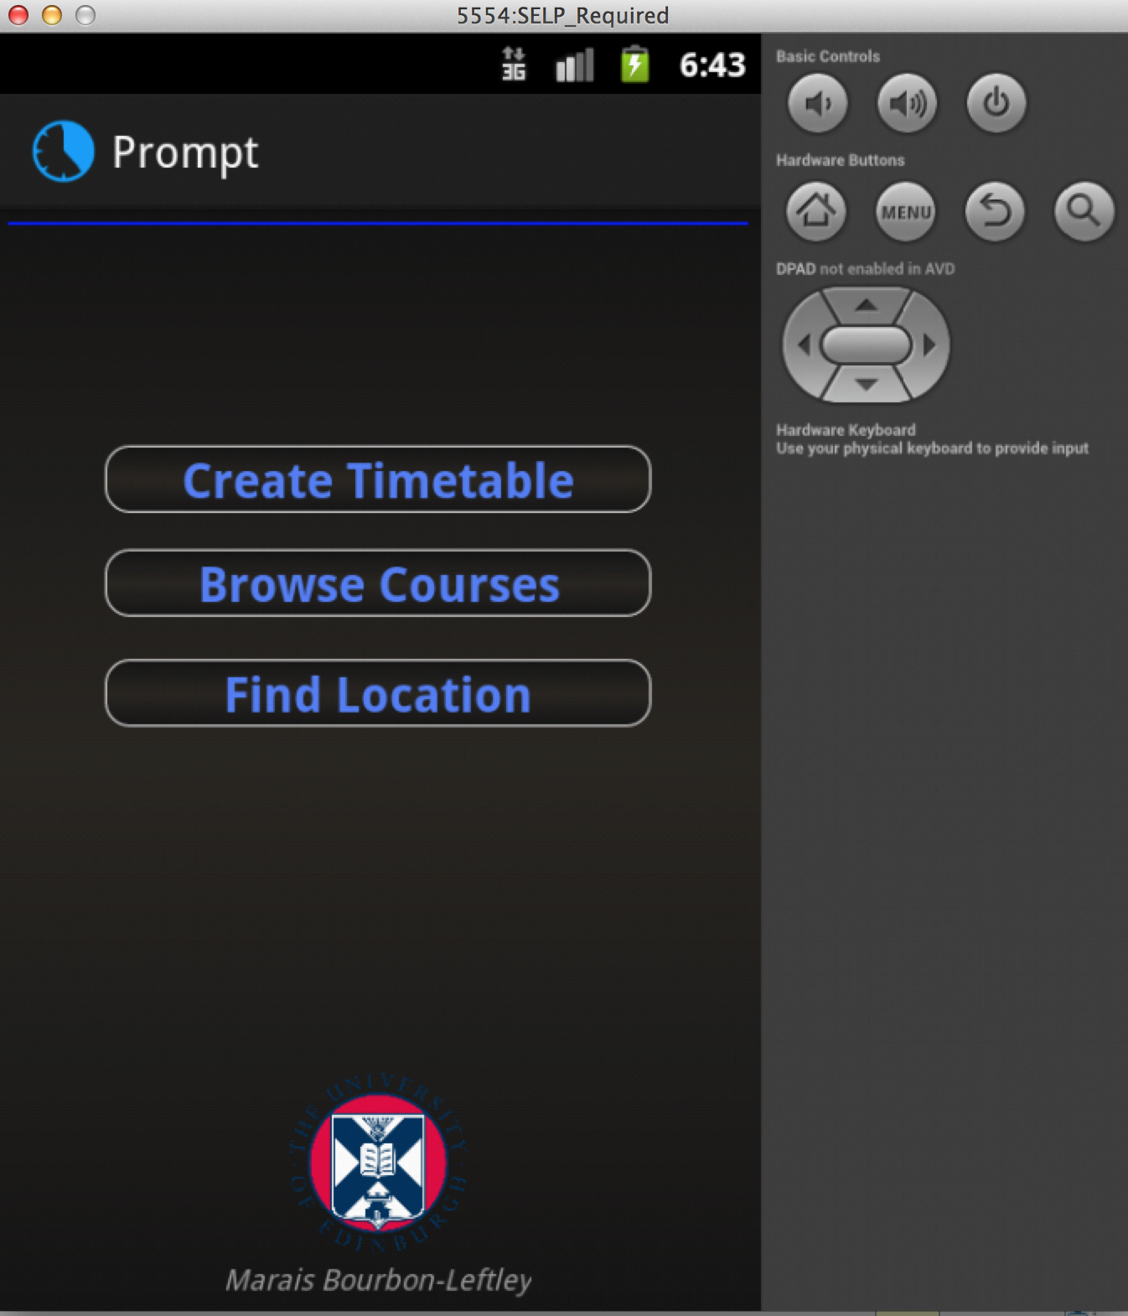

Figure 3: View on AVD as you start the application.

2.1 Browsing and Searching for Courses

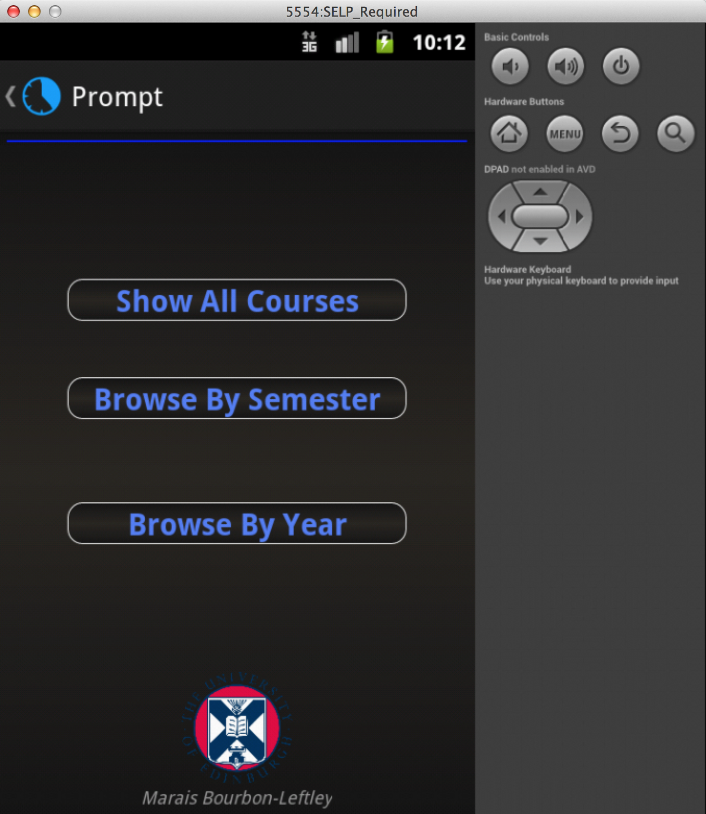
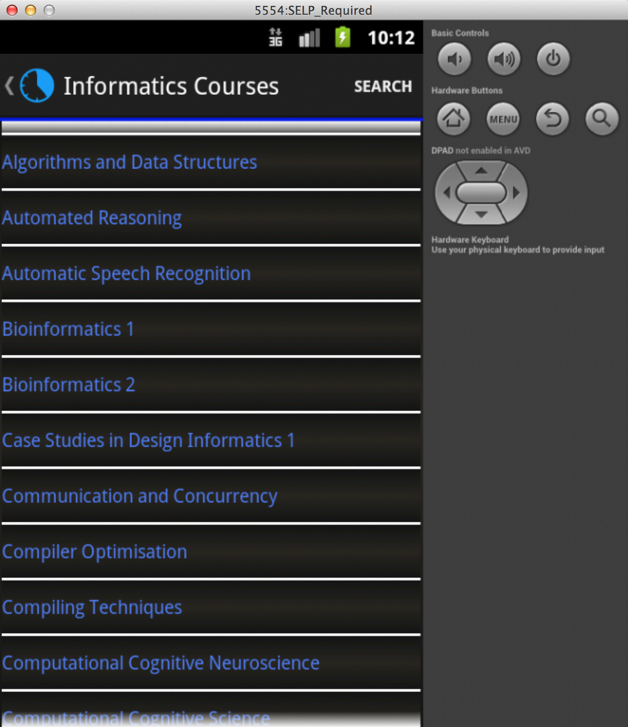
Figure 4: On selecting Browse Courses from the start activity, filter choices are displayed.
Figure 5: All courses displayed on selection of Show All Courses.

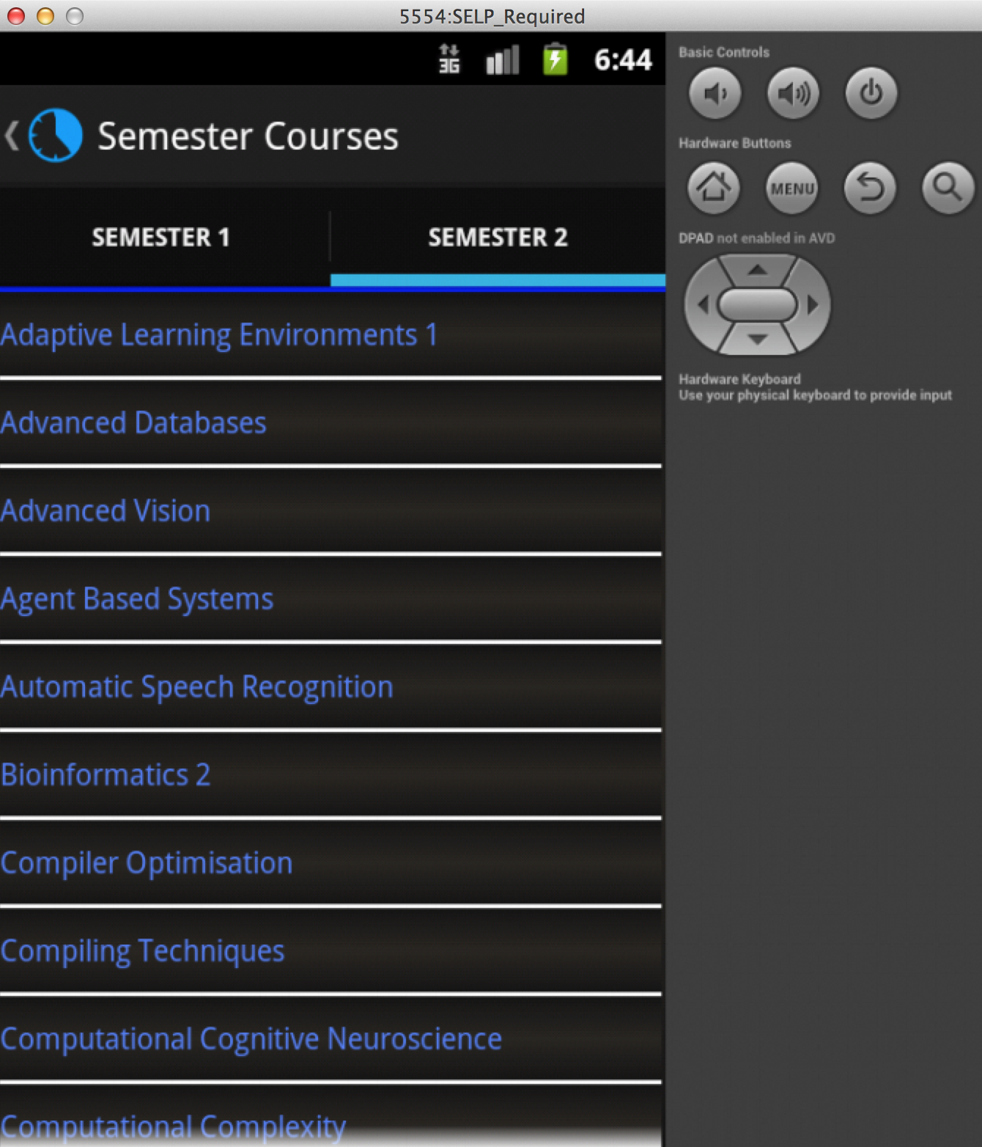
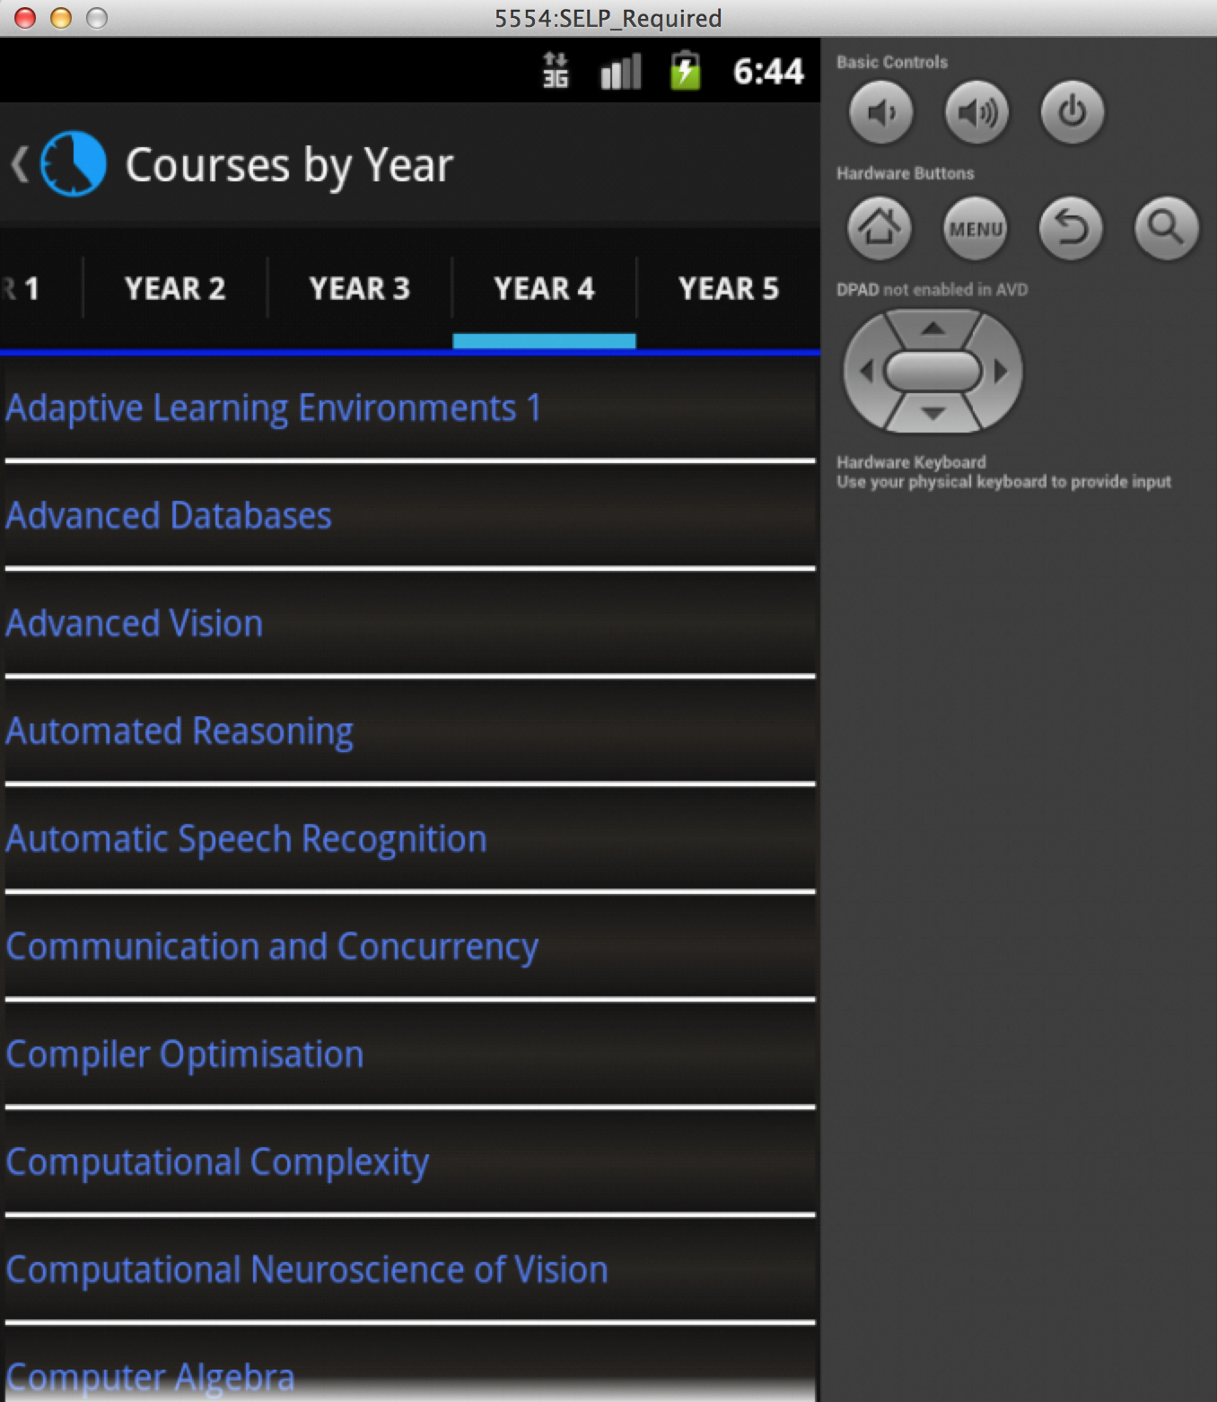

Figure 6: Filtering courses by Semester 2.
Figure 7: Filtering courses by Year 4.

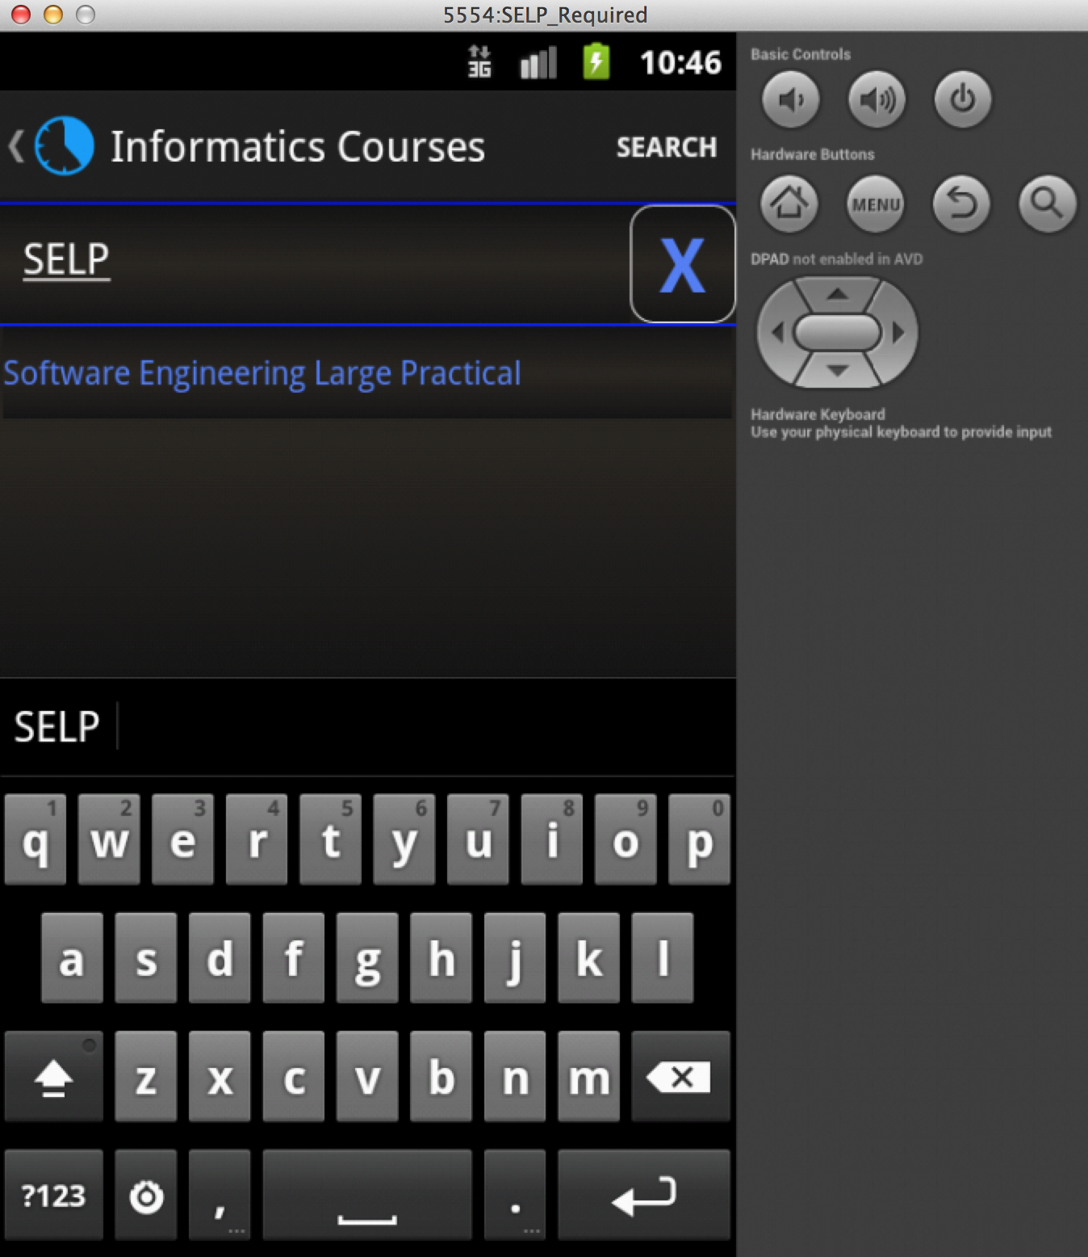
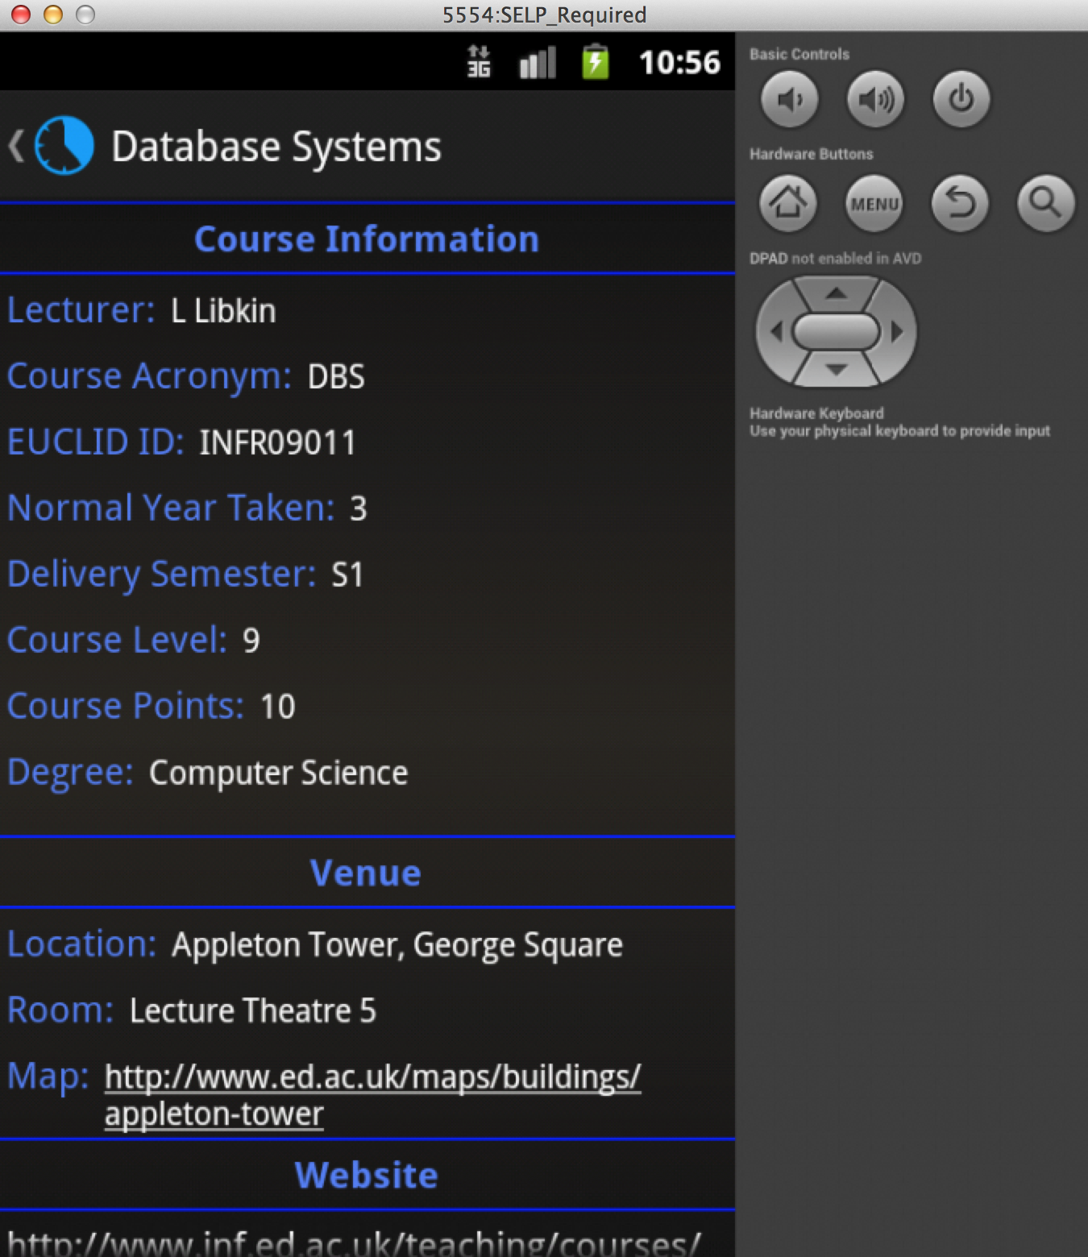
Figure 8: Accessing the search feature from the Action Bar allows searches for course acronyms or course names.
Figure 9: Course Information for Database Systems.

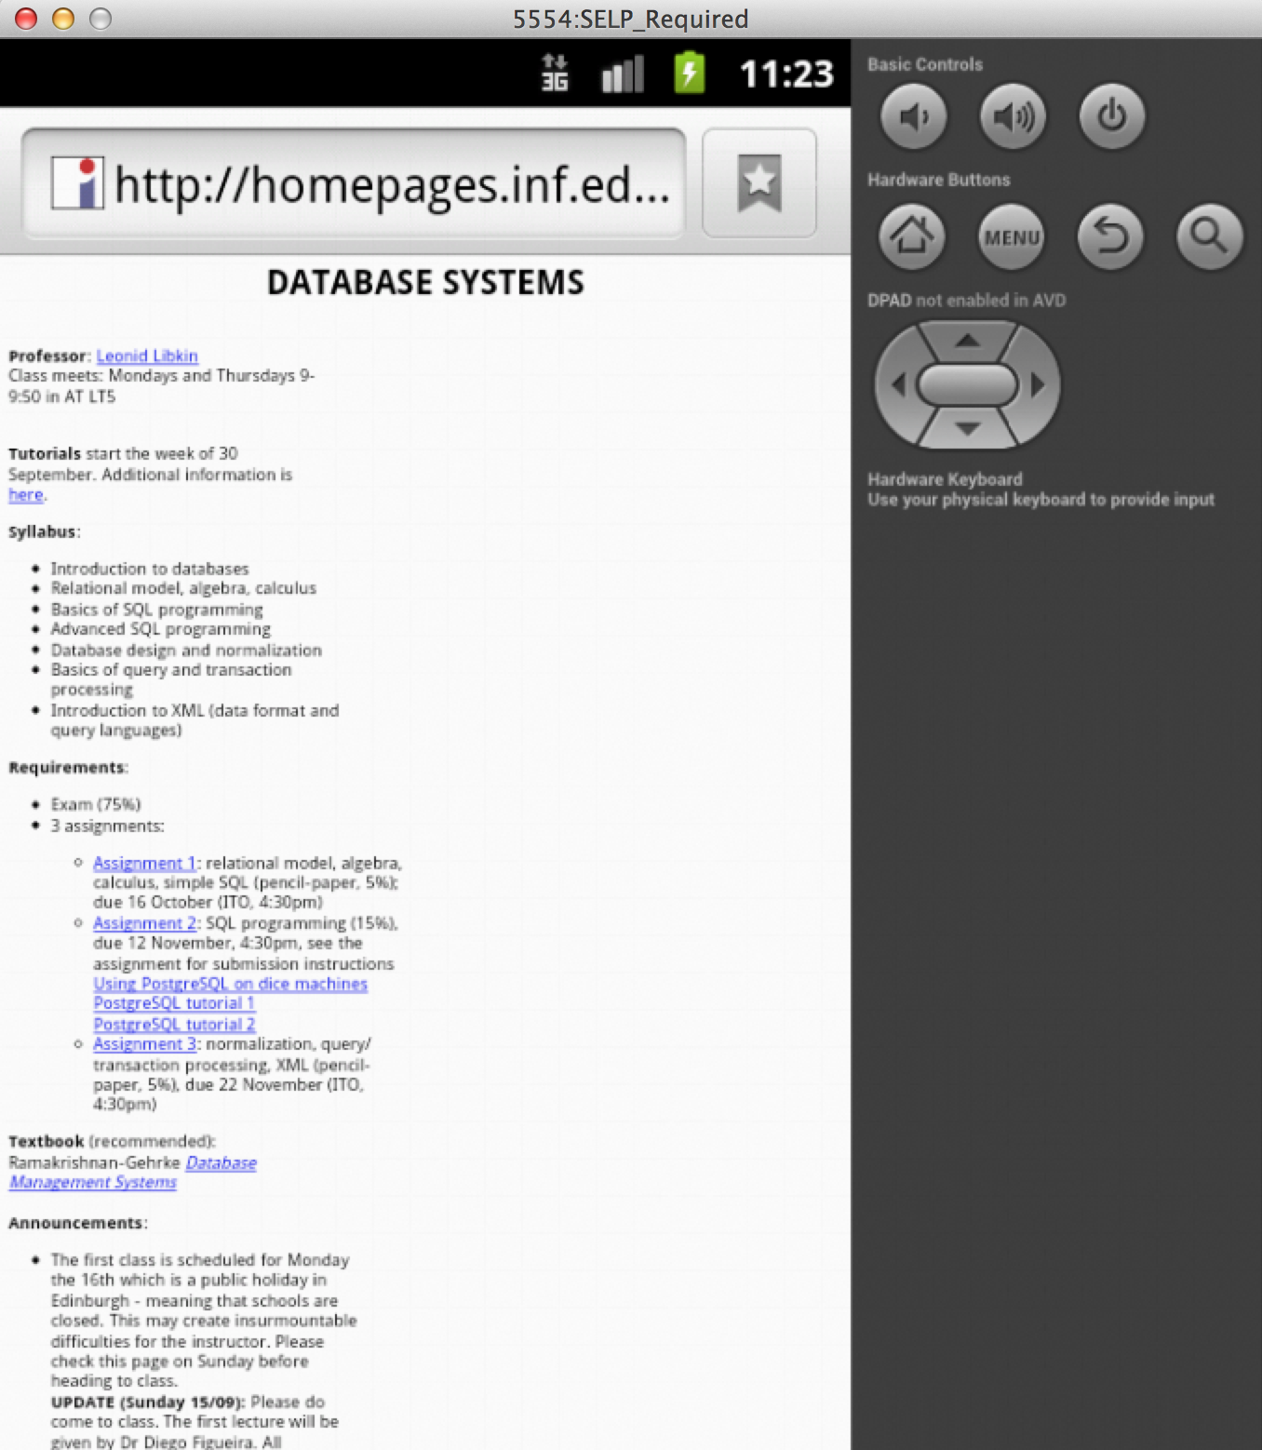
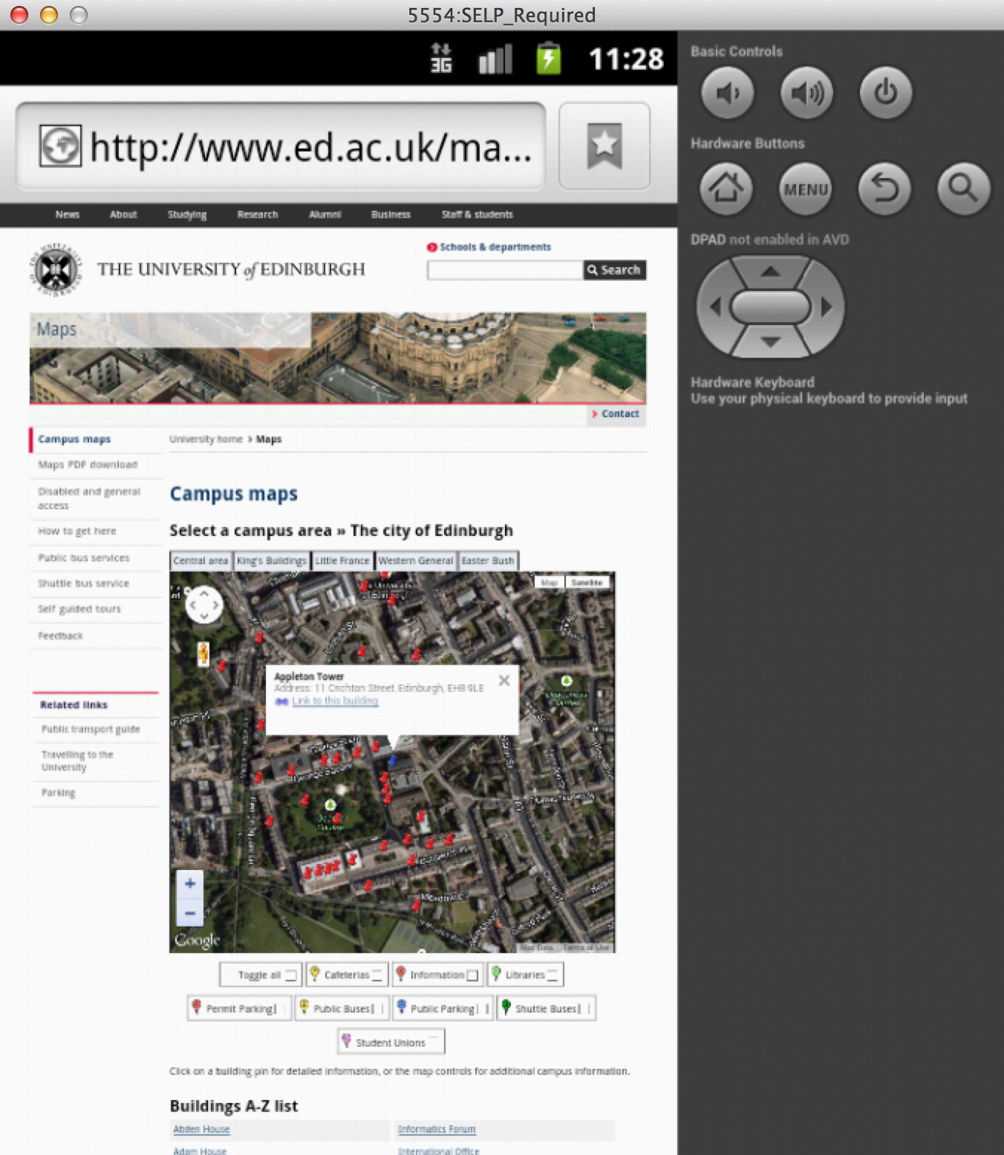
Figure 10: Linking to the course web page through the local browser on the device.
Figure 11: Linking to the map for Appleton Tower, where Database Systems is given.

2.2 Building your Personal Timetable

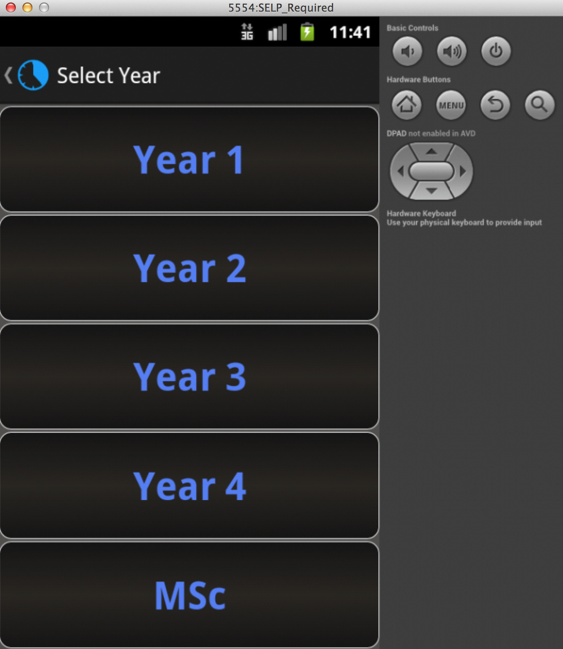
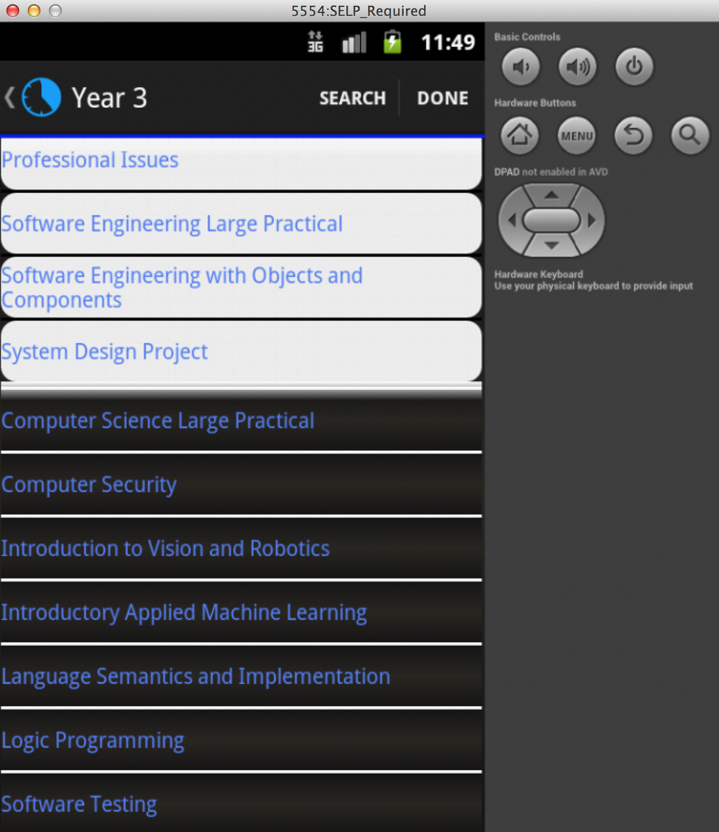

Figure 12: After clicking Create Timetable from the first activity, you will be given options of which year you are in.
Figure 13: Building your timetable will add courses to the white list, and they are removable by clicking on the course in the white list.

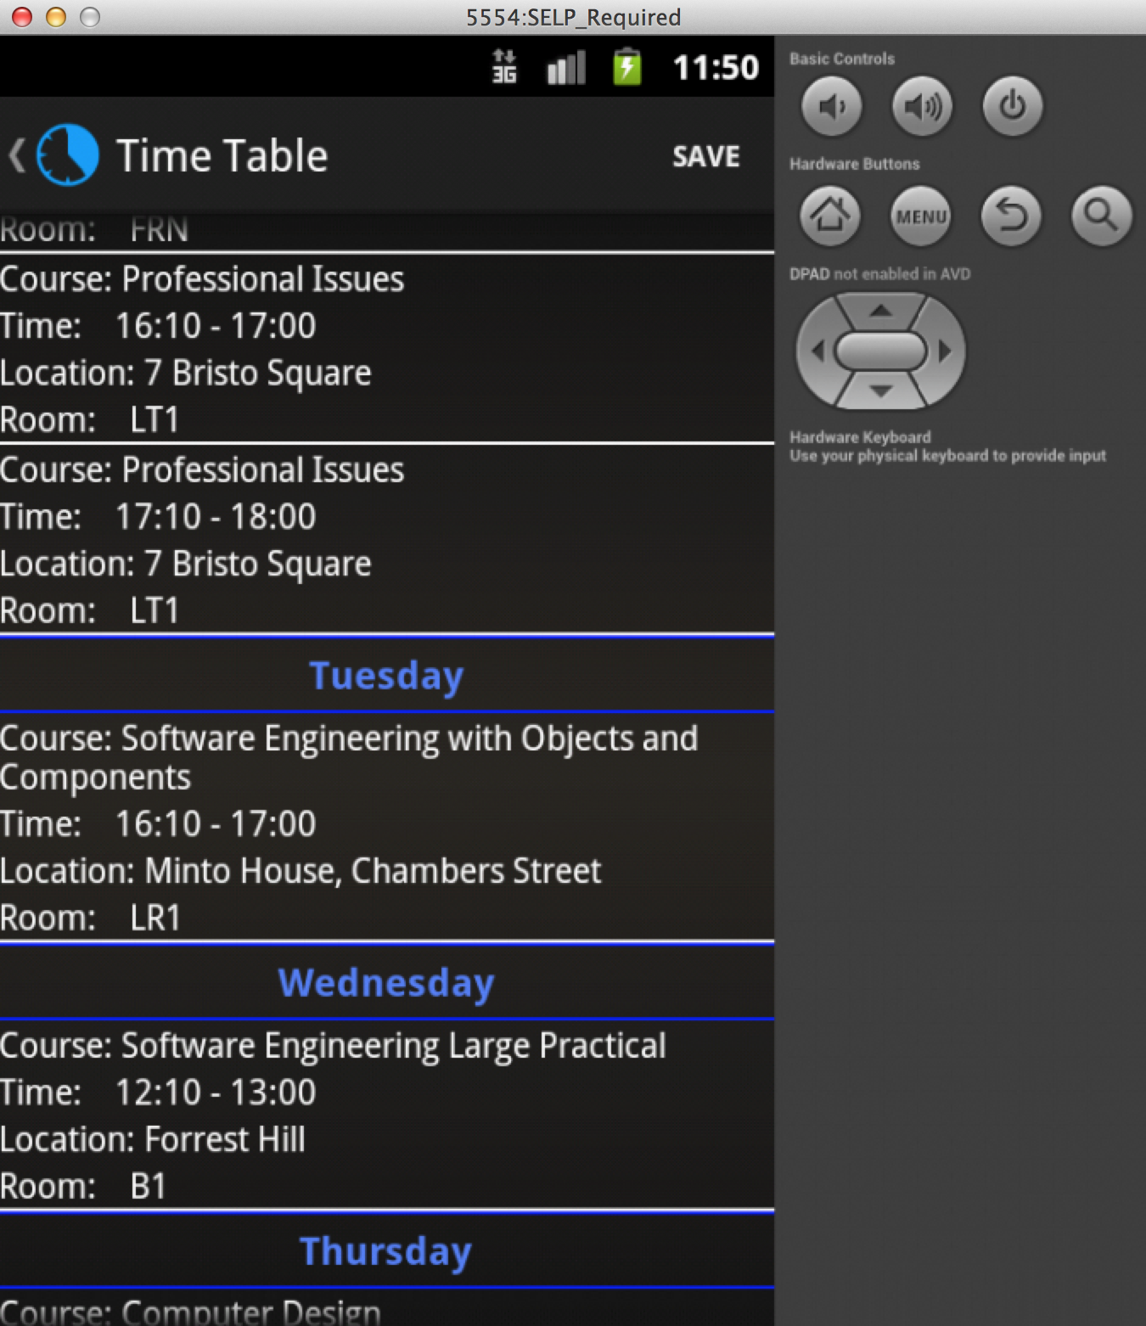
Figure 14: Your timetable will be built after clicking DONE in the previous activity and be displayed in a scrollable page per day of the week.

2.3 Saving and Loading your Timetable

After creation of the timetable, the user will get the option to save their time table for future use, as shown in Figure 15. This saved copy of their timetable will be stored for whenever the app is used again. If however the user forgets to save and tries to navigate away from the page, they will be prompted with a dialog box asking them if they would like to save their timetable, or if they would rather want to go back and edit it, as shown in Figure 16.

On application start up, a LOAD button is visible in the Action Bar, however if no timetable is saved yet the user will be notified as shown in Figure 17. If however the user has previously saved a timetable, on the click of LOAD, they will be taken straight to their saved timetable, Figure 18.

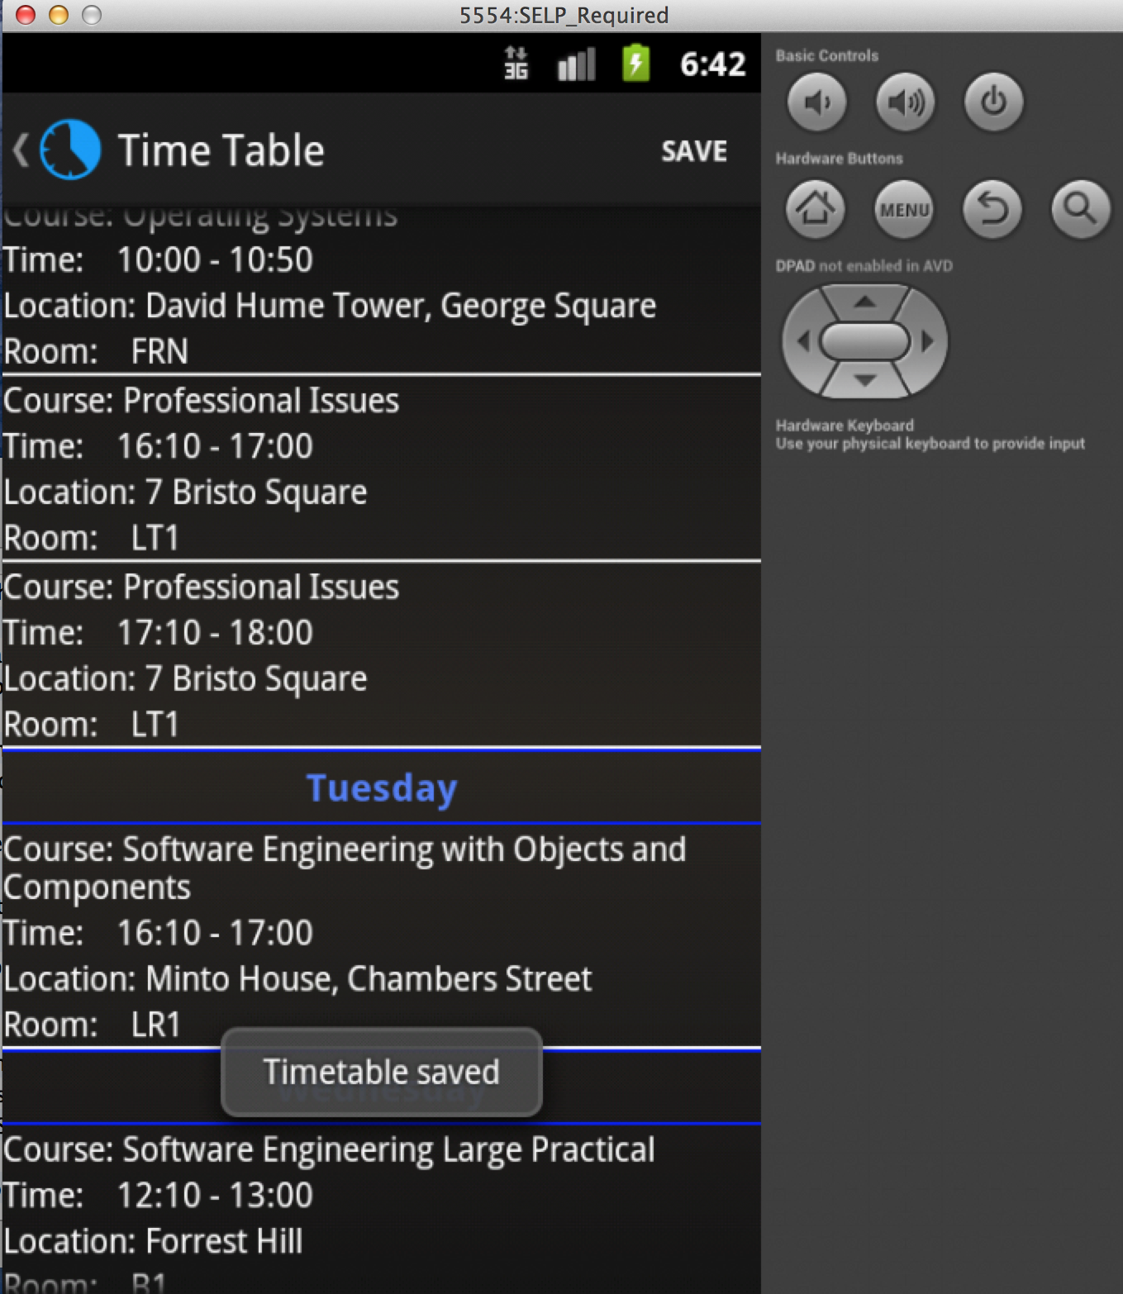
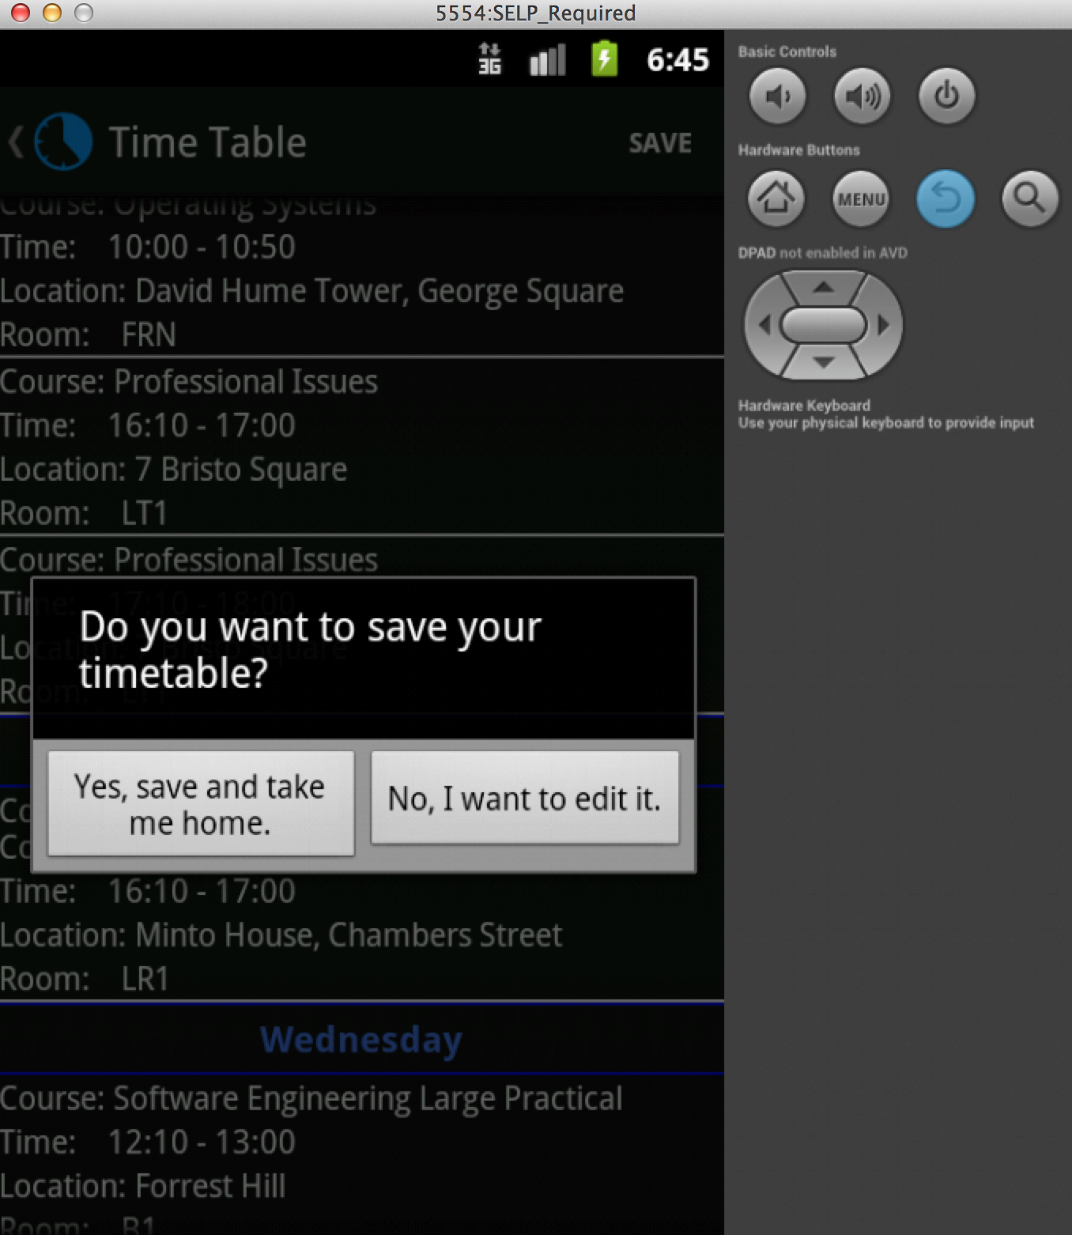
Figure 15: Upon clicking the save button in the Action Bar, the user will be notified that their timetable is saved for future use.
Figure 16: Dialog box upon pressing the back button.

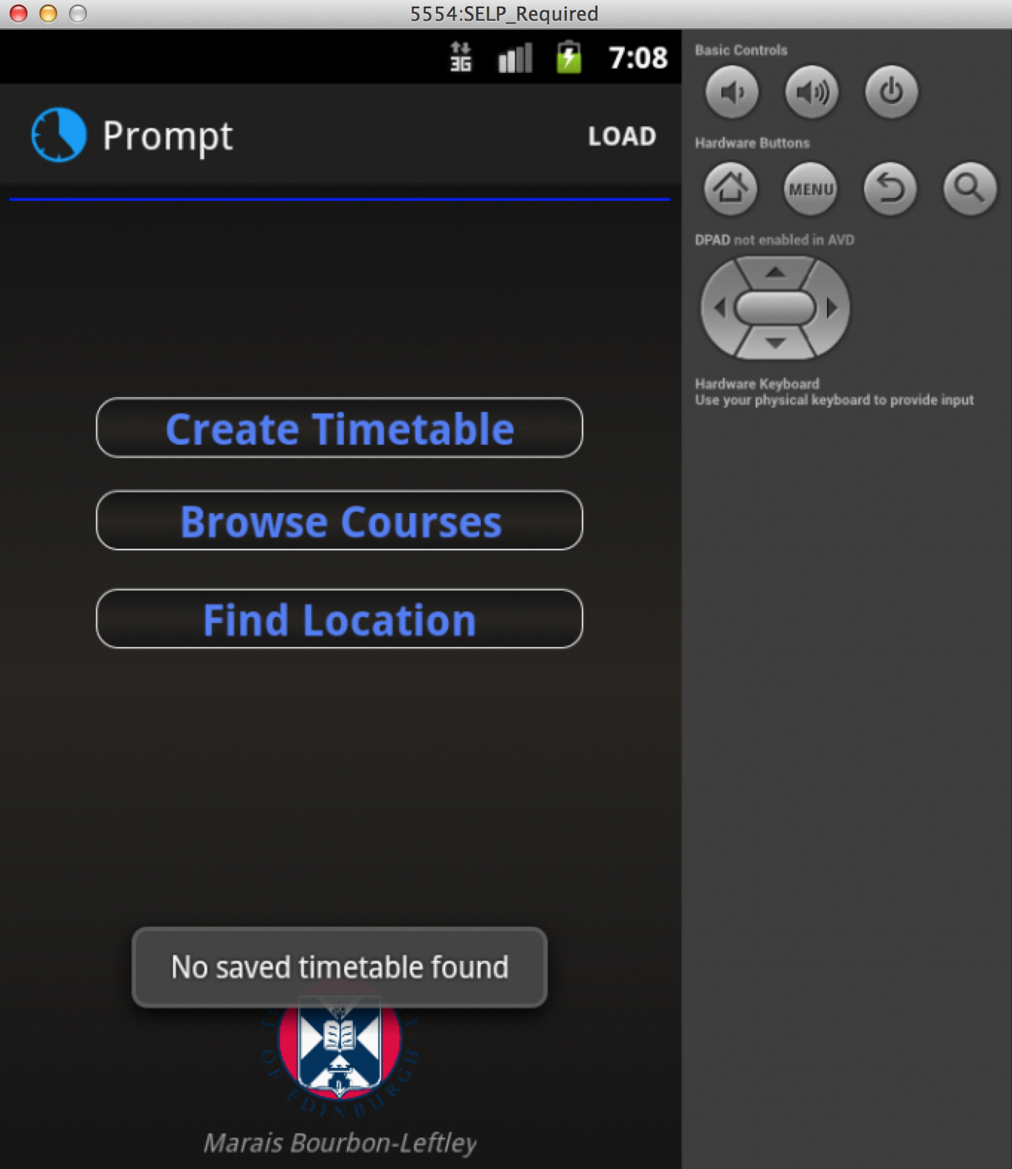

Figure 18: The loaded timetable.
Figure 17: A toast informing the user that no timetable was found.

3. Additional Features

I have added a few features as well as some design work that I would like to point out.

3.1 Location Finder

Although the user will be able to navigate to the map of the specified building, that will not give them direction as to how to get there. I have added a feature to my application that will allow the user to browse for a certain location and with the help of Google Maps be navigated from their location to a selected building.

If however the user's device does not have Google Maps installed, they will be navigated to the Google Maps Web Page, where the same functionality will take place. In Figure 19 I show the ability to browse for buildings and on selection in the AVD the location is loaded using the web browser, Figure 20. I have included a screenshot of the same activity being executed on my device, Samsung Galaxy S4, which come with Google Maps, Figure 21.

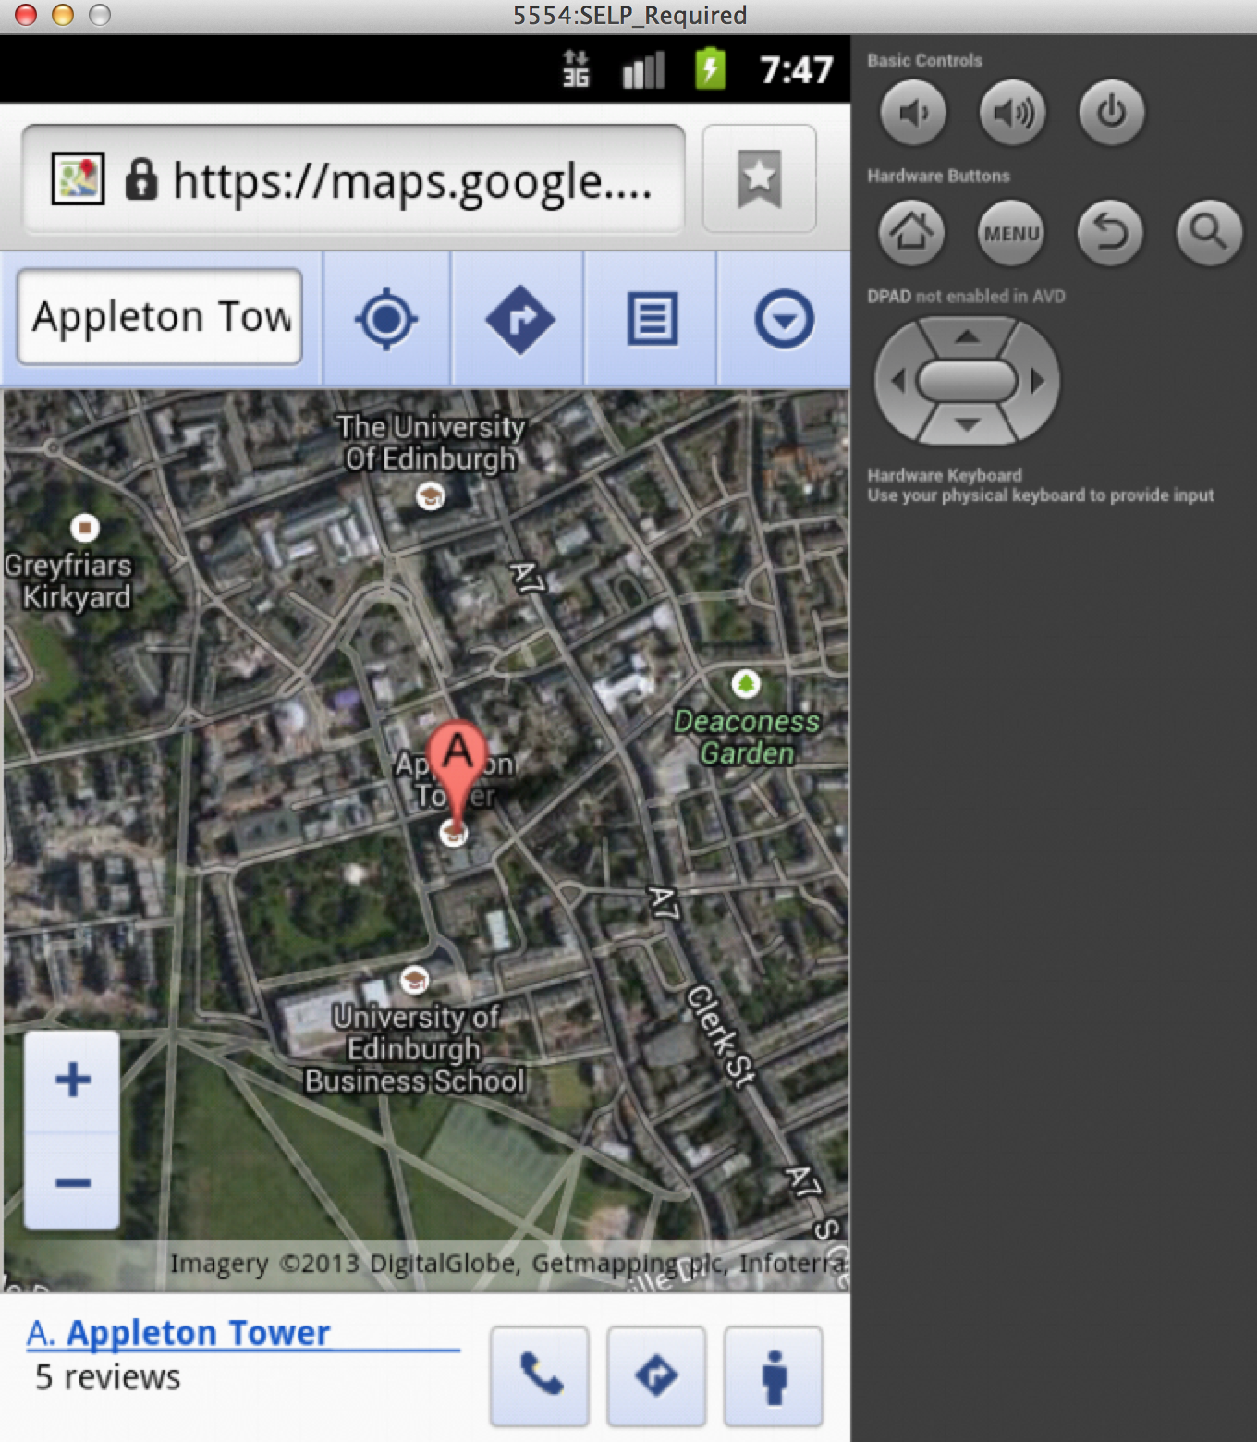
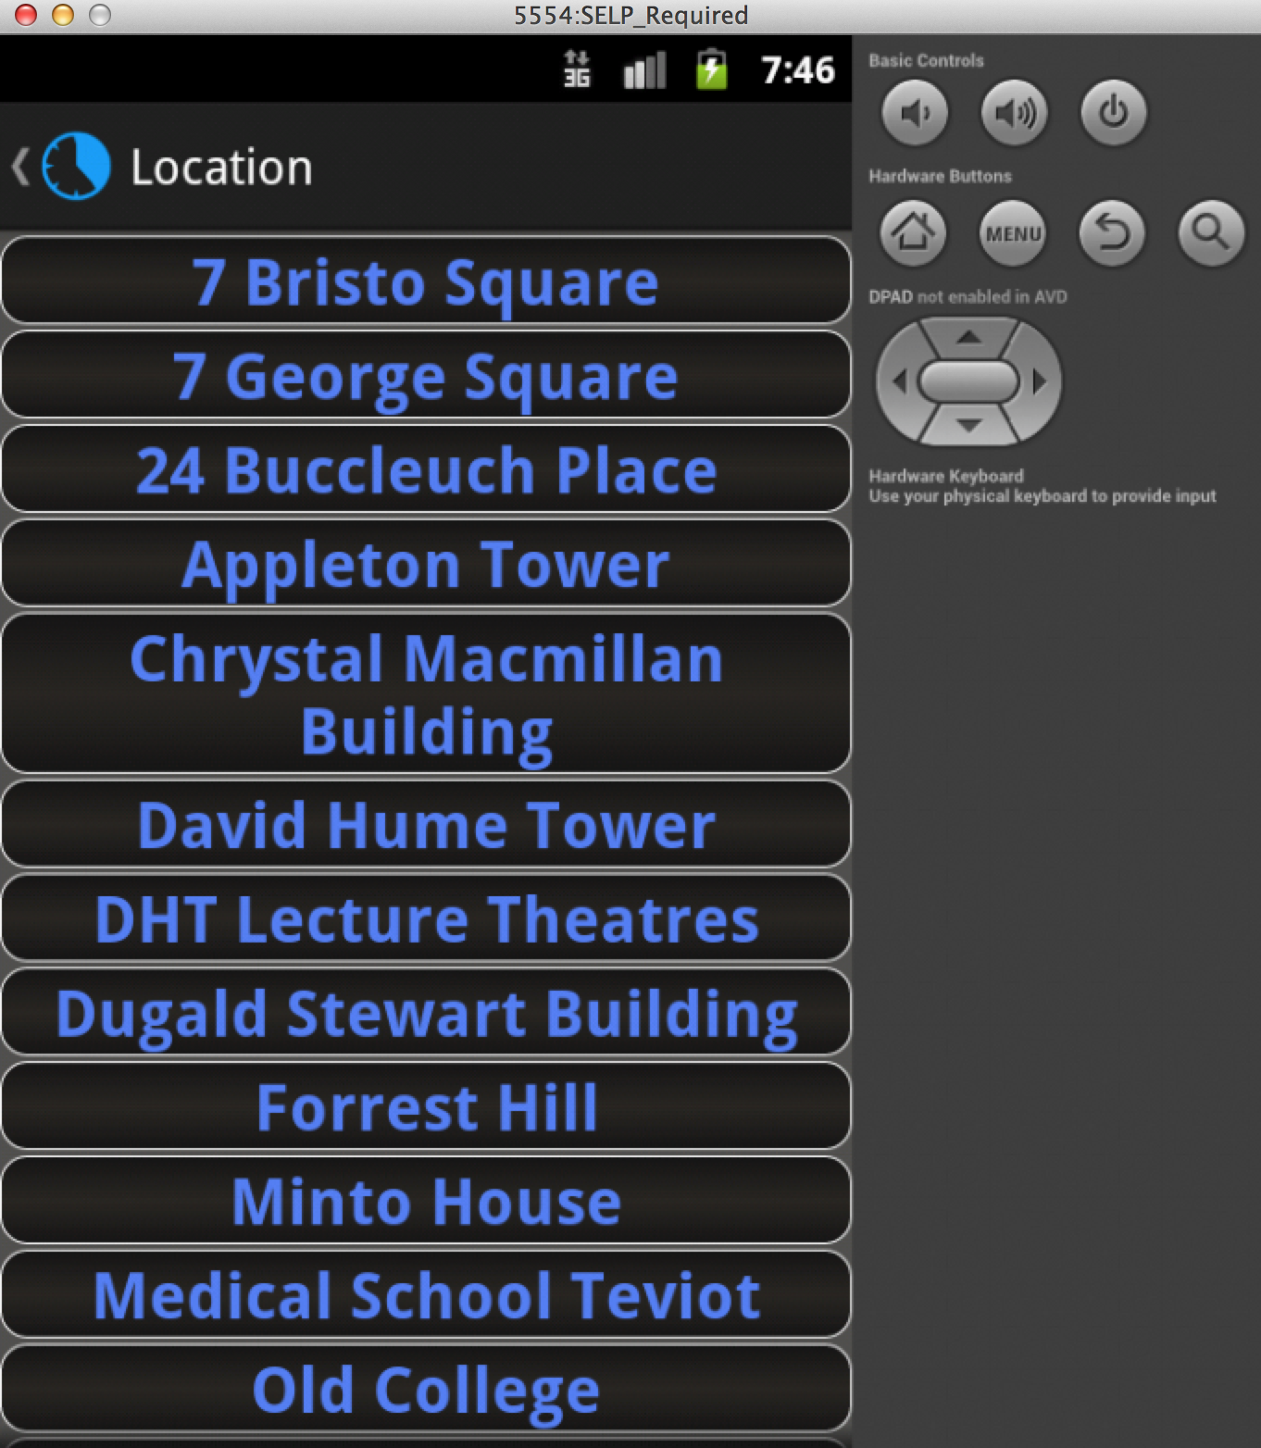

Figure 19: List of Buildings after the click of ­Find Location from the main activity.
Figure 20: Google Maps view of Appleton Tower in the browser of the device.

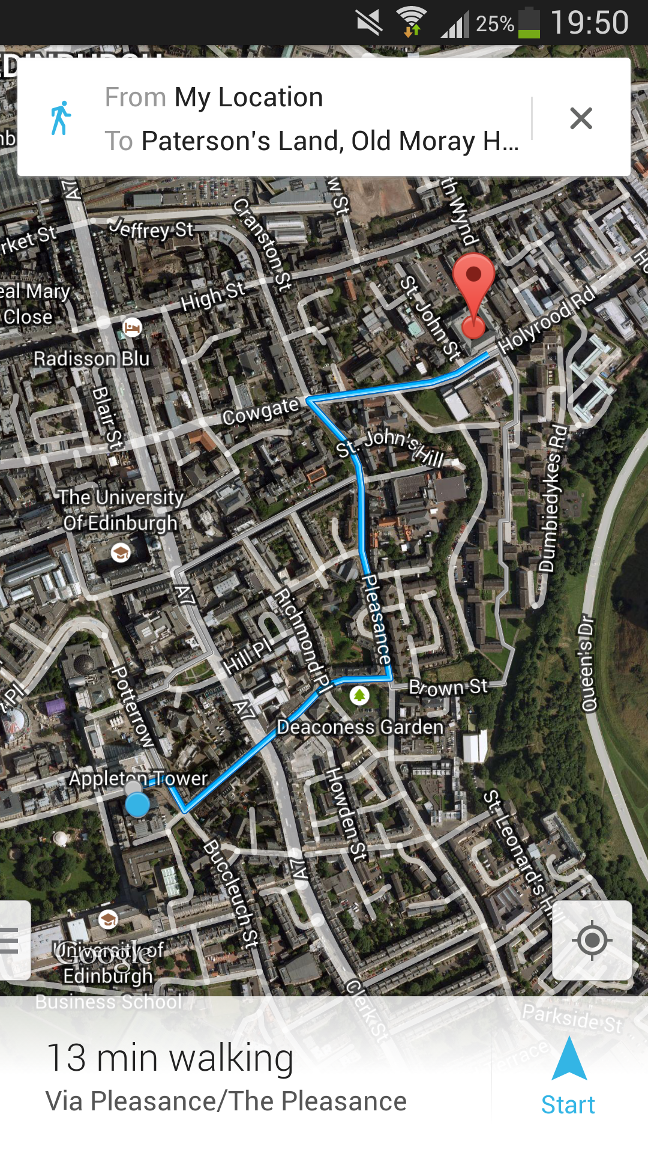
Figure 21: Google Maps application guiding the user to their selected building.

3.2 Offline Compatibility Mode

On running the application the first time, the XML files will be downloaded and saved for offline mode. Whenever the application is run again, checks will be done to see if there is an Internet connection, if there is the latest files will be downloaded and parsed. However if there is no Internet Connection, the user will be notified and the latest saved XML files will be used for parsing. Some features such as accessing the Internet will be blocked as well as the Find Location feature. All other
features which does not need the Internet will work smoothly.

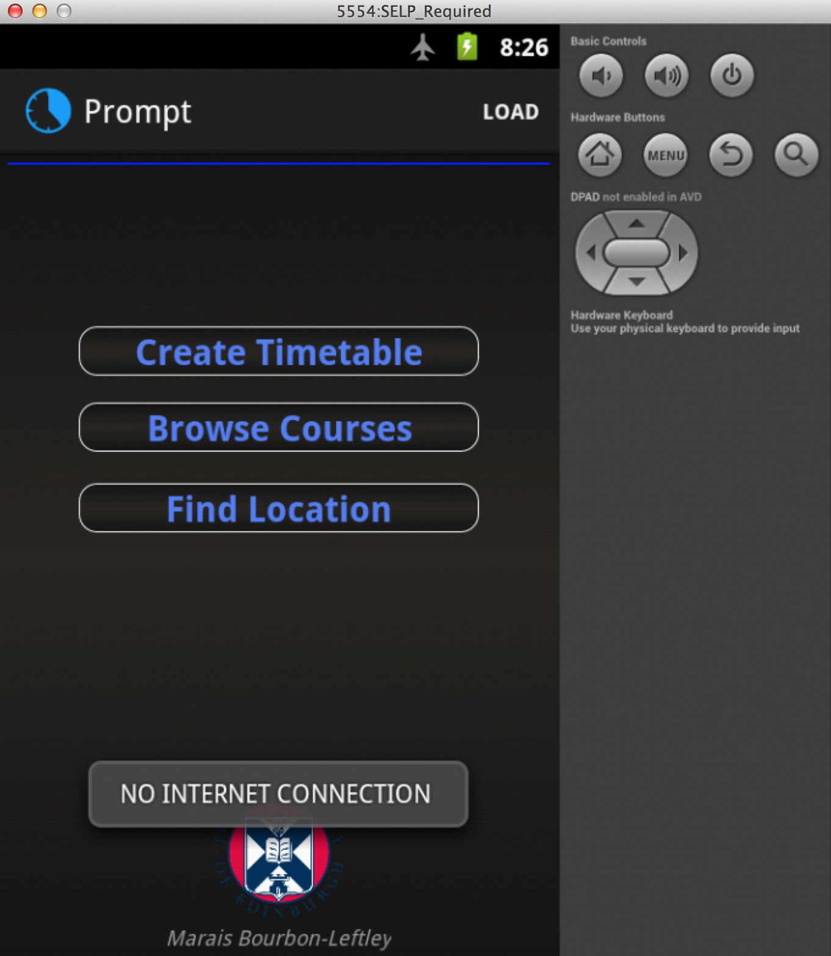
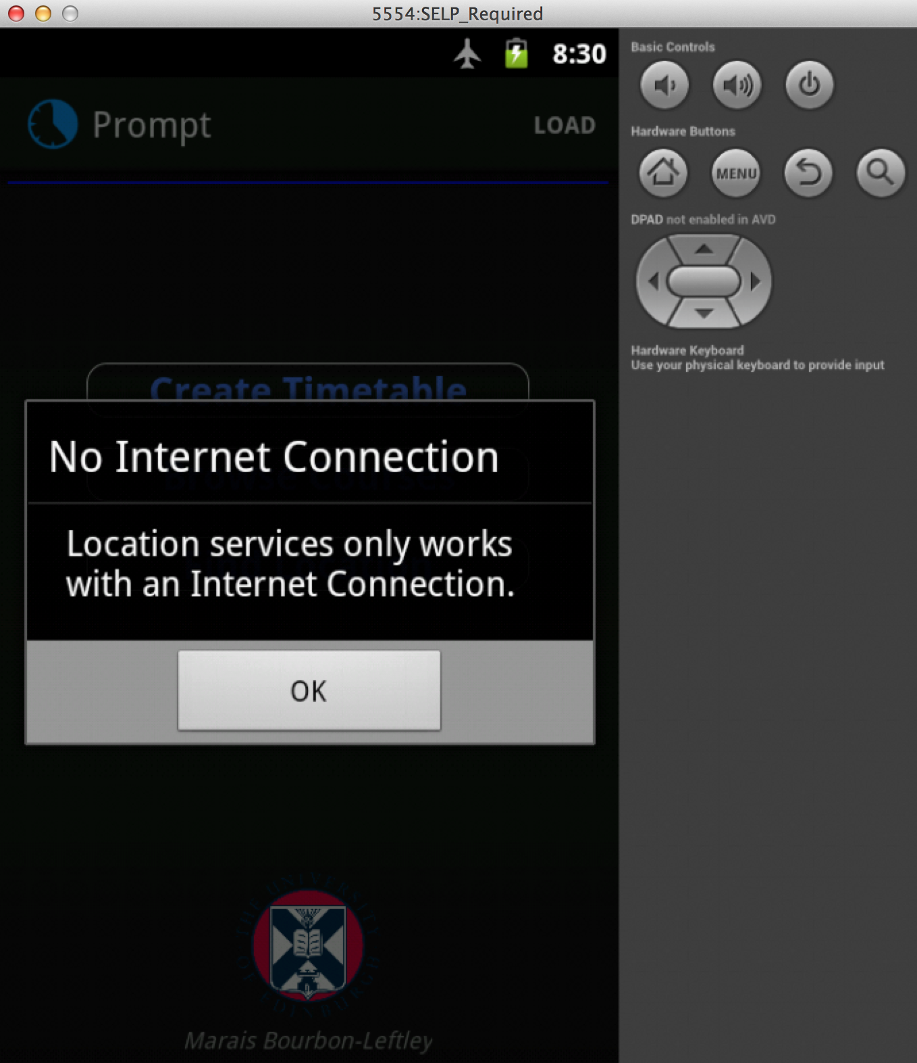

Figure 22: A toast notifies the user on startup that there is no Internet Connection.

Figure 23: An Alert box notified the user on select of Find Location that the service is only available with an Internet Connection.

3.3 Design Features

All backgrounds, buttons and themes were created by myself, as well as animations between activities. A hidden feature is on the click of the Edinburgh University Logo, the Informatics Home Page will be loaded.

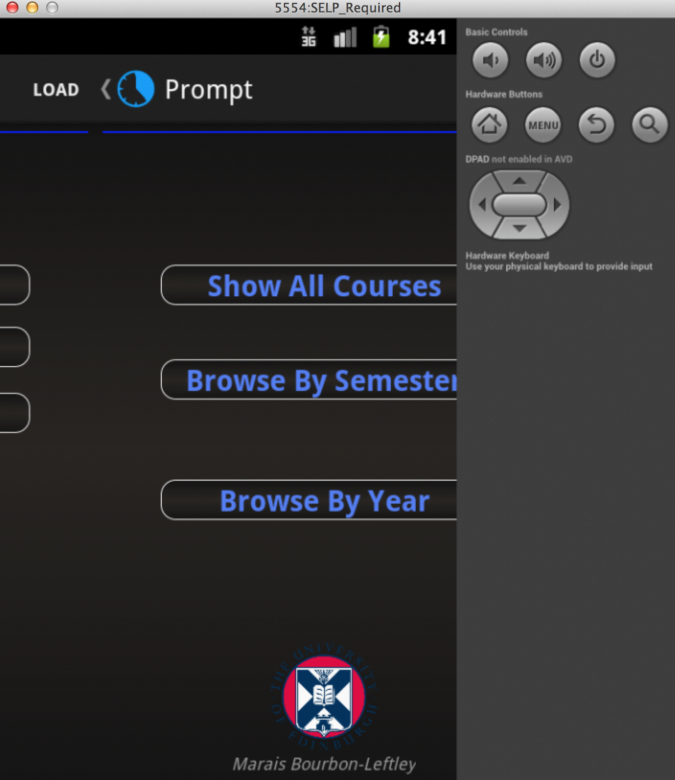
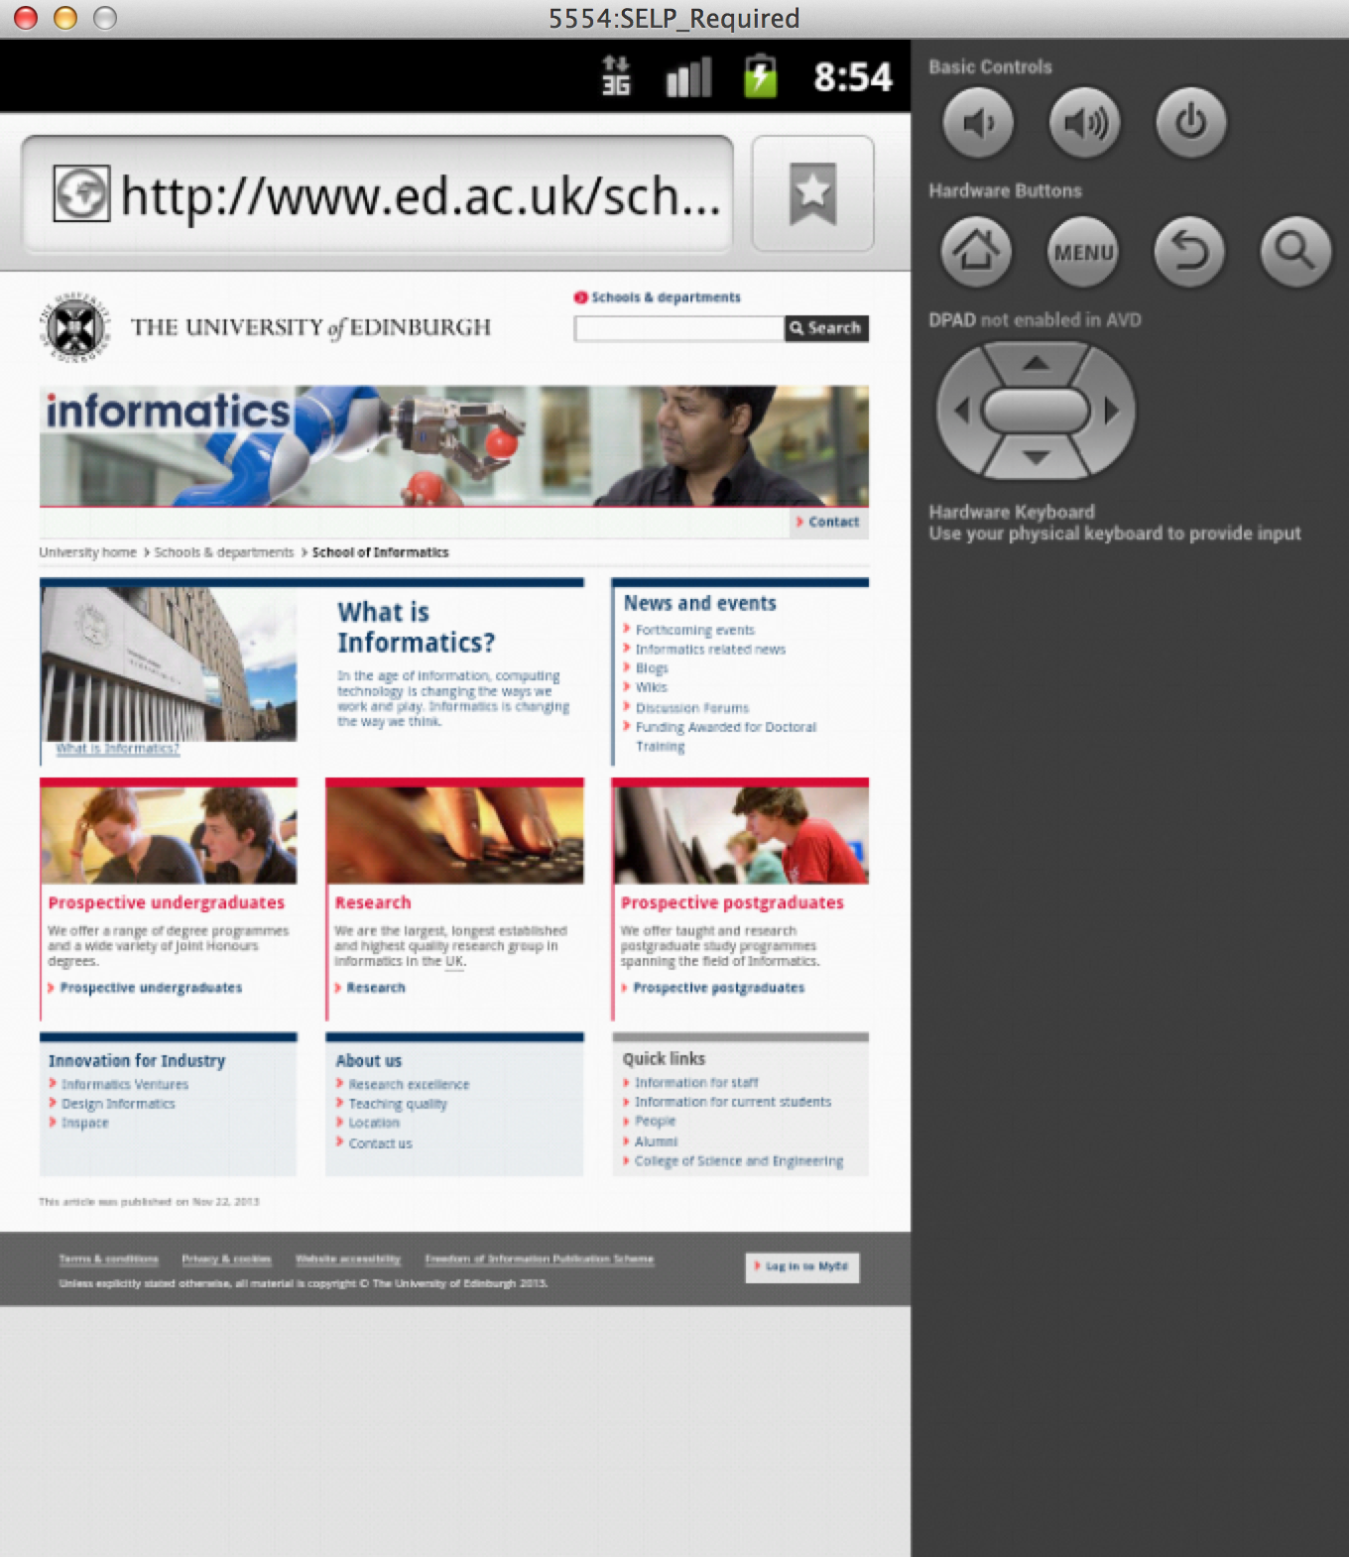
Figure 24: Slide Animation between activities.
Figure 25: Informatics Home Page, navigated to on click of the Edinburgh Logo.

4. Android Lint

When running Android Lint on the project, actionbarsherlock will be checked as well. As we are targeting minimum API level 10, Lint will come up with errors from the actionbarsherlock library. These will not disrupt the compiling of the project and you should still be able to run it on the AVD. Please ignore other warnings from the support library.

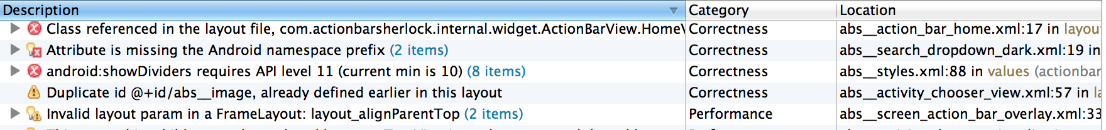
Figure 26: Android Lint warnings for actionbarsherlock support library.

