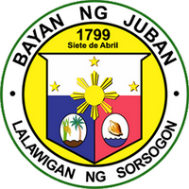

Republic of the Philippines
Province of Sorsogon
Municipality of Juban

Municipal Social Welfare and Development Office
CERTIFICATE OF TRANSFER
This is to certify that {{Person_Name}}, {{Age}} years old, a senior citizen, is a former resident of Barangay {{Brgy}}, {{Address}}.
This is to further certify that the above-named individual has transferred her place of residence to {{Transferred_Place}}.
This certification is likewise issued to confirm the transfer of her senior citizen records to the Office for Senior Citizens Affairs (OSCA) of {{Transfer_Address}} for purpose of updating her residency and senior citizen registration.
For reference, her senior citizen record/details are as follows:
OSCA ID No.: {{Osca_Id_No}}
Date of Issue: {{Date_Issued}}

This certificate is issued upon the request of the above-named individual for whatever legal and official purpose it may serve.

Issued this {{Day}} day of {{Month_Year}} at {{Address}}.

Certified by:

{{OSCA_Head_Name}}
OSCA Head

{{Acting_Head_Name}}
{{License_No}}
{{Acting_Position}}

