Machine Learning

Introduction to K-Nearest Neighbors:
- DataQuest quick summary
Here's the strategy we wanted to use:
Find a few similar listings.
  - Calculate the average nightly rental price of these listings.
  - Set the average price as the price for our listing.
  - The k-nearest neighbors algorithm is similar to this strategy. Here's an overview:
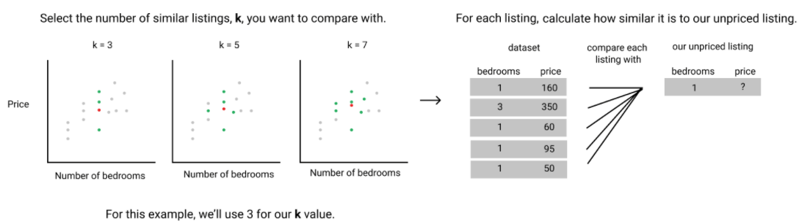
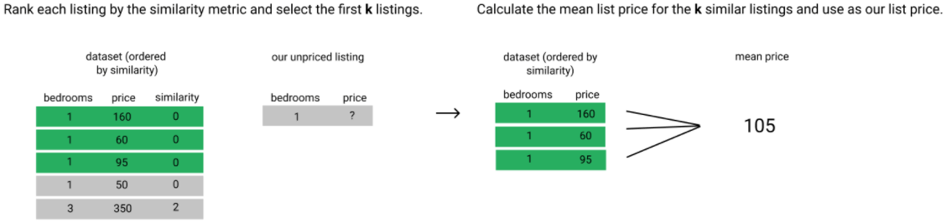

  - There are 2 things we need to unpack in more detail:
    - the similarity metric
    - how to choose the k value
  - In this mission, we'll define what similarity metric we're going to use. Then, we'll implement the k-nearest neighbors algorithm and use it to suggest a price for a new, unpriced listing. We'll use a k value of 5 in this mission. In later missions, we'll learn how to evaluate how good the suggested prices are, how to choose the optimal k value, and more.
  - Similarity metric: The similarity metric works by comparing a fixed set of numerical features, another word for attributes, between 2 observations, or living spaces in our case. When trying to predict a continuous value, like price, the main similarity metric that's used is Euclidean distance. Here's the general formula for Euclidean distance:
  - where q₁ to q_{n} represent the feature values for one observation and p₁ to p_{n} represent the feature values for the other observation. Here's a diagram that breaks down the Euclidean distance between the first 2 observations in the dataset using only the host_listings_count, accommodates, bedrooms, bathrooms, and beds columns:
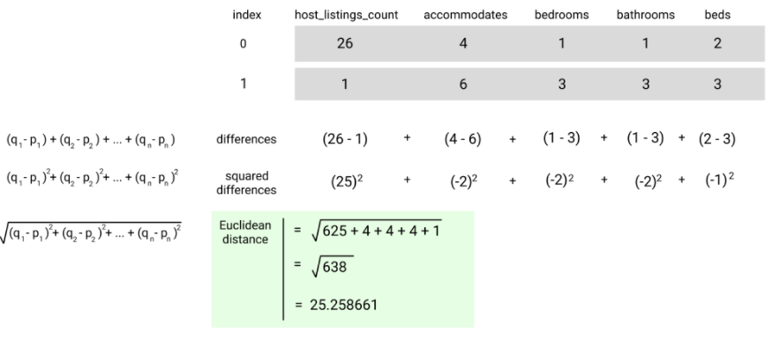
  - In this mission, we'll use just one feature in this mission to keep things simple as you become familiar with the machine learning workflow. Since we're only using one feature, this is known as the univariate case. Here's how the formula looks like for the univariate case:
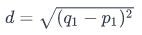
  - The square root and the squared power cancel and the formula simplifies to:
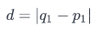
  - The living space that we want to rent can accommodate 3 people. Let's first calculate the distance, using just the accommodates feature, between the first living space in the dataset and our own.
  - When using a multivariate case the calculation will look like this:
  - Calculate Euclidean distance:
    - from scipy.spatial import distance
- place holder

Evaluating Model Performance
- A simple way to test the quality of your model is to:
  - split the dataset into 2 partitions:
    - the training set: contains the majority of the rows (75%)
    - the test set: contains the remaining minority of the rows (25%)
  - use the rows in the training set to predict the price value for the rows in the test set
    - add new column named predicted_price to the test set
  - compare the predicted_price values with the actual price values in the test set to see how accurate the predicted values were.
- train/test validation: This validation process, where we use the training set to make predictions and the test set to predict values for, is known as train/test validation.
- error metric: A metric that quantifies how good the predictions were on the test set. As the name suggests, an error metric quantifies how inaccurate our predictions were from the actual values. In our case, the error metric tells us how off our predicted price values were from the actual price values for the living spaces in the test dataset.
  - mean absolute error:
  - mean squared error: For many prediction tasks, we want to penalize predicted values that are further away from the actual value much more than those that are closer to the actual value.
  - The model we trained achieved a mean squared error of around 18646.5. Is this a high or a low mean squared error value? What does this tell us about the quality of the predictions and the model? By itself, the mean squared error value for a single model isn't all that useful. To evaluate, we must train another model and compare mse values to evaluate a given model.
  - While comparing MSE values helps us identify which model performs better on a relative basis, it doesn't help us understand if the performance is good enough in general. This is because the units of the MSE metric are squared (in this case, dollars squared). An MSE value of 16377.5 dollars squared doesn't give us an intuitive sense of how far off the model's predictions are systematically off from the true price value in dollars.
  - Root mean squared error: an error metric whose units are the base unit (in our case, dollars). RMSE for short, this error metric is calculated by taking the square root of the MSE value:
- Standard normal distribution: The simplest case of a normal distribution is known as the standard normal distribution. This is a special case when (average) µ =0 and (standard deviation) µ=1, and it is described by this probability density function:
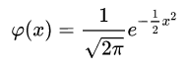
  - In our dataset we can simply do the 2 following things:
    - from each value, subtract the mean of the column
    - divide each value by the standard deviation of the column
  - Here's the mathematical formula describing the transformation that needs to be applied for all values in a column:
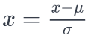
- Placeholder

Multivariate K-Nearest Neighbors:
- Fit Method
  - from sklearn.neighbors import KNeighborsRegressor
  - https://www.dataquest.io/m/140/multivariate-k-nearest-neighbors/7/fitting-a-model-and-making-predictions
  - http://scikit-learn.org/stable/modules/generated/sklearn.neighbors.KNeighborsRegressor.html#sklearn.neighbors.KNeighborsRegressor.fit
- Hyperparameters: Values that affect the behavior and performance of a model that are unrelated to the data that's used are referred to as hyperparameters. The process of finding the optimal hyperparameter value is known as hyperparameter optimization. A simple but common hyperparameter optimization technique is known as grid search, which involves:
  - selecting a subset of the possible hyperparameter values,
  - training a model using each of these hyperparameter values,
  - evaluating each model's performance,
  - selecting the hyperparameter value that resulted in the lowest error value.
- Grid Search: Grid search essentially boils down to evaluating the model performance at different k values and selecting the k value that resulted in the lowest error. While grid search can take a long time when working with large datasets, the data we're working with in this mission is small and this process is relatively quick.
- Alternatives to train/test validation:
In an earlier mission, we learned about train/test validation, a simple technique for testing a machine learning model's accuracy on new data that the model wasn't trained on. In this mission, we'll focus on more robust techniques.
  - holdout validation:
    - splitting the full dataset into 2 partitions:
      - a training set
      - a test set
    - training the model on the training set,
    - using the trained model to predict labels on the test set,
    - computing an error metric to understand the model's effectiveness,
    - switch the training and test sets and repeat,
    - average the errors.
In holdout validation, we usually use a 50/50 split instead of the 75/25 split from train/test validation. This way, we remove number of observations as a potential source of variation in our model performance.
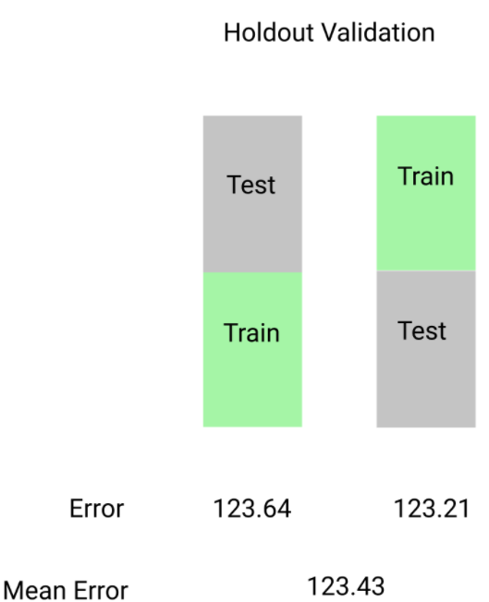
  - k-fold cross-validation:
Holdout validation is actually a specific example of a larger class of validation techniques called k-fold cross-validation. While holdout validation is better than train/test validation because the model isn't repeatedly biased towards a specific subset of the data, both models that are trained only use half the available data. K-fold cross validation, on the other hand, takes advantage of a larger proportion of the data during training while still rotating through different subsets of the data to avoid the issues of train/test validation.
    - Here's the algorithm from k-fold cross validation:
      - splitting the full dataset into k equal length partitions,
        - selecting k-1 partitions as the training set and
        - selecting the remaining partition as the test set
      - training the model on the training set,
      - using the trained model to predict labels on the test fold,
      - computing the test fold's error metric,
      - repeating all of the above steps k-1 times, until each partition has been used as the test set for an iteration,
      - calculating the mean of the k error values.
Holdout validation is essentially a version of k-fold cross validation when k is equal to 2. Generally, 5 or 10 folds is used for k-fold cross-validation. Here's a diagram describing each iteration of 5-fold cross validation:
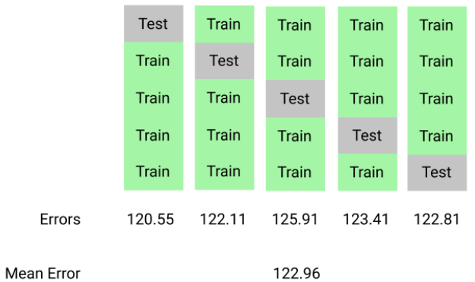
  - K-Fold cross-validation using scikit-learn
    - from sklearn.model_selection import cross_val_score, KFold
    - kf = KFold(n_splits, shuffle=False, random_state=None)
    - where:
      - n_splits is the number of folds you want to use,
      - shuffle is used to toggle shuffling of the ordering of the observations in the dataset,
      - random_state is used to specify the random seed value if shuffle is set to True.
    - cross_val_score(estimator, X, Y, scoring=None, cv=None)
    - where:
      - estimator is a sklearn model that implements the fit method (e.g. instance of KNeighborsRegressor),
      - X is the list or 2D array containing the features you want to train on,
      - y is a list containing the values you want to predict (target column),
      - scoring is a string describing the scoring criteria (list of accepted values here: http://scikit-learn.org/stable/modules/model_evaluation.html#common-cases-predefined-values).
      - cv describes the number of folds. Here are some examples of accepted values:
        - an instance of the KFold class,
        - an integer representing the number of folds.
    - Work flow using the aforementioned classes:
      - instantiate the scikit-learn model class you want to fit,
      - instantiate the KFold class and using the parameters to specify the k-fold cross-validation attributes you want,
      - use the cross_val_score() function to return the scoring metric you're interested in.
  - K Value Selection:
Choosing the right k value when performing k-fold cross validation is more of an art and less of a science. As we discussed earlier in the mission, a k value of 2 is really just holdout validation. On the other end, setting k equal to n (the number of observations in the data set) is known as leave-one-out cross validation, or LOOCV for short. Through lots of trial and error, data scientists have converged on 10 as the standard k value.

In the following code block, we display the results of varying k from 3 to 23. For each k value, we calculate and display the average RMSE value across all of the folds and the standard deviation of the RMSE values. Across the many different k values, it seems like the average RMSE value is around 128. You'll notice that the standard deviation of the RMSE increases from approximately 1.1 to 37.3 as we increase the number the folds.

  - Conclusions:
So far, we've been working under the assumption that a lower RMSE always means that a model is more accurate. This isn't the complete picture, unfortunately. A model has two sources of error, bias and variance.
Bias describes error that results in bad assumptions about the learning algorithm. For example, assuming that only one feature, like a car's weight, relates to a car's fuel efficiency will lead you to fit a simple, univariate regression model that will result in high bias. The error rate will be high since a car's fuel efficiency is affected by many other factors besides just its weight.
Variance describes error that occurs because of the variability of a model's predicted values. If we were given a dataset with 1000 features on each car and used every single feature to train an incredibly complicated multivariate regression model, we will have low bias but high variance. In an ideal world, we want low bias and low variance but in reality, there's always a tradeoff.
The standard deviation of the RMSE values can be a proxy for a model's variance while the average RMSE is a proxy for a model's bias. Bias and variance are the 2 observable sources of error in a model that we can indirectly control.
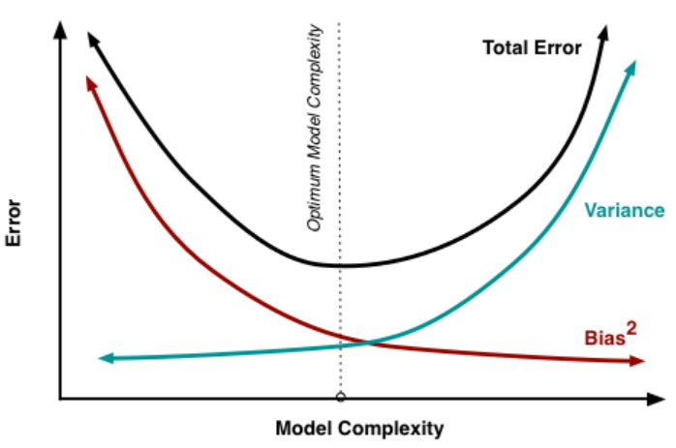
While k-nearest neighbors can make predictions, it isn't a mathematical model. A mathematical model is usually an equation that can exist without the original data, which isn't true with k-nearest neighbors. In the next two courses, we'll learn about a mathematical model called linear regression. We'll explore the bias-variance tradeoff in greater depth in these next 2 courses because of its importance when working with mathematical models in particular.
- instance-based learning:
  - A family of learning algorithms that, instead of performing explicit generalization, compares new problem instances with instances seen in training, which have been stored in memory. It is called instance-based because it constructs hypotheses directly from the training instances themselves. Some examples include:
    - k-nearest neighbor algorithm
    - kernel machines
    - RBF networks.
  - One advantage that instance-based learning has over other methods of machine learning is its ability to adapt its model to previously unseen data. Instance-based learners may simply store a new instance or throw an old instance away.
  - Disadvantage: Because the entire training dataset is used to find a new instance's nearest neighbors to make label predictions, this algorithm doesn't scale well to medium and larger datasets.
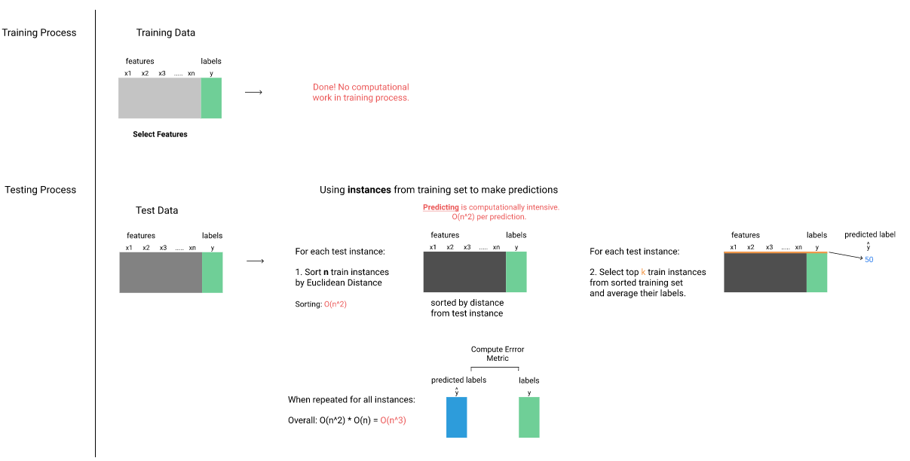
- parametric machine learning
  - The result of the training process for these machine learning algorithms is a mathematical function that best approximates the patterns in the training set. In machine learning, this function is often referred to as a model. One example is the linear regression model. Parametric machine learning approaches work by making assumptions about the relationship between the features and the target column. In linear regression, the approximate relationship between the feature columns and the target column is expressed as a linear regression equation.
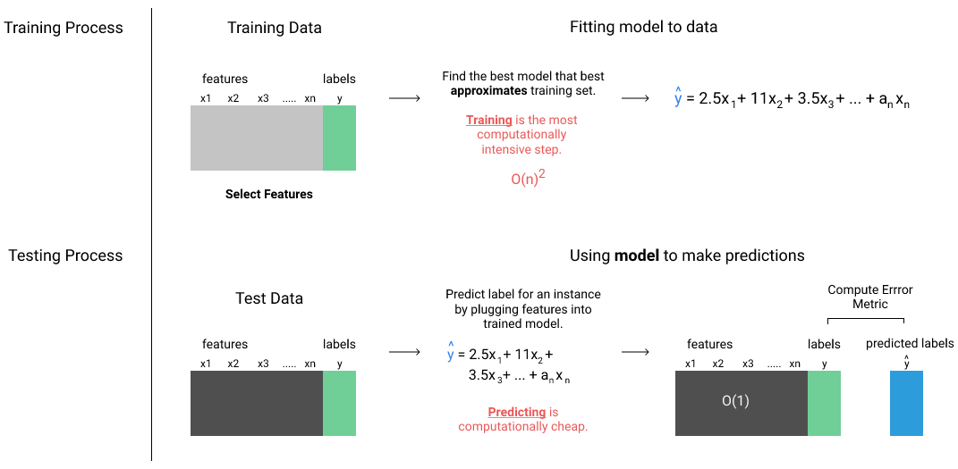
- Simple Linear Regression:
  - We'll start by understanding the univariate case of linear regression, also known as simple linear regression. The following equation is the general form of the simple linear regression model.
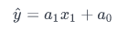
  - ŷ represents the target column while x₁ represents the feature column we choose to use in our model. These values are independent of the dataset. On the other hand, a₀ and a₁ represent the parameter values that are specific to the dataset. The goal of simple linear regression is to find the optimal parameter values that best describe the relationship between the feature column and the target column. The following diagram shows different simple linear regression models depending on the data:
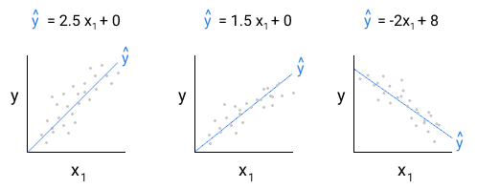
  - The first step is to select the feature, x₁, we want to use in our model. Once we select this feature, we can use scikit-learn to determine the optimal parameter values a₀ and a₁ based on the training data. Because one of the assumptions of linear regression is that the relationship between the feature(s) and the target column is linear, we want to pick a feature that seems like it has the strongest correlation with the final sale price.
  - Determining the correlation coefficient threshold:
    - We now have a decent list of candidate features to use in our model, sorted by how strongly they're correlated with the SalePrice column. For now, let's keep only the features that have a correlation of 0.3 or higher. This cutoff is a bit arbitrary and, in general, it's a good idea to experiment with this cutoff. For example, you can train and test models using the columns selected using different cutoffs and see where your model stops improving.
  - Collinearity
    - Collinearity is when 2 feature columns are highly correlated and stand the risk of duplicating information. If we have 2 features that convey the same information using 2 different measures or metrics, we don't need to keep both.
  - Rescaling:
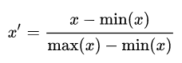
- Variance: When the values in a feature column have low variance, they don't meaningfully contribute to the model's predictive capability. On the extreme end, let's imagine a column with a variance of 0. This would mean that all of the values in that column were exactly the same. This means that the column isn't informative and isn't going to help the model make better predictions.
  - This can be calculated using pandas.DataFrame.var()

- Model Fitting:
  - In the previous missions, we learned how the linear regression model estimates the relationship between the feature columns and the target column and how we can use that for making predictions. In this mission and the next, we'll discuss the 2 most common ways for finding the optimal parameter values for a linear regression model. Each combination of unique parameter values forms a unique linear regression model, and the process of finding these optimal values is known as model fitting. Both approaches to model fitting we'll explore aim to minimize the following function:
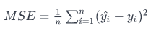
- Optimization Problem:
  - In mathematics and computer science, an optimization problem is the problem of finding the best solution from all feasible solutions. Optimization problems can be divided into two categories depending on whether the variables are continuous or discrete.
  - Example of Model Fitting & Optimization Problem:
    - To build intuition for the optimization process, let's start with a single parameter linear regression model:
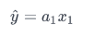
    - Note that this is different from a simple linear regression model, which actually has two parameters: x₀ and x₁.
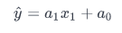
    - Let's use the Gr Liv Area column for the single parameter:


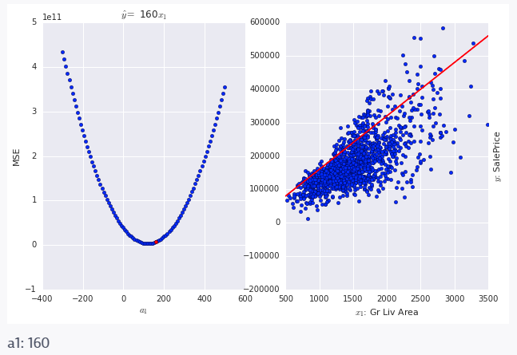
    - If you recall, we computed the critical points by calculating the curve's derivative, setting it equal to 0, and finding the x value at this point. Unfortunately, this approach won't work when we have multiple parameter values because minimizing one parameter value may increase another parameter's value. In addition, while we can plot the MSE curve when we only have a single parameter we're trying to find and visually select the value that minimizes the MSE, this approach won't work when we have multiple parameter values because we can't visualize past 3 dimensions.
    - Gradient Descent or The gradient descent algorithm: iteratively trying different parameter values until the model with the lowest mean squared error is found. Gradient descent is a commonly used optimization technique for other models as well, like neural networks.
      - Overview of the gradient descent algorithm for a single parameter linear regression model:
        - select initial values for the parameter: α₁
        - repeat until convergence (usually implemented with a max number of iterations):
          - calculate the error (MSE) of model that uses current parameter value:
          - calculate the derivative of the error (MSE) at the current parameter value:
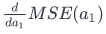
          - Update rule - update the parameter value by subtracting the derivative times a constant (α₁, called the learning rate):
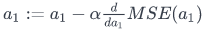
            - Note “:=” used in the equation above is a variable assignment operator.
            - this is like using += or -= in python
          - Selecting an appropriate initial parameter and learning rate will reduce the number of iterations required to converge, and is part of hyperparameter optimization. This will be covered later.
    - Cost or loss function: a function that we optimize through minimization. Because we're trying to fit a single parameter model, we can replace with y^(i) with a1x1(i) in the cost function:
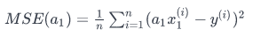
- Ordinary Least Squares
  - In the last mission, we explored an iterative technique for model fitting named gradient descent. The gradient descent algorithm requires multiple iterations to converge on the optimal parameter values and the number of iterations is highly dependent on the initial parameter values and the learning rate we select.
  - In this mission, we'll explore a technique called ordinary least squares estimation or OLS estimation for short. Unlike gradient descent, OLS estimation provides a clear formula to directly calculate the optimal parameter values that minimizes the cost function. To understand OLS estimation, we need to first frame our linear regression problem in the matrix form. We've mostly worked with the following form of the linear regression model:
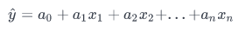
  - While this form represents the relationship between the features (x₁ to x_{n}) and the target column (y) well when there are just a few parameter values, it doesn't scale well to when we have hundreds of parameters. If you recall from the Linear Algebra for Machine Learning course, we explored how matrix notation lets us better represent and reason about a linear system with many variables. With that in mind, here's what the matrix form of our linear regression model looks like:
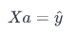
  - Where X is a matrix representing the columns from the training set our model uses, a is a vector representing the parameter values, and y^ is the vector of predictions. Here's a diagram with some sample values for each:
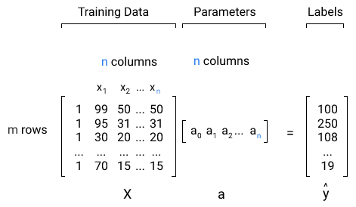
  - Now that we've gained an understanding for the matrix representation of the linear regression model, let's take a peek at the OLS estimation formula that results in the optimal vector A:
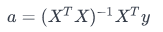
  - Cost Function
    - closed form solution: Unlike gradient descent, OLS estimation provides what is known as a closed form solution to the problem of finding the optimal parameter values. A closed form solution is one where a solution can be computed arithmetically with a predictable amount of mathematical operations. Gradient descent, on the other hand, is an algorithmic approach that can require a different number of iteration (and therefore a different number of mathematical operations) based on the initial parameter values, the learning rate, etc. While the approach is different, both techniques share the high level objective of minimizing the cost function.
    - Before we can dive into how the cost function is represented in the matrix form, let's understand how the error is represented. Because the error is the difference between the predictions made using the model y^ and the actual labels y, it's represented as a vector. The greek letter for E (epsilon ϵ) is often used to represent the error vector:
    - We can build on this to define y:
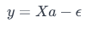
    - Even though this closely resembles the matrix equation of Ax=b, we have 2 unknowns (the vector a and the vector y^. We're looking for a model, represented using the parameter vector a, that will minimize the mean squared error between the labels, y, and the predictions, y^. Said another way, the cost function is this mean squared error.
    - Here's what the cost function looks like in matrix form:
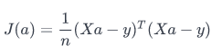
  - Derivative Of The Cost Function
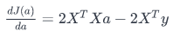
    - To find the vector a that minimizes the cost function J(a), we need to set the derivative equal to 0 and solve for a:
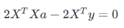
    - Let's move the second term to the right hand side and divide both sides by 2:
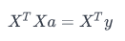
    - Our goal is to isolate a, the parameter vector. The last step we need to perform is "divide out" X^{T}X from the left hand side.
    - If you recall, we can "divide" matrix terms by computing the inverse. Let's dig up the example we explored in the linear algebra course. We can cancel A from the following equation Ax=b by multiplying both sides by the inverse A⁻¹Ax=A⁻¹b. This leaves us with x=A⁻¹b .
    - To cancel X^{T}X from the left side, we need to compute the inverse of it and multiply it by both sides. We're now left with the OLS estimation formula:
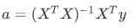
  - Ordinary Least Squares vs Gradient Descent
    - Now that we've explored a lot of the math that underlies OLS estimation, let's understand its limitations. The biggest limitation is that OLS estimation is computationally expensive when the data is large. This is because computing a matrix inverse has a computational complexity of apprximately O(n^3). You can read more about computational complexity of the matrix inverse and other common matrix operations on Wikipedia.
    - OLS is commonly used when the number of elements in the dataset (and therefore the matrix that's inverted) is less than a few million elements. On larger datasets, gradient descent is used because it's much more flexible. For many practical problems, we can set a threshold accuracy value (or a set number of iterations) and use a "good enough" solution. This is especially useful when iterating and trying different features in our model.
- Processing & Transforming Features
  - Feature Engineering: is the process of using domain knowledge of the data to create features that make machine learning algorithms work. Feature engineering is fundamental to the application of machine learning, and is both difficult and expensive. The need for manual feature engineering can be obviated by automated feature learning.
    - My guess is that I’ll be learning how to make use of Ordinal, Nominal (categorical), & Discrete numbers useful in algorithms. Let’s see if my assumption is correct.
  - Categorical Type:
    - pandas.DataFrame.astype('category')
    - When we convert a column to the categorical data type, pandas assigns a number from 0 to n-1 (where n is the number of unique values in a column) for each value. The drawback with this approach is that one of the assumptions of linear regression is violated here. Linear regression operates under the assumption that the features are linearly correlated with the target column. For a categorical feature, however, there's no actual numerical meaning to the categorical codes that pandas assigned for that colum. An increase in the Utilities column from 1 to 2 has no correlation value with the target column, and the categorical codes are instead used for uniqueness and exclusivity (the category associated with 0 is different than the one associated with 1).
  - Dummy Coding
    - The common solution is to the problem described above is to use a technique called dummy coding. Instead of having a single column with n integer codes, we have n binary columns. Here's what that would look like for the Utilities column:
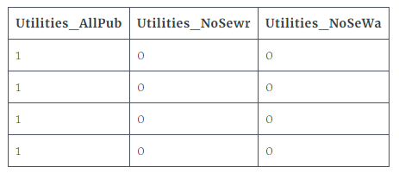
    - Is one that takes the value 0 or 1 to indicate the absence or presence of some categorical effect that may be expected to shift the outcome.
    - Dummy variables are used as devices to sort data into mutually exclusive categories (such as smoker/non-smoker, etc.).^{[2]} For example, in econometric time series analysis, dummy variables may be used to indicate the occurrence of wars or major strikes. A dummy variable can thus be thought of as a truth value represented as a numerical value 0 or 1 (as is sometimes done in computer programming).
    - pandas.get_dummies
- Missing Values:
  - Remove rows containing missing values for specific columns
    - Pro: Rows containing missing values are removed, leaving only clean data for modeling
    - Con: Entire observations from the training set are removed, which can reduce overall prediction accuracy
  - Impute (or replace) missing values using a descriptive statistic from the column
    - Pro: Missing values are replaced with potentially similar estimates, preserving the rest of the observation in the model.
    - Con: Depending on the approach, we may be adding noisy data for the model to learn
- Data Leaking:
  - When the data you are using to train a machine learning algorithm happens to have the information you are trying to predict.
  - Data leakage can manifest in many ways including:
    - Leaking data from the test set into the training set.
    - Leaking the correct prediction or ground truth into the test data.
    - Leaking of information from the future into the past.
    - Reversing obfuscation, randomization or anonymization of data that were intentionally included.
    - Information from data samples outside of scope of the algorithm’s intended use.
    - Any of the above existing in external data coupled with the training set.
  - An over simplified way to say this, is data that we would not have prior to the event being predicted. In the home price prediction exercise, Sale Condition (Normal Sale, trade, foreclosure, short sale) or month a home is sold are examples of this. You won’t know what the sale condition is or the month a home is sold prior to the sale of the home.
- Logistic Regression Introduction:
  - General remarks:
    - Classification problems, predicting which group or category something belongs to.
    - While a linear regression model outputs a real number as the label, a logistic regression model outputs a probability value.
    - In binary classification, if the probability value is larger than a certain threshold probability, we assign the label for that row to 1 or 0 otherwise.
  - Logistic Function
    - In linear regression, we used the linear function y = mx + b to represent the relationship between the independent variables and the dependent variable. In logistic regression, we use the logistic function, which is a version of the linear function that is adapted for classification.
    - Unlike in linear regression, where the output can be any real value, in logistic regression the output has to be a real value between 0 and 1, since the output represents a probability value. Note that the model can't output a negative value or it would violate this criteria.
    - Here's the mathematical representation of the logistic function:
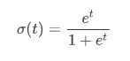
    - The logistic function is broken up into 2 key parts:
      - The exponential transformation, transforming all values to be positive:
      - The normalization transformation, transforming all values to range between 0 and 1:
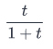
    - The exponential transformation and the normalization forces the output values to be squeezed between 0 and 1. If you plot just the exponential part, the output values won't be limited to the range of 0 to 1:
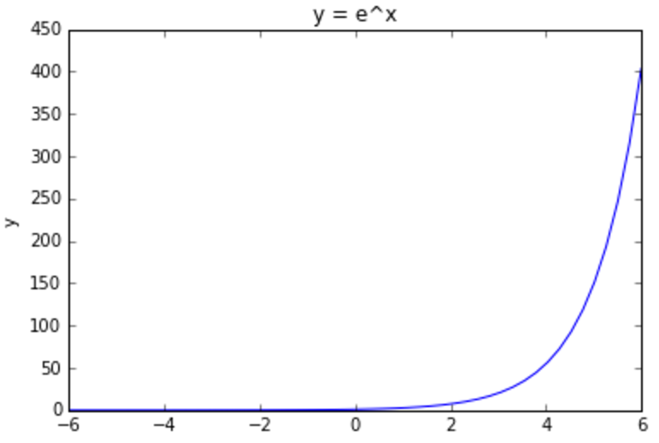
    - The normalization part alone unfortunately isn't sufficient since it struggles at constraining negative values:
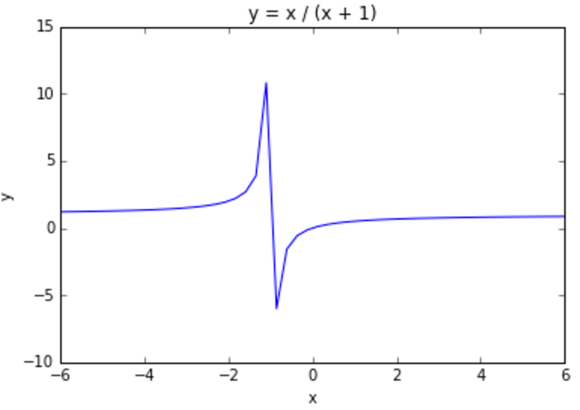
  - Calculating the Accuracy of a Logistic Model
    - This is determined by calculating what fraction of the predictions were correct (actual label matched predicted label).
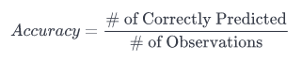
  - Discrimination threshold: The model's output is a probability between 0 and 1. To decide who gets admitted, we set a threshold; scikit-learn sets it to 0.5 by default when predicting labels. If the predicted probability is greater than 0.5, the label for that observation is 1. If it is instead less than 0.5, the label for that observation is 0.
    - An accuracy of 1.0 means that the model predicted 100% correctly for the given discrimination threshold. An accuracy of 0.2 means that the model predicted 20% correctly.
  - Binary classification outcomes:
    - The accuracy doesn't tell us how the model performs on data it wasn't trained on. A model that returns a 100% accuracy when evaluated on its training set doesn't tell us how well the model works on data it's never seen before (and wasn't trained on).
    - Accuracy also doesn't help us discriminate between the different types of outcomes a binary classification model can make.
    - Four Different Outcomes of a binary classification model:
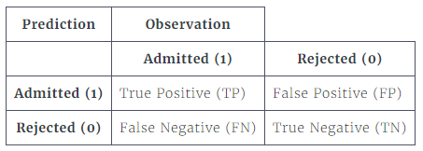
      - True Positive (TP) - The model predicted that the label would be Positive, and that ended up being True.
      - True Negative (TN) – The model predicted that the label would be Negative, and that ended up being True.
      - False Positive (FP) – The model predicted that the label would be Positive, and that ended up being False.
      - False Negative (TN) - The model predicted that the label would be Negative, and that ended up being False.
    - Sensitivity or True Positive Rate
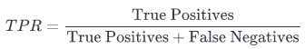
    - Specificity or True Negative Rate
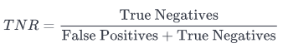
    - Multiclass classification: classification when we have 3 or more categories.
      - one-versus-all method: A technique where we choose a single category as the Positive case and group the rest of the categories as the False case. We're essentially splitting the problem into multiple binary classification problems. For each observation, the model will then output the probability of belonging to each category.
        - In the one-vs-all approach, we're essentially converting an n-class (in our case n is 3) classification problem into n binary classification problems.
- Overfitting: Overfitting is a modeling error which occurs when a function is too closely fit to a limited set of data points. Overfitting the model generally takes the form of making an overly complex model to explain idiosyncrasies in the data under study.
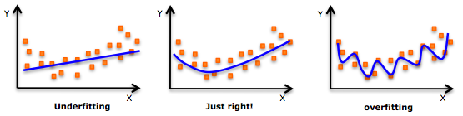
  - Some basics regarding Overfitting:
    - overfitting happens because our model is too powerful for the amount of data we have.
    - when we have overfitting our model is great with the training set but is not good with the test set, the algorithm is bad at generalization
    - overfitting algorithms hallucinate impossible results from their input.
    - getting more data is always a way to mitigate or avoid overfitting.
    - when more data doesn’t help we have to restrict the model with regularization or change the algorithm
    - some algorithms are more resistant to overfitting than others.
  - Understanding Overfitting: Bias and variance make up the 2 observable sources of error in a model that we can indirectly control.
    - Bias describes error that results in bad assumptions about the learning algorithm. For example, assuming that only one feature, like a car's weight, relates to a car's fuel efficiency will lead you to fit a simple, univariate regression model that will result in high bias. The error rate will be high since a car's fuel efficiency is affected by many other factors besides just its weight.
    - Variance describes error that occurs because of the variability of a model's predicted values. If we were given a dataset with 1000 features on each car and used every single feature to train an incredibly complicated multivariate regression model, we will have low bias but high variance.
    - In an ideal world, we want low bias and low variance but in reality, there's always a tradeoff.
The bias-variance tradeoff is a central problem in supervised learning. Ideally, one wants to choose a model that both accurately capture the regularities in its training data, but also generalizes well to unseen data. Unfortunately, it is typically impossible to do both simultaneously. High-variance learning methods may be able to represent their training set well but are at risk of overfitting to noisy or unrepresentative training data. In contrast, algorithms with high bias typically produce simpler models that don't tend to overfit but may underfit their training data, failing to capture important regularities.
Models with low bias are usually more complex (e.g. higher-order regression polynomials), enabling them to represent the training set more accurately. In the process, however, they may also represent a large noise component in the training set, making their predictions less accurate - despite their added complexity. In contrast, models with higher bias tend to be relatively simple (low-order or even linear regression polynomials) but may produce lower variance predictions when applied beyond the training set.
At its root, dealing with bias and variance is really about dealing with over- and under-fitting. Bias is reduced and variance is increased in relation to model complexity. As more and more parameters are added to a model, the complexity of the model rises and variance becomes our primary concern while bias steadily falls. For example, as more polynomial terms are added to a linear regression, the greater the resulting model's complexity will be. In other words, bias has a negative first-order derivative in response to model complexity while variance has a positive slope.
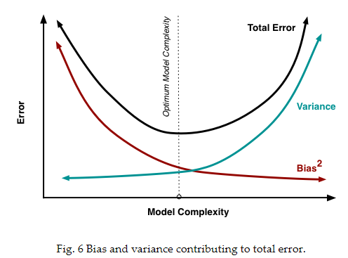
Understanding bias and variance is critical for understanding the behavior of prediction models, but in general what you really care about is overall error, not the specific decomposition. The sweet spot for any model is the level of complexity at which the increase in bias is equivalent to the reduction in variance. Mathematically:
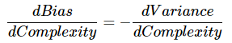
If our model complexity exceeds this sweet spot, we are in effect over-fitting our model; while if our complexity falls short of the sweet spot, we are under-fitting the model. In practice, there is not an analytical way to find this location. Instead we must use an accurate measure of prediction error and explore differing levels of model complexity and then choose the complexity level that minimizes the overall error. A key to this process is the selection of an accurate error measure as often grossly inaccurate measures are used which can be deceptive. The topic of accuracy measures is discussed here but generally resampling based measures such as cross-validation should be preferred over theoretical measures such as Aikake's Information Criteria.
  - Checking for Overfitting:
A good way to detect if your model is overfitting is to compare the in-sample error and the out-of-sample error, or the training error with the test error. So far, we calculated the in sample error by testing the model over the same data it was trained on. To calculate the out-of-sample error, we need to test the data on a test set of data. We unfortunately don't have a separate test dataset and we'll instead use cross validation.
If a model's cross validation error (out-of-sample error) is much higher than the in sample error, then your data science senses should start to tingle. This is the first line of defense against overfitting and is a clear indicator that the trained model doesn't generalize well outside of the training set.
  - Conclusions in the Intermediate Machine Learning / Overfitting Section:
While the higher order multivariate models overfit in relation to the lower order multivariate models, the in-sample error and out-of-sample didn't deviate by much. The best model was around 50% more accurate than the simplest model. On the other hand, the overall variance increased around 25% as we increased the model complexity. This is a really good starting point, but your work is not done! The increased variance with the increased model complexity means that your model will have more unpredictable performance on truly new, unseen data.
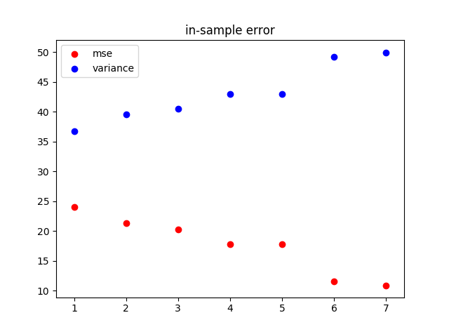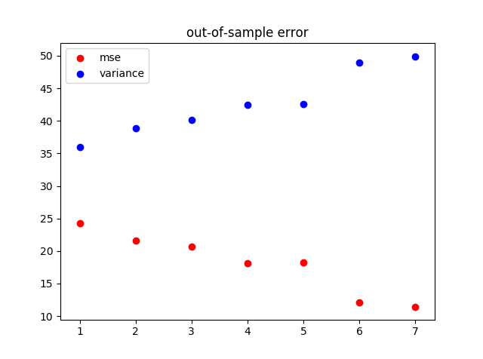
If you were working on this problem on a data science team, you'd need to confirm the predictive accuracy of the model using completely new, unobserved data (e.g. maybe from cars from later years). Since often you can't wait until a model is deployed in the wild to know how well it works, the exploration we did in this mission helps you approximate a model's real world performance.
- Supervised Machine Learning:
  - Supervised learning is the machine learning task of learning a function that maps an input to an output based on example input-output pairs. It infers a function from labeled training data consisting of a set of training examples. In supervised learning, each example is a pair consisting of an input object (typically a vector) and a desired output value (also called the supervisory signal). A supervised learning algorithm analyzes the training data and produces an inferred function, which can be used for mapping new examples. An optimal scenario will allow for the algorithm to correctly determine the class labels for unseen instances. This requires the learning algorithm to generalize from the training data to unseen situations in a "reasonable" way.
  - Examples:
    - k-Nearest Neighbor
    - Linear Regression
    - Logistical Regression
- Unsupervised Machine Learning:
  - Unsupervised machine learning is the machine learning task of inferring a function to describe hidden structure from "unlabeled" data (a classification or categorization is not included in the observations). Since the examples given to the learner are unlabeled, there is no evaluation of the accuracy of the structure that is output by the relevant algorithm—which is one way of distinguishing unsupervised learning from supervised learning and reinforcement learning.
  - A central case of unsupervised learning is the problem of density estimation in statistics, though unsupervised learning encompasses many other problems (and solutions) involving summarizing and explaining key features of the data.
  - Examples:
    - Clustering
    - Place holder
- Clustering:
  - We use clustering when we're trying to explore a dataset, and understand the connections between the various rows and columns. For example, we can cluster NBA players based on their statistics. Here's how such a clustering might look:

  - The clusters made it possible to discover player roles that might not have been noticed otherwise.
  - Clustering algorithms group similar rows together. There can be one or more groups in the data, and these groups form the clusters. As we look at the clusters, we can start to better understand the structure of the data. Clustering is a key way to explore unknown data, and it's a very commonly used machine learning technique. In this mission, we'll work on clustering US Senators based on how they voted.
- k-means clustering
  - k-means clustering is a method of vector quantization, originally from signal processing, that is popular for cluster analysis in data mining. k-means clustering aims to partition n observations into k clusters in which each observation belongs to the cluster with the nearest mean, serving as a prototype of the cluster. This results in a partitioning of the data space into Voronoi cells.
  - Extremes: To exaggerate the distances between the clusters we cube the values then sum them together. We can then sort the resulting Series and key in on the largest few to focus in on the most extreme cases.
  - k-means clustering is a centroid based clustering algorithm:
In centroid-based clustering, clusters are represented by a central vector, which may not necessarily be a member of the data set. When the number of clusters is fixed to k, k-means clustering gives a formal definition as an optimization problem: find the k cluster centers and assign the objects to the nearest cluster center, such that the squared distances from the cluster are minimized.
The optimization problem itself is known to be NP-hard, and thus the common approach is to search only for approximate solutions. A particularly well known approximate method is Lloyd's algorithm,[8] often just referred to as "k-means algorithm" (although another algorithm introduced this name). It does however only find a local optimum, and is commonly run multiple times with different random initializations. Variations of k-means often include such optimizations as choosing the best of multiple runs, but also restricting the centroids to members of the data set (k-medoids), choosing medians (k-medians clustering), choosing the initial centers less randomly (k-means++) or allowing a fuzzy cluster assignment (fuzzy c-means).
Most k-means-type algorithms require the number of clusters - k - to be specified in advance, which is considered to be one of the biggest drawbacks of these algorithms. Furthermore, the algorithms prefer clusters of approximately similar size, as they will always assign an object to the nearest centroid. This often leads to incorrectly cut borders of clusters (which is not surprising since the algorithm optimizes cluster centers, not cluster borders).
K-means has a number of interesting theoretical properties. First, it partitions the data space into a structure known as a Voronoi diagram. Second, it is conceptually close to nearest neighbor classification, and as such is popular in machine learning. Third, it can be seen as a variation of model based clustering, and Lloyd's algorithm as a variation of the Expectation-maximization algorithm for this model discussed below.
  - Procedure for using k-means clustering:
Setup K-Means is an iterative algorithm that switches between recalculating the centroid of each cluster and the (in this case) players that belong to that cluster. To start, select (k) 5 players at random and assign their coordinates as the initial centroids of the just created clusters.
    - Step 1 (Assign Points to Clusters) For each player, calculate the Euclidean distance between that player's coordinates, or values for atr & ppg, and each of the centroids' coordinates. Assign the player to the cluster whose centroid is the closest to, or has the lowest Euclidean distance to, the player's values.
    - Step 2 (Update New Centroids of the Clusters) For each cluster, compute the new centroid by calculating the arithmetic mean of all of the points (players) in that cluster. We calculate the arithmetic mean by taking the average of all of the X values (atr) and the average of all of the Y values (ppg) of the points in that cluster.
    - Iterate Repeat steps 1 & 2 until the clusters are no longer moving and have converged.
    - Observates From this Manual K-means iteration:
      - As you repeat Steps 1 and 2 and run visualize_clusters, you'll notice that a few of the points are changing clusters between every iteration (especially in areas where 2 clusters almost overlap), but otherwise, the clusters visually look like they don't move a lot after every iteration. This means 2 things:
      - K-Means doesn't cause massive changes in the makeup of clusters between iterations, meaning that it will always converge and become stable
      - Because K-Means is conservative between iterations, where we pick the initial centroids and how we assign the players to clusters initially matters a lot
      - To counteract these problems, the sklearn implementation of K-Means does some intelligent things like re-running the entire clustering process lots of times with random initial centroids so the final results are a little less biased on one passthrough's initial centroids.
  - Pros of using k-means clustering:
  - Cons of using k-means clustering:
- Placeholder

