Git Basics
- git init – We can initialize a repository by typing “git init” inside the folder we want to use for our project
  - Initializing a Git repository will create a folder called .git inside the repository folder.
  - Files and folders with a period prefix (.) are typically private, and don't show up by default when we list the files in a folder.
- git status → check the state of each file within a Git repository
- git add → add files to the staging area
  - git add script.py
  - git rm file → stage a file that has been deleted
- git config → Configures identity in git
  - git config --global user.email "your.email@domain.com"
  - git config --global user.name "Your name"
- git commit → stores a snapshot of the files in the repository at a certain point in time. By building a history of these snapshots, we can rewind to an earlier point in time, or merge someone else's changes with our own.
  - The -m flag indicates that we're adding a message, and the text in quotes that comes after it is the commit message itself. It's customary to make the commit message something informative, so if we do have to rewind or merge code, it's obvious what changes we made and when.
  - git commit -m "Commit message here"
    - Note, commit message should be very detailed with file names as they do not seem to be included in the log output.
- git diff → view all of the line differences between the current and previous version. We can scroll up and down with the arrow keys, and exit git diff with the q key. If we want to see the differences after we stage a file, we can use git diff –-staged.
  - We can pull up the difference between two commits with the git diff command -- we just pass the two commit hashes as arguments to git diff. To save typing time, we can also just write the first few characters of the hash to uniquely identify the commit (four is usually enough). The order in which we pass the two hashes to git diff influences whether changes appear as deletions or additions. It's generally preferable to put the "older" branch first
- git log → pull up a repository's commit history. This command will show us a list of all of the commits to the repository, in descending order by creation date. If the output is very long, it will allow us to scroll. We can scroll through the log with the up and down arrows, and use the q key to exit.
  - git log –-stat → see more details about the commits in the git log output
- git show “enter commit ID (hash)” → an quickly view a previous commit.
- git clone URL of repository → clone a remote repository locally.
  - git clone rep_url directory_to_clone_into
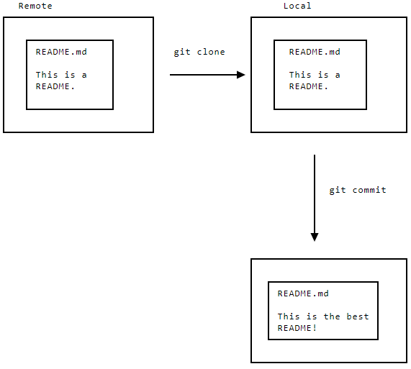
- git branch → check which branch we're on. This command will list all of the branches in the repo. It will also highlight the currently active branch, and add an asterisk next to its name.
- git push → Once we've made changes to the local version of a repo, we can push those changes to the remote repo so that everyone can see them. Edits we make locally are only reflected in our local repo. Unless we push them to the remote, the remote repo doesn't change. The git push command accomplishes this task.
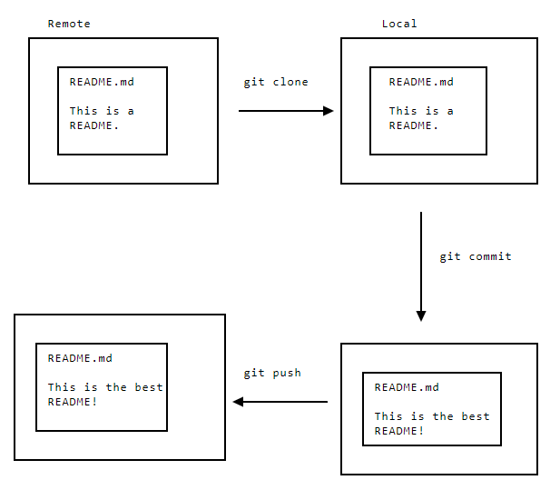
  - As the diagram shows, until we push the branch to the remote repo, the changes are only in our local repo. Pushing to the remote will update the remote with our latest changes. Anyone else who pulls from the remote repo will then have access to the same two commits that we have in our local repo.
  - When we run git push, we need to specify both the name of the remote repo to push to, and the name of the branch we're pushing. When we clone a repo, Git automatically names the remote repo origin. This means that the following command will push the master branch to the remote repo:
    - git push origin master
  - git remote → It's possible, but rare, that a remote will have a name other than origin. If we're unsure, we can list the remote(s) associated with our local repo using git remote.
    - The git remote command will list all of the repo's remotes. If we specify the -v option, we'll get additional information about where the remote repos are located.
  - git reset --hard [commit hash ID] → switch between commits in the local repo without changing what commits are in the remote repo
    - flags:
      - -- hard → resets both the working directory and the Git history to a specific state
      - -- soft → skip making changes to the working directory, and only reset the Git history
  - git pull → When the latest commit in our local repo is older than the latest commit in the remote repo, we can use git pull to update the current branch with the latest commits. The git pull command will also update our working directory so that it has the same files as the latest commit.
    - It seems like it “un-does” the git reset
  - HEAD → always refers to the most recent commit in the current branch
    - We can use the HEAD variable to switch to the most recent commit more easily. Let's say we modify a file and then want to undo our changes; using HEAD will revert the working directory to the state of the most recent commit.
    - We can also use shortcuts to get older commit hashes. HEAD~1 will get the second newest commit in the local repo, HEAD~2 will get the third newest commit, and so on.
    - git reset -- hard HEAD~1
      - This will reset the repo to the second most recent commit.
  - git rev-parse HEAD → will return the hash ID of the most recent commit
  - git branch NameOfBranch → creates a new branch with the name “NameOfBranch”
    - git branch -r → show all of the branches on the remote and confirm that ours is there. The following is an example of possible output from this command:
origin/HEAD -> origin/master
origin/master
origin/more-speech
      - The output shows that there are two branches (master and more-speech) on the remote called origin, and that the current branch (the HEAD branch) is master. Git uses HEAD to refer to the current branch, as well as the latest commit in that branch.
    - git branch -a → show all of the branches available locally
    - git branch -d [BranchName] → delete a branch once we've merged all of its commits into another branch. If a branch has unmerged commits inside it, Git will prevent it from being deleted, so its generally safe to delete branches we think are old or unnecessary.
  - git checkout [NameOfBranch]→ Switch to the new branch
    - git checkout -b NameOfBranch → creates and switches to newly create branch with a single command
    - Switching between branches is very useful when we want to work on changes to a project that require different amounts of testing or development time. By putting them in separate branches, we can save the state of each addition, without them conflicting with each other.
    - The git checkout command allows us to switch branches. If we still have changes in the working directory we haven't committed yet, though, Git will check whether there's a potential merge conflict with the branch we're switching to. If there is, Git won't let us change branches.
    - git checkout -- ours file(s) → keep files from the current branch
    - git checkout -- theirs file(s) → keep files from the branch we're merging in

  - git merge → command to merge a branch into another branch. In order to merge branch b into branch a, we first have to switch to branch a, then run git merge.
    - git merge --abort → We'd typically do an abort if we merged one branch into another by accident, or wanted to deal with large merge conflicts in another way. When we abort a merge, Git resets the working directory and Git history to the state they were in before we tried to merge.
  - git fetch → will fetch all of the current branches and commits from the remote. This won't make any changes to the working directory, but will update Git's list of branch names and commits.
  - .gitignore → A file that contains a list of all the files (this list can handle wild card characters) to be ignored by git.
    - adding files to .gitignore doesn't remove any files that have already been added to a Git commit.
    - git rm --cached .DS_Store → remove any files called .DS_Store from our Git repo, but not from our working directory. The files will still exist on the computer, but will be invisible to Git for version tracking purposes.

- Note…
  - The typical Git workflow involves adding files, making changes, and then storing a checkpoint (or "snapshot") of those changes. These checkpoints are called commits.
  - More detailed workflow
    - Create a branch off of master with the name of your feature. Let's say feature/better-algo
    - Make your changes on the branch and create commits.
    - Push the branch to the remote repo
    - Ask others to review and evaluate your branch
    - Merge the branch into master once everyone thinks it looks okay
    - Delete the branch
  - Instead of storing every file in every commit, Git stores the diff, or the things that change between commits.

- Files can have one of three states in Git:
  - committed → The current version of the file has been added to a commit, and Git has stored it.
  - Staged → The file has been marked for inclusion in the next commit, but hasn't been committed yet (and Git hasn't stored it yet). You might stage one file before working on a second file, for example, then commit both files at the same time when you're done.
  - Modified → The file has been modified since the last commit, but isn't staged yet.

- Branches:
  - Every Git repository consists of one or more branches. Each branch contains a slightly different version of the code. Developers create separate branches when they want to work on new features for a project, then add the commits in those branches back into master when the features are ready.
    - Master → main branch of a Git repo
    - Naming Conventions
      - Feature - feature/happy-bot (commits that add functionality to a project)
      - Fix - fix/remove-error (resolve bugs and other issues)
      - Chore - chore/add-analytics (things that end users won't necessarily notice, but help us reorganize the project or make the code more efficient)

