Silverleaf Desk
Improved system map · updated from the original 1–5s Excalidraw
Same drawing you had — Users and Admin still meet at “Adds 1 to 5’s” — cleaned up, numbered fully, and updated with department desks, the 9:30 a.m. auto-close, Thursday pulse, and the project manager desk.
Staff  (any department) | → Adds | Adds 1 to 5’s | ← Do | Admin | → Do | Admin work
Staff file a personal 1–5. Admin can file one too, and also runs holidays, users, and the board.
Users — what staff do  1. Login by email (password or OTP).  2. Fill in the form — slots 1 to 3 for today. At least one must be filled.  3. View previous tasks. Older days are locked (uneditable for staff).  4. Mark tasks: completed, in progress, abandoned, not started.  5. Close the day in the evening, and read feedback on the desk.  Each person’s 1–5 is personal (what they typed). It also sits on their department desk: Onboarding, Uniforms, Marketing, Operations, Data & Tech, HR, Academic, Finance, Facilities. | Admin — what admin does  1. Views 1–5s for every user, grouped by department. (Trend over time still to add.)  2. Graphical presentation of work: weekly snapshot with project %. (1–5 accomplishment charts still to add.)  3. Logs: user and tool audit exist. (1–5 activity log still to add.)  4. Can mark public holidays. Can add a weekend as an extra work day.  5. Daily board and weekly academy snapshot. (Monthly 1–5 summary still to add.)  Admin also adds people (name + email). Spreadsheet / Excel batch import is still to add. | The form — original blue list, updated  1. Login by email.  2. Five parts: (1)(2)(3) what I will do today — at least one; (4) blockers; (5) how yesterday went.  3. Today’s date is used by default (Nairobi).  4. Shows previous tasks.  5. Marks completed / in progress / abandoned / not started.  6. Skips holidays set by admin.  7. Skips weekends, unless admin turns that date on.  8. Admin adds users one by one: full name + email. (Excel batch still to add.)  9. Skipped dates with no reason are marked missed at 9:30 a.m.  10. Staff must give a reason to skip.  11. Cutoff is 9:30 a.m. Nairobi. Late and missed are marked automatically — nobody checks the board by hand.  12. Today’s 1–5 stays editable until the day is closed.

The picture
Left: the original Excalidraw you sent. Right: the same map, improved and updated with desks, automation, pulse, and projects.
Original (what you gave)  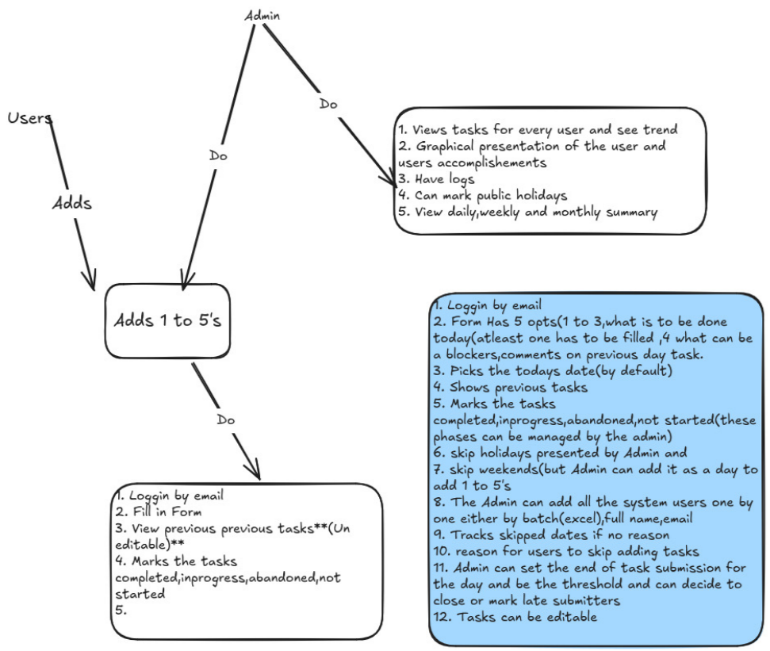 | Updated (what we have now)  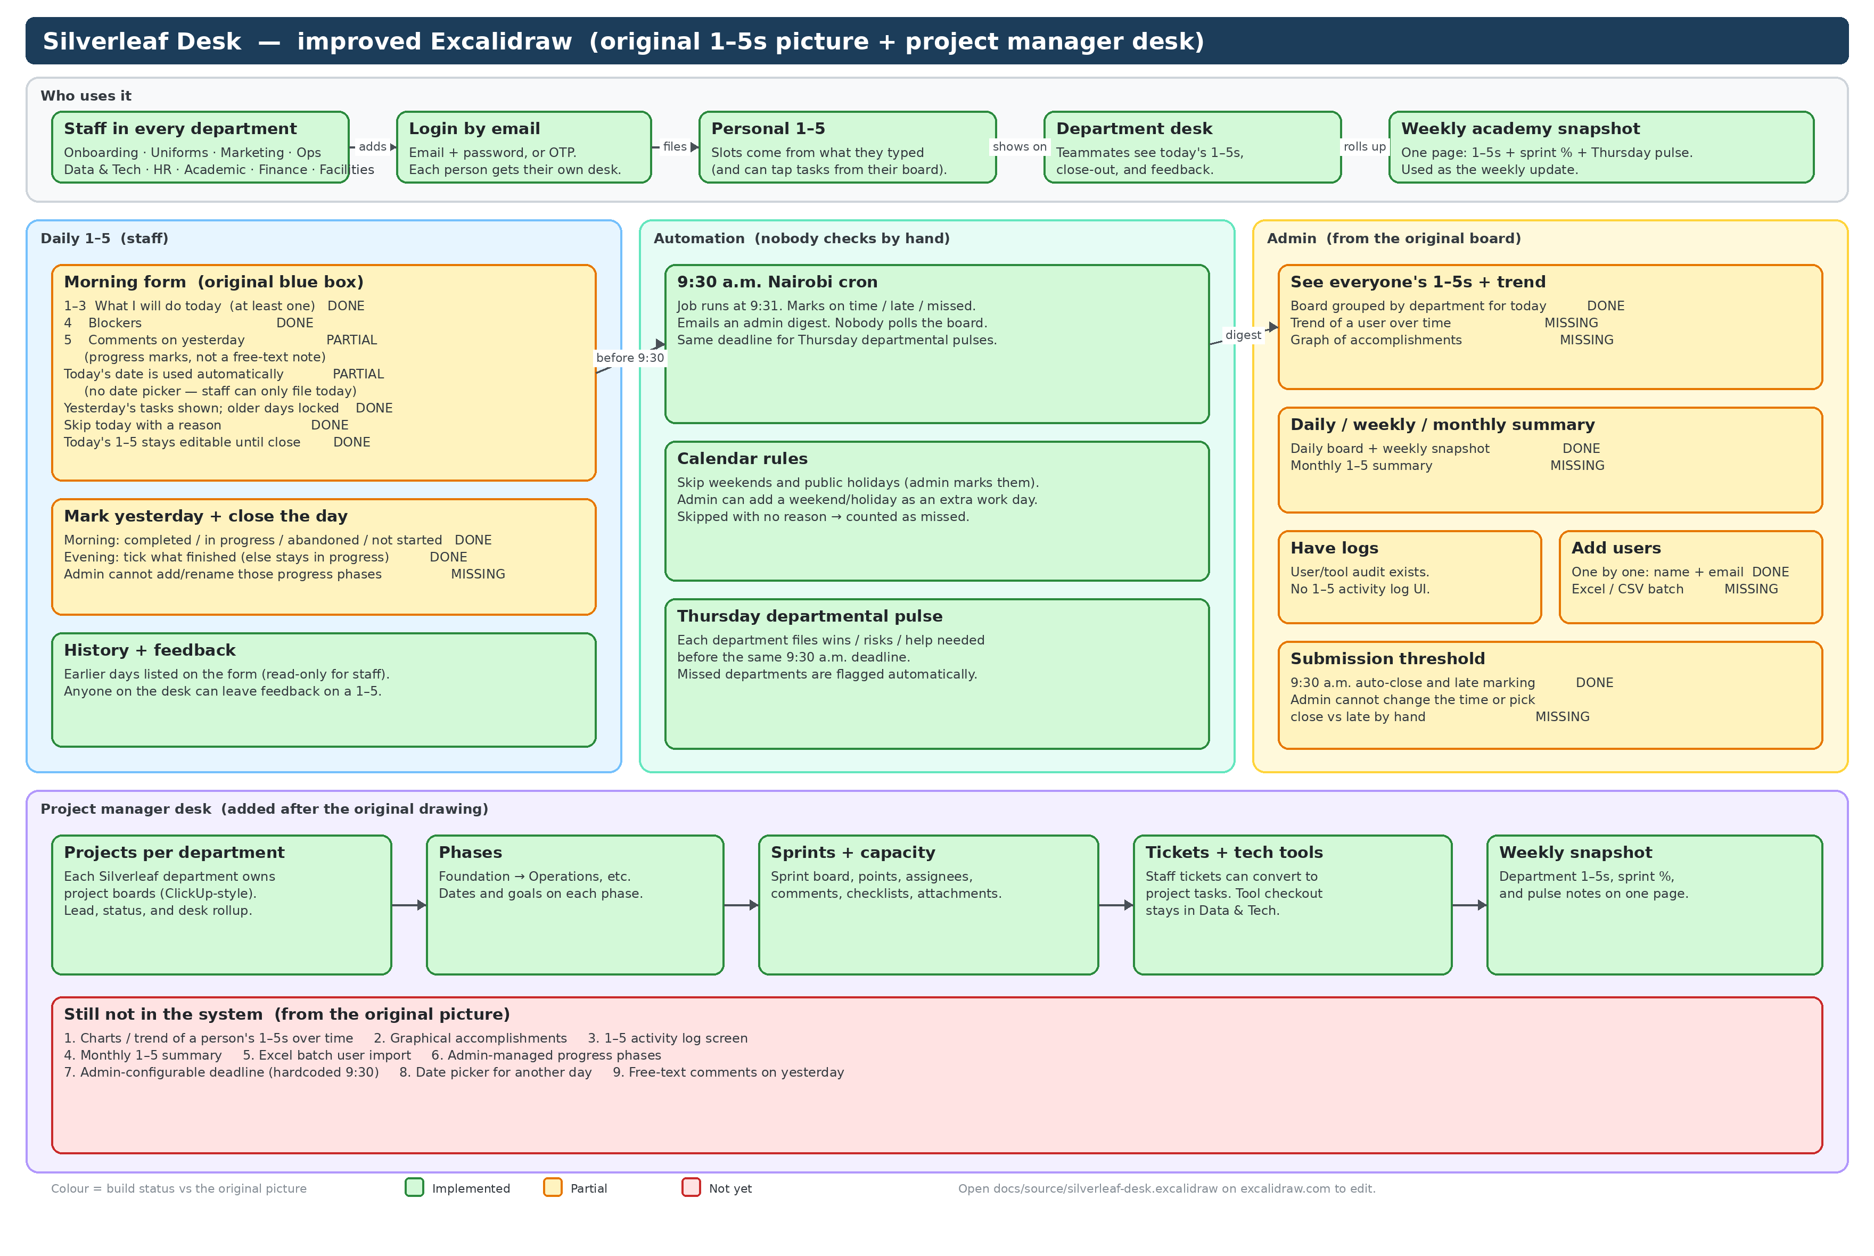

What we added after the original drawing
9:30 a.m. Nairobi cron — nobody checks by hand  A job runs at 9:31 a.m. Nairobi.  Anyone who filed before 9:30 is on time.  Anyone who files after 9:30 is late.  Anyone with no 1–5 and no skip reason is missed.  Admins get an email digest.  The same cutoff applies to Thursday departmental pulses. | Thursday departmental pulse  Each department files three lines: wins, risks, help needed.  Due before 9:30 a.m. on Thursday.  Missed departments are flagged automatically.  This is the weekly check-in that sits next to 1–5s.
Project manager desk  Each department owns projects (ClickUp-style boards).  A project has phases, then sprints, then tasks.  Sprints have points, assignees, comments, checklists, attachments.  Tickets in Data & Tech can convert into project tasks.  Tech-tool checkout stays in Data & Tech.  Personal 1–5s can be filled from the person’s open tasks. | Weekly academy snapshot  One page for Thursday (or any day).  Rolls up: department 1–5s, sprint progress, and pulse notes.  This is the weekly update the desks add up to.  Open it from My desk → Weekly snapshot.
Still to build (from the original picture)
Not in the system yet
1. Trend of a person’s 1–5s over time.
2. Graphical presentation of user accomplishments (charts).
3. A 1–5 activity log screen.
4. Monthly 1–5 summary.
5. Excel / CSV batch import for users.
6. Admin-managed progress phases (the four statuses are fixed today).
7. Admin-configurable deadline (9:30 a.m. is hardcoded).
8. Date picker so staff can file a day other than today.
9. Free-text comments on yesterday (today we only store a progress mark).
Silverleaf Academy · Data & Tech · 15 Sep 2026
Open the drawing: docs/source/silverleaf-desk.excalidraw · Picture in the app: 1–5s page, “Silverleaf Desk — system map”

