Silverleaf Uniform Tracker

Planning & Design Report
Product | Silverleaf Uniform Tracker (silverleaf-uniforms)
Document type | Planning-week report — requirements understood, architecture and ERD agreed, diagrams included
Period | Week of 26 August 2026 (process meeting through design close)
Prepared by | Construction team — Mourine (platform), Geoffrey (desks), Irene (money)
Reviewed with | Nelly (parent / FIFO rules); operators Imani (store) and Loveness (tailoring) named on the map
Status | Design complete. Ready to enter Phase 1 — Foundation, Sprint 1 (Platform & map)
Decision recorded | Build the complete operations system (not a thin inventory-only slice)
Version | 1.0 — 31 August 2026

This report includes the architecture diagrams as pictures so they display when the file is opened on WhatsApp, Slack, or Word.

Executive summary
Last week the team moved into the initial planning and design of a new school uniform management system. The work was to understand requirements, business rules, data structure, relationships between users and components, and how the system would operate — before writing product features.
We agreed:
- Who — eight desks (Imani store, Loveness tailor, finance, CEO, campus admin, head teacher, principal, parent) and the role walls between them.
- Where — five campuses (Usa River, Arusha Town / AM, Kijenge, Ilboru, Boma) and two warehouses (MAIN, Usa River shop). Kilizona is not in v1.
- What flows — city buy and sewing into MAIN; Imani distributes; parents order then pay (FIFO by order date); campus staff issue paid kits; finance sees cost, sales, and a next-year size plan.
- Data — one ERD covering parents, campuses, uniform requests, catalogue items (including tracksuits), inventory, materials (vitambaa / jora), student sizes, and system administration.
- Stack — Next.js, Prisma, SQLite for build/demo, integer TZS, cookie sessions. Excel stays fallback until a campus is trained.
The rest of this report is that design, with diagrams. Next steps and blockers at the end are Sprint 1 only (Phase 1 Foundation — Platform & map). Later sprints are out of scope for this close-out.

Contents
- What this week settled
- Context — people and places
- Roles picture
- Software architecture
- Network / physical architecture
- Data architecture (ERD)
- Workflows (orders, stock, distribution, pricing, sizes, reporting)
- System administration and configuration
- How the zones connect
- SRS modules → tables → routes
- Constraints locked this week
- Next steps and blockers — Sprint 1 only

1. What this week settled
Decision: build the complete operations system (production, inventory, parent FIFO, distribution, money, year-end plan) — not a thin inventory slice.
Replacing: Google Sheets / Excel (Master sheet + 2026 Uniform Analysis). Excel stays fallback until a campus is trained; the app is then the record.
Spine of the process (from the meeting + system map):
Stock in → parents order online → campuses receive → finance plans next year
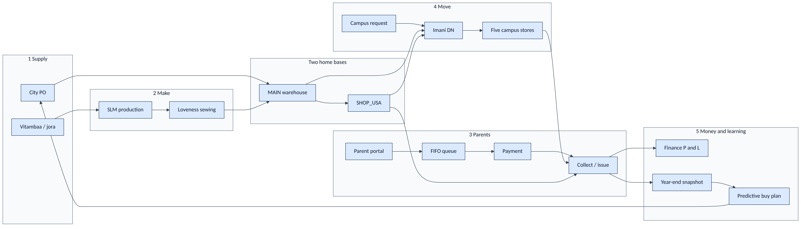
Figure 1
People named on the map: Imani (store & distribution), Loveness (tailoring + Usa River shop), Nelly (parent FIFO rules), campus admins & head teachers, finance.
Campuses (five): Usa River, Arusha Town (AM), Kijenge, Ilboru, Boma. Kilizona is on an older sheet only — not in v1.

2. Context — the system among people and places
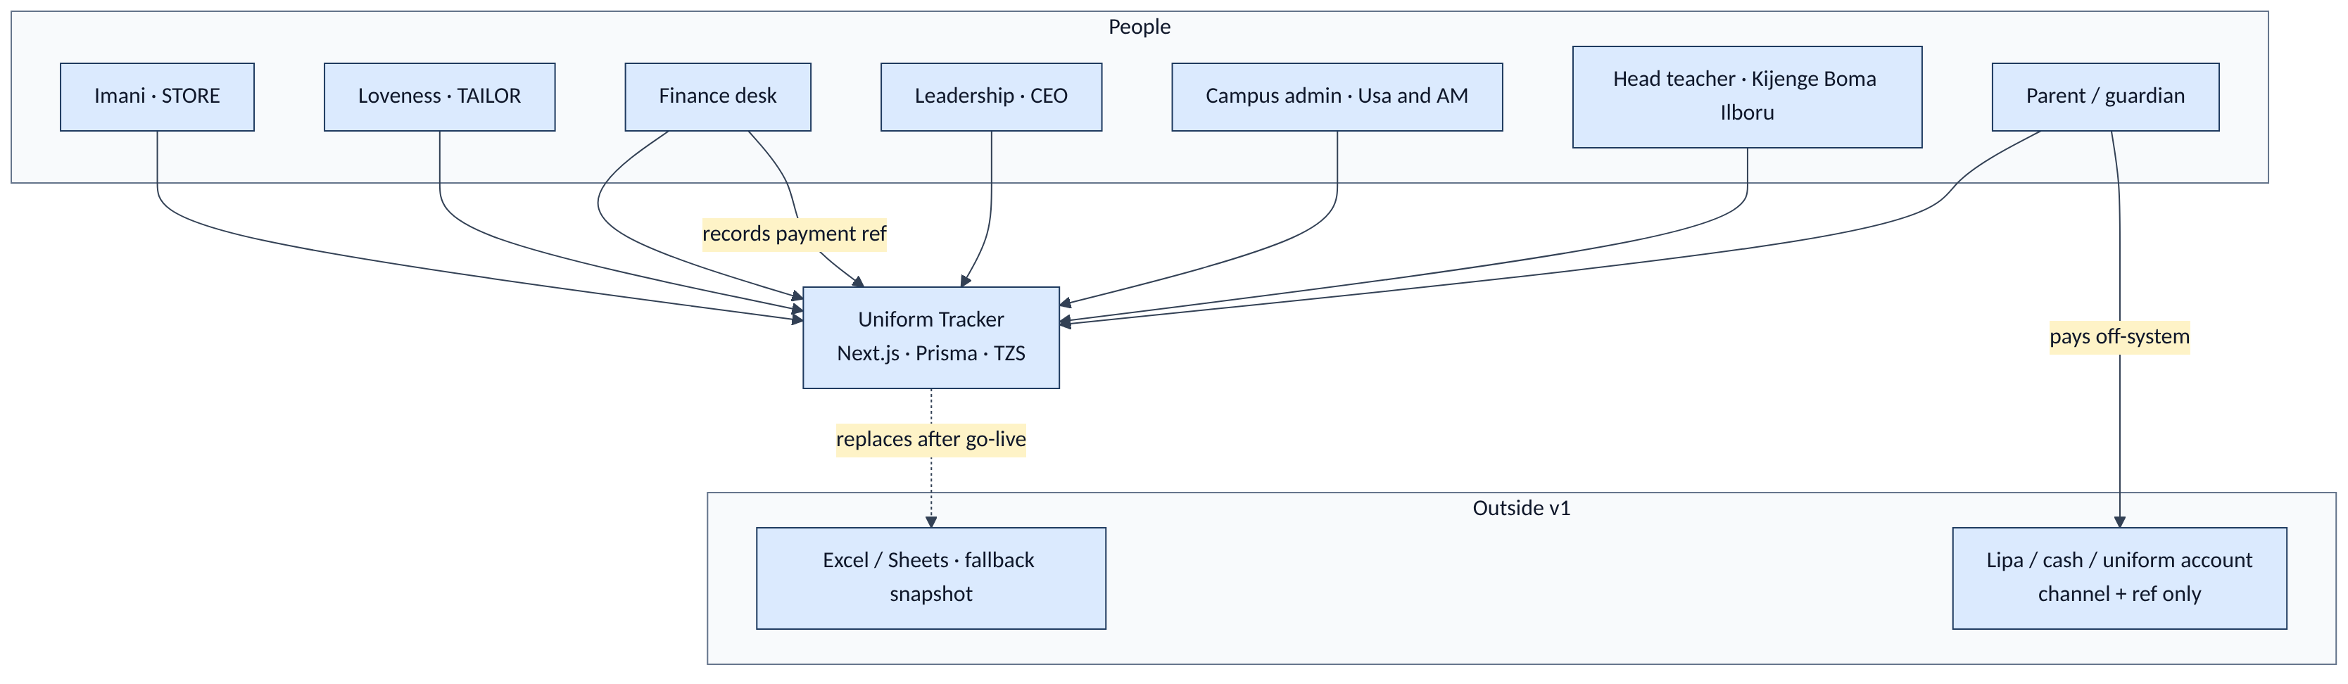
Figure 2

3. Roles picture
This is the roles picture from the system map, mapped onto the eight User.role values in the schema.
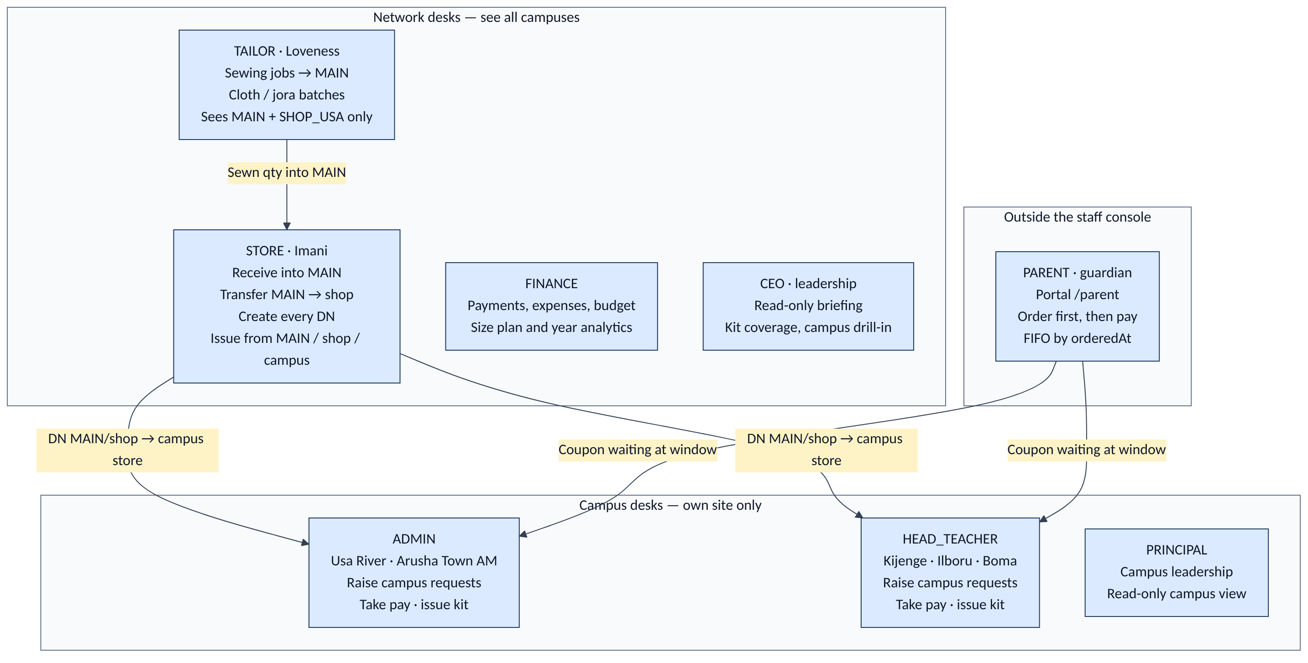
Figure 3

3.1 Who sits where
Role | Named / pattern | Bound to campus? | What they see
STORE | Imani | No | Whole network stock; every request; every DN
TAILOR | Loveness | Usa River | MAIN + SHOP_USA; sewing + cloth
FINANCE | Finance desk | No | Money, plan, year, payments
CEO | Leadership | No | Briefing / reports (read-only)
ADMIN | Usa River, AM administrators | Yes — that campus | Own campus stock, orders, requests, DNs in
HEAD_TEACHER | Kijenge, Boma, Ilboru | Yes — that campus | Same as ADMIN, for Mbegu campuses
PRINCIPAL | Campus / school leadership | Yes — that campus | Read-only campus view
PARENT | Guardian | Via family ↔ students | Own children’s orders only

Campus request rights are not “any staff at any site”:
- ADMIN may request only for USA and AM
- HEAD_TEACHER may request only for KIJENGE, ILBORU, BOMA
That is Campus.requestBy plus canRequestForCampus in code.

3.2 Role × screen (staff console)
Matches src/lib/roles.ts. Parents never enter /(app).
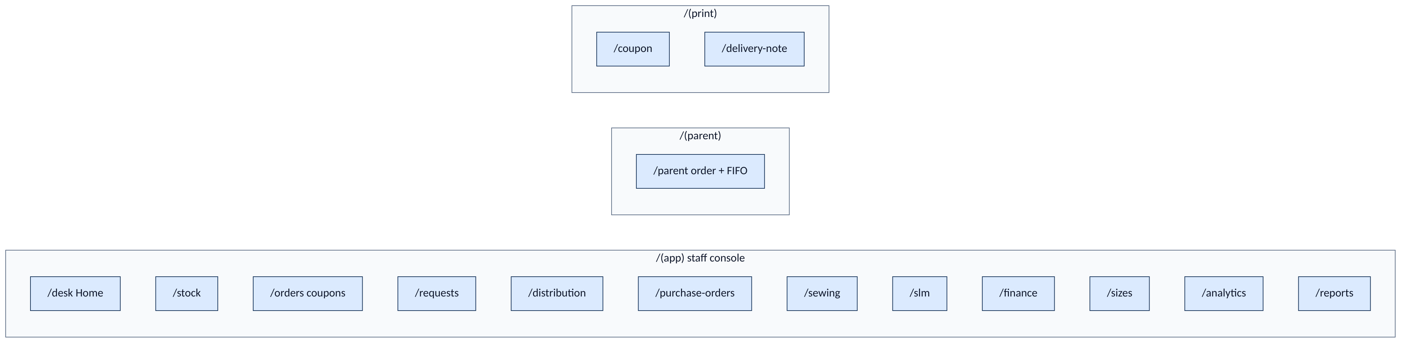
Figure 4
Route | STORE | TAILOR | FINANCE | CEO | ADMIN | HT | PRINCIPAL | PARENT
/desk | ● | ● | ● | ● | ● | ● | ●
/stock | ● | ● |  |  | ● | ● | ●
/orders | ● |  | ● | ● | ● | ● | ●
/requests | ● |  |  |  | ● | ●
/distribution | ● |  |  |  | ● | ● | ●
/purchase-orders | ● |  | ●
/sewing /slm | ● | ●
/finance | ● |  | ● | ●
/sizes /analytics | ● |  | ● | ●
/reports | ● |  | ● | home | ● | ● | ●
/parent |  |  |  |  |  |  |  | home
/coupon print | ● |  |  |  | ● | ●
/delivery-note print | ● |  |  |  | ● | ● | ●

CEO home is /reports. Finance home is /finance. Everyone else on staff lands on /desk.

3.3 Visibility walls (server-side)
Role walls are not only nav pills — queries are scoped in src/lib/visibility.ts.
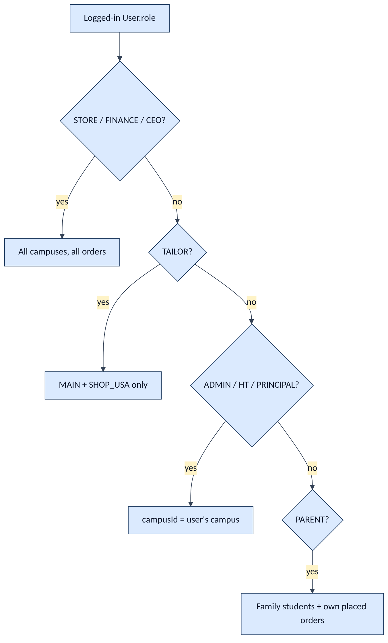
Figure 5

4. Software architecture

4.1 Containers
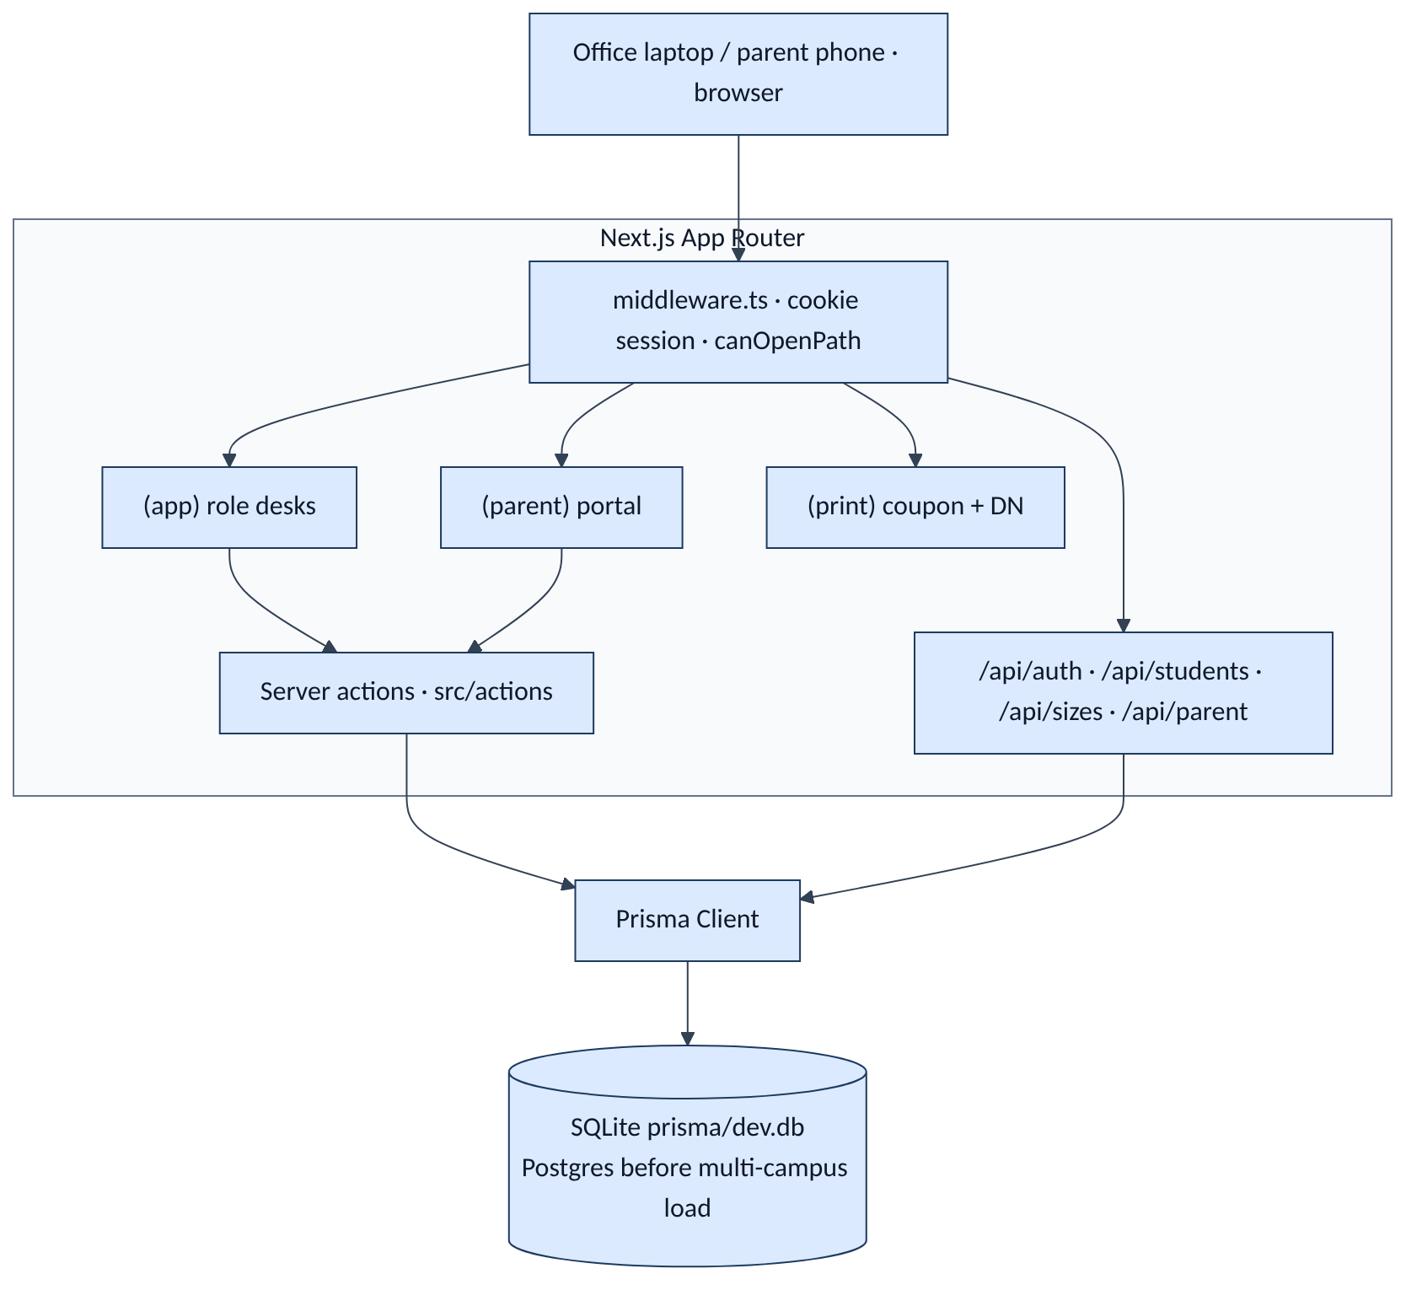
Figure 6
Layer | Choice | Why
App | Next.js App Router + TypeScript | Same family as Shule One; staff desks + parent portal
UI | React + Tailwind | Fast tables; no extra design system
Data | Prisma + SQLite in demo | db:setup reseeds; swap URL to PostgreSQL for production
Auth | Cookie slu_session, 7 days | Role on the token; walls in middleware + requireUser
Money | Integer TZS | Matches the sheets; no floats
Print | Dedicated print routes | Coupon + delivery note

Not in v1: live Lipa API, barcodes, merge into Shule One.

4.2 Folder map (what talks to what)
src/app/
login/ public
(app)/ staff — role-scoped
desk/ stock/ orders/ requests/ distribution/
purchase-orders/ sewing/ slm/ finance/
sizes/ analytics/ reports/ alerts/ audit/ train/
(parent)/parent/ guardian — online order + FIFO
(print)/coupon/ printable coupon
(print)/delivery-note/ printable DN
src/actions/ mutations (orders, stock, DNs, POs, sewing, plan)
src/lib/ roles, visibility, stock ledger, sheet-math, money
prisma/schema.prisma ERD

4.3 Write path (every stock-changing action)
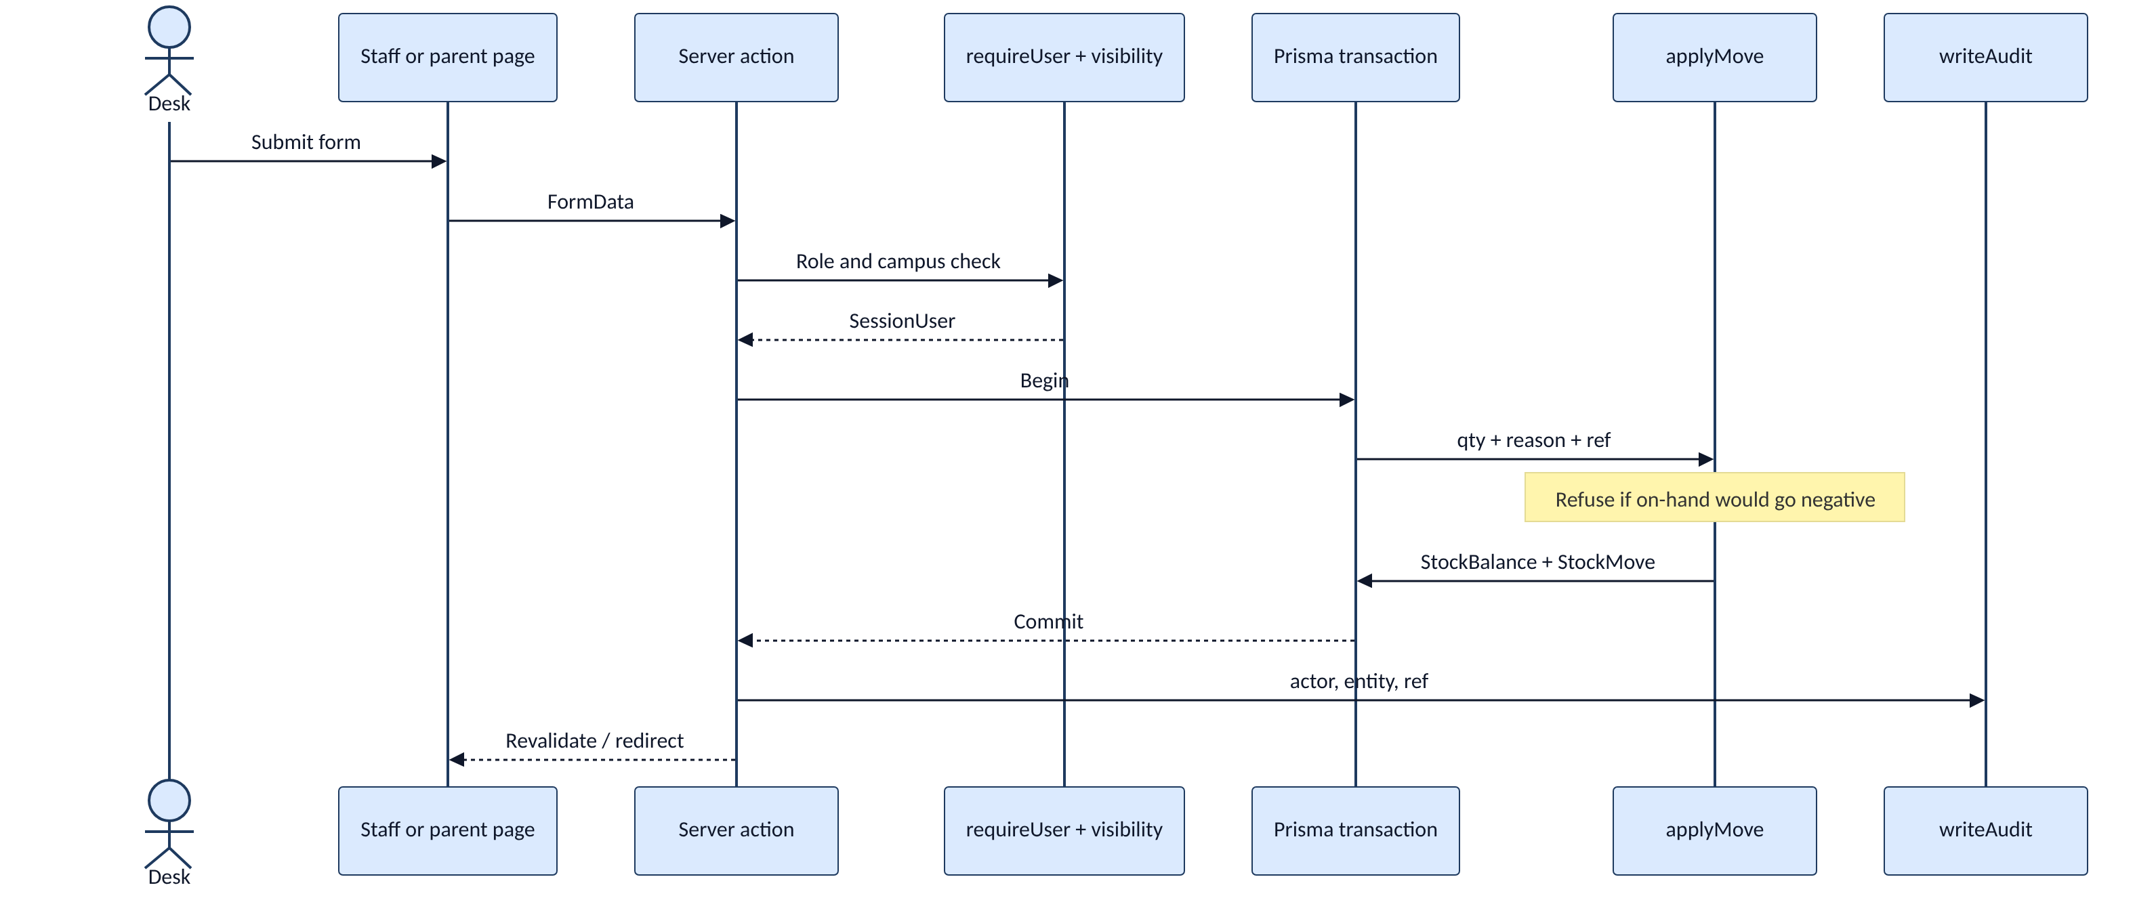
Figure 7
Stock is never updated by overwriting a cell. Every receive, sew-in, transfer, DN, parent issue, and adjust goes through applyMove (src/lib/stock.ts).

5. Network / physical architecture
Five campuses, two warehouses, plus one store per campus. City goods and sewn goods land in MAIN first.
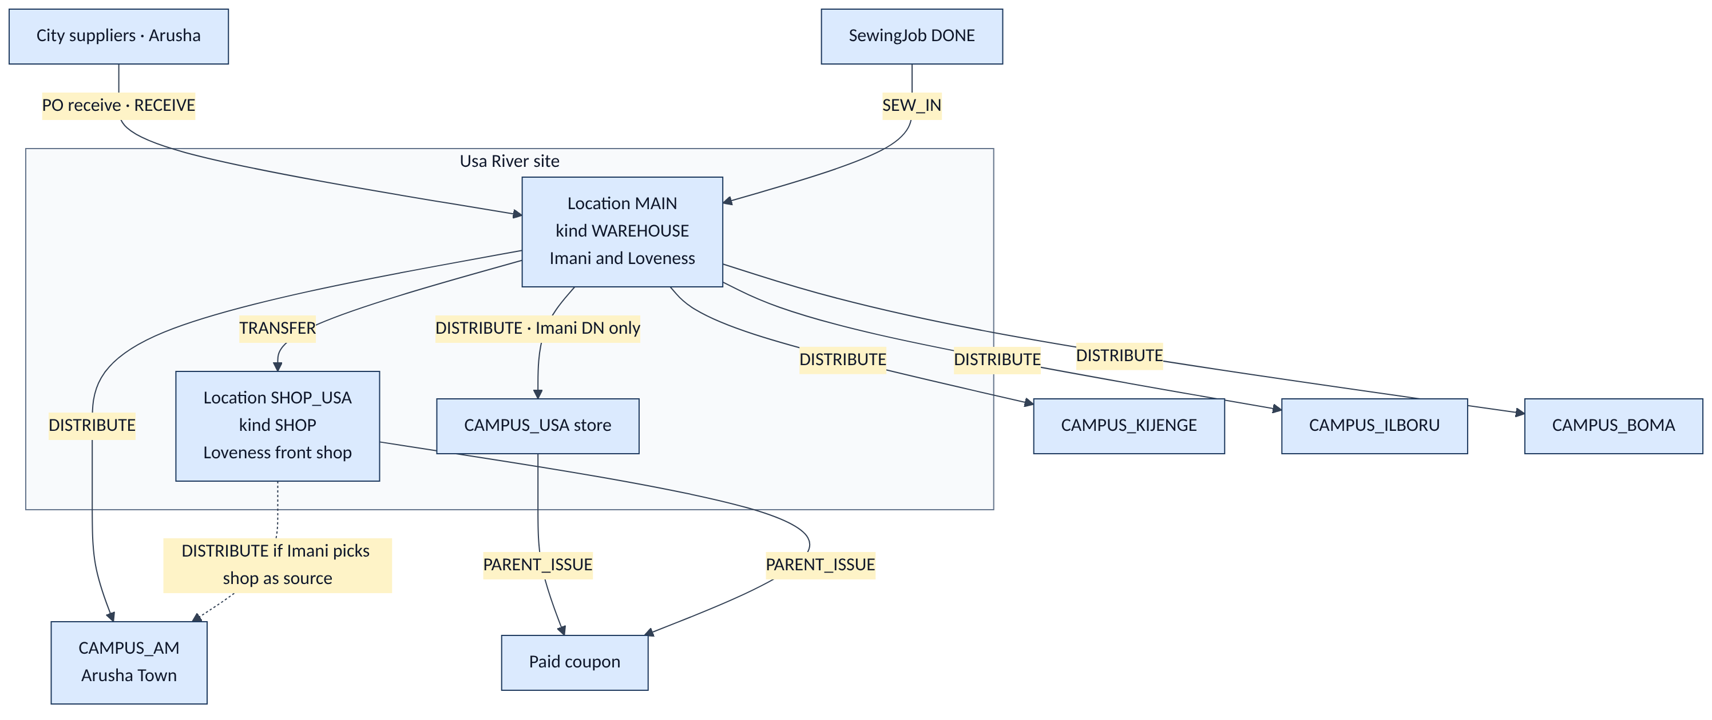
Figure 8
Location code | Kind | Campus | Who operates it
MAIN | WAREHOUSE | — | Imani (receive, DN); Loveness (sew-in)
SHOP_USA | SHOP | Usa River | Loveness; Imani may transfer in and DN from here
CAMPUS_USA | CAMPUS | Usa River | Usa admin issues to parents
CAMPUS_AM | CAMPUS | Arusha Town | AM admin
CAMPUS_KIJENGE | CAMPUS | Kijenge | Head teacher
CAMPUS_ILBORU | CAMPUS | Ilboru | Head teacher
CAMPUS_BOMA | CAMPUS | Boma | Head teacher

Hard rules
- Purchase-order goods receipt is into MAIN only, then optional transfer to the shop.
- A DN may leave MAIN or SHOP — never a campus store (distribution.ts).
- Only STORE creates distributions.
- Parent issue decrements the location that actually hands over the kit (campus store, shop, or MAIN).

6. Data architecture
Source of truth: [prisma/schema.prisma](../prisma/schema.prisma). The compact ERD in GOING-FORWARD is the same model; the diagrams below split it so each subject area is readable, then show the full relationship set.
Grain reminder: one catalogue row is a SKU (e.g. polo PT1). Stock is SKU + size + location, not one SKU per physical shirt.

6.1 Physical flow vs tables
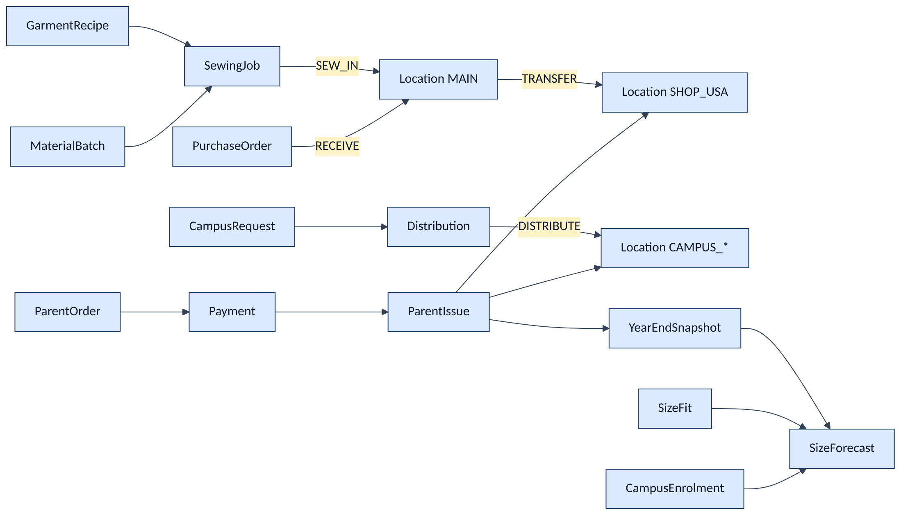
Figure 9

6.2 Organisation, people, students
Parents are not a special table — a User with role = PARENT belongs to a Family. Staff User rows optionally bind to one Campus.
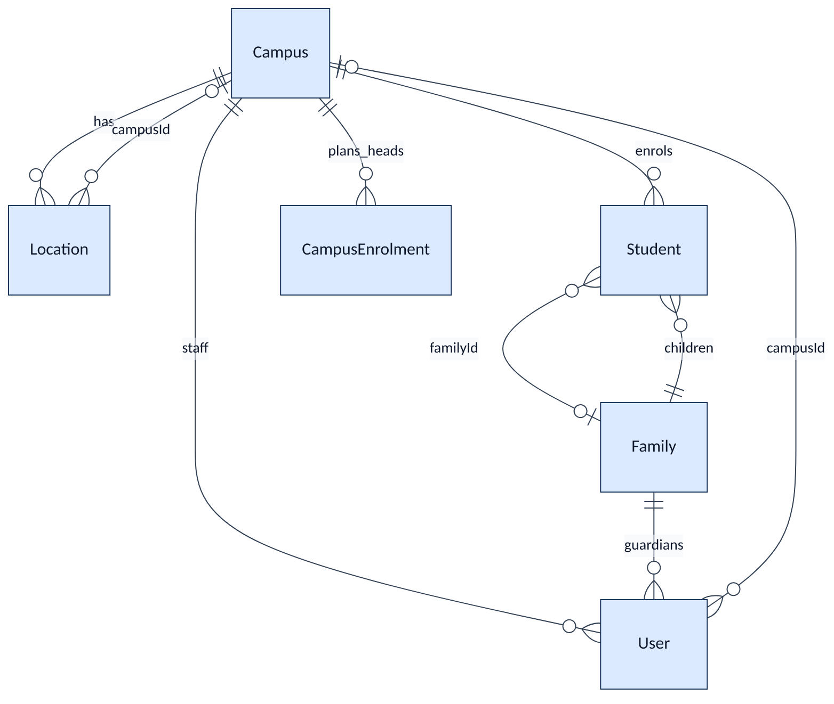
Figure 10
Entity | Purpose
Campus | Five sites. code USA / AM / KIJENGE / ILBORU / BOMA. requestBy = ADMIN vs HEAD_TEACHER
Location | MAIN, SHOP_USA, or CAMPUS_*. kind WAREHOUSE / SHOP / CAMPUS
User | Desk login: role, optional campusId, optional familyId, active
Family | Groups parent users with students (siblings)
Student | Unique regNo (e.g. SLA/UR/2023/312) hydrates class, gender, campus
CampusEnrolment | Expected headcount by campus + year + class — input to the buy plan

6.3 Catalogue, sizes, recipes
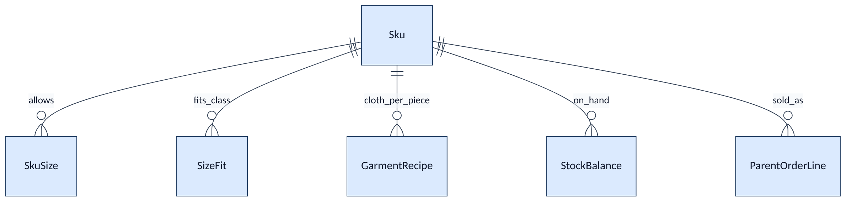
Figure 11
Entity | Purpose
Sku | Catalogue item: code, name, colour, kind SCHOOL / BOARDING, gender, buyTzs, sellTzs, reorder point
SkuSize | Allowed sizes on that SKU (18–38; S/M plus numbers on tracksuits)
SizeFit | Which size fits which class + gender for a garment — drives required qty onto real sizes
GarmentRecipe | Metres/cm of jora or fabric each SKU+size needs

Day vs boarding colourways (seed / parent form)
Code | Name | Kind | Sell TZS | Buy TZS
SS1 | Navy sweater | SCHOOL | 25,000 | 18,000
PT1 | Light-blue polo | SCHOOL | 15,000 | 11,000
RT2 | Yellow round-neck | SCHOOL | 10,000 | 6,000
TS1 | Light-blue tracksuit | SCHOOL | 30,000 | 22,000
GS1 | Grey skirt / trouser (girl) | SCHOOL | 30,000 | 20,000
BT1 | Grey trousers (boy) | SCHOOL | 30,000 | 20,000
BSS1 / BPT1 / BRT2 / BTS1 | Boarding grey / red / black | BOARDING | same sell | same buy

Pack per child (sheet math): day = PT1×2, SS1×1, RT2×1, TS1×1, GS1×1 (girl) or BT1×1 (boy). Boarding = BPT1×2, BSS1 / BRT2 / BTS1 ×1.

6.4 Inventory ledger
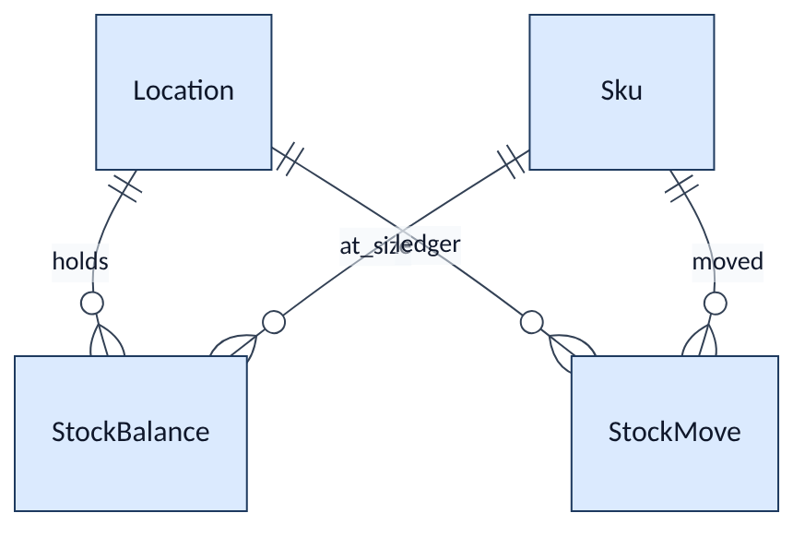
Figure 12
Entity | Purpose
StockBalance | Qty on hand. Unique (locationId, skuId, size)
StockMove | Immutable ledger line: signed qty, reason, ref, note, createdAt

Move reasons (MOVE_REASONS)
Reason | Sign at location | When
RECEIVE | + MAIN | PO goods in
SEW_IN | + MAIN (or job location) | Sewing job completed
TRANSFER_OUT / TRANSFER_IN | − source / + dest | MAIN → SHOP_USA
DISTRIBUTE | − MAIN or shop / + campus store | Imani DN
PARENT_ISSUE | − issuing location | Kit handed over
ADJUST | ± | Correction; still cannot go below zero

applyMove refuses any post that would make on-hand negative.

6.5 Parent demand — order, pay, issue
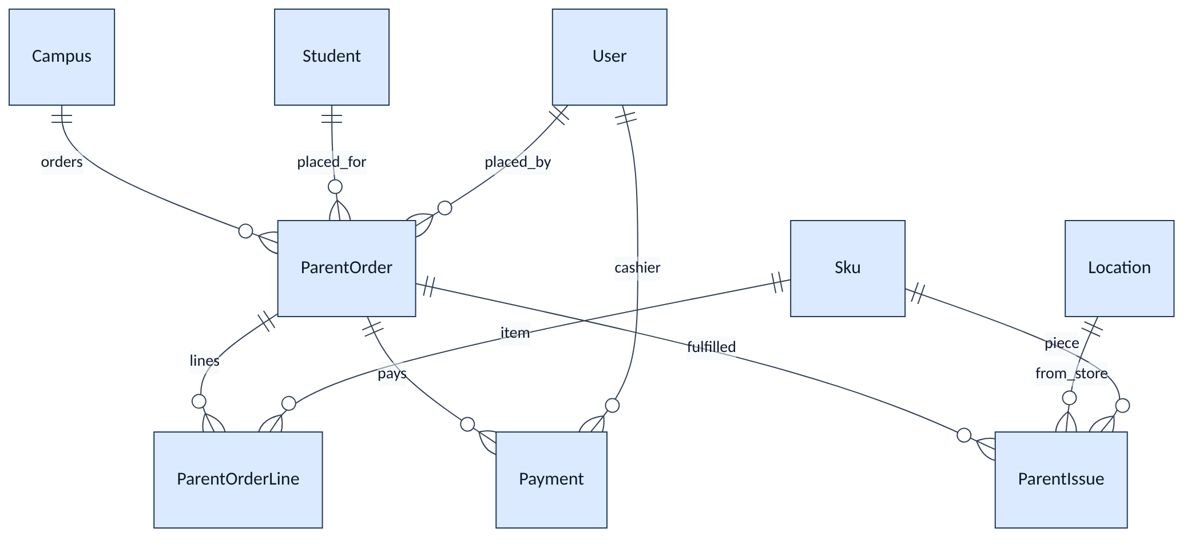
Figure 13
Entity | Purpose
ParentOrder | Coupon. orderedAt is the FIFO key. Status ORDERED → PAID → PARTIAL / FULFILLED
ParentOrderLine | SKU, size, qty, unitTzs (sell price snapshot), issued so far
Payment | Second step. Channel CASH / LIPA / UNIFORM_ACCOUNT. Partial amounts allowed; kit issue waits until paid in full
ParentIssue | Hand-over event. Supports Received all / Received few

FIFO: queue position is earlier unpaid-or-unfulfilled orders by orderedAt ascending. Payment date does not jump the line. Nelly’s rule: order first, then pay.
PARTIAL on the order means some pieces issued, not a part-payment.

6.6 Campus request and distribution
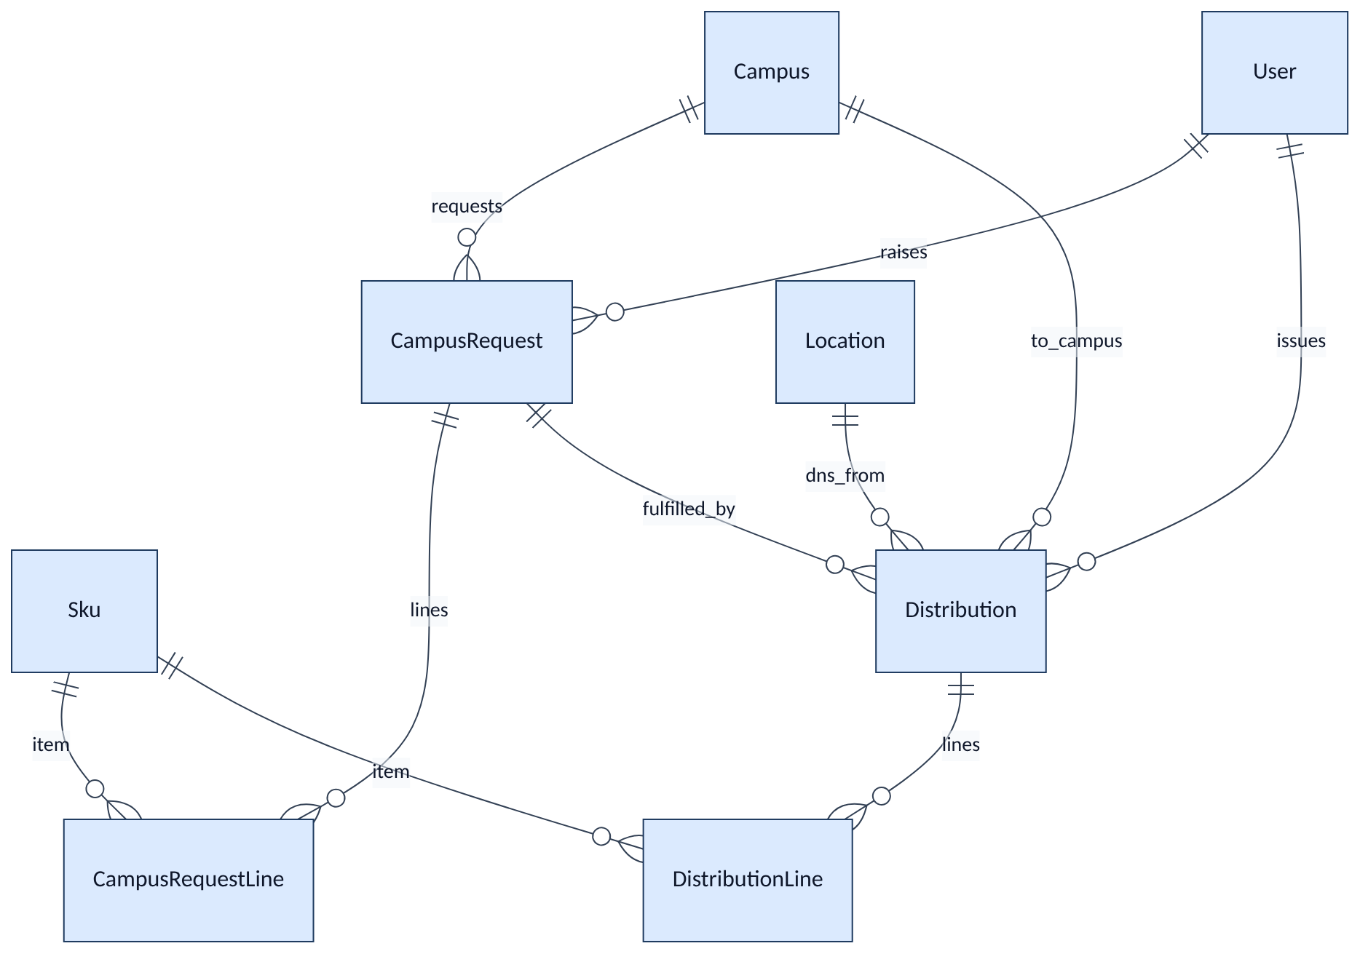
Figure 14
Entity | Purpose
CampusRequest | Admin/HT ask. Status OPEN / FULFILLED / CANCELLED. Lines: SKU, size, qty, neededBy
Distribution | Delivery note. STORE only. Optional link to a request. receiver name on the DN
DistributionLine | What moved

Posting a DN writes two StockMove rows (out of source, into campus store) and marks the request FULFILLED when linked.

6.7 Buying, SLM, money, year plan
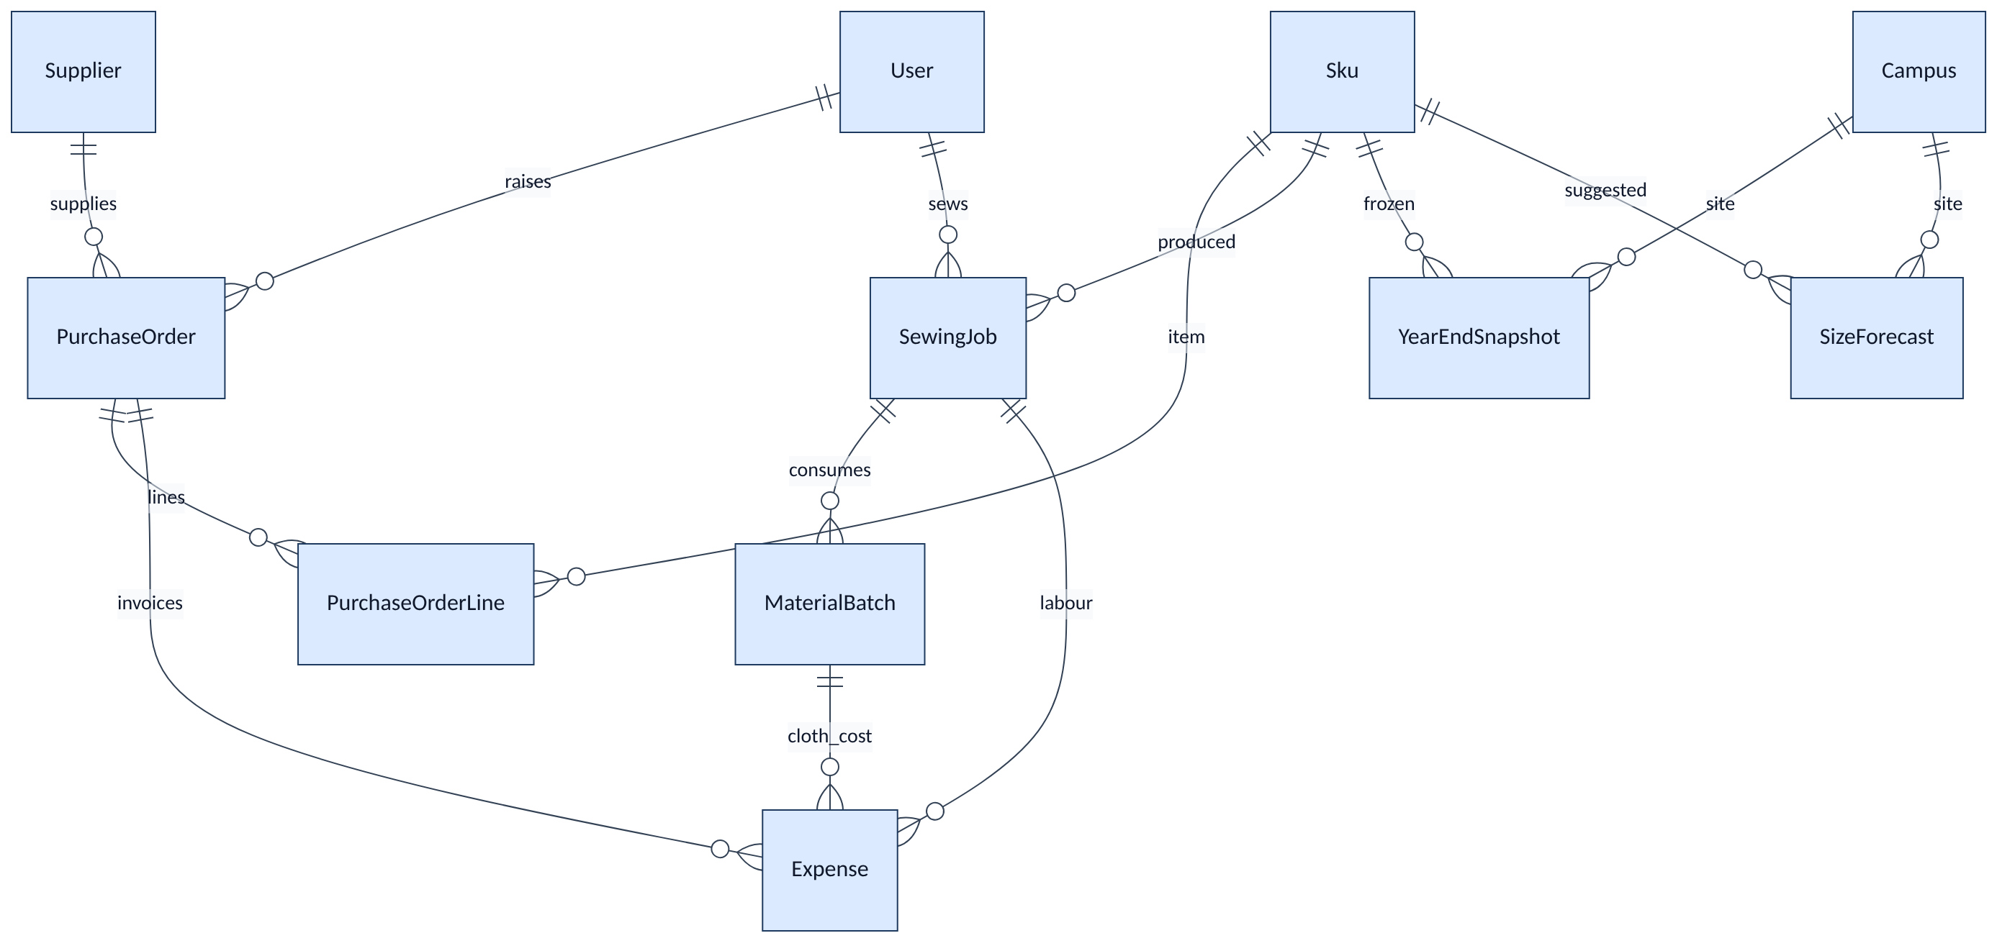
Figure 15
Entity | Purpose
Supplier | City vendors (from master pricing sheet)
PurchaseOrder | DRAFT → SENT → PARTIAL → CLOSED. Receive into MAIN
PurchaseOrderLine | SKU, size, qty, unitTzs (buy), received
MaterialBatch | Cloth/jora bought: qty, remaining, unit, unitCostTzs
SewingJob | Loveness daily: expected vs actual, QUEUED → IN_PROGRESS → DONE
Expense | Supplier invoices, tailor labour, materials
Budget | Year allocation vs committed POs vs actual receive
YearEndSnapshot | Frozen issued / stock left / revenue / cost by year + campus + SKU + size
SizeForecast | Next-year suggested buy (method from OVERALL sheet math, not a guess)
AuditEvent | Who touched stock, pay, distribute, PO receive

Budget and AuditEvent are standalone (no FK to Campus / User). Expense.campusId is optional and not a Prisma relation.

6.8 Full relationship set (one diagram)
Same core as GOING-FORWARD §4, with Family and the money/plan tables the live schema actually has.
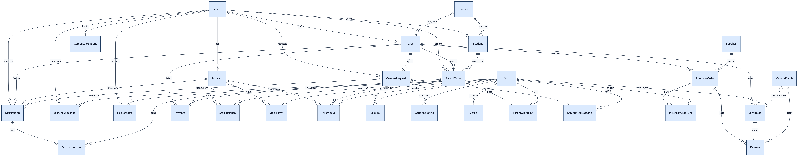
Figure 16

7. Workflows

7.1 Parent uniform request — order, FIFO, pay, collect
Nelly: order precedes payment. Fulfilment order is orderedAt, not who paid first and not who shouts first.
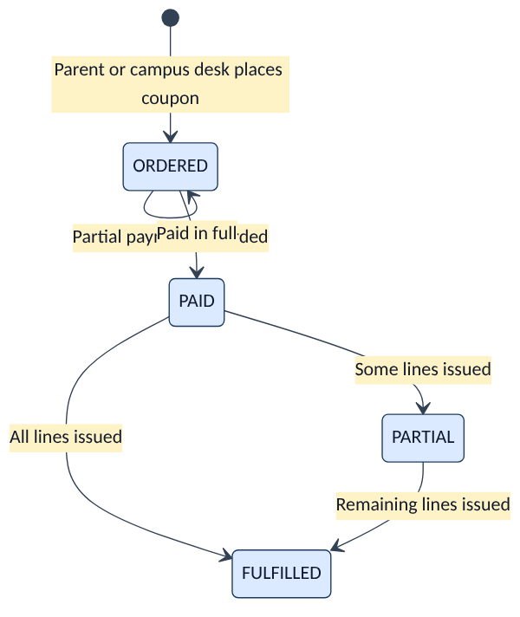
Figure 17
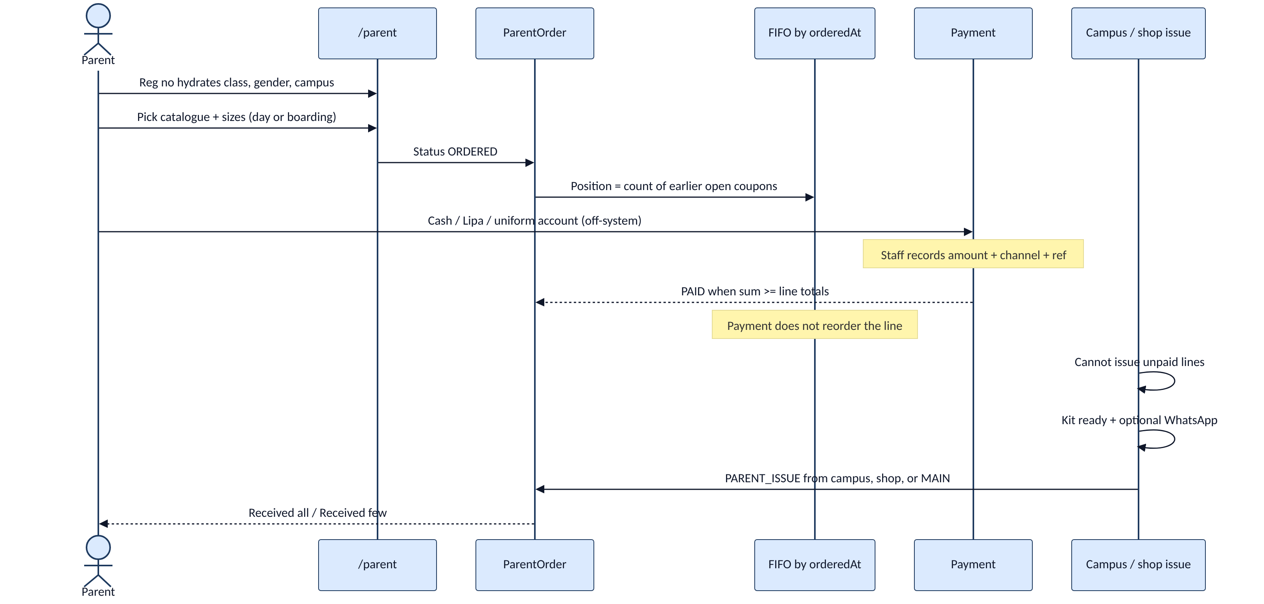
Figure 18
Stock availability at issue: applyMove with PARENT_ISSUE fails if that location+SKU+size would go negative. Partial issue is allowed (issued on the line vs qty).
Who may write orders / take pay / issue:
Action | STORE | FINANCE | ADMIN / HT | PARENT
Place order | ● |  | ● (own campus) | ● (linked child)
Record payment | ● | ● | ●
Issue kit | ● |  | ● (own campus store)

STORE may issue from MAIN, SHOP_USA, or the order’s campus store. Campus desks issue only from their own campus store.

7.2 Campus request → Imani assigns / distributes
Usa River and AM admins request; Kijenge, Boma, Ilboru head teachers request. Imani sees one queue of open requests and is the only person who creates a DN.
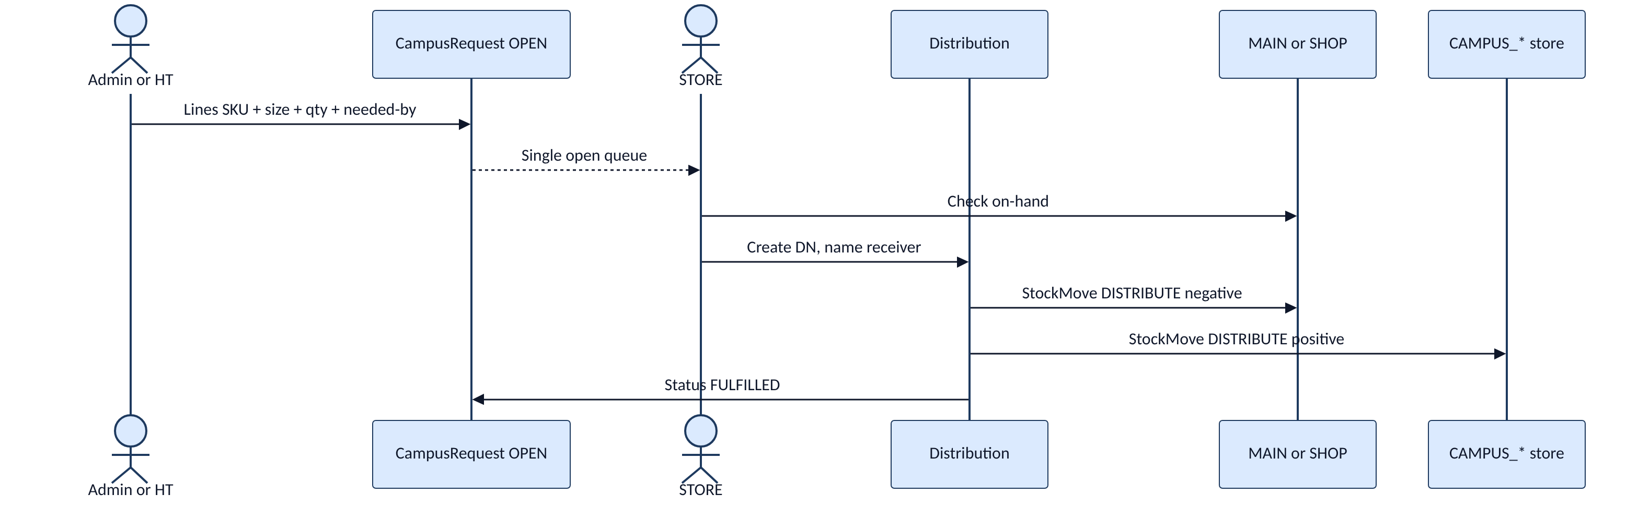
Figure 19
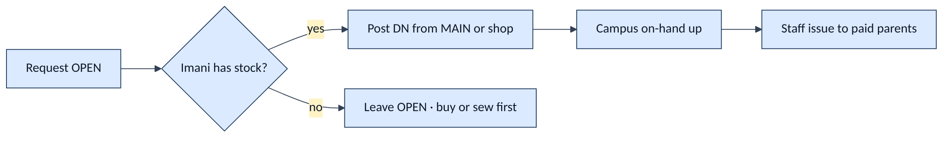
Figure 20

7.3 Inventory in — city buy and shop transfer
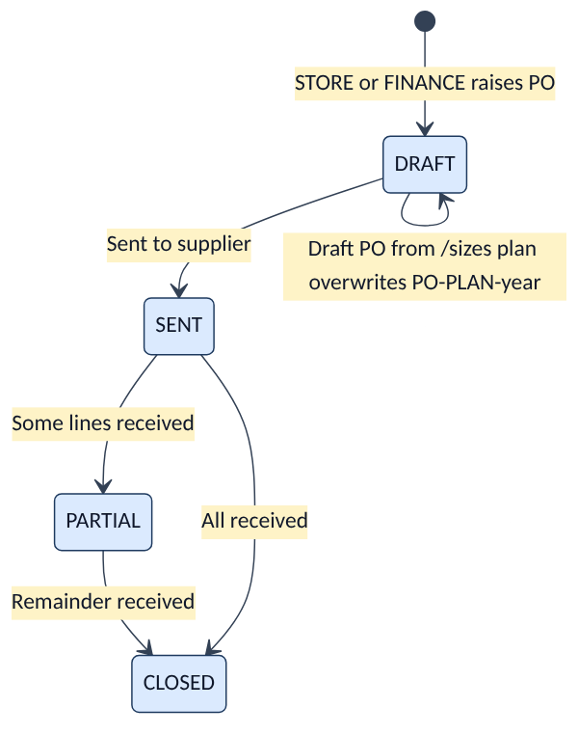
Figure 21
Figure 22
City purchases must receive into MAIN first. Transfer to the shop is a separate movement. Cost lives on PurchaseOrderLine.unitTzs and related Expense rows.

7.4 SLM — materials, sewing, ready-made
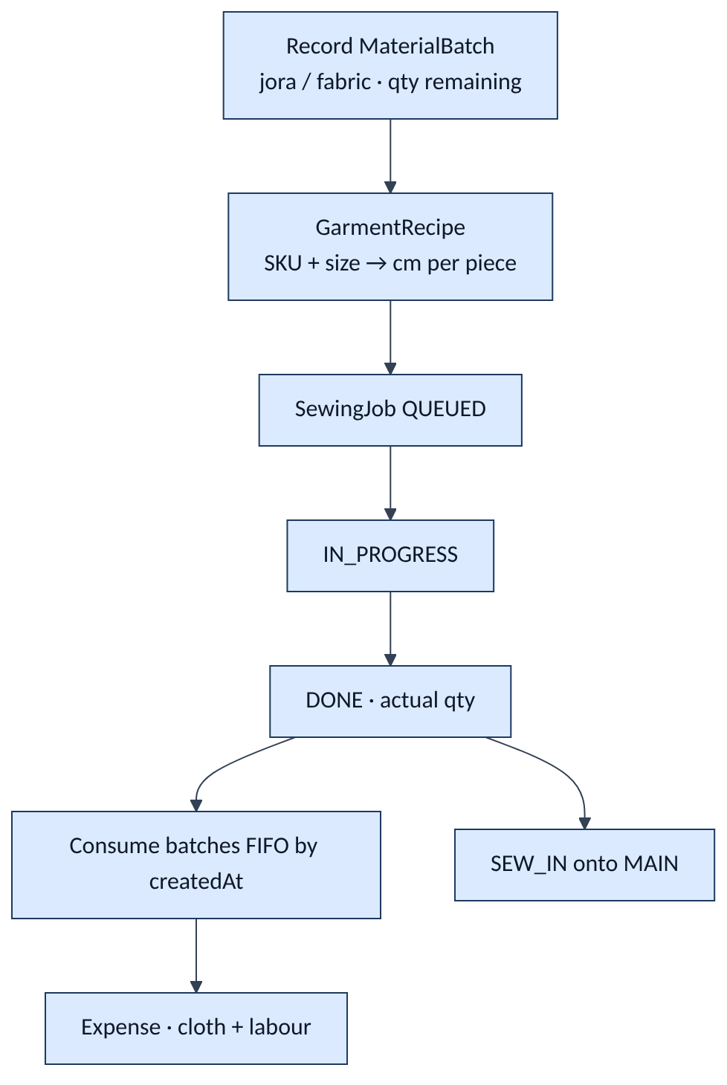
Figure 23
Student size collection (SizeFit + parent order sizes + optional sewing-tracker notes) feeds what Loveness should queue, and later the buy plan — not a separate inventory of children.

7.5 Pricing, sales, profit
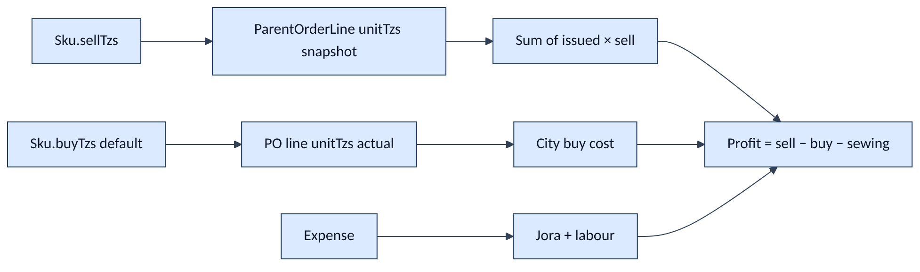
Figure 24
- Catalogue prices can be updated on the SKU; a coupon keeps the unitTzs from order time.
- Payment channels: cash, Lipa, uniform account (ref stored; no live API).
- Finance views: network and campus; budget vs committed POs vs actual receive.
- Sewing P&L (sheet): city-buy replacement − (jora + labour) = saved.

7.6 Size collection, availability, reporting, next-year buy
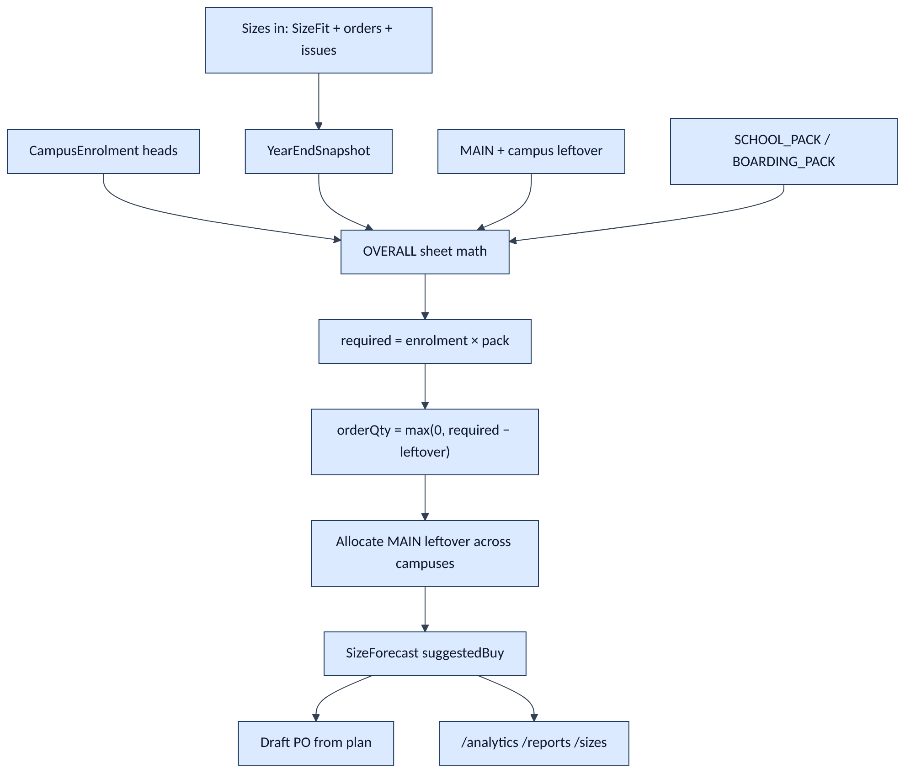
Figure 25
Do not forecast with issued × 1.1 or invented size shares. Refresh buy plan writes SizeForecast from loadOverallPlan only (docs/source/EXCEL-IMPORT.md).
Reports the desks actually use
Surface | Audience | Content
/stock | Imani, Loveness, campus | On-hand by location + SKU + size; low-stock vs reorder
/orders | Imani, finance, campus | Coupons, FIFO, paid vs waiting
/alerts | Store | Low sizes, cloth shortfall
/finance | Finance, STORE, CEO | Budget, spend, sales, profit
/sizes | Finance, STORE, CEO | Class fit, OVERALL buy plan, draft PO
/analytics | Finance, STORE, CEO | Year-end issued / leftover / margin
/reports | CEO + campus leadership | Kit coverage briefing (campus drill-in for admin/HT)
/audit | STORE, FINANCE, CEO | Who touched stock, pay, DN, PO receive

8. System administration and configuration
The Excalidraw “system admin → configs” zone maps to data, not a separate product.
Figure 26
Admin concern (map) | Where it lives
Pin campuses; admin vs HT | Campus + seed
Desk login; deactivate user | User.active; M1-F01
Update stock and prices | Sku.sellTzs / buyTzs; stock via ledger not a raw edit
Manage suppliers | Supplier
Staff notifications | Kit-ready / WhatsApp from the orders desk (v1: copy/link, not a gateway)
Purchases & sales log | StockMove + Payment + /audit

9. End-to-end: how the zones connect
Same legend as the Excalidraw board: mint = supply, pink = sewing, blue = parents & campuses, yellow = money.
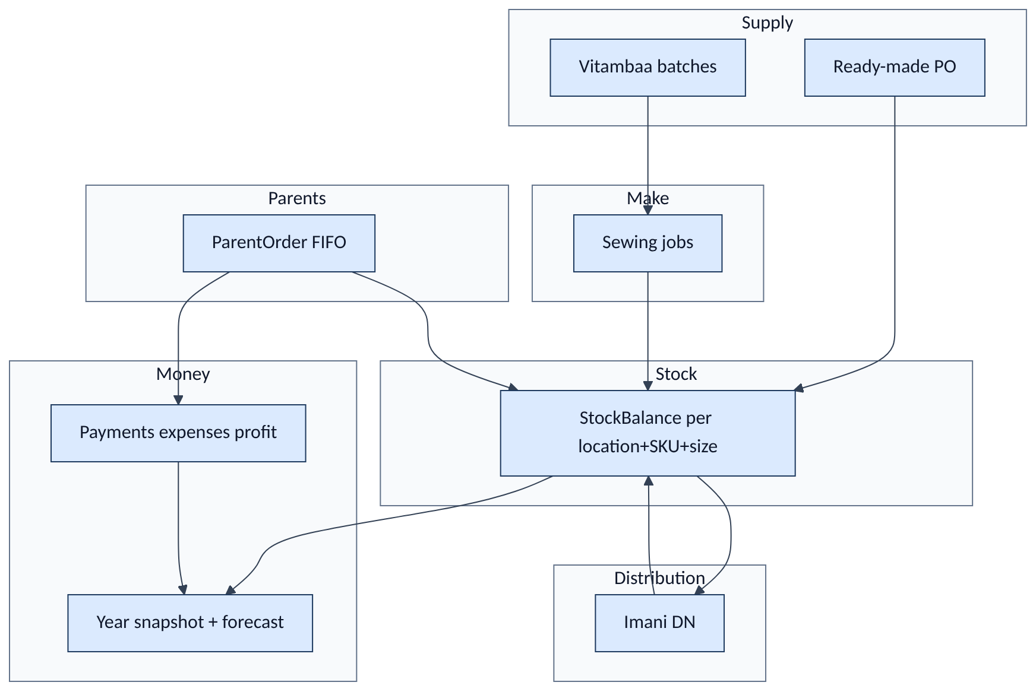
Figure 27

10. SRS modules → tables → routes
SRS | Module | Core tables | Staff route
M1 | Platform & roles | User, AuditEvent | /login, /audit, /train
M2 | Campuses & warehouses | Campus, Location | /desk
M3 | Catalogue | Sku, SkuSize | /stock, /parent
M4 | Stock ledger | StockBalance, StockMove | /stock, /alerts
M5 | Parent portal & FIFO | ParentOrder, ParentOrderLine, Student, Family | /parent, /orders
M6 | Payments & profit | Payment, Expense, Budget | /finance
M7 | Campus requests | CampusRequest, CampusRequestLine | /requests
M8 | Distribution & DNs | Distribution, DistributionLine, ParentIssue | /distribution, /delivery-note
M9 | Purchase orders | Supplier, PurchaseOrder, PurchaseOrderLine | /purchase-orders
M10 | Demand & size analytics | SizeFit, YearEndSnapshot, SizeForecast, CampusEnrolment | /sizes, /analytics
M11 | Sewing / SLM | SewingJob, MaterialBatch, GarmentRecipe | /sewing, /slm
M12 | Printables | (views over Order / Distribution) | /coupon, /delivery-note

11. Constraints the diagrams assume
These are the rules this week locked. Diagrams that contradict them are wrong.
- Five campuses only — Usa River, AM, Kijenge, Ilboru, Boma.
- All city purchases land in MAIN first.
- Only Imani (STORE) initiates campus distribution.
- Parent order before payment. FIFO is orderedAt ascending.
- Cannot fulfil unpaid lines. Issue waits until paid in full; PARTIAL means partial kit, not partial pay.
- Cannot issue more than on-hand at that location+SKU+size.
- Admins request for USA/AM; head teachers for Kijenge/Boma/Ilboru.
- Campus desks see their campus only. STORE / FINANCE / CEO see the network. TAILOR sees MAIN + shop.
- Amounts are integer TZS.
- Role walls are enforced server-side (middleware + requireUser + query where).
- Excel is the import snapshot, not the live ledger after a campus is trained.
- No live Lipa API, no barcodes, no Shule One merge, no Kilizona in this architecture.

12. Next steps and blockers — Sprint 1 only
This report closes planning. The phased plan is eight one-week sprints. This close-out commits only to Sprint 1. Sprint 2 (catalogue & stock) and later phases are not next steps here.
Phase 1 — Foundation has two sprints. We enter the first:
Phase | 1 — Foundation
Sprint | 1 — Platform & map
Length | One week · six day-sized tasks · two per person (A holds the schema extra)
Goal | Campuses, warehouses, roles, and a home desk that matches the system map — so every named operator can log in and see the right wall
Not this sprint | Catalogue SKUs, stock ledger UI, parent FIFO, DNs, POs, sewing, analytics

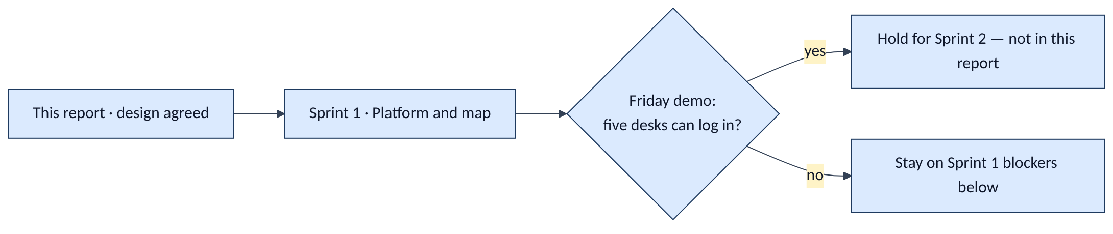
Figure 28

12.1 Sprint 1 next steps
Three streams. Mourine owns Prisma — Geoffrey and Irene consume it; no forked models.
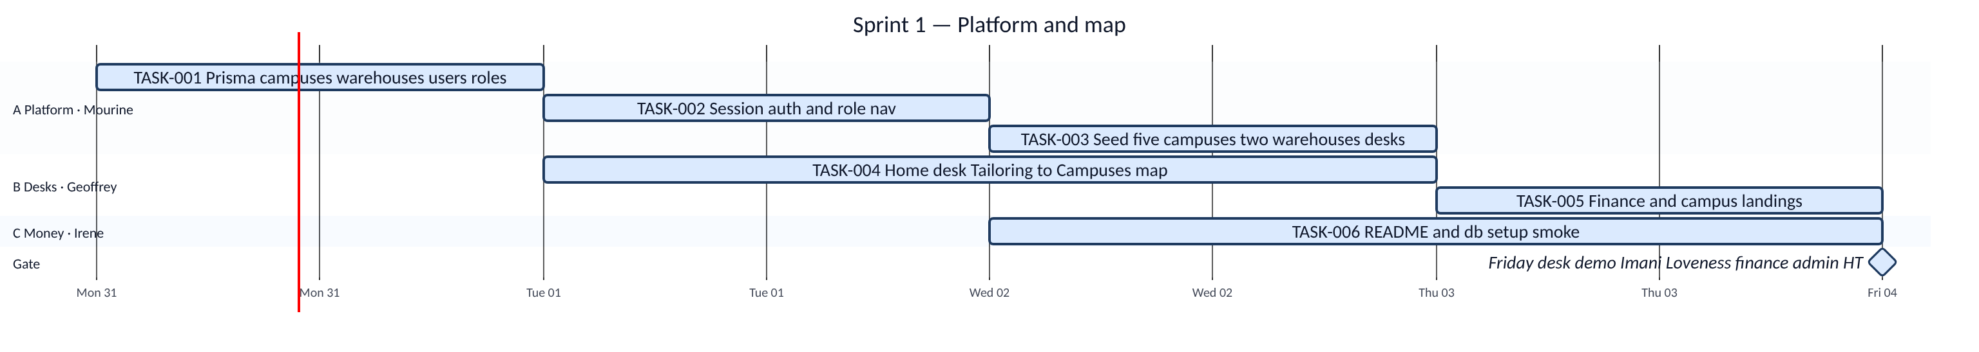
Figure 29
Dates on the chart assume Sprint 1 starts Monday 31 August 2026 (report date). Shift them if the calendar slides; the task order does not change.
ID | Owner | Next step | Done when
TASK-001 | A Mourine | Prisma schema: Campus, Location, User + roles | Five campus codes and MAIN + SHOP_USA are in the model; prisma generate succeeds
TASK-002 | A Mourine | Session auth + role nav matching the roles picture (section 3) | Login sets httpOnly cookie; unknown role cannot open STORE routes; logout clears session; session lasts 7 days
TASK-003 | A Mourine | Seed five campuses, two warehouses, named desks | Imani, Loveness, finance, two admins, three HTs, one parent; password Silverleaf@2026; npm run db:setup can re-run after reset
TASK-004 | B Geoffrey | Home desk that mirrors Tailoring → Inventory → Distribution → Campuses | STORE and TAILOR see the four-stage map with counts or links; stages match the process map
TASK-005 | B Geoffrey | Finance and campus views as separate landings | FINANCE lands on costs/budget summary; ADMIN/HT land on their campus only; PARENT does not see staff nav
TASK-006 | C Irene | README + npm run db:setup smoke | README lists demo accounts; docs linked; db:setup documented; TZS helper in place for later money screens

Sprint 1 sequence (dependency, not preference)
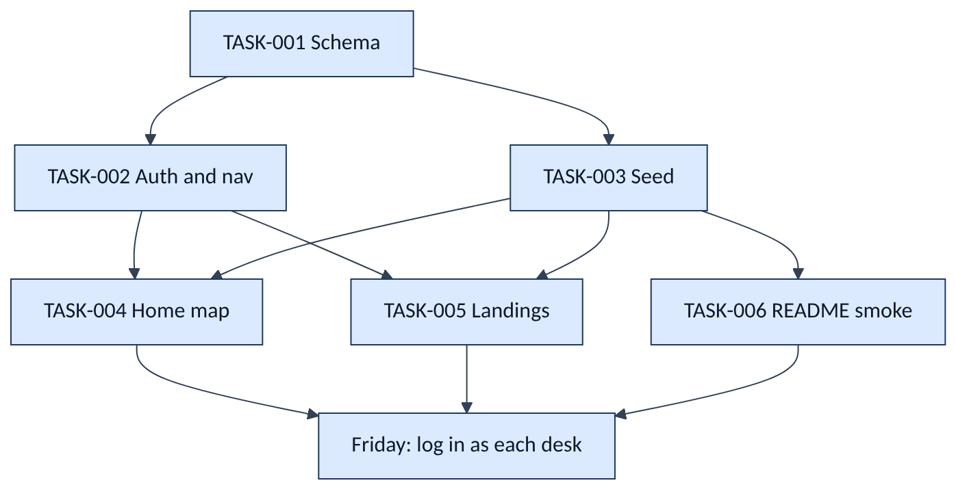
Figure 30
Sprint 1 definition of done
- Each of the six tasks meets the acceptance column above.
- A person can log in as Imani, Loveness, finance, one Usa/AM admin, one Mbegu HT, and a parent — and each sees a different home.
- Excel remains the live operations tool this week; the app is a shell with real campuses and roles, not stock movement yet.
- Friday demo on those desks. No Sprint 2 work is pulled forward.
Demo accounts (seed target for TASK-003)
Desk | Email | Role
Imani | imani@silverleaf.ac.tz | STORE
Loveness | loveness@silverleaf.ac.tz | TAILOR
Finance | finance@silverleaf.ac.tz | FINANCE
Usa River admin | usa.admin@silverleaf.ac.tz | ADMIN
Arusha Town admin | am.admin@silverleaf.ac.tz | ADMIN
Kijenge / Boma / Ilboru HT | kijenge.ht@ / boma.ht@ / ilboru.ht@silverleaf.ac.tz | HEAD_TEACHER
Parent | parent@silverleaf.ac.tz | PARENT

Shared demo password: Silverleaf@2026.

12.2 Sprint 1 blockers (phased — what would stop this week)
These are the blockers we would have to clear before or during Sprint 1. They are not Sprint 2–8 issues.
# | Blocker | Why it stops Sprint 1 | Who unblocks | If it stays blocked
B1 | Campus list not signed (five vs Kilizona on an older sheet) | TASK-001/003 cannot freeze Campus.code or seed locations | Product / Paul | Do not seed a sixth campus. Default remains USA, AM, KIJENGE, ILBORU, BOMA
B2 | Roles picture not signed (section 3) | TASK-002 nav and TASK-005 landings will be ripped out | Team + Nelly on parent | Freeze the eight roles in this report; extra desks go to a later note, not Sprint 1
B3 | Who may request stock (admin vs head teacher by campus) | Seed User.campusId and Campus.requestBy are wrong | Meeting rule already in SRS | ADMIN → Usa + AM only; HEAD_TEACHER → Kijenge, Ilboru, Boma
B4 | Named operators missing emails (Imani, Loveness, finance) | TASK-003 has nothing to seed | Ops | Use the @silverleaf.ac.tz accounts in the table above until HR confirms
B5 | Prisma not owned by one person | Geoffrey/Irene fork models; home desk binds to the wrong Campus | Mourine (stream A) | TASK-004/005 wait on TASK-001. No parallel schema
B6 | TASK-001 late | Auth, seed, and UI have no tables | Mourine | B and C idle on schema-dependent work; Irene can still draft README copy
B7 | Node 20+ / `AUTH_SECRET` / SQLite path not on laptops | db:setup and login fail; Friday demo dies | Irene + Mourine | Document in TASK-006 on day 1, not day 5
B8 | Home map disagrees with the process drawing | TASK-004 acceptance is “matches the system map stages” | Geoffrey vs map in section 1 | Stages are Tailoring → Inventory → Distribution → Campuses. Do not invent a fifth stage
B9 | Pressure to build stock or catalogue this week | Sprint 1 scope explodes; roles/nav slip | Team lead | Catalogue is Sprint 2. This sprint is login, campuses, warehouses, map
B10 | Parent seeing staff nav | TASK-005 fails; role wall is the whole point of Sprint 1 | Geoffrey after TASK-002 | PARENT home is /parent only — even if that page is a stub
B11 | Excel still the live ledger | Confusion over “is the app source of truth yet?” | Whole team | Not a code blocker. Decision: Excel stays live through Sprint 1. App is the shell
B12 | Shared demo password not agreed | Cannot smoke six desks | Irene | Use Silverleaf@2026 from this report

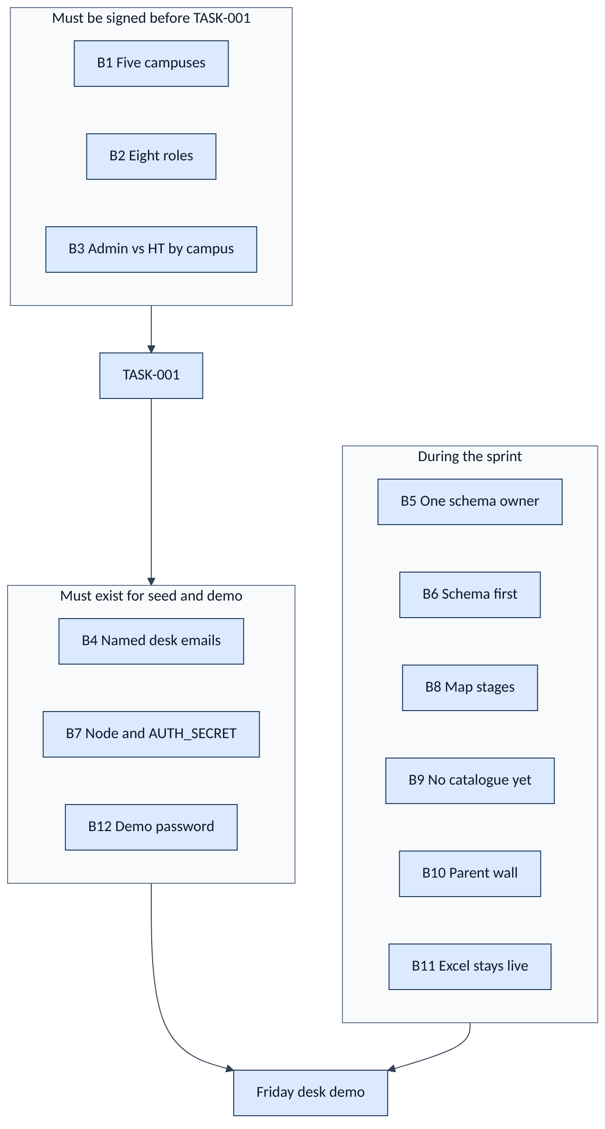
Figure 31
Sprint 1 exit criteria (blockers cleared)
- B1–B4 signed (this report is the proposed sign-off).
- B5–B6 held: one Prisma, schema before UI.
- B7 and B12: any laptop on the team can run npm run db:setup && npm run dev and log in.
- B8–B10: map and role walls match sections 1 and 3.
- B11: nobody treats Sprint 1 screens as the inventory of record.
If Friday’s demo cannot log in the five desks (store, tailor, finance, one admin, one HT) plus a parent stub, Sprint 1 is not done. We do not open Sprint 2 from this report.

*End of report. Diagrams in sections 1–11 are the design of record for this planning week.*

