HW 5

Functional Programming and SML

Kito Beirens

Due date: 12/17/2018

Date Completed: 12/14/2018

Problem 1: FindBug
Use FindBug on the scanner and parser code you wrote and provide the results in a readable way.
http://findbugs.sourceforge.net

Problem 2: Types

- What are the types of the following expressions?
- 1; => int
- 1+0.5; => real
- (1,2); => int * int
- [true, false, true]; => bool list
- [(1,5), (2,3), (5,6)]; => (int * int) list
- fun f(x:real) = true; => real -> bool

- Provide expressions of the following types:
- bool => true
- int * bool =>(18,true)
- real list=>[4.2,3.4]
- (int list) * bool => ([5.6,7.8], true)
- int -> bool list => fun f(x:int) = false;

Problem 3: Factorial and Fibonacci

Write the factorial and fibonnaci functions using exceptions in SML.

fun factorial n =
if n <= 1 then
1
else
factorial (n-1) * n;

factorial 6;
- val factorial = fn : int -> int
val it = 720 : int

fun fib n =
if n = 0 then
0
else if n = 1 then
1
else
fib(n-1) + fib(n-2);

fib(8)
- val fib = fn : int -> int
= val it = 21 : int

Provide the SML code. Show evidence of testing of your functions.

Problem 4: Evaluation of Functions

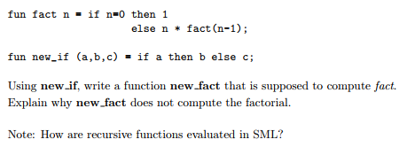
fun new_fact (n) =
new_if (n = 0, 1, n * new_fact(n-1));

SML uses eager evaluation which means the first expression is the one evaluated. Because of this new-fact(n-1) doesn’t check if n=0, it just recursively continues to call new-fact(n-1) again and again so it gets stuck in a loop. Because of this new_fact is not computed because it is using the innermost evaluation and not checking n for termination.

Problem 5: map
What is the map function? (In plain English)
What is the type of map?

Map applies f to each element of l from left to right, returning the list of results. ('x -> 'y) -> 'x list -> 'y list

Problem 6: Functions
Write a recursive function called sum that computes the sum of the n first ints.
Write a recursive function called exp that computes x^n where x and n are ints.
Provide the SML code. Show evidence of testing of your function.

fun sum(x) =
if x = 1 then 1
else x + sum(x-1);

sum 5
- val sum = fn : int -> int
= val it = 15 : int

fun exp (x, n) =
if n = 1 then x
else x*exp(x,n-1);

exp(3,3);
- val exp = fn : int * int -> int
val it = 27 : int

