The Mid-Autumn Festival (Moon Festival)
Also known as the Chinese Moon Festival but more often called the "Mooncake Festival" by travelers, the Mid-Autumn Festival is an annual harvest celebration. The event is observed throughout Asia; Taiwan and Hong Kong observe the Mid-Autumn Festival as a public holiday. The Moon Festival is a very commercialized event with, you guessed it, many types of mooncakes for sale.
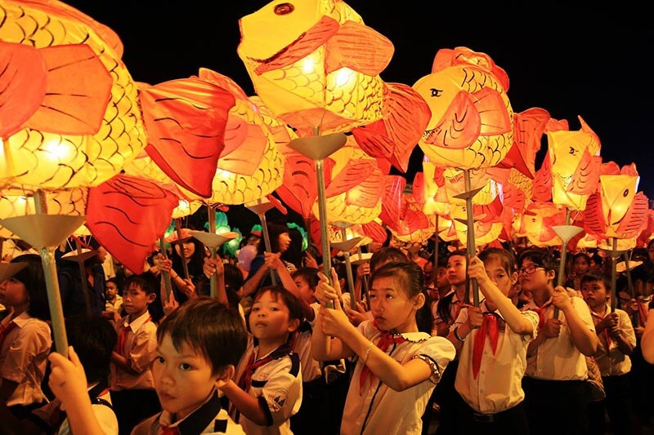
Aside from buying mooncakes, the Mid-Autumn Festival is about enjoying a brief respite from work to have reunions with family, friends, and loved ones. Mooncakes are exchanged with someone special.
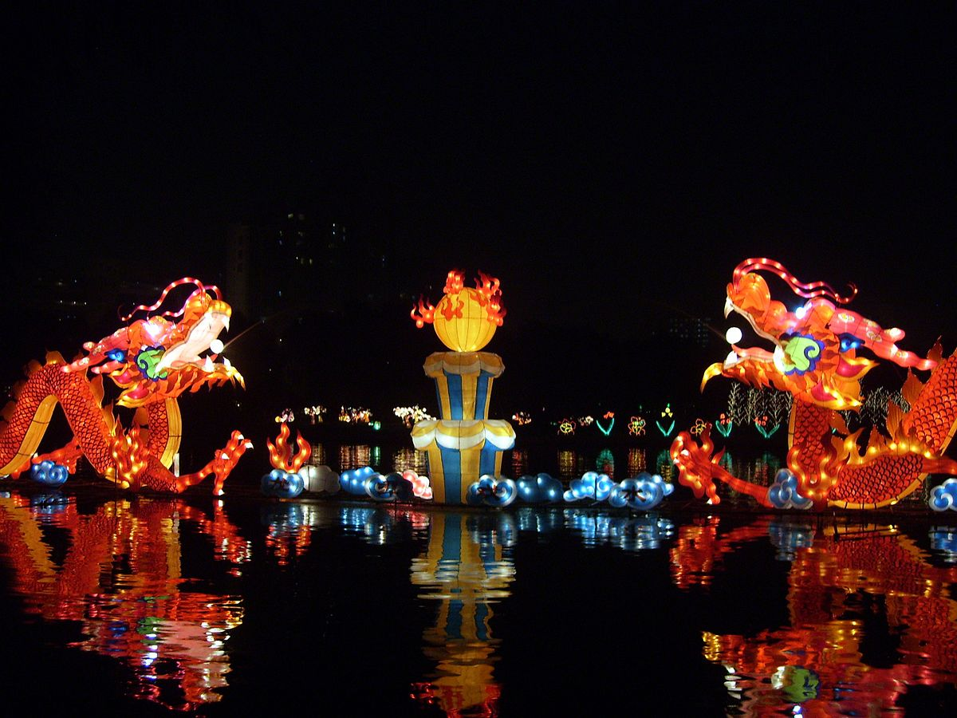
Perhaps unfairly, mooncakes could be called Asia's answer to Christmas fruitcakes. They make cute gifts, but whether or not the dense, high-calorie little cakes get eaten or not—that's another story.
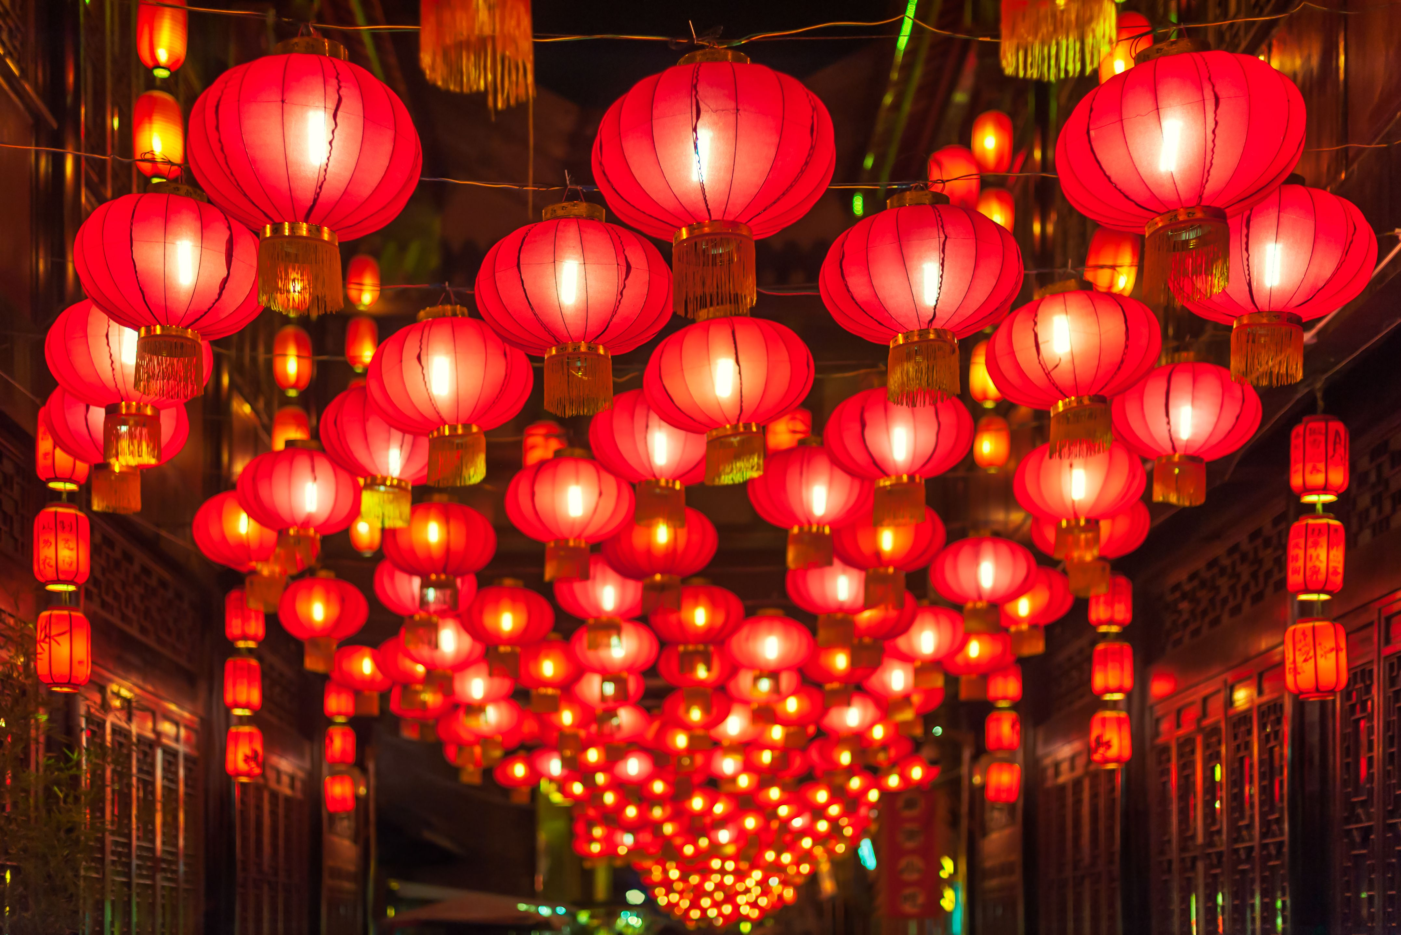
Commercialization hit this fall festival hard: Some of the mooncakes for sale are made from exotic ingredients (gold leaf, anyone?) and can cost hundreds of dollars. Beijing's taxation on mooncakes received created outcry and controversy—some mooncakes are so luxurious they are considered taxable income!
- Where: The epicenter is China, but the festival is observed throughout Asia.
- When: Usually in September but sometimes October

