**Ati-Atihan Festival**

Ati–Atihan is not only a festival with a long history, but also considered the largest, most colorful and exciting spring festival in the Philippines.

Held every year on the 3rd week of January, the Kalibo people in the center of Aklan province in Panay Island, Philippines are always eager to welcome the brilliant Ati–Atihan festival. The festival attracts the participation of many people, creating a magnificent, colorful and extremely interesting scene. And the Philippine tourist groups in this season are also eager and enthusiastic to participate in the festival.

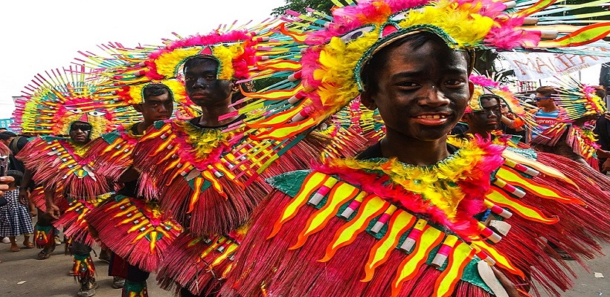

The festival is an occasion for Filipinos to honor the child god, the guardian deity for the whole country. Every time on this occasion, the whole Kalibo seems to change skin, the air is always resounding with the sound of drums and trumpets, the colorful dresses are decorated with feathers to create eye-catching and vibrant costumes in wild dances. This is what attracts Filipino tourists this season.

Ati–Atihan được bắt nguồn từ thế kỉ XIII, khi một nhóm người nhập cư từ Malaysia đến nơi đây. Để có thể hòa nhập với người dân bản địa có làn da tối màu, họ đã sơn mặt mình thành màu đen và tổ chức ca hát nhảy múa nhằm thể hiện lòng biết ơn vì đã được mọi người chu cấp đồ ăn và đất để sinh sống.

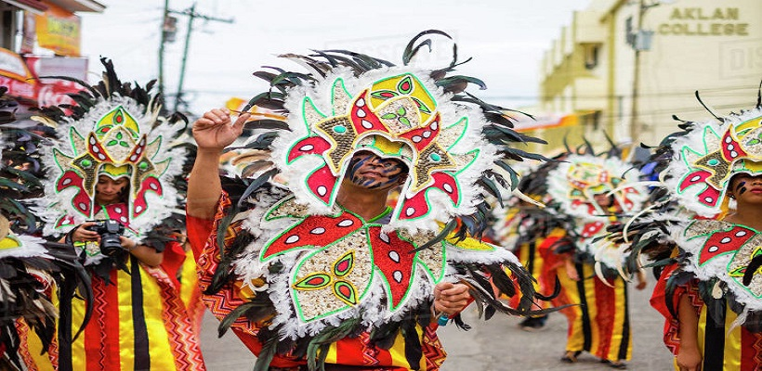

Today, this custom is still preserved and promoted. Festival participants are dressed in soot and dressed in colorful traditional costumes representing their locality. The whole road at this time suddenly became lively with the sound of trumpets, drums, unique melodious songs and wild and powerful ethnic dances. If you picture a carnival, Ati–Atihan is similar.

The time of the Ati–Atihan festival lasts for a week, but mainly focuses on the last 3 days, Friday, Saturday and Sunday. Especially on Sunday when the baby Jesus statue is carried from Kalibo church to Pastrana park. The procession is like a monumental parade that attracts a lot of participants, almost all Filipino tourists are present in this majestic procession.

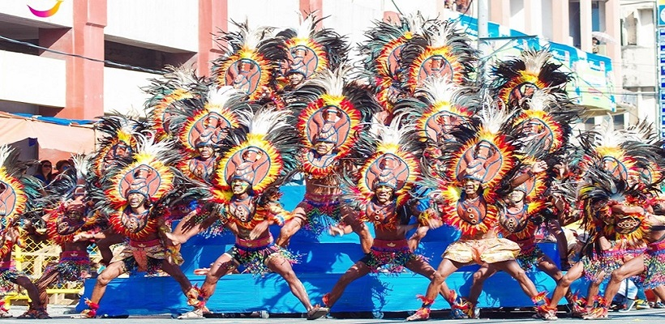

Not only that, Ati-Atihan also attracts visitors with an outdoor dance competition. To participate in this competition, each team of amateur dancers of 40 to 50 people practiced hard every week before coming to the show. They are people from different localities, meeting to represent their place to dance and compete with other teams. Although the prize money is large, it is still important to have fun and dancing spirit of the whole team.

The passionate atmosphere of the Ati–Atihan festival makes us feel like we are living in a carefree world, without the hustle and bustle, only music, laughter, colors and sounds of happy parties.

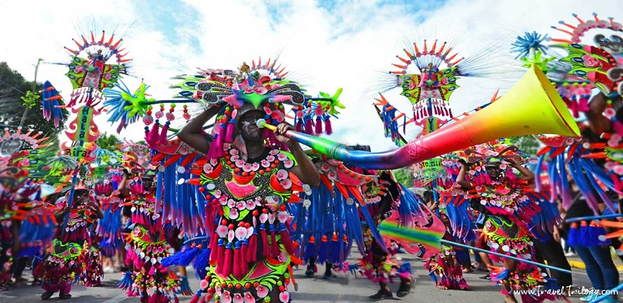

However, at this time, the hotels and resorts around here are full because they have been fully booked since a month ago. If unfortunately can not find yourself a room in the hotel, you can also temporarily rent a room in the homestay nearby to rest. Another point worth noting is that although the festival is very grandiose and lasts for many days, there is always police to ensure security. Moreover, after participating in the festival, visitors can also go to Boracay beach less than an hour away by car to have fun and swim.