**Christmas**

Some countries celebrate this day on December 25, some countries again on the evening of December 24. According to Roman Catholics, the official feast is December 25, also known as 'the main day of the day', and the night of the 24th of the month. 12 is called the “vigil”. However, the December 24 night ceremony usually attracts more news to attend. The Eastern Orthodox still use the Julian calendar to determine this date, so they celebrate Christmas on January 7 according to the Gregorian calendar.

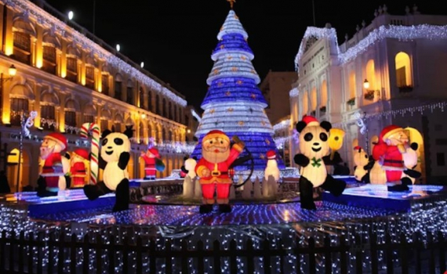

**The word Christmas consists of the letters Christ and Mas**

The word Christ (the Anointed One) is the title of Jesus. The word Mas is an abbreviation for Mass. When the words Christ and Mas are written, it becomes the word Christmas. Christmas means the feast of Christ, that is, the feast of the Nativity of Jesus.The words Christmas and Xmas both have the same meaning. Because the Greek word for Christ is Christos, Spiotós or Xristos. People use the consonant X to represent the entire letter Xristos or Spiotós, then add the adjacent Mas to form the word Xmas. Thus Xmas also means the feast of Christ.



During the early Christian Church (first 2-3 centuries C.E.), this feast was celebrated with Epiphany. However, as early as the year 200, Saint Clement of Alexandria (150-215) spoke of a very special feast celebrated on May 20. And the Latin Church celebrates it on December 25. Another source is that early Christians did not celebrate birthdays, because they believed that celebrating birthdays was following the custom of pagan idolatry. That is why they did not celebrate the birth of Jesus during the first three centuries. In the 4th century, Christians began to want to celebrate the Nativity of Jesus once a year, but were afraid of being discovered and persecuted by the Roman authorities because by that time Christianity had not recognized as a legitimate religion.The Romans, every year, celebrated the 'Sun God' who brought light to the world on December 25. Christians took advantage of this opportunity to celebrate the birth of Jesus and bring light. Light and life came to mankind on the same day as the Roman 'Sun God' holiday. As a result, the authorities did not detect that Christians were celebrating the Nativity of Jesus.

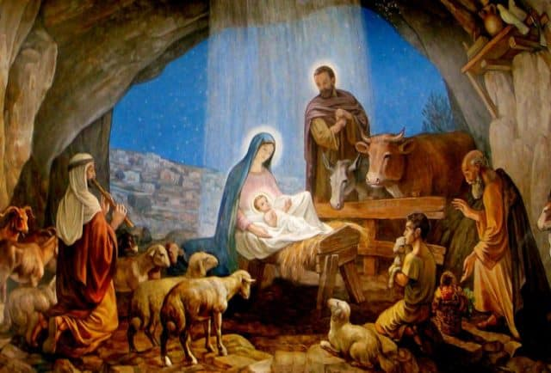

**Christmas symbols and meanings**

The Advent wreath is a circle made of green branches and leaves that is often placed on a table or hung high for all to see. Trees are often decorated at parties during the winter solstice - a sign of the coming end of winter. On leaves placed within 4 candles. This custom was started by the Lutherans in Germany in the 16th century to represent the struggle between light and darkness.The round leaf wreath represents the eternal character and endless love of God. Green represents the hope that the Savior will come to save people. 4 candles include three purple ones - the color of Advent, the 4th is pink, the color of the third Sunday of Advent, also known as Gaudete Sunday.



**Ice cave and slide máng**

Today, on the night of December 24, every church has a cave with a manger, inside there is a statue of the Child Jesus, a statue of the Virgin Mary, surrounded by donkeys, a statue of the Three Kings, some angels, and a saint. Joseph on the roof has a light, shining from a star to guide the three kings to God. Everyone turned to the benevolent God, praying to God to save humanity from war, poverty and misfortune.

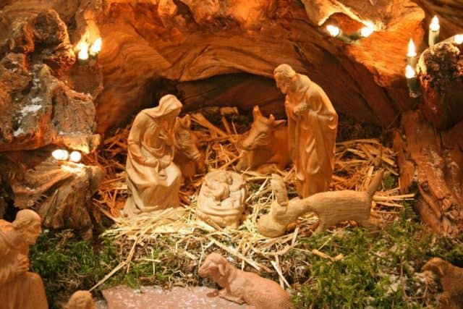

**Christmas tree**

The Christmas tree originated in Germany in the 16th century. This is a tree that lives in harsh climates but still retains its strong, solid and eternal green color. Gradually the image of this tree appeared more and more often and it was considered the center of the festival, where people held hands and danced around the ornate pine tree both inside and outside with flowers. roses, apples and colored paper. In the 19th century, Christmas trees began to be widely used in England. In the 1820s, the Christmas tree was brought to the United States by Germans in Pennsylvania. Nowadays, near Christmas, people often buy a pine tree and decorate it with stars, pearls, glittering tinsel. , flowers... The pine tree is considered a symbol of hope and new vitality in the festival to welcome the new year.

