**Nha Trang Sea Festival - 2019: Festival of legends**

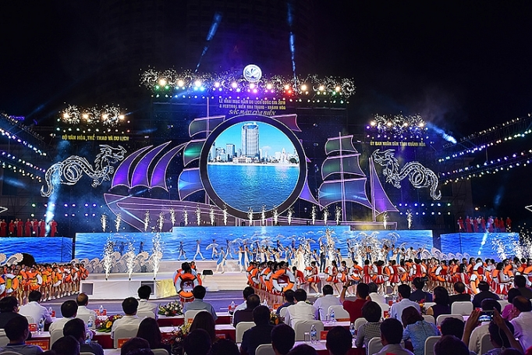

Historic 2/4 Square on Tran Phu Street, City. Nha Trang welcomed over 20,000 people to attend the opening and closing ceremonies of the Sea Festival. The festival with over 59 welcoming and jubilant activities took place from April 26 to May 14, 2019. At the opening and closing night, the program featured a special and attractive performance with 50 elaborately staged music and dance performances, with 1,400 famous artists and singers, and ended with a fireworks display. art at sea. 10 Vietnamese records were set and awarded at the closing ceremony…

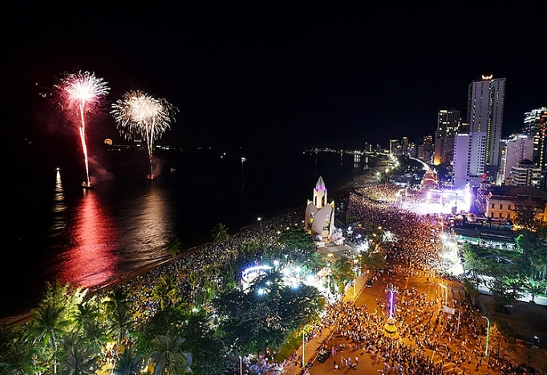

Nha Trang - Khanh Hoa Sea Festival 2019, with the theme 'Colors of the sea' has brought locals and visitors special emotions. The festival has brought visitors from all over the world as if living in fairy tales, with interesting experiences, different levels of emotions and together discovering the unique cultural beauty of the Land of Tram Huong. Ms. Nguyen Hai Duong - a businessman returning from Australia shared: “I was really touched when I attended Nha Trang Sea Festival programs, very impressive and attractive. I am looking for investment opportunities in Khanh Hoa. I will be back one day soon…”

Nguyen Anh Hung - General Director of Khanh Hoa Salanganes Nest Company: 'We are very proud to be the sponsor of Diamond for the festival. In addition to sponsoring, Khanh Hoa Salanganes Nest Company also actively organizes a series of events to participate in the main program of the Sea Festival 2019, to promote and honor the industry of exploiting natural island nests.

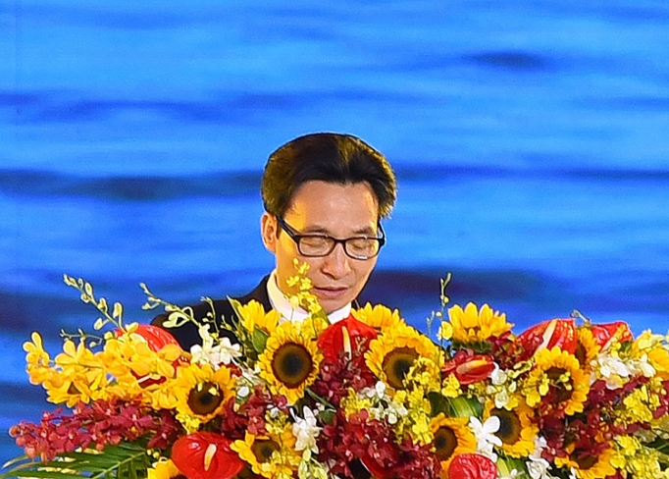

In particular, if the opening ceremony of the Sea Festival - Nha Trang - Khanh Hoa 2019, was honored to welcome Deputy Prime Minister Vu Duc Dam to attend and deliver the opening speech, the closing ceremony ended impressively with 10 Khanh Hoa records. A tie is established and recognized. Representative of the Vietnam Book of Records, Mr. Duong Duy Lam Vien - Director of the Vietnam Record Institute, Mr. Nguyen Manh Quy - Vice Chairman of the Vietnam Record Association and Mr. Nguyen Van Xang - a member of the Vietkings Advisory Council - Especially the Central region took the stage to award the Certificate of Vietnam Record Setting to organizations and individuals that own 10 records honored: Khanh Hoa - the locality with many beautiful and famous bays in Vietnam Male; The first telescope in Vietnam; The largest set of marine life stamps in Vietnam; The oldest horse breeding farm for research and production of vaccines and serums in Vietnam; Khanh Hoa Agarwood - Spirit of heaven and earth; The largest box of seaweed and sea grapes with VMAX brand in Vietnam; The largest collection of products made from tire scraps in Vietnam; The largest pair of Mid-Autumn Festival lanterns in the shape of a star and a moon cake with a bamboo frame in Vietnam was made to serve the Mid-Autumn Festival for pediatric patients; The set of terracotta figurines that represent the most biblical parables; The most ceramic set of doctor Alexandre Yersin statues.

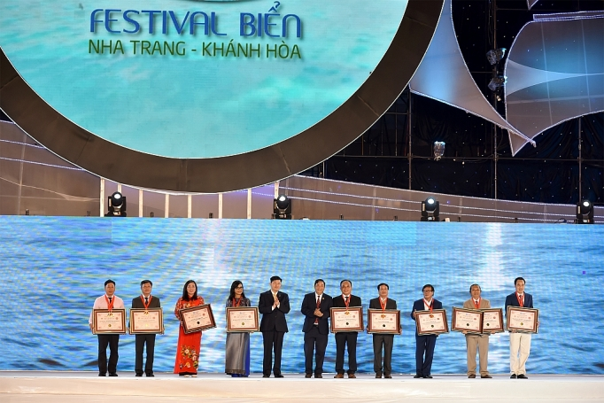

Tram Huong - Khanh Hoa bids farewell to the 9th Sea Festival - Nha Trang, but the program accompanying the series of activities of the National Tourism Year 2019 will continue continuously in the near future, with the following events: Competition Miss Universe Vietnam, Miss Tourism ASEAN contest, sailing race Hong Kong - Nha Trang; Festival of performances of the representative intangible cultural heritage of humanity,…