Asymmetric Effects of Stability-Inducing Operators across Trajectory and Population Search in Job-Shop Rescheduling

Takumi Kito
Department of Industrial and Management Systems Engineering, Graduate School of Creative Science and Engineering, Waseda University, Tokyo, Japan
Tel: (+81) 80-4756-3741, Email: kito@toki.waseda.jp

Abstract. In predictive-reactive rescheduling, a high-quality preschedule S_{p} already exists before the disruption, and revised schedules must be both efficient (makespan) and stable (small deviation from S_{p}). Filling the vicinity of S_{p} (the high-stability region) thus becomes a performance axis as important as global search quality. Through controlled comparisons sharing an identical N5 local search, we show that a trajectory-based method (ILS) fills this vicinity by itself through continuous transformation, whereas a population-based method (memetic algorithm) remains structurally coarse there because of crossover (H1); ILS thereby wins high-stability coverage in all eight scenarios with complete separation (|δ|=1.0). We further propose a rescheduling-specific adaptation of path relinking whose guiding solution is fixed to S_{p} (PR), and its one-step variant (repair), as stability-inducing operators that pull solutions toward S_{p}. Experiments over eight scenarios, seven methods, and ten trials show that the same operator acts asymmetrically depending on the host structure—more than doubling the population's high-stability coverage and lifting it to first place in overall quality, while the trajectory host is already saturated (H2)—and quantify a complementary structure in which the best method switches with the evaluation metric.

Keywords: Rescheduling; Job-shop scheduling; Stability; Iterated local search; Path relinking

1. INTRODUCTION
Manufacturing shop floors frequently face disruptions—operation delays, machine breakdowns—that make the original schedule infeasible. Among the static (built-in tolerance) and dynamic (after-the-fact revision) responses, we address the latter, specifically predictive-reactive rescheduling (Ouelhadj and Petrovic, 2009), which repairs the executing schedule into a feasible one after a disruption. We focus on operation delays, handled by resequencing alone (machine assignments kept), for which the premise of keeping the revised schedule near the original holds most clearly.
The efficiency of the revised schedule (makespan, MS) and the amount of change from the pre-disruption schedule S_{p} (stability) trade off. Large changes incur shop-floor confusion, setup and fixture changeovers, material re-kitting, worker re-assignment, and rippling schedule changes to downstream or outsourced operations, so stability is an objective on par with MS (Wu et al., 1993; Rangsaritratsamee et al., 2004); we formulate multi-objective optimization of efficiency and stability.
The essential peculiarity of rescheduling is that a high-quality pre-disruption schedule S_{p} already exists as an initial solution, and the revised schedule must deviate little from it. Optimal solutions are likely distributed near S_{p}, so the merit of a search method acquires a new axis: not mere global search ability, but how well it fills the vicinity of S_{p} (the high-stability region).
Our objectives are threefold: (1) a comparative analysis of how the existence of a high-quality initial solution S_{p} affects the search behavior of single-solution and population-based methods; (2) the design of stability-inducing operators (PR and repair) that pull solutions toward S_{p}, and of their interaction with the host search structure; (3) a multi-perspective evaluation methodology integrating speed, Pareto coverage, and performance by stability band. Our focus is the structural analysis of the mechanism–host interaction rather than a performance race against the state of the art (Sörensen, 2015).

2. RELATED WORK AND POSITIONING
Joint consideration of efficiency and stability. The JSSP is NP-hard and metaheuristics are the mainstream (Ouelhadj and Petrovic, 2009). Joint optimization of efficiency and stability in rescheduling was pioneered by Wu et al. (1993) and pursued for the JSSP by Rangsaritratsamee et al. (2004) (hybrid GA) and Zhang et al. (2013) (GA + tabu search), and for flow shops by Katragjini et al. (2013). These works mostly bundle the two objectives into one weighted-sum scalar (Rangsaritratsamee et al., 2004; Zhang et al., 2013), where stability enters not as an independent mechanism but passively, as a single evaluation term of the objective. Of the two metaheuristic families—trajectory (single-solution) and population-based (Blum and Roli, 2003)—the solvers here are predominantly population-based, anchored in GAs.
Embedding stability as a mechanism (scope-limiting approaches). A separate lineage guarantees stability structurally by limiting the rescheduling scope: match-up scheduling (Bean et al., 1991), AOR, which reschedules only the affected operations (Abumaizar and Svestka, 1997), Zakaria and Petrovic (2012), who restrict the chromosome to an interval, and Sun et al. (2026), who formalize the scope into a four-level hierarchy. Common to all is guaranteeing stability by restricting the search space.
Remaining issues and positioning. Three issues remain. First, existing rescheduling studies are predominantly GA-based (population) and lack a controlled contrast with a trajectory-based method; to our knowledge, how the rescheduling-specific existence of a high-quality initial solution S_{p} affects search-structure behavior (trajectory vs. population) has not been analyzed head-on; we do so via a controlled contrast between ILS and a memetic algorithm sharing the same local search (N5). Second, neither existing means of securing stability steers the search toward stability actively: they fall into scope limiting, which excludes trade-off solutions outside the restriction, and objective embedding, in which the search itself does not pursue stability, leaving high-stability filling to the raw ability of the base search. We propose operators (PR, repair) that actively pull solutions toward S_{p}; securing stability as an operator rather than by restricting the space is our core design claim against the scope-limiting family. Third, existing evaluations are mostly scalar comparisons at a few fixed weights, lacking a multi-axis methodology covering Pareto coverage, convergence speed, and stability bands; we evaluate with union HV, high-stability HV, and AOC (Section 3.4).
We pose two hypotheses. H1 (suitability): a population-based method (memetic) that largely recombines solutions by crossover scatters offspring away from S_{p} and fills the high-stability region (near S_{p}) only coarsely, whereas a trajectory-based method (ILS) that fills the neighborhood by continuous transformation from S_{p} covers it efficiently. H2 (complementarity): operators pulling solutions toward S_{p} (PR, repair) complement precisely the neighborhood filling that populations are structurally poor at, so their effect appears asymmetrically with the host structure (large for the population, marginal for the trajectory). Section 3 presents the methods; Section 4 tests both hypotheses.

3. PROBLEM SETTING AND PROPOSED METHODS

3.1 Problem Definition
After a single operation delay (length Δ) in an n-job, m-machine JSSP, we seek a revised schedule S_{q} against the original S_{p}. Feasibility is first restored by the right-shift repaired solution S_{RSR}, which keeps the machine sequences of S_{p}. Operations started before the rescheduling time t_{r} (when the delay is resolved) are frozen; those from t_{r} onward are the optimization targets. The decision variables are only the per-machine sequences of the target operations; a solution becomes an executable schedule by fixing the frozen part and shifting each operation to its earliest feasible start after t_{r} under the given machine sequences.
Stability metric. Deviation measures fall into two families: (i) start-time deviation (temporal stability) and (ii) processing-sequence (permutation) deviation (sequence stability). Sun et al. (2026), for example, distinguish the two explicitly and adopt the former (the sum of absolute start-time deviations, ADST). We adopt the latter because our search mechanisms (the direct swaps of PR/repair, the N5 neighborhood) are all permutation operations and it is highly independent of MS.
$D(S_{p},S_{q})=\sum_{(i,j)∈O_{opt}}{\left|r_{i,j}^{p}−r_{i,j}^{q}\right|}$ (1)
Here r_{i,j} is the processing rank of job j on machine i, and O_{opt} is the set of target operations (from t_{r} onward). D=0 corresponds to the sequence-preserving right-shift solution S_{RSR}. Temporal stability based on start times is outside this metric's scope—an explicit limitation.
Multi-objective formulation and scalarization. We minimize (MS(S_{q}), D(S_{p}, S_{q})) jointly via a weighted sum with weight λ∈[0,1].
$F(S_{q})=λ\hat{D}(S_{p},S_{q})+(1−λ)\hat{MS}(S_{q})$ (2)
Hatted symbols denote min–max normalized values. We sweep the weight over multiple points, merge the solutions, and evaluate Pareto coverage (Section 3.4). The premise for method differences to appear is that room remains to improve MS from S_{RSR} by sequence re-optimization (non-degeneracy).
Why weighted scalarization rather than Pareto-native methods. First, consistency with operational practice: the efficiency–stability priority is specified in advance as a weight by the decision maker (the standard rescheduling framework (Rangsaritratsamee et al., 2004)); each weight yields a solution, aligning with the per-weight anytime HV(t) (AOC, Section 3.4) that measures preference-specific ramp-up. Second, a common basis for controlled comparison: only by having ILS and the memetic share the same scalar objective F(λ) can we mount the same mechanism on both structures unmodified and isolate structural differences (methods premised on population-specific non-dominated sorting, e.g., NSGA-II, do not fit this control). To avoid dependence on any single weight, we sweep λ and merge all non-dominated solutions under UEA (Ishibuchi et al., 2020). The weighted sum misses concave parts of the front (Marler and Arora, 2010), but because all methods are evaluated under identical conditions, the structural discussion is unaffected (re-verification with Pareto-native methods is future work).

3.2 ILS and Its Rationale (H1)
In rescheduling—where the initial solution S_{p} is high-quality and optima lie near it—a trajectory (single-solution) method that continuously transforms from S_{p} should fill the high-stability region better (H1). We therefore center the comparison on ILS vs. Memetic-LS with the local search (N5) aligned, removing the local-search confound and contrasting only the search structure.
Among single-solution methods we adopt ILS (Lourenço et al., 2019) because exploitation (local search) and escape (perturbation) are separated, the perturbation strength directly controls the distance from S_{p}, and the stability-inducing mechanism (Section 3.3) inserts naturally as a perturbation. The local search is the standard N5 neighborhood (Nowicki and Smutnicki, 1996) (candidates restricted to swaps of adjacent jobs at critical-block ends—only moves with a prospect of makespan improvement), shared by ILS and Memetic-LS. Its unit of search—an adjacent swap at a critical-block end—is a minimal structural change, so it fills the high-stability region in fine increments of deviation from S_{p}, fitting our stability-focused setting. The perturbation is an insert move whose strength (= distance from S_{p}) cycles in a sawtooth with stagnation (VNS-type (Mladenović and Hansen, 1997)); best and current update only when F(λ) strictly improves. The candidate set is makespan-motivated and λ-independent, but moves are accepted by F(λ), so the local optima shift toward efficiency or stability with λ.
Population-based methods (GA / Memetic-LS). The population control encodes individuals in the operation-based representation (Bierwirth, 1995) with a standard GA (PPX crossover (Bierwirth et al., 1996), inversion mutation, tournament selection with elitism), applying the same N5 to each individual in a Lamarckian manner to form Memetic-LS (GA + local-search integration (Neri and Cotta, 2012)); the plain GA is a reference baseline. Sharing N5 with ILS, its difference reduces solely to the search structure (single trajectory vs. population + crossover). Crossover is a destructive operation splicing two parents, so offspring readily jump away from the vicinity of S_{p}; even Memetic-LS with N5 therefore fills the high-stability region only coarsely—the crux of H1.

3.3 Stability-Inducing Operators (PR and repair) and H2
Path relinking (PR). PR exploits the idea that good intermediate solutions lie on the path connecting two high-quality solutions; it is commonly combined with scatter search, linking solutions within an elite pool (Glover et al., 2000; Peng et al., 2015). Our rescheduling-specific feature is that the guiding solution is fixed to the single point S_{p}, the pre-disruption schedule: from the current local optimum (initiating) toward S_{p} (guiding), the path is traced by shrinking the disagreements one by one with direct swaps, returning the best solution on the path. Fixing to S_{p} (a) makes PR uniquely interpretable as a "directed move toward the stability anchor," S_{p} being the optimal endpoint of the stability objective, and (b) lines the intermediates between S_{cur}, a local optimum of F(λ), and S_{p} up along the MS–stability trade-off, contributing directly to Pareto filling. Each step picks one feasible disagreement swap at random, keeping evaluations at O(d) (d = number of disagreements; no significant HV difference from best-selection O(d²) in preliminary experiments).
Stability repair kick (repair). This transfers PR's "one-step approach toward S_{p}" to the perturbation kick of ILS—a mini-PR truncated midway. Upon stagnation, a few direct swaps pull the solution toward S_{p} ("repairing" the stability lost by drifting), and the local search restarts. The depth also cycles in a sawtooth, covering the stability side of the front in a band.
H2 (complementarity hypothesis). PR and repair both pull solutions toward S_{p}, complementing exactly the high-stability filling that population-based search is poor at; ILS has already filled the neighborhood by itself (H1), leaving little headroom. The mechanism lies in solution redundancy and path length: GA-derived solutions are not MS-optimized as rigorously as N5 achieves—leaving redundant sequences whose stability can improve without hurting MS—and sit far from S_{p} with long PR paths, while ILS clings to the vicinity of S_{p} with short paths. Hence we predict an asymmetry: large effects on the population, marginal on the trajectory.
Figure 1 schematizes the three structures' behavior on the (MS, D) plane—population scattering (H1), trajectory neighborhood filling (H1), and mechanism pull-back (H2). We study seven methods: ILS-baseline / ILS+repair / ILS+PR / GA / Memetic-LS / Memetic+PR / Memetic+repair.

3.4 Evaluation Framework
Scalar comparison at one weight makes conclusions weight-dependent and cannot capture how much of the efficiency–stability trade-off was covered. We therefore sweep λ (weighted-sum sweep) and measure Pareto coverage under UEA (Ishibuchi et al., 2020), which archives all non-dominated solutions visited. Rescheduling also values stable solutions near S_{p} over the efficiency extreme, and "whether a good solution is available whenever computation stops" matters operationally. Three metrics answer the three questions—overall quality, filling with stable solutions, speed: union HV (overall quality) = hypervolume over the whole region; high-stability HV (primary) = hypervolume restricted to D < P50 (near S_{p}), P50 being the median D of Pareto solutions pooled over all methods and trials; AOC (anytime performance (López-Ibáñez and Stützle, 2014)) = the time average of the HV-versus-log-time curve.
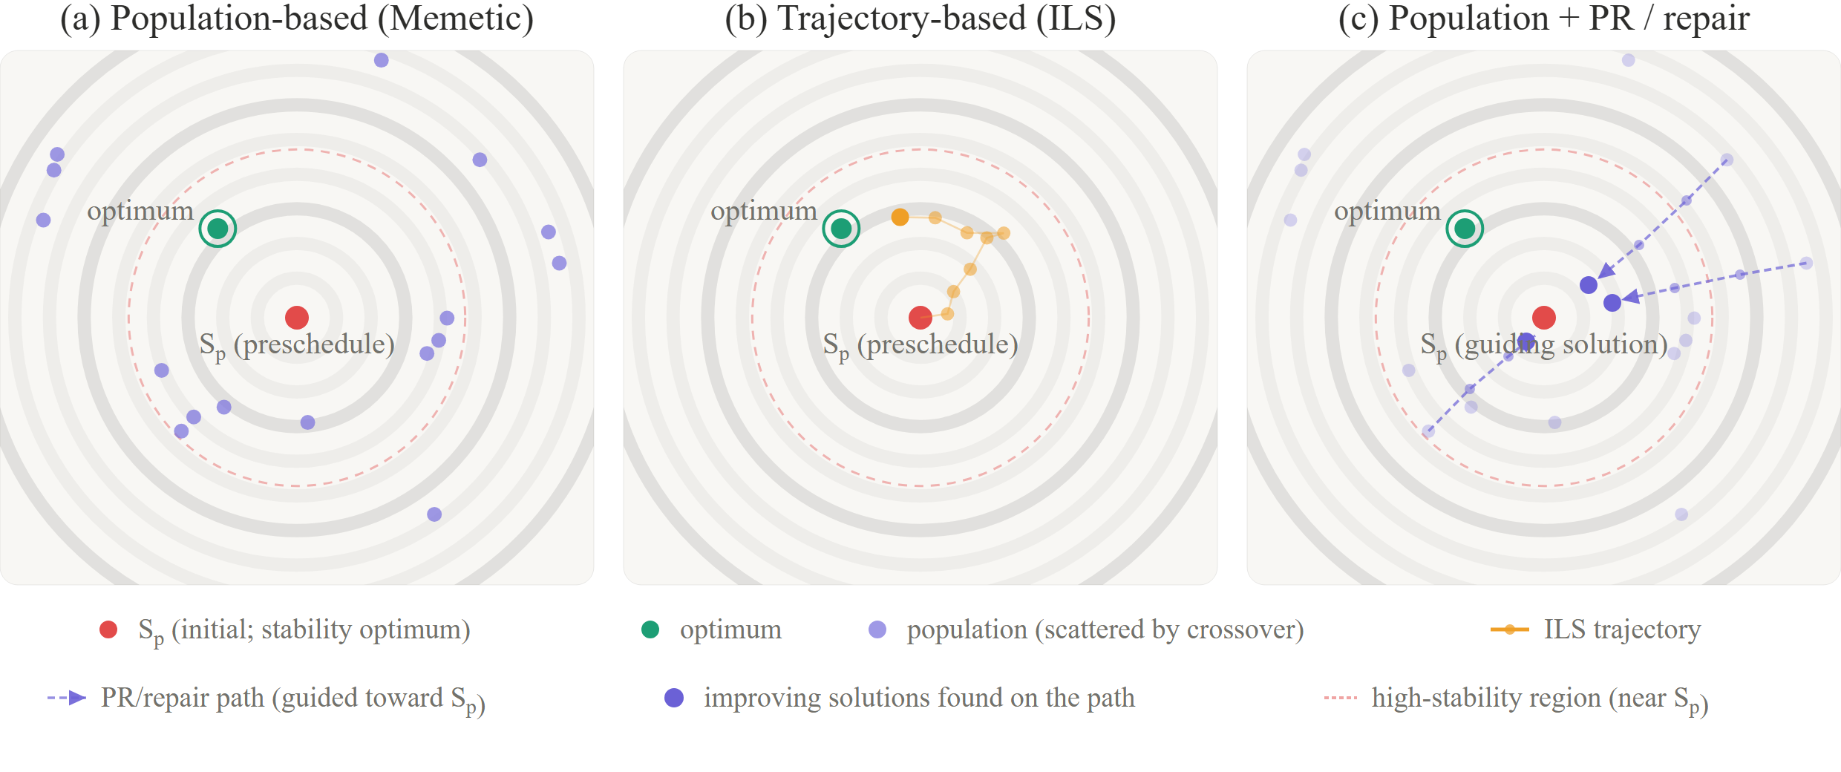
Figure 1: Schematic search behavior on the (MS, D) plane. (a) population scatters away from S_{p} via crossover; (b) trajectory (ILS) fills the vicinity of S_{p}; (c) PR/repair pulls scattered solutions back toward S_{p}.

For cross-scenario comparison, HV is computed after affine normalization to [0,1]² per scenario with reference point (1.1,1.1). The anytime HV(t) for AOC is measured on the wall clock, with the integration window common to all methods and the same logarithmic-width normalization (apples-to-apples). AOC averages the anytime HV(t) over the 10-weight sweep.
Statistics. Within each scenario we use the one-sided Wilcoxon signed-rank test (paired by trial; one-sided since H1 and H2 fix the direction in advance) plus Cliff's δ. When |δ|=1.0 (complete separation), the one-sided Wilcoxon with n=10 reaches its lower bound p ≈ 0.001, so "p=0.001" below signifies complete directional consistency (magnitudes are reported via δ and ratios). Cross-scenario tendencies are summarized by Friedman tests, average ranks, and Kendall's W; since the eight scenarios derive from five instances and the la36 ladder and ta21 pair vary only the disruption within one instance, these cross statistics are an exploratory summary of rank consistency, not independent-sample tests. Magnitudes are also given as ARPD% ((best − x)/best × 100; lower is better).

4. COMPUTATIONAL EXPERIMENTS
This chapter establishes H1 (Section 4.2, the trajectory's suitability for the high-stability region) and H2 (Section 4.3, the host-dependent asymmetric effect of the same mechanism) through controlled pairwise comparisons, then surveys the implications with an overall scoreboard (Section 4.4). The central finding is that implementing the stability lever as an operator allowed the host-structure × stability-mechanism interaction to be isolated under control; as a consequence we also observe a complementary structure in which the best method changes with the evaluation axis (Section 4.4).

4.1 Experimental Setup
Benchmarks: mt10, la21, la36, la40, ta21. Disruptions total 8 scenarios: la36S/la36M/la36L (27/54/73%), ta21S/ta21L (32/82%), mt10 (72%), la21 (35%), la40 (32%), where the percentage is the rescheduling ratio ρ=n_{res}/ops—the fraction of all operations that became re-optimization targets O_{opt}. We adopt ρ as the control axis because it appears to be the main determinant of effective difficulty here (see the end of Section 4.4). In particular, the la36 ladder (27/54/73%) and the ta21 pair (32/82%) vary only the rescheduling ratio stepwise within the same instance and the same S_{p}, isolating the ρ-dependence of method differences without confounds. Each disruption is a completion delay of one operation; Δ is about 0.9–1.5 times the affected operation's processing time (Δ=60–148), and t_{r} is the delay resolution (= delayed completion) time (Section 3.1). Complete per-scenario definitions of the affected operation, Δ, t_{r}, and how ρ was controlled (via the disrupted operation's position in S_{p}) are in the public repository (below).
Weights and trials. λ is swept over 10 points (0–0.9, step 0.1; the pure-stability endpoint λ=1.0 is excluded since the optimum degenerates to the trivial S_{RSR} (D=0)); 10 trials per (scenario × method). The unit of analysis is the trial: one trial is the whole 10-weight sweep—the non-dominated set merging each weight's visited solutions under UEA. HV thus yields one value per trial, and all tests use n=10.
Computational budget. ILS iteration cap 3000; GA/memetic 500 generations (both to natural convergence). Iterations and generations differ in unit, so nominal values are aligned within each family and cross-method speed is compared by wall-clock AOC. Wall-clock time differs across families (Memetic+PR is 5–8× ILS, owing to path decoding toward S_{p} in our Python implementation), but this is a mechanism cost, not a truncation artifact: a convergence check over all seven methods shows the median run reaching 99% of its final HV within half its budget.
Initial solution and GA settings. S_{p} is a high-quality active schedule generated by GA-500 (decoded by the GT algorithm (Giffler and Thompson, 1960); it satisfies the non-degeneracy condition of Section 3.1). All methods receive S_{p} as a common start (ILS as the initial solution; GA/memetic within the initial population). The GA backbone (cx_{pb}=0.85, mut_{pb}=0.1, pop=50) is fixed at standard values, not an independent variable.
Environment and reproducibility. AMD Ryzen 5 7530U; Python 3.12 (NumPy, DEAP, SciPy). All seeds fixed. Code and scenario definitions: https://github.com/kitotakumi/stability_scheduling.

4.2 Result 1: Trajectory (ILS) vs. Population (Memetic) (H1)
To avoid mechanism confounds, we compare ILS-baseline vs. Memetic-LS with the local search aligned (both carry the identical N5, so differences stem from the search structure, not the presence of local search). The high-stability gap is therefore attributable to the fact that even a competent population with the same local search cannot structurally fill the vicinity of S_{p} because of crossover. Figure 2 shows the results.
• Union HV: comparable (ILS 5 wins, Memetic 3). Memetic wins precisely on the scenarios with large improvement headroom at mid-to-high rescheduling ratios (la36M, mt10, la36L; 54–73%), the winner switching with the ratio (Section 4.4).
• High-stability HV (primary): ILS wins in all 8 scenarios with complete separation (p=0.001, |δ|=1.0). In the three low-ratio scenarios (la36S, ta21S, la40), Memetic-LS places not a single solution in the high-stability region—only ILS covers the vicinity of S_{p}; in the remaining five, ILS is 2–4.5×. With |δ|=1.0, significance survives Holm correction over the 8-scenario family everywhere.
• AOC: ILS significantly ahead in 6/8 (the exceptions la36S and mt10 have small re-optimization subproblems where the population's early coverage pays off).
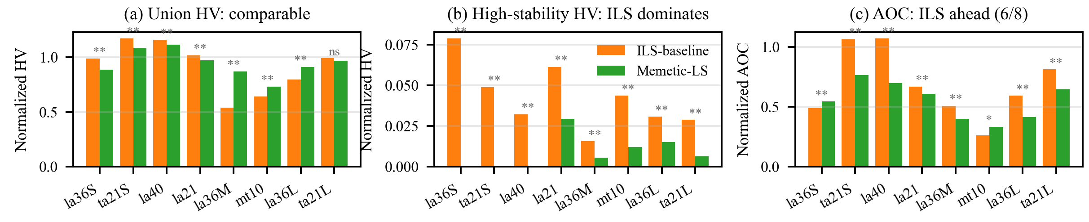
Figure 2: H1—(a) union HV is comparable, but (b) high-stability HV favors ILS in all 8 scenarios, and (c) AOC favors ILS in 6/8 (ILS-baseline vs. Memetic-LS, medians; *p<.05 **p<.01 ***p<.001).

Structural cause (visit-density difference map, Figure 3). The per-method normalized visit-density difference on an (MS,D) grid shows ILS concentrating on the low-D front band while Memetic disperses into the high-D unstable region. The population does visit low D, but destructive crossover keeps it from refining MS there as thoroughly as the continuously transforming ILS, even with the same N5; at equal low D its solutions lose to ILS in MS and fail to fill the region in the Pareto sense—the structural cause of the high-stability HV gap. Holding many solutions far from S_{p} also lengthens the paths, creating exactly the headroom the mechanisms (PR/repair) can fill by pulling back—picked up in H2 (Section 4.3).

4.3 Result 2: Asymmetric Effects of the PR/repair Operators (H2)
We examine the high-stability HV gain from adding the mechanisms to each baseline, by host (Figure 4).
• Population (Memetic): substantial improvement (more than 2× in all 8 scenarios, p=0.001, |δ|=1.0). The mechanisms directly fill the previously unreachable vicinity of S_{p}; the population catches up with ILS in the high-stability region and overtakes it in overall quality (union HV) (Section 4.4).
• Trajectory (ILS): mostly saturated. In most scenarios the baseline has already filled the high-stability region, tying at the ceiling. The mechanisms are significant only in the highest-ratio band: la36L (73%) and ta21L (82%) (raw p=0.016, 0.001; after Holm correction over the 8-scenario ILS family only ta21L remains significant, p_{adj}≈0.008; the gain is small—the ta21L median rises 0.029 → 0.031—but consistently positive across all trials). The effect is thus not absent: ILS leaves little headroom by filling the neighborhood itself, and a small margin remains only when the disruption is so large that the filling cannot keep up.
Mechanistic cause (PR path statistics, Figure 5). The path statistics directly corroborate the asymmetry: Memetic has large path lengths d₀ and finds improving solutions on roughly 30–65% of paths, whereas ILS has short paths and a discovery rate near 0% everywhere (0.4% even on ta21L). This reflects more than trial opportunities: ILS has already filled the vicinity of S_{p}—the short paths are themselves a symptom—so no headroom remains on the segments PR traverses, whereas in Memetic many unoptimized intermediates remain between the scattered solutions and S_{p}; the directed move thus comes up empty on ILS. The slight la36L/ta21L effect owes to the post-kick local search re-optimizing pockets that ILS's own filling left unfilled, not to the directing itself.
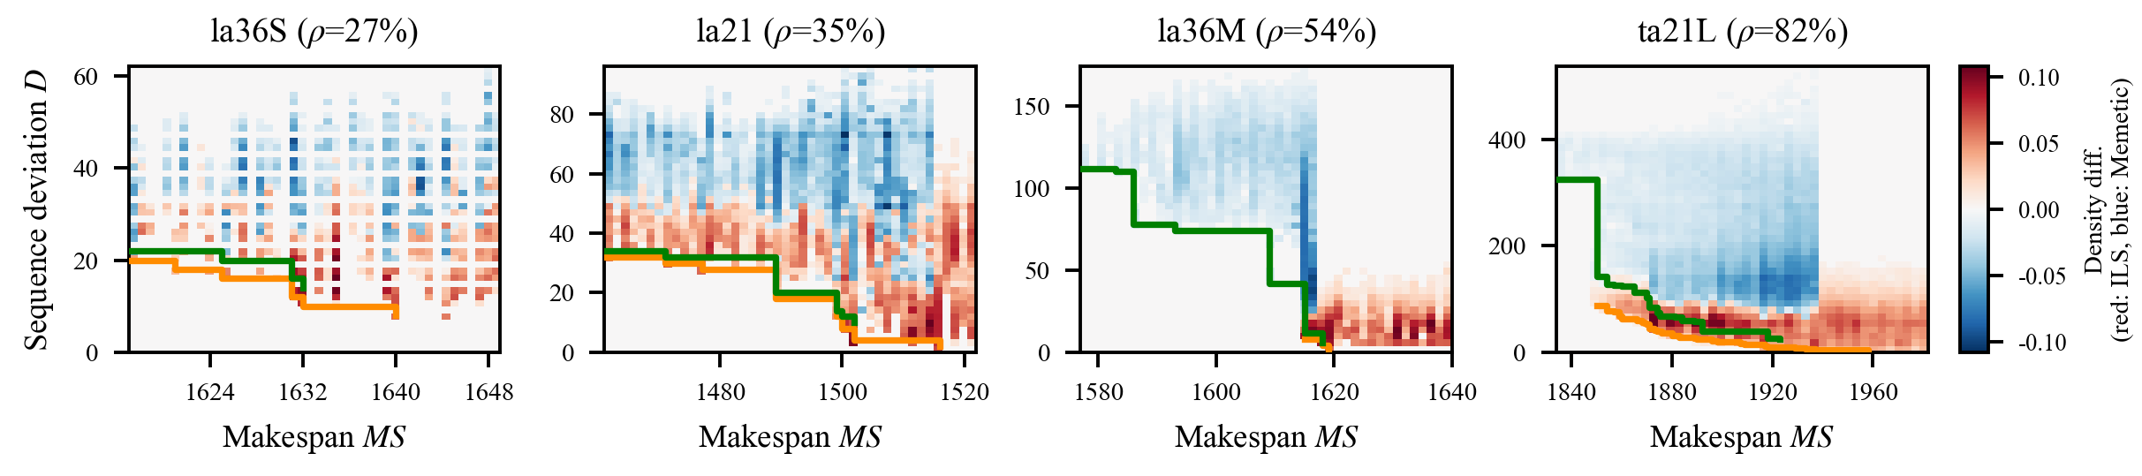
Figure 3: Structural cause of H1—normalized visit-density difference maps (red: ILS-baseline denser; blue: Memetic-LS denser; sign·√|Δ|); orange: ILS PF; green: Memetic PF. Four representative scenarios; the rest are in the repository.

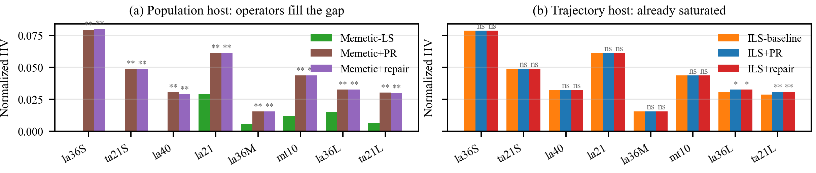
Figure 4: H2—the operators (PR, repair) (a) more than double the population's high-stability HV in every scenario, but (b) are mostly saturated on the trajectory host (high-stability HV medians vs. baseline; *p<.05 **p<.01 ***p<.001).

PR or repair—host-dependent usage. Whether PR and repair need distinguishing—on quality (union/high-stability HV) and anytime performance (AOC)—depends on the host. On ILS (small d) they are nearly indistinguishable: quality is saturated with either (significant only on la36L/ta21L), and—the mechanism fires only upon stagnation (not in the early phase log-time AOC weights heavily) with short, cheap O(d) paths—the AOC differences among ILS-baseline/+repair/+PR are non-significant in all 8 scenarios (effectively tied); the choice is immaterial. On Memetic (large d) the division is clear: PR is slightly better in quality, while repair beats PR in AOC in all 8 scenarios (δ up to +1.00)—PR traverses the long path to S_{p} before returning the best intermediate, ramping up slowly, whereas repair truncates after a few moves and updates the incumbent immediately. Hence: Memetic+PR when final quality is paramount, repair when the budget is tight and anytime performance matters.
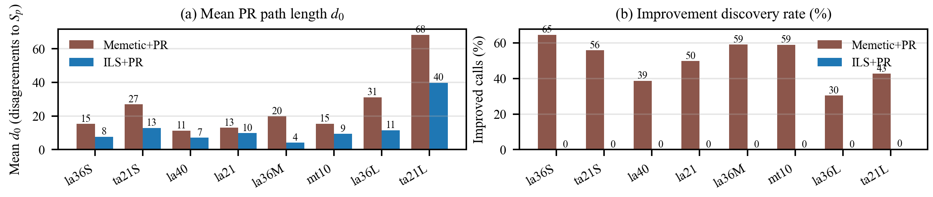
Figure 5: Mechanistic cause of H2—(a) PR path length d₀ (mean disagreements to S_{p}) and (b) improvement discovery rate (share of calls finding a solution better than the initiating one). Memetic: long paths, many improvements; ILS: short paths, almost none.

4.4 Overall Scoreboard and Integration of Results
We survey the structures established by H1 and H2 on the overall scoreboard of 7 methods × 8 scenarios × 3 metrics (Figure 6), corroborating the complementary structure announced at the outset: the best method switches with the metric—the reshuffling of green (best) cells across the metrics is the visual evidence. Friedman average ranks separate the methods clearly on all three metrics, with medium-to-large cross-scenario rank consistency (Kendall's W=0.59/0.81/0.63, p<0.001; per Section 3.4, an exploratory summary given the correlated scenarios).
Reading the metrics. Reading the green (best) distribution metric by metric makes the complementary structure concrete (parenthetical figures are Friedman average ranks, lower is better). On union HV (quality), the operator-equipped populations form the top group (Memetic+PR 2.0, Memetic+repair 2.5), the three ILS variants and the plain Memetic-LS sit in the middle (3.6–4.8), and only GA trails (6.9); the method that tied ILS in Section 4.2 was the plain population (Memetic-LS), and the mechanism-equipped Memetic+PR rises above it to lead—robust to leave-one-out (unchanged whichever scenario is removed), so the narrow margin is not driven by any single scenario. On high-stability HV (primary), the ILS family and the operator-equipped Memetic cluster at the top (2.6–3.4), while only the operator-less populations collapse with ARPD ≈ 70–78%, failing to reach the vicinity of S_{p} (GA 6.4, Memetic-LS 6.6)—exactly what H1 (the trajectory fills it natively) and H2 (the operators complement the population's coarseness so it catches up) predict. On AOC (anytime), the three ILS variants lead (2.5–2.8), the plain Memetic-LS and Memetic+repair are in the middle (3.5, 4.0), and the slow-warming Memetic+PR and GA trail (5.6, 7.0). The best method changes with the evaluation axis (Memetic+PR for overall quality; the ILS family for stability emphasis and speed), and the two structures complement the different demands of rescheduling.
[Exploratory observation] Union-HV winner and the rescheduling ratio. The union HV winner corresponds to ρ, splitting at around 50%: ILS below, Memetic at mid-to-high (on the same la36 ladder 27/54/73%, ILS → Memetic → Memetic); only ρ, which incorporates the fixed-skeleton proportion, captures this split—the number of movable operations or the problem size does not. Our reading: the stability term makes S_{p} (D=0) an attractor. At small ρ the fixed skeleton dominates the solution, so no good local optimum far from S_{p} can arise however the movable part is reordered; good solutions are thus confined to the S_{p} neighborhood and ILS's neighborhood filling suffices; as ρ grows and the efficiency extreme recedes, the single trajectory struggles to escape the basin while Memetic, retaining crossover-scattered individuals, reaches it (isomorphic to H1)—ρ thus proxies the difficulty of escaping the attractor. However, ta21L (82%) is an exception (≈tie, p=0.053), and confounding by S_{p} quality and dependence on the permutation-deviation representation remain, so this stays exploratory; the primary high-stability dominance and mechanism asymmetry are established independently by direct tests on all 8 scenarios.
Divergent vs. convergent. ILS (spreading outward from S_{p}) and Memetic+PR (pulling a scattered population toward S_{p}) reach similar final Pareto quality from opposite directions, but ILS holds a good incumbent early while Memetic+PR ramps up after a warm-up (overtaking later when headroom exists); AOC aggregates this crossover on a log-time axis, reflecting early performance—hence the ILS family's clear lead there.

5. CONCLUSIONS
Targeting stability-aware JSSP rescheduling, this study compared trajectory vs. population search structures, proposed the stability-inducing operators (PR, repair), and built a multi-perspective evaluation methodology, verified over 8 scenarios × 7 methods × n=10. The claims are threefold.
1. The trajectory-based method (ILS) efficiently fills the high-stability region (H1). Comparable to the population in overall quality, it wins in all 8 scenarios with complete separation over the counterpart sharing the identical N5 in the primary high-stability region (p=0.001, |δ|=1.0; 2–4.5× in five scenarios, the population reaching the region not at all in the other three) and leads in anytime performance in 6/8—derived from the search structure, not the presence of local search.
2. The effects of PR and repair appear asymmetrically depending on the host structure (H2). They more than double the population's high-stability HV, lifting it to the ILS level, whereas the trajectory, having already filled the neighborhood, is mostly saturated. The asymmetry is not fixed, however: at extremely high rescheduling ratios where ILS's filling cannot keep up (ta21L, 82%), a significant mechanism effect remains even on the trajectory.
3. Complementary structure of trajectory and population. The best method changes with the metric, and the two structures complement the different demands of rescheduling. The practical prescription is clear—Memetic+PR when final quality is paramount, Memetic+repair when the budget is tight and anytime performance matters, the ILS family when stability and responsiveness are the priority (Section 4.3).
Implementing the stability lever as an "operator" made the same mechanism portable to both hosts, and isolating its host-dependent asymmetry under control is the central contribution of this study.
Limitations. (i) Results rest on n=10 (the saturated main conclusions are robust; borderline cases are another matter). (ii) The rescheduling-ratio–union-HV-winner correspondence involves confounding by S_{p} quality and representation dependence, and stays exploratory. (iii) Stability is measured only by permutation deviation; validity under start-time (temporal) deviation is unverified (Section 3.1).
Future work. Re-verification under start-time deviation (temporal stability); extension to disruptions altering machine assignments (e.g., breakdowns); integrating the scope lever with the operator lever (the inducing operators within the affected range); comparison with an S_{p}-biased crossover as an alternative population-side prescription (a direct test of the crossover-destructiveness reading of H1); and re-verification with Pareto-native methods (e.g., NSGA-II).
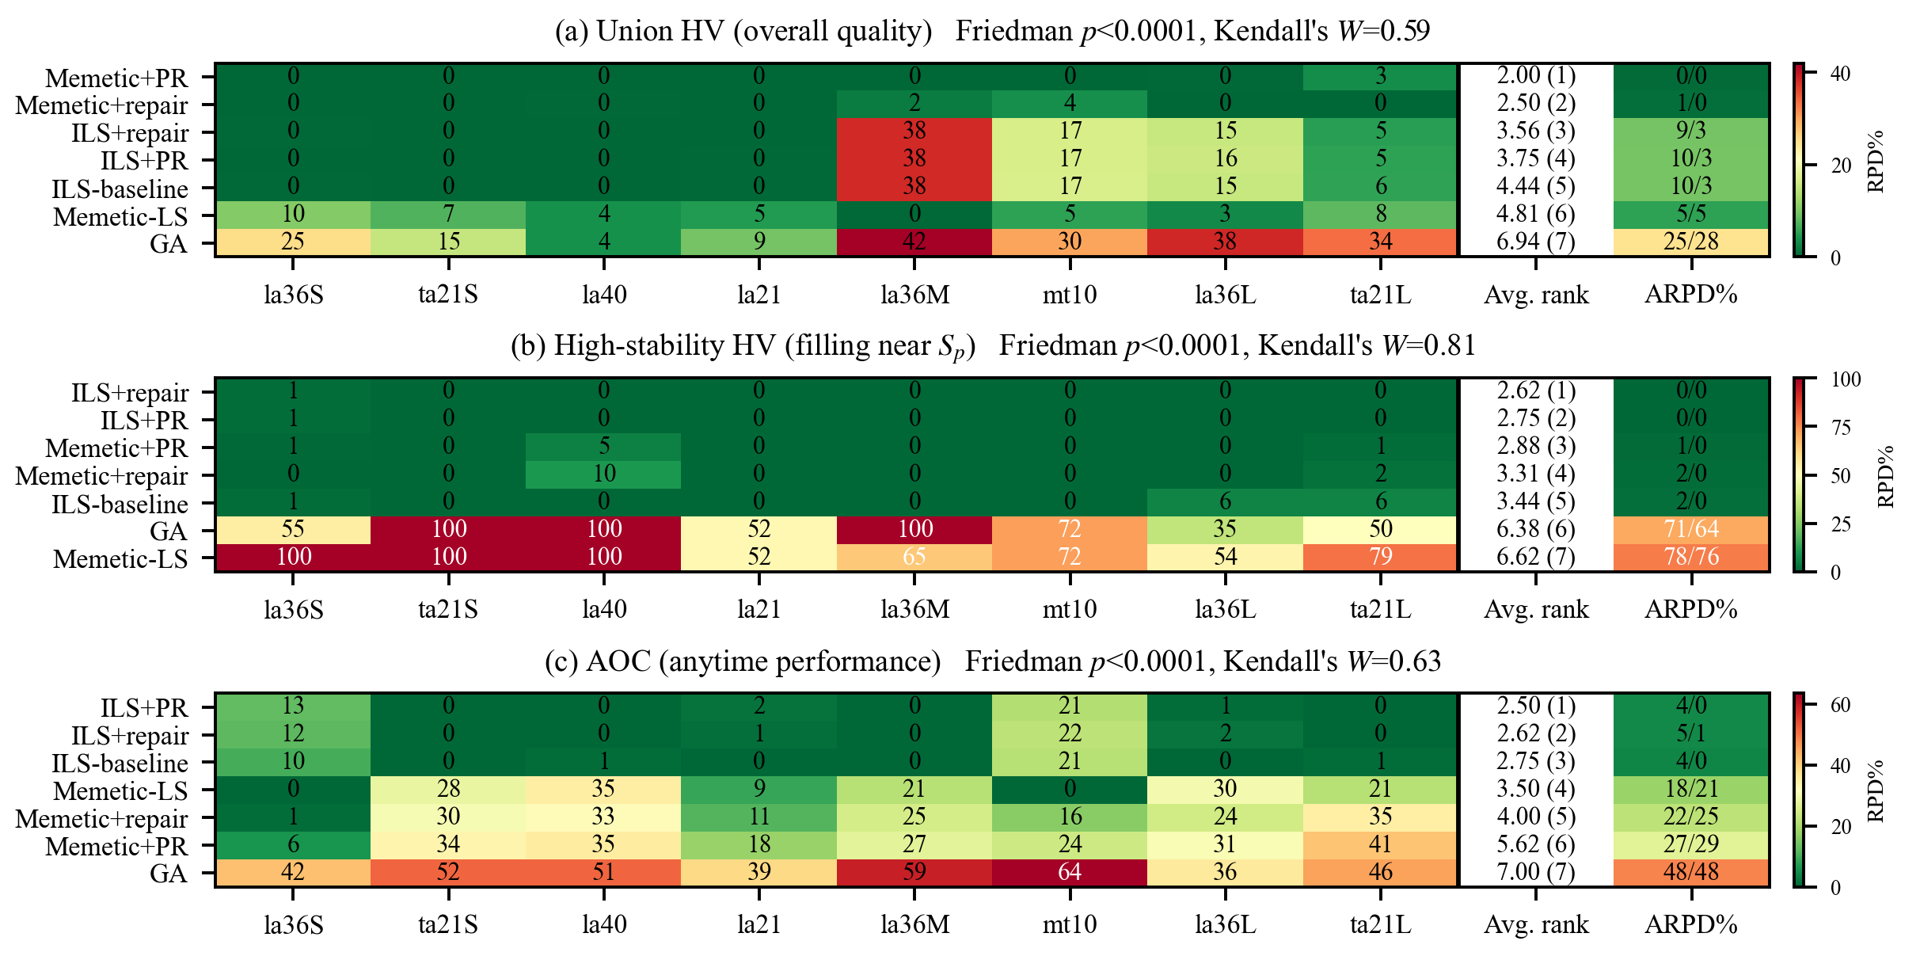
Figure 6: Overall scoreboard—(a) union HV, (b) high-stability HV, (c) AOC over 7 methods × 8 scenarios. Cells: RPD% relative to the best of each scenario (green = best, 0%); each panel sorted by its own Friedman average rank.

REFERENCES
Abumaizar, R. J. and Svestka, J. A. (1997) Rescheduling job shops under random disruptions. International Journal of Production Research, 35, 2065-2082.
Bean, J. C., Birge, J. R., Mittenthal, J., and Noon, C. E. (1991) Matchup scheduling with multiple resources, release dates and disruptions. Operations Research, 39, 470-483.
Bierwirth, C. (1995) A generalized permutation approach to job shop scheduling with genetic algorithms. OR Spektrum, 17, 87-92.
Bierwirth, C., Mattfeld, D. C., and Kopfer, H. (1996) On permutation representations for scheduling problems. Parallel Problem Solving from Nature—PPSN IV, LNCS 1141, Springer, 310-318.
Blum, C. and Roli, A. (2003) Metaheuristics in combinatorial optimization: overview and conceptual comparison. ACM Computing Surveys, 35, 268-308.
Giffler, B. and Thompson, G. L. (1960) Algorithms for solving production-scheduling problems. Operations Research, 8, 487-503.
Glover, F., Laguna, M., and Martí, R. (2000) Fundamentals of scatter search and path relinking. Control and Cybernetics, 29, 653-684.
Ishibuchi, H., Pang, L. M., and Shang, K. (2020) A new framework of evolutionary multi-objective algorithms with an unbounded external archive. Proceedings of the 24th European Conference on Artificial Intelligence (ECAI 2020), IOS Press, 283-290.
Katragjini, K., Vallada, E., and Ruiz, R. (2013) Flow shop rescheduling under different types of disruption. International Journal of Production Research, 51, 780-797.
López-Ibáñez, M. and Stützle, T. (2014) Automatically improving the anytime behaviour of optimisation algorithms. European Journal of Operational Research, 235, 569-582.
Lourenço, H. R., Martin, O. C., and Stützle, T. (2019) Iterated local search: framework and applications. In Gendreau, M. and Potvin, J.-Y. (eds.), Handbook of Metaheuristics, 3rd ed., Springer, 129-168.
Marler, R. T. and Arora, J. S. (2010) The weighted sum method for multi-objective optimization: new insights. Structural and Multidisciplinary Optimization, 41, 853-862.
Mladenović, N. and Hansen, P. (1997) Variable neighborhood search. Computers & Operations Research, 24, 1097-1100.
Neri, F. and Cotta, C. (2012) Memetic algorithms and memetic computing optimization: A literature review. Swarm and Evolutionary Computation, 2, 1-14.
Nowicki, E. and Smutnicki, C. (1996) A fast taboo search algorithm for the job shop problem. Management Science, 42, 797-813.
Ouelhadj, D. and Petrovic, S. (2009) A survey of dynamic scheduling in manufacturing systems. Journal of Scheduling, 12, 417-431.
Peng, B., Lü, Z., and Cheng, T. C. E. (2015) A tabu search/path relinking algorithm to solve the job shop scheduling problem. Computers & Operations Research, 53, 154-164.
Rangsaritratsamee, R., Ferrell Jr, W. G., and Kurz, M. B. (2004) Dynamic rescheduling that simultaneously considers efficiency and stability. Computers & Industrial Engineering, 46, 1-15.
Sörensen, K. (2015) Metaheuristics—the metaphor exposed. International Transactions in Operational Research, 22, 3-18.
Sun, R., Cheng, G., Ding, Q., and Zhao, X. (2026) Impact of optimization scope on solution quality and stability in dynamic flexible job shop rescheduling. Computers & Industrial Engineering, 215, Article 111943.
Wu, S. D., Storer, R. H., and Chang, P.-C. (1993) One-machine rescheduling heuristics with efficiency and stability as criteria. Computers & Operations Research, 20, 1-14.
Zakaria, Z. and Petrovic, S. (2012) Genetic algorithms for match-up rescheduling of the flexible manufacturing systems. Computers & Industrial Engineering, 62, 670-686.
Zhang, L., Gao, L., and Li, X. (2013) A hybrid genetic algorithm and tabu search for a multi-objective dynamic job shop scheduling problem. International Journal of Production Research, 51, 3516-3531.

