KNOWLEDGE ANALYST – RAG DOCUMENT INTELLIGENCE

1. Introduction
This project demonstrates an AI-based document analysis system using a Retrieval-Augmented Generation (RAG) approach. The system allows users to extract structured information from large documents efficiently using natural language queries.

2. Objective
The objective of this project is to analyze a large document using AI and extract:
- Key summaries
- Important risks
- Critical dates
- Main stakeholders
- Structured insights

3. Tools Used
- ChatGPT / Copilot
- PDF Document Reader
- Prompt Engineering Techniques

4. Methodology
The following steps were performed:
- A large PDF document was uploaded to the AI system.
- A strict prompt was used to ensure answers were based only on the document.
- Multiple queries were executed to extract structured information.
- Results were validated and captured as screenshots.
- Outputs were organized into categories for analysis.

5. Prompt Strategy
The system was instructed using the following rule:
- Use only the uploaded document
- Provide exact answers with references when possible
- If information is missing, respond with: “Not found in document”

6. Extracted Information
6.1 Document Summary
The document was analyzed and key information was extracted and summarized into concise points covering the main ideas and objectives.
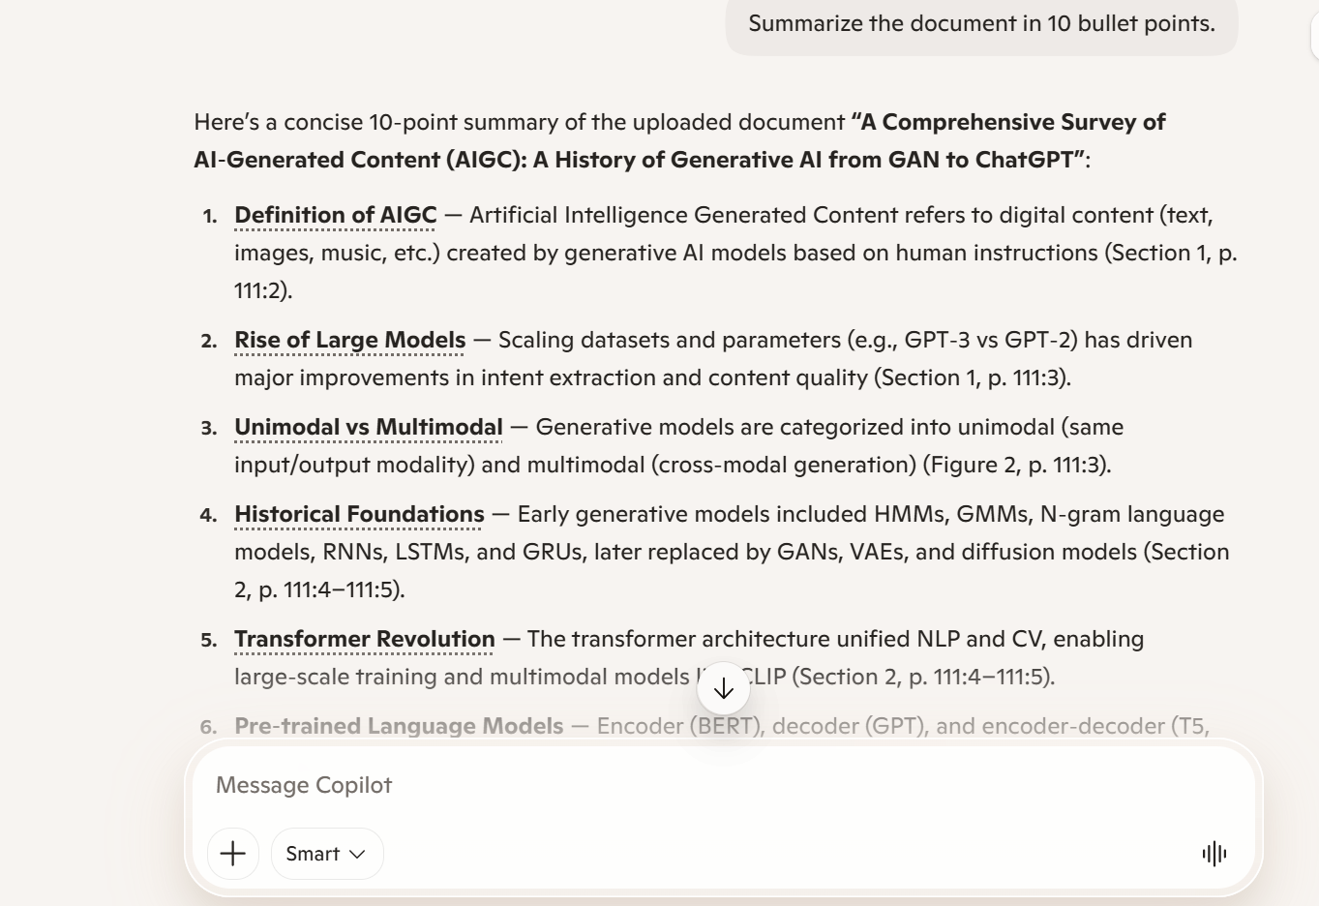
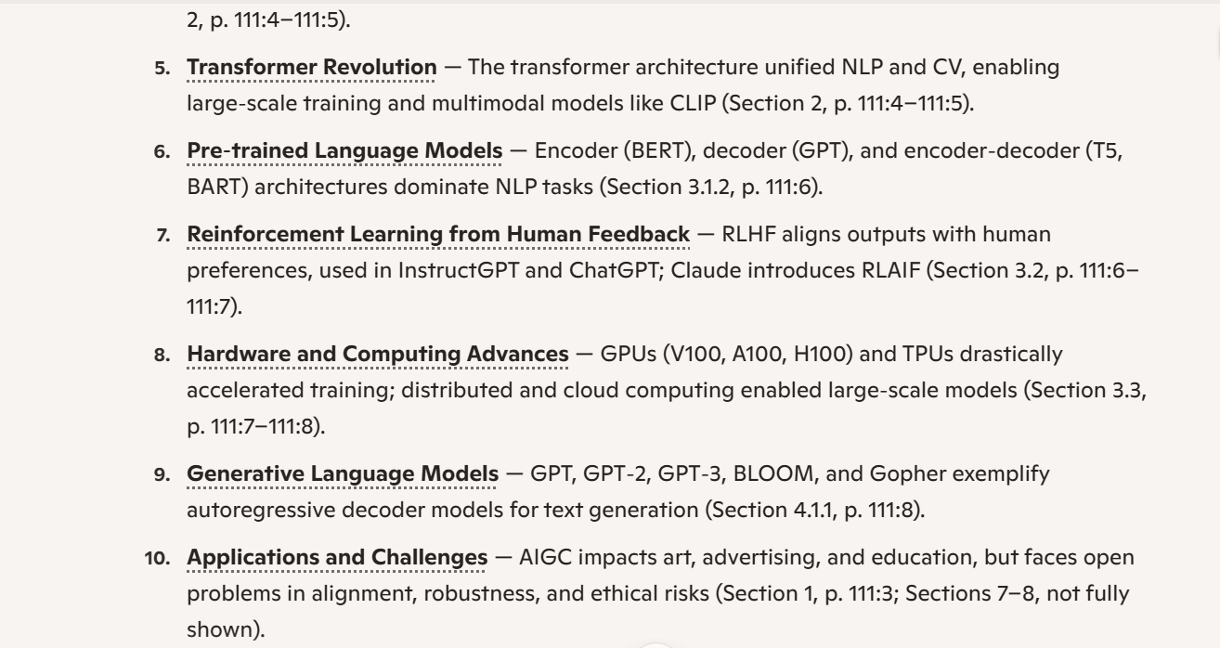

6.2 Risks Identified
The AI identified and extracted all risks mentioned in the document, including operational, financial, or technical risks. 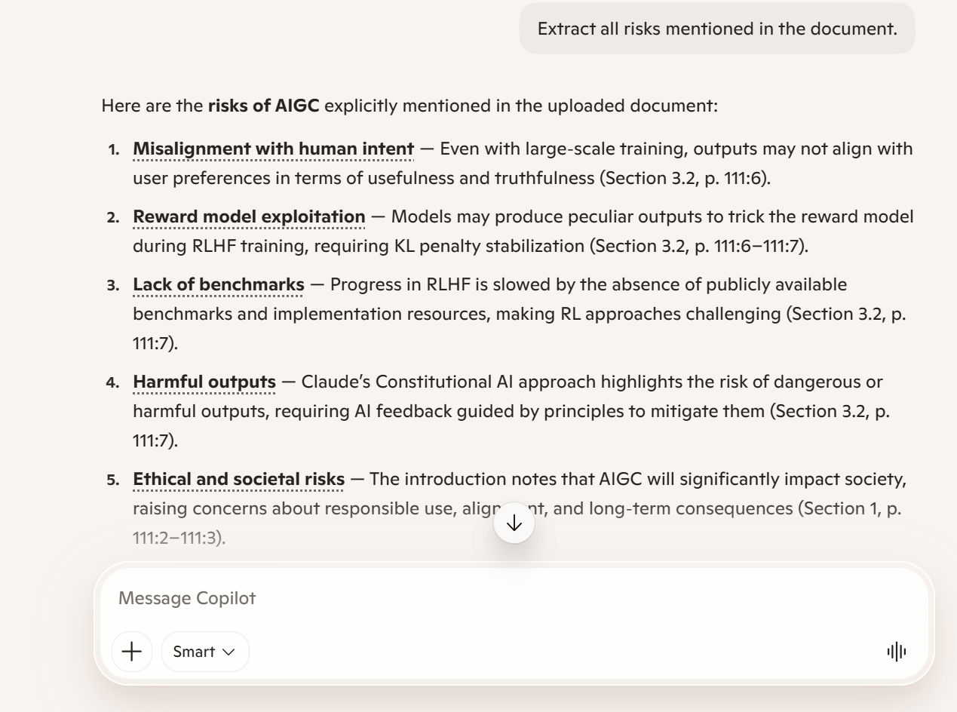
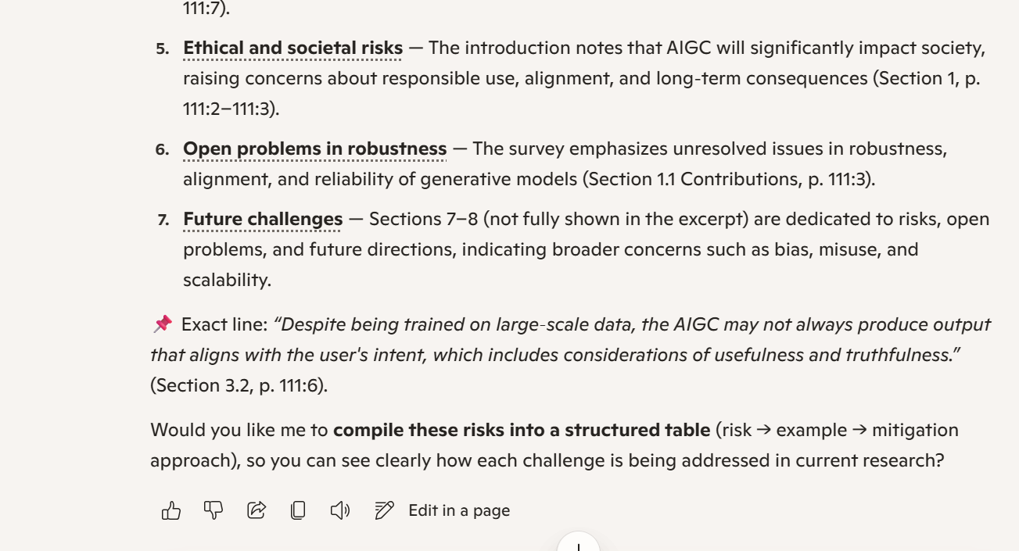

6.3 Important Dates
All relevant dates mentioned in the document were extracted and listed in chronological order.
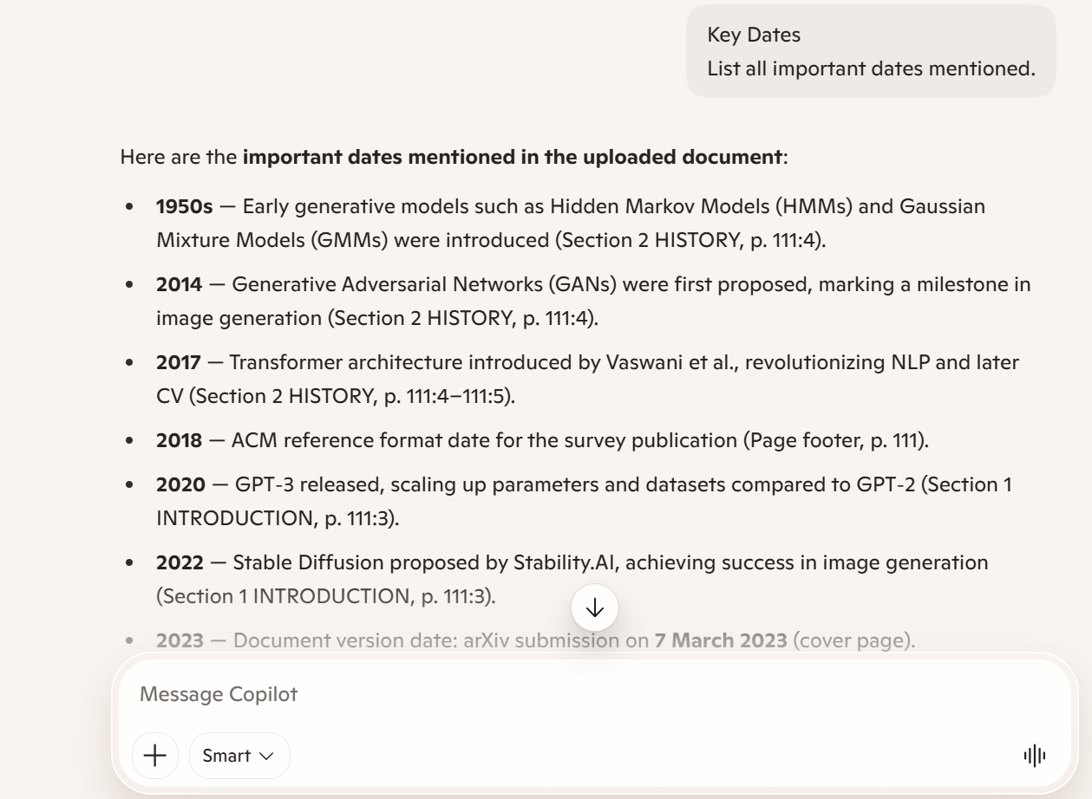
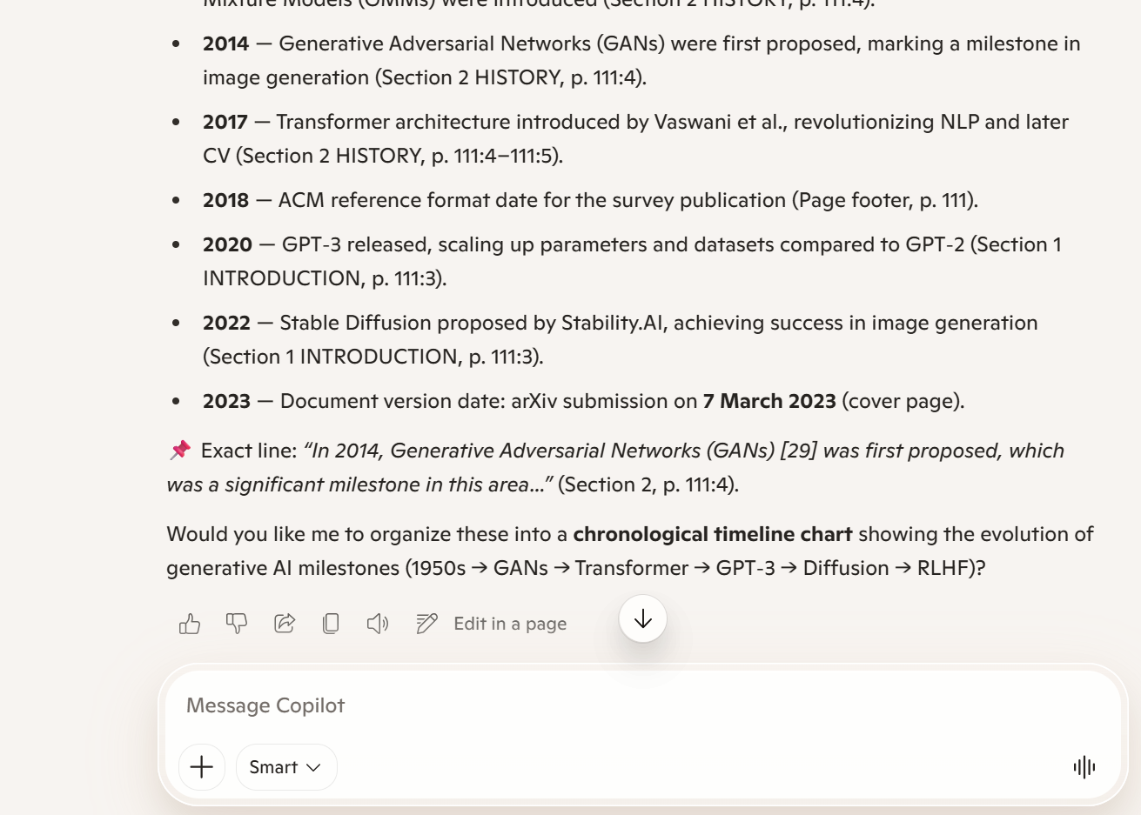

6.4 Stakeholders The main stakeholders identified in the document include individuals, organizations, or groups involved in the context of the document.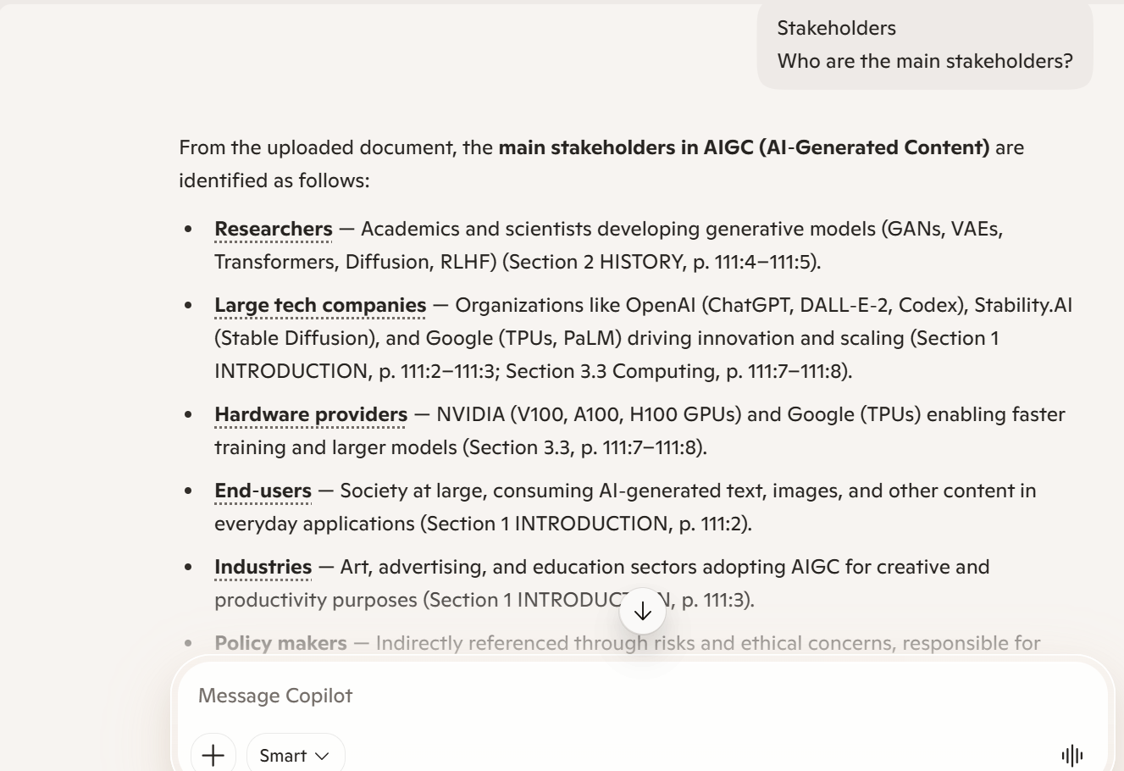
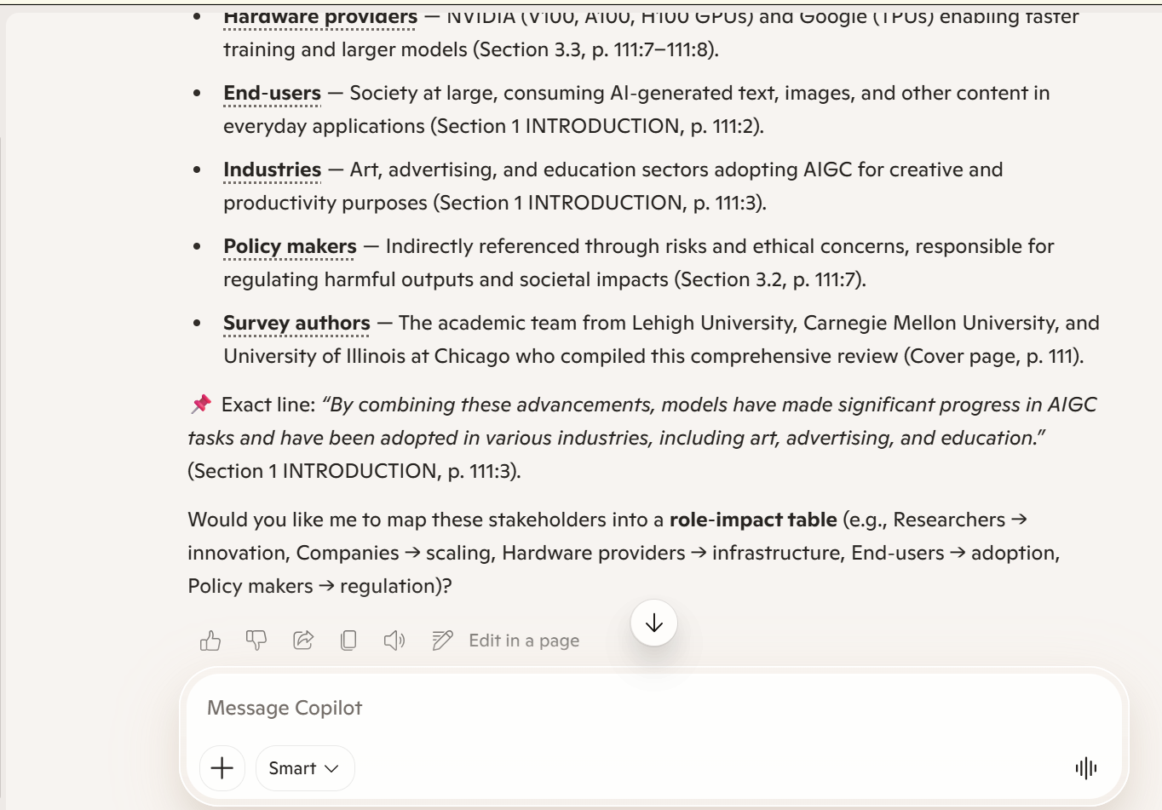

6.5 Structured Summary Table: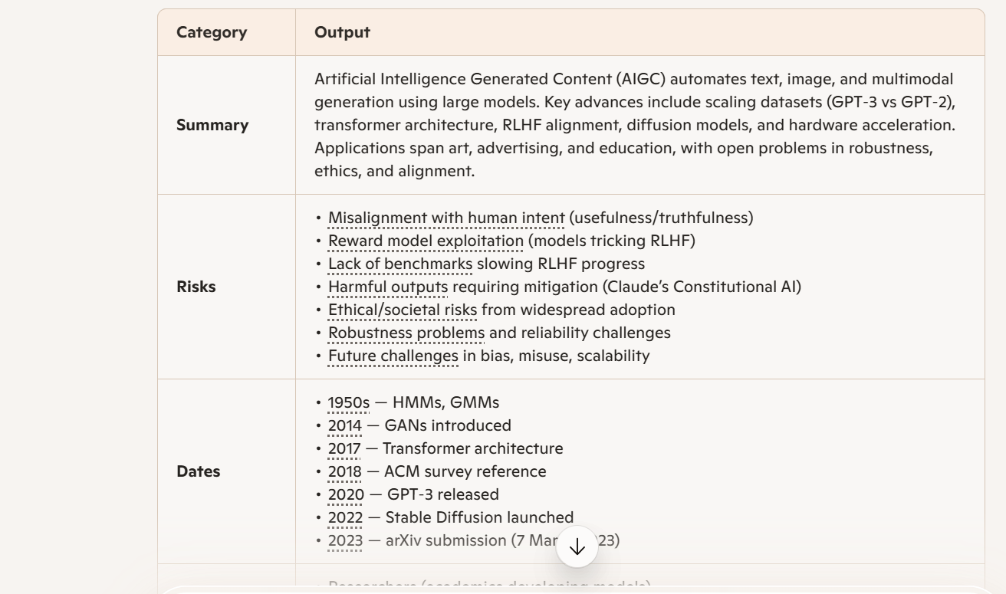
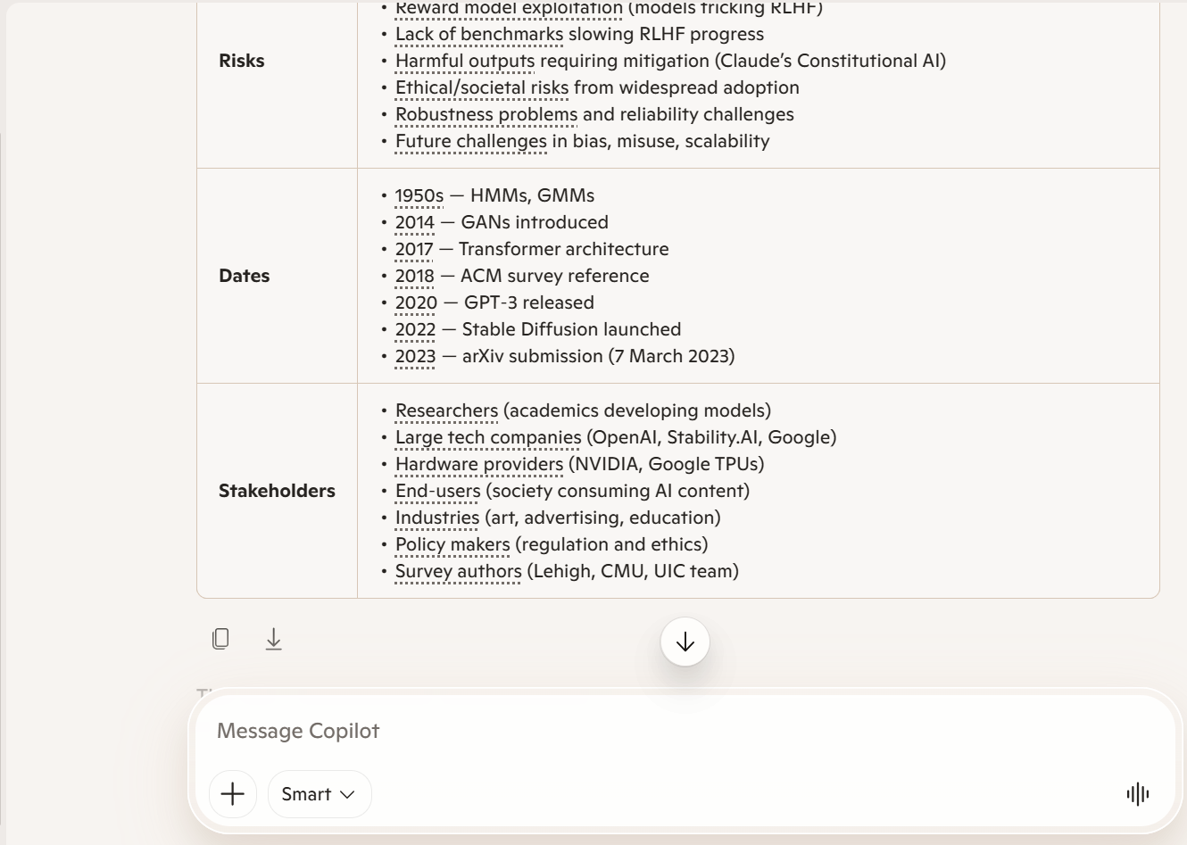

7. Results
The AI system successfully processed the document and extracted structured information with high accuracy. The use of prompt constraints ensured that all answers were grounded in the provided text.

8. Conclusion
This project demonstrates the effectiveness of AI in document intelligence tasks. By using a RAG-style prompting approach, large documents can be analyzed efficiently, enabling fast extraction of key insights without manual reading.

9. Evidence (Screenshots)
- Summary output
- Risks output
- Dates output
- Stakeholders output
- Structured Summary Table

