Video-Based Human Emotion Recognition
Using CNN-Transformer Temporal Modeling on RAVDESS
Mila Ranocha Julia Yu Christina Yang Jaysen Kang
University of Virginia
Abstract
We propose a video-based emotion recognition system that identifies facial expressions and classifies them into eight classes of human emotions using temporal modeling. Our system leverages a frozen ResNet-18 backbone for frame-level spatial feature extraction and a Transformer encoder for temporal feature extraction from sampled video frames. Our system is evaluated on the RAVDESS dataset using an actor-disjoint evaluation protocol to ensure that the system generalizes well to unseen actors. Our best model attains a test accuracy of 31.25% on 8 classes of emotions using an actor-disjoint evaluation protocol. Our system has several limitations, including a high degree of confusion in identifying similar emotions and a high gender bias in recognition accuracy.

1. Introduction
Human emotion recognition from visual data is a fundamental problem in computer vision that has a wide range of applications in human-computer interaction systems, mental health monitoring systems, education technology systems, and adaptive user interfaces. While there has been significant progress in automatic emotion recognition systems for still images, there has been relatively little research on video-based emotion recognition systems that leverage the temporal features of videos for more accurate human emotion recognition. Video-based systems can leverage the subtle movements of facial muscles, micro-expressions, and other movements for more accurate human emotion recognition.
This project proposes a video-based system for emotion recognition that can identify facial expressions and classify them into eight distinct classes of human emotions: neutral, calm, happy, sad, angry, fearful, disgust, and surprised.
Unlike other systems that rely on static image processing and examine each frame independently, this project attempts to use a combination of both spatial and temporal features to identify emotions.
The proposed system has four stages: (1) Face detection using MTCNN for each frame in the video; (2) Spatial feature extraction using a frozen ResNet-18 CNN; (3) Temporal feature extraction using a Transformer encoder; and (4) Emotion classification using a fully connected output layer.
For evaluation, this project has used the RAVDESS dataset [1] and a disjoint actor set for testing the system’s ability to generalize and perform well on unseen data.
2. Background & Related Work
One study offers a framework for emotion recognition through infrared video in Human-Computer Interaction environments. The authors employ a Faster R-CNN model to detect facial regions of interest and track them through frames by utilizing a Multiple Instance Learning approach. The mean intensity values from the facial regions are then converted to multivariate time-series data and classified as emotional states through Dynamic Time Warping. The authors also employed Kalman filtering to improve the quality of the signals. The main advantage of this approach, unlike most RGB-based methods, is that it utilizes infrared video to detect physiological signals such as changes in skin temperature to recognize emotions. The study emphasizes the significance of incorporating time modeling in emotion recognition, similar to video-based methods that analyze changes in frames. The drawback of this approach is that it utilizes handcrafted features, which may be limited compared to the power of contemporary models in time modeling (Nayak).
Another significant work is centered on facial expression recognition from video sequences, specifically for Human-Computer Interaction. The authors have developed a system that extracts frames from video, undergoes various preprocessing steps, and then tracks facial feature points using model-based approaches like Active Shape Models. Emotion detection is carried out by identifying Facial Action Units (AUs), which are unique muscle movements, and then establishing relationships between AUs using Dynamic Bayesian Networks. The key advantage is that facial movements are analyzed across video frames, as opposed to static images, which is more relevant to current video-based emotion detection techniques. The work emphasizes the need to model relationships between facial components, as opposed to individual facial expressions, and is more relevant to current video-based emotion detection techniques. However, the use of handcrafted features and traditional models might not be as effective as recent deep learning techniques employing CNNs and temporal networks (KalaiSelvi).
Another work is centered on emotion detection using computer vision techniques for a dynamic music recommendation system. The authors have employed various techniques like image processing and machine learning to recognize facial emotions from video captured using a webcam. They have employed OpenCV to develop the system and then recommended music according to the emotions identified. The work shows the practical application of emotion detection and its importance in various systems. However, the work is more centered on static image analysis rather than video analysis, and hence might not be as effective in identifying emotions from video sequences (ShanthaShalini).
A highly relevant approach to video-based emotion recognition has been proposed in the form of a hybrid CNN-RNN model that has been specifically designed to capture the spatio-temporal dynamics of facial expressions in a video. In this approach, the authors have employed a convolutional neural network to capture the spatial features in individual frames of a video, and then employed a recurrent neural network to capture the temporal features. This has allowed them to make a prediction of the emotion in the video. In this work, the authors have also explored the use of audio features in the form of fusion with video features. In their work, the authors have shown the significance of temporal dependencies in improving the accuracy of emotion recognition in videos (EbrahimiKahou).
3. Methods
3.1 Overview
Our approach takes a variable-length emotion video as input and applies a four-stage pipeline: face detection/alignment, spatial feature extraction, temporal modeling via self-attention, and classification. Our key insight lies in recognizing that emotion evolution in a video has a natural progression of onset, peak, and offset, which cannot be captured by a purely spatial model. By utilizing a transformer encoder on spatial features, we enable our model to focus on frames containing more emotional information and capture pairwise relationships between frames at any two time indices.
3.2 Face Detection/Preprocessing
For a given video, we uniformly sample 15 frames to obtain a fixed-length representation. Then, we apply MTCNN face detection with a margin of 40 pixels to each frame. This results in a cropped and resized face image of size 224x224. If MTCNN fails to detect a face in a specific frame, we use the nearest detected face. Finally, we store the preprocessed face sequence as a NumPy array of shape (15, 224, 224, 3) for efficient loading during training.
3.3 Architecture
Our architecture consists of four components stacked in sequence: a Frozen ResNet-18 Feature Extractor, a Face Detection/Preprocessing module, a Temporal Modeling component, and a Classification Head.
Frozen ResNet-18 Feature Extractor: Each frame of a video is fed independently into a ResNet-18 network pretrained on ImageNet. All weights are frozen. This results in a 512-dimensional feature vector per frame, which gives us a tensor of shape (B, 15, 512) given a batch of B videos, each containing 15 frames. This network is frozen since our training set contains only 1,000 videos, which is insufficient to fine-tune a CNN without overfitting to actor identities instead of emotions.
Linear Projection with Positional Encoding. The frame features are then projected from a 512-dimensional space to a 256-dimensional space by a learned linear transformation. This is followed by a sinusoidal positional encoding to inject temporal order information.
Transformer Encoder. A 2-layer Transformer encoder with 4 attention heads processes the sequence of frame features. The self-attention mechanism enables all frames to attend to all frames, helping to better capture the onset and apex of expressions. This outperforms the sequential processing in the LSTM. We also apply dropout regularization with a dropout rate of 0.4.
Attention Pooling and Classification. We also employ a learned attention pooling approach to compute a weighted sum over all frames, unlike naive mean or last frame pooling. This enables the model to better focus on frames that are most emotionally salient. The learned pooling reduces to a 256-dimensional vector, and then a fully connected classification layer to output logits for the 8 classes of emotions.
3.4 Design Rationale
We select the Transformer over an LSTM approach for temporal modeling due to empirical performance. The self-attention mechanism over all pairs of frames to compute the output at a frame better captures onset and apex in expressions. The frozen CNN backbone prevents overfitting to the actor’s identities given limited training data. The learned attention pooling weights the frames to be more emotionally salient. This is important as the frames containing emotional expressions are usually concentrated in a small segment of the video.
3.5 Training Details
The training is performed using the AdamW optimizer with a learning rate set to 5e-4, Cosine Annealing Warm Restarts as the scheduler, and class weights to balance the classes due to minor class imbalances. Data augmentation techniques involve random horizontal flip, rotation (±15°), color jitter, affine transform, and random erasing. We apply Mixup data augmentation with α=0.4 and label smoothing with 0.1 to further augment the training data. The training is performed for a maximum of 40 epochs with early stopping (patience=10) and gradient clipping.
4. Experiments
4.1 Dataset
The experiments are performed using the RAVDESS (Ryerson Audio-Visual Database of Emotional Speech and Song) dataset [1], consisting of 7,356 videos from 24 professional actors, with equal split between males and females (12 actors per gender). Every video shows one emotional utterance corresponding to one of eight emotions: neutral, calm, happy, sad, angry, fearful, disgust, and surprised. We split the dataset such that actors 1-18 are for training, 19-22 for validation, and 23-24 for testing. Thus, the model is forced to recognize emotions from novel actors and not memorize them.
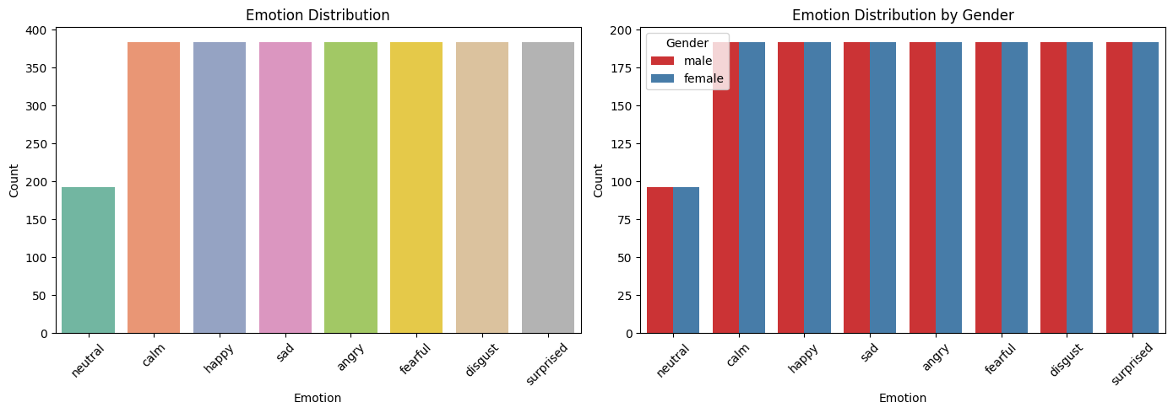
Figure 1. Emotion distribution in the RAVDESS dataset. All emotions except “neutral” are balanced at ~384. Right: Distribution across gender is equal, i.e., males and females are both represented equally.
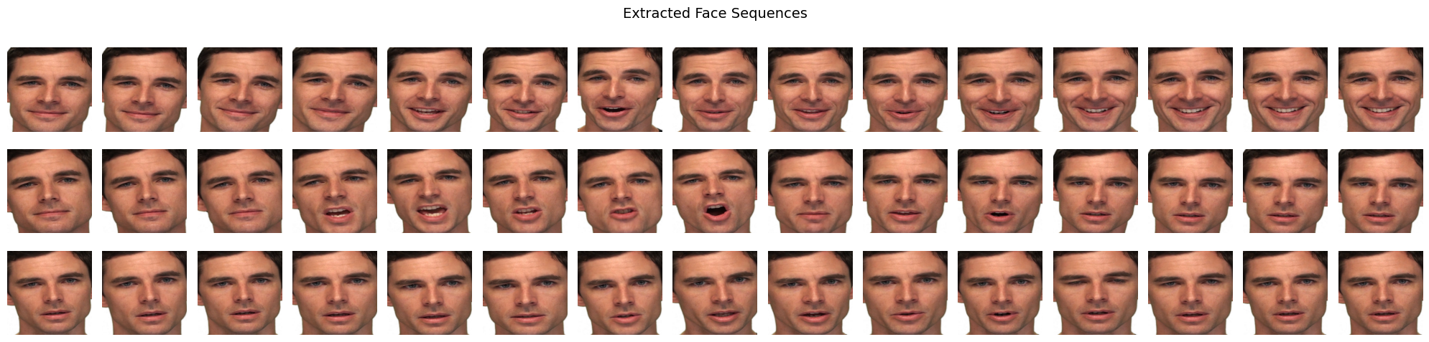
Figure 2. Extracted and aligned face sequences from the videos in the RAVDESS dataset after applying MTCNN preprocessing. Every row shows the first 15 frames from one video, sampled at equal intervals.
4.2 Experimental Questions
Our experiments are designed to investigate the following aspects: (1) Is there an improvement in the recognition performance by employing the temporal modeling approach over video frames compared to the baseline approach? (2) How does the choice between the two architectures, LSTM and Transformer, affect performance? (3) Does fine-tuning the CNN backbone improve or degrade the performance under the actor disjoint setting? (4) Which are the most challenging emotion classes in recognition performance? Are there any confusions between classes? (5) Is there any gender bias in the recognition performance?
4.3 Architecture Evolution
Experiment 1 (Baseline): We began with a simple baseline approach by employing a frozen ResNet-18 backbone and a 1-layer LSTM for the temporal modeling approach.
Experiment 2 (Fine-tuned CNN + BiLSTM): In an effort to improve the performance by fine-tuning the CNN backbone and employing a better approach for the temporal modeling, we unfroze layers 3 and 4 of the ResNet-18 backbone and replaced the LSTM with a 2-layer Bidirectional LSTM. We employed discriminative learning rates for the unfrozen layers. Unfortunately, the unfrozen approach led to overfitting to the actor’s identity.
Experiment 3 (Final Model): We reverted to the simple baseline approach by employing a frozen ResNet-18 backbone and replaced the LSTM with a 2-layer Transformer. We employed 4 attention heads in the Transformer. We also employed the Mixup data augmentation approach.
4.4 Results
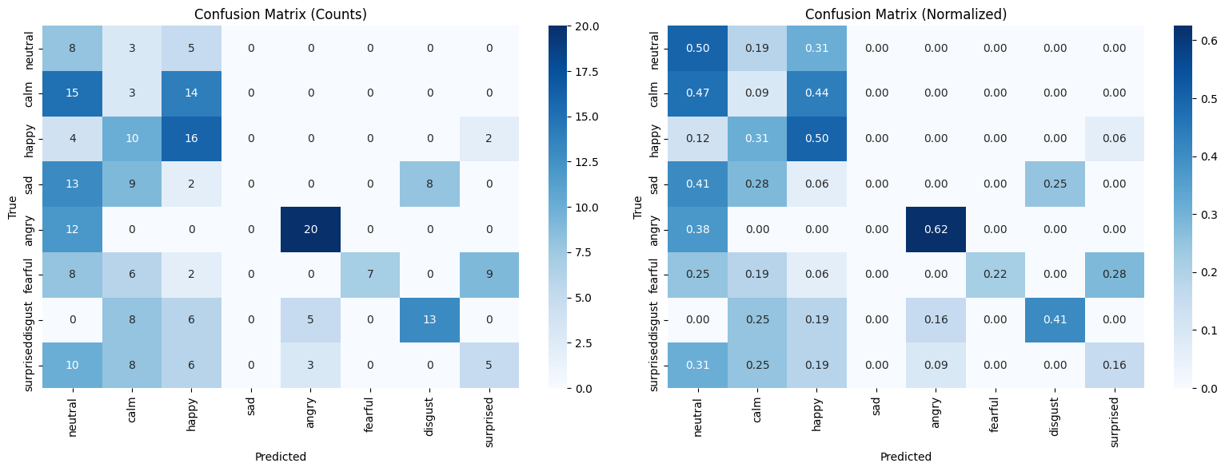
Figure 3. Confusion matrices (counts and normalized) for the CNN-Transformer model on the test set. Notable confusion between perceptually similar emotions (calm/neutral, fear/surprise).
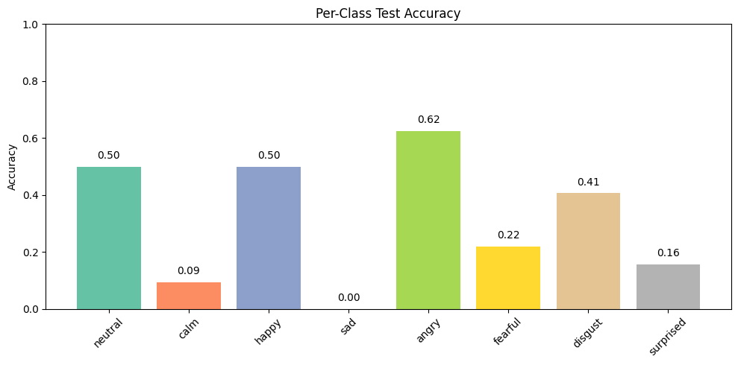
Figure 4. Per-class test accuracy. Angry (62%) and happy/neutral (50%) are best recognized; sad (0%) and calm (9%) are most challenging.
We show the confusion matrices for the CNN-Transformer model in Figure 3. We also show the normalized version of the same. We can clearly see confusions between similar emotions such as calm and neutral, and also between fear and surprise. In Figure 4, we show the per-class accuracy for the CNN-Transformer model. The highest accuracy is for the angry and happy/neutral classes. The sad and calm classes are the most challenging. The happy and neutral classes are lumped together as the happy/neutral class. The accuracy for the happy/neutral class is 50%, whereas the accuracy for the angry class is 62%. The accuracy for the sad class is 0%, and the accuracy for the calm class is 9%.
The model attains an average accuracy of 31.25% on the test set for the 8-class emotion recognition. The performance on individual classes shows significant variance. The model performs best on angry (62%), happy (50%), and neutral (50%) emotions, while it performs poorest on sad (0%), calm (9%), and surprised (16%) emotions. The confusion matrices show that there are consistent confusions between pairs of emotions that are similar in perception, such as calm and neutral, and fear and surprise, which are similar in facial configuration.
4.5 Gender Bias Analysis
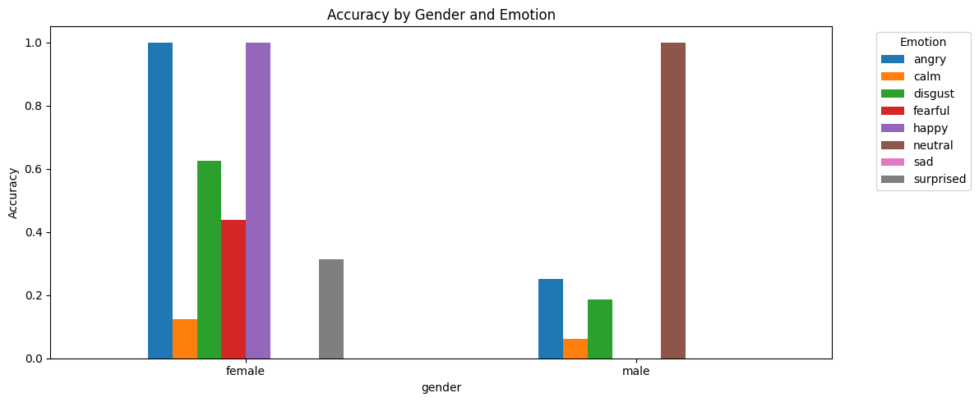
Figure 5. Accuracy broken down by gender and emotion. It is clear that there is a strong gender bias in this model, where it performs much better on female actors for most emotion classes.
From this analysis, it is clear that there is a strong disparity in accuracy between male and female actors, where the model performs much better on female actors for most emotion classes, such as angry, where accuracy is 100% for females and 25% for males, and happy, where accuracy is 100% for females and 0% for males. On the other hand, male actors have a higher accuracy in neutral expressions, where accuracy is 100% for males and 0% for females.
4.6 Qualitative Analysis
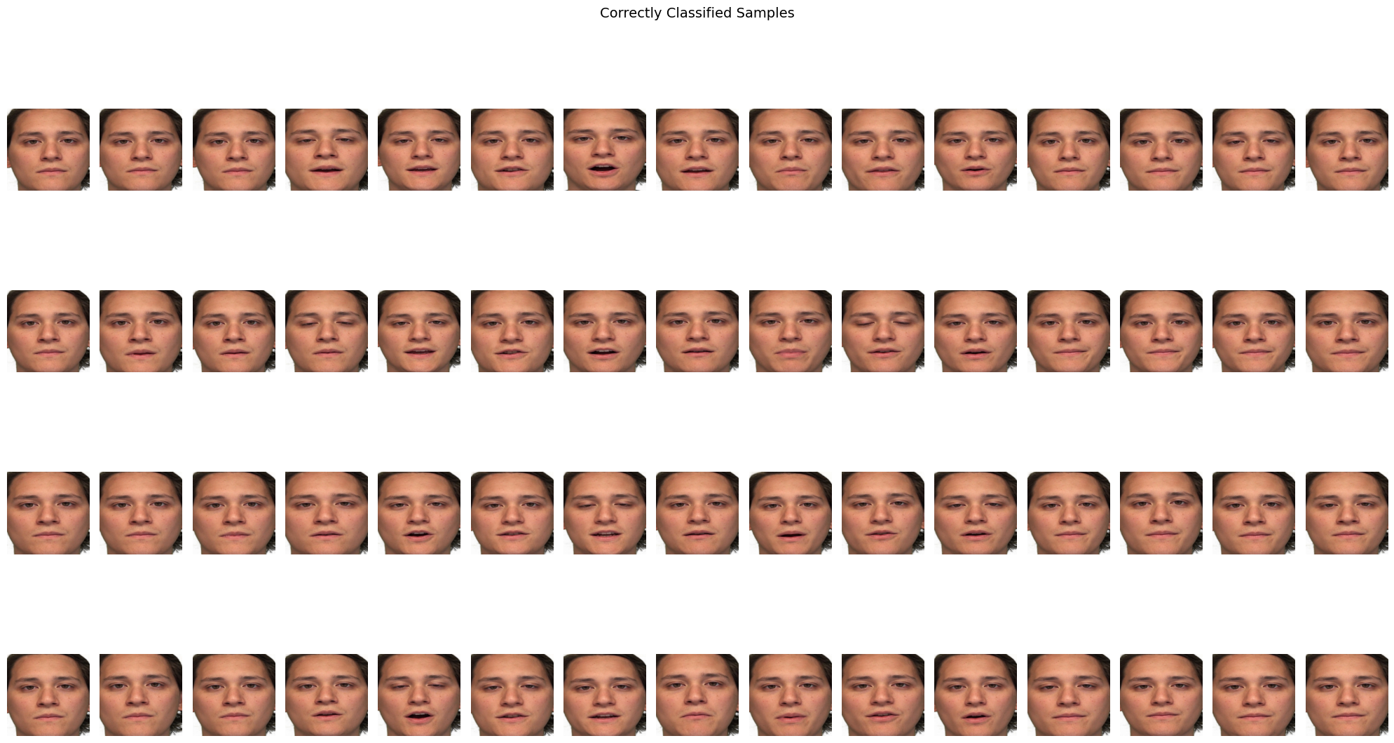
Figure 6. Correctly classified face sequences from the test set. Each row of this figure shows a video that was correctly classified by the model, with a clear progression of facial expressions over time.
From this qualitative analysis of correctly classified samples, it is clear that this model performs better on samples where facial expressions are clearly articulated, with a clear progression of facial expressions over time. This model performs poorly in samples where facial expressions are very subtle, with a very small difference between emotion classes, such as between calm and neutral, or where expressions are very weak.
5. Conclusion
We implemented a video-based emotion recognition system based on a combination of frozen ResNet-18 spatial features and a Transformer encoder. Our experimental results on the RAVDESS dataset, following an actor-disjoint protocol, showed 31.25% overall accuracy. Our iterative development process highlighted the need to avoid actor identity overfitting when fine-tuning a CNN backbone on such a small dataset, as well as the advantages of using a Transformer-based approach compared to LSTM-based approaches for modeling temporal dependencies in emotional expressions.
The model’s current performance on our dataset is 31.25% accuracy. There are significant differences in accuracy between emotion classes, as well as a gender bias. Our limitations are: our dataset size is small, containing only 1,000 training videos. Our use of ImageNet-pretrained features may not be ideal since our dataset contains facial expressions. Our actor-disjoint protocol restricts our dataset to only 2 actors in our testing set.
Future Directions. There are several avenues to improve our model’s performance significantly. One such improvement would be to use a face-pretrained CNN backbone instead of an ImageNet-pretrained one. This would provide us with features more relevant to facial expressions. Another improvement would be to use multimodal fusion of audio features, as implemented by Ebrahimi Kahou et al. in [5]. Increasing our dataset size would also be a great improvement. This could be done by collecting more data or even more aggressive data augmentation. Finally, we would like to explore what our model learns about emotions by looking at attention visualization.
. References
[1] S. R. Livingstone and F. A. Russo, “The Ryerson Audio-Visual Database of Emotional Speech and Song (RAVDESS),” PLOS ONE, vol. 13, no. 5, 2018.
[2] S. Nayak, B. Nagesh, A. Routray, and M. Sarma, “A Human-Computer Interaction framework for emotion recognition through time-series thermal video sequences,” Computers & Electrical Engineering, vol. 93, 2021.
[3] R. Kalai Selvi, P. Kavitha, and K. L. Shunmuganathan, “Automatic emotion recognition in video,” 2014 Int. Conf. on Green Computing Communication and Electrical Engineering (ICGCCEE), pp. 1–5, 2014.
[4] K. ShanthaShalini, “Facial Emotion Based Music Recommendation System using computer vision and machine learning techniques,” Turkish Journal of Computer and Mathematics Education, vol. 12, no. 2, pp. 912–917, 2021.
[5] S. Ebrahimi Kahou, V. Michalski, K. R. Konda, R. Memisevic, and C. J. Pal, “Recurrent neural networks for emotion recognition in video,” in Proc. ACM ICMI, pp. 467–474, 2015.

