**Canteen Ordering System for Unilever**



**Canteen Ordering System for Simplilearn**

**Simplilearn CBAP Certification Project 1**

Submitted by

**Krittika Biswas**

Date of submission

**19th January, 2025**

**Table of Contents:**

1. Business Analysis Core Concept Model
2. Requirements Classification Schema
3. List of Project Tasks
4. Identification of Stakeholders
5. Problem Statement
6. Business Objectives
7. As –is and Future Process Map
8. Scope of the Canteen Ordering System using Context Diagram
9. In Scope & Out of Scope Requirements
10. Activity Diagram
11. ER Diagram
12. Functional and Non-Functional Requirements
13. Use of Wireframes

**Business Analysis Core Concept Model (BACCM)**

|  |  |
| --- | --- |
| Need | The need is to have an online Canteen ordering system for the employees which could save considerable time of the employees, getting the food items they prefer, food wastage to be reduced and in turn will reduce the cost |
| Change | To automate the ordering system by making it online so that Canteen user gets to order meals online to get their choice of food. |
| Solution | The screens should be self-explanatory and very user friendly they want meals to be delivered to their work station at a specified time and date. Java tools can be used |
| Context | * 1500 Employees * 2 canteens -Canteen space was designed only for 150 employees at a time which resulted in waiting time of 30-35 mins * Huge rush in the canteen during lunch hours resulting in employees wasting a lot of time waiting for tables to be vacant. * No payment gateway |
| Value | * A system would have considerable time to those employees who use the service * It would increase the chance of them getting the food items they prefer * This would improve their quality of work life and their productivity * The food wastage will be reduced * This will reduce the cost |
| Stakeholders | External stakeholders:   * Supplier * Project Manager * Implementation SME * Operational IT team * Testers   Internal stakeholders:   * Inventory manager * Chef * Canteen manager * Employees * Meal deliverer * Payroll team   Business Analyst |

**REQUIREMENT CLASSIFICATION SCHEMA (RCS)**

**1. Business Requirements:**

1. Management of the Canteen Ordering system online for the employees and getting the food
2. delivered to their respective workstations so that the average effective work time will be increased by 30 minutes.
3. The operating costs to be reduced by 15% within 12 months
4. Reduce the wastage of food by a minimum of 30% within 6 months of implementing the online food ordering system.
5. By making the ordering process automated and by delivering the food to the user's workstation, the canteen will be able to operate with lesser manpower.

**2. Stakeholder Requirements:** The key stakeholders are employees, canteen manager, meal deliverer, payroll team and Project Manager

* **Customer:** Employees should be able to order the preferred food from the menu which is displayed on the online food ordering system portal with their respective prices.
* **Canteen Manager:** The canteen manager should be able to view the orders placed by the employees. She/he should take an inventory check of all the dishes ordered by the employees and get them cooked by the chef. Also, assign the deliver associates to their respective delivery locations.
* **Deliverer:** There shall be a meal deliverer (delivery boy) who shall deliver the food to the employee's desk. After delivering the lunch, the delivery boy should close the online customer order.
* **Payroll System:** At the end of the month the payroll system shall calculate the total number of dishes ordered by each employee. The payroll system shall deduct money from the employee’s salary
* **Project Manager:** No. of employees using the system, looking for the most popular dishes, satisfaction of employees based on feedback, sales for each day, total monthly earnings and order forecasting.

**3. Solution Requirements:**

1. **Functional Requirements**

**•** User Sign Up/Sign In

• Up-to-date menu for the day

• Order to be placed by 11.00 am

• Create and edit the order before check out

• Delivery to the employees’ work station

• After delivery, the delivery associate shall close the online customer order

• Customer should be able to submit the feedback regarding their orders

• Generation of reports for management regarding the utilization of the canteen order system, reduction in operational costs

1. **Non-Functional Requirements**

• Scalability & Performance: Scalable for 1500 employees at a time

• Availability: System to be light and fast

• Usability: User friendly and self-explanatory

• Maintainability: Software in Java

**4. Transition Requirements:**

• Training to the employees and canteen management on the usage of the online food ordering system, ease of use

• Data to be recorded securely and easily accessible

• Satisfaction of the employees on using the new canteen order system

**LIST OF PROJECT TASKS**

1. Identifying stakeholders – Create a list of stakeholders (as taught in Business Analysis Planning and Monitoring Knowledge Area)
2. Identify the problem statement in this system
3. Identify objectives of the new Canteen Ordering System
4. Create as-is and future process map (using flowcharts). You can use any of the popular tools in the market like Microsoft Visio, Lucid Chart, Creately, Pidoco, or Balsamiq
5. As a Business Analyst working on this project, find out the scope of the Canteen Ordering System. To find the scope you can use the case diagram (UML) or context diagram for the same.
6. Write down the main features that need to be developed.
7. Write the in-scope and out-of-scope items for this software.
8. Draw an activity diagram for the system.
9. Draw an ER diagram of the system.
10. Write out the business requirements, both the functional and non-functional requirements.
11. Draw wireframes or mock screens for any two of the features namely Menu Creation and any other feature as deemed fit by the student. (Use the technique prototyping or wire framing that is taught in the Training). You can use any of the wireframing tools like Microsoft PowerPoint, Microsoft Word, Balsamiq, Sketch, Adobe XD, Adobe Illustrator, Figma, UXPin, InVision Studio, InVision Freehand, or Moqups.

**TASK 1: IDENTIFYING STAKEHOLDERS:**

**RACI MATRIX**

1. **RESPONSIBLE:** The person who will be performing the work on the task
2. **ACCOUNTABLE:** The person who is ultimately held accountable for successful completion of the task and is the decision maker. Only one stakeholder receives this assignment
3. **CONSULTED:** The stakeholder or stakeholder group who will be asked to provide an opinion or information about the task. This assignment is often provided to the subject matter experts (SMEs)
4. **INFORMED:** A stakeholder or stakeholder group that is kept up to date on the task and notified of its outcome

|  |  |  |  |  |
| --- | --- | --- | --- | --- |
| **Stakeholders** | **Responsible** | **Accountable** | **Consulted** | **Informed** |
| Supplier | **R** |  |  |  |
| Tester | **R** |  |  |  |
| Operational support (IT) |  |  | **C** |  |
| Implementation SME |  |  | **C** |  |
| Project Manager |  | **A** |  |  |
| Canteen Manager | **R** |  |  |  |
| Employees |  |  |  | **I** |
| Chef | **R** |  |  |  |
| Inventory Manager | **R** |  |  |  |
| Payroll System |  |  |  | **I** |
| Deliverer | **R** |  |  |  |
| Business Analyst | **R** |  |  |  |

**TASK 2: IDENTIFY THE PROBLEM STATEMENT**

Unilever is a British-Dutch MNC FMCG company, headquartered in London, England. Unilever is one of the oldest FMCG companies, and its products are available in around 190 countries. In its UK offices, Unilever had around 1500 employees which were spread across 12 floors. They had 2 canteens to cater to these 1500 employees. Each canteen could seat around 150 employees at a time.

Most employees would prefer to take their lunch between 12 noon to 1 pm. This led to a huge rush in the canteen during lunch hours resulting in employees wasting a lot of time waiting for tables to be vacant.

Management calculated that it took around 60 minutes for employees to go and come back from lunch. Almost 30-35 minutes were wasted in waiting in a queue to collect their food and get a table to sit and eat. However, the time spent eating was barely 10-15 minutes. The remaining 10 minutes were spent reaching and coming back from the canteen using the elevators.

Employees don’t always get their choice of food they want because the canteen runs out of certain items. The canteen wastes a significant quantity of food by throwing away what is not purchased.

Many employees have requested a system that would permit a canteen user to order meals online, to be delivered to their work location at a specified time and date.

The above Problem/Root Cause Analysis is represented by a Fishbone diagram below:

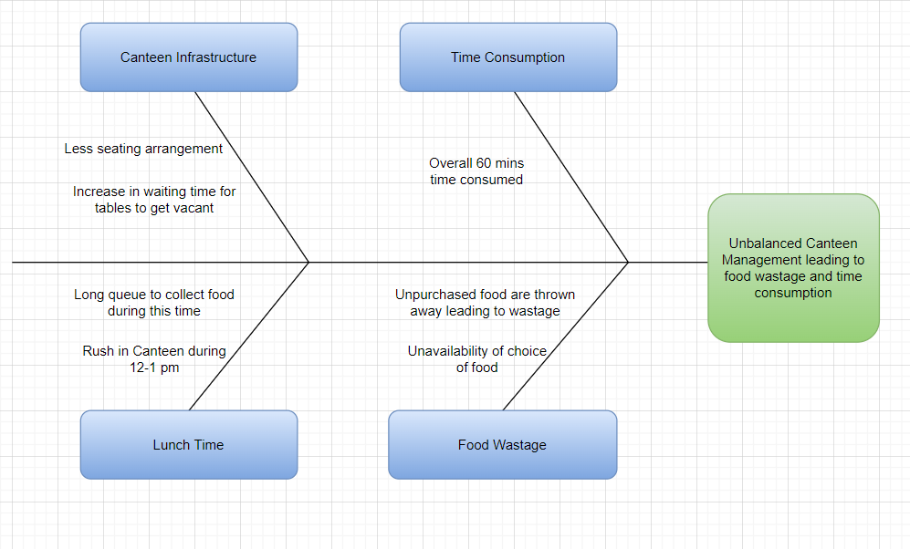

**TASK 3: IDENTIFY OBJECTIVES OF NEW CANTEEN ORDERING SYSTEM**

**Business Objective 1:**

Reduce canteen food wastage by a minimum of 30% within 6 months following first release.

Scale: Value of food thrown away each month by examining the canteen inventory

Previous - 25% wasted

Must plan for: Less than 15%

**Business Objective 2:**

Reduce canteen operating costs by 15% within 12 months, following initial release.

**Business Objective 3:**

Increase average effective work time by 30 minutes per employee per day, within 3 months.

**Business Objective 4:**

By making the ordering process automated and by delivering the food to the user's workstation, the canteen will be able to operate with lesser manpower.

**Mind Map:**

**TASK 4: AS-IS AND FUTURE STATE PROCESS MAPS**

**AS-IS/Current State of the Process:**

**Future State:**

**TASK 5: CONTEXT DIAGRAM FOR CANTEEN ORDERING SYSTEM**

The scope of the canteen management system has 5 components: Unilever management, Unilever employees, Canteen management ,Payroll team and Project Manager.

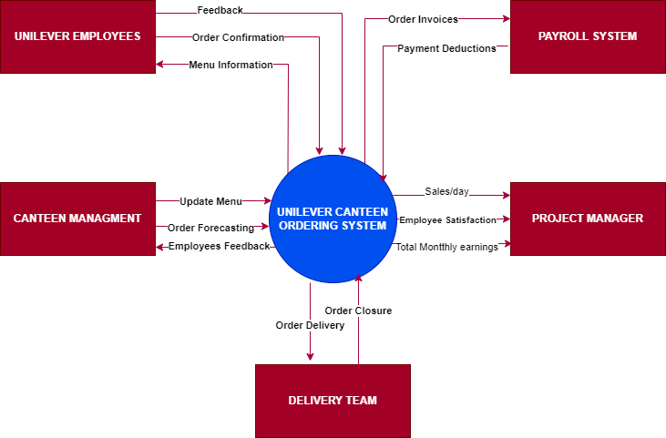

**TASK 6: FEATURES TO BE DEVELOPED:**

1. Employee registration and login credentials
2. Update the list of menus offered for the day
3. Employees must be able to select and edit the order they prefer before confirmation
4. User will not be able to edit the order after the confirmation of the order on the system
5. The canteen manager views the orders and assign to Chef for the preparation
6. Canteen manager also assigns a delivery associate to deliver food to the employees’ desk
7. After delivering the lunch the delivery boy shall close the order
8. A feedback system for the employees regarding the order
9. The payroll system shall calculate the total number of dishes ordered by each employee. The payroll system shall deduct money from the employee’s salary.

10. Generation of the reports and submission of the same to the Management.

**TASK 7: IN-SCOPE AND OUT OF SCOPE FOR SOFTWARE:**

**In scope requirements:**

* Employee sign up/sign in
* Menu page
* Meal ordering screen
* Order confirmation screen
* Order status page
* Meal delivery details
* Close delivered order by delivery associate
* Monthly payroll adjustment
* Feedback submission
* Sales report for canteen management system

**Out of scope requirements:**

* Food vendor management
* Food supplies out of stock notification
* Canteen staff payment management
* Pre-Order requirement
* Refund Options
* Chef and meal delivery person payment details

**TASK 8: ACTIVITY DIAGRAM FOR SYSTEM**

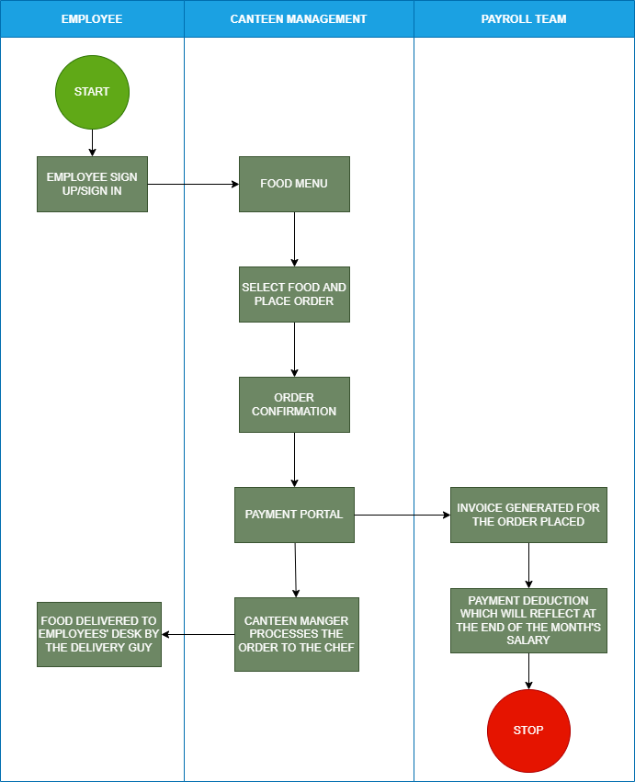

**TASK 9: ER DIAGRAM OF CANTEEN ORDERING SYSTEM:**

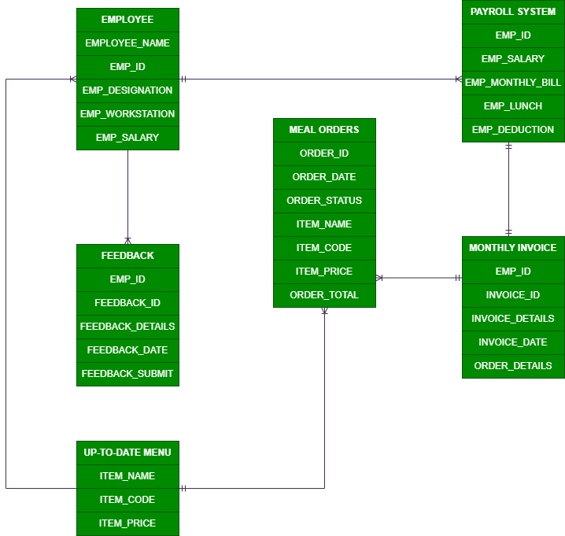

**TASK 10: FUNCTIONAL AND NON-FUNCTIONAL BUSINESS REQUIREMENTS:**

**Functional Business Requirements:**

* User Registration and Login
* Up-to-date Menu for the day
* Order to be placed by 11.00 am
* Create and edit the order before check out
* Delivery to the employees’ work station
* After delivery, the delivery associate shall close the online customer order
* Customer should be able to submit the feedback
* Generation of reports for management regarding the utilization of the canteen order system, reduction in operational cost.

# Non-Functional Business Requirements:

* Scalability & Performance: Scalable for 1500 employees at a time
* Availability: System to be light and fast
* Usability: User friendly and self-explanatory
* Maintainability: Software in Java

**TASK 11: WIREFRAMES FOR CANTEEN ORDERING SYSTEM:**

