Symmetry-resolved GC-skew reveals higher-harmonic phase coherence beyond the first Fourier mode in bacterial chromosomes
[Author Name(s)]
[Affiliation(s)]
[Corresponding author email]
Article type: Original Article | Suggested category: Sequence Analysis / Genome Analysis

Abstract
GC skew is a replication-associated compositional asymmetry in many bacterial chromosomes, but established Fourier summaries emphasize the first harmonic. We introduce a symmetry-resolved statistic that measures the fraction of centered GC-skew signal energy lying in the reversal-odd, half-turn-odd sector. The corresponding projector score, J, aggregates all odd harmonics sharing a common replication axis and can be evaluated for every candidate axis in O(M log M) time by circular convolution. To test whether J captures organization beyond first-harmonic information, we used Fourier surrogates that preserve the complete magnitude spectrum and the exact complex k=1 coefficient while randomizing higher-harmonic phases. An exploratory nine-genome set motivated a preregistered independent confirmation on 15 previously unopened complete circular bacterial chromosomes from 15 genera. Fisher combination of the 15 prespecified one-sided Monte Carlo tests was significant (X=104.46, df=30, P=3.63e-10). Six of 15 genomes (40%; Wilson 95% CI 19.8%-64.3%) remained significant after Benjamini-Hochberg correction. These results show that higher odd GC-skew harmonics can exhibit common-axis phase coherence in a substantial subset of bacterial chromosomes beyond first-harmonic phase and the Fourier power spectrum alone. The method is not presented as a universal replacement for cumulative-skew or first-harmonic oriC localization.
Keywords: GC skew; bacterial replication; Fourier analysis; symmetry projector; phase coherence

1 Introduction
Bacterial chromosomes often exhibit strand-specific compositional asymmetry associated with bidirectional replication. GC skew, commonly defined locally as (G-C)/(G+C), changes sign across the two replichores and has long been used to visualize and estimate replication-associated structure. Early work established bacterial strand asymmetries and cumulative-skew representations, and later methods formalized Fourier or scalar summaries of skew strength.
The GC Skew Index (GCSI) incorporated fast Fourier transform information together with cumulative-skew geometry, while subsequent large-scale methods such as SkewIT quantified skew across more than 15,000 RefSeq bacterial genomes. SkewDB extended accessible skew resources to more than 30,000 chromosomes and plasmids. These approaches establish that GC skew is measurable at scale, but they do not directly test whether higher odd Fourier modes share a common replication axis after conditioning on the first harmonic.
Here we formulate the problem using two commuting involutions on a circular skew profile: reflection about a candidate axis and translation by half a chromosome. The ideal two-replichore component is odd under both operations. This implies an odd-sine Fourier sector and yields an orthogonal projector that combines all compatible odd harmonics. We then ask a narrower empirical question: does real bacterial GC skew contain higher-harmonic phase organization that cannot be explained by the Fourier magnitude spectrum or by the complete k=1 coefficient alone?

2 Mathematical formulation

2.1 Circular sequence representation and half-turn parity
Let s[n], n in Z_M, be an even-length, mean-centered GC-skew profile. Define the half-turn H and reflection R_a by
H s[n] = s[n + M/2], R_a s[n] = s[a - n] (mod M).
Both are involutions, and for each candidate axis a they commute. The four orthogonal (R,H) symmetry sectors are selected by
P_(r,h)^(a) = 1/4 (I + r R_a)(I + h H), r,h in {+1,-1}.
On Fourier mode k, the half-turn eigenvalue is (-1)^k. Therefore the H=-1 subspace contains exactly the odd Fourier modes. If a real signal is also reversal-odd about its replication axis, its Fourier representation contains only odd sine harmonics relative to that axis.

2.2 Projector score
For the target reversal-odd, half-turn-odd sector, define
J(a) = ||P_(−,−)^(a) s||_2^2 / ||s||_2^2, J_max = max_a J(a).
Thus J(a) is the exact fraction of centered signal energy lying in the ideal two-replichore symmetry sector at axis a. Let u_-=(I-H)s/2. Then
J(a) = [ ||u_-||_2^2 − <u_-, R_a u_-> ] / [2 ||s||_2^2].
The correlation term is a circular self-convolution, so the full axis scan is computed in O(M log M) time with a single FFT. This distinguishes the method from a first-harmonic estimator: J can pool coherent k=3,5,7,... information even when k=1 is weak.

2.3 Energy decomposition and coherence measures
Orthogonality gives an exact four-sector energy decomposition. We report first-harmonic energy P1, total half-turn-odd energy E_H−, higher-odd energy E_H−−P1, and odd-axis coherence
C_odd = J_max / E_H−.
C_odd measures what fraction of all odd-mode energy can be organized about one reversal-odd axis. This is a mathematical signal-energy quantity and is not a thermodynamic energy claim.

3 Materials and methods

3.1 Sequence signal
Complete circular chromosome sequences were downloaded by exact RefSeq/GenBank nucleotide accession. Each sequence was divided into M equal contiguous bins (primary M=512; robustness M=256 and 1024). Within each bin, normalized GC skew was computed as (G-C)/(G+C), with zero assigned only when G+C=0. Profiles were mean-centered before projection.

3.2 Exploratory and confirmatory cohorts
An exploratory set of nine chromosomes with experimentally anchored oriC coordinates was used to validate the computational pipeline and to assess whether higher-harmonic coherence occurred in real genomes. After those data were opened, an independent confirmatory cohort was frozen before sequence inspection: 15 complete circular bacterial chromosomes from 15 different genera, with exact accessions and expected lengths specified in advance. No genome from the exploratory set or the prior development set was reused in the confirmatory cohort. All 15 confirmatory FASTAs passed the frozen provenance gate before GC-skew analysis. Broad phylum labels used for descriptive cohort reporting followed NCBI Taxonomy [8].

3.3 Phase-randomized null model
For each chromosome, 4,999 Fourier surrogate signals were generated. Every surrogate preserved (i) the exact magnitude of every Fourier coefficient and (ii) the complete complex k=1 coefficient, including its phase. Only higher-harmonic phases were randomized subject to conjugate symmetry. For each surrogate, J_max was recomputed. The prespecified one-sided Monte Carlo P-value was
p_i = [1 + #{J_max,null ≥ J_max,obs}] / 5000.
The minimum attainable reported P-value was therefore 1/5000=0.0002. This null retains first-harmonic axis information and the complete power spectrum. Rejection therefore targets higher-harmonic phase organization rather than extra spectral power alone.

3.4 Confirmatory analysis
The primary cohort-level endpoint was frozen before opening any confirmatory sequence. Per-genome P-values were combined by Fisher's method, X = -2 sum_i log p_i, with 30 degrees of freedom for N=15. The study was declared confirmatory-positive if the combined P-value was below 0.05. Genome-level tests were additionally adjusted by the Benjamini-Hochberg procedure. Resolution stability was assessed at 256, 512 and 1024 bins using the prespecified axis-shift criterion. Localization superiority was not a confirmatory endpoint. A separate tomography endpoint (joint-Hankel s4/s1) was frozen in an addendum before confirmatory sequence opening, but it was not executed because the prespecified tomography implementation was unavailable at unblinding. It is therefore not analyzed here and cannot be reconstructed post hoc on this opened cohort.

3.5 Reproducibility and AI-assisted workflow
The analysis used deterministic accession lists, frozen cohort manifests, SHA-256 provenance records, fixed random seeds, executable Python scripts, and archived result tables. Generative AI (OpenAI ChatGPT) assisted with mathematical formalization, code development, workflow design, debugging, and manuscript drafting. All numerical results reported here were produced by executable analysis code under frozen specifications; AI output was not treated as empirical evidence. Source code and frozen analysis bundles will be deposited in a public repository and archived with a persistent DOI before submission.

4 Results

4.1 Exploratory pilot
In the nine-genome exploratory set, two chromosomes remained significant after high-precision 4,999-surrogate testing and Benjamini-Hochberg correction: Escherichia coli K-12 (q=0.0306) and Bdellovibrio bacteriovorus HD100 (q=0.0054). The exploratory analysis did not show overall superiority of J for oriC-axis localization relative to first-harmonic or cumulative-skew baselines, so localization improvement was not promoted to the confirmatory primary endpoint.

4.2 Independent confirmatory cohort
All 15 preregistered confirmatory chromosomes passed accession, length, FASTA, sequence-alphabet and hash provenance checks. Direct recomputation from the 15 stored Monte Carlo P-values gave X=104.456327692 with 30 degrees of freedom, corresponding to P=3.63e-10 and reproducing the preregistered result to rounding. One genome had zero surrogate exceedances and therefore attained the minimum possible Monte Carlo P=1/5000=0.0002 under the prespecified +1 correction; no sub-grid P-value was imputed. The remaining significant raw P-values were 0.0004, 0.0006, 0.0008, 0.0038 and 0.0054.
6/15 chromosomes (40%) had raw genome-level P<0.05, with a Wilson 95% interval of 0.198-0.643. All 6 remained significant after Benjamini-Hochberg correction. The median J_max was 0.6236, median P1 was 0.4968, median higher-odd energy was 0.2827, and median C_odd was 0.8859. The full 15-genome result set, including non-significant chromosomes and resolution-stability status, is shown in Table 1.
Table 1. All chromosomes in Confirmatory Cohort A. Raw P-values derive from the prespecified k=1-preserving phase-randomization test; qBH denotes Benjamini-Hochberg adjustment. Phylum labels follow NCBI Taxonomy [8].
Organism | Accession | Phylum | Jmax | P | qBH | Stable
Francisella tularensis subsp. holarctica OSU18 | NC_017463.1 | Pseudomonadota | 0.603 | 0.1822 | 0.3416 | Yes
Mycoplasma mycoides subsp. capri str. GM12 | NZ_CP001668.1 | Mycoplasmatota | 0.395 | 0.3800 | 0.4750 | No
Candidatus Endomicrobium trichonymphae | NC_020419.1 | Elusimicrobiota | 0.698 | 0.4942 | 0.5702 | Yes
Streptococcus mitis NCTC 12261 | NZ_CP028414.1 | Bacillota | 0.842 | 0.0002 | 0.0030 | Yes
Enterococcus casseliflavus EC20 | NC_020995.1 | Bacillota | 0.874 | 0.0004 | 0.0030 | Yes
Prevotella sp. oral taxon 299 str. F0039 | NC_022124.1 | Bacteroidota | 0.343 | 0.3102 | 0.4230 | No
Rhizobium sp. CIAT894 | NZ_CP020947.1 | Pseudomonadota | 0.490 | 0.0724 | 0.1551 | Yes
Acidithiobacillus caldus ATCC 51756 | NZ_CP005986.1 | Pseudomonadota | 0.527 | 0.9366 | 0.9366 | No
Acinetobacter baumannii D1279779 | NC_020547.2 | Pseudomonadota | 0.786 | 0.0006 | 0.0030 | Yes
Bordetella pertussis B1917 | NZ_CP009751.1 | Pseudomonadota | 0.400 | 0.2524 | 0.3786 | Yes
Clostridioides difficile CF5 | NC_017173.1 | Bacillota | 0.866 | 0.0008 | 0.0030 | No
Bifidobacterium breve UCC2003 | NC_020517.1 | Actinomycetota | 0.361 | 0.6372 | 0.6827 | No
Thioalkalivibrio paradoxus ARh 1 | NZ_CP007029.1 | Pseudomonadota | 0.703 | 0.0038 | 0.0114 | Yes
Thermobacillus composti KWC4 | NC_019897.1 | Bacillota | 0.624 | 0.2278 | 0.3786 | Yes
Cytobacillus oceanisediminis 2691 | NZ_CP015506.1 | Bacillota | 0.852 | 0.0054 | 0.0135 | Yes
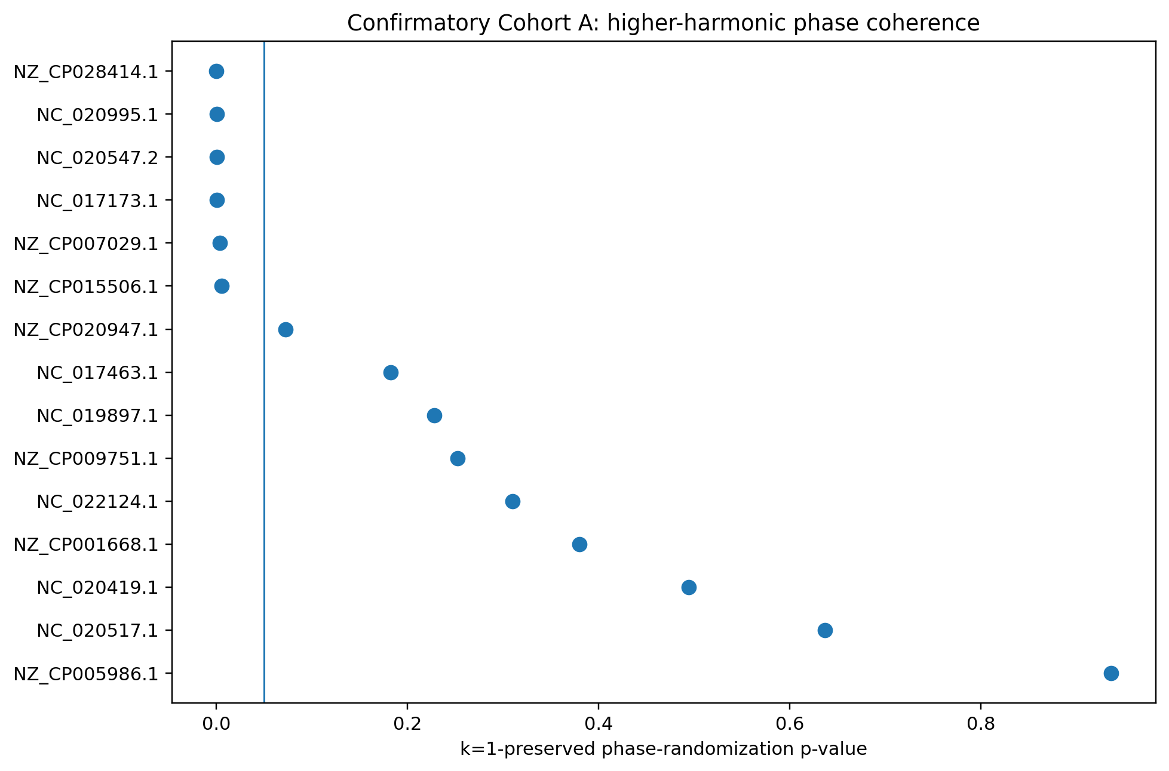
Figure 1. Genome-level k=1-preserving phase-randomization P-values in Confirmatory Cohort A. The vertical reference line marks P=0.05.
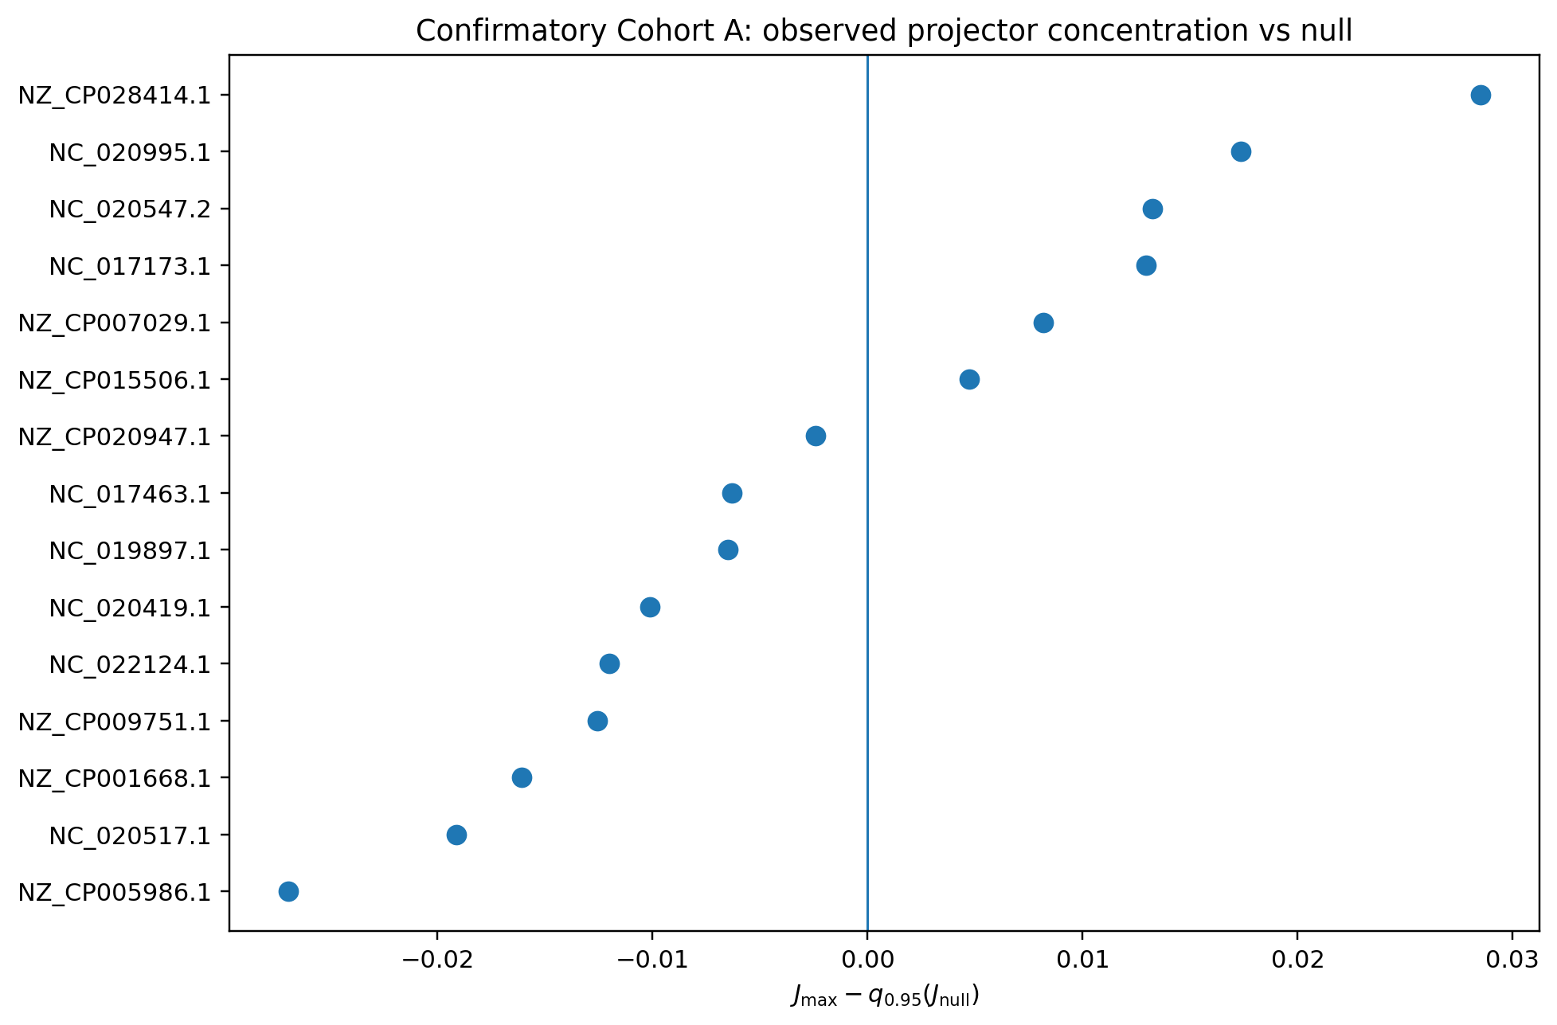
Figure 2. Difference between observed J_max and the 95th percentile of the k=1-preserving null distribution for each confirmatory chromosome.

4.3 Resolution robustness
10/15 confirmatory chromosomes met the frozen 256/512/1024 resolution-stability criterion. Among the six BH-significant chromosomes, five were resolution-stable; Clostridioides difficile CF5 was the sole significant chromosome that failed the prespecified stability criterion. Resolution dependence therefore remains material for a subset of genomes and is reported rather than filtered post hoc.

5 Discussion
The principal result is not that bacterial GC skew contains higher odd harmonics; that is compatible with any non-sinusoidal two-replichore profile. The stronger result is that, in a substantial subset of an independent cohort, those higher harmonics exhibit phase organization around a common symmetry axis that survives a null model preserving both the complete Fourier magnitude spectrum and the entire complex first harmonic.
This distinction matters relative to earlier FFT-based summaries. GCSI established the usefulness of Fourier structure for characterizing GC skew, and SkewIT and SkewDB demonstrated large-scale biological utility. The present statistic instead asks whether information remains in the relative phases of higher odd modes after first-harmonic phase and all spectral amplitudes have been fixed. The confirmatory result answers that question positively at the cohort level.
The method should not be presented as a universal replacement for cumulative-skew or first-harmonic oriC localization. The exploratory pilot did not establish overall localization superiority. Its current contribution is a symmetry-resolved descriptor and a controlled test for multi-harmonic phase coherence.
The confirmatory cohort used one chromosome per genus to reduce obvious redundancy, but bacterial genomes are not independent evolutionary replicates. Using current NCBI Taxonomy phylum labels [8], Bacillota comprised 5/15 chromosomes and 4/6 BH-significant chromosomes, whereas Pseudomonadota comprised 6/15 chromosomes and 2/6 BH-significant chromosomes. These counts are descriptive only: no phylogenetic correction or taxonomic-enrichment test was prespecified or performed on this opened cohort. Accordingly, the nominal Fisher calculation should not be interpreted as a phylogenetically adjusted population-level probability. A larger phylogenetically stratified analysis is the appropriate next test of prevalence and lineage clustering. In addition, only 10/15 confirmatory genomes met the strict resolution-stability rule; five of six BH-significant genomes did so. These limitations constrain biological generalization but do not alter the prespecified within-cohort confirmation.
The mathematical formulation also separates structural statements from biological interpretation. Half-turn parity forces odd Fourier support in the ideal target sector, while orthogonal projection quantifies sector energy exactly. No thermodynamic, symbolic or metaphysical equivalence is required for the method.

6 Conclusion
A symmetry projector on circular GC-skew profiles provides an efficient, interpretable measure of common-axis odd-harmonic organization. In a preregistered independent 15-genome cohort, the prespecified cohort-level phase-coherence test was significant, and the signal remained individually detectable in six chromosomes after multiple-testing correction (40%; Wilson 95% CI 19.8%-64.3%). These findings support a subset-limited computational signal beyond first-harmonic phase and Fourier power alone and motivate broader phylogenetically controlled validation.

Data and code availability
Genome sequences are public NCBI nucleotide records identified by exact accessions in the supplementary cohort manifest. DoriC was used for replication-origin metadata in the exploratory stage. Frozen code, accession manifests, provenance hashes, null-model scripts and result tables will be released in a public version-controlled repository and archived with a DOI before submission. [INSERT GITHUB URL] [INSERT ZENODO DOI]

Funding
[Insert funding statement or “No specific funding was received for this work.”]

Conflict of interest
[Insert competing-interest statement.]

Author contributions
[Insert CRediT author contributions.]

References
1. Lobry JR. Asymmetric substitution patterns in the two DNA strands of bacteria. Mol Biol Evol. 1996;13(5):660-665. doi:10.1093/oxfordjournals.molbev.a025626.
2. Grigoriev A. Analyzing genomes with cumulative skew diagrams. Nucleic Acids Res. 1998;26(10):2286-2290. doi:10.1093/nar/26.10.2286.
3. Arakawa K, Tomita M. The GC Skew Index: a measure of genomic compositional asymmetry and the degree of replicational selection. Evol Bioinform Online. 2007;3:159-168.
4. Arakawa K, et al. Quantitative analysis of replication-related mutation and selection pressures in bacterial chromosomes and plasmids using generalised GC skew index. BMC Genomics. 2009;10:640. doi:10.1186/1471-2164-10-640.
5. Lu J, Salzberg SL. SkewIT: The Skew Index Test for large-scale GC skew analysis of bacterial genomes. PLoS Comput Biol. 2020;16(12):e1008439. doi:10.1371/journal.pcbi.1008439.
6. Hubert B. SkewDB, a comprehensive database of GC and 10 other skews for over 30,000 chromosomes and plasmids. Sci Data. 2022;9:92. doi:10.1038/s41597-022-01179-8.
7. Dong MJ, Luo H, Gao F. DoriC 12.0: an updated database of replication origins in both complete and draft prokaryotic genomes. Nucleic Acids Res. 2023;51(D1):D117-D120. doi:10.1093/nar/gkac964.
8. Schoch CL, Ciufo S, Domrachev M, et al. NCBI Taxonomy: a comprehensive update on curation, resources and tools. Database (Oxford). 2020;2020:baaa062. doi:10.1093/database/baaa062.

