
Handover Report & User Guide
Mendez Brothes General Construction website
Handover date | October 2, 2026
Website address | [domain — to be filled in at handover]
Admin panel | [domain]/admin
Admin login | Sent separately, not written in this document
Document version | 1.0

Contents

1. Handover summary
A company website with an admin panel, so you can update the content yourself without a developer. Changes made in the admin panel appear on the website as soon as you publish them.

What has been delivered
Item | Details
Website | Home, About, Services (10 services, one page each), Projects (with filters), Equipment & Technology, Contact, News, and a page for each town you serve. Works on computers and phones.
Project filters | Filter by service, town, lot size, year and client type, plus a search box.
Estimate form | Visitors fill in the form on the website; each request lands in Quote requests. The list can be exported to Excel (CSV).
Admin panel | Add projects and news posts, edit every page, change photos, logo, colours and menu.
Colours | 13 ready-made palettes, plus a tool that builds a palette from one brand colour. Preview before it goes live.
User roles | 3 levels: Editor (staff), Manager (owner), Admin (technical).
Backups | Automatic every day, the last 7 are kept. Download or restore one at any time from the admin panel.

To do before going live
- Replace the sample photos with your own job photos. The current photos are placeholders from Wikimedia Commons.
- Replace the sample text. Reviews and posts marked [DEMO] are examples.
- Set up email. It is not switched on yet, so there are no email alerts for new quote requests and "Forgot password" does not work. This needs the details of a company mailbox (SMTP).
- Change the admin password right after the first login (section 3.12).
- Give each person their own login instead of sharing one (section 3.11).

2. The website
Screenshots of every page, on a computer and on a phone. Long pages are cut into columns; read them left to right.

Home
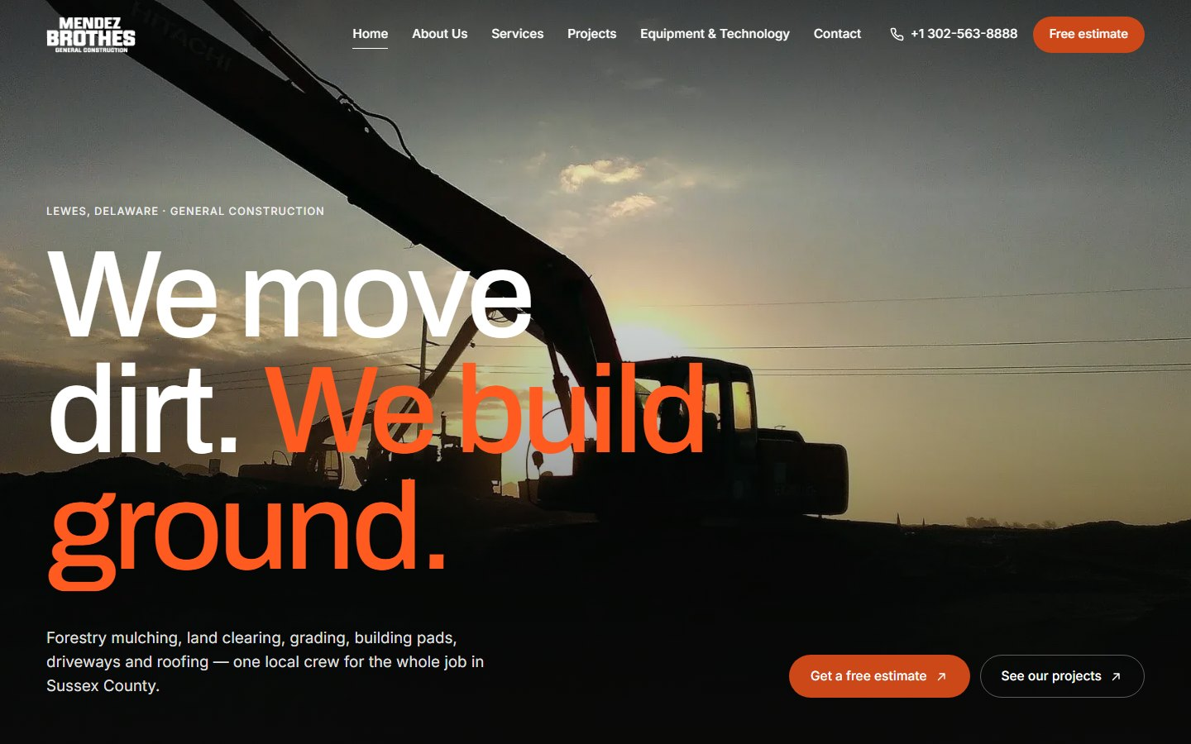
Home — desktop
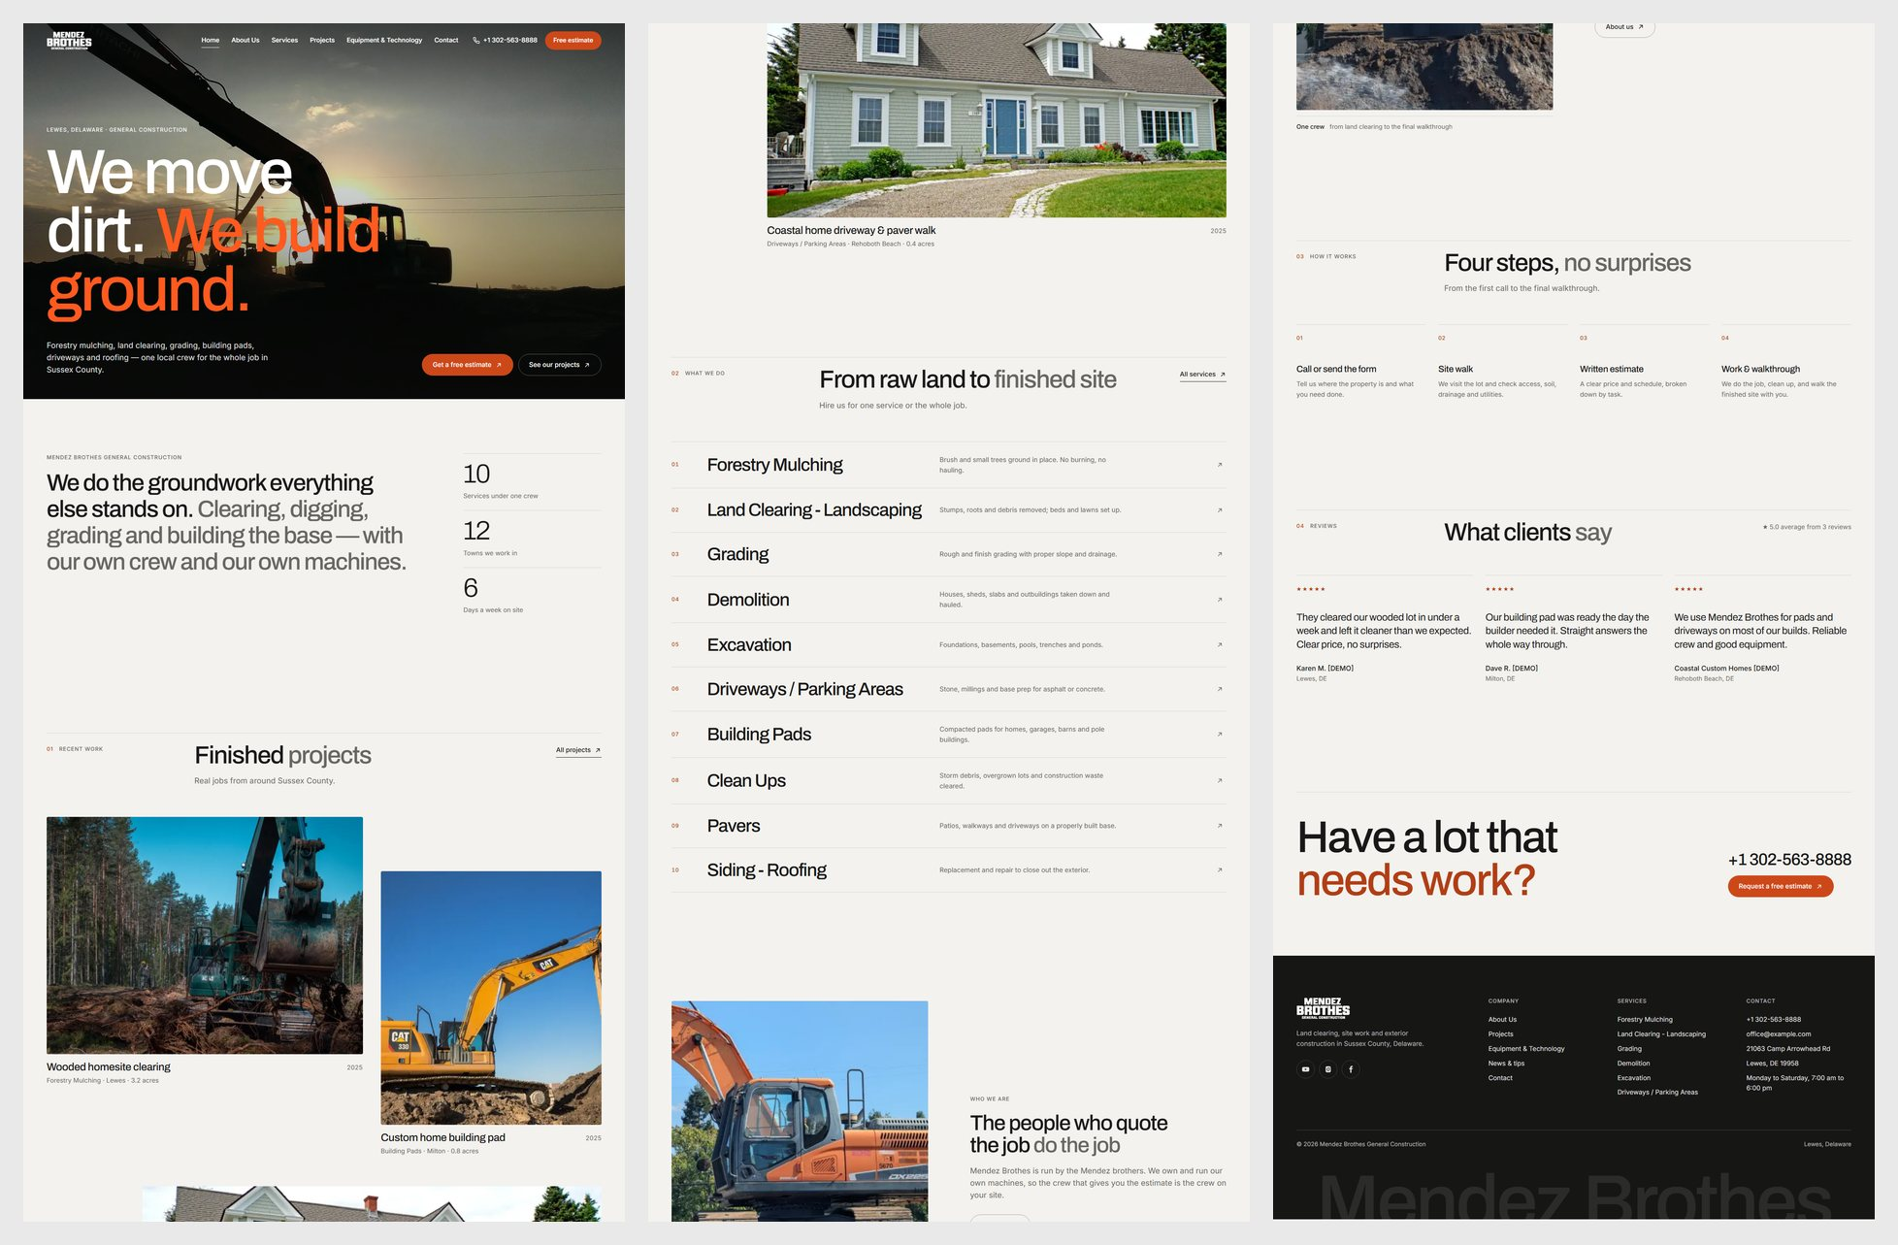
Home — the whole page on desktop (read left to right)
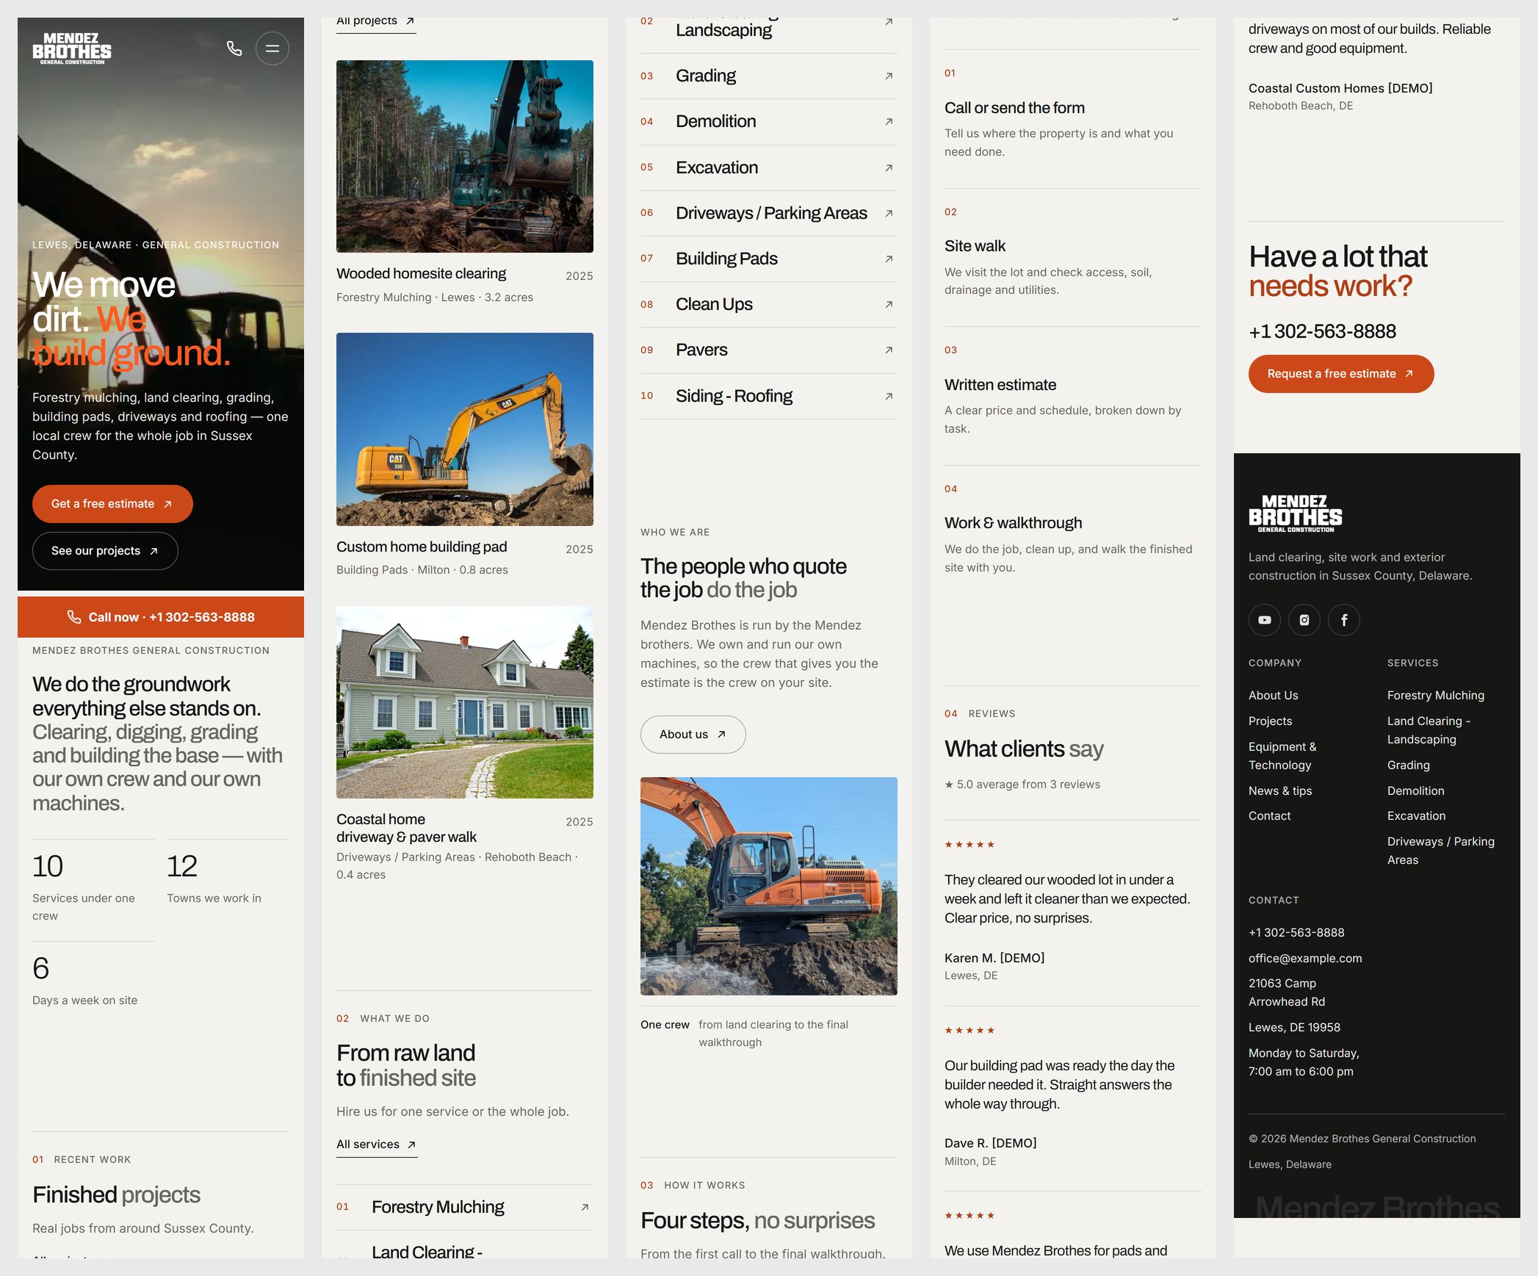
Home — phone (read left to right)

About Us
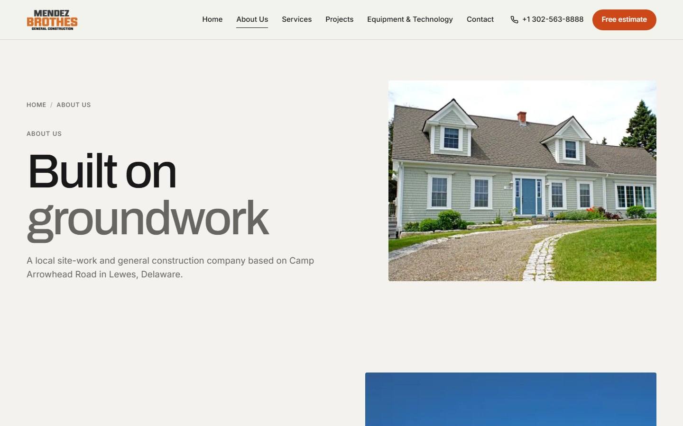
About Us — desktop
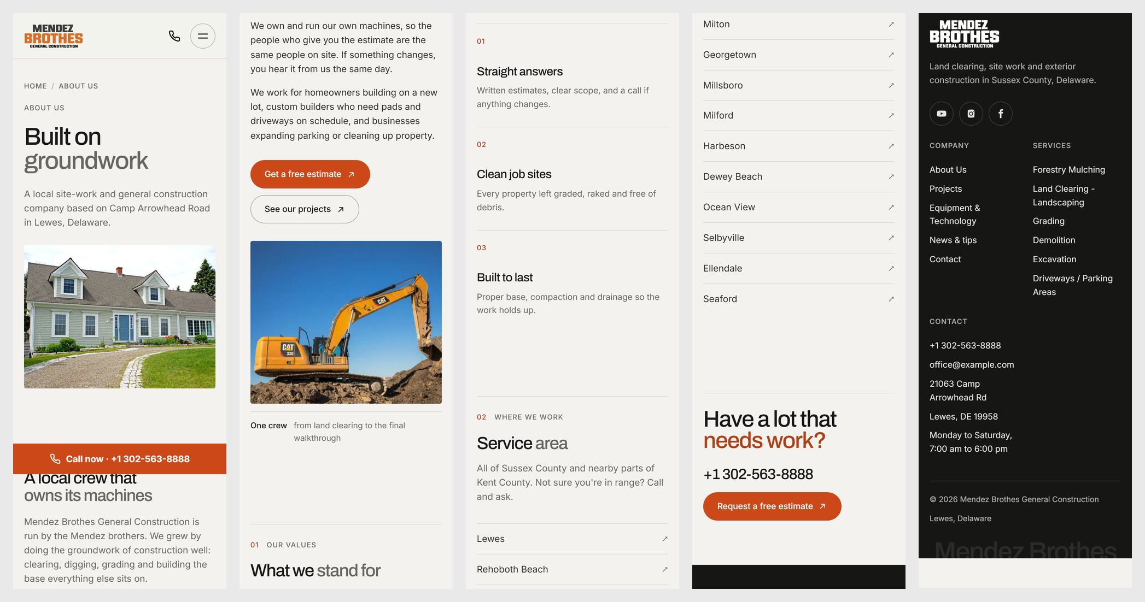
About Us — phone (read left to right)

Services
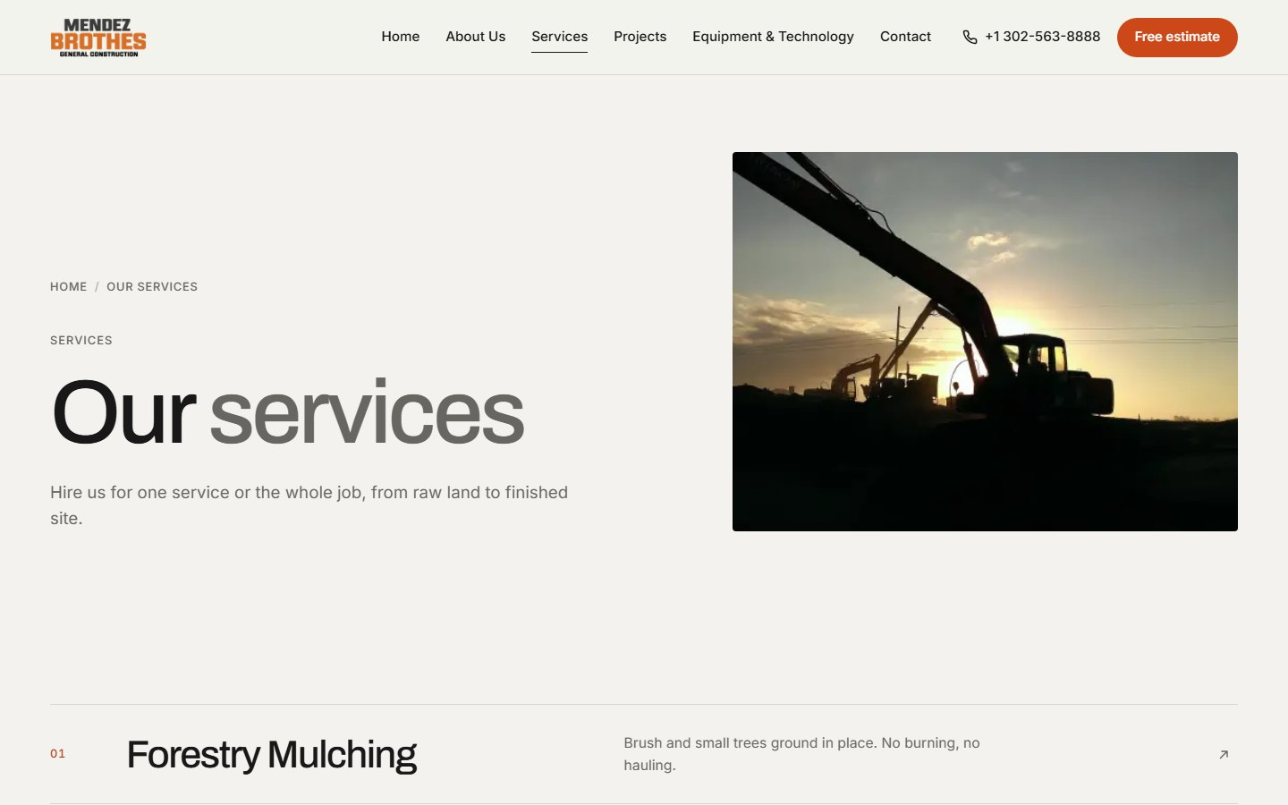
Services — desktop
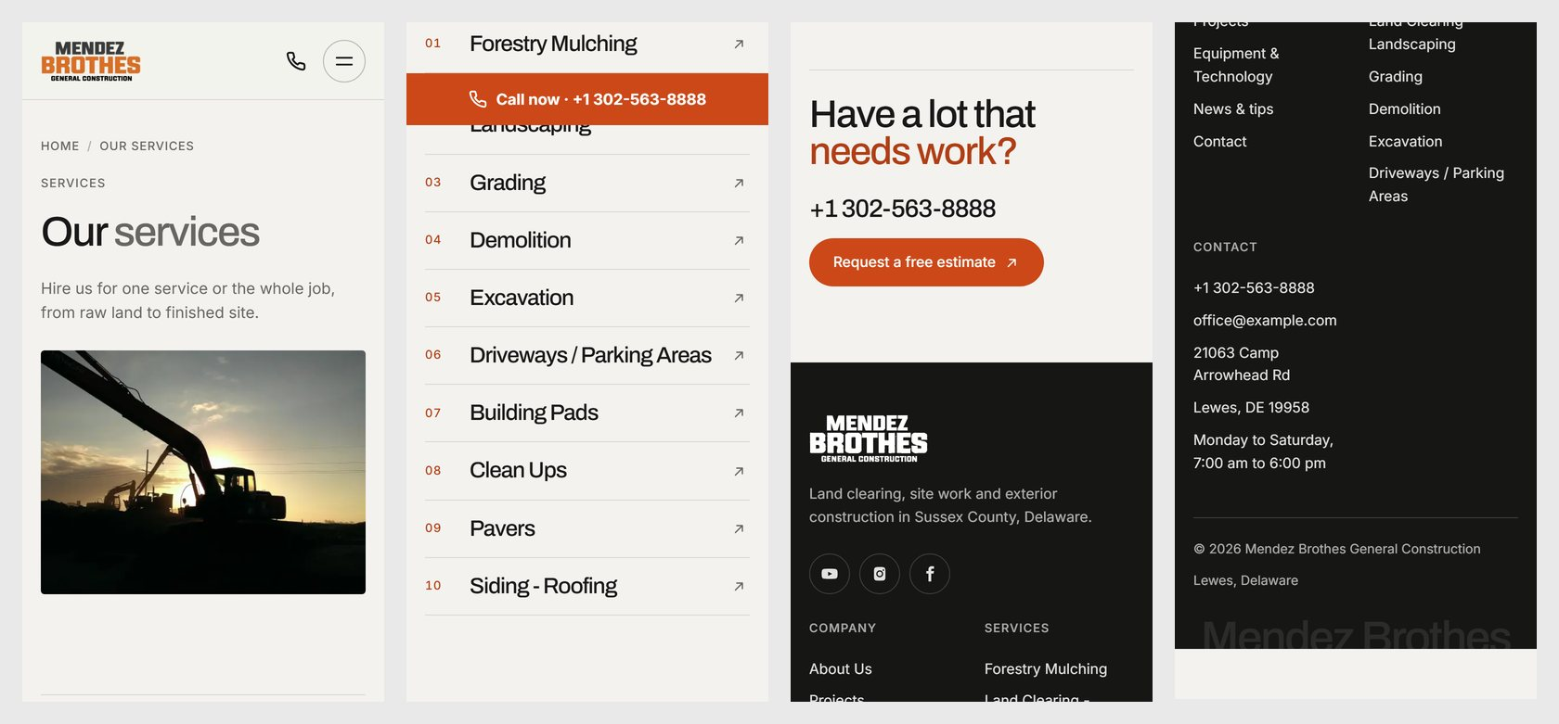
Services — phone (read left to right)

One service
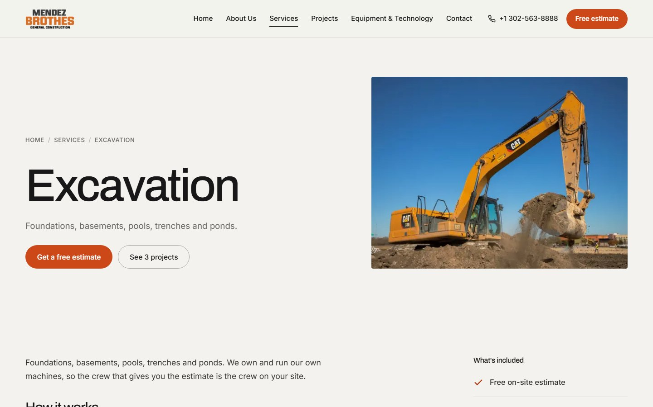
One service — desktop
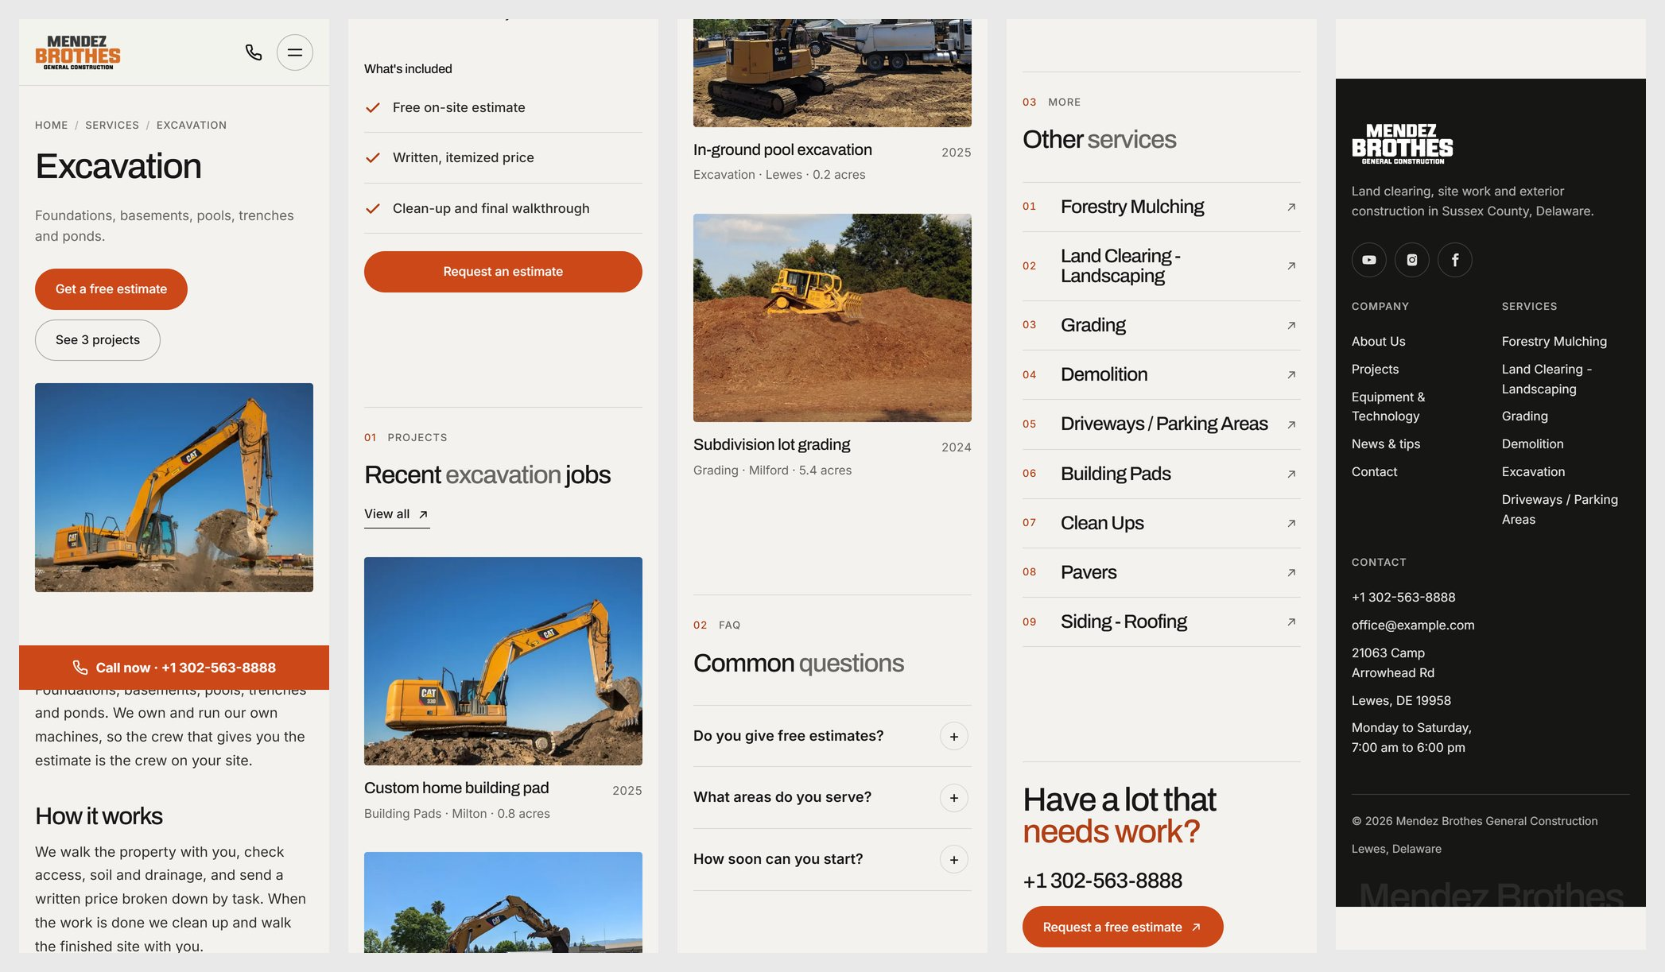
One service — phone (read left to right)

Projects — with filters
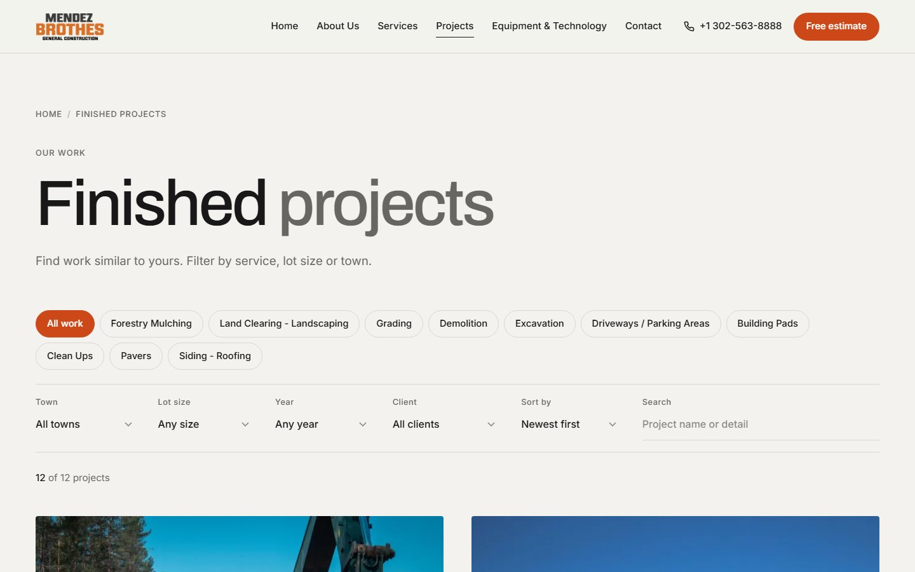
Projects — with filters — desktop
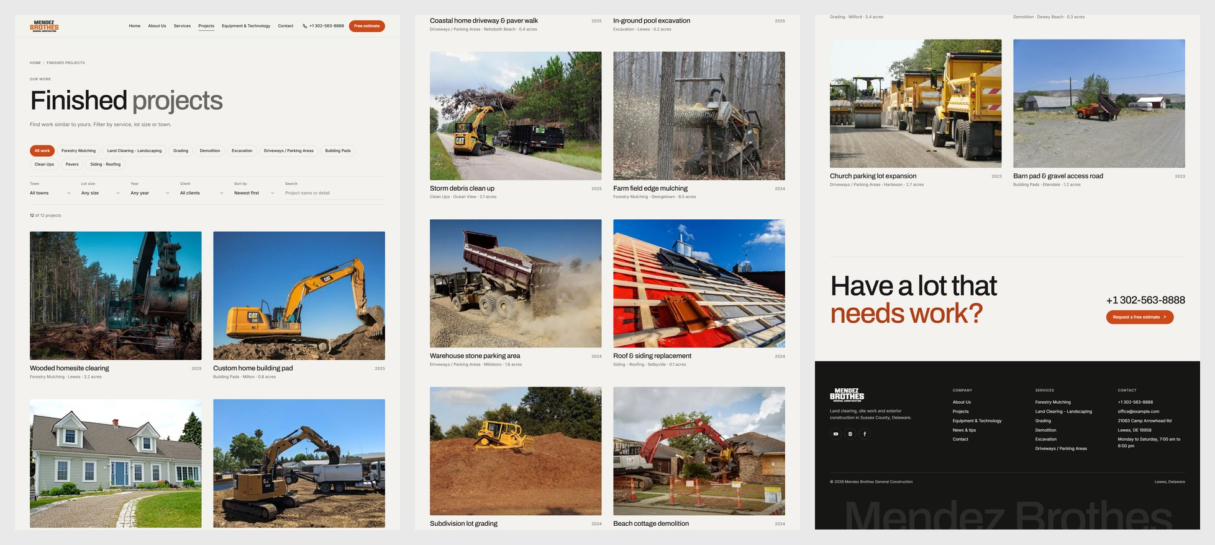
Projects — with filters — the whole page on desktop (read left to right)
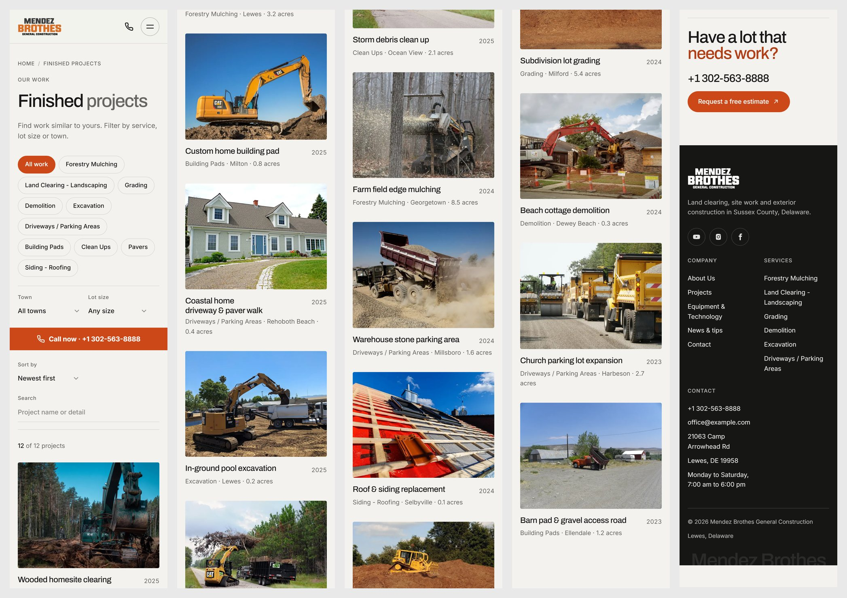
Projects — with filters — phone (read left to right)

One project
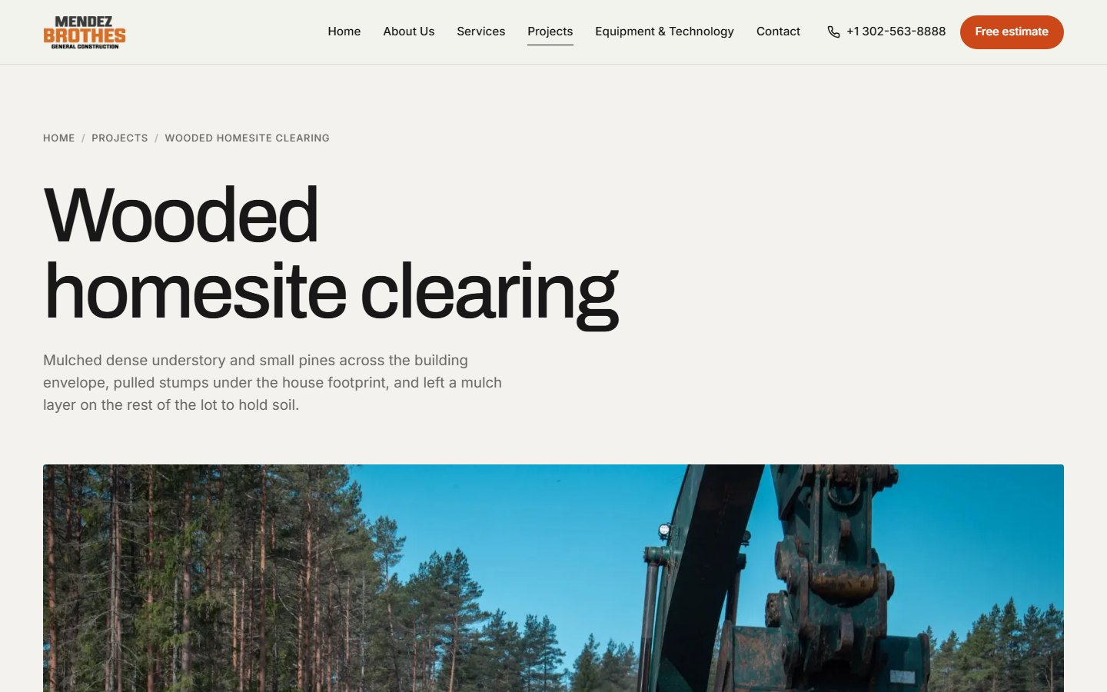
One project — desktop
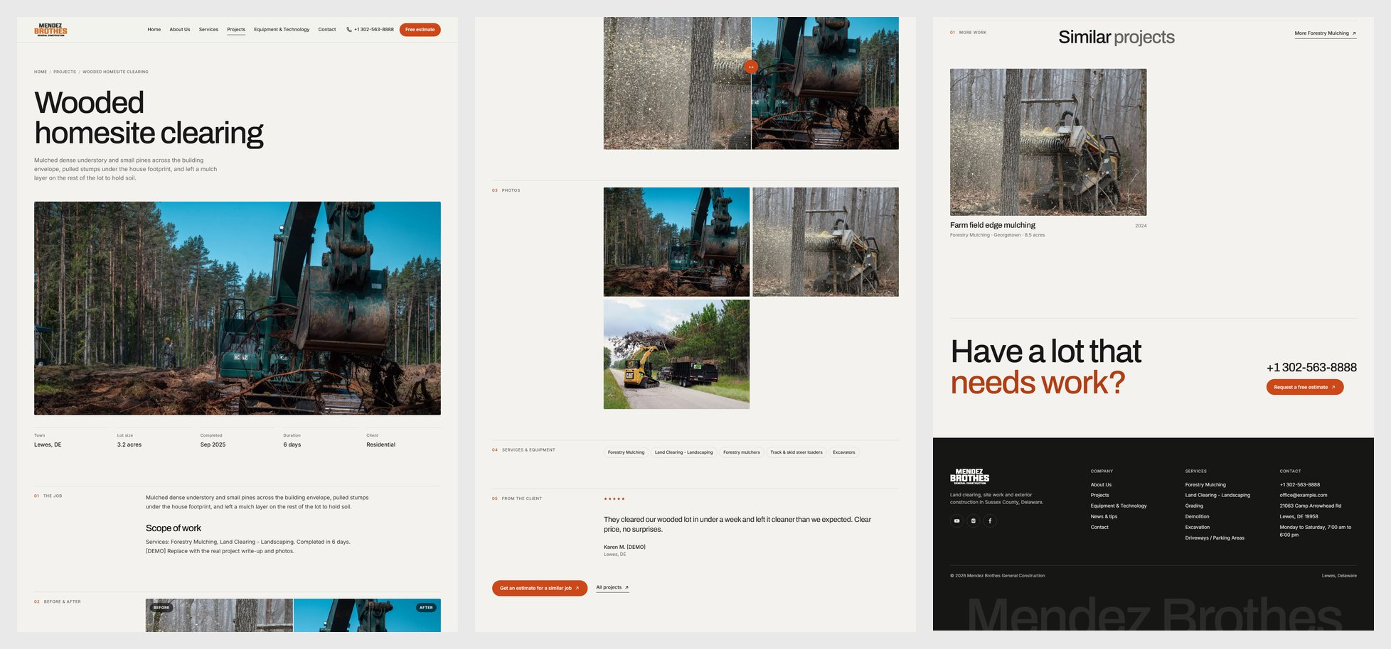
One project — the whole page on desktop (read left to right)
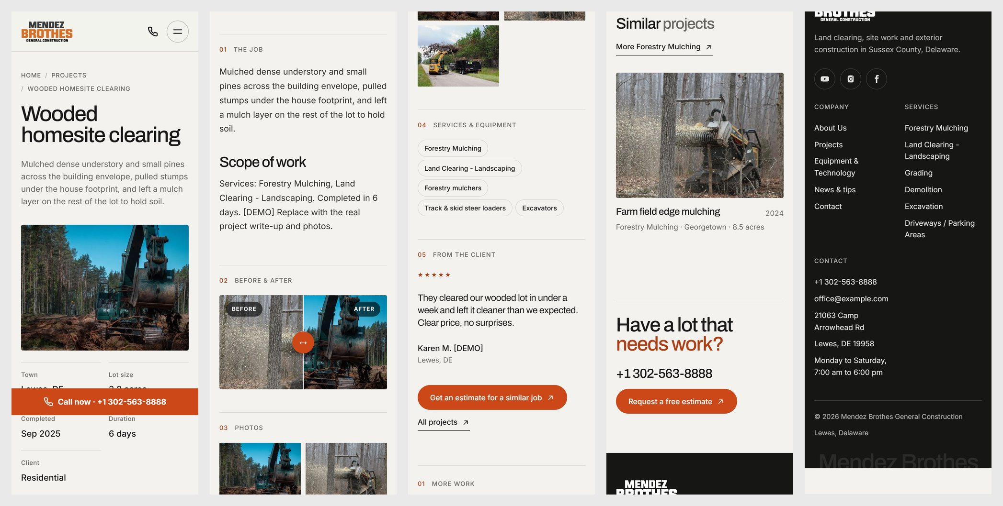
One project — phone (read left to right)

Equipment & Technology
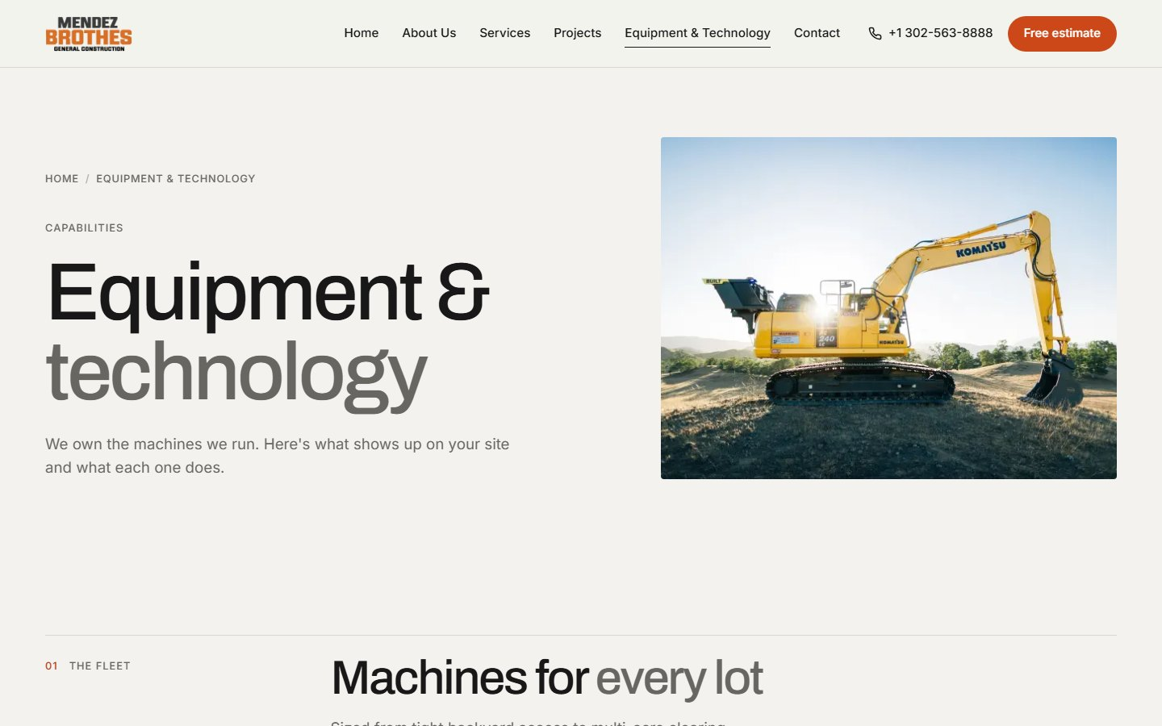
Equipment & Technology — desktop
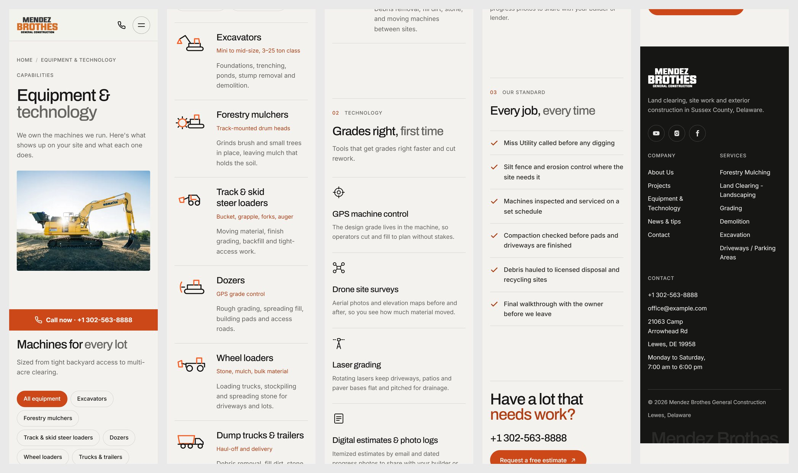
Equipment & Technology — phone (read left to right)

Contact
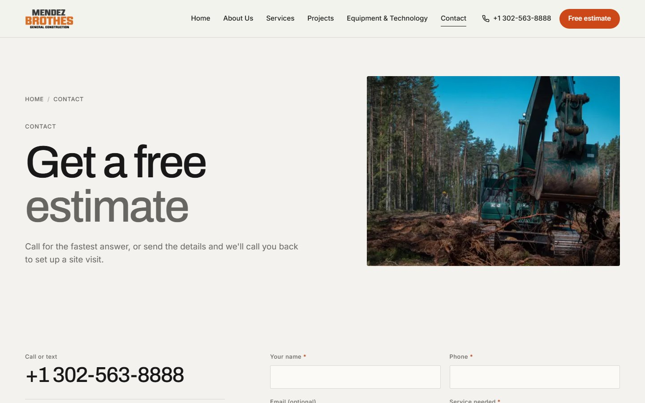
Contact — desktop
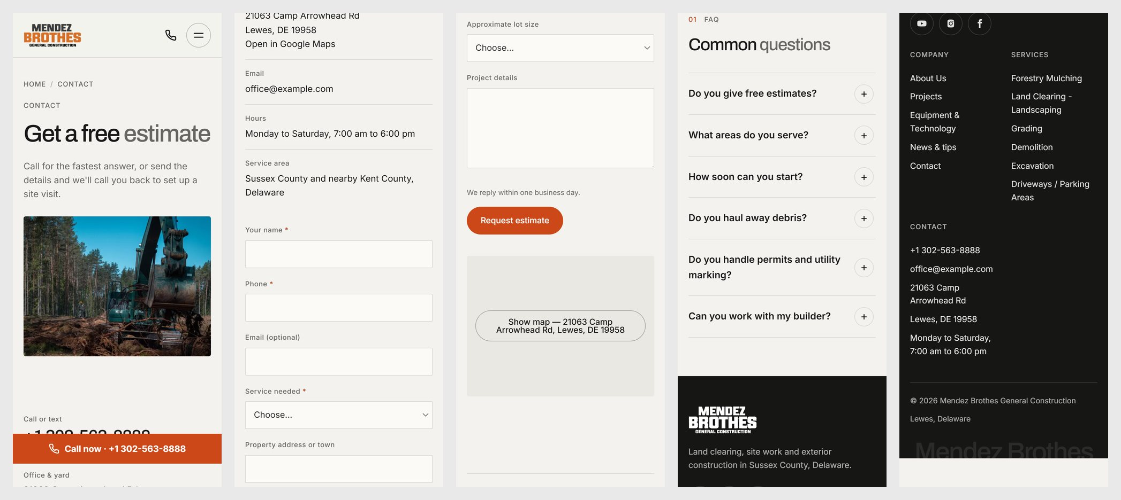
Contact — phone (read left to right)

News
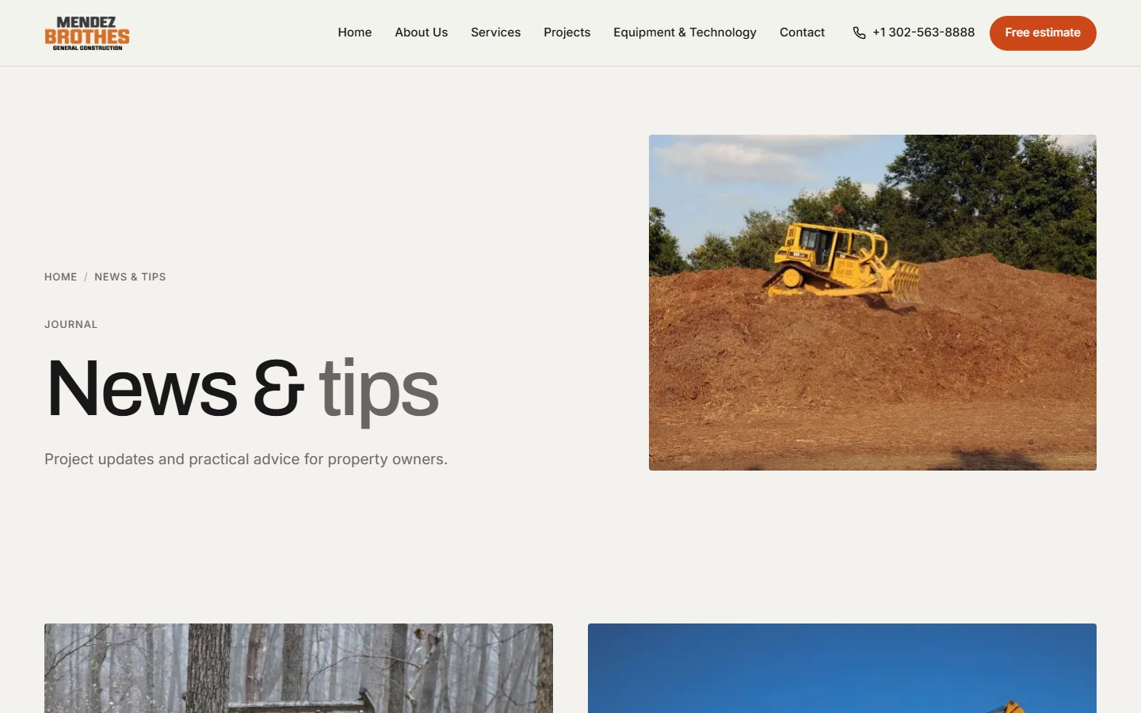
News — desktop
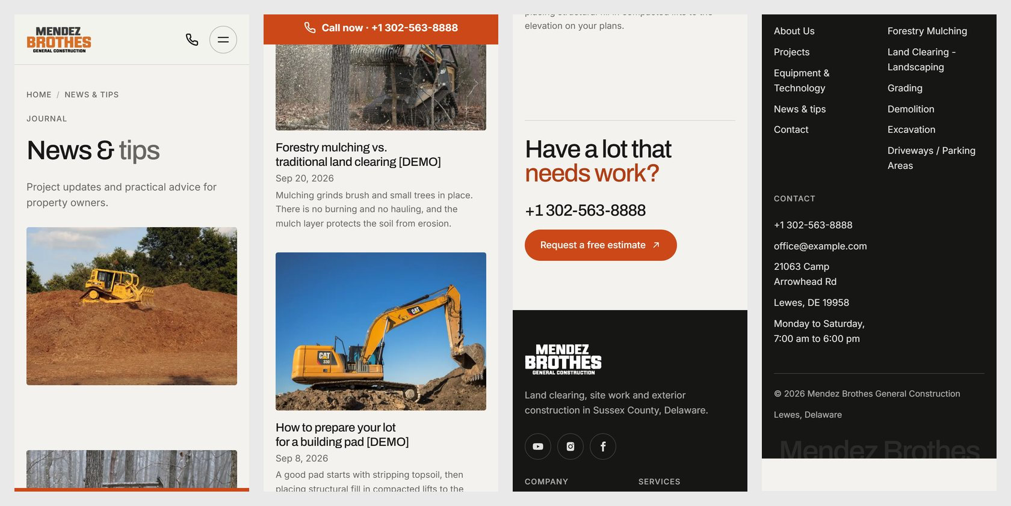
News — phone (read left to right)

One news post
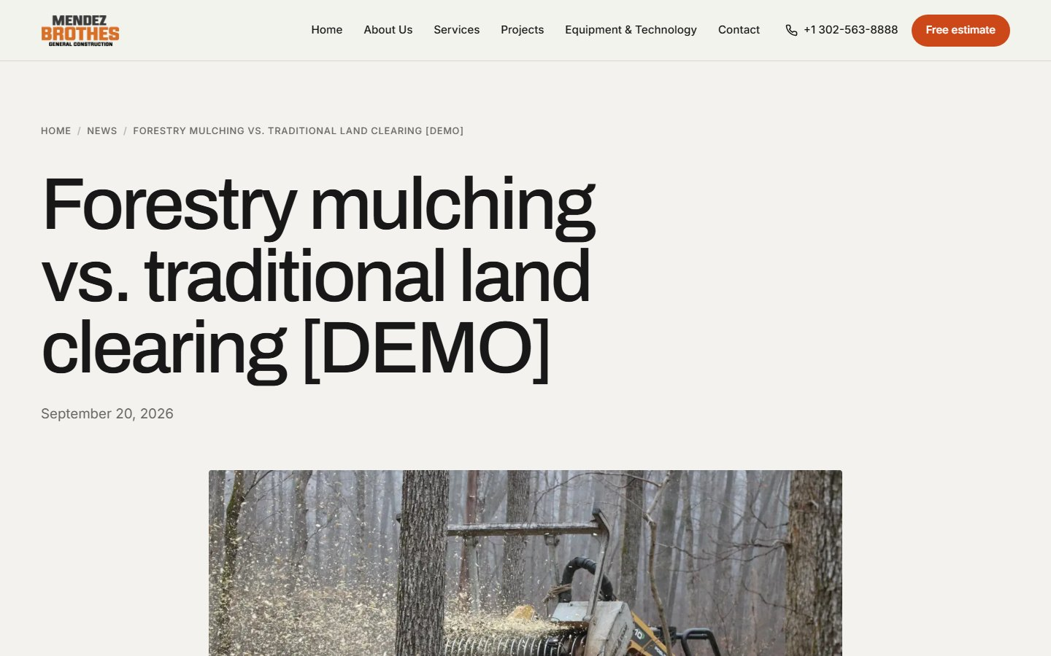
One news post — desktop
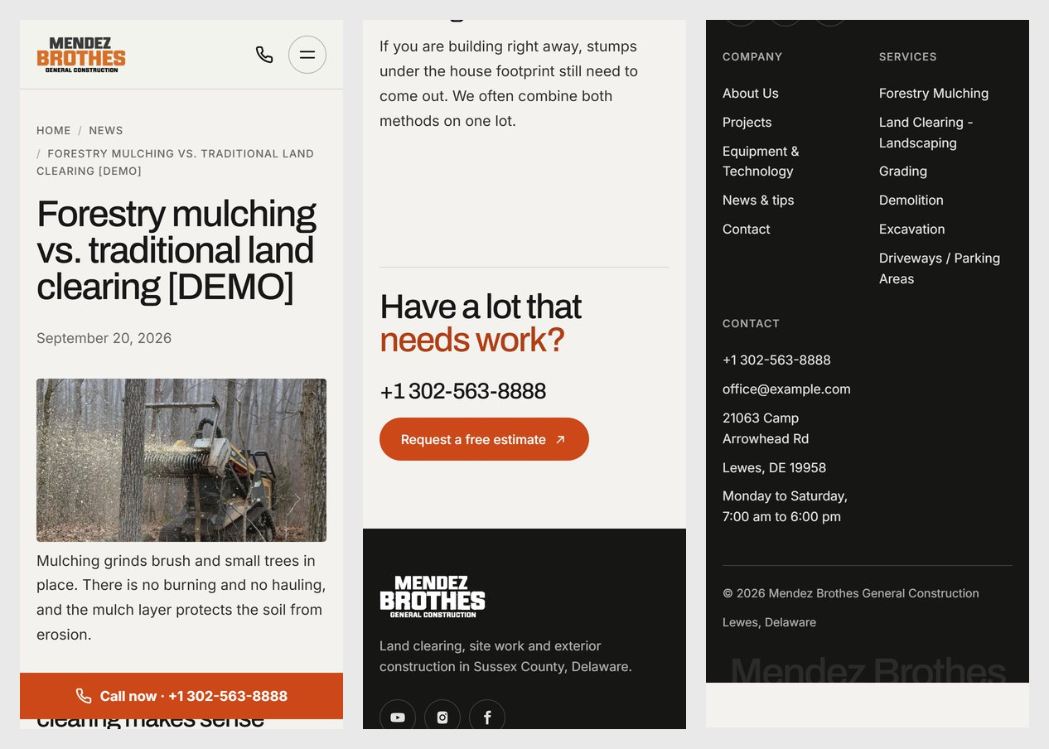
One news post — phone (read left to right)

Town page
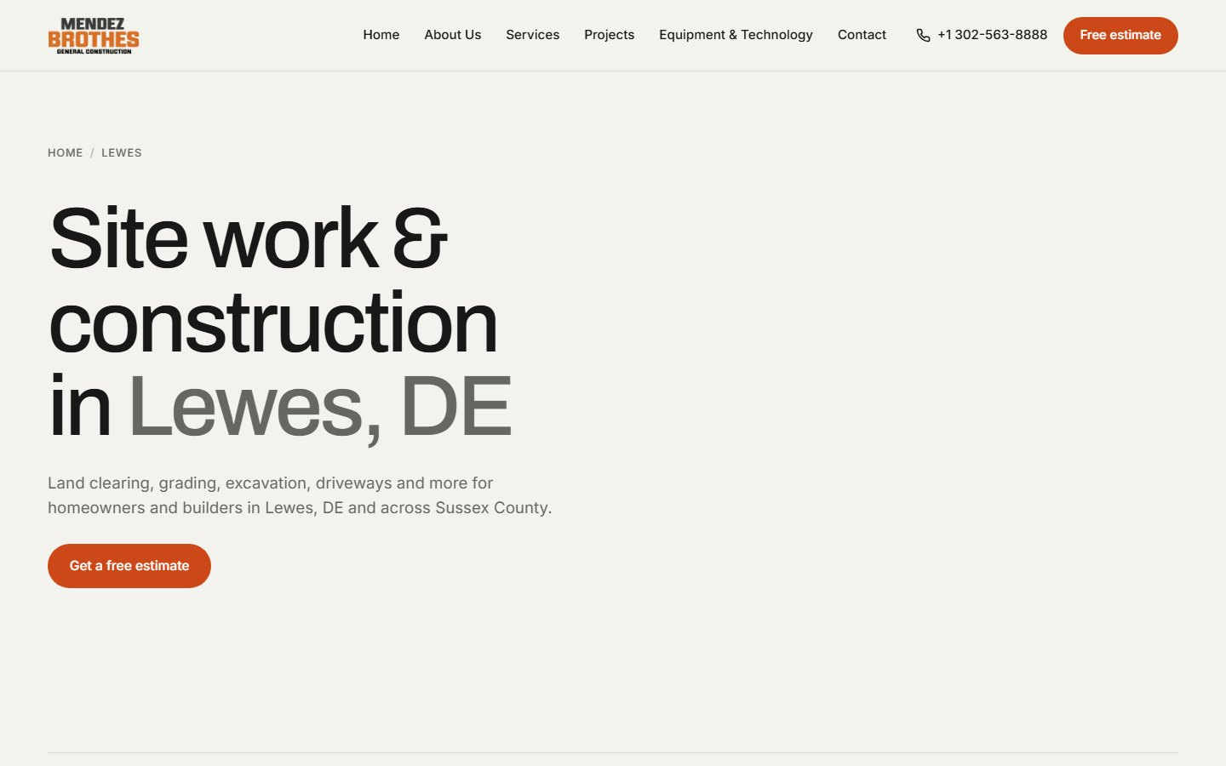
Town page — desktop
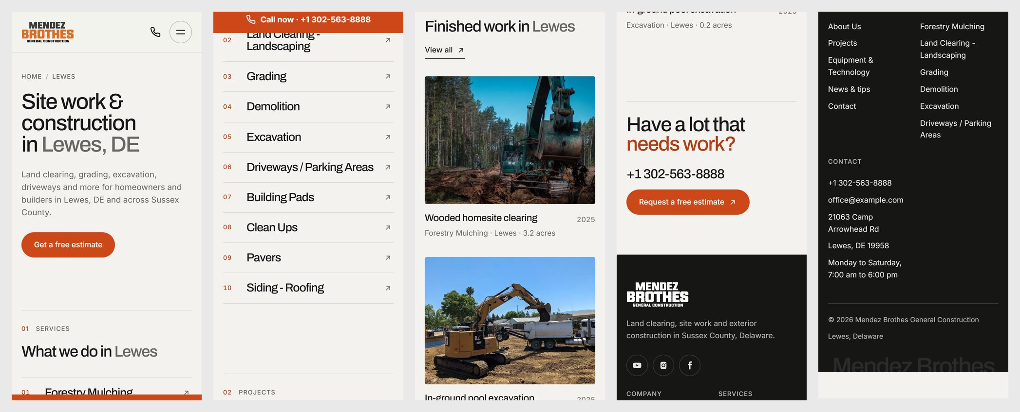
Town page — phone (read left to right)

Menu on a phone
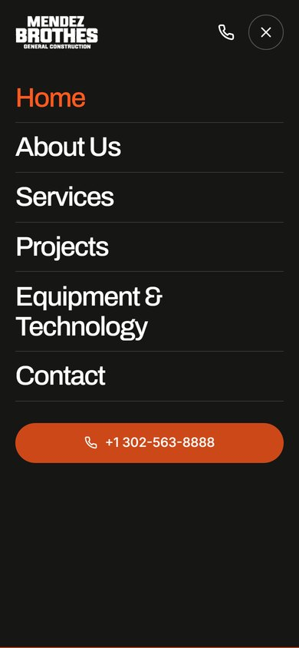
The menu opens full screen, with a call button

3. Using the admin panel
In the pictures below, each red number matches the step with the same number.
You cannot break anything: every change to a page or project is kept in a history and can be undone (section 3.14). Visitors only see a change after you press Publish changes.

3.1 Logging in
Open [domain]/admin in your browser.
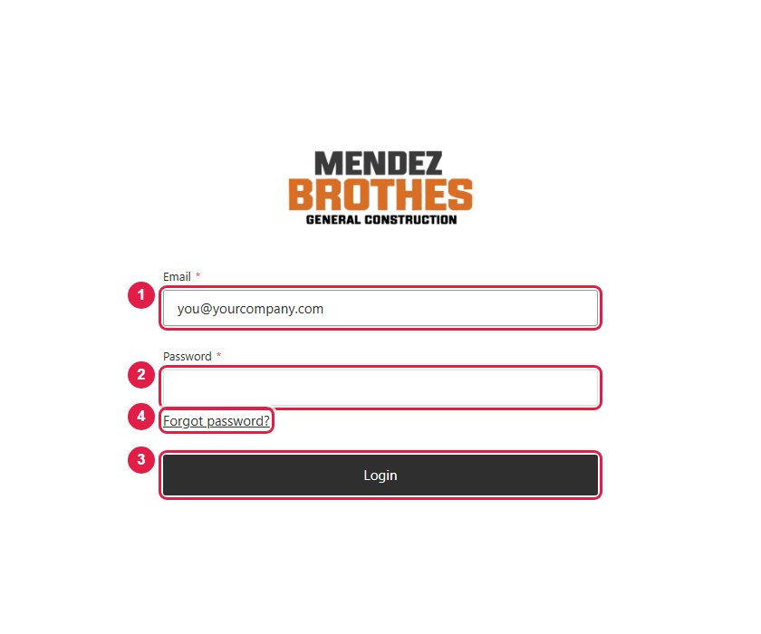
1 Type your Email.
2 Type your Password.
3 Press Login.
4 Forgot password? emails you a reset link. It only works once company email has been set up; until then, ask a Manager to reset your password (section 3.12).

3.2 The home screen
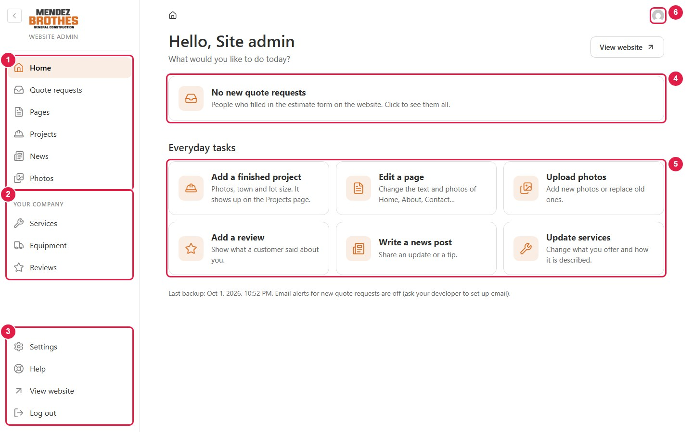
1 Everyday work: Quote requests, Pages, Projects, News, Photos.
2 About your company: Services, Equipment, Reviews.
3 Settings, Help (short how-to guides inside the admin panel), View website, Log out.
4 New quote requests. Click to open them.
5 Shortcuts to the most common tasks.
6 Your account: change your password or the language.

3.3 Adding a finished project
Once published, a project shows up on the Projects page and in the filters by itself.
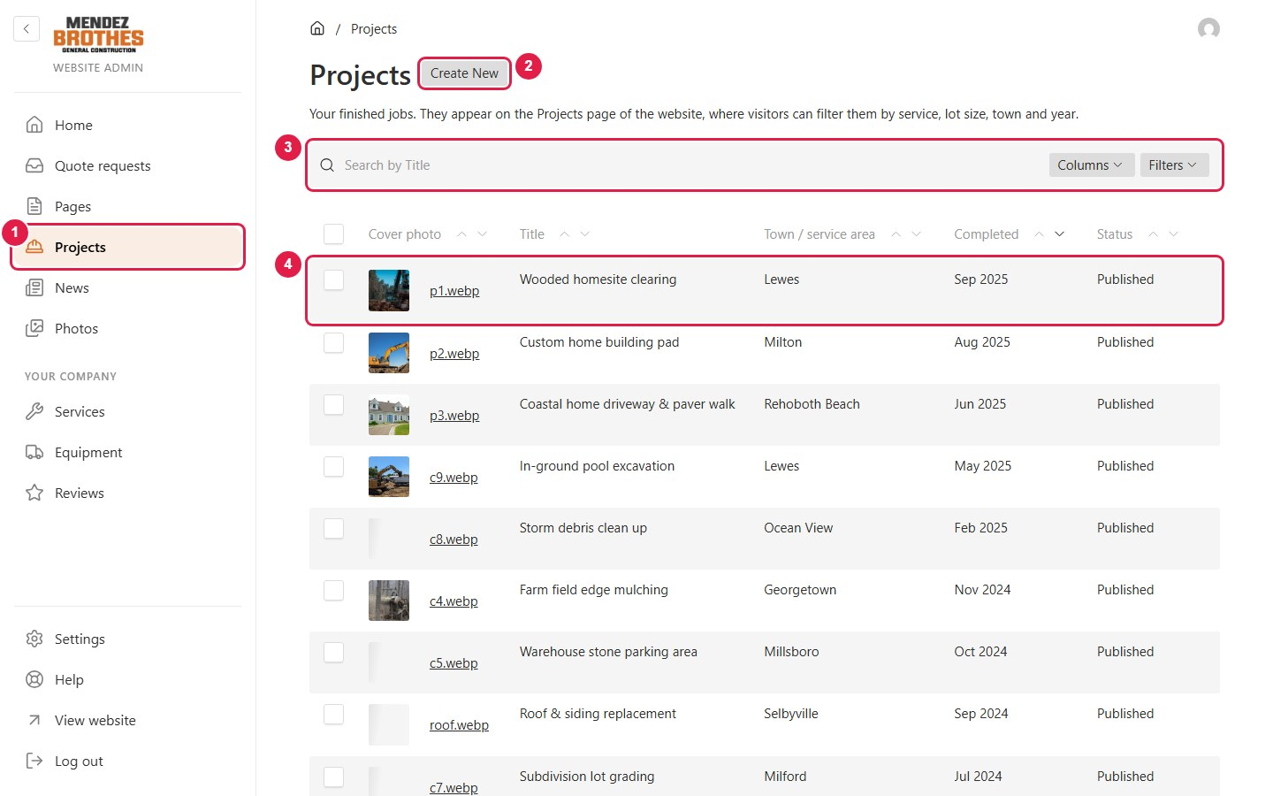
1 Click Projects in the left menu.
2 Click Create New to add a project.
3 Search and filters, useful once the list gets long.
4 Click the name of an existing project to edit it.
Fill in the Overview tab:
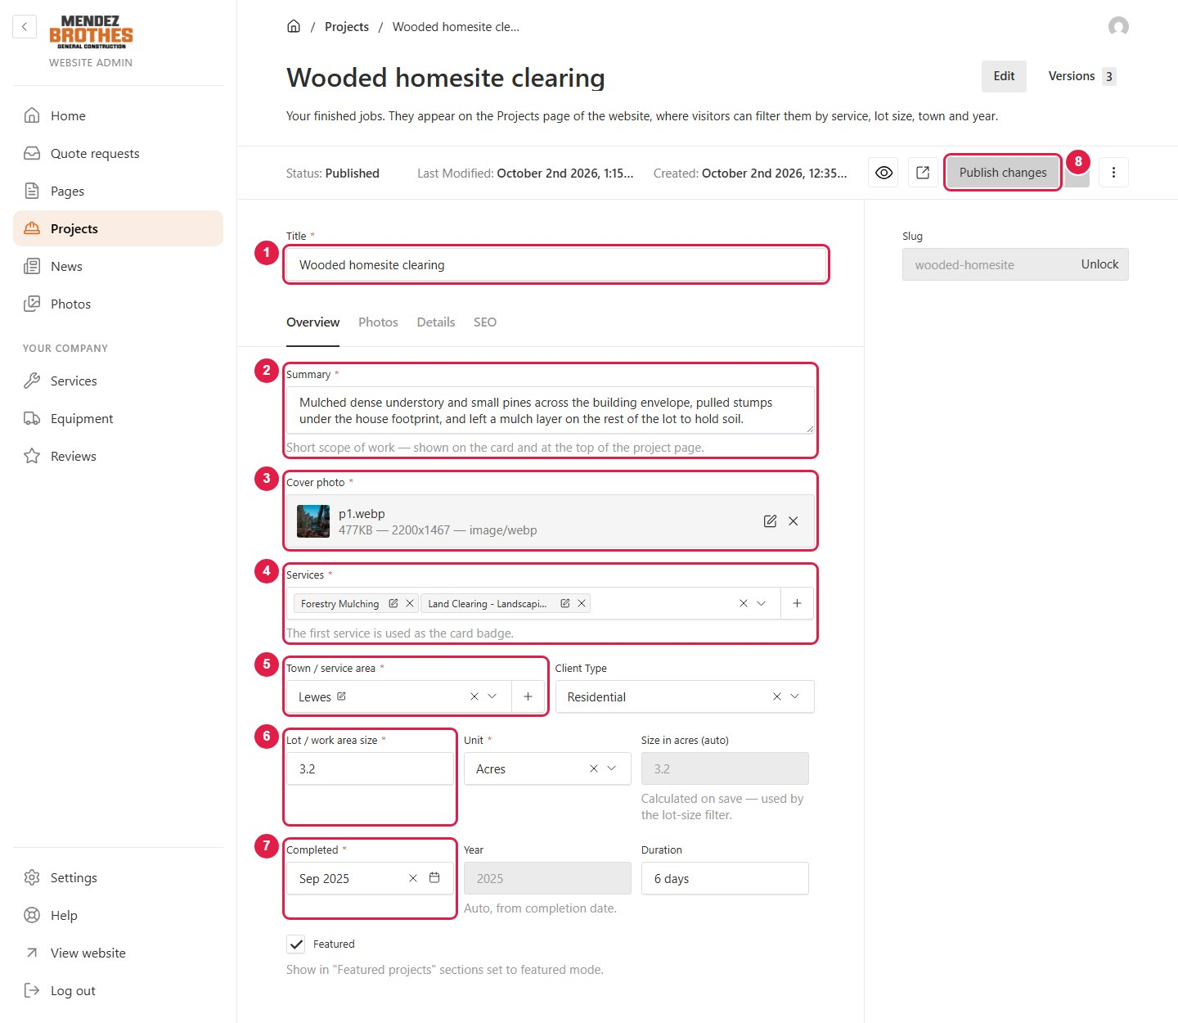
1 Title: the name of the project.
2 Summary: one or two sentences, shown under the title.
3 Cover photo: the main photo. Click the box, then Create New to upload a photo from your computer or Choose from existing to use one already uploaded. To change it, click the X and choose again.
4 Services: pick one or more. The first one is shown on the project card.
5 Town / service area: the town. If it is not in the list, click + to add it.
6 Lot / work area size: the size and its unit (acres or sq ft).
7 Completed: the month the job was finished.
8 Press Publish changes. The project is on the website straight away.
Add more photos in the Photos tab:
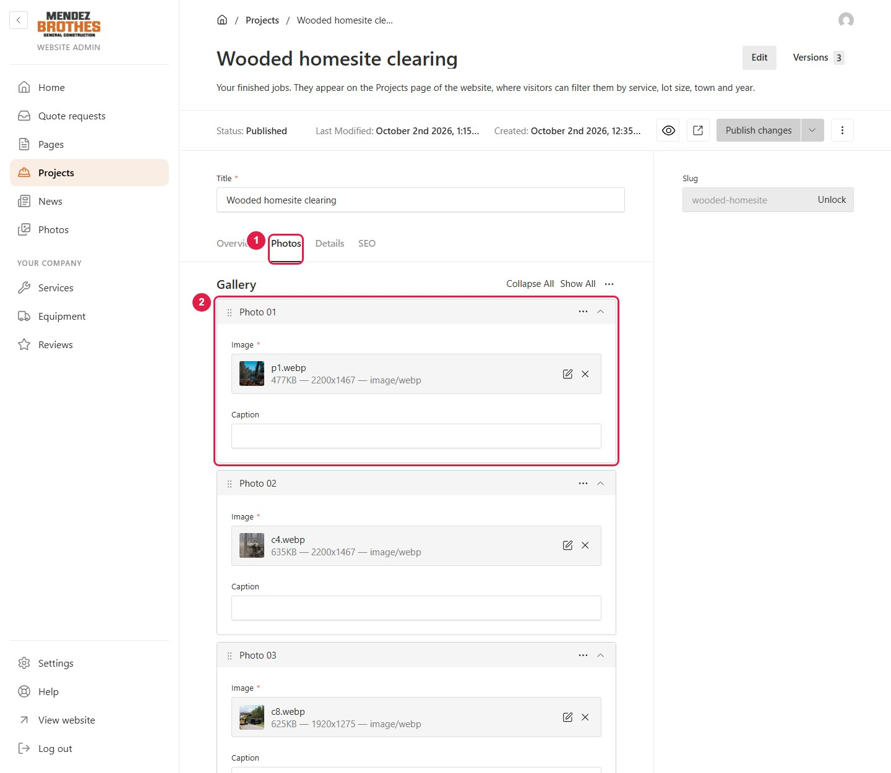
1 Open the Photos tab.
2 Each box is one photo in the gallery, with an optional Caption. Drag the ⠿ handle to change the order.
At the end of the list there is a button to add another photo, and below it a Before / After pair that visitors can compare with a slider.

3.4 Drafts, preview and publishing
This toolbar is on every page, project and news post.
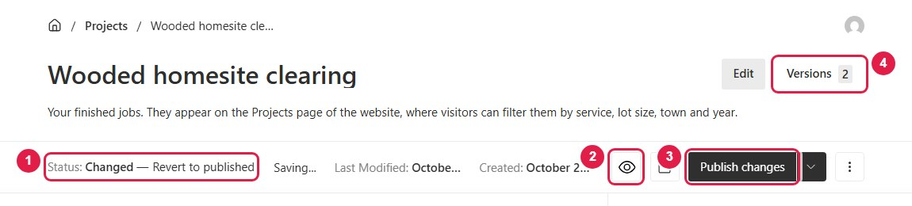
1 Status: "Published" means it is live; "Changed" or "Draft" means there are changes that are not live yet. Your changes are saved as a draft while you type.
2 The eye icon: preview the result next to the form while you edit.
3 Publish changes: put the changes on the website.
4 Versions: the history of changes, used to go back to an older version (section 3.14).

3.5 Writing a news post
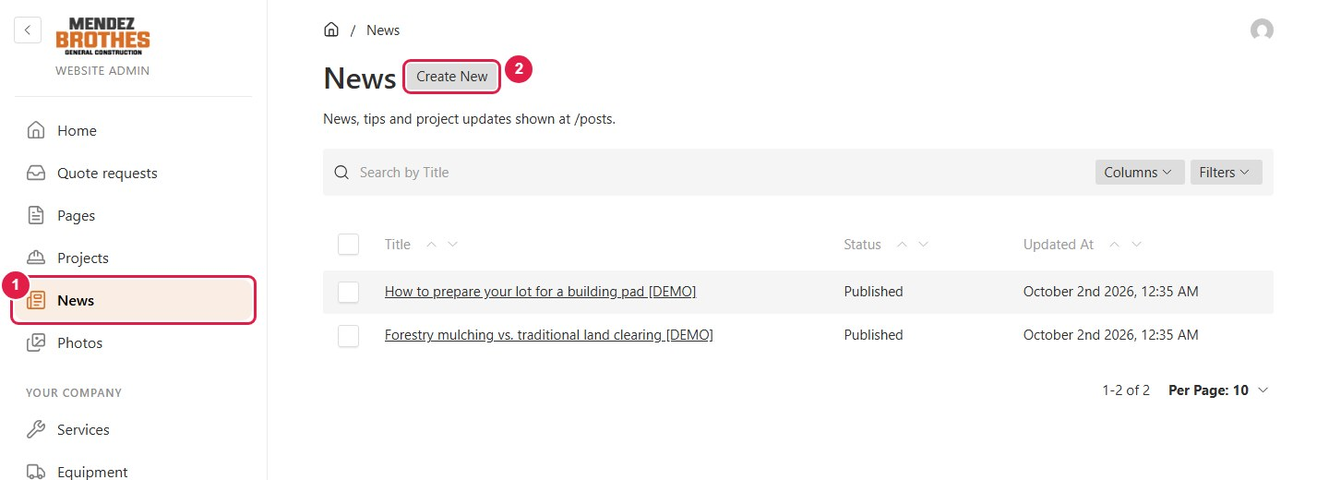
1 Click News.
2 Click Create New.
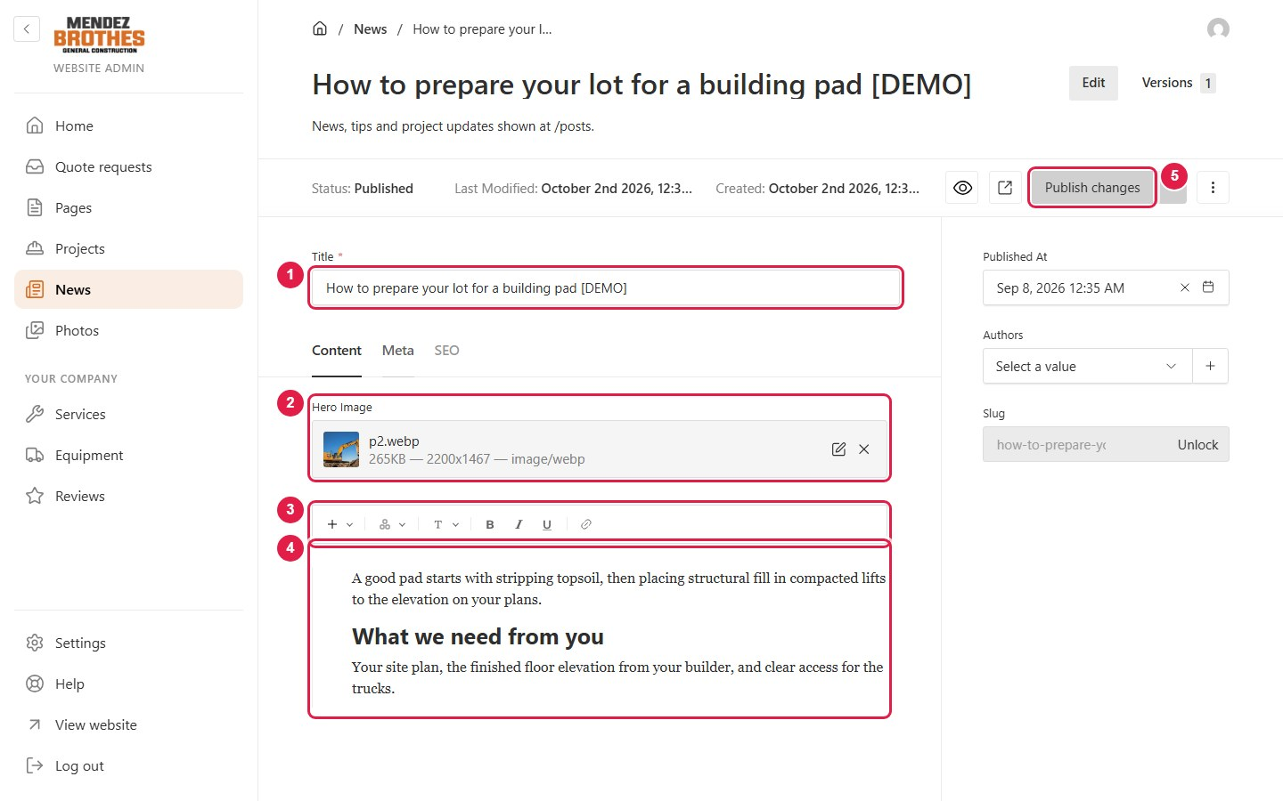
1 Title: the headline.
2 Hero Image: the photo at the top of the post.
3 Formatting bar: sub-headings, bold, italic, links, photos.
4 The text of the post. Type it as you would in Word.
5 Press Publish changes.

3.6 Editing a page
Use this to change the text, photos or layout of Home, About, Equipment & Technology and Contact.
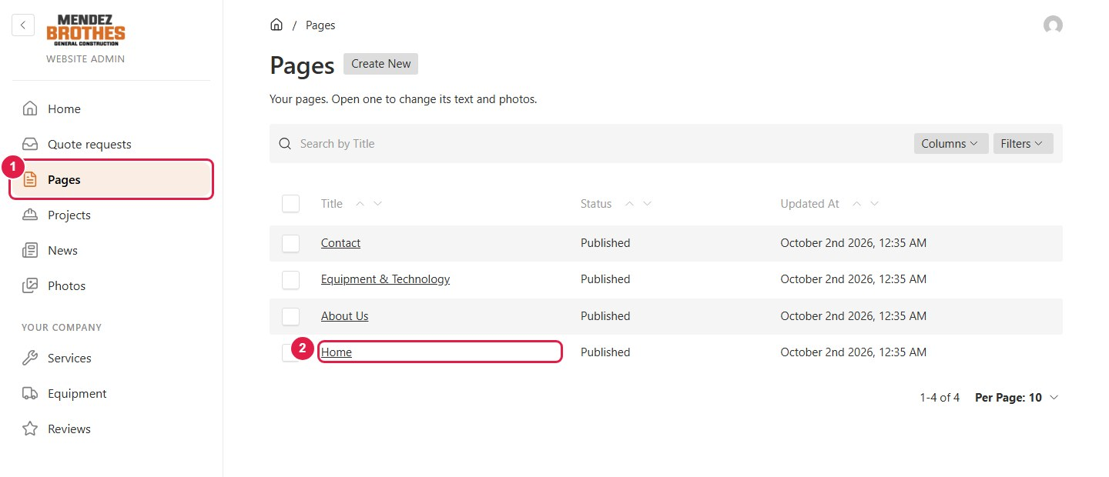
1 Click Pages.
2 Click the page you want to edit, for example Home.
A page is a list of sections, top to bottom, in the same order as on the website:
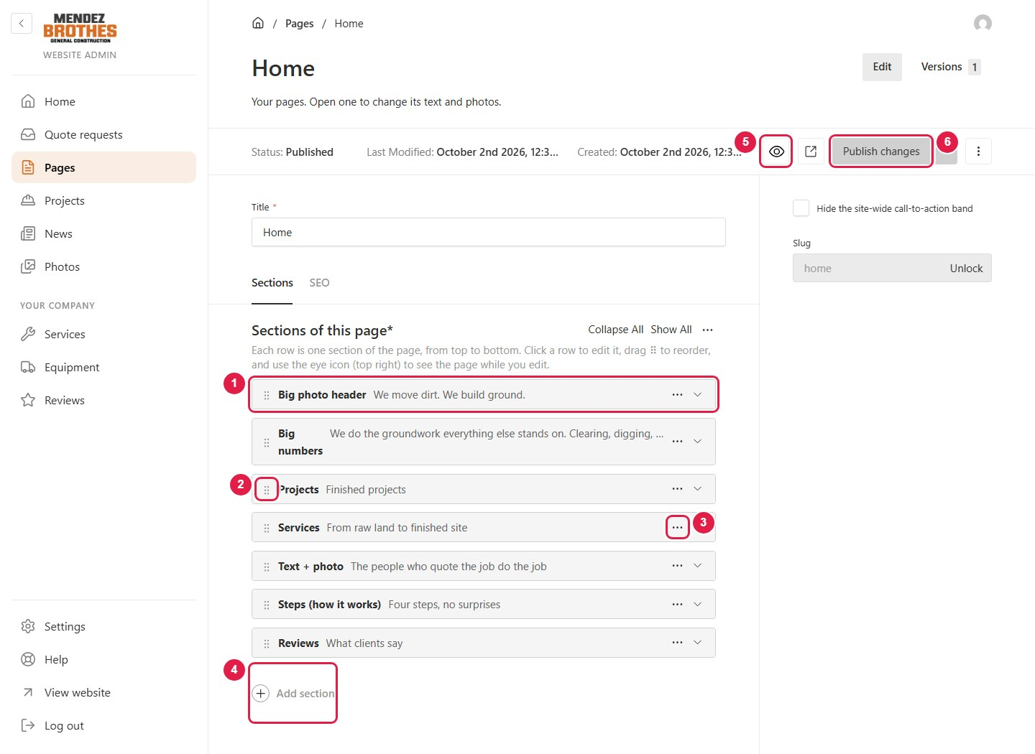
1 Click a row to open that section and edit it.
2 Drag the ⠿ handle to move a section up or down.
3 The ⋯ button: Duplicate or Remove the section.
4 Add section: add a new one.
5 The eye icon: preview the page while you edit.
6 Publish changes: make the changes live.
Inside a section (here, the large photo at the top of Home):
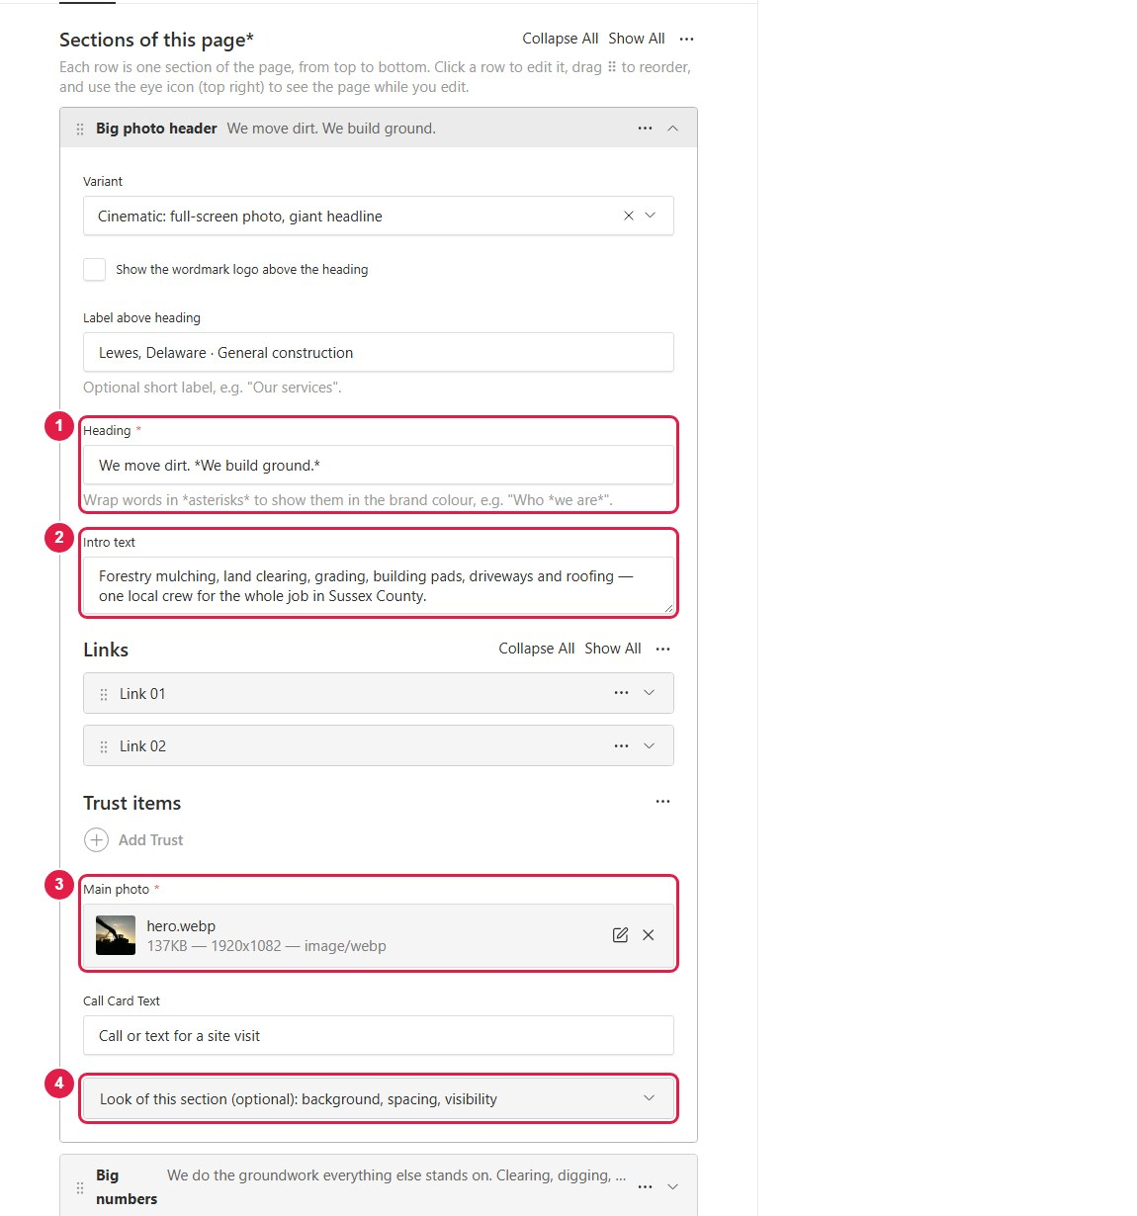
1 Heading: the title. Put stars around words, for example *We build ground.*, to show them in a different colour.
2 Intro text: the short introduction.
3 Main photo: the photo of the section. Click the X, then choose another photo.
4 Look of this section: background, spacing, hide on phones. You rarely need this.
When you press Add section, pick the kind of section by its picture:
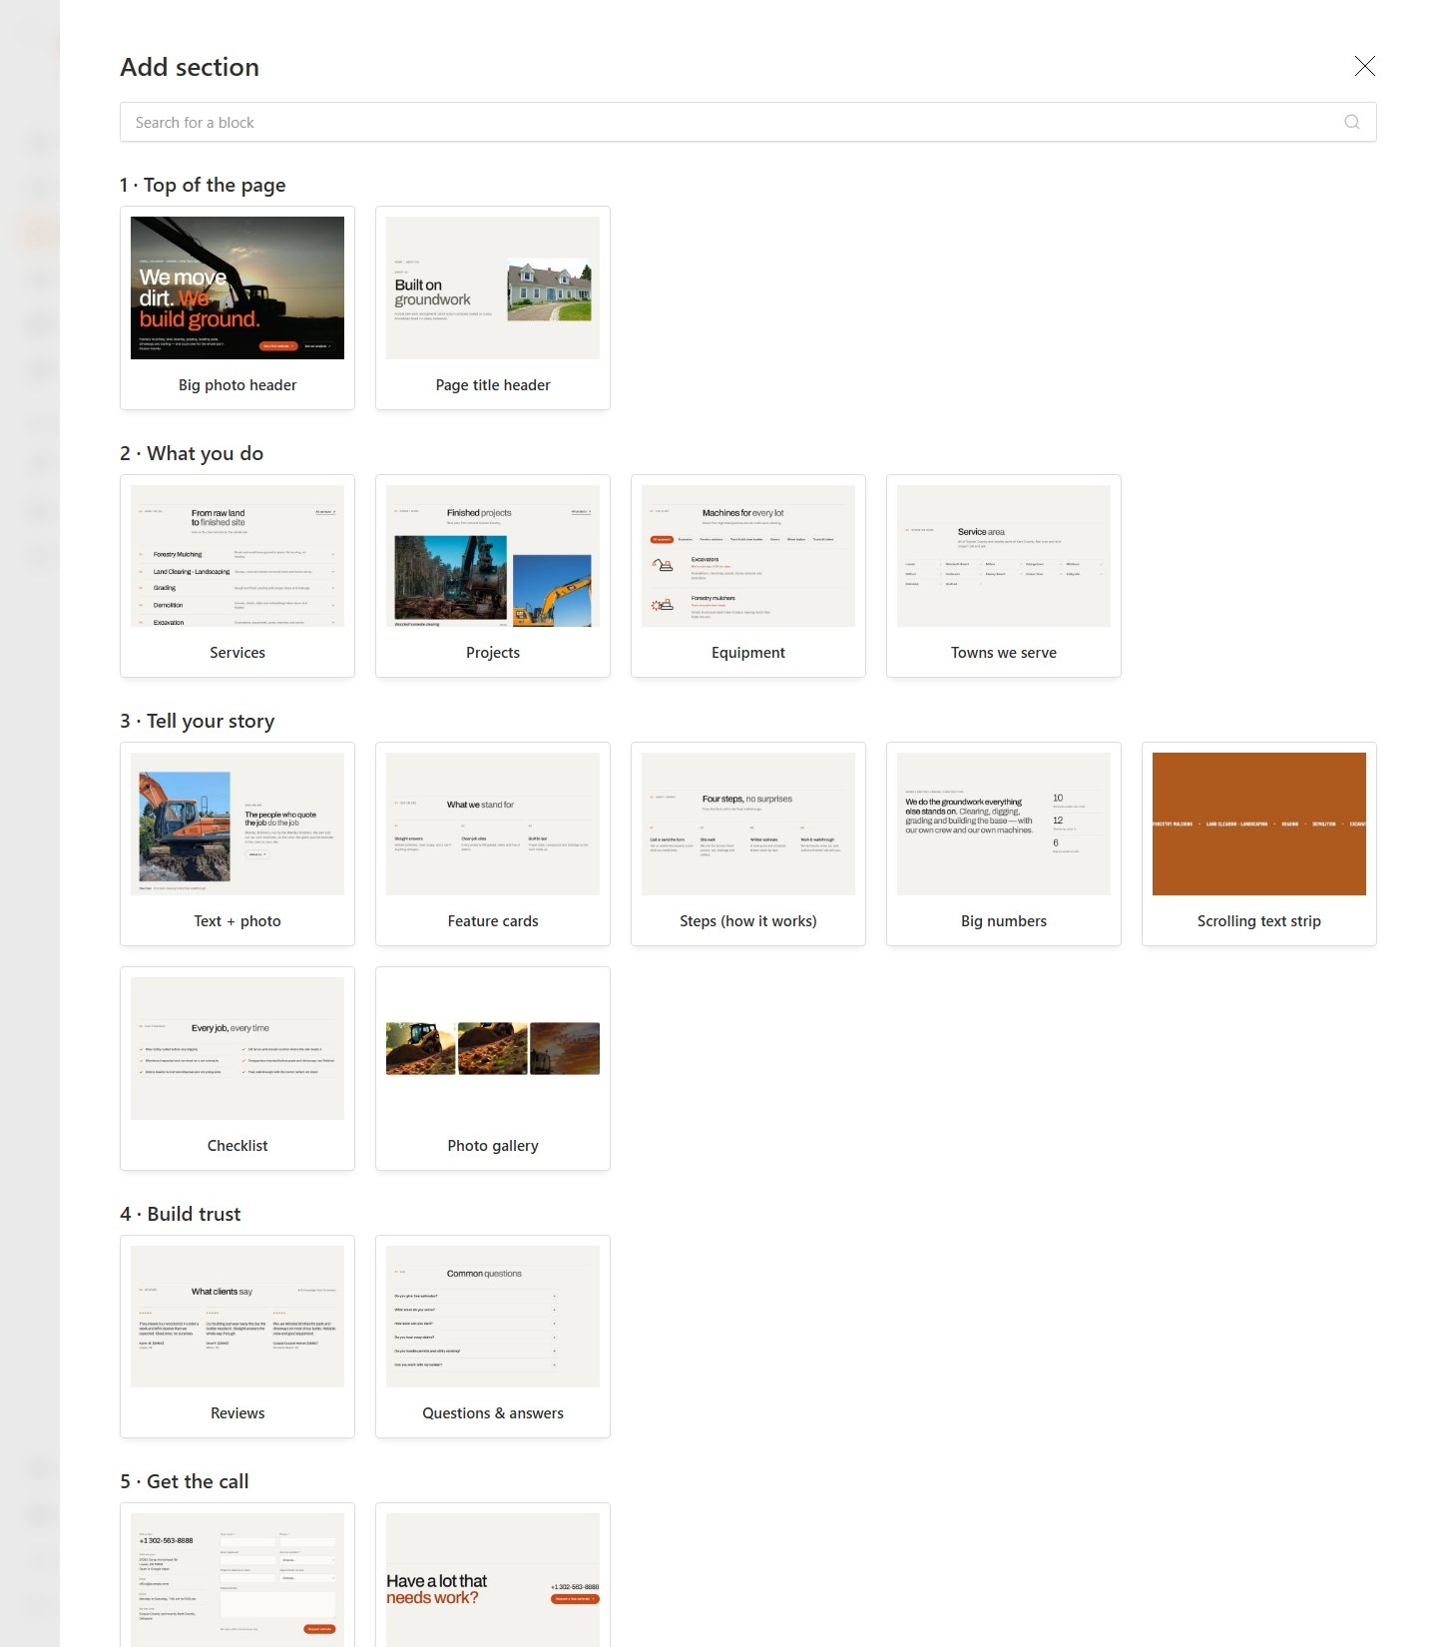
To preview while you edit, click the eye icon. The website appears on the right and follows every change.
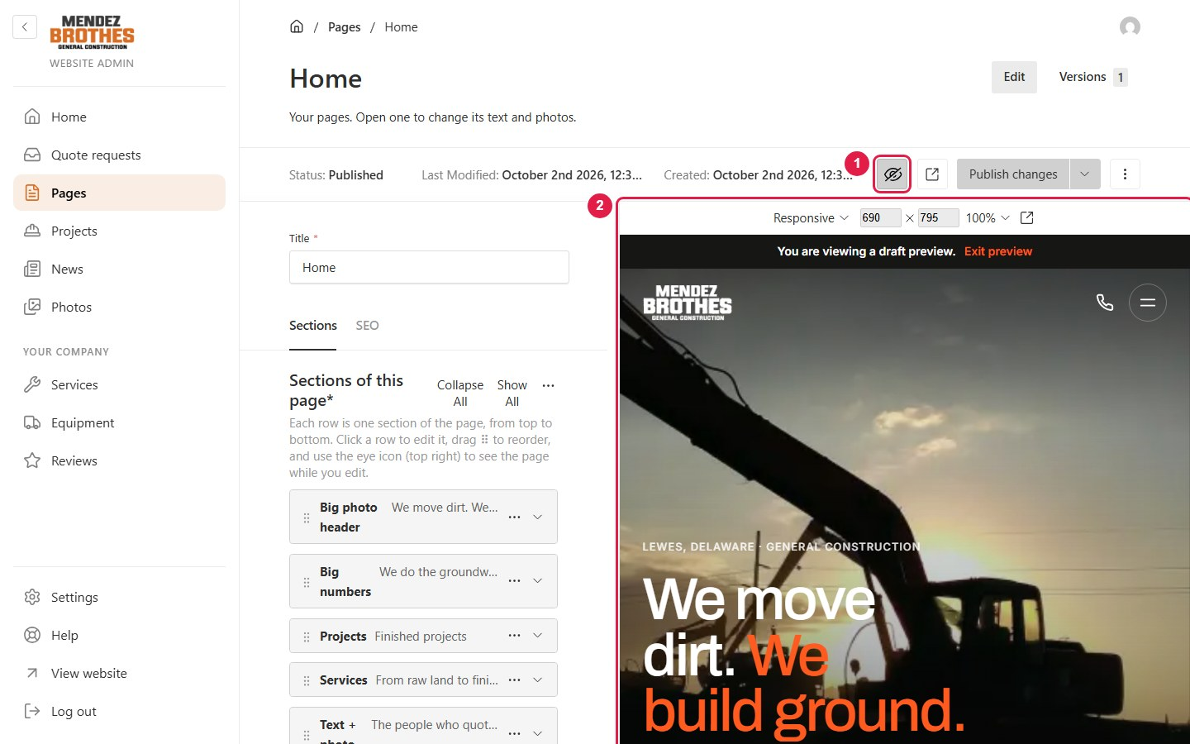
1 Switch the preview on or off.
2 The preview. You can choose phone, tablet or desktop size.

3.7 Photos: uploading and replacing
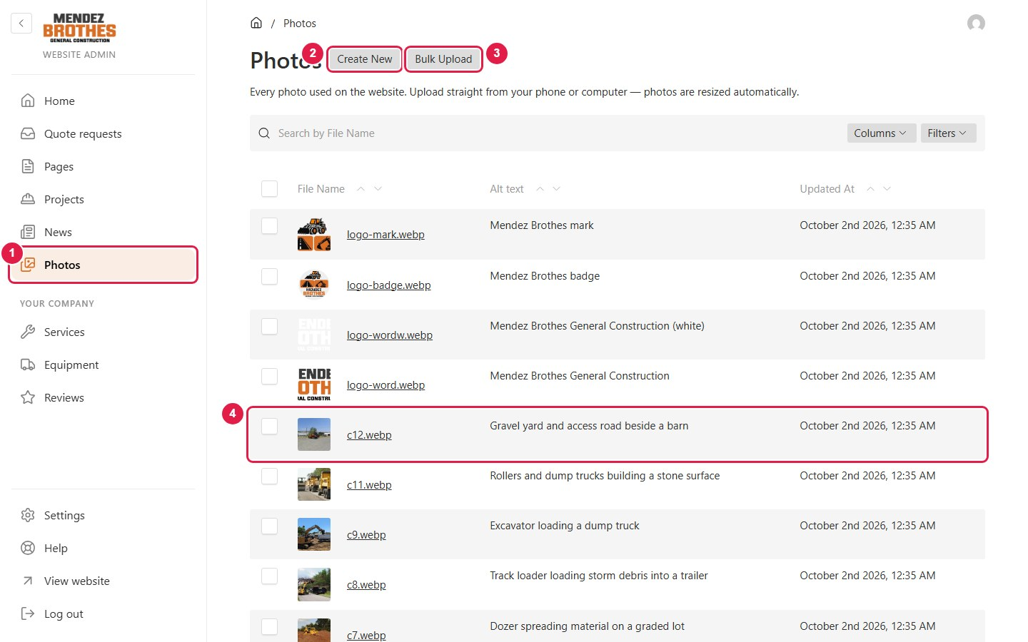
1 Click Photos to open the photo library.
2 Create New: upload one photo.
3 Bulk Upload: upload several photos at once.
4 Click a file name to change its description or replace the file.
Photos straight from a phone are fine. They are resized and compressed automatically, so there is no need to shrink them first.
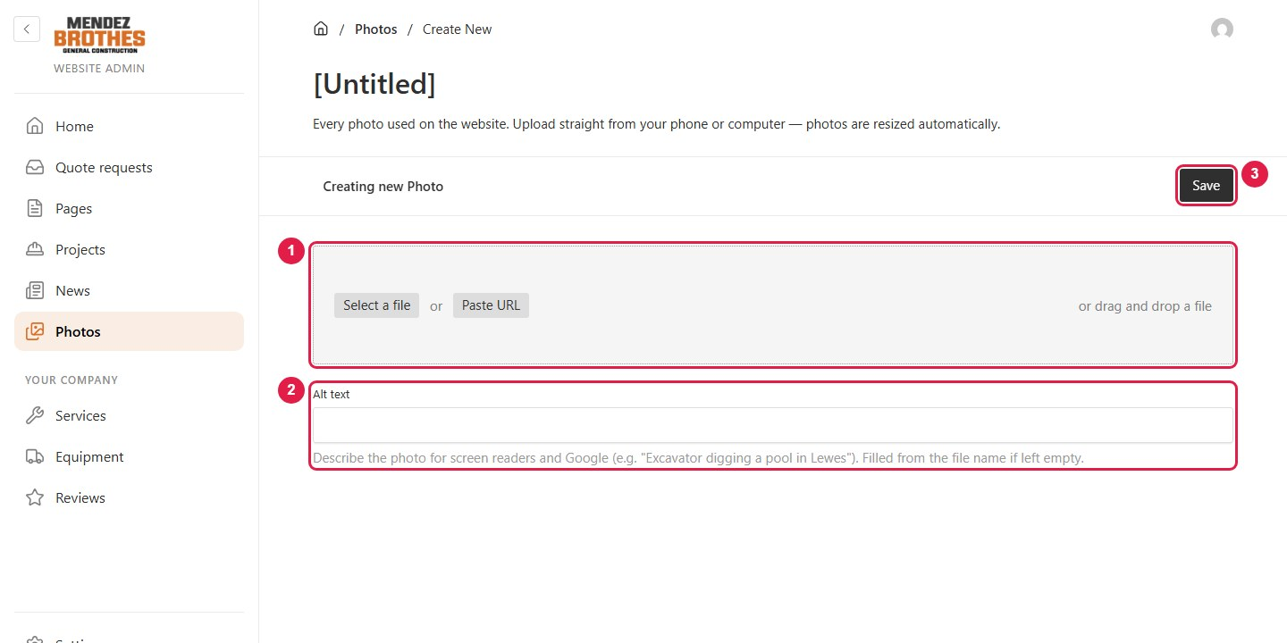
1 Drag a photo from your computer onto this box, or click Select a file.
2 Alt text: a few words saying what the photo shows (it helps Google). If left empty, the file name is used.
3 Press Save.

3.8 Logo and company details
Open Settings at the bottom of the left menu. Everything you set up once and rarely change is here.
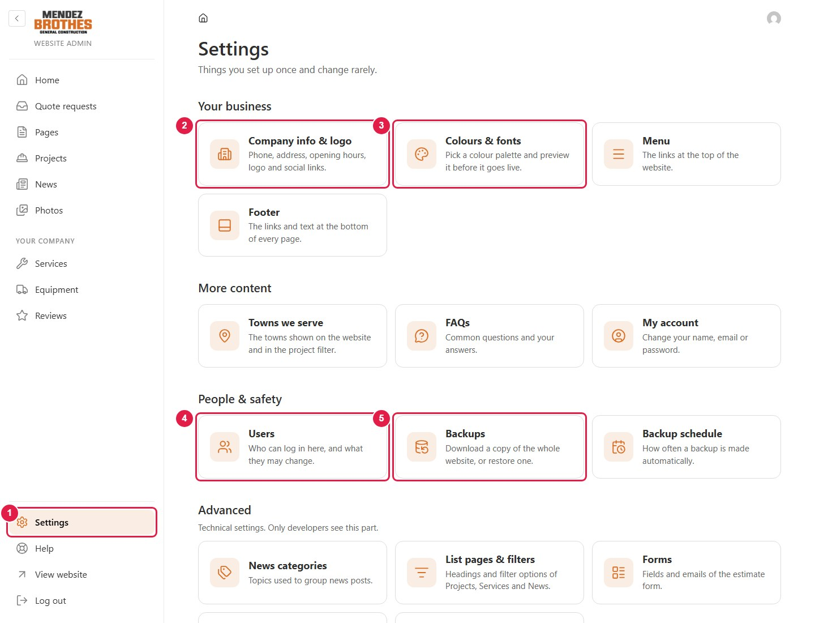
1 Click Settings.
2 Company info & logo: phone, address, opening hours, logo.
3 Colours & fonts: colours and typefaces (section 3.9).
4 Users: logins and roles (section 3.11).
5 Backups (section 3.13).
To change the logo, open Company info & logo:
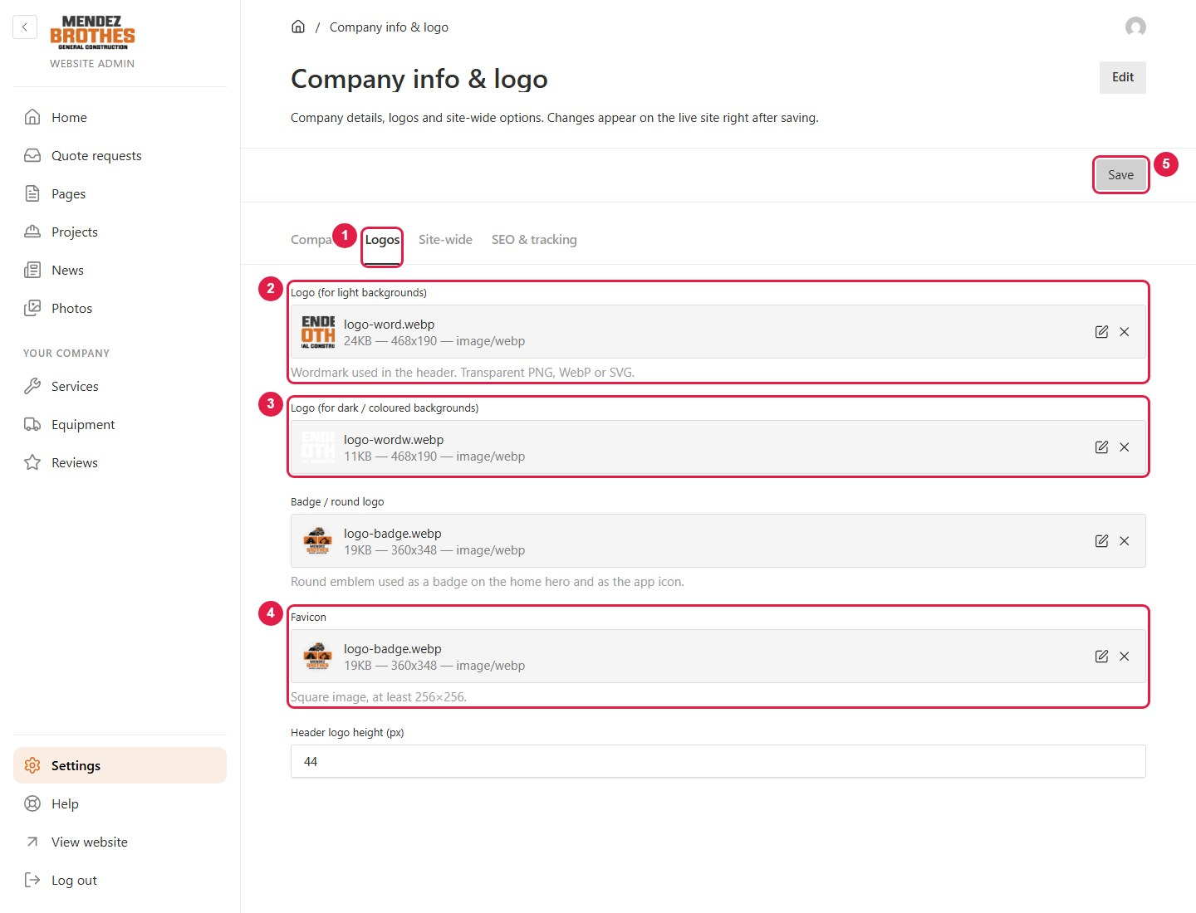
1 Open the Logos tab.
2 The logo for light backgrounds (top of every page). Click the X, then upload the new logo. A PNG with a transparent background works best.
3 The logo for dark backgrounds (the white version), used over the home photo and in the footer.
4 Favicon: the small icon in the browser tab. Use a square image.
5 Press Save. The new logo is used across the whole website.
Phone number, email and address are in the Company tab:
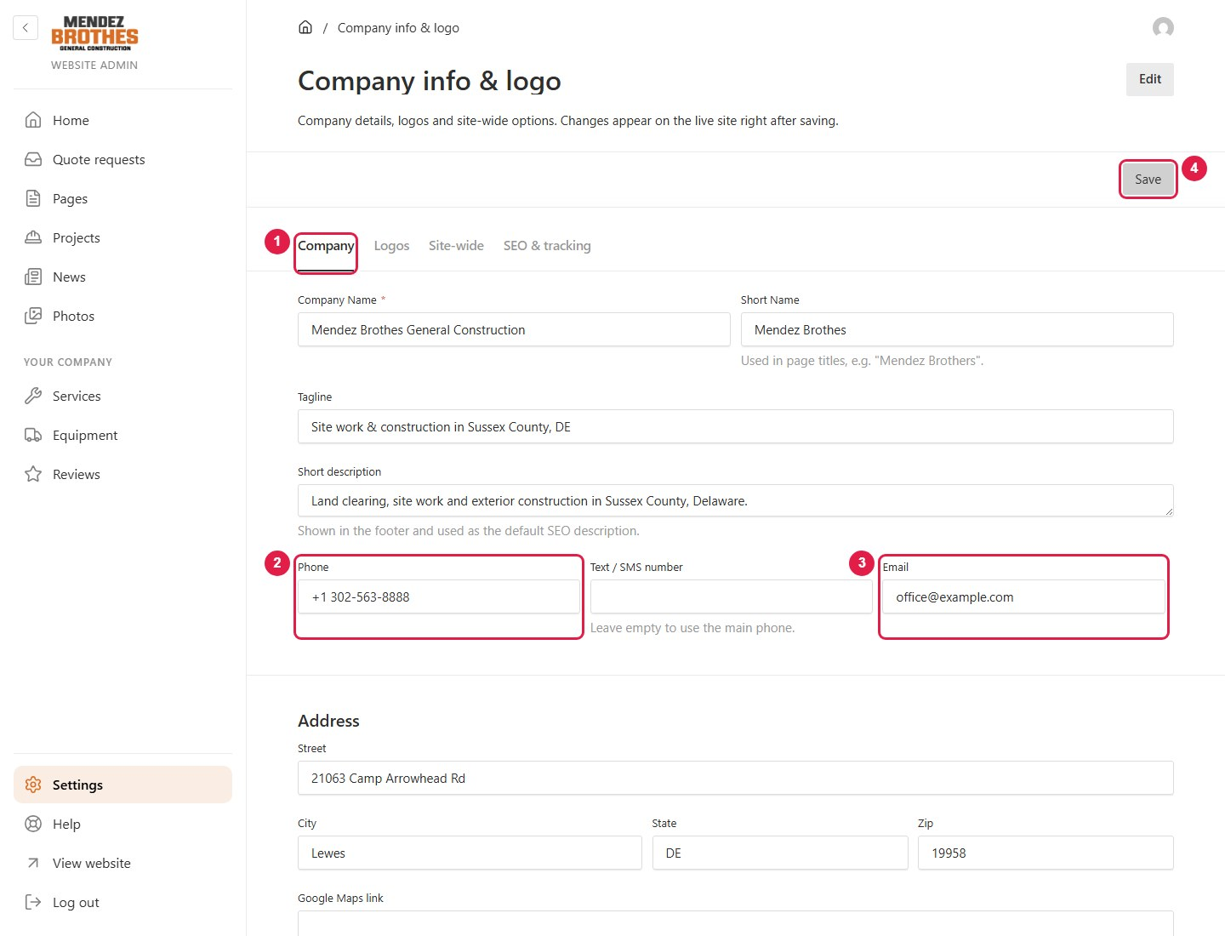
1 Open the Company tab.
2 Phone: shown in the header, the footer and on the Contact page.
3 Email.
4 Press Save.
To change the links in the website menu, open Settings → Menu.
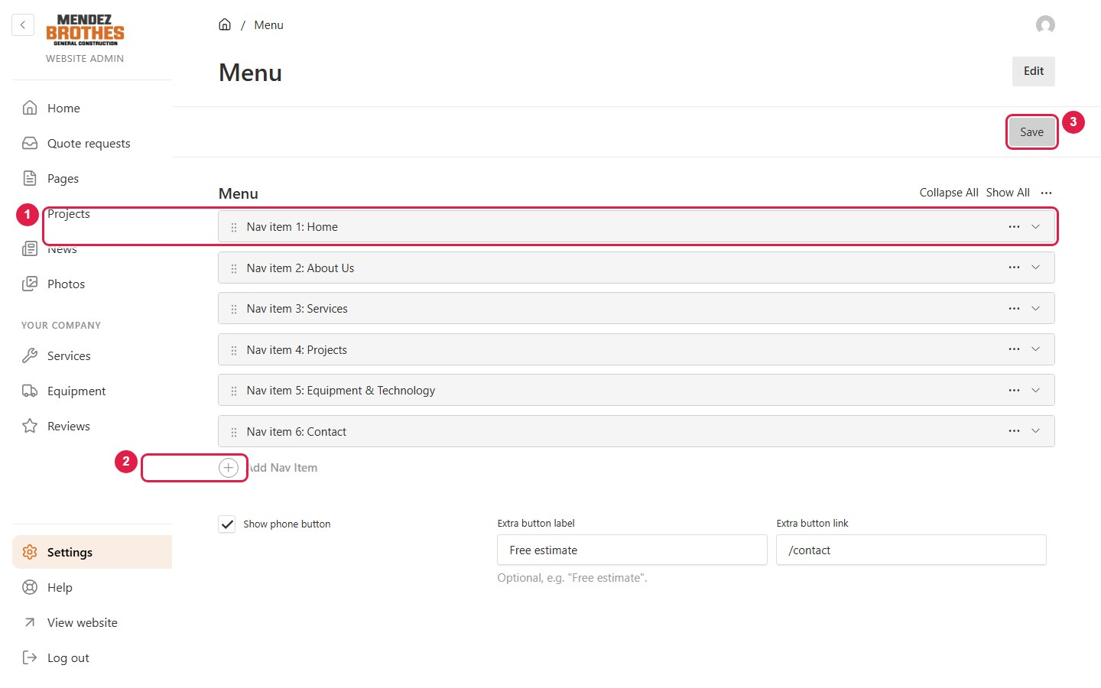
1 Click a row to change its name or link; drag ⠿ to change the order.
2 Add Nav Item: add a new link.
3 Press Save.

3.9 Changing the colours
Open Settings → Colours & fonts.
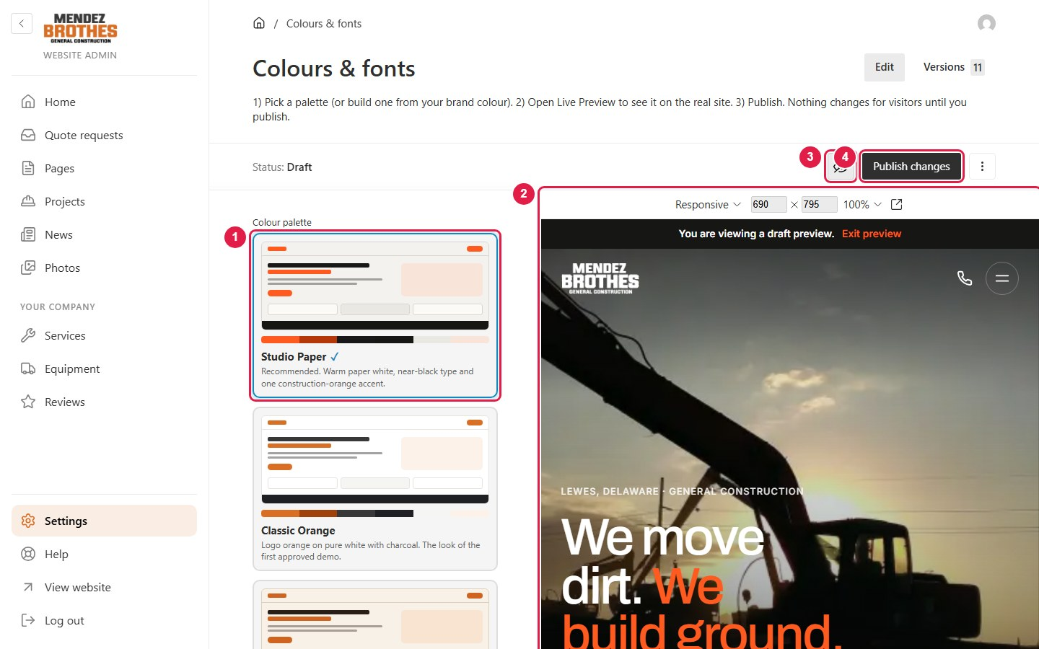
1 Click a palette to choose it.
2 The website appears on the right in the new colours. Visitors still see the old colours at this point.
3 Switch the preview on or off.
4 Happy with it? Press Publish changes. Until you do, the website does not change.
There are 13 ready-made palettes:
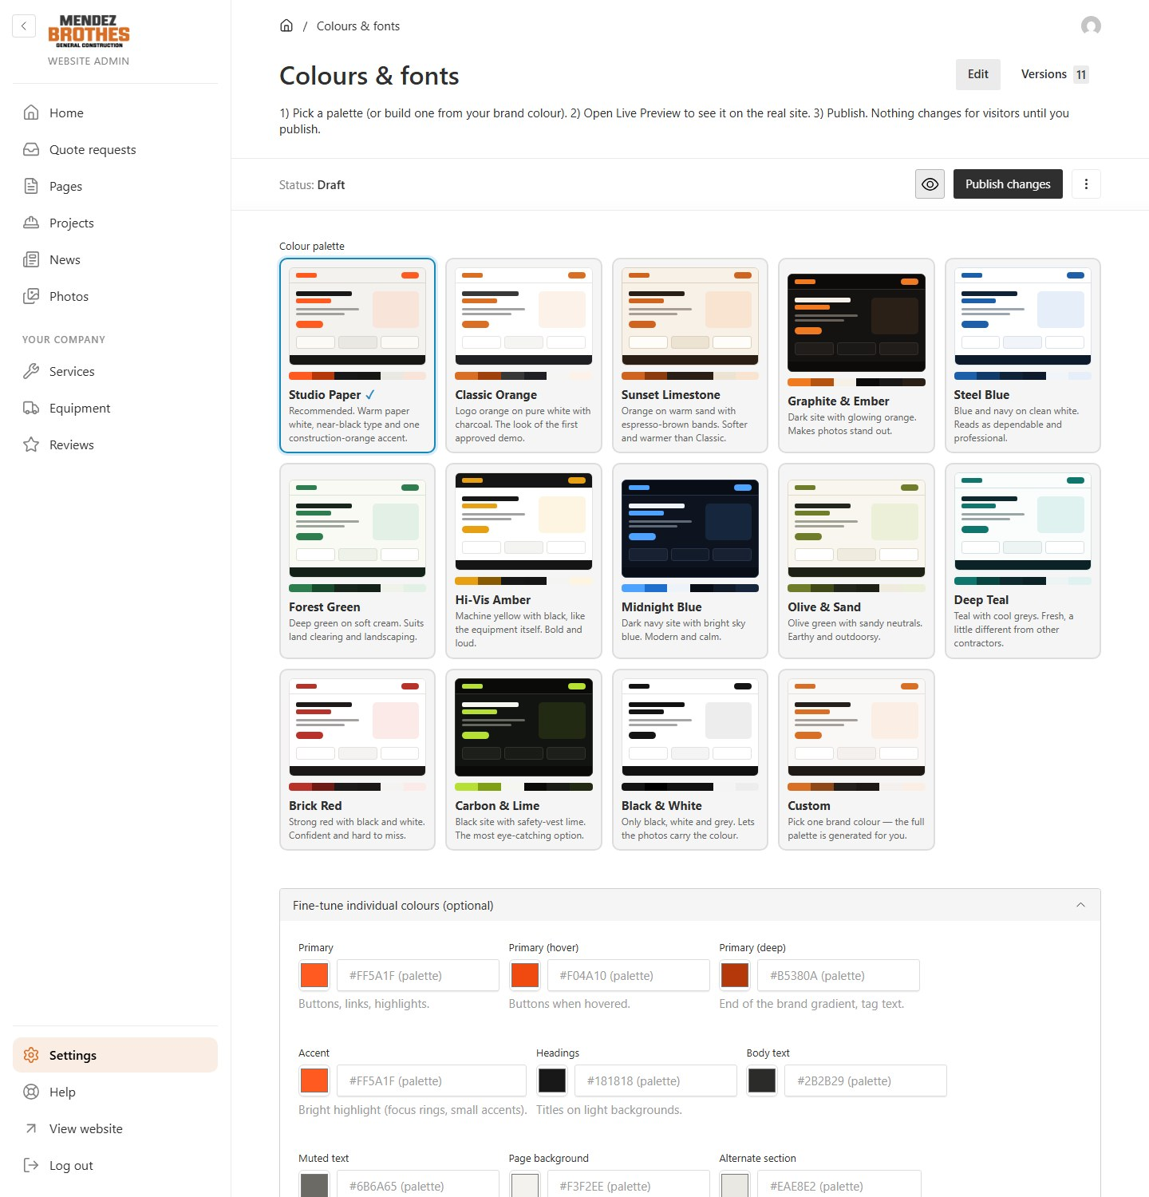
To use your own brand colour, choose Custom:
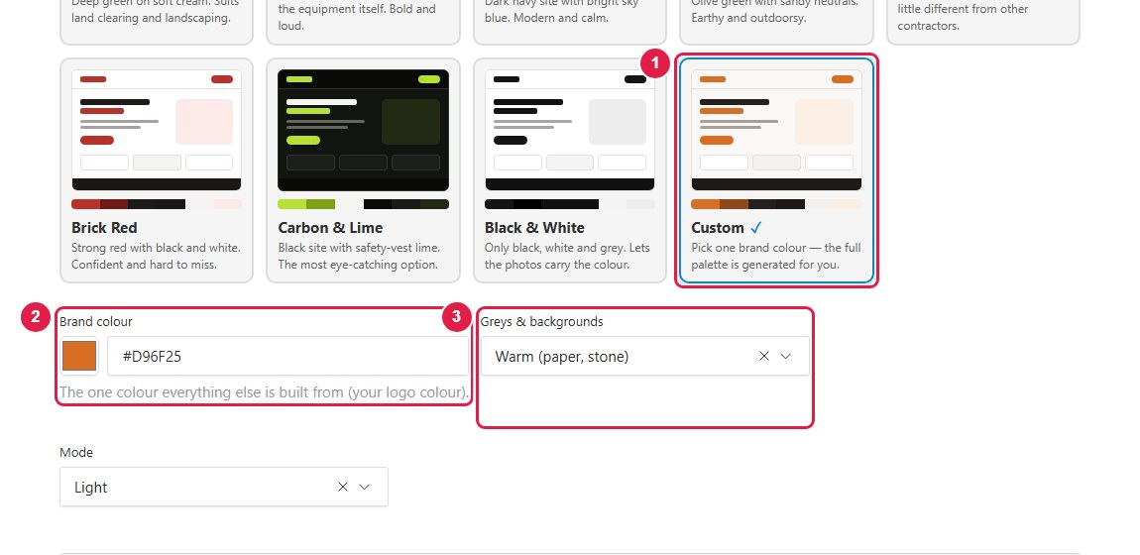
1 Choose the Custom card.
2 Brand colour: click the colour box and pick your colour. The other colours are worked out to match it and stay easy to read.
3 Greys & backgrounds: warm, neutral or cool backgrounds.
Further down the same screen you can change the typefaces, the roundness of corners and the button style. All of it can be previewed before publishing.

3.10 Quote requests
Each time a visitor sends the estimate form, a new request appears on the home screen and under Quote requests.
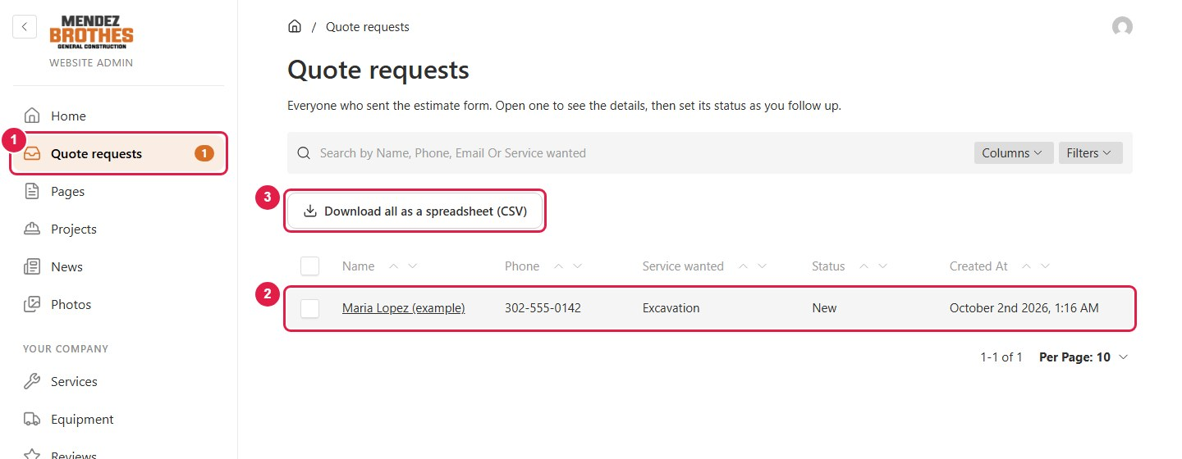
1 Click Quote requests. The orange number is how many are still new.
2 Click a name to see the details.
3 Download the whole list as a spreadsheet that opens in Excel.
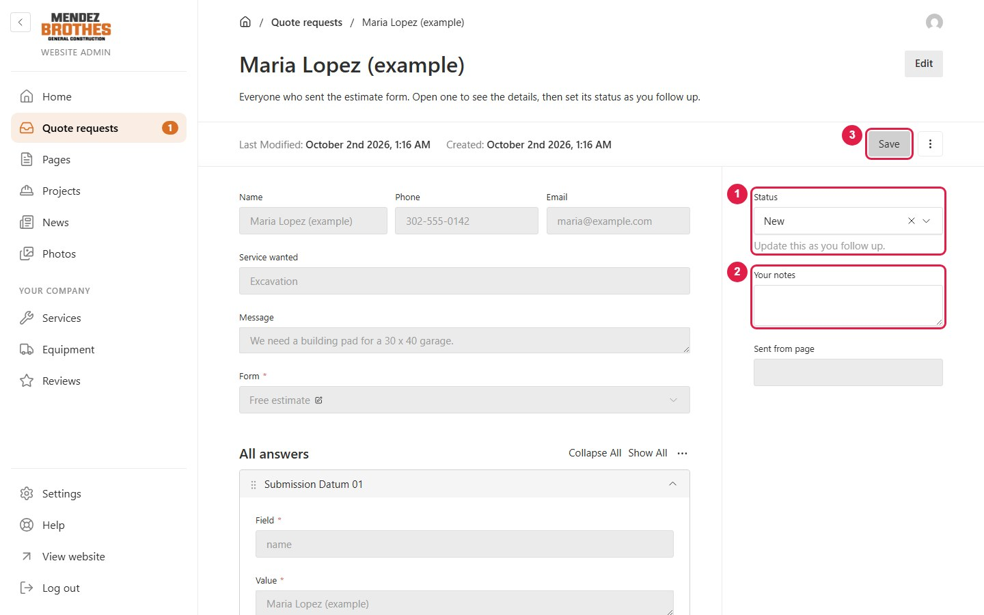
1 Status: update it as you follow up: New → Contacted → Quoted → Won / Lost.
2 Your notes: private notes, never shown to the customer.
3 Press Save.

3.11 Users and roles
Role | For | Can do
Editor | Staff | Add projects and news, edit pages, upload photos, handle quote requests.
Manager | The owner | Everything an Editor can, plus company details, logo, colours, menu, users and backups.
Admin | Technical contact | Everything a Manager can, plus the technical settings.

To add a login, open Settings → Users.
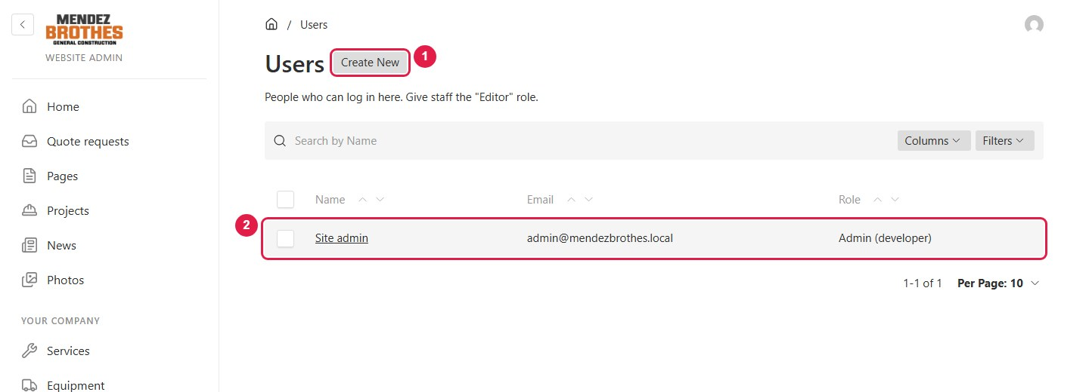
1 Click Create New.
2 Click an existing user to edit them or reset their password.
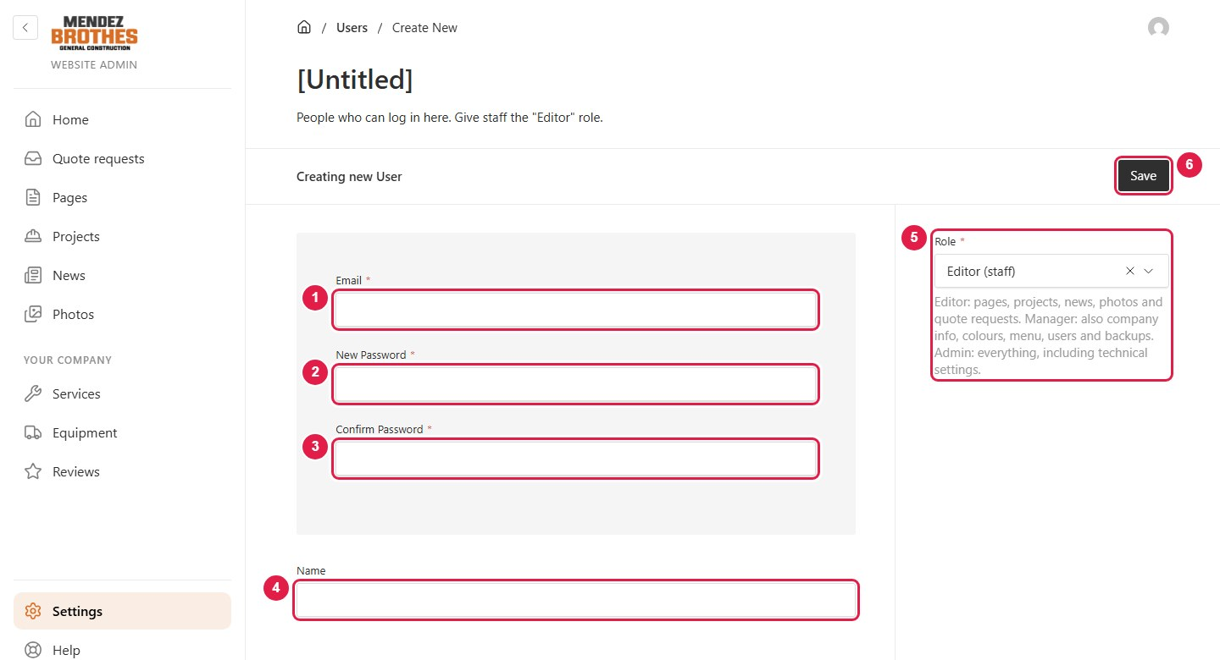
1 Email: what they log in with.
2 New Password: their first password.
3 Confirm Password: the same password again.
4 Name.
5 Role: choose from the table above. For staff, choose "Editor".
6 Press Save, then give the person their email and password.
Only an Admin can give or take away the Admin role. When someone leaves the company, open their user, click the ⋮ button and choose Delete.

3.12 Changing and resetting passwords
To change your own password:
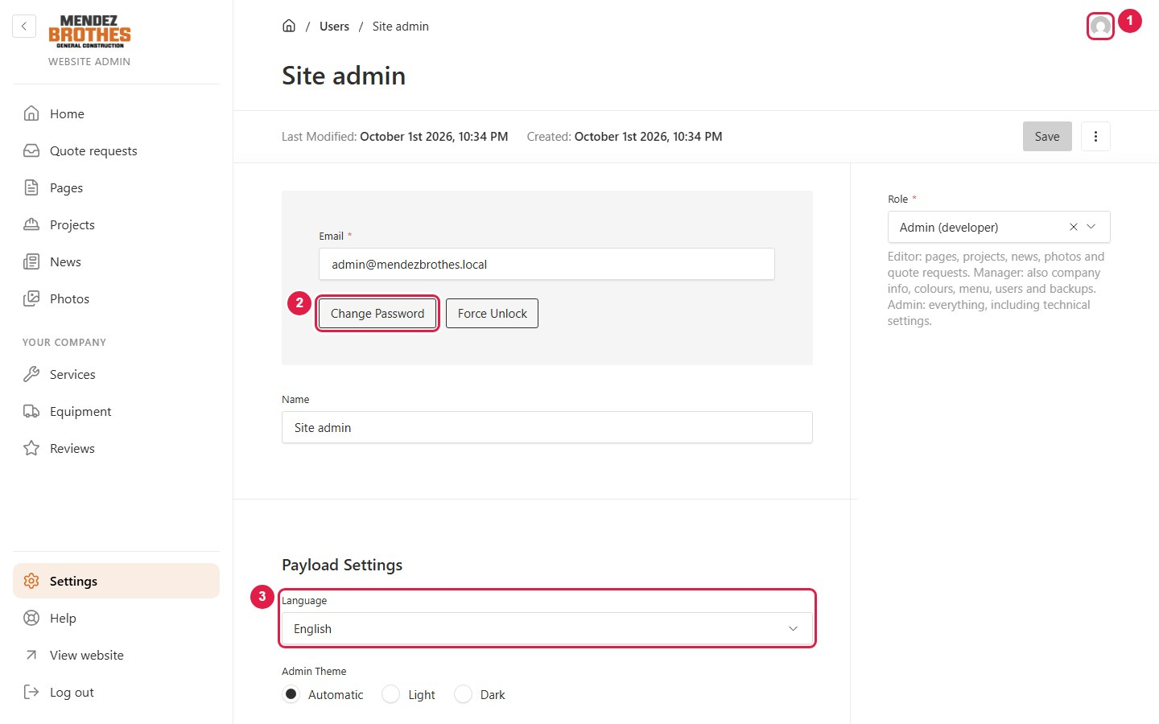
1 Click the account icon in the top right corner.
2 Click Change Password.
3 Language: the language of the admin panel.
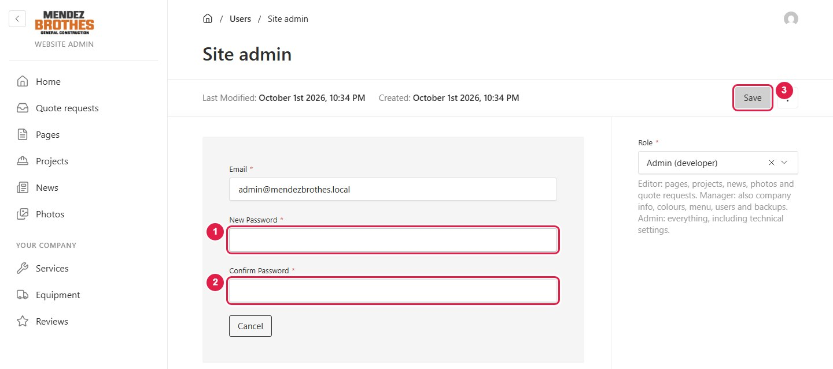
1 Type the new password.
2 Type it again.
3 Press Save.
- Forgot your password: ask a Manager to open Settings → Users, open your user, click Change Password and set a new one.
- Locked out after too many wrong attempts: a Manager opens that user and clicks Force Unlock.
- Use a long password (12 characters or more) that you do not use anywhere else.

3.13 Backups
Open Settings → Backups. A backup holds all the content and photos of the website.
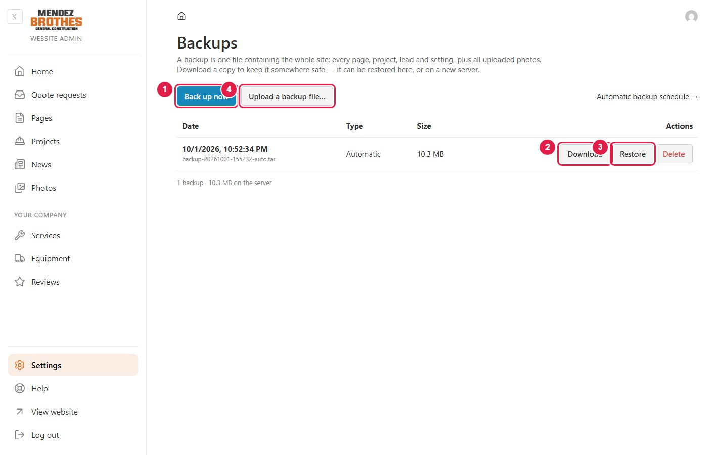
1 Back up now: make a backup straight away. Do this before any large change.
2 Download: save the backup to your computer.
3 Restore: put the website back to how it was at that moment. A safety backup is made first, so a restore can itself be undone.
4 Upload a backup file: bring a backup file in from your computer.
The website backs itself up every day and keeps the last 7. These sit on the same server as the website, so press Download about once a month to keep a copy on a company computer.

3.14 Undoing a mistake
Each time a page, project or post is published, the previous version is kept.
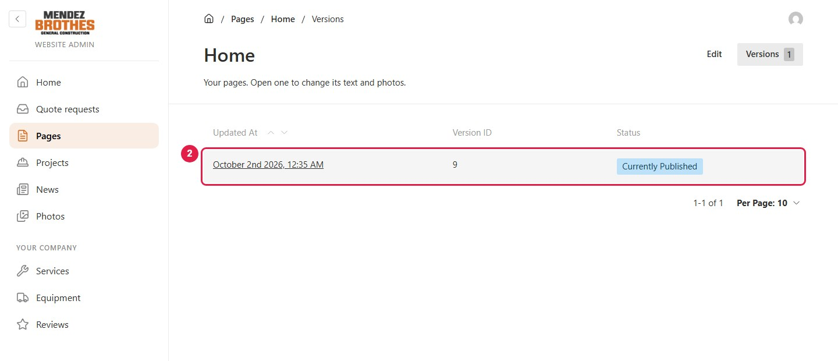
1 Open the page you want to bring back and click the Versions tab.
2 Click the version you want, then press Restore this version.

4. Common questions
Situation | What to do
I changed something but the website looks the same | Check that you pressed Publish changes (or Save). If Status still says "Changed" or "Draft", the change is not live yet.
I want to hide a project or post for now | Open it, click the ⋮ button at the right of the toolbar and choose Unpublish. Press Publish changes to show it again.
A photo is cropped in the wrong place | Open the photo in Photos, click Edit Image and move the focal point onto the part that must stay visible.
No email arrives when someone asks for a quote | Email has not been set up yet. Until it is, new requests are shown on the home screen of the admin panel.
Something was deleted or badly changed | Use Versions for a single page (section 3.14), or Restore a backup for the whole website (section 3.13).
I need a quick reminder while working | Click Help in the left menu.

