Review Notes

Fixed Assets Register

Section 1: Report vs User Interface (Accounting/Assets/Assets)

1. Assets Description → Create new field on menu Accounting/Assets/Assets. Name 'Product Description'. (please see figure 1 and 2.)

2. Location → Create new field on menu Accounting/Assets/Assets. Name 'Asset Location'. (please see figure 1 and 2.)

3. Requisition Date = Purchase Date field on Accounting/Assets/Assets. (please see figure 1 and 2.)

4. Assets are run in Report when Assets Status = Running only. (Please see figure 1 and 2)

5. Amount is valid (Please see figure 1 and 3) when

- Assets status = Running and Depreciation is Posted.

- Amount, Period and Effective date is from related Journal Entries (account move).

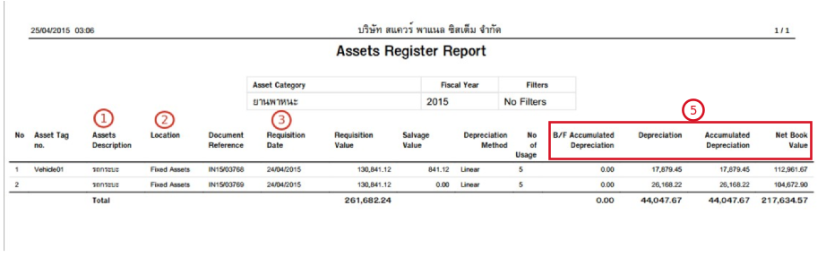

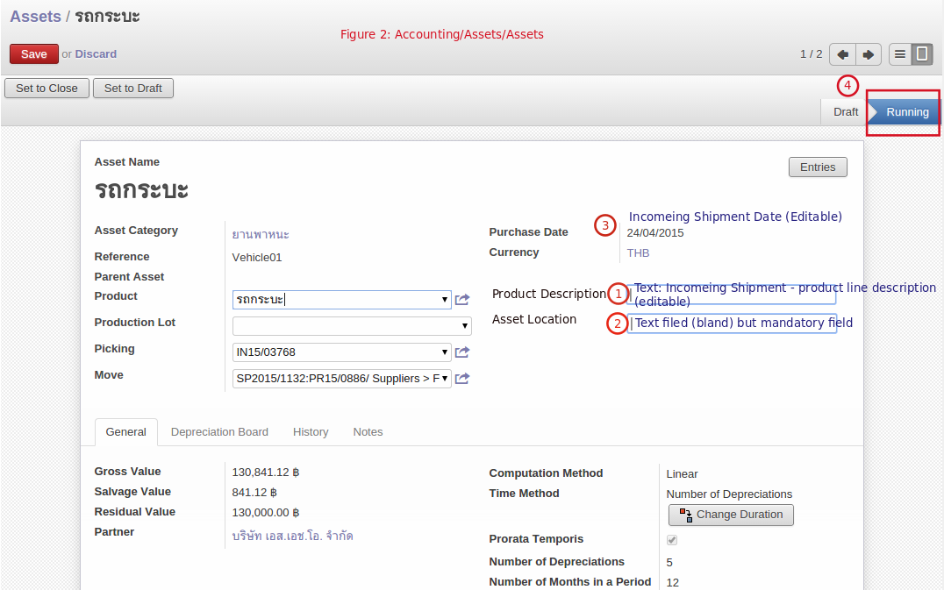

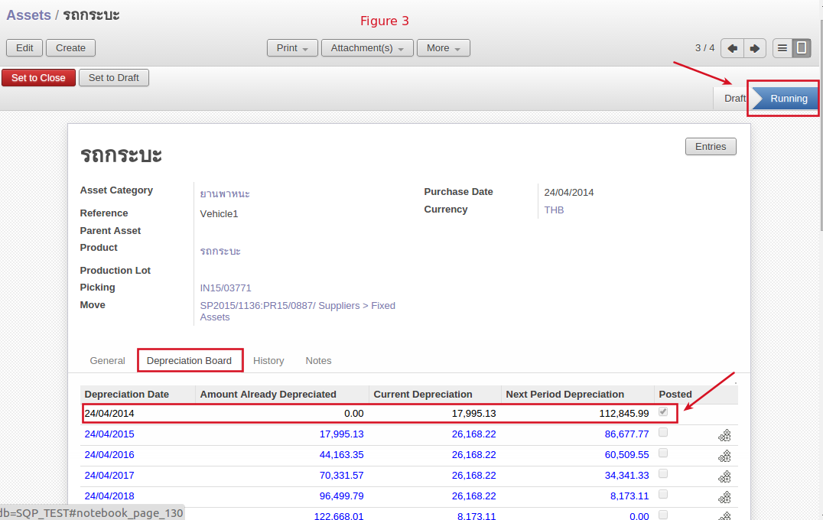

Section 2: Calculation (Figure 4 and 5)

Sample case: There are 2 assets, Vehicle 1 and Car 1

Vehicle 1: Depreciated by year for 5 years

Car 1: Depreciated by month for 5 years (60 months)

**Requirements:** Report has to show depreciation, Accumulated Depreciation and Net Book Value in line with Depreciation board (posted), which link to Journal Entries (Accoutn move) and Report filters as user selection.

Sample: Car 1: Depreciated by month for 5 years (60 months) and post Depreciation every end of months starting from 30/04/2014 (the first month of purchasing) until 31/12/2014

Journal Entries: There will be 9 Journal Entries related to this Assets.

Report filter: If user select Period/Date from x to y,

- B/F Accumulated Depreciation (B) = Amount Already Depreciated of x.

- Depreciation (C) = Sum of Depreciation for x to y.

- Accumulated Depreciation = (B) + (C) no change from spreadsheet design.

Figure 4

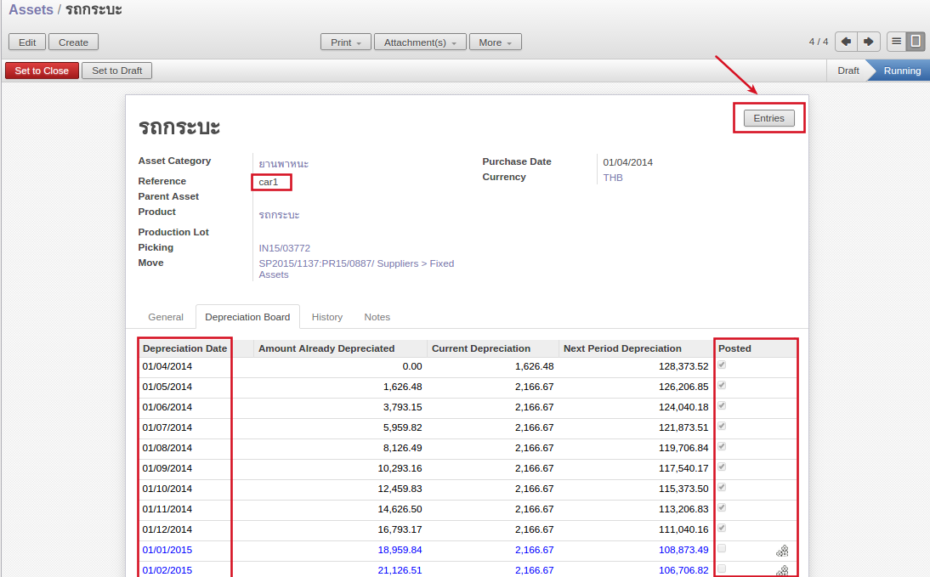

Figure 5

