**Ideation and Stakeholder need analysis**

**Description:**

The objective of the Capstone project is to build reliable communication protocols like UART/I2C over FPGA board on Altera Cyclone II to easily interface sensors and different module to interface the Input and Output via FPGA boards using the unique features of the FPGA board. It will help the people to understand the FPGA and communication protocol structure and use of it while testing.

### **Project Proposal:**

A Field-Programmable Gate Array (FPGA) is a semiconductor device based on a matrix of configurable logic blocks (CLBs) connected via programmable interconnects. FPGAs are reconfigurable, meaning that the logic functions within the FPGA can be reprogrammed to implement different designs or algorithms after manufacturing. This reconfigurability contrasts with fixed-function Application-Specific Integrated Circuits (ASICs), making FPGAs highly versatile for prototyping and deployment in a wide range of applications.

The FPGA boards are quite faster than usual microcontroller because of its capability to adapt the advantage of different parameter like high speed parallel processing, custom GPIO interfaces, frequency trading, While FPGAs offer superior hardware-level performance and flexibility, microcontrollers are generally better for cost-sensitive or low-power applications with sequential tasks, thanks to their easier development process and lower unit cost.

Here we can use FPGA board of Altera Cyclone II or Xilinx Nexys 4 DDR, which are very well known FPGA Board for implementing Prototype of HDL design on it and test its compatibility for moving forward the Chip manufacturing or for making a design for an system in less time to build application with low cost.

**Altera Cyclone II with EP2C5T144 chip**

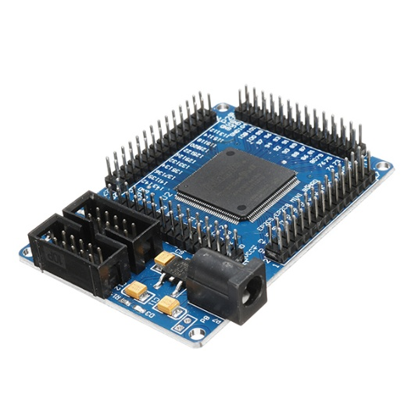

* EPROM chip configuration using EPCS4, the size of 4Mbit
* Onboard 50M active patch crystal (Crystal Slaughter halfback)
* Power supply with a largemouth outlet, single 5V power supply
* Board has power indicator and resets switch
* Onboard 3 SMD LED, the LED test can be done an experiment, more experiments using lead to complete

**Nexys 4 DDR with XC7A100TCS0324A**

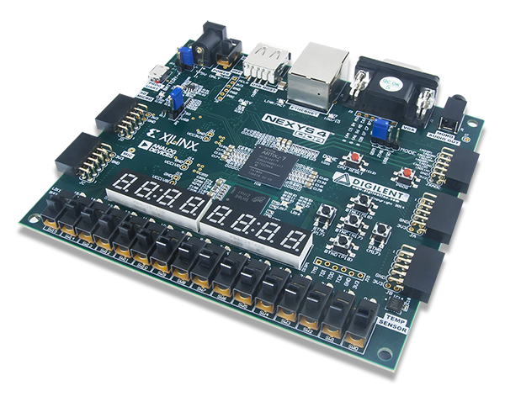 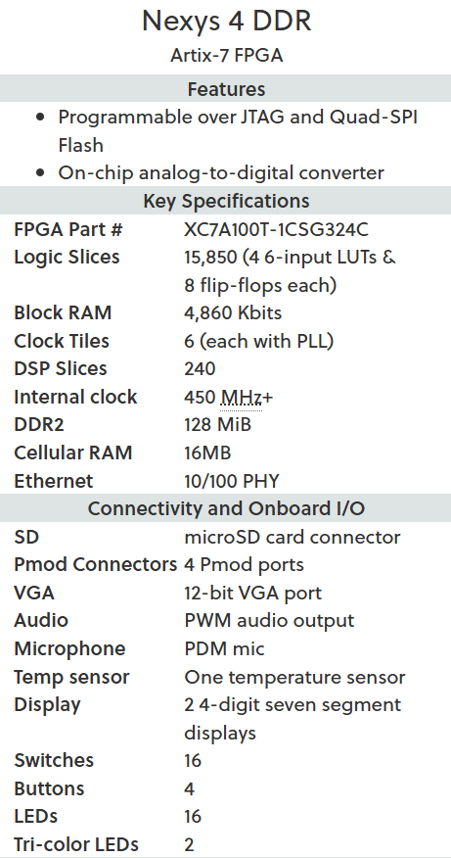

The use of FPGA board is identified above but also there is need to look at the Practical implementation of Communication Protocols and such topics to gain experience the complexity of real time application. There are some embedded tools and software which are able to do this kind of practical implementation but in reality, embedded focuses over only Programming languages like C, C++, Python, Rust and Assembly. Hardware Description language is rarely used to build to give exposure to these protocols on FPGA.

**Stakeholder Identification:**

There are many stakeholder for this problem statement like Students, Educators, University, Hardware developer and many technician who are unaware about FPGA capabilities.

Students: They need simple and practical examples to understand FPGA concepts and protocols like UART, SPI, and I2C. Many students find textbooks too theoretical, so they want real, working hardware designs they can practice on.

Educators/University: Teachers need lab-ready projects to help students connect theory with hands-on experiments in digital design and FPGA prototyping.

Hardware Developer/Technicians: – Beginners in FPGA and digital design want affordable and accessible ways to test ideas before moving to industry-level ASIC or embedded system development.

**Needs Analysis:**

The above stakeholders in some way defines the lack of information and technologies when this kind of application might be required on high level which can be fulfilled by FPGA boards. By implementation of FPGA board, we can get quick prototyping for Communications protocols with Trial-and-Error process.   
Also, this can be useful to student/people who aims to target VLSI industries to learn about FPGA applications.   
  
**Problem Statement:**

In digital system design, reliable communication between sensors, modules, and processors is essential. While protocols like UART, SPI, and I2C are widely used in embedded systems and IoT devices, most available in microcontroller-based implementations.

To gain practical exposure to FPGA-based system design and understand how commonly used communication protocols such as UART, SPI, and I2C can be implemented in hardware like FPGA. Also it can help understand real time prototyping and ASIC design flow via simulation and implementation of it.

**Solution Ideation:**

To address this problem, the project proposes the following solutions:

**FPGA-Based Protocol Implementation Kit**

* Create Verilog designs for UART, SPI, and I2C protocols on Cyclone II FPGA or Nexys4 DDR
* Provide test benches and hardware demos.

**Educational Learning Platform**

* Combine documentation, diagrams, and lab manuals with FPGA code.
* Allow teachers to use it as a plug-and-play lab exercise.
* Helps universities and students directly in coursework.

**Prototype-to-Industry Pathway**

* Show how these FPGA designs can be extended into ASIC design flow.
* It can be used to prepare students and developers for industry-level chip prototyping.

**ICT Relevance:**

This project fits directly into ICT areas like Digital Logic Design, VLSI, and Embedded Systems. It also supports modern ICT trends:

* IoT: Most IoT devices rely on UART, SPI, and I2C for sensor communication.
* VLSI/Chip Prototyping: FPGAs are used as the first step before chip manufacturing.
* Industry Readiness: Students trained in FPGA communication protocols are better prepared for careers in hardware design and system integration.

In this project we design the basic requirement of decided topic with digital design flow and then according to flow of the definition we decide to use which kind of method to use in Verilog code to design the architecture of the definition then make the code such that it can be synthesizable and implementable on FPGA board. By following this process with different trials, we can accomplish the final definition requirements.

By solving this problem, the project not only helps students and educators but also strengthens the link between academic training and industry requirements in ICT.

**References:**

* <https://si.farnell.com/communication-network-protocols-trc-ar>
* <https://www.maven-silicon.com/blog/top-5-best-programming-languages-for-embedded-systems/>